Accessories Tracking System
Client Overview & User Guide

Zaber & Zubair Accessories Ltd.
Prepared: 23 July 2026

Introduction
The Accessories Tracking System (ATS) is a web-based order management platform designed for Zaber & Zubair Accessories Ltd. It manages the complete lifecycle of an accessories export order — from initial marketing intake through to final forwarding documents.
The system guides each order through 13 workflow steps, automatically carrying forward data (PI details, LC info, applicant codes) so each document is pre-filled from the previous step. All documents are ready to print directly from the browser.

Workflow Summary
Step | Page | Purpose
1 | Marketing Intake | Record PO details, items, specs from buyer
2 | Costing Review | Finance reviews cost per item
3 | Sales / PI | ERP import → generate Proforma Invoice
4 | Marketing | Sales snapshot & PO breakdown
5 | Letter of Credit | Record LC from buyer's bank
6 | Bill of Exchange | Applicant codes, export contract, carrier
7 | Commercial Invoice | Full auto-filled commercial invoice
8 | Packing List | Item packing document with signatures
9 | Delivery Challan | Dispatch document for consignee
10 | Truck Challan | Transport document for truck dispatch
11 | Certificate of Origin | Origin certificate
12 | Beneficiary Cert. | Beneficiary confirmation
13 | Forwarding | Final freight & forwarding details

Page-by-Page Overview
The following pages walk through each screen of the system with a screenshot and description of its purpose and key features.

Login Page
Secure login portal for the Accessories Tracking System. Users authenticate with their company email and password. Role-based access controls what each user can see and edit.
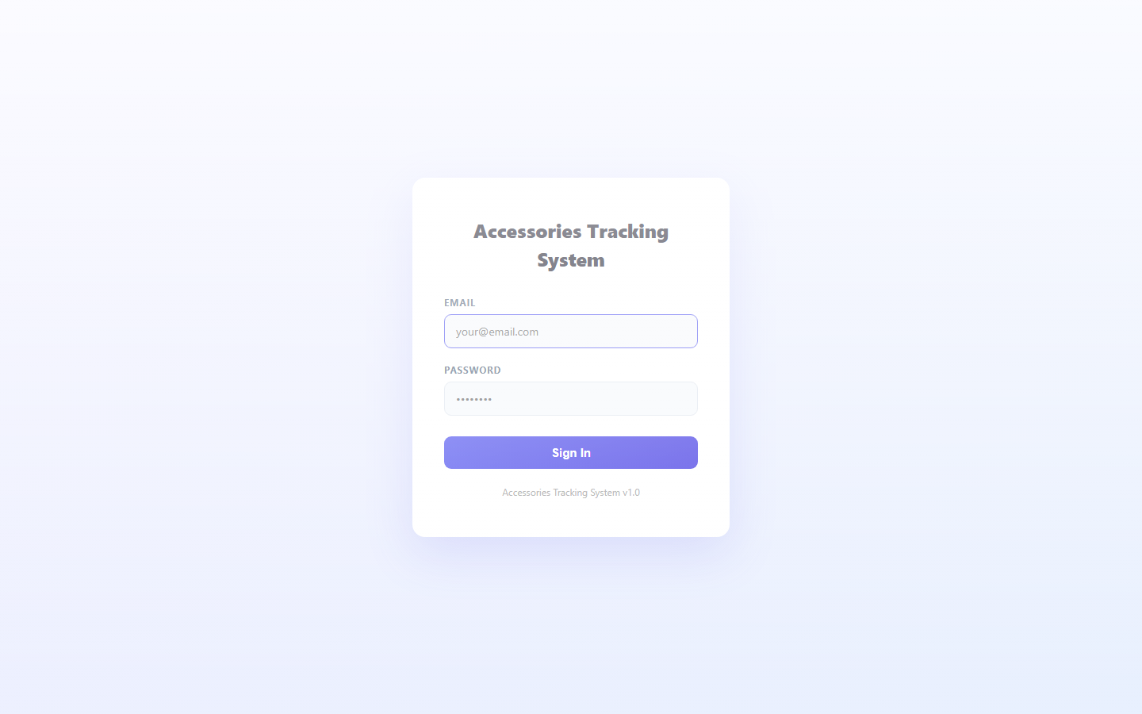

Dashboard
Central hub showing all active work orders. Each card displays the order ID, customer, current workflow step, and quick-action links. New orders are created from here.
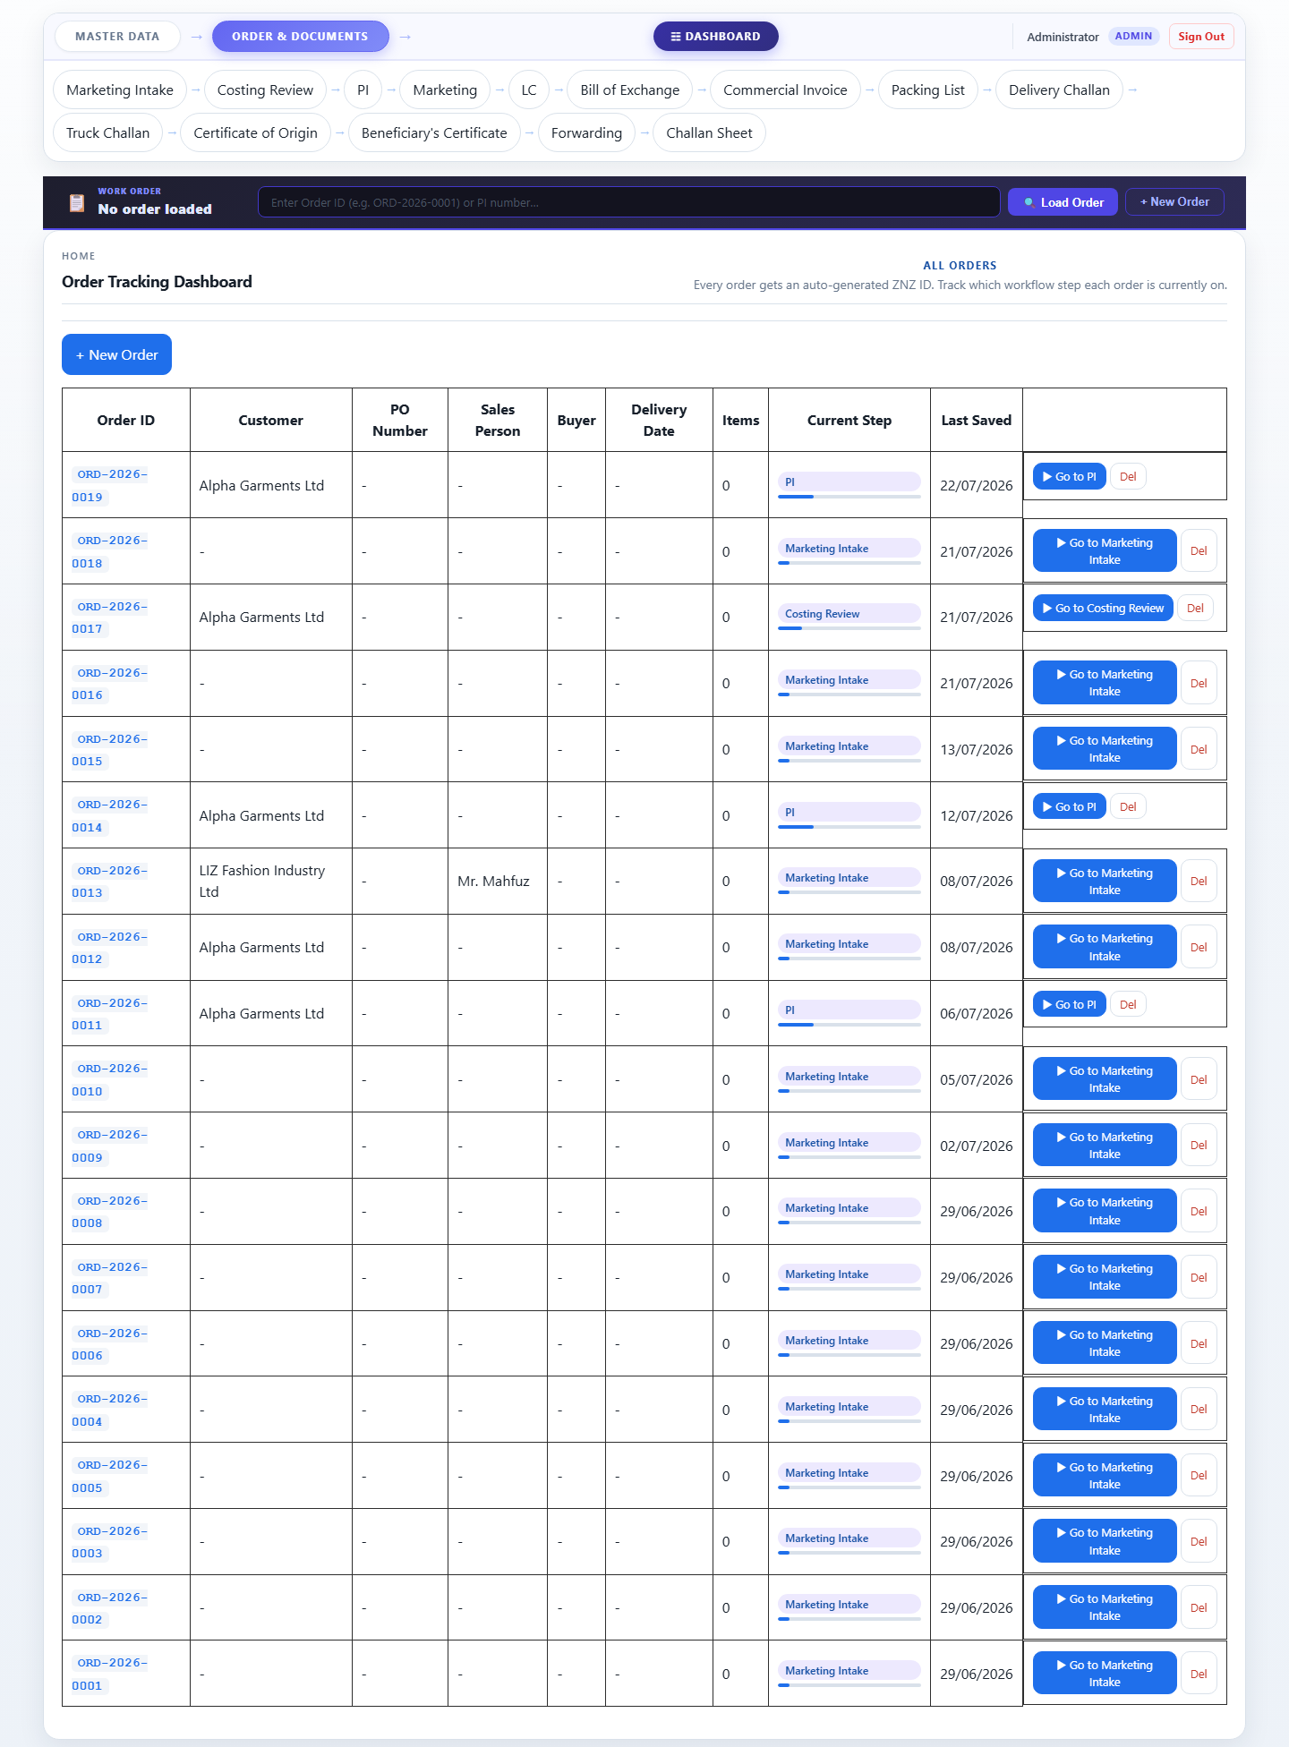

PO Overview
Bird's-eye view of every Purchase Order across all customers. Filter by buyer, status, or date range. Clicking a row opens the full order workflow.

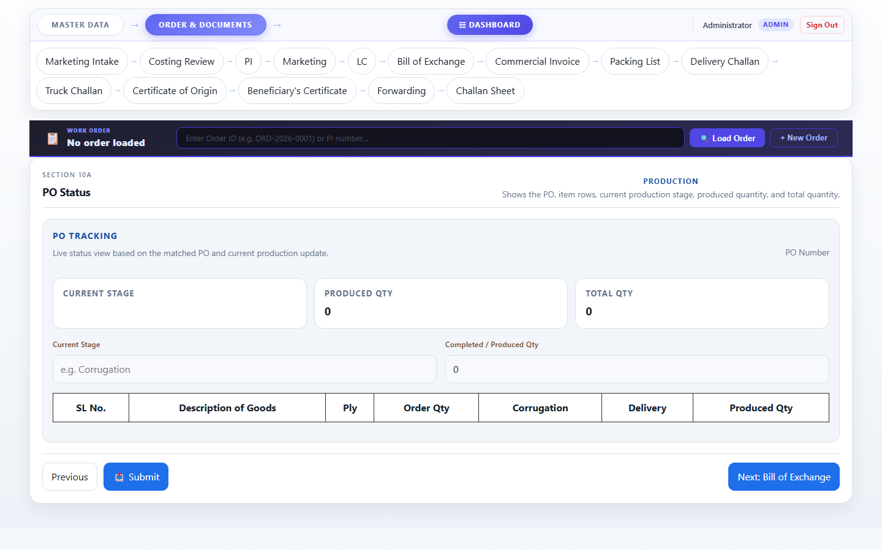

Step 1 — Marketing Intake
First step of the order workflow. The marketing team records customer details, PO numbers, product lines, item specifications (ply, grade, size), quantities, and unit prices per buyer. Each product line shows relevant spec fields automatically.

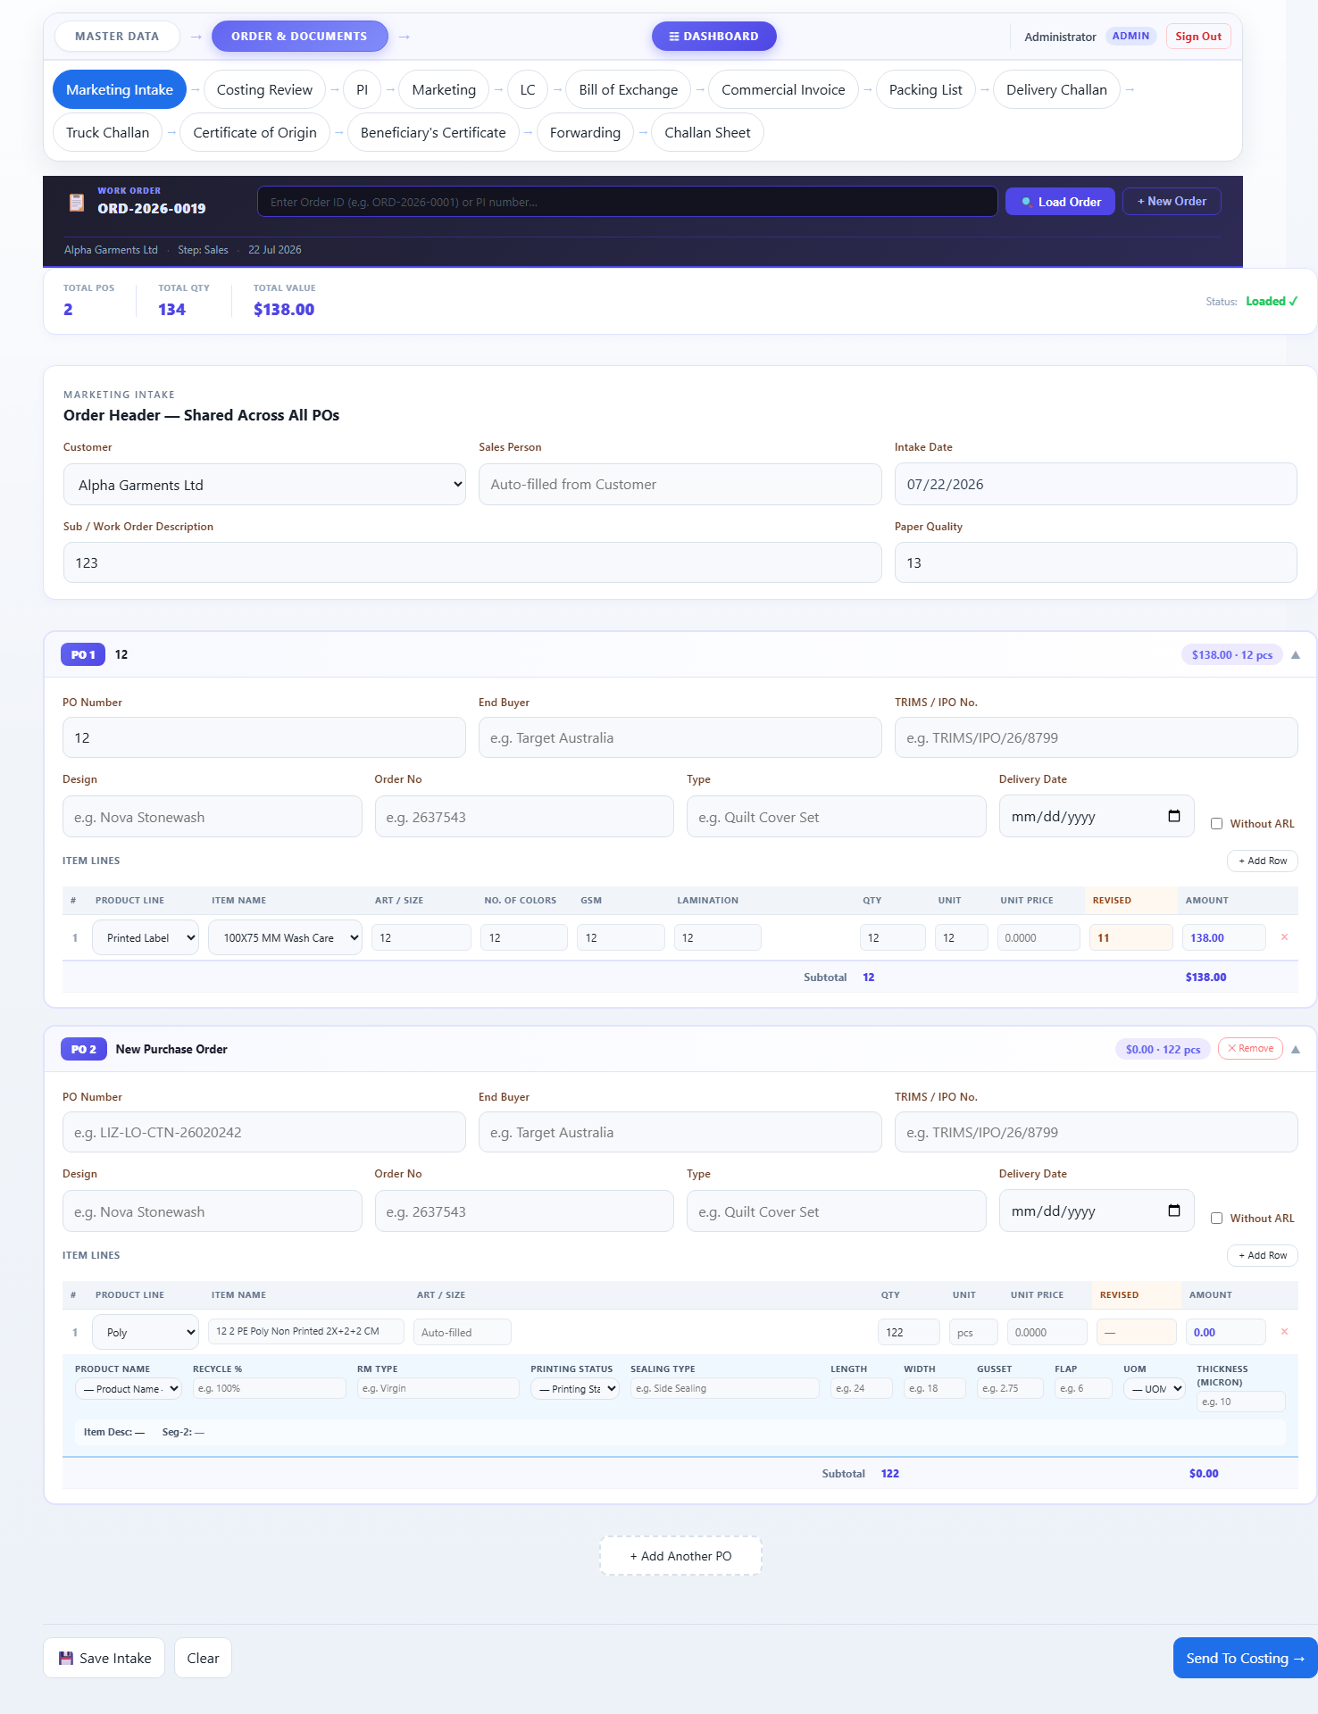

Step 2 — Costing Review
Finance team reviews the cost breakdown for every item in the order. Shows product specs, quantities, and pricing pulled from the intake form. Revised prices can be entered per line.
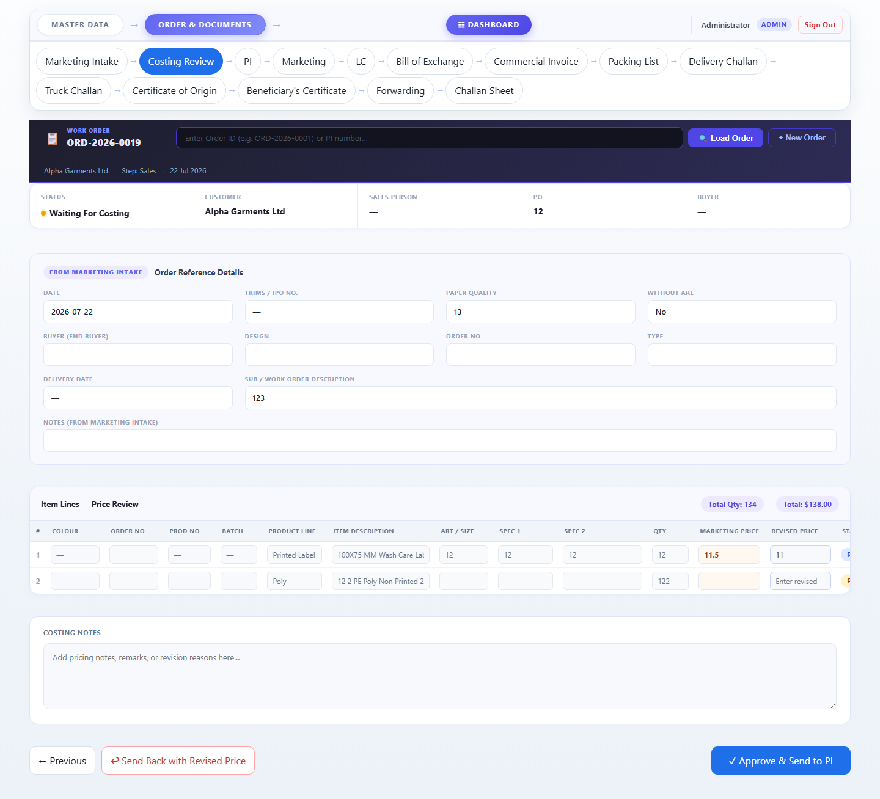

Step 3 — Sales / Proforma Invoice
Sales team searches the ERP system for the matching sales order. ERP items (authoritative) are imported and a Proforma Invoice (PI) is generated. The PI can be marked as Master PI when confirmed.
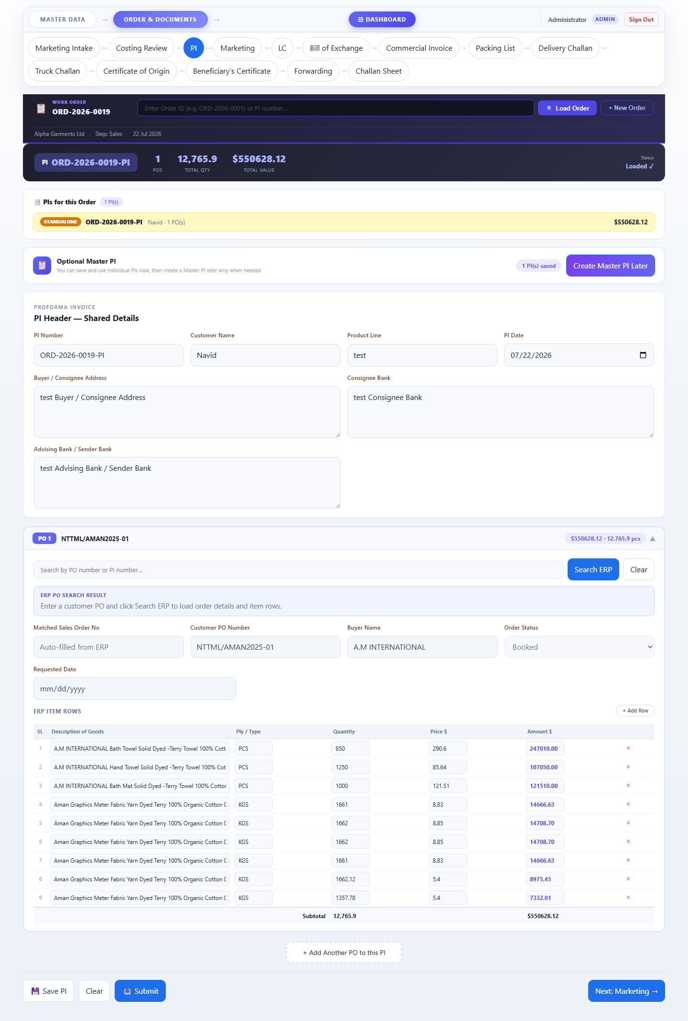

Step 4 — Marketing Summary
Marketing overview for the confirmed order. Shows the sales snapshot with PO-wise item breakdown, quantities, and values. Collapsible PO blocks allow quick review of each buyer's items.
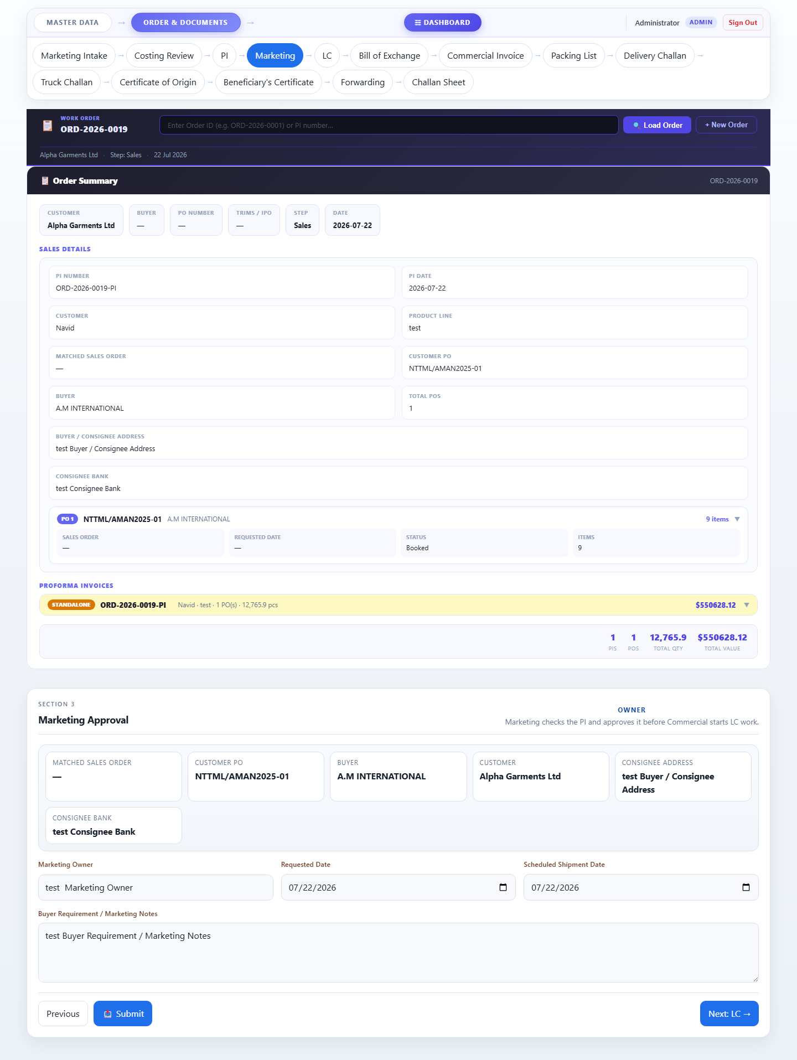

Step 5 — Letter of Credit (LC)
Records the LC details received from the buyer's bank. Captures LC number, date, payment terms, amount, advising bank, and consignee bank information.
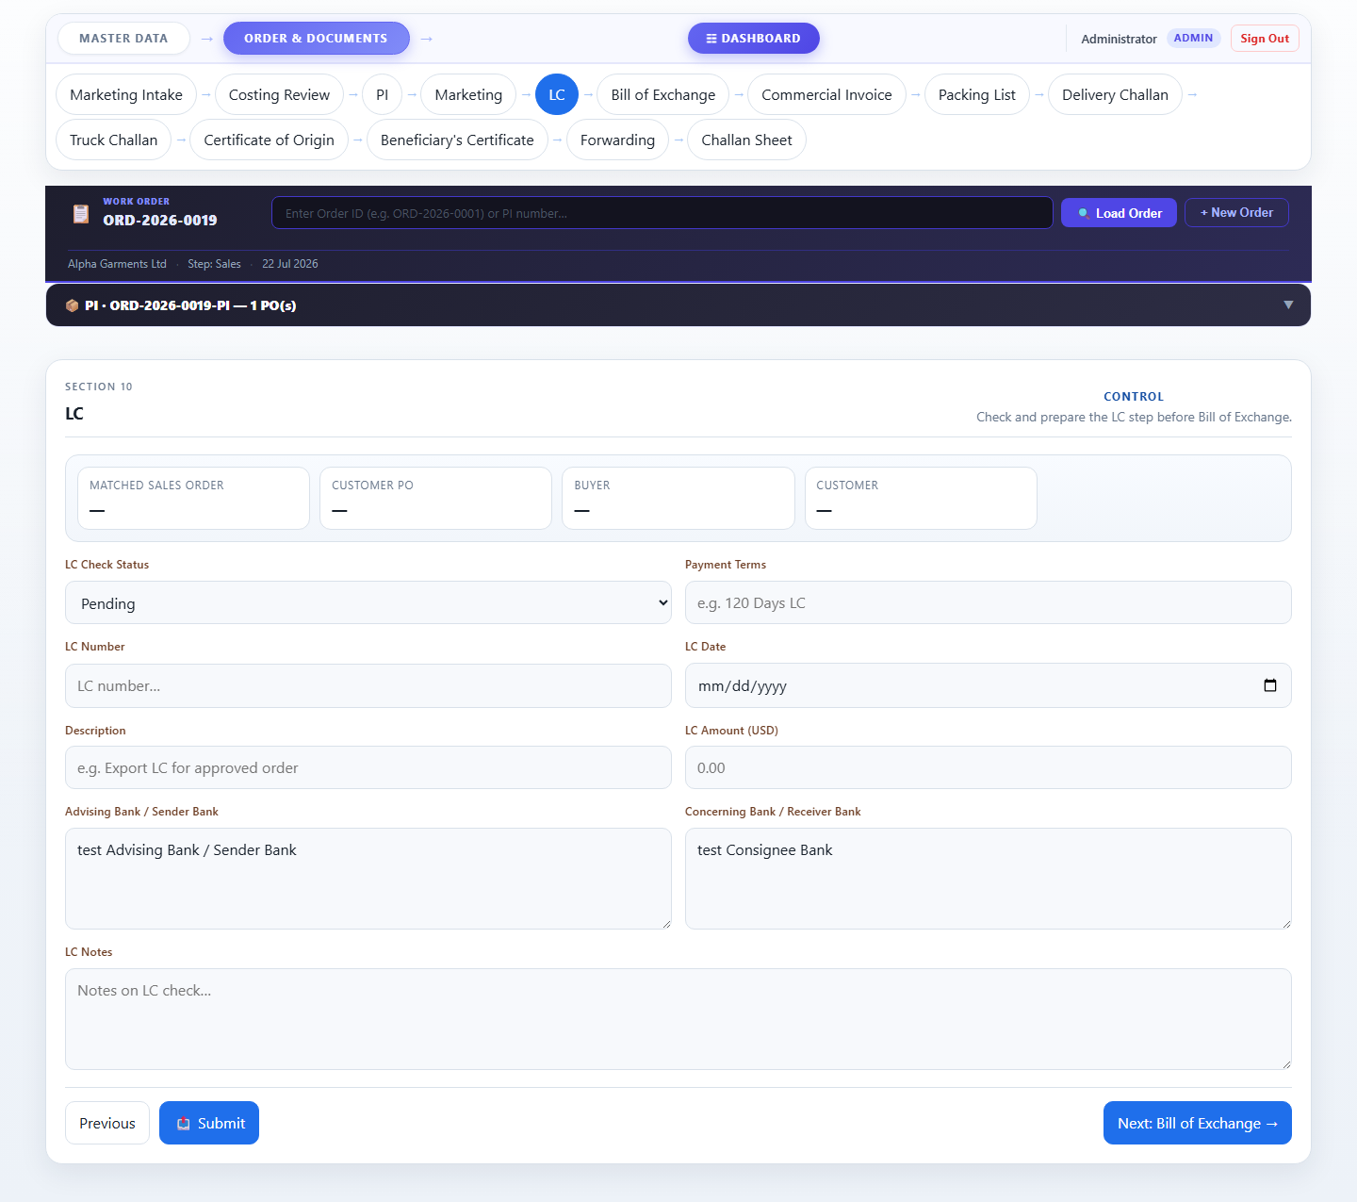

Step 6 — Bill of Exchange
Captures the Bill of Exchange details: LC drawn-under reference, applicant details (IRC, TIN, VAT/BIN, Bank BIN, Bond License), HS Code, export sales contract number, and carrier information. These feed automatically into the Commercial Invoice and all subsequent documents.
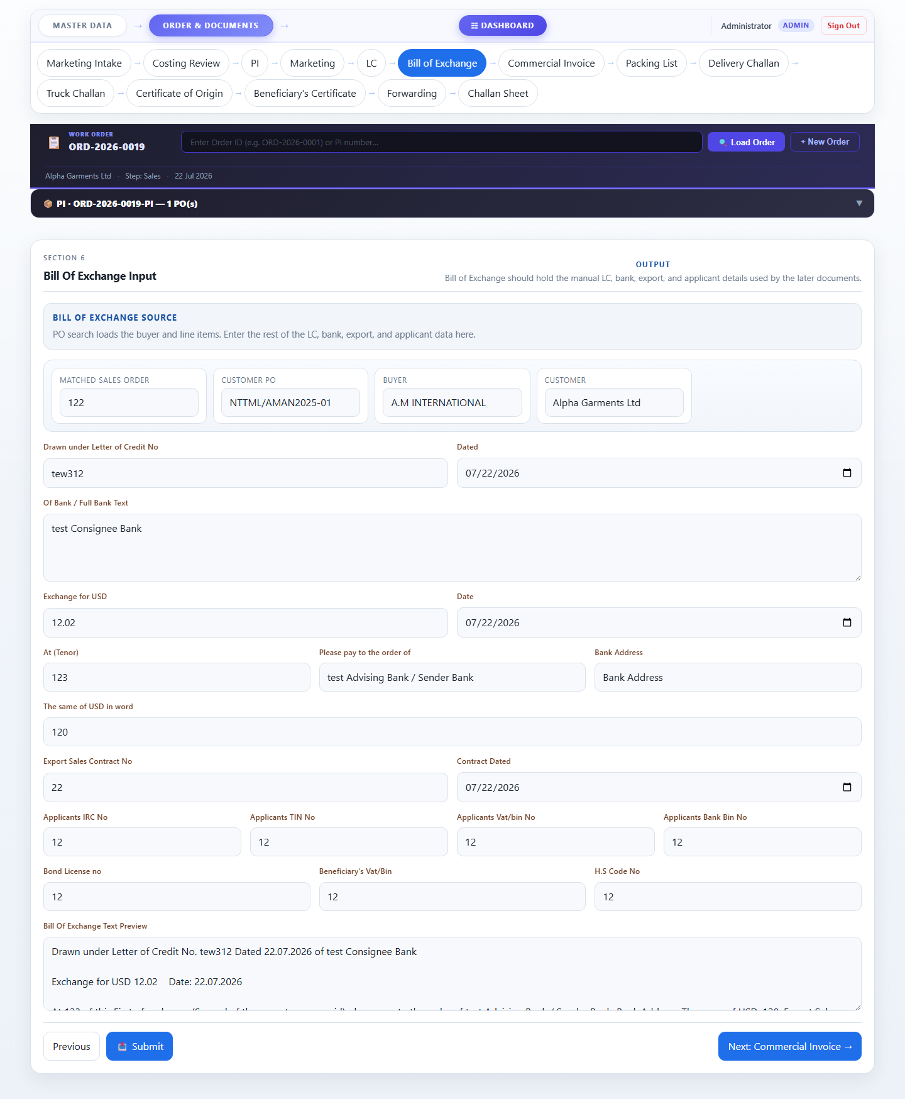

Step 7 — Commercial Invoice
Auto-populated commercial invoice showing beneficiary, consignee, advising bank, LC details, and the full item table with quantities, unit prices, and total amounts. The applicants footer text is auto-built from the Bill of Exchange data.
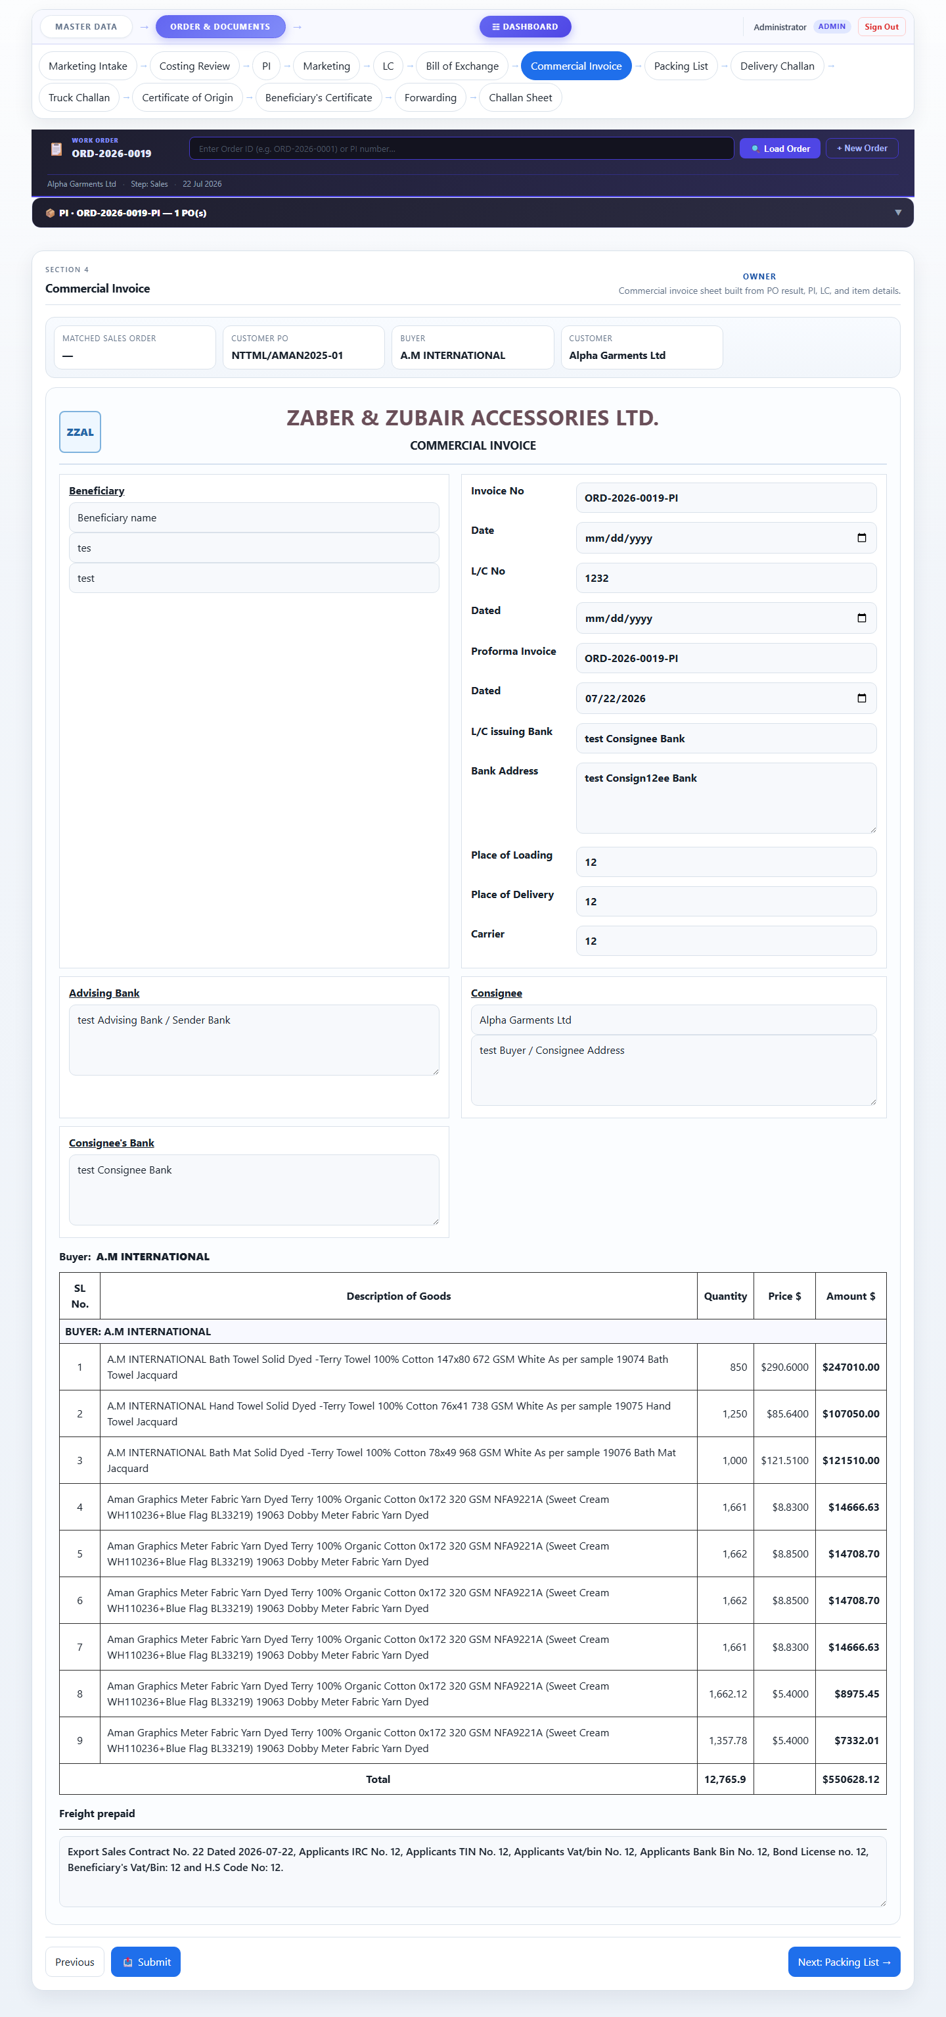

Step 8 — Packing List
Packing list document auto-filled from the PI and exchange data. Lists all items with descriptions, ply/unit, and quantities. Signature slots for authorized representative and consignee.

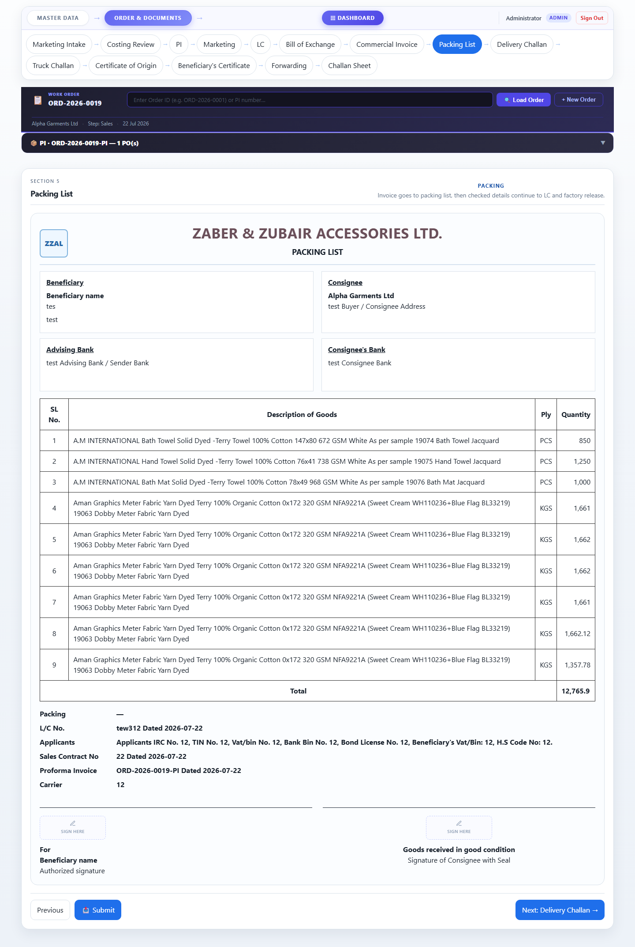

Step 9 — Delivery Challan
Delivery challan for dispatching goods to the consignee. Auto-filled from PI items, LC, exchange, and commercial data. Includes beneficiary, consignee, advising bank blocks and LC/contract/proforma references.
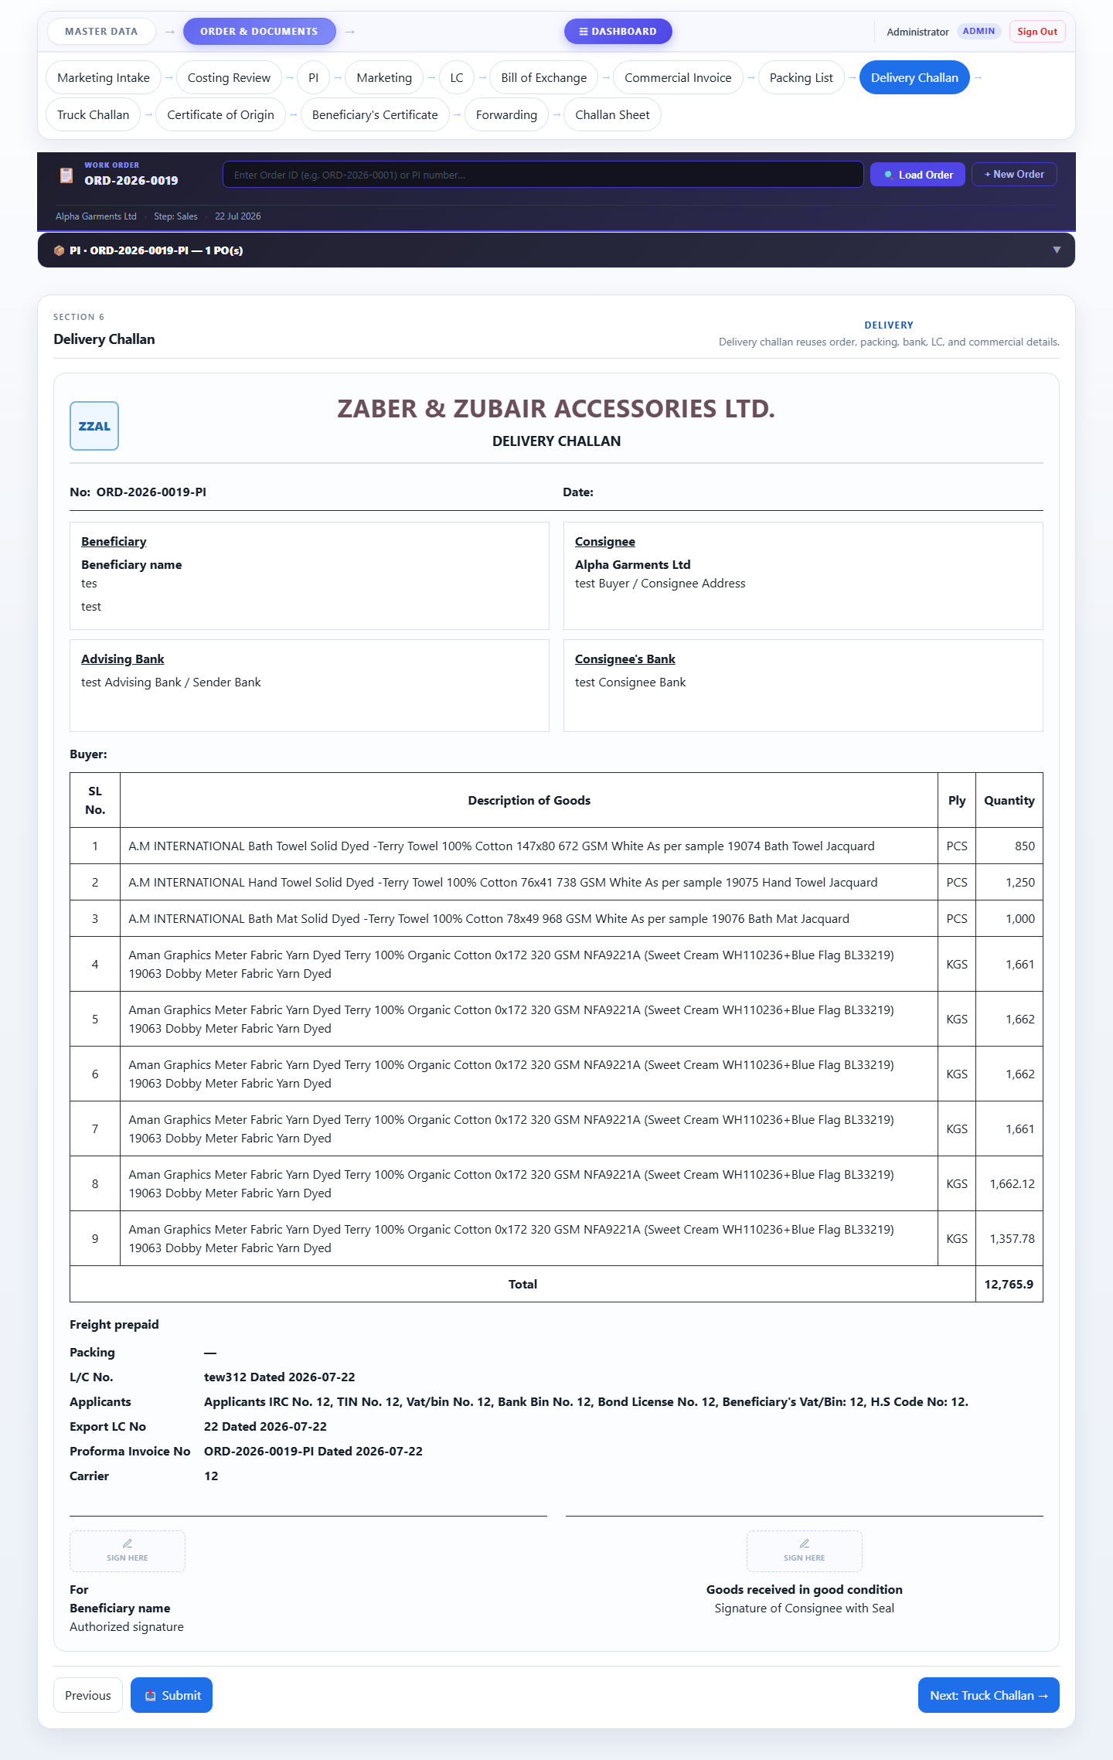

Step 10 — Truck Challan
Transport document for truck dispatch. Mirrors the delivery challan with buyer name, item list, and all reference numbers. Signature areas for company representative and consignee.
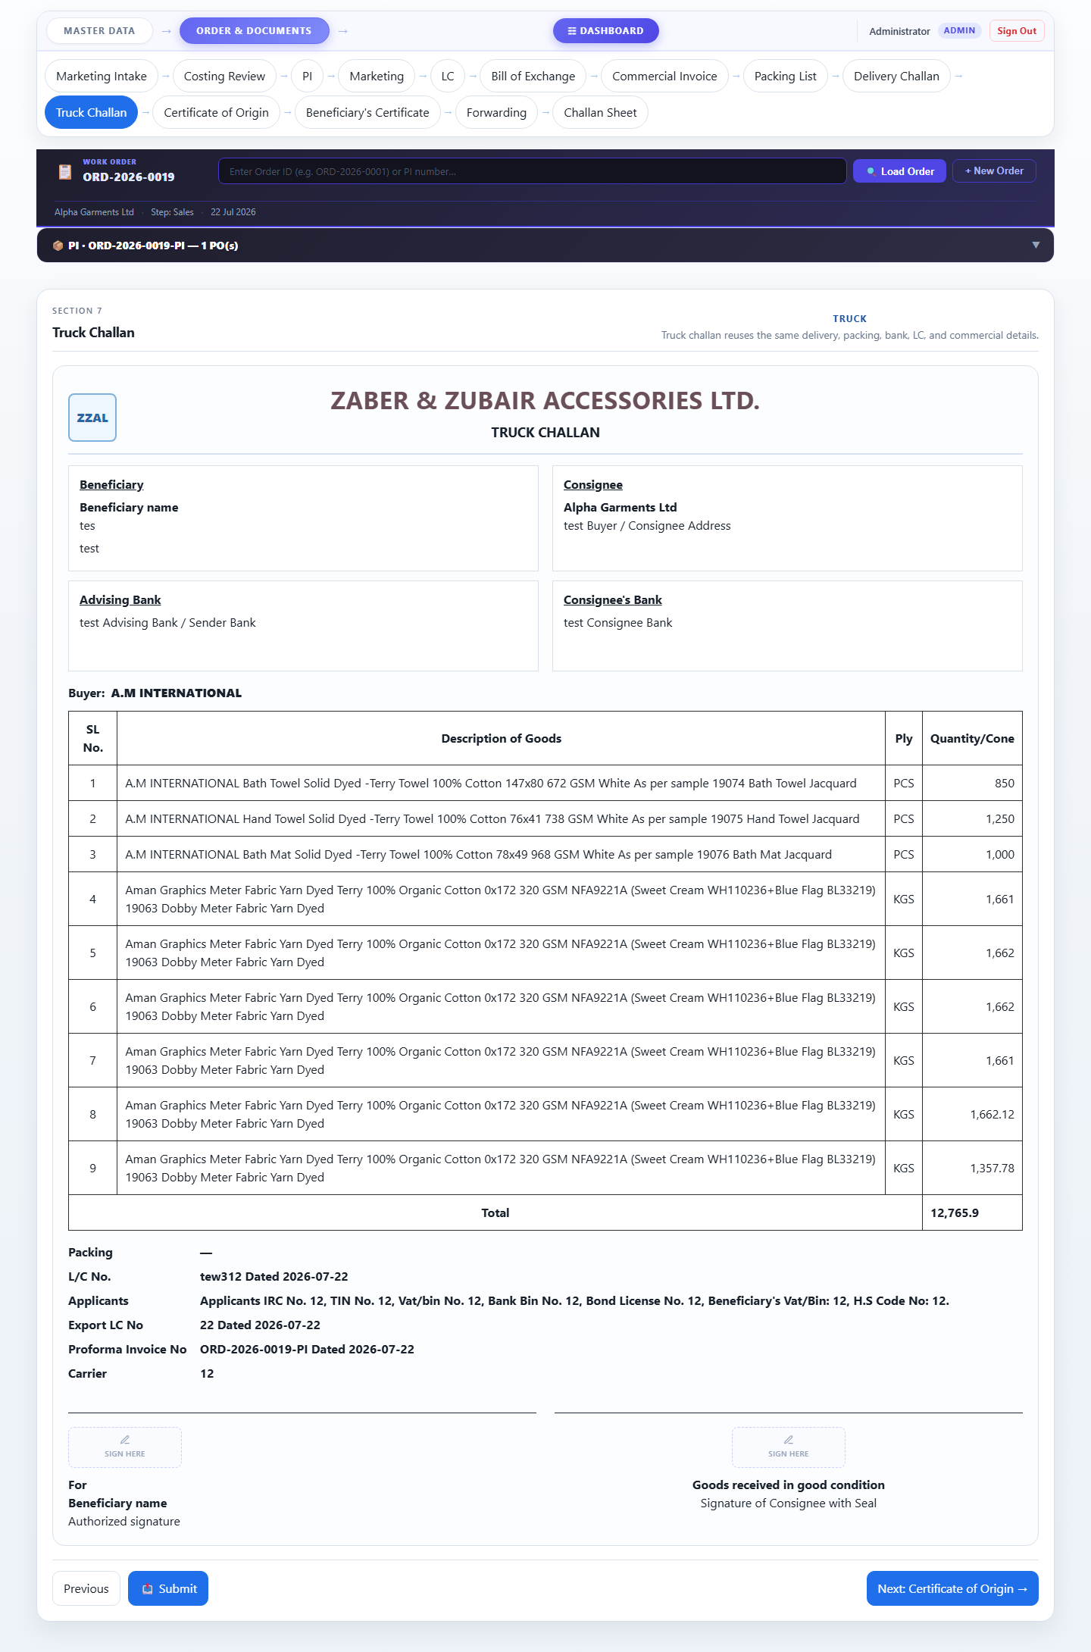

Step 11 — Certificate of Origin
Certificate of Origin auto-filled with order and PI data. Records the country of origin, manufacturer details, and certifying authority signature.

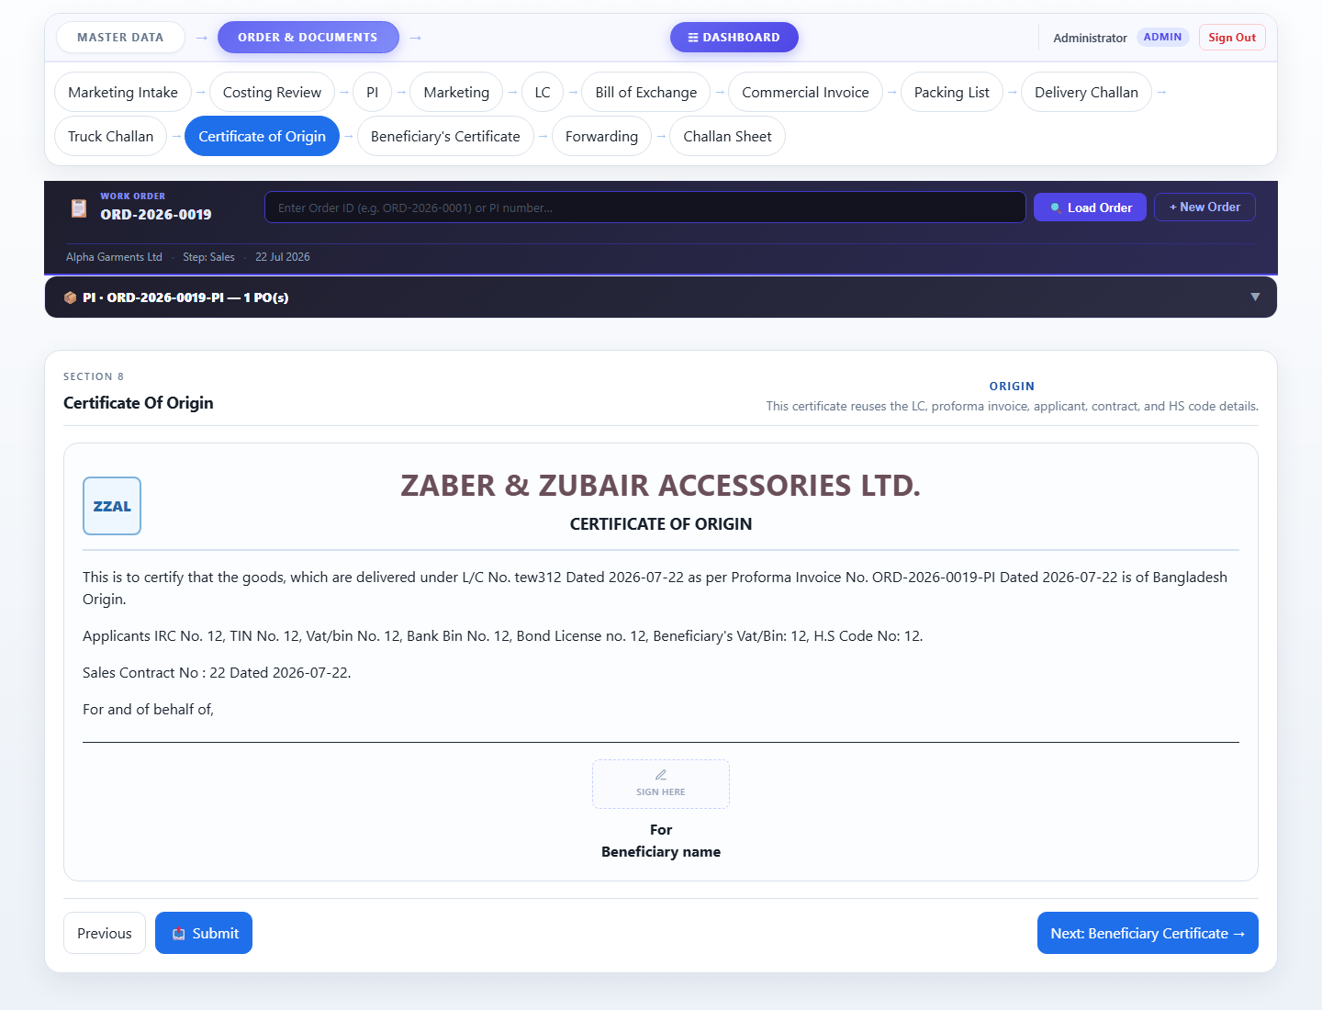

Step 12 — Beneficiary Certificate
Beneficiary certificate confirming the goods match the LC terms. Auto-populated with consignee, LC, and shipment details.
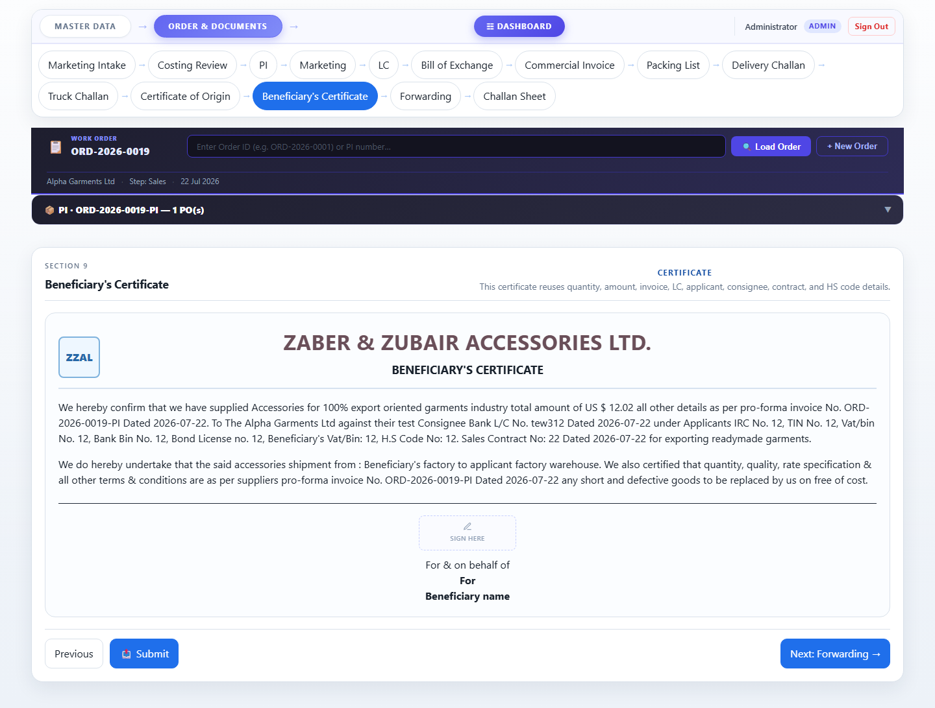

Step 13 — Forwarding
Final forwarding / freight document. Captures shipping details, freight forwarder information, and confirms dispatch.
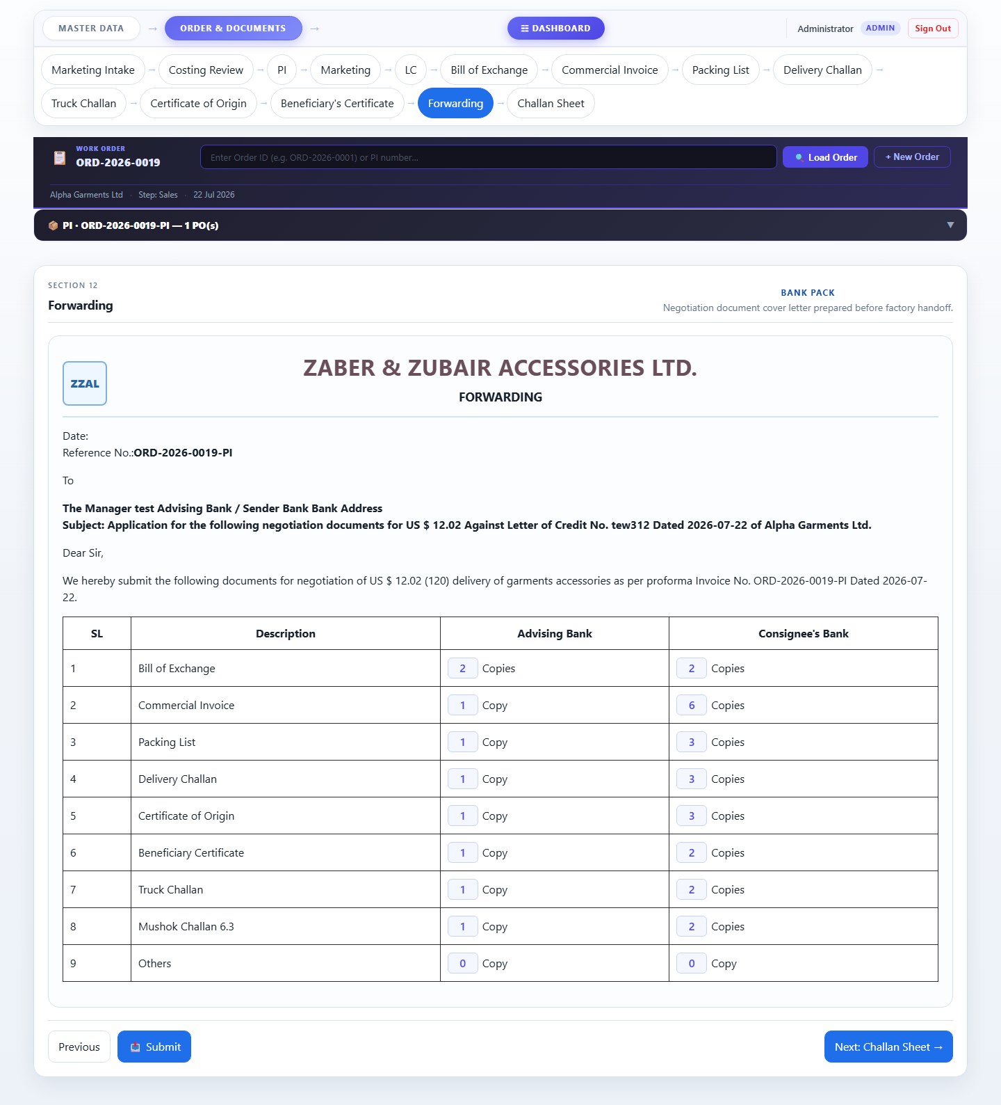

Key Features
- Auto Data Flow: Every field that can be derived from a previous step is filled automatically. LC number, applicant codes, PI number, buyer address — enter once, used everywhere.
- Master PI Priority: When a Master Proforma Invoice is created, all downstream documents (Commercial Invoice, Packing List, Delivery Challan, etc.) use it as the authoritative source for items and pricing.
- ERP Integration: The Sales page connects to the ERP system to import real PO line items. These ERP items become the definitive item list for all export documents.
- Digital Signatures: Every challan and certificate has a signature slot. Users can draw their signature with a mouse/finger or upload an image. Signatures are saved per slot.
- Role-Based Access: Five roles (Admin, Sales Person, Commercial Officer, Team Leader, Sales Coordinator) each see only the signature fields and actions relevant to their function.
- Multi-PO Support: An order can have multiple POs from different buyers. All unique values (Sales Order nos., PO nos., Buyer codes) are shown together on reference fields.
- Print Ready: Every document page is styled for A4 printing directly from the browser. No export needed — just File → Print from any document page.
- Order Items Panel: A collapsible 📦 Order Items panel appears on every document page showing the Master PI items at a glance without leaving the current page.

Accessories Tracking System · Zaber & Zubair Accessories Ltd.
Document generated 23 July 2026 · Confidential

