Accessories Tracking System
Commercial Officer — User Guide

Handles all export documentation from PI through to final forwarding.

Email: commercial@zzal.com | Password: comm@123
Role: Commercial Officer | Pages: 10 page(s)
Prepared: 25 July 2026

About This Guide
Handles all export documentation from PI through to final forwarding.

This guide shows every screen the Commercial Officer can access in the Accessories Tracking System. Each page is shown with a live order loaded so you can see exactly what data appears.

Your Pages at a Glance
- PI — Proforma Invoice — Search the ERP for the matching sales order, import PO line items, and generate the Proforma Invoice.
- Letter of Credit — Record the LC details received from the buyer's bank — LC number, date, payment terms, amount, advising bank, and consignee bank.
- Bill of Exchange — Enter applicant codes (IRC, TIN, VAT/BIN, Bank BIN, Bond License), HS Code, export sales contract, and carrier info.
- Commercial Invoice — Auto-populated invoice with beneficiary, consignee, LC details, and the full item table with quantities, unit prices, and totals.
- Packing List — Auto-filled packing list showing all items, quantities, and ply.
- Delivery Challan — Dispatch document auto-filled from PI items, LC, exchange, and commercial data with all reference numbers.
- Truck Challan — Transport document for truck dispatch with buyer name, item list, and all LC/contract references.
- Certificate of Origin — Records country of origin, manufacturer details and the certifying signature.
- Beneficiary Certificate — Confirms that goods match the LC terms — auto-populated with consignee and LC details.
- Forwarding — Final freight and forwarding document capturing shipping details and freight forwarder information.

Page Screenshots
The following pages show each screen with a real order loaded.
PI — Proforma Invoice
Search the ERP for the matching sales order, import PO line items, and generate the Proforma Invoice. Mark as Master PI when confirmed.
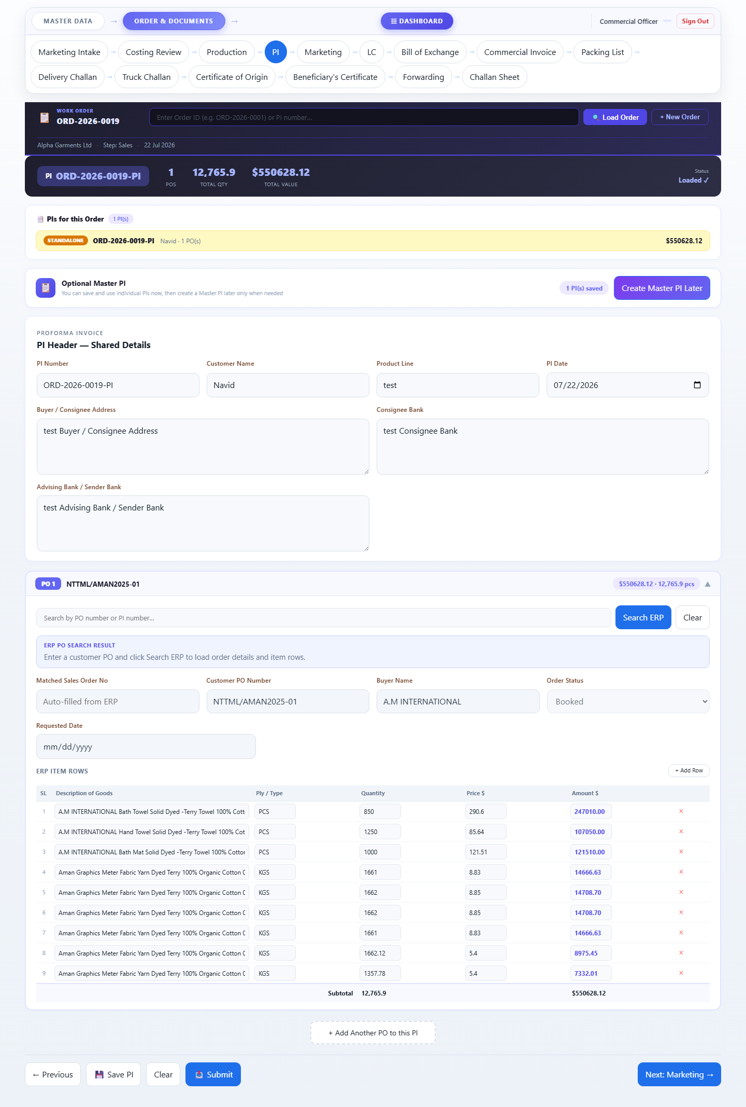

Letter of Credit
Record the LC details received from the buyer's bank — LC number, date, payment terms, amount, advising bank, and consignee bank.
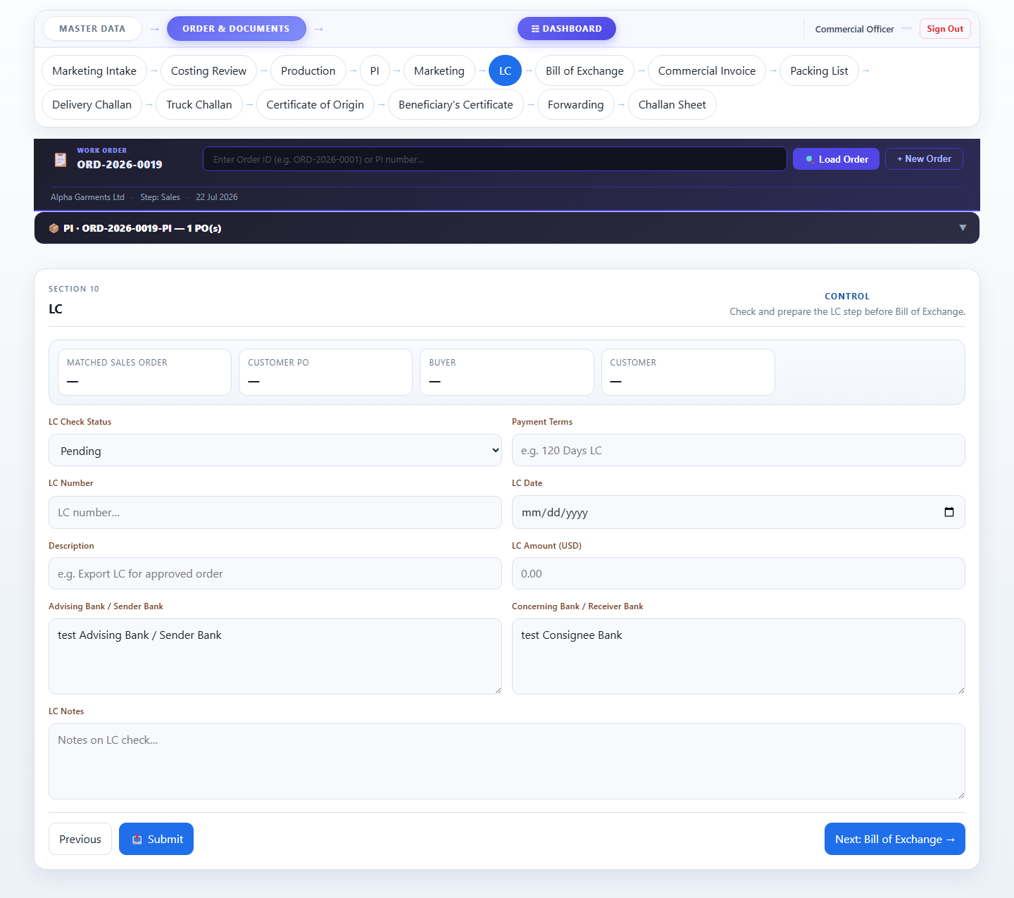

Bill of Exchange
Enter applicant codes (IRC, TIN, VAT/BIN, Bank BIN, Bond License), HS Code, export sales contract, and carrier info. These auto-fill all downstream documents.
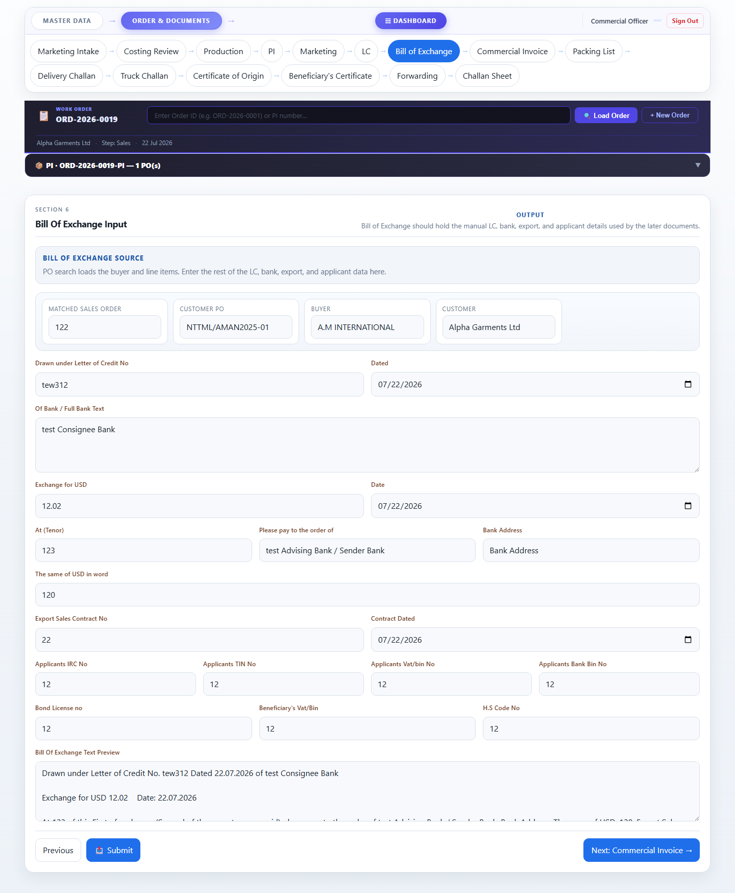

Commercial Invoice
Auto-populated invoice with beneficiary, consignee, LC details, and the full item table with quantities, unit prices, and totals.
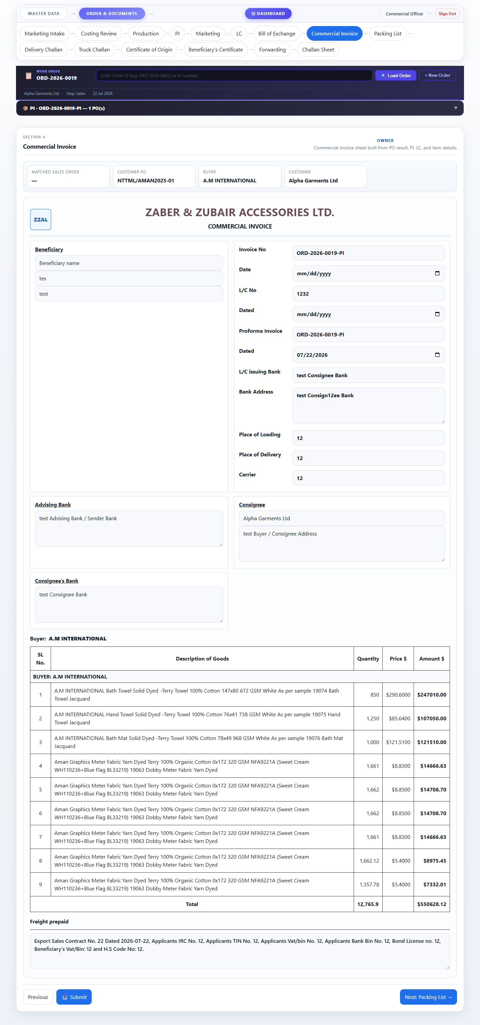

Packing List
Auto-filled packing list showing all items, quantities, and ply. Includes signature slots for the authorized representative and consignee.
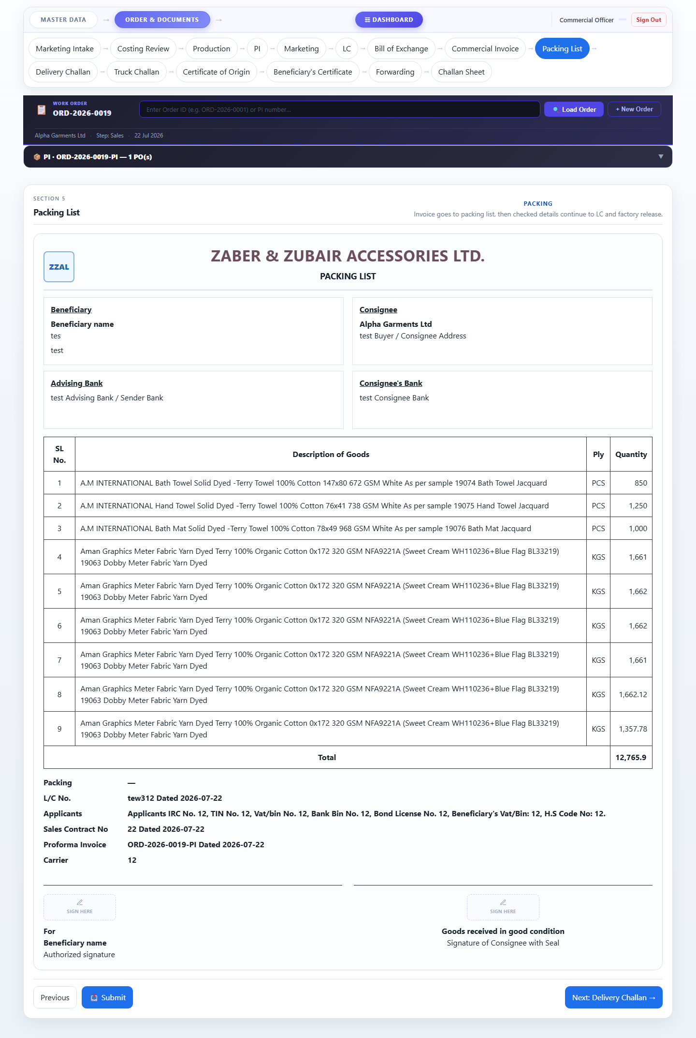

Delivery Challan
Dispatch document auto-filled from PI items, LC, exchange, and commercial data with all reference numbers.
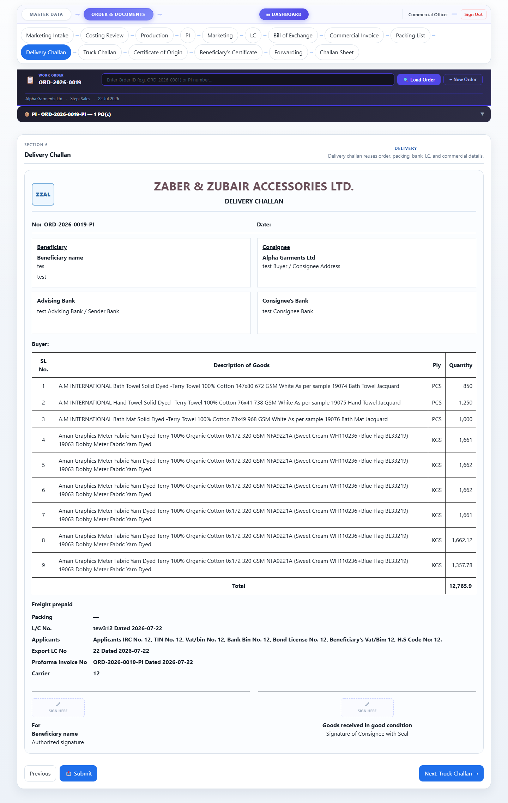

Truck Challan
Transport document for truck dispatch with buyer name, item list, and all LC/contract references.
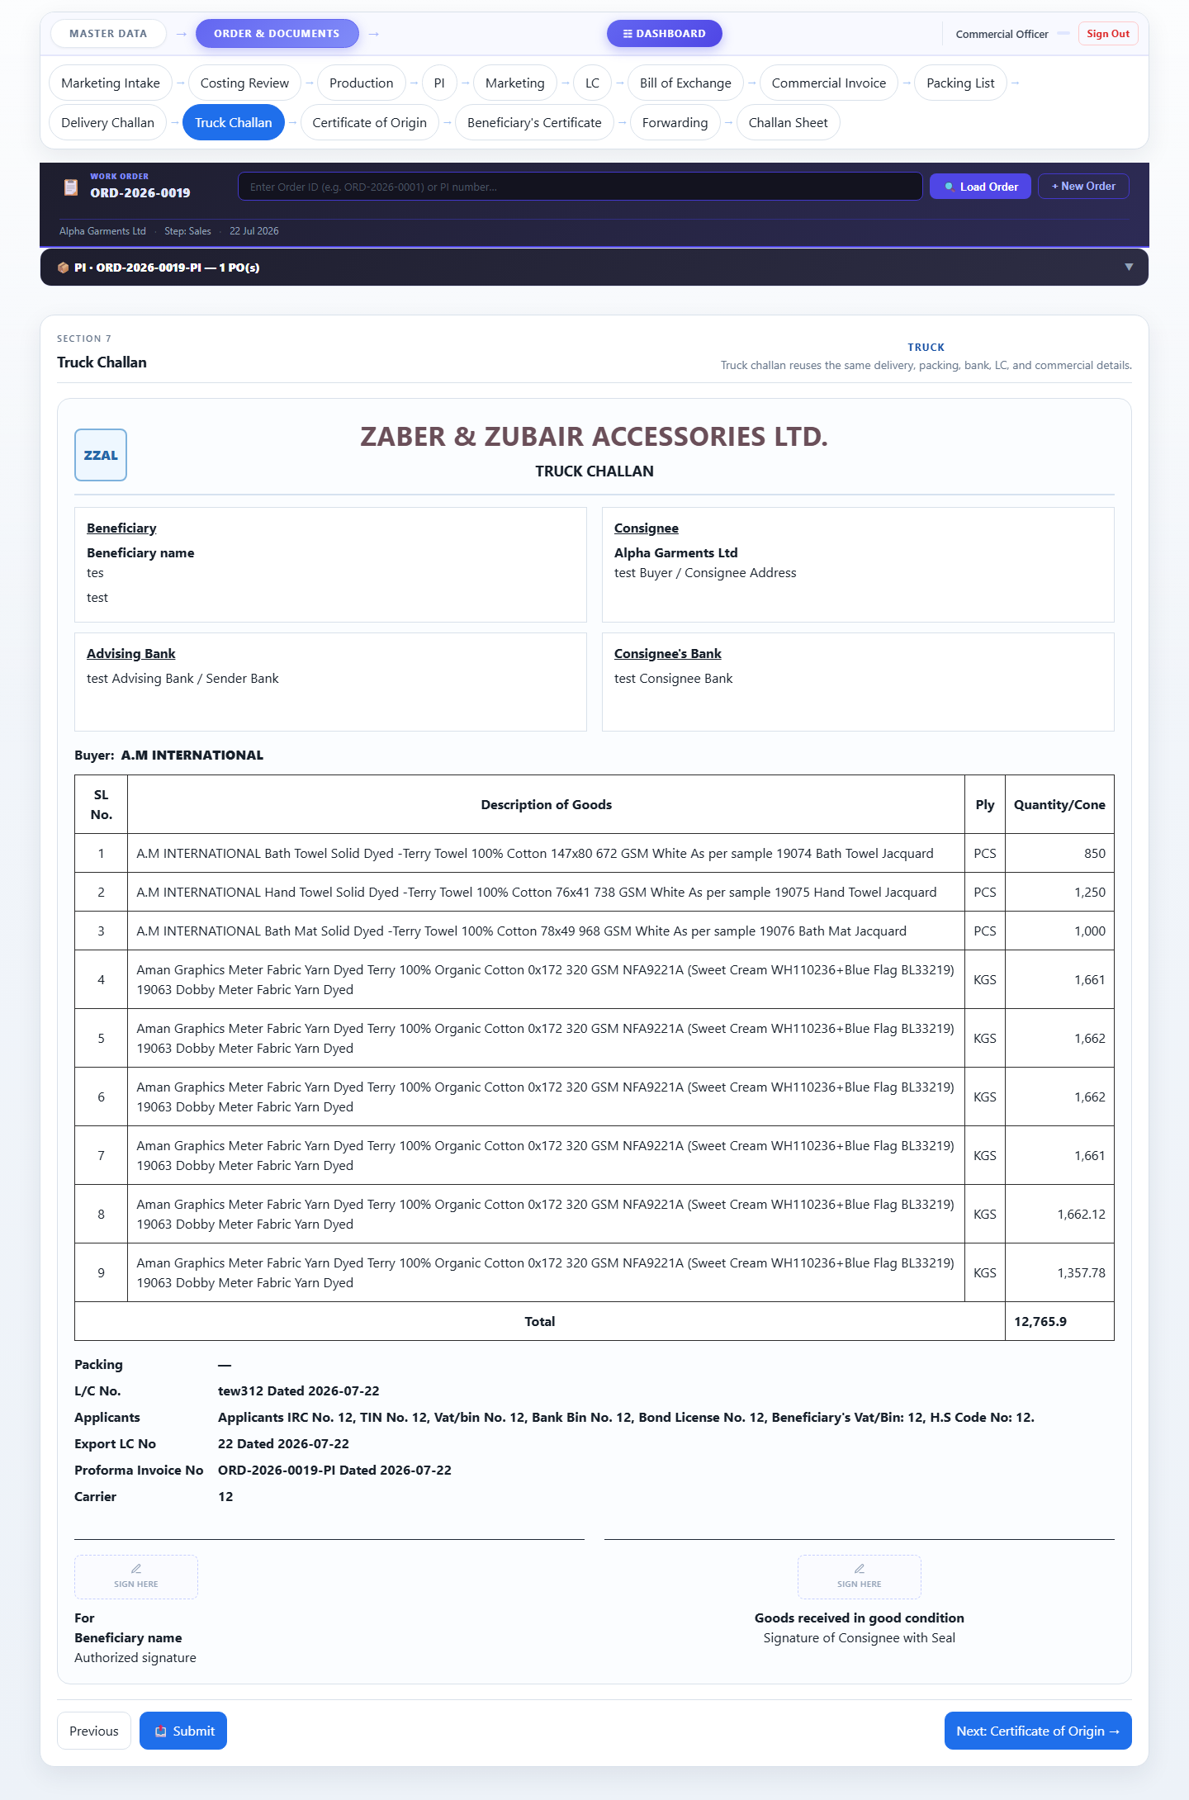

Certificate of Origin
Records country of origin, manufacturer details and the certifying signature.
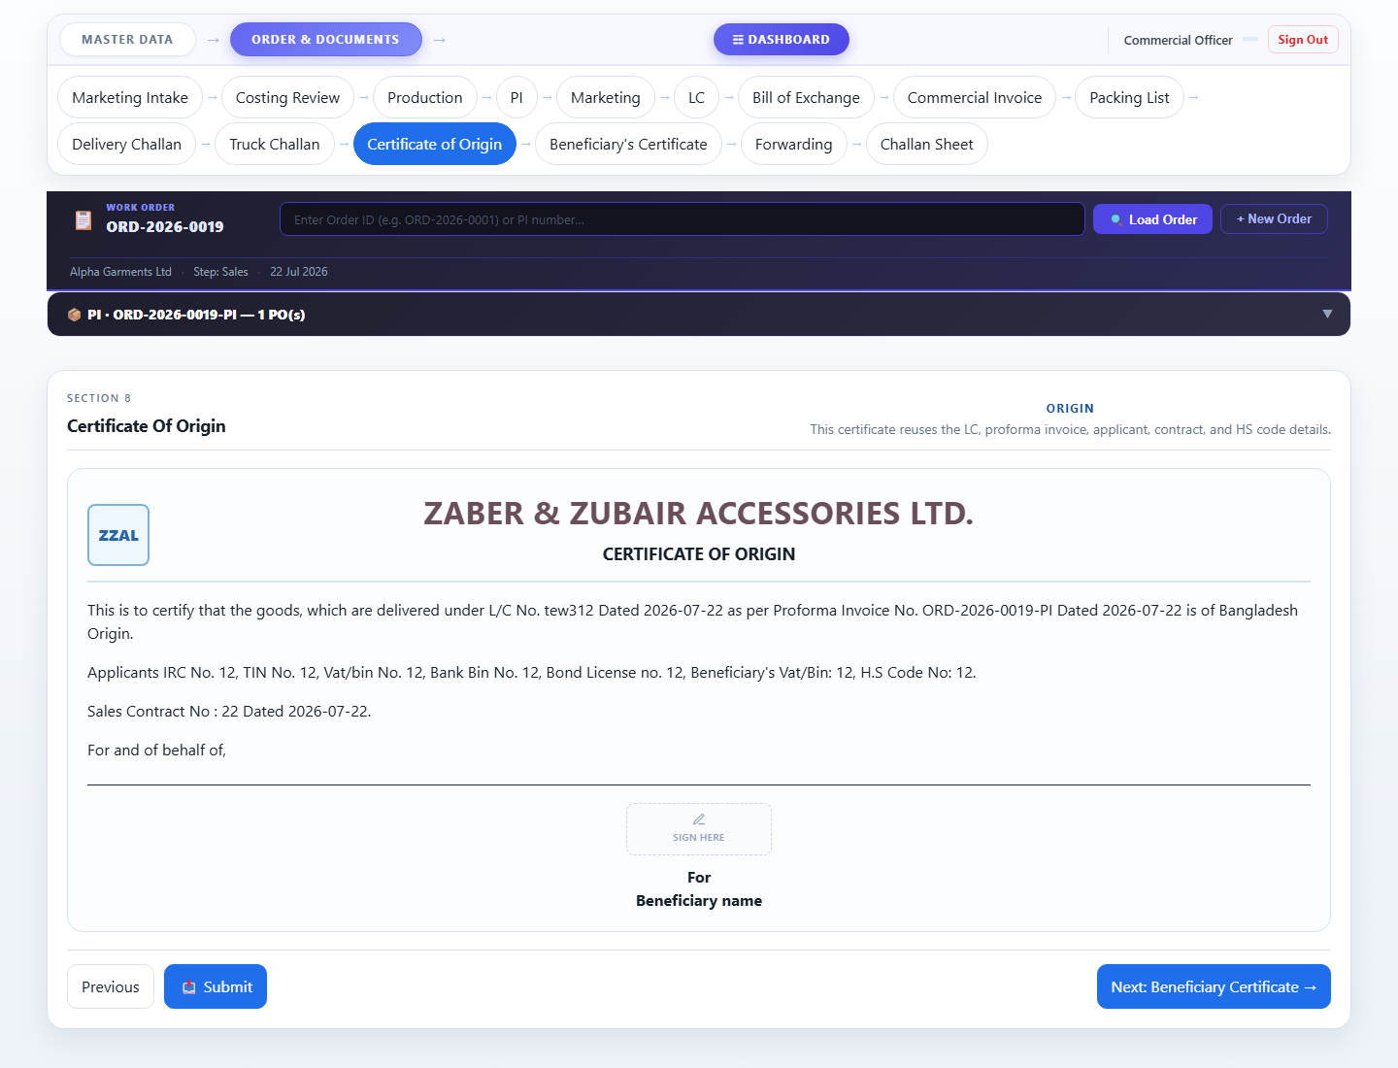

Beneficiary Certificate
Confirms that goods match the LC terms — auto-populated with consignee and LC details.
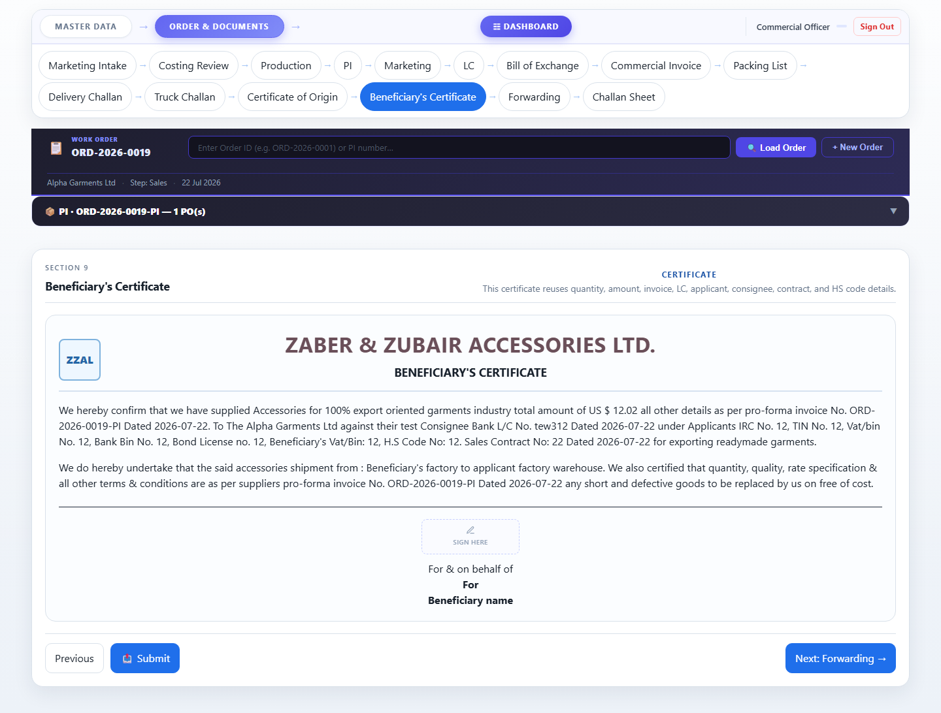

Forwarding
Final freight and forwarding document capturing shipping details and freight forwarder information.
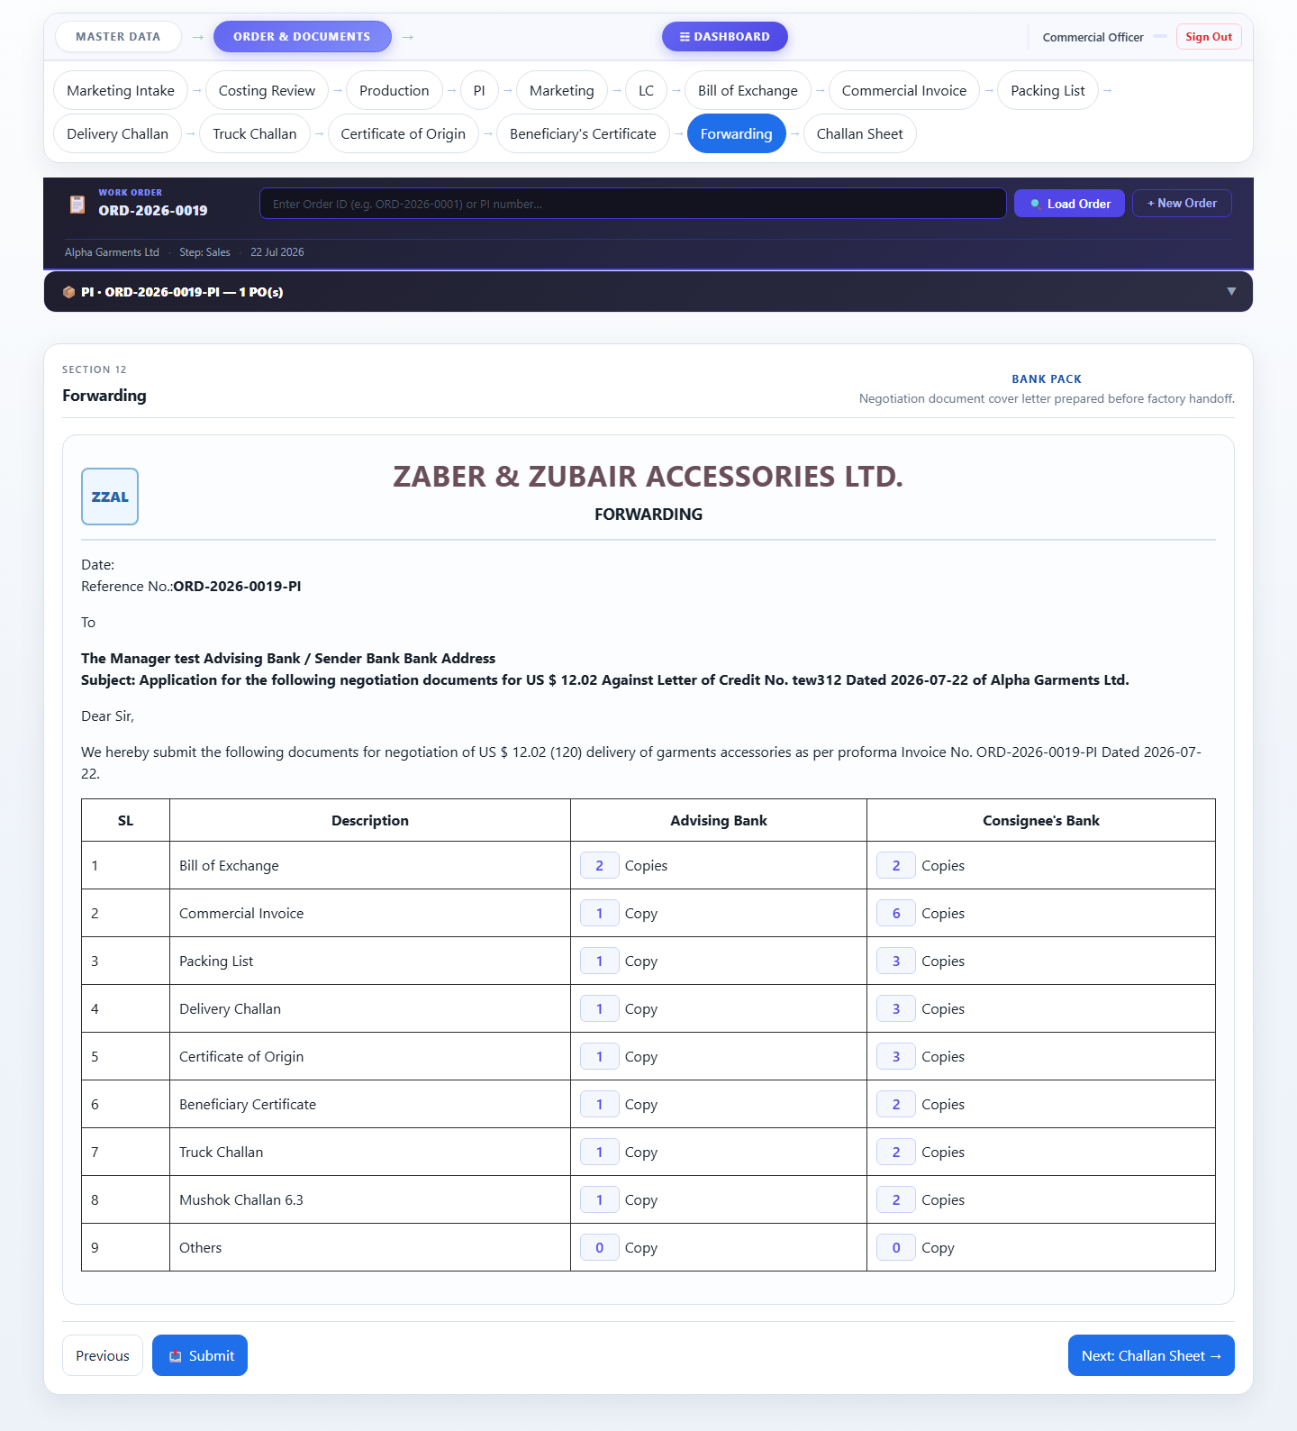

Accessories Tracking System · Zaber & Zubair Accessories Ltd.
For: Commercial Officer · 25 July 2026 · Confidential

