Accessories Tracking System
Costing Officer — User Guide

Reviews cost per item and approves the order before it enters production.

Email: costing@zzal.com | Password: cost@123
Role: Costing Officer | Pages: 1 page(s)
Prepared: 25 July 2026

About This Guide
Reviews cost per item and approves the order before it enters production.

This guide shows every screen the Costing Officer can access in the Accessories Tracking System. Each page is shown with a live order loaded so you can see exactly what data appears.

Your Pages at a Glance
- Costing Review — Check quantities, specs, and unit prices pulled from Marketing Intake.

Page Screenshots
The following pages show each screen with a real order loaded.
Costing Review
Check quantities, specs, and unit prices pulled from Marketing Intake. Revised prices can be entered per line. Click 'Approve & Send to Production' when satisfied.
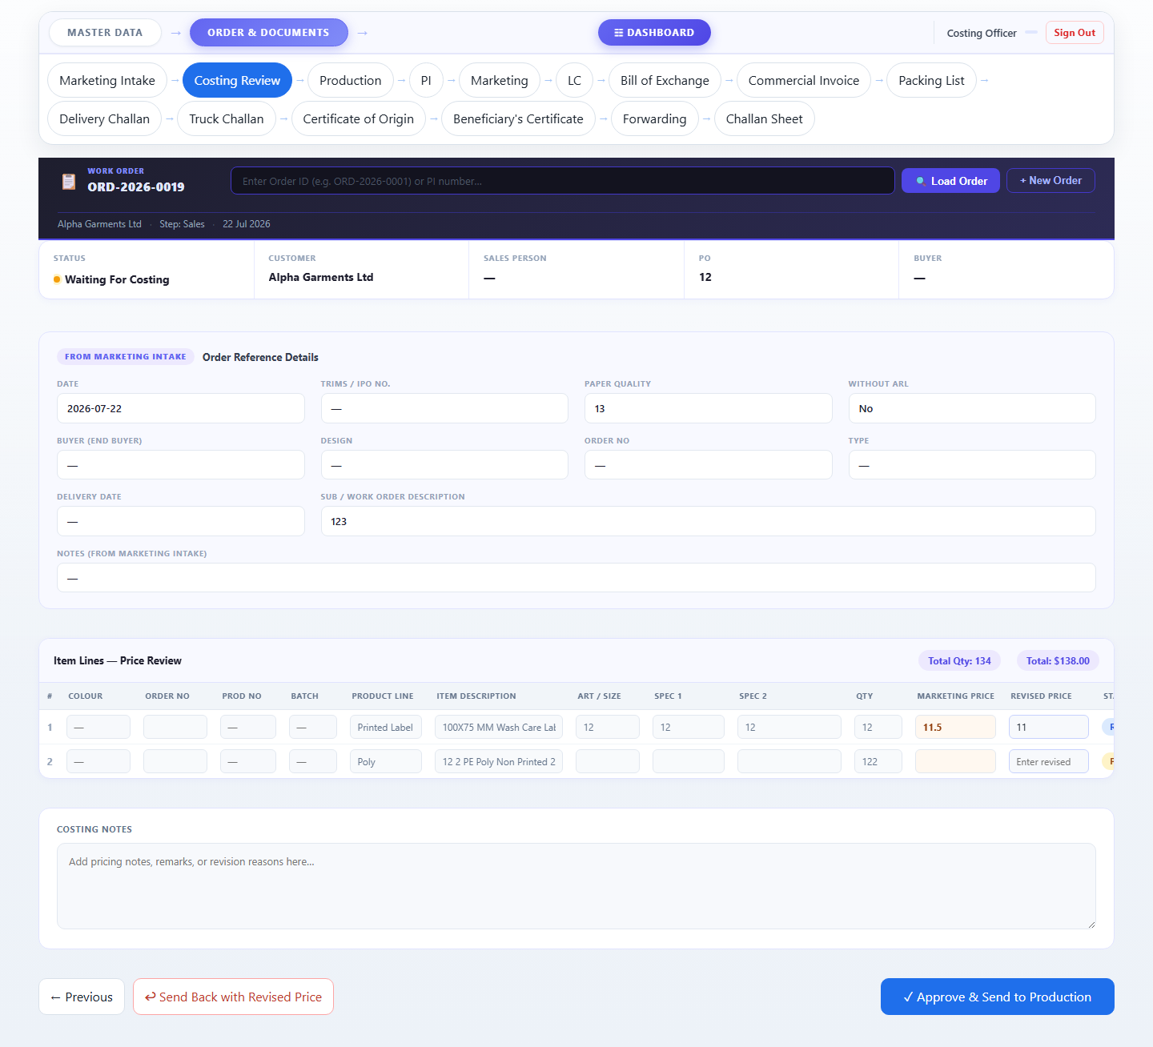

Accessories Tracking System · Zaber & Zubair Accessories Ltd.
For: Costing Officer · 25 July 2026 · Confidential

