Accessories Tracking System
Marketing Officer — User Guide

Manages the first impression — from buyer PO intake to sales summary.

Email: marketing@zzal.com | Password: mkt@123
Role: Marketing Officer | Pages: 2 page(s)
Prepared: 25 July 2026

About This Guide
Manages the first impression — from buyer PO intake to sales summary.

This guide shows every screen the Marketing Officer can access in the Accessories Tracking System. Each page is shown with a live order loaded so you can see exactly what data appears.

Your Pages at a Glance
- Marketing Intake — Record customer PO details, buyer info, product lines, item specs, quantities and unit prices.
- Marketing Summary — Review the confirmed sales snapshot with PO-wise item breakdown and totals.

Page Screenshots
The following pages show each screen with a real order loaded.
Marketing Intake
Record customer PO details, buyer info, product lines, item specs, quantities and unit prices. Each product line shows relevant spec fields automatically.
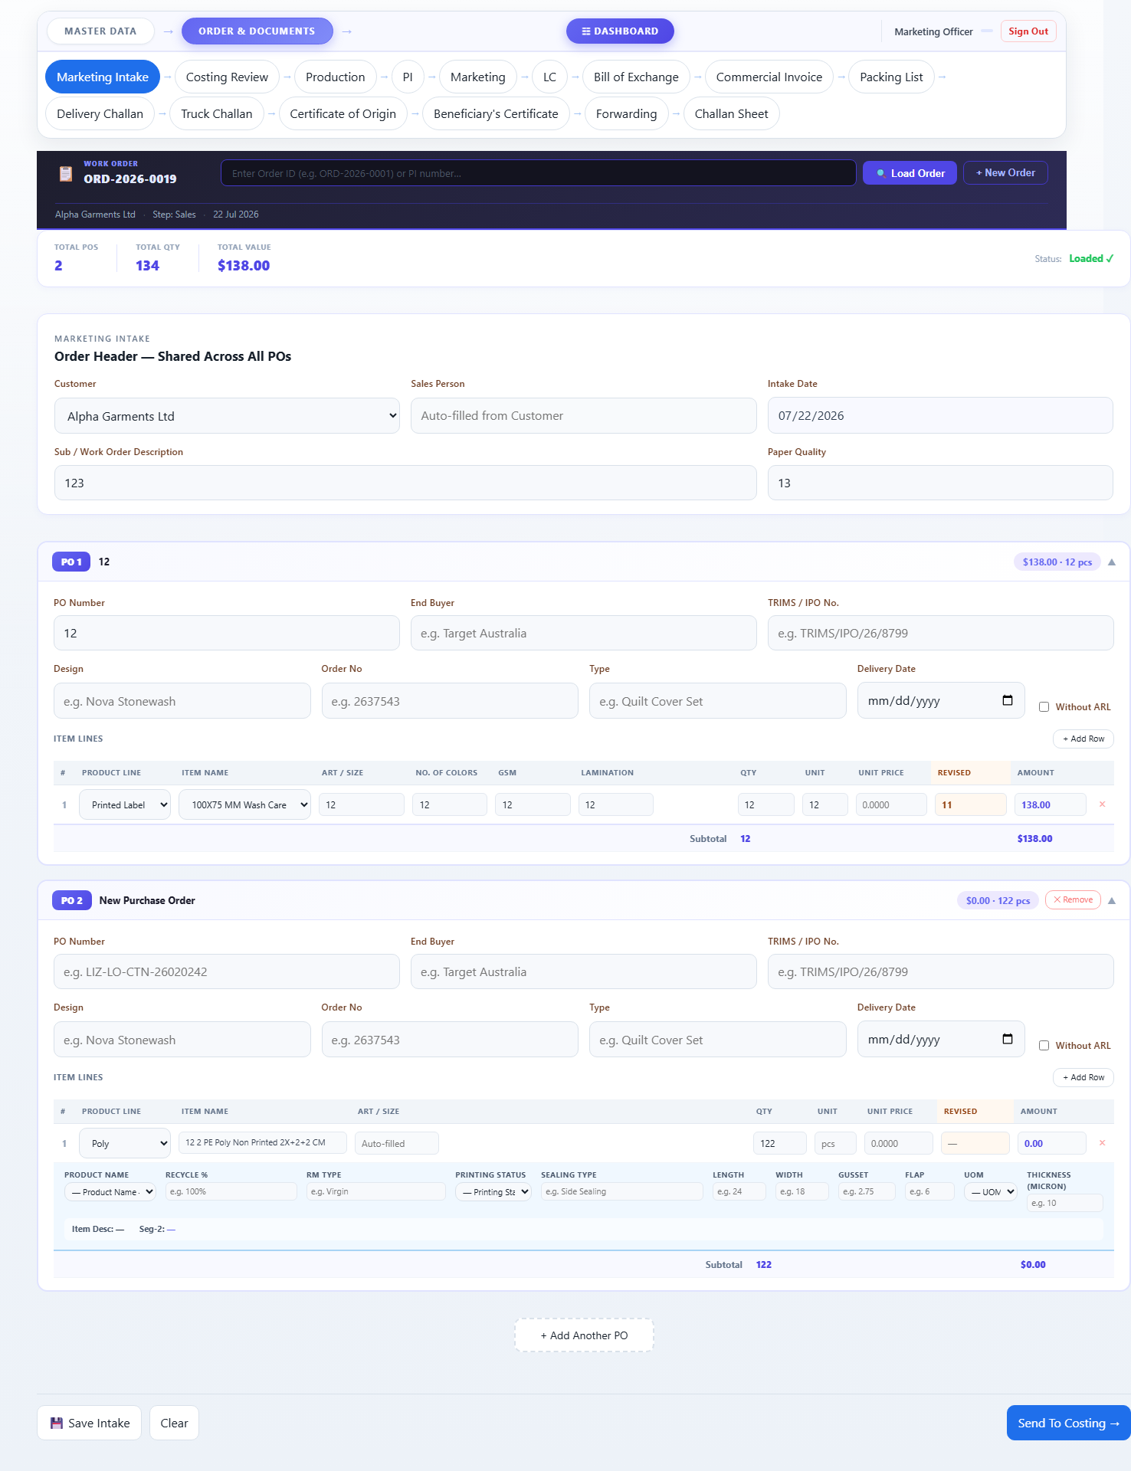

Marketing Summary
Review the confirmed sales snapshot with PO-wise item breakdown and totals. Collapsible PO blocks let you drill into each buyer's items.
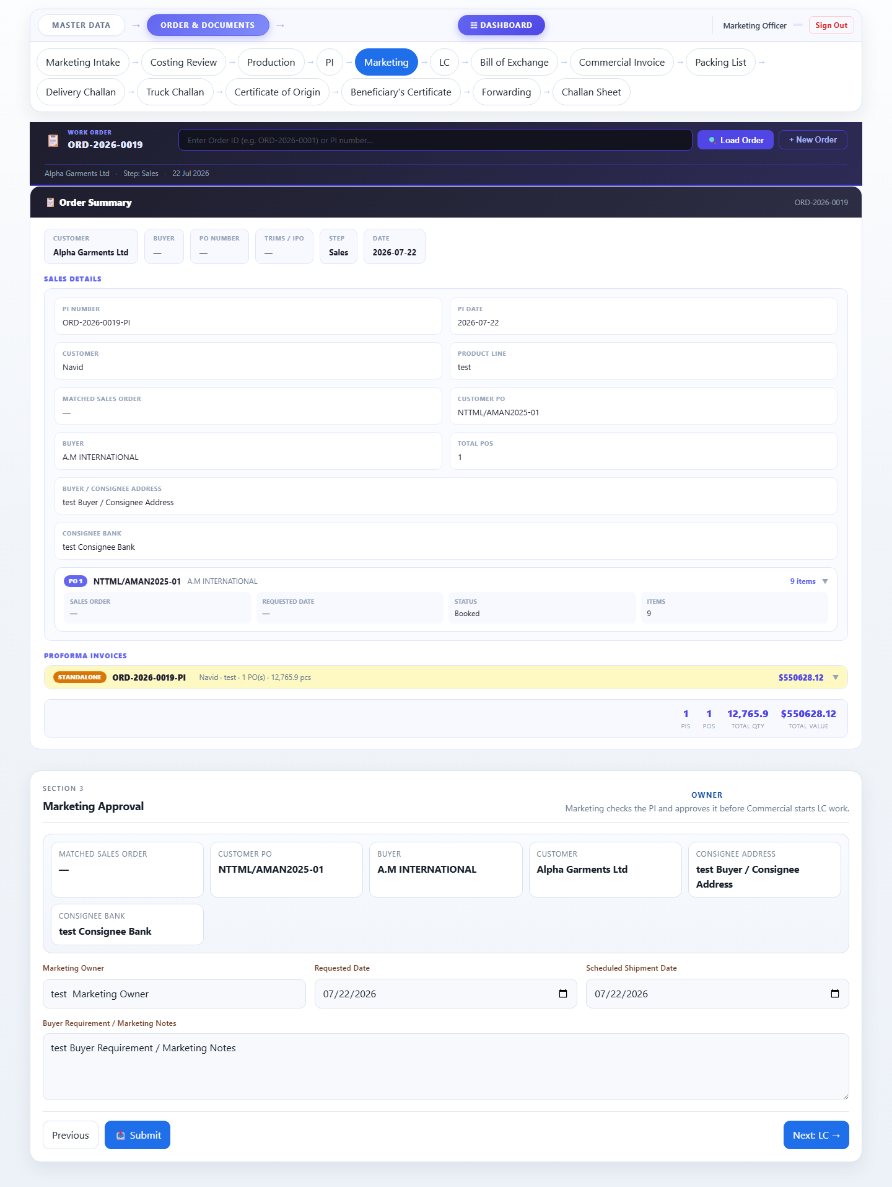

Accessories Tracking System · Zaber & Zubair Accessories Ltd.
For: Marketing Officer · 25 July 2026 · Confidential

