Accessories Tracking System
Production Officer — User Guide

Confirms production has started so the Commercial team can raise the PI.

Email: production@zzal.com | Password: prod@123
Role: Production Officer | Pages: 1 page(s)
Prepared: 25 July 2026

About This Guide
Confirms production has started so the Commercial team can raise the PI.

This guide shows every screen the Production Officer can access in the Accessories Tracking System. Each page is shown with a live order loaded so you can see exactly what data appears.

Your Pages at a Glance
- Production Entry — Mark the order as 'Started' once production begins.

Page Screenshots
The following pages show each screen with a real order loaded.
Production Entry
Mark the order as 'Started' once production begins. Set the start date and expected completion date. The PI step is unlocked for the Commercial team only after this is confirmed.
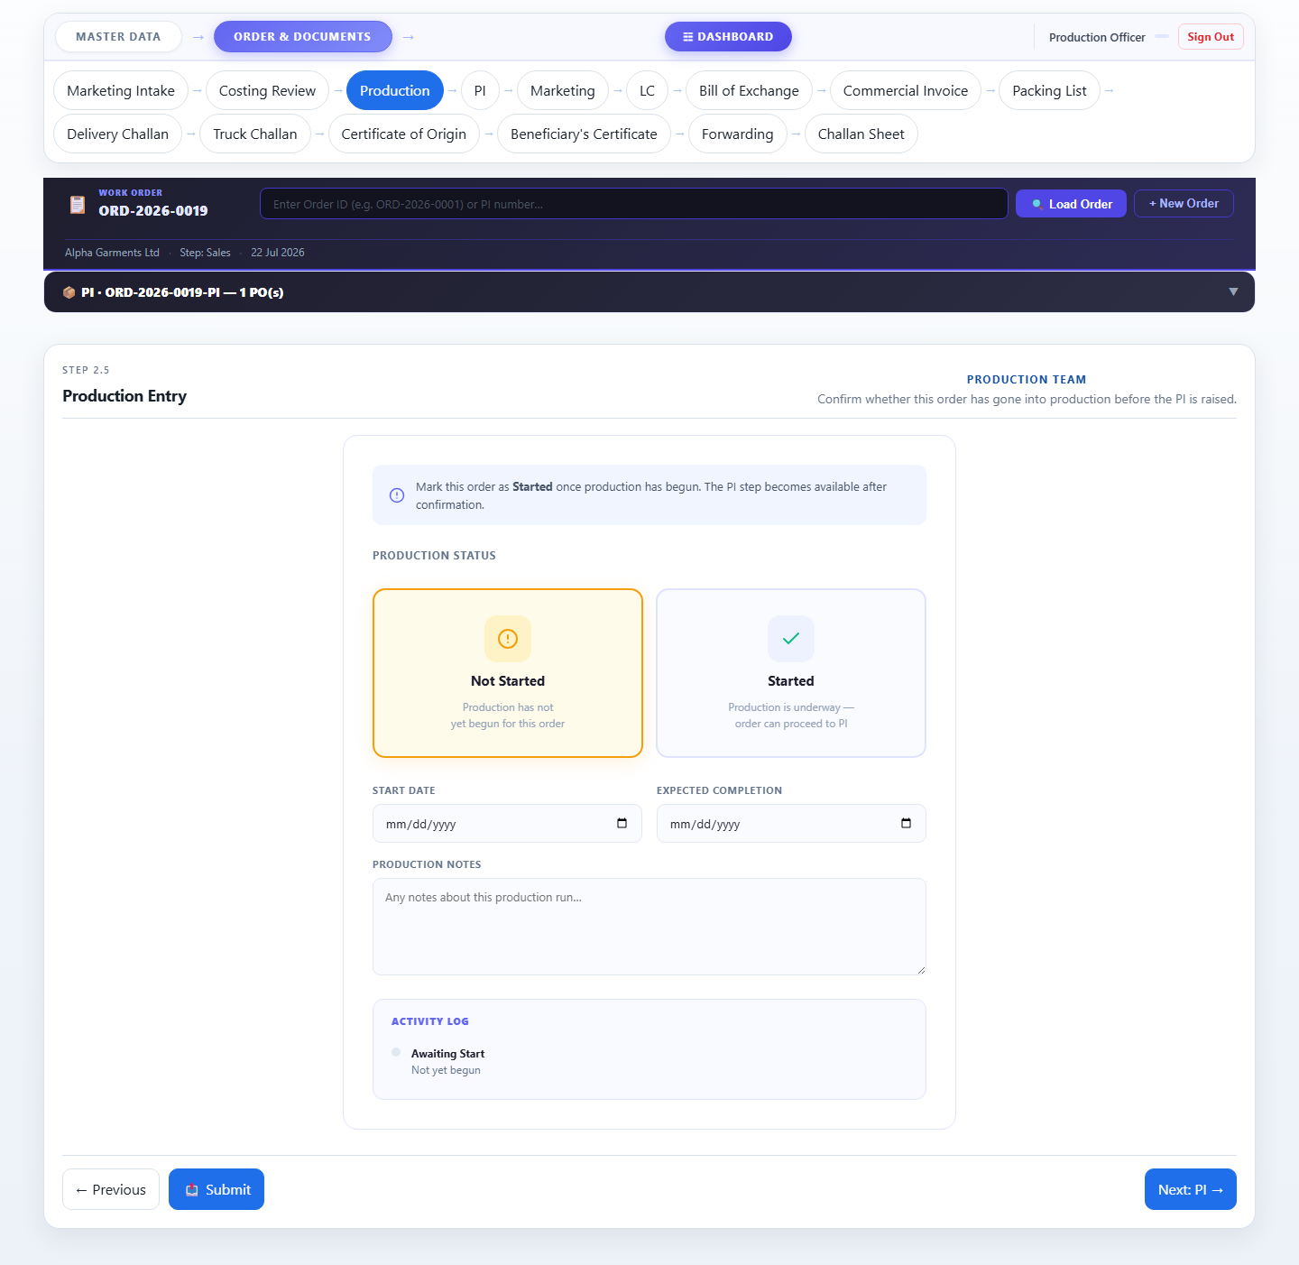

Accessories Tracking System · Zaber & Zubair Accessories Ltd.
For: Production Officer · 25 July 2026 · Confidential

