Accessories Tracking System
Role-Based Access Guide

Zaber & Zubair Accessories Ltd.
Prepared: 25 July 2026

Role Overview
The system has four department roles. Each role sees only the workflow pages relevant to their function. The table below summarises each role and its login credentials.

Role | Email | Password | Pages
Marketing Officer | marketing@zzal.com | mkt@123 | Marketing Intake, Marketing
Costing Officer | costing@zzal.com | cost@123 | Costing Review
Production Officer | production@zzal.com | prod@123 | Production
Commercial Officer | commercial@zzal.com | comm@123 | PI → LC → Bill of Exchange → Commercial Invoice → Packing → Delivery → Truck → Origin → Beneficiary → Forwarding
Administrator | admin@ed.local | admin@ | All pages + User Management

Administrator
Login: admin@ed.local | Password: admin@
Full access to all pages, user management, master data, and every workflow step.

Navigation tabs visible to this role:
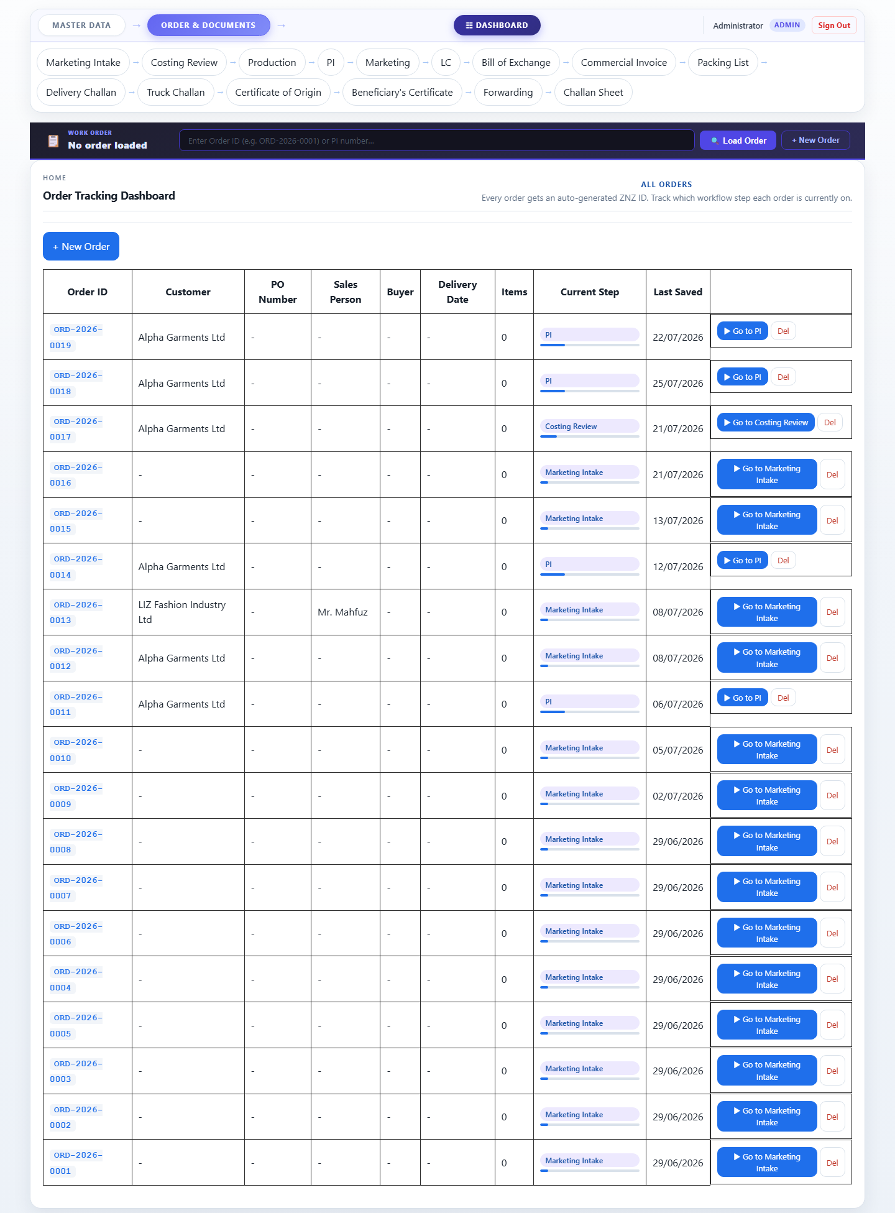

Dashboard


Marketing Intake
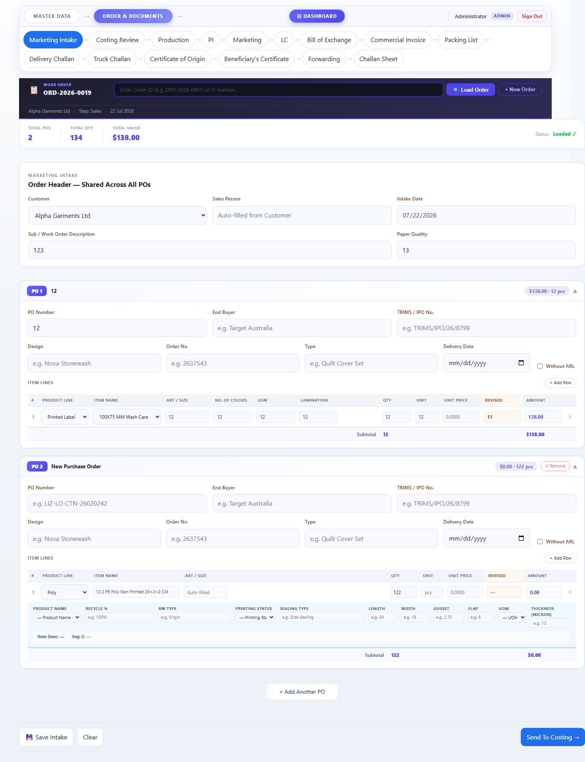

Costing Review
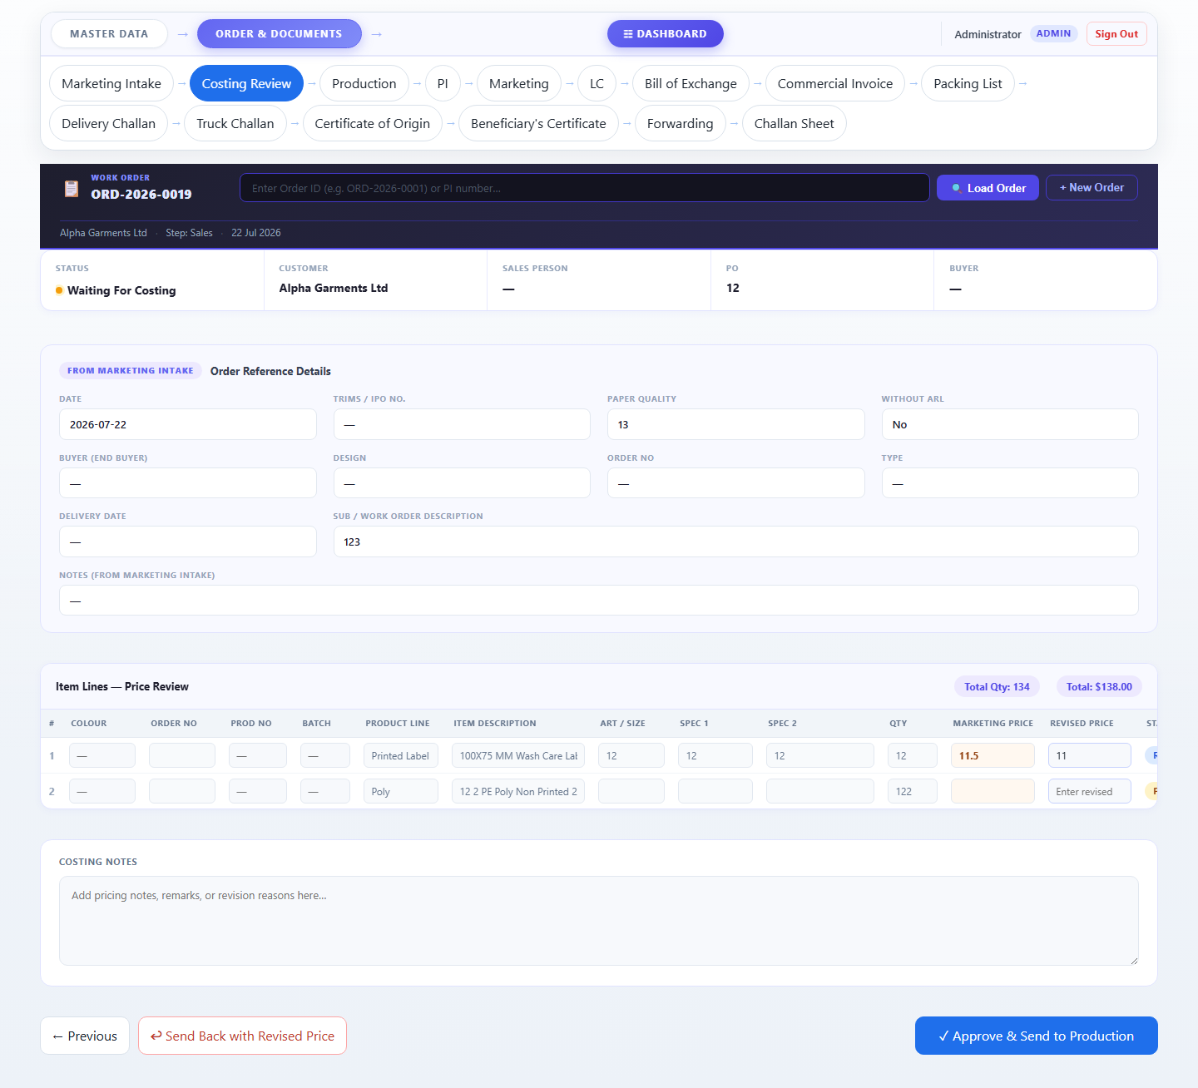

Production
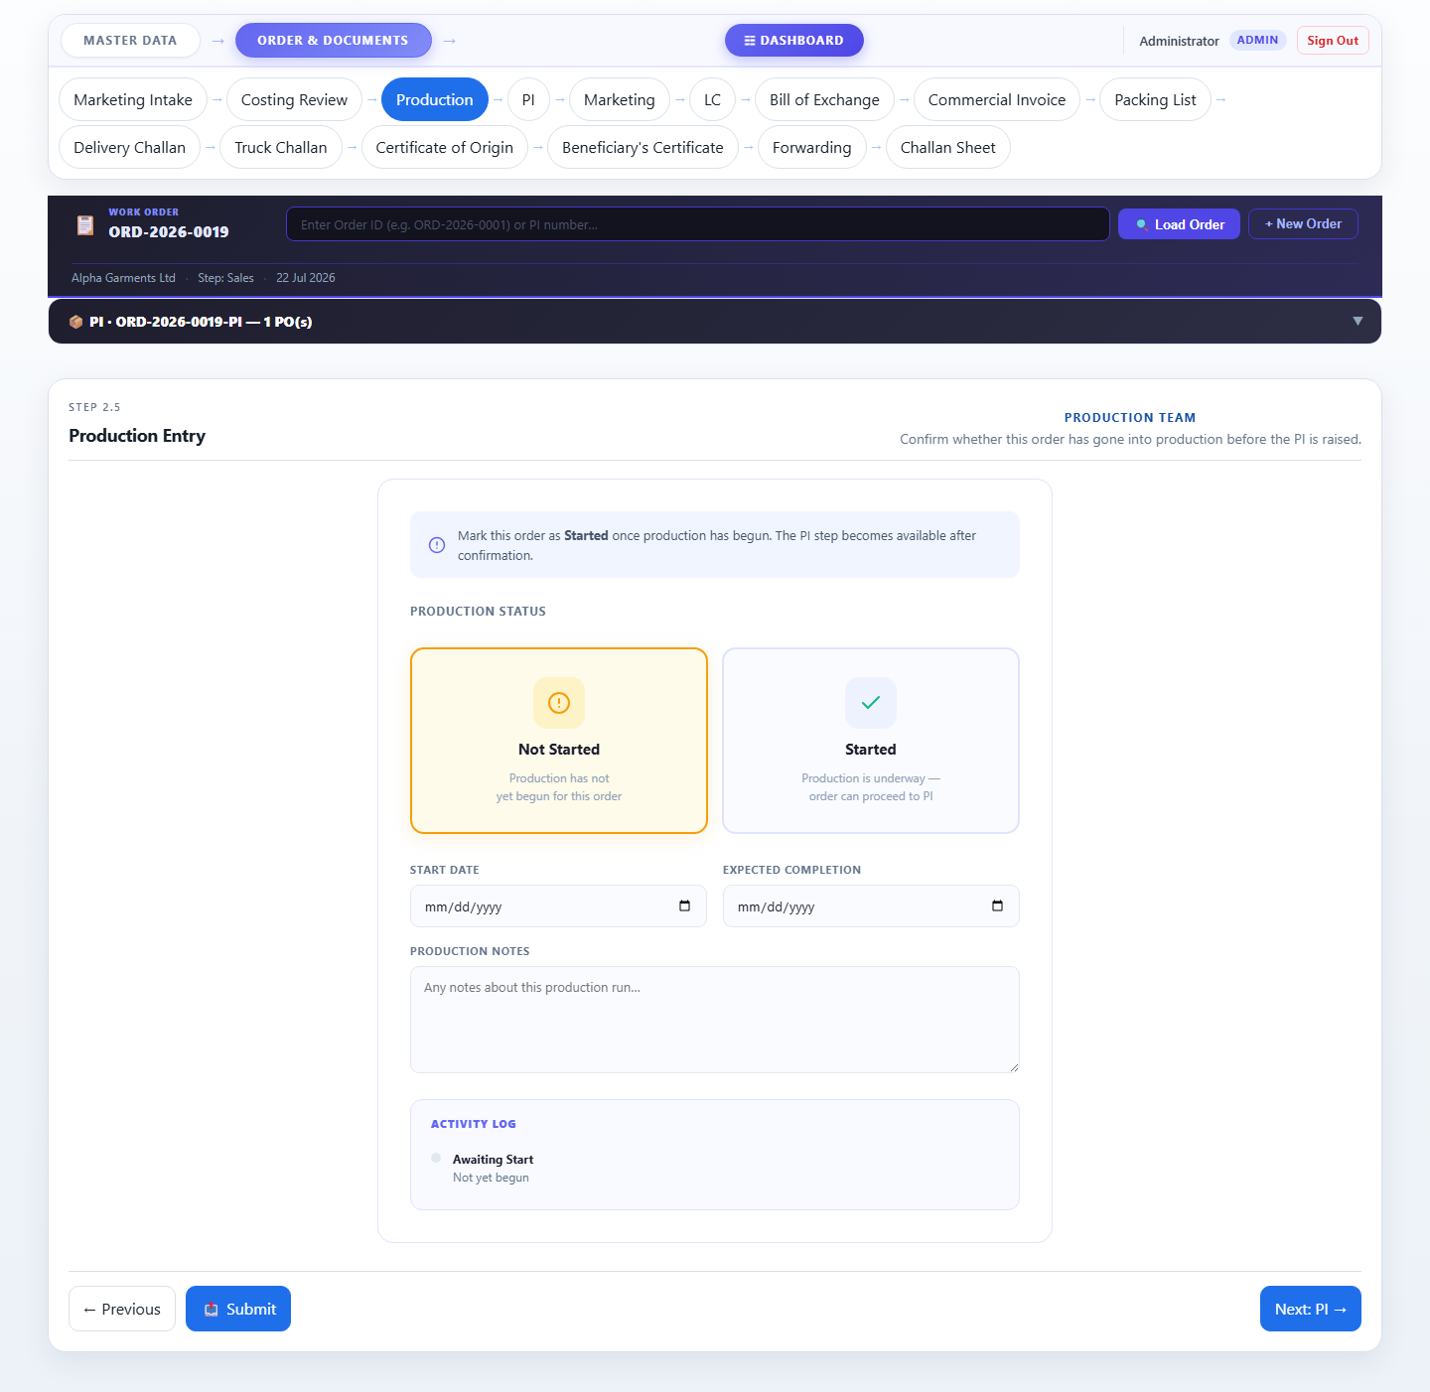

PI (Sales)
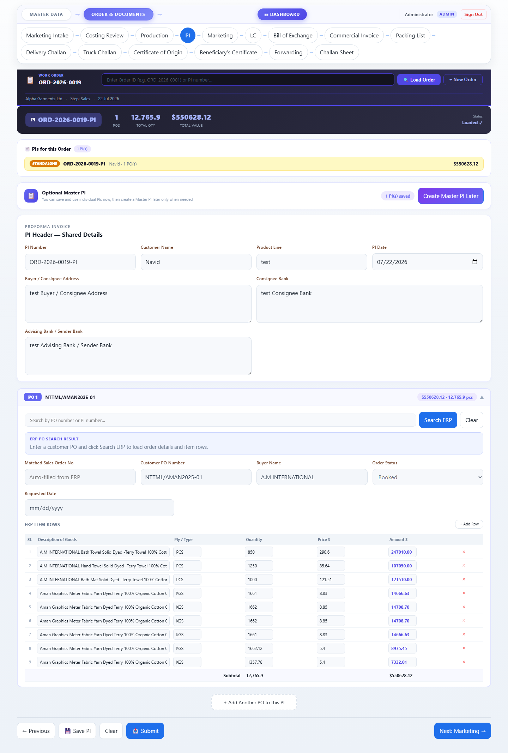

Marketing
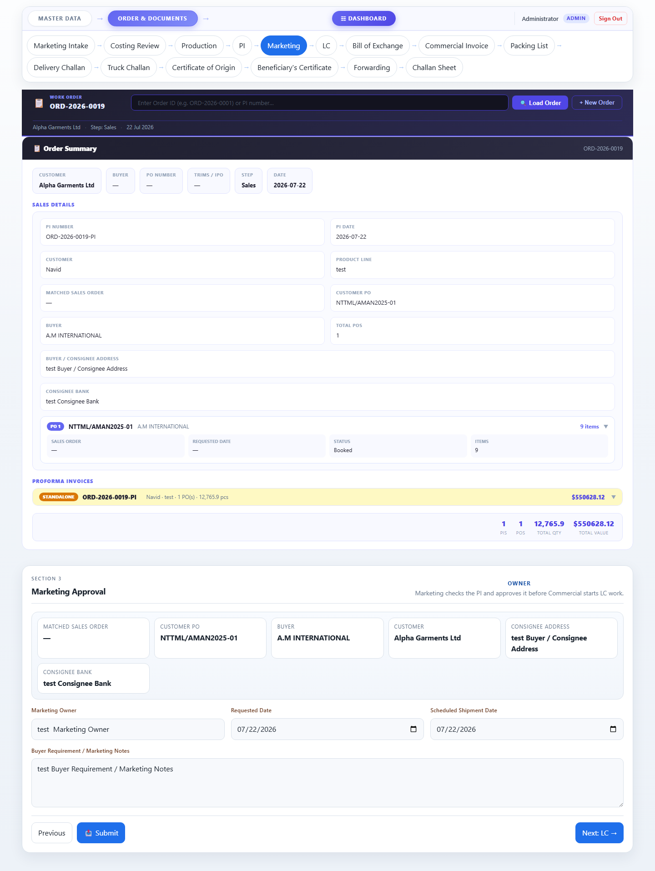

Letter of Credit
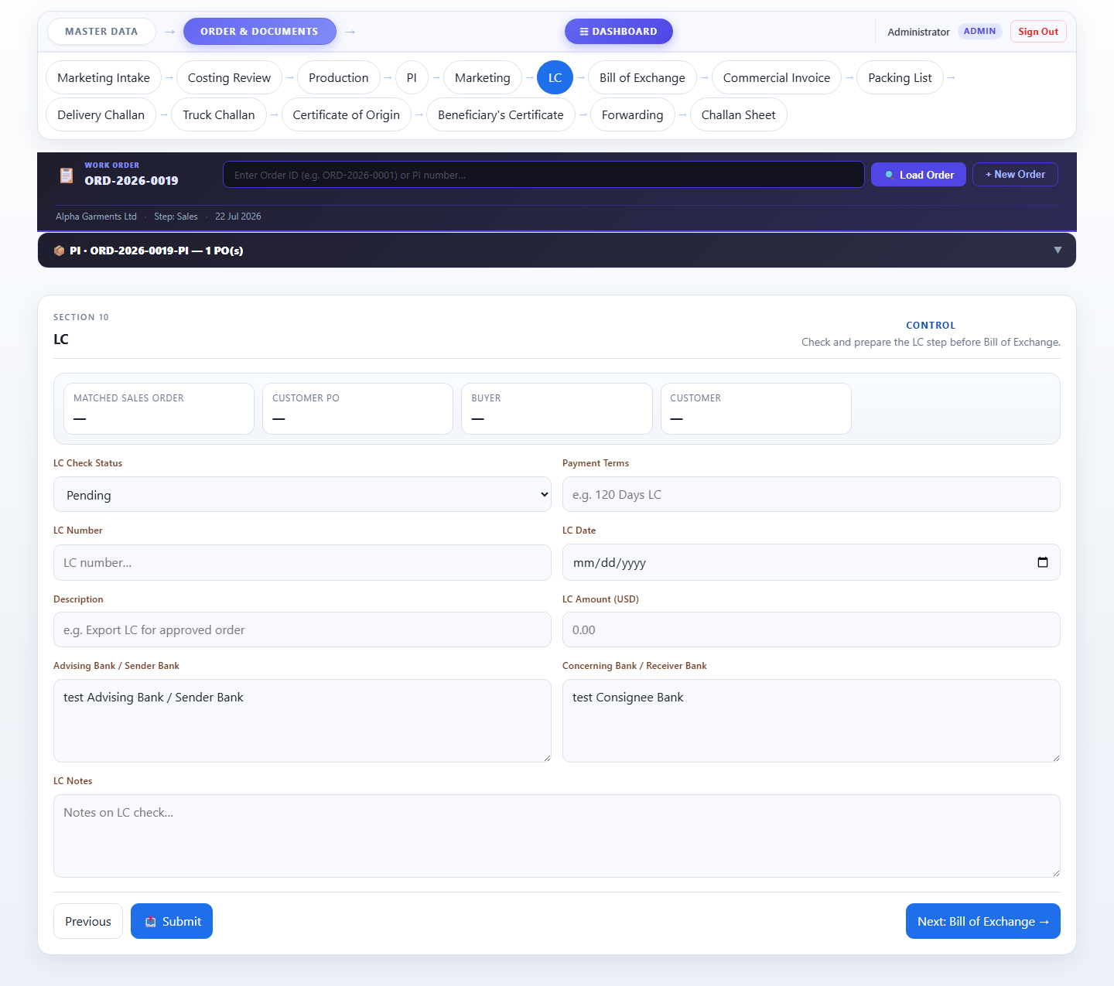

Bill of Exchange
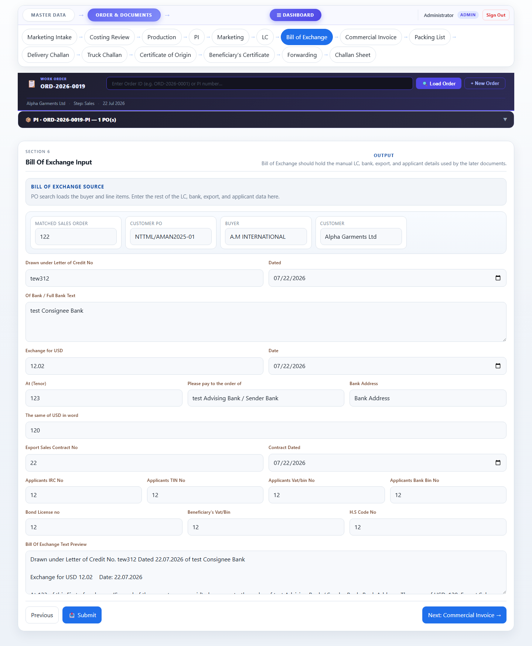

Commercial Invoice
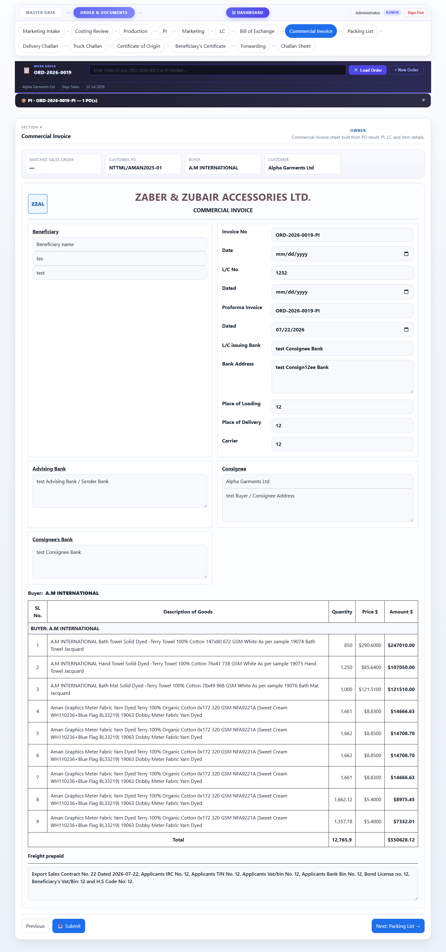

Packing List
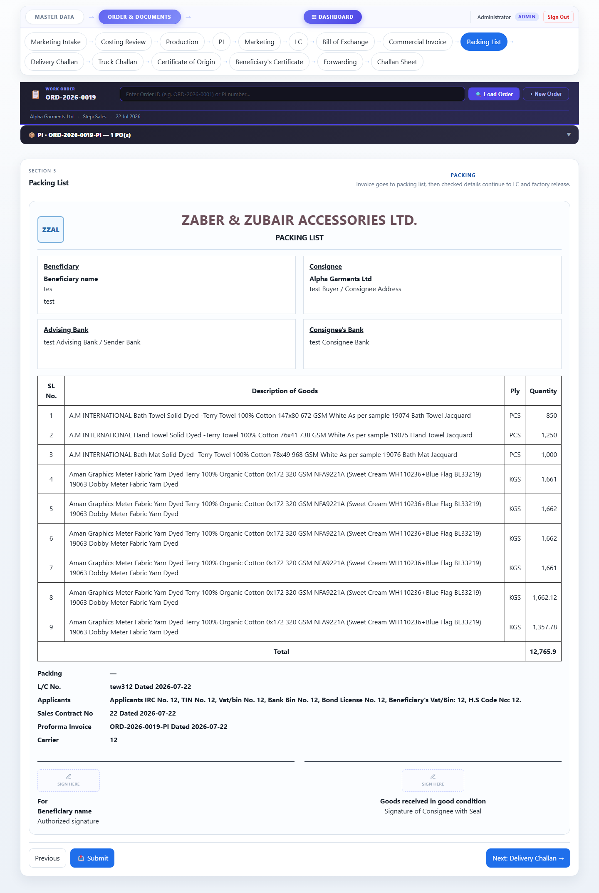

Delivery Challan
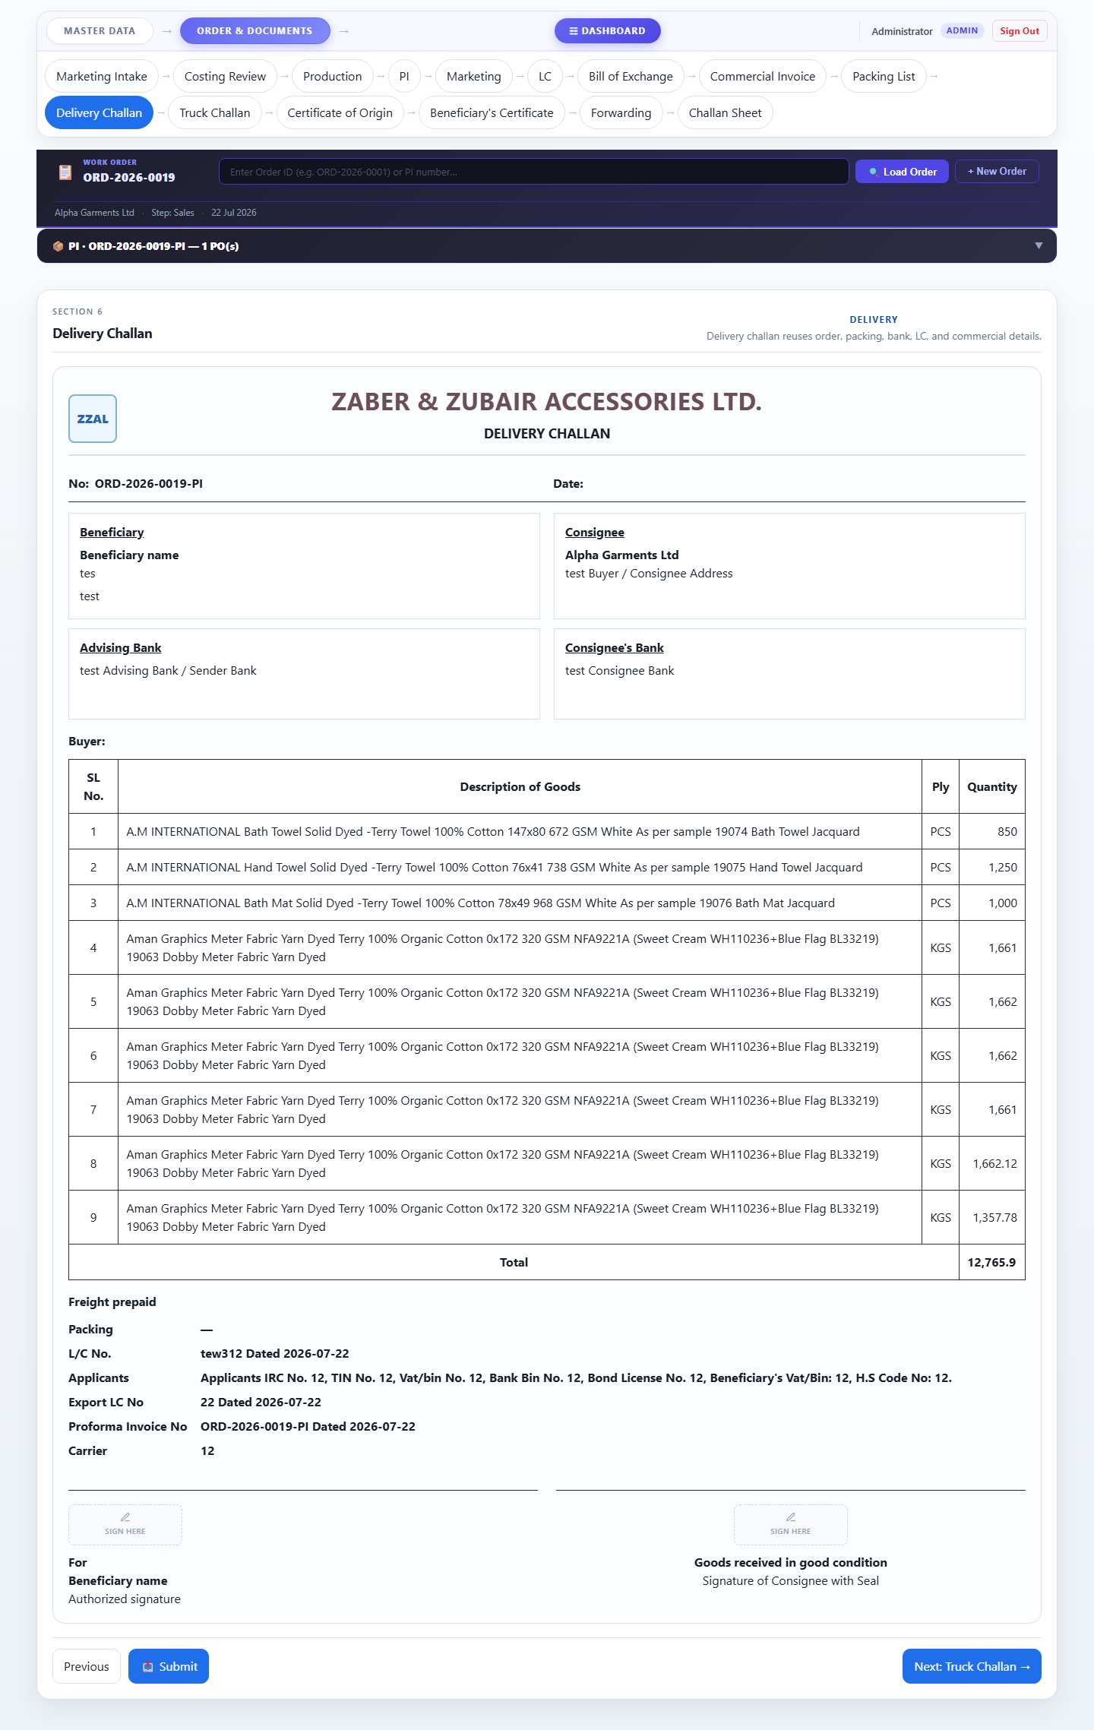

Truck Challan
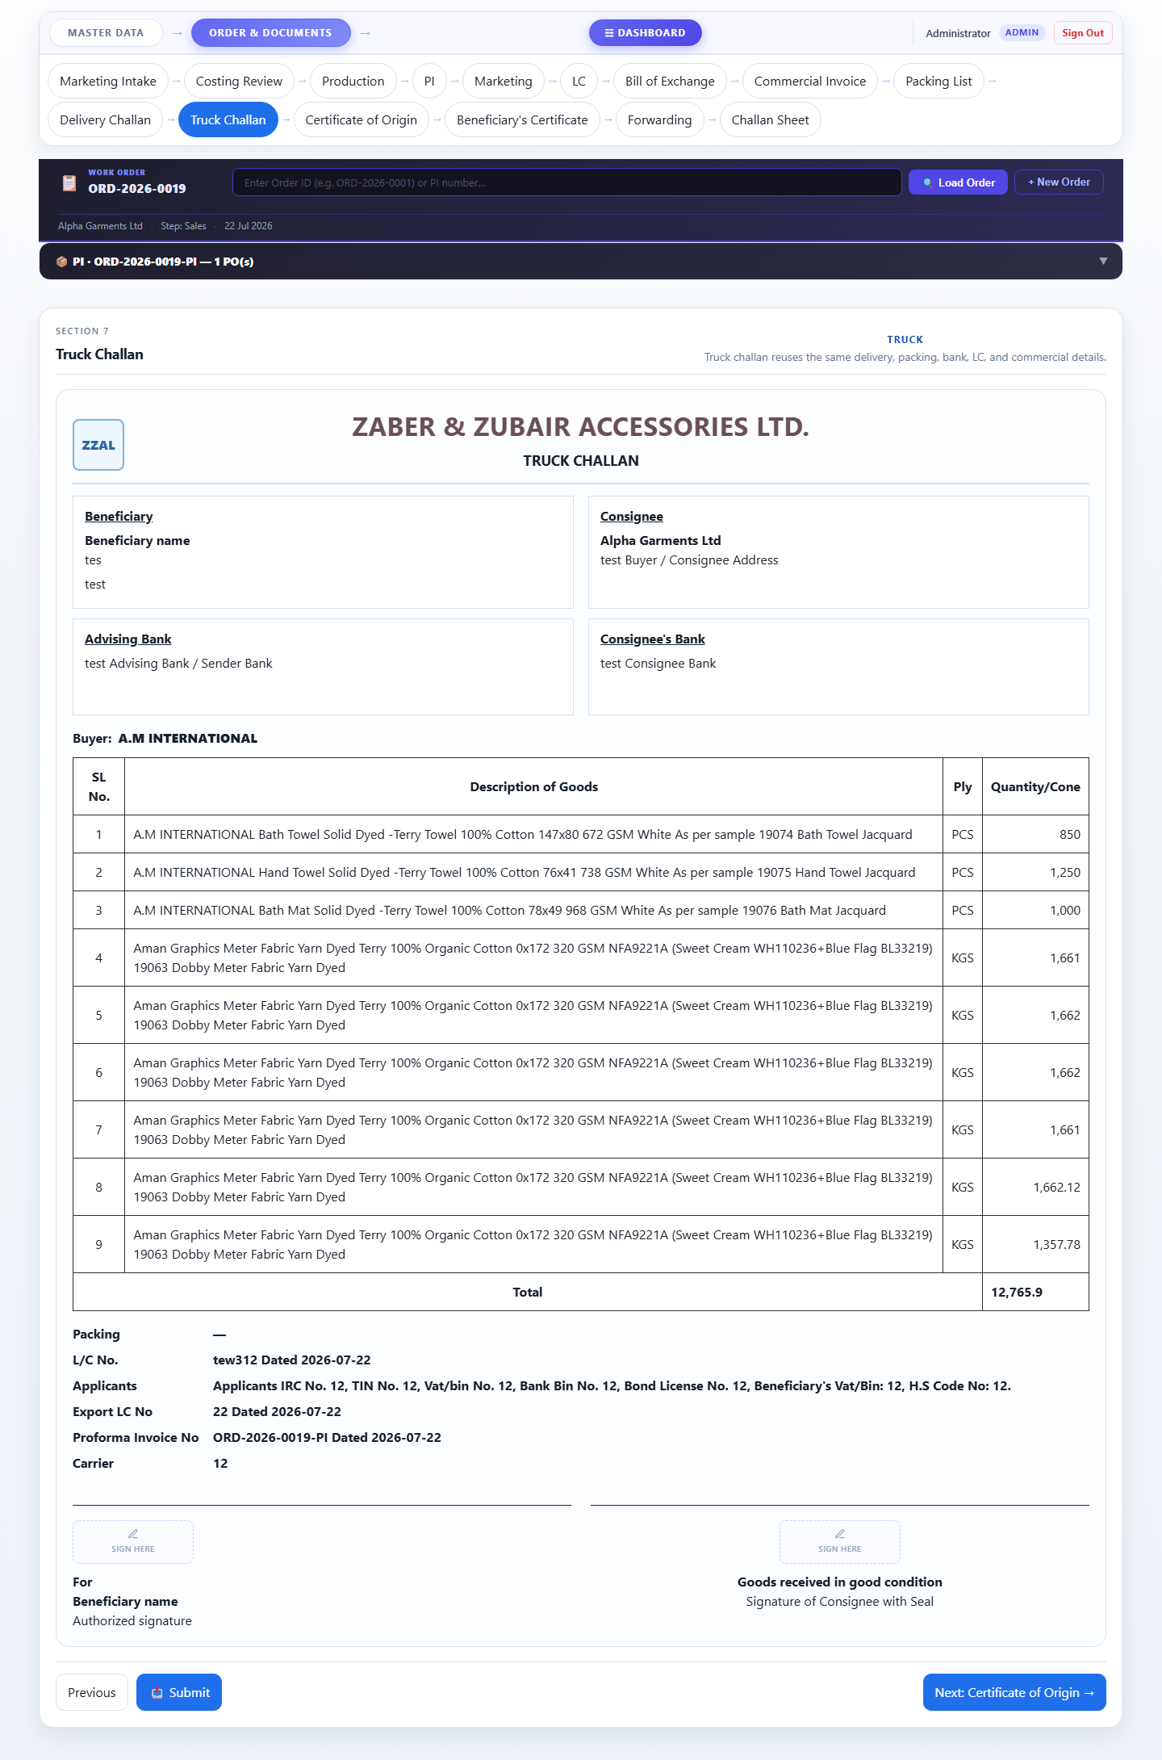

Marketing Officer
Login: marketing@zzal.com | Password: mkt@123
Handles the first and fourth steps of the workflow.
- Marketing Intake — records PO details, items, and specs from the buyer.
- Marketing — reviews the sales snapshot and PO-wise item breakdown.

Navigation tabs visible to this role:
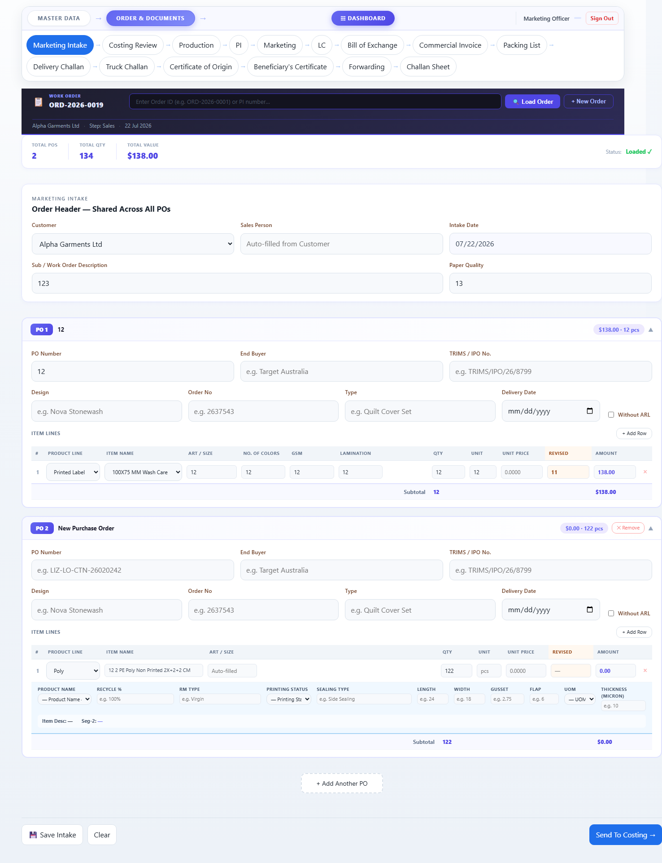

Marketing Intake


Marketing
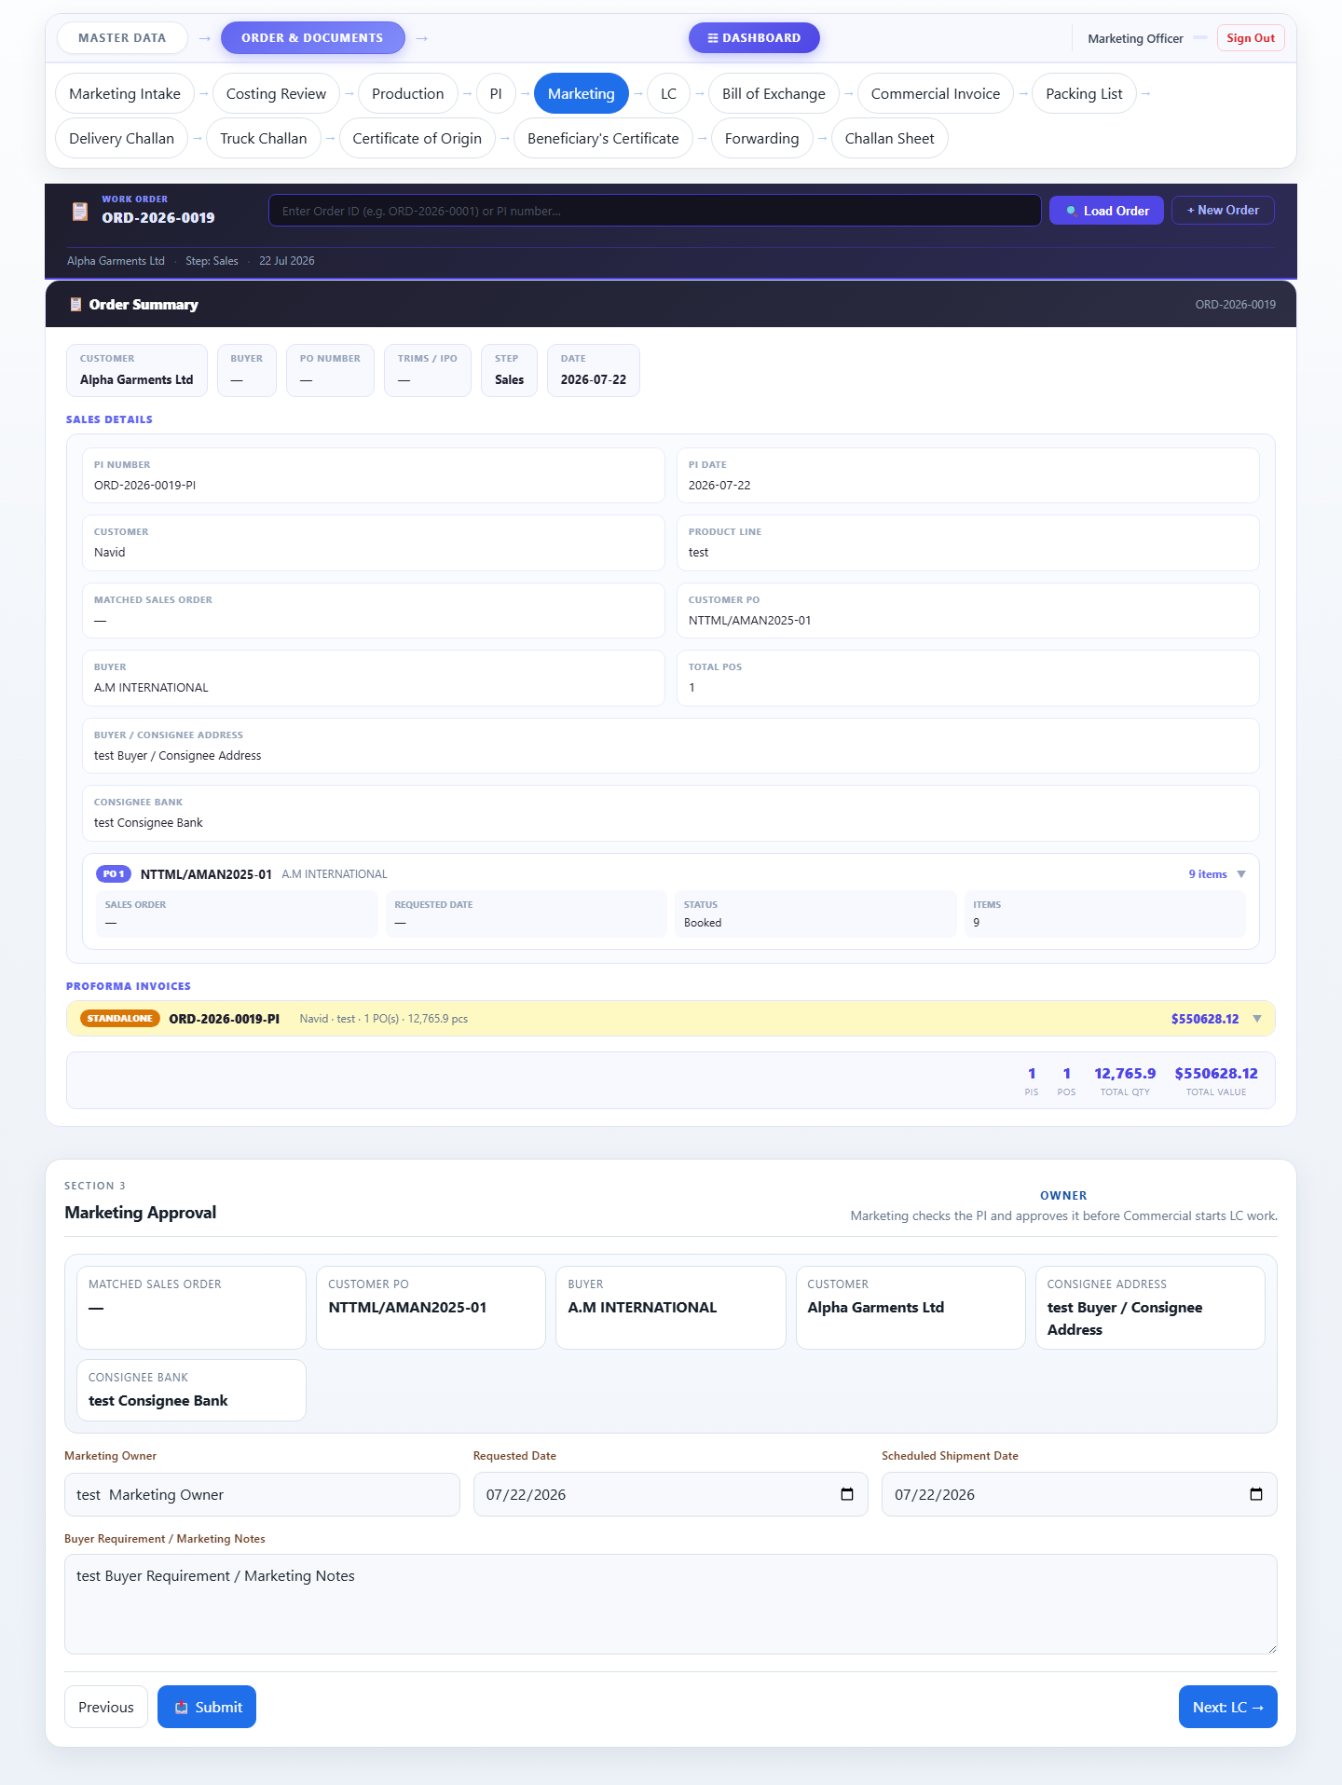

Costing Officer
Login: costing@zzal.com | Password: cost@123
Reviews cost per item and approves the order for production.
- Costing Review — checks quantities, unit prices, and can revise costs before approving.

Navigation tabs visible to this role:
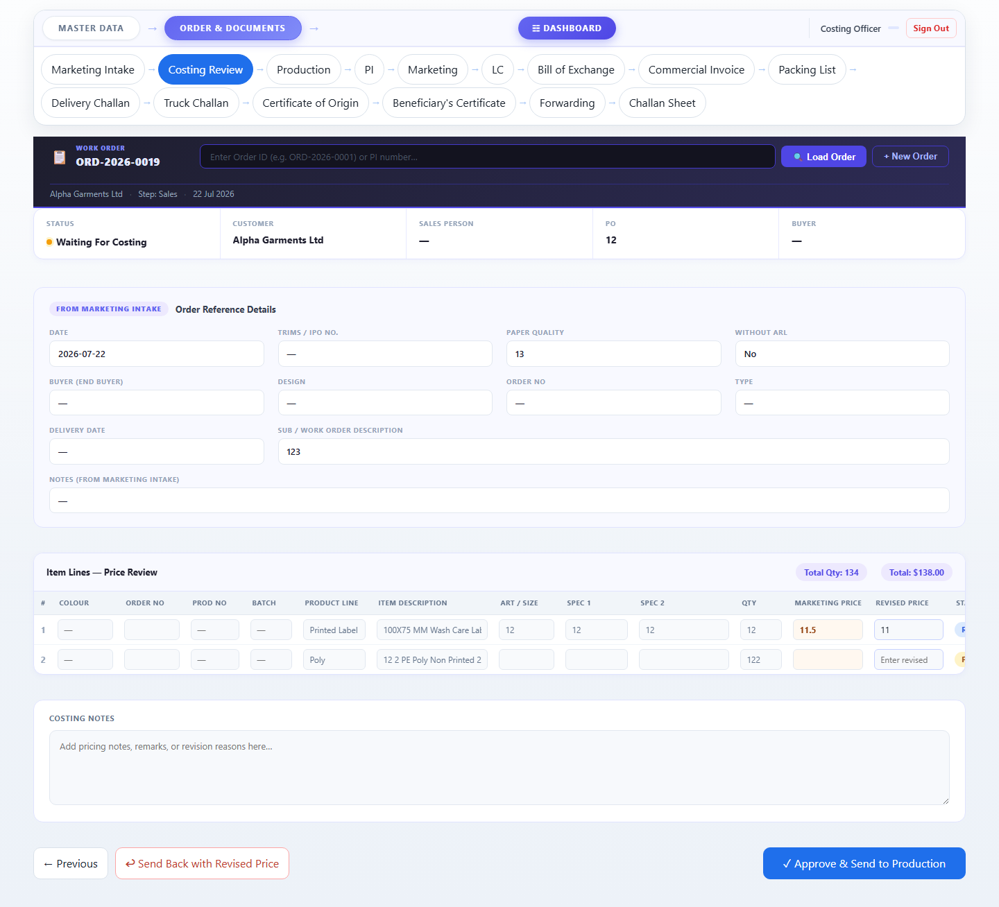

Costing Review


Production Officer
Login: production@zzal.com | Password: prod@123
Confirms whether the order has gone into production.
- Production — marks the order as Started or Not Started. The PI step is unlocked once production is confirmed.

Navigation tabs visible to this role:
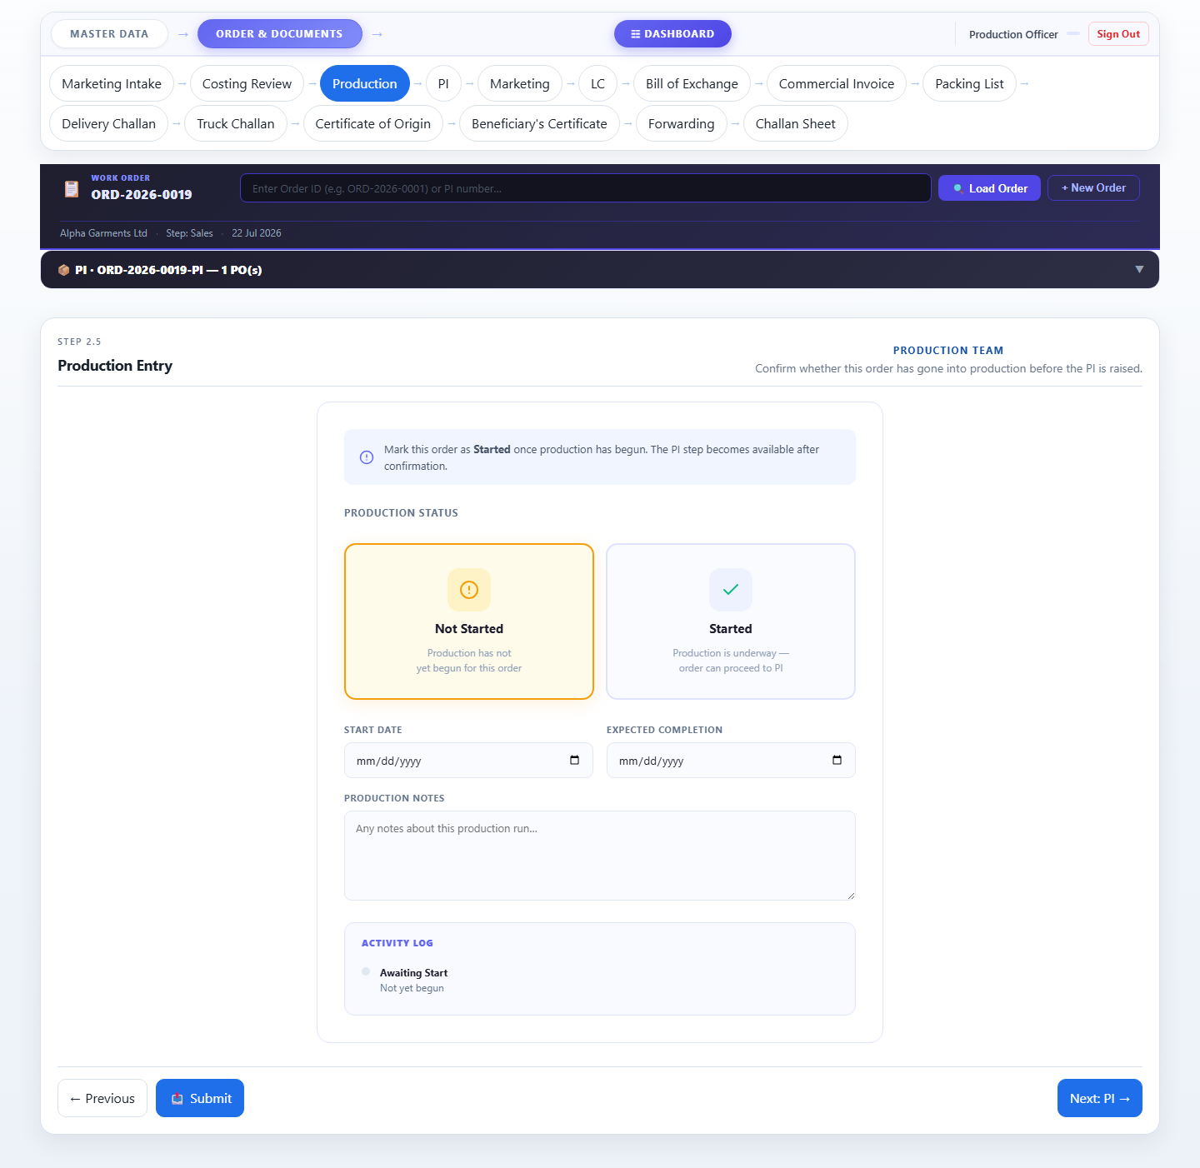

Production Entry


Commercial Officer
Login: commercial@zzal.com | Password: comm@123
Handles all export documentation from PI through to final forwarding.
- PI, LC, Bill of Exchange, Commercial Invoice, Packing List, Delivery Challan, Truck Challan, Certificate of Origin, Beneficiary Certificate, Forwarding, Challan Sheet.

Navigation tabs visible to this role:
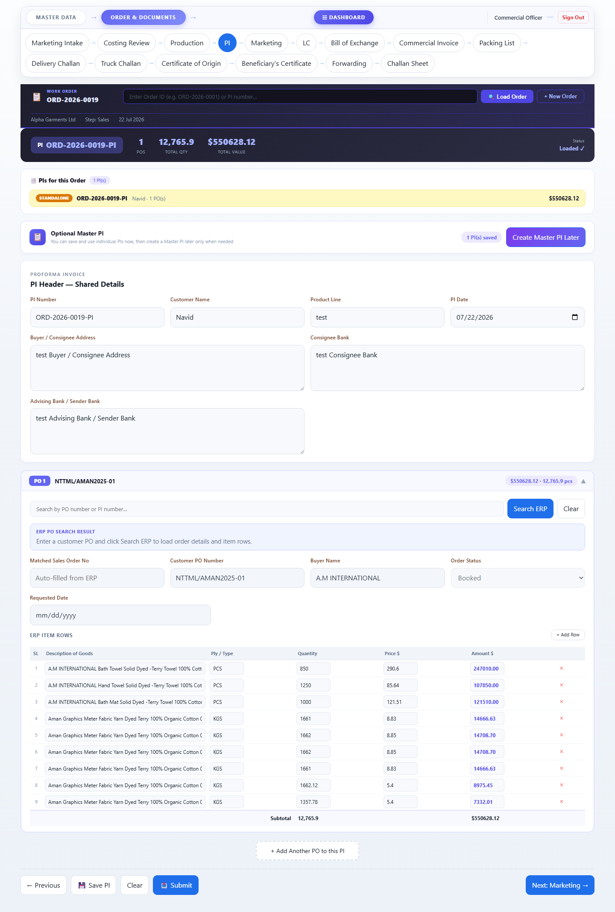

PI (Sales)


Letter of Credit
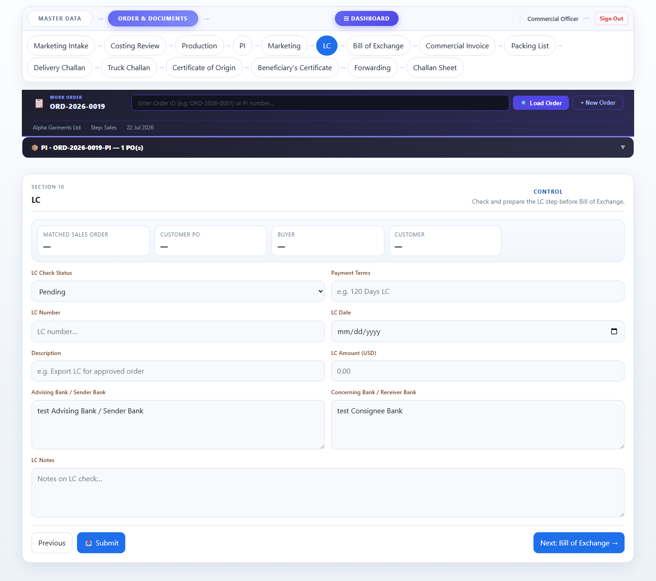

Bill of Exchange
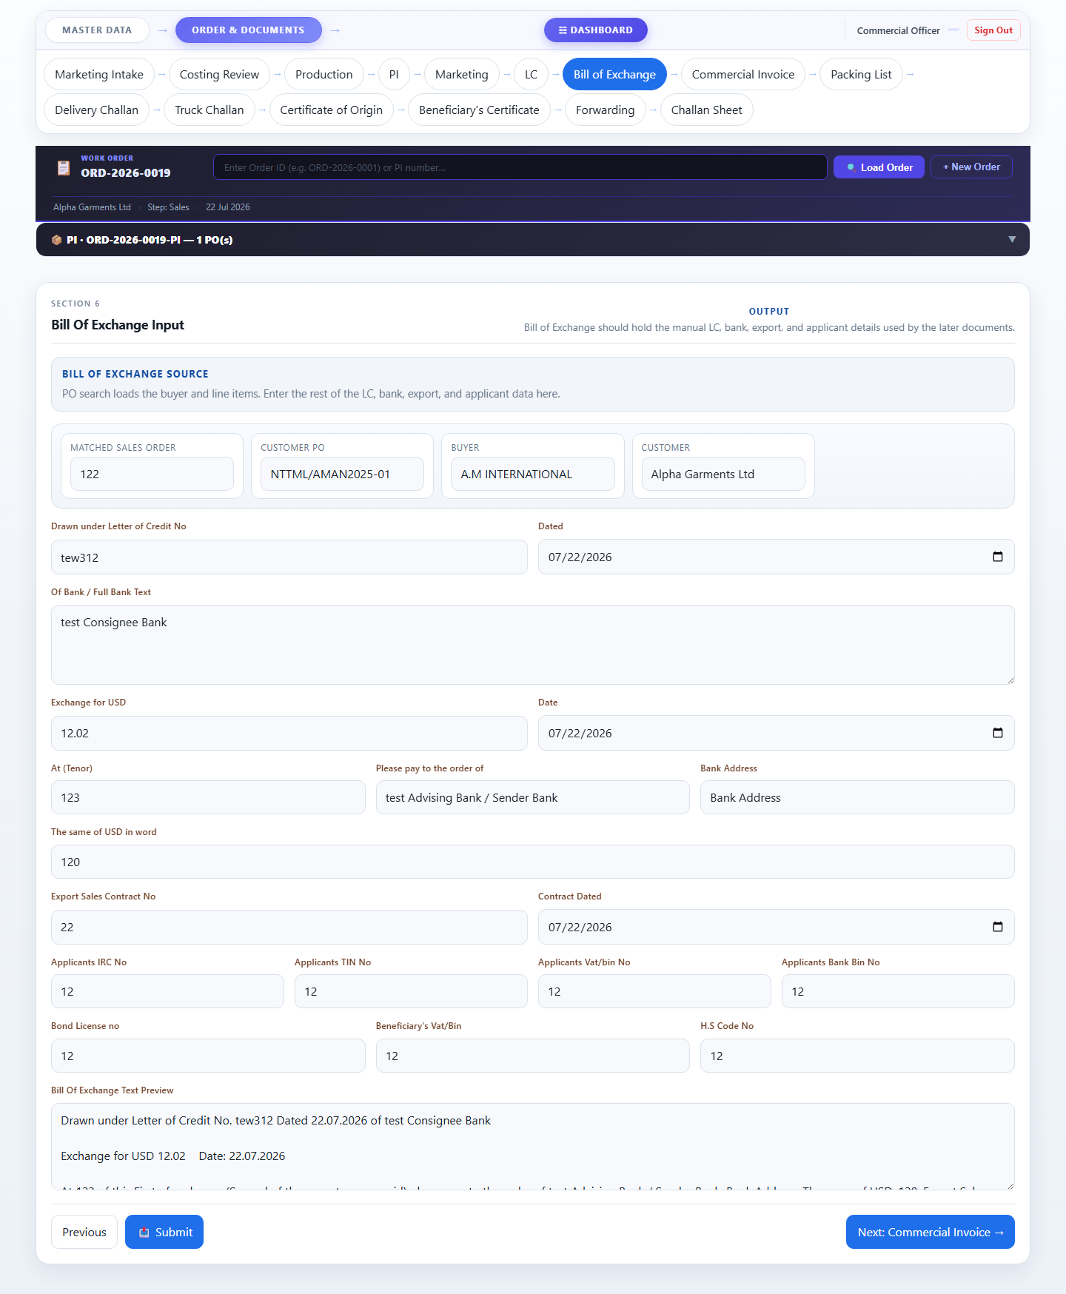

Commercial Invoice
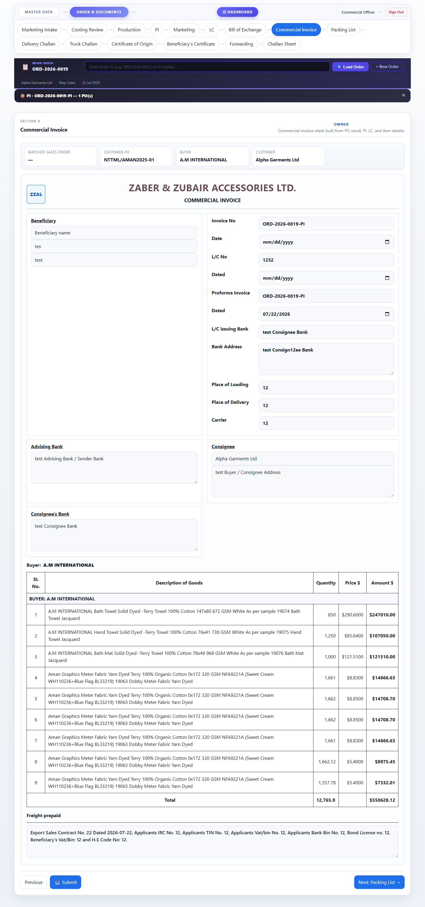

Packing List
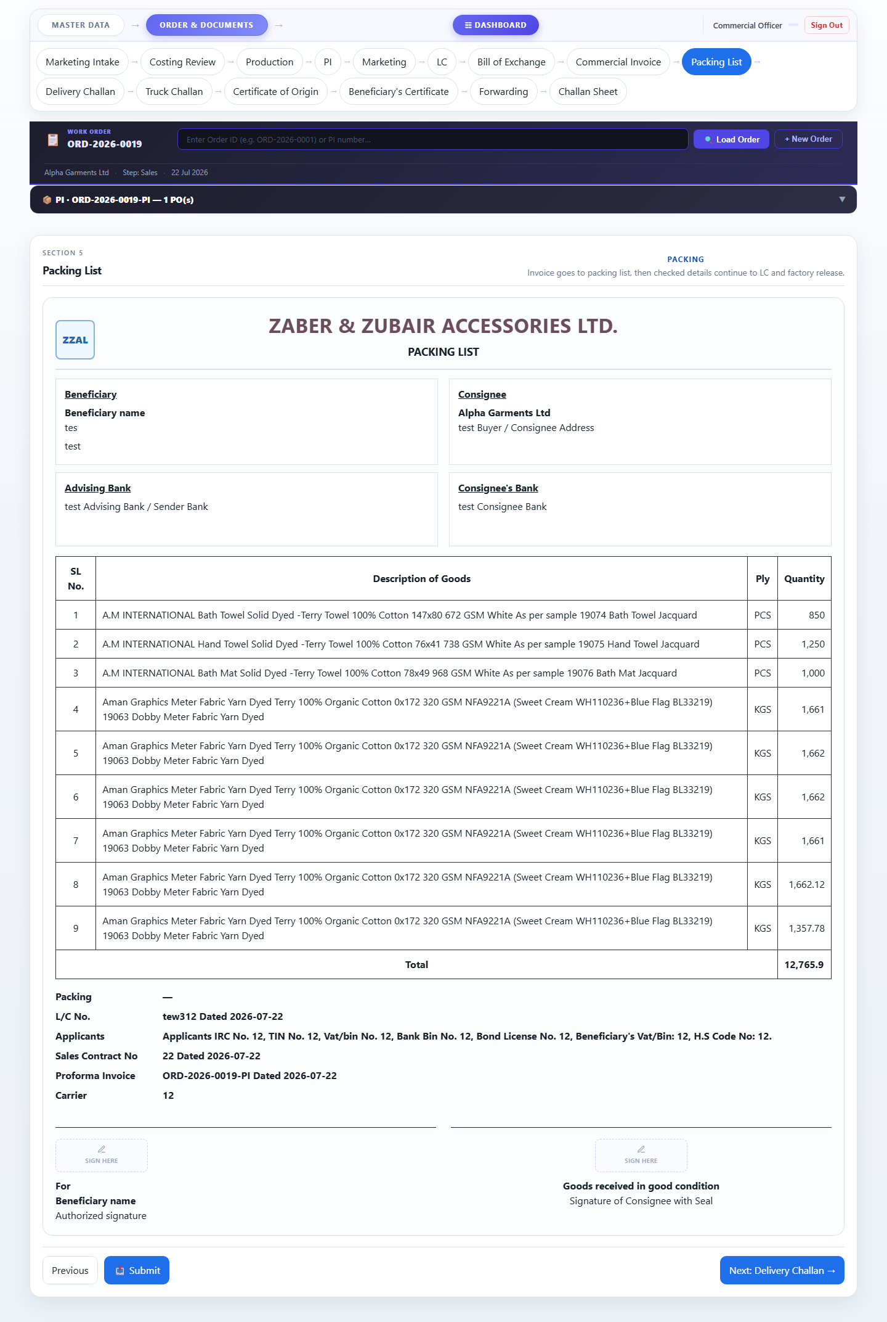

Delivery Challan
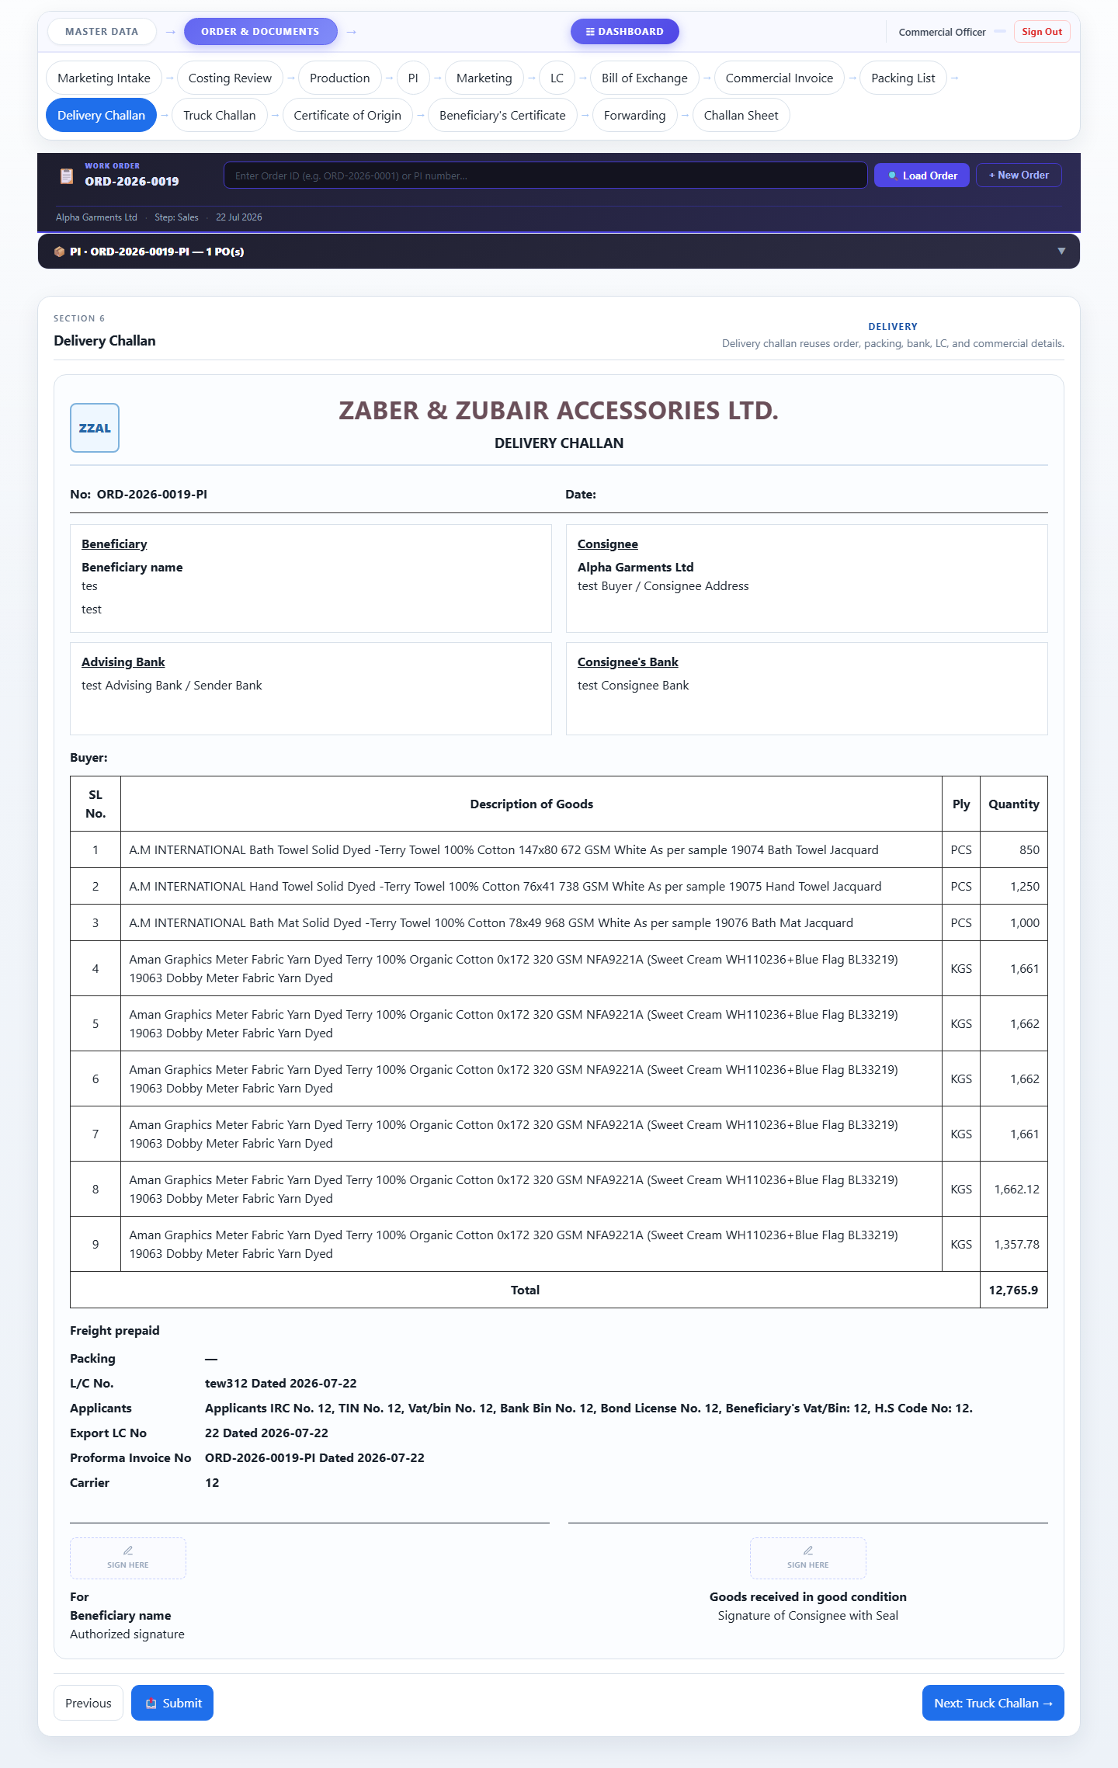

Truck Challan
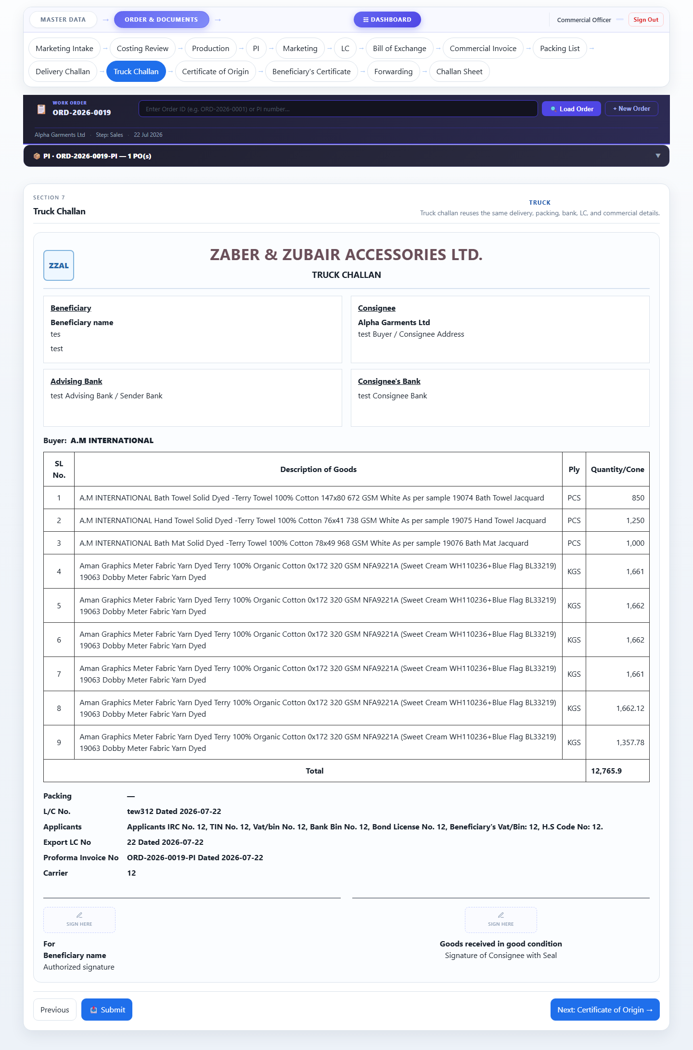

Cert. of Origin
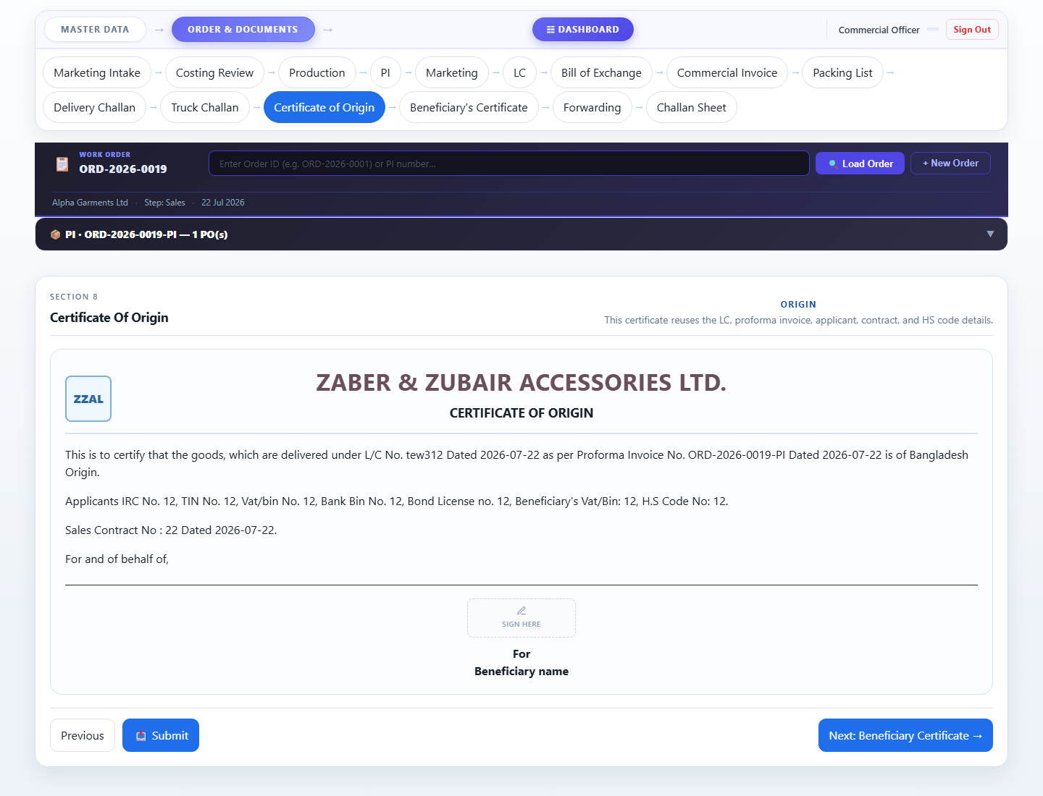

Beneficiary Cert.
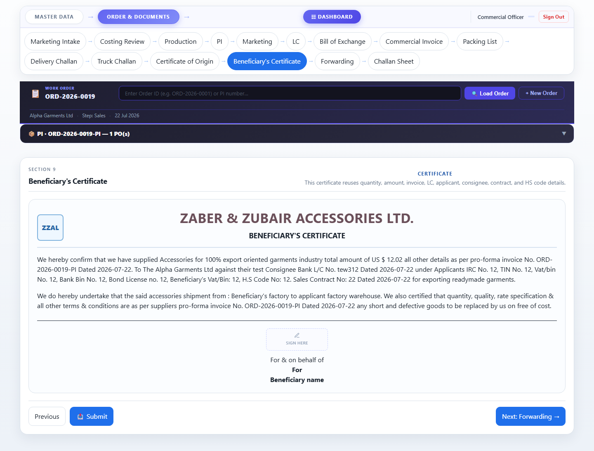

Forwarding
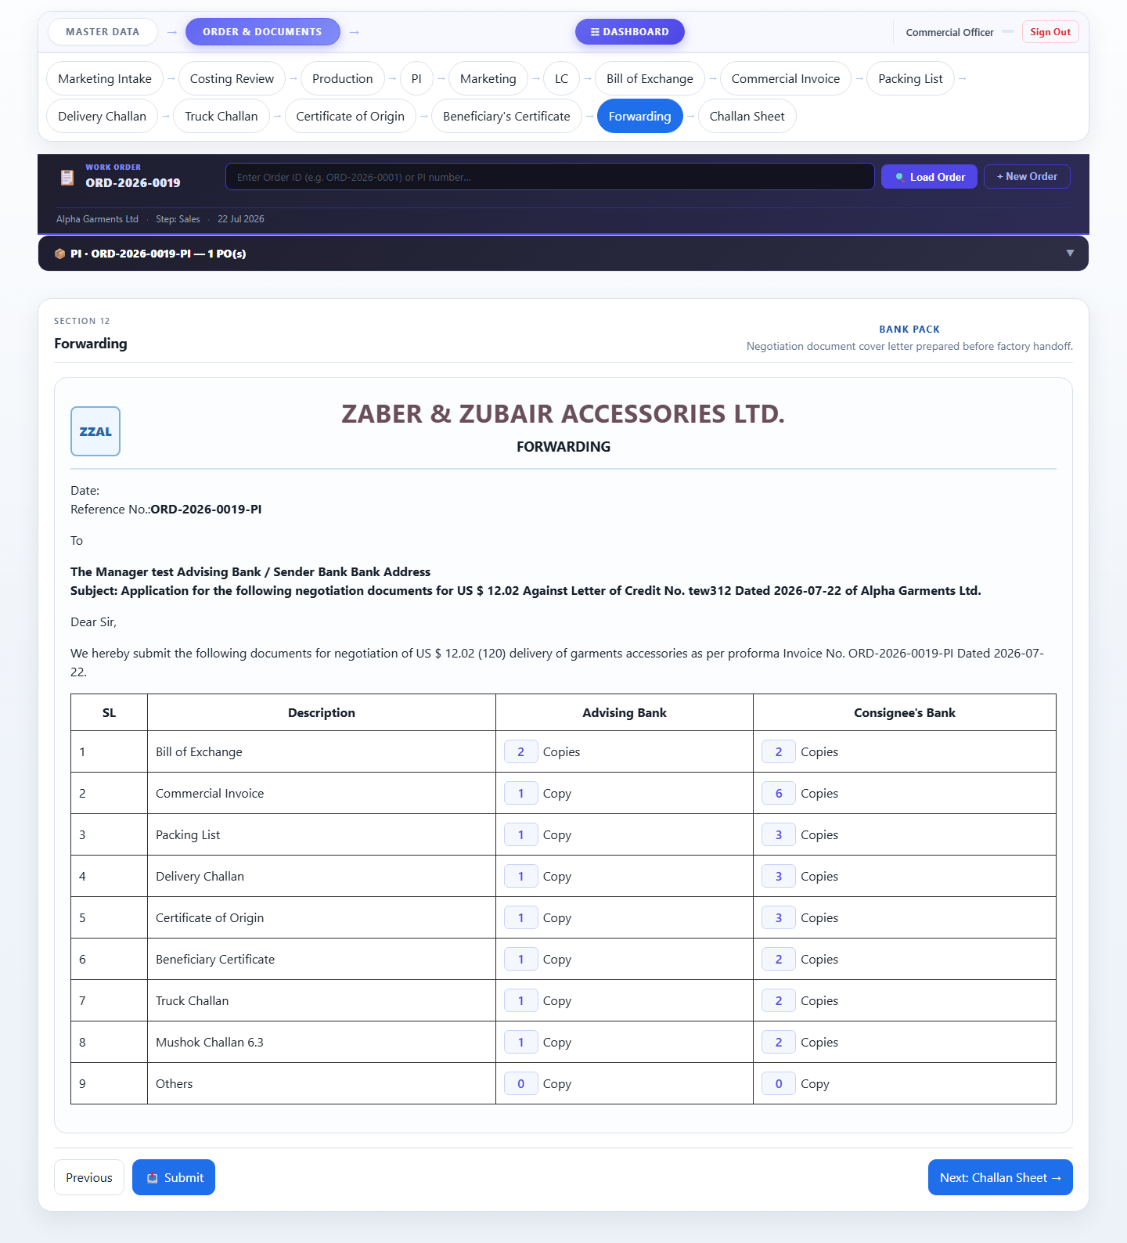

End-to-End Workflow
Below shows which role handles each step of the order lifecycle:

Step | Page | Handled By
1 | Marketing Intake | Marketing Officer
2 | Costing Review | Costing Officer
3 | Production | Production Officer
4 | PI (Proforma Invoice) | Commercial Officer
5 | Marketing Summary | Marketing Officer
6 | Letter of Credit | Commercial Officer
7 | Bill of Exchange | Commercial Officer
8 | Commercial Invoice | Commercial Officer
9 | Packing List | Commercial Officer
10 | Delivery Challan | Commercial Officer
11 | Truck Challan | Commercial Officer
12 | Certificate of Origin | Commercial Officer
13 | Beneficiary Cert. | Commercial Officer
14 | Forwarding | Commercial Officer

Accessories Tracking System · Zaber & Zubair Accessories Ltd.
Generated 25 July 2026 · Confidential

