**Objectives**

* Demonstrate the creation of Azure Kubernetes service cluster
  + AKS with basic server configuration, with 1 node pool
* Demonstrate creation of Azure container repository
  + Create an Azure container repository to host all docker images

1. **Azure Kubernetes Service creation**

Logon to the Azure portal. Click on ‘Create a resource’ link on the top.

Click on ‘Kubernetes Service’. Fill in the details in the first screen

* Choose the resource group ‘**DNAzure_ResGrp’**
* Provide the name as ‘**DNAzure-AKS**’
* Click the ‘Change size’ link under ‘Node Size’
* In the pop-up that comes up, please choose the option ‘BS2’ and click ‘Select’
* Modify the ‘Node count’ to 1 from 3
* Click ‘Review and Create’
* In the final screen, click ‘Create’ button
* Click the notification to see if the action is complete or not.
* Once complete, thru the notification pop-up, click the ‘Go to resource’ to view the Azure Kubernetes cluster(AKS)
* On viewing the AKS, verify the following
  + Name
  + Node pools
    - Click the Node pool to view the node count, node size and provisioning state

**Output>>**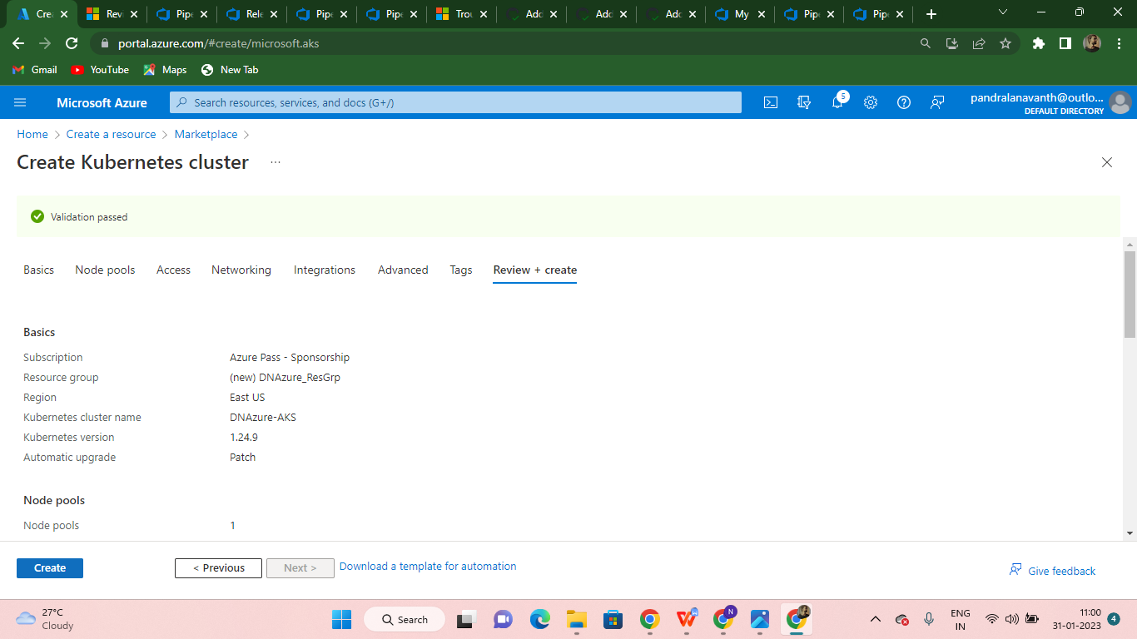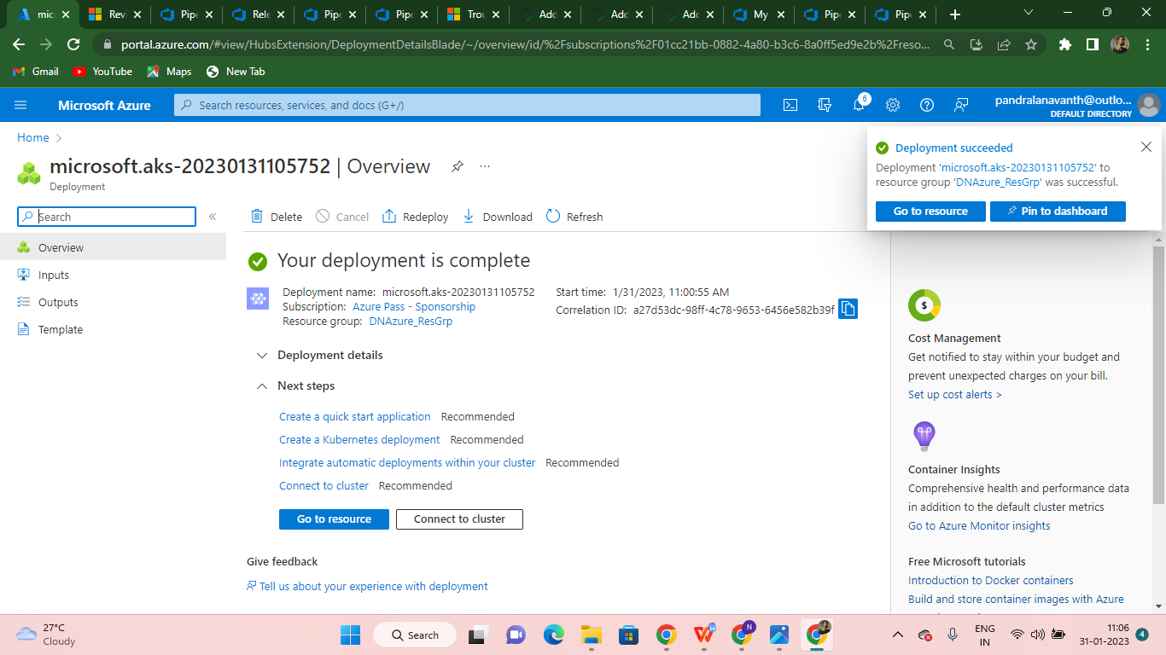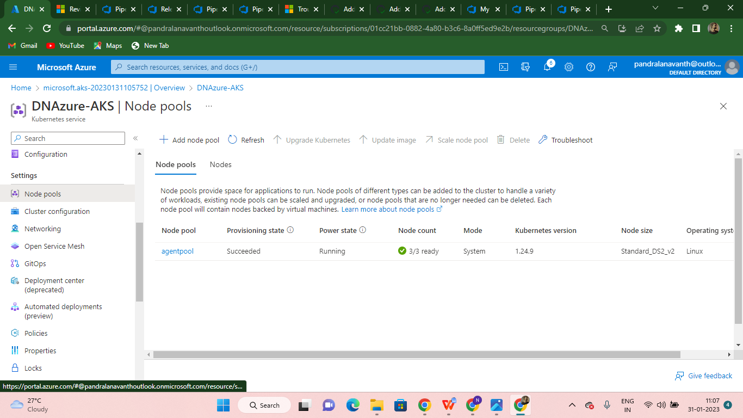

1. **Azure Container Registry creation**

As done in the previous hands-on, navigate to the Containers section to create an Azure Container registry. Name it ‘**DNAzureACR**’.

* While creating the ACR, choose the resource group ‘**DNAzure_ResGrp’**
* Modify the SKU from ‘Standard’ to ‘Basic’
* Notice the Registry complete name -> DNAzureACR.azurecr.io; azurecr represents Azure container registry
* Click ‘Review + Create’ button
* In the final screen, click ‘Create’ button to complete the process
* Thru the notification, click ‘Go to resource’ to view the container registry detail. Verify
  + Resource group
  + Login server name

**Output>>**

