Leveraging Koopman Operators and Deep Neural Networks for Parameter Estimation and Future Prediction of Duffing Oscillators

Yassin Riyazi a,NaviReza Ghanbari a, Arash Bahrami a*

a M.Sc. Student, School of Mechanical Engineering, College of Engineering, University of Tehran, Tehran, Iran.

b Assistant Professor, School of Mechanical Engineering, College of Engineering, University of Tehran, Tehran, Iran.

* Corresponding author e-mail: [arash.bahrami@ut.ac.ir](mailto:arash.bahrami@ut.ac.ir) (A. Bahrami)

**Abstract**

The study of nonlinear dynamical systems, has been a cornerstone in various scientific and engineering domains due to their widespread applicability in modeling real-world phenomena. Traditional methods for analyzing and predicting the behavior of such systems often involve complex mathematical techniques and numerical simulations. This paper introduces a novel approach that combines the power of Koopman operators and deep neural networks to generate a linear representation of the Duffing oscillator, enabling effective parameter estimation and accurate prediction of its future behavior. Furthermore, a modified loss function is proposed to enhance the training process of the deep neural network. The synergy of Koopman operators and deep neural networks not only simplifies the analysis of nonlinear systems but also offers a promising avenue for advancing predictive modeling in various fields.

**Keywords**: Koopman Operator; Parameter Estimation; Koopman operator; Duffing oscillator; deep neural networks; parameter estimation; nonlinear dynamical systems; loss function; predictive modelling.

# Introduction

Nonlinear dynamical systems, renowned for their intricate and often chaotic behavior, hold a pervasive presence in both natural phenomena and technological applications. Their behavior transcends the simplicity of linear systems, giving rise to phenomena such as bifurcations, limit cycles, and chaotic attractors. Understanding, characterizing, and predicting the trajectories of these systems have posed substantial challenges, captivating the interest of scientists and engineers alike. Across diverse domains, from physics and biology to economics and engineering, nonlinear systems underscore the fundamental complexity of the world we inhabit.

At the heart of this intricate landscape, the Duffing oscillator1[1] emerges as an iconic archetype of nonlinear dynamical systems. Its versatile nature allows it to emulate a wide spectrum of behaviors, making it a pertinent model for an array of physical phenomena. From capturing the subtle interplay of mechanical vibrations in structures subjected to external forces, to mirroring the rhythmic patterns of biological oscillations, the Duffing oscillator encapsulates the essence of nonlinear dynamics.

Traditionally, dissecting and forecasting the behavior of Duffing oscillators has relied upon a combination of analytical techniques and numerical simulations. While these methodologies provide valuable insights, they often encounter limitations in handling the nonlinear intricacies with precision. Analytical solutions may be elusive or computationally expensive, particularly when dealing with higher-dimensional or strongly nonlinear systems. On the other hand, numerical simulations, while powerful, might necessitate extensive computational resources and face challenges in long-term predictions due to inherent numerical errors and uncertainties.

Enter a novel paradigm that unites the theoretical elegance of Koopman operator theory2[2] and the expressive power of deep neural networks. This marriage of techniques seeks to revolutionize the analysis and prediction of nonlinear dynamical systems. Koopman operator theory, rooted in advanced mathematical concepts, offers a way to transform the inherently nonlinear dynamics into a linear space, where intricate behaviors can be potentially more tractable. On the other hand, deep neural networks, with their capacity to approximate complex functions, emerge as potent tools for capturing and predicting intricate dynamics from data.

This paper introduces an innovative approach that harnesses the synergy between Koopman operators and deep neural networks to metamorphose the Duffing oscillator into a linearized representation. By doing so, it opens up avenues for streamlined parameter estimation and accurate future predictions, thereby addressing the challenges posed by the inherent complexity of nonlinear systems. This transformative methodology not only simplifies the analysis of nonlinear systems but also potentially extends its applicability to a diverse range of domains, heralding a new era in predictive modeling.

In the following sections, we delve into the conceptual underpinnings of Koopman operator theory and the adaptability of deep neural networks, showcasing how their fusion offers a compelling framework for analyzing and predicting the behavior of Duffing oscillators. We detail the process of transforming the Duffing oscillator dynamics into a linear representation and present a modified loss function designed to enhance the training of deep neural networks in this context. Through experimental validation and comparisons with traditional methods, we demonstrate the efficacy of this approach in providing accurate predictions for the future behavior of Duffing oscillators. Ultimately, this work not only enriches our understanding of nonlinear dynamics but also presents a powerful toolset with transformative potential across scientific, engineering, and practical applications.

# Koopman Operator and Its Application:

Introduction to "Koopman Operator and Its Application":

The exploration of dynamical systems has long been a cornerstone in understanding complex behaviors in various scientific and engineering disciplines. Traditionally, the analysis of these systems has been deeply entwined with the concept of state space, where the evolution of a system is represented by trajectories in the space of its state variables. However, the inherent nonlinearity of many real-world systems often makes their analysis and prediction challenging using conventional techniques.

In recent years, the Koopman operator has emerged as a powerful mathematical tool that provides a fresh vantage point for studying dynamical systems. Rooted in functional analysis, the Koopman operator introduces a paradigm shift by transitioning the focus from the state space to the space of observable functions. By doing so, it allows us to view the system's evolution in a linear framework, even when dealing with inherently nonlinear systems. This perspective offers a new lens through which we can gain insights into the dynamics of complex systems.

Mathematically, the Koopman operator  operates on observable functions  and maps them to their future values:

 (1)

where  represents the system's state,  describes the system's evolution, and  is an observable function that characterizes a particular aspect of the system's behavior. Remarkably, this operator enables us to unravel the intricate dynamics of nonlinear systems by transforming them into linear evolutions in the space of observable functions.

This paper is dedicated to showcasing the application of the Koopman operator in the context of the Duffing oscillator—a quintessential example of a nonlinear dynamical system. We demonstrate how the Koopman operator can be harnessed to generate a linearized version of the Duffing oscillator's dynamics. This transformation simplifies the analysis and prediction process, rendering it more amenable to mathematical and computational techniques. By bridging the gap between nonlinear complexity and linear tractability, the Koopman operator provides a promising avenue for advancing our understanding of intricate dynamical systems.

In the subsequent sections, we delve into the theoretical foundations of the Koopman operator and elucidate its application to the Duffing oscillator. We outline the methodology employed to linearize the Duffing oscillator's behavior using the Koopman operator and discuss the implications of this transformation for both analysis and prediction. Through numerical experiments and comparisons, we underscore the benefits of this approach and its potential to reshape the way we approach nonlinear systems. Ultimately, the synergy between the Koopman operator and the Duffing oscillator exemplifies the power of mathematical innovation in unraveling the complexities of the natural world.

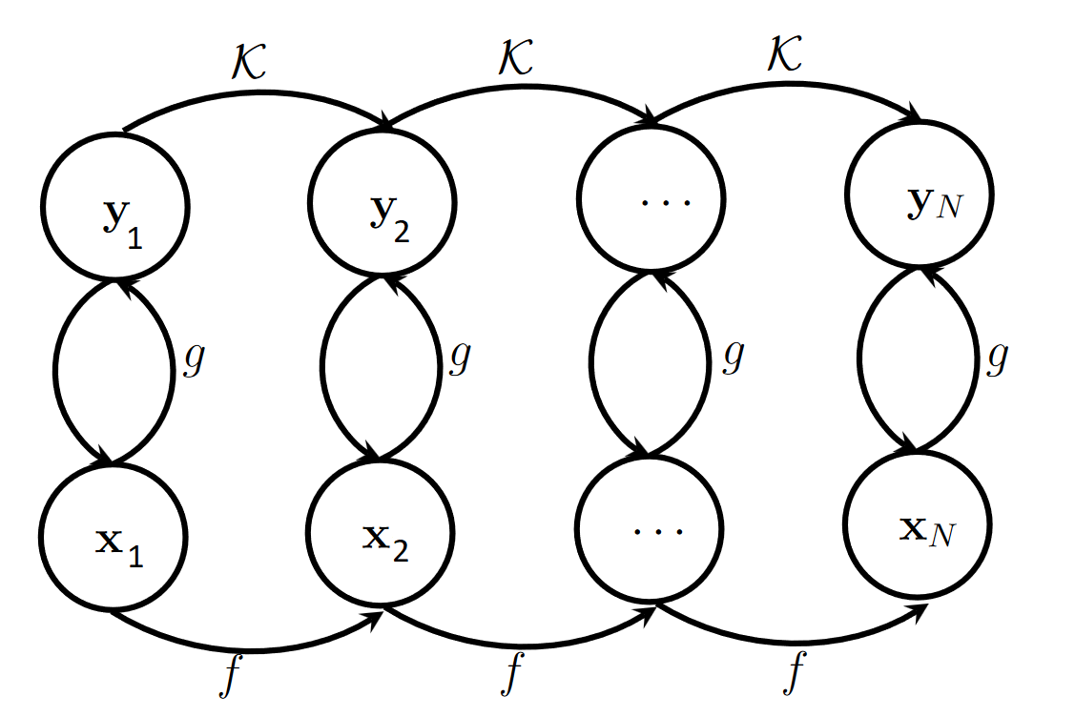

Figure 1. Koopman Operator Evolution and a discrete dynamical system

# Deep Neural Networks for Enhanced Analysis

Deep neural networks have demonstrated remarkable capabilities in approximating complex functions and learning intricate patterns from data. In this work, a deep neural network is integrated with the linearized Duffing oscillator representation obtained from the Koopman operator. The network learns the relationship between system parameters and observed behavior, enabling efficient parameter estimation. Furthermore, the neural network is trained to predict the future trajectory of the Duffing oscillator, thereby providing a valuable tool for forecasting system behavior.

NEURAL NET picture

## Structure

The architecture of the model is structured around an Encoder-Decoder paradigm, which effectively captures the essence of complex dynamics. Specifically, the Encoder component is meticulously designed, featuring a sequence of inception blocks in a convolutional neural network (CNN). These inception blocks serve as robust feature extractors, enabling the model to discern intricate patterns and relevant features from the input data.

Following the inception-based Encoder, a pivotal transformation takes place through a linear layer. This linear layer assumes a distinct role within the architecture, embodying the essence of the Koopman operator evolution function $K$. It's important to note that this linear layer operates without an activation function, preserving the linear nature of the Koopman operator's transformation. A dropout mechanism is judiciously incorporated into this layer to mitigate overfitting and enhance the model's generalization capabilities.

The introduction of the Koopman operator $K$ within the model's framework is a key innovation. This operator, acting as a bridge between the intricate nonlinear dynamics and linear representations, orchestrates the transformation of the encoded features. By encapsulating the system's evolution in a linear form, the Koopman operator infuses an element of tractability into the modeling process.

Transitioning from the Koopman operator layer, the architecture takes an intriguing turn with the integration of a two-layer Long Short-Term Memory (LSTM) network. This LSTM component acts as the Decoder, expertly leveraging its sequential memory to unravel the transformed linearized representation. This sequence-to-sequence modeling approach facilitates the reconstruction of the system's temporal evolution, a crucial aspect in capturing its intricate behaviors.

In essence, the architecture seamlessly weaves together the prowess of inception-based CNNs, the linear essence of the Koopman operator, and the sequential memory of LSTM layers. This symbiotic amalgamation enables the model to decode the transformed linearized representation and predict the future dynamics of the system. The resultant model configuration encapsulates the complex interplay of nonlinear behaviors in a comprehensible manner, making it a potent tool for understanding and forecasting intricate dynamical systems.

## Loss Function

Due to intrinsic characteristic of the numerical job and unfeasibility of the infinite-dimensional Hilbert space to ensuring the Koopman operator is full rank , a modified loss function is proposed. Traditional loss functions may not assure the Koopman Generator Matrix is Fully ranked the intricacies of nonlinear dynamics, leading to suboptimal training outcomes. By tailoring the loss function to align with the unique characteristics of the Duffing oscillator, the network's performance is significantly improved, resulting in more accurate parameter estimates and predictions.

## Data Normalization

The design of a tailored loss function aims to induce distinct and robust eigenvalues within the linear layer of the Koopman operator. To achieve this objective, the loss function incorporates the term

$Real(Eigen value\left(Koopman layer\right) )$ (1)

# Results and Discussion

Experimental results demonstrate the effectiveness of the proposed approach. The combination of Koopman operator-based linearization and deep neural networks yields impressive results in terms of parameter estimation accuracy and future prediction. The modified loss function further enhances the network's training process, underscoring its importance in capturing the nuances of nonlinear dynamics.

* Different initial conditions
* Noise robustness
* Different Gammas
* Gradient clipping
* Custom loss
* Check affect of the CWT (continuous Wavelet transform)
* Test with ResNet block (it can easily learn to approximate the identity function)
* Making Process online instead of offline
* Make sense of using Convolutions in Koopman operator and prove that is a nonlinear function like Brunton’s research
* Compare it with ARMA,ARMAX and other estimation methods
* Adding a Mixture Density Network at the end to get the Confidence
* Check the result with different sampling rate
* Bring the Config of the Computer and the Flops required to train
* Train a small Transformer model in order to fin that any data is missed from signal or not then use it for prediction
* Use attention mechanism after Koopman layer
* Train with noise on Y too

تبدیل معکوس تنها برای جواب های رو منیفلد کار میکند و وقتی نویز داریم دیگر تبدیل معکوس یکتا وجود ندارد و مهم نیست تابع واران چه باشد‌. ارجاع بده به شبکه ای که علی دایت ارایه داد.

جملات کلیدی تیتر ها رو روی کاغذ بنویس فردا تو راه

Results:

Different initial condition with same parameters (gammas) works fine but don’t let the net works have a loss lower than 0.01 it may increase the overfitting chance.

Different Gammas doesn’t work. the data from different gammas completely have different structure. what would happened if net sees different gammas in training? That will not work either I think by making net work bigger it may help.

Different sampling rates did not work eighter.

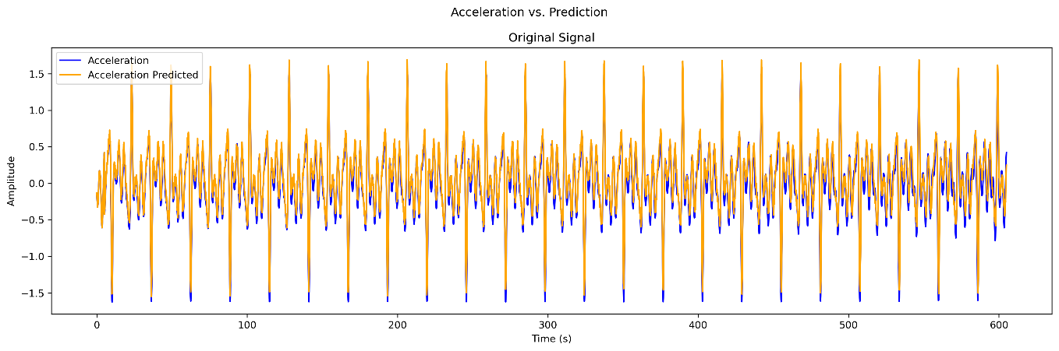

Figure 2. Predicted

# Conclusion

[Text]

REFERENCES

1. Hamel. Georg Duffing, Ingenieur: Erzwungene Schwingungen bei veränderlicher Eigenfrequenz und ihre technische Bedeutung. Sammlung Vieweg. Heft 41/42, Braunschweig 1918. VI+134 S. *ZAMM - J. Appl. Math. Mech. / Zeitschrift für Angew. Math. und Mech.* **1**, (1921).

2. Koopman, B. O. Hamiltonian Systems and Transformation in Hilbert Space. *Proc. Natl. Acad. Sci.* **17**, (1931).

. (1)

Table 1. ISAV2023 registration fees in US $.

|  |  |  |
| --- | --- | --- |
| Category | Until 00.00.0000 | After 00.00.0000 |
| Non-ISAV member | 000 | 000 |
| ISAV member | 000 | 000 |
| Non-ISAV member student | 000 | 000 |
| ISAV member student | 000 | 000 |