**Step-by-Step Guide to Host a Static Resume Website on S3 Using CloudFront and GitHub Actions**

Create a GitHub Repository

1. Go to GitHub and create a new repository .
2. Clone the repository to your local machine.

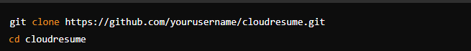

**2. Prepare Your Resume Files**

1. Create the required files (**index.html**, **styles.css**, **script.js**) in your repository directory. You can modify these files as you need. You can push the files from your local machine to your repo.

**3. Set Up AWS S3 and CloudFront**

1. Create an S3 Bucket:

1. Log in to the AWS Management Console.
2. Navigate to S3 and create a new bucket (e.g., my-resume-bucket).
3. Make the bucket public and enable static website hosting.
4. You can specify block all public access to your bucket if you wish to keep it private.
5. Enable **Static website hosting**and choose **Host a static website** as **Hosting type**. Enter the **Index document** name and then click **the Save Changes** button.
6. Go to **Permissions tab>Edit bucket policy**. Paste the bucket policy below and then click the Save Changes button. Attached below is the bucket policy I’ve created to allow OAC Cloudfront distribution to access the bucket.

1. **Create a CloudFront Distribution:**
   * Go to the CloudFront console and create a new distribution.
   * Set the origin domain name to your S3 bucket.
   * Configure the distribution settings as needed.

**4. Configure GitHub Actions for CI/CD – You can use AWS CodePipeline here if you want to deploy changes to your website . This example is using GitHubActions to automatically deploy changes from your code in the GitHub repository and the changes will be automatically reflected on your website hosted in S3.**

1. In your local repository, create the GitHub Actions workflow file:

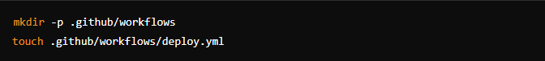

1. **Set Up GitHub Secrets:**
   1. Go to your GitHub repository settings.
   2. Add the following secrets: This is from the IAM user that you have created initially .
      1. **AWS_ACCESS_KEY_ID**
      2. **AWS_SECRET_ACCESS_KEY**

**5. Push Changes to GitHub**

1. Add and commit your changes:

