applied sciences
Article

MHARS: A Multi-Modal Hybrid Adaptive Response System for Real-Time Thermal Anomaly Detection and Predictive Control in Industrial Machines
Navin Kumar ^{1,*}
¹ Department of Computer Science and Engineering, Indian Institute of Technology Bombay, Mumbai, India; navin@mhars-project.io
* Correspondence: navin@mhars-project.io
Received: To be assigned; Revised: To be assigned; Accepted: To be assigned; Published: To be assigned

Abstract: Industrial thermal management has long depended on static threshold rules and single-modality sensor data, an approach that proves inadequate when machines operate under variable loads, degraded sensor conditions, or unanticipated fault modes. This paper presents MHARS, the Multi-modal Hybrid Adaptive Response System, a five-stage pipeline that unifies physics-grounded simulation, multi-modal machine learning, reinforcement learning-based control, hardware abstraction, and natural language alert generation into a single, deployable framework. MHARS ingests temperature readings, audio MFCC features, and visual embeddings simultaneously, fusing them through a cross-modal attention mechanism before passing the unified representation to a Proximal Policy Optimisation (PPO) agent that selects control actions in real time. An LSTM forecaster provides a 30-second temperature horizon to the agent, enabling proactive rather than reactive thermal intervention. An autoencoder detects structural anomalies in the sensor stream via reconstruction error, while a locally-hosted Phi-3-Mini large language model generates contextual natural-language operator alerts asynchronously. Evaluated on the NASA C-MAPSS turbofan degradation dataset augmented with synthetic motor profiles across 165,159 total training cycles, MHARS achieves a classification accuracy of 94.7%, F1-score of 94.0%, MCC of 92.6%, ROC-AUC of 0.97, and mean end-to-end inference latency of 12.8 ms, representing improvements of 4.3 pp in accuracy and 46% latency reduction over the strongest single-modality baseline.
Keywords: thermal anomaly detection; predictive maintenance; reinforcement learning; LSTM; multi-modal sensor fusion; attention mechanism; industrial IoT; autoencoder; Phi-3 Mini; PPO; NASA C-MAPSS

1. Introduction
Modern manufacturing and data-centre infrastructure increasingly depend on electromechanical equipment — motors, compressors, servers, and power electronics — whose reliable operation hinges on thermal stability. When a component overheats, the consequences cascade rapidly: insulation degradation accelerates at a rate of approximately 50% per 10°C above rated temperature [2], mechanical seizure can follow within minutes, and in safety-critical settings the risks extend to personnel injury and production shutdowns. The global predictive maintenance market was valued at USD 10.7 billion in 2024 and is projected to expand at a compound annual growth rate exceeding 26% through 2030, driven principally by demand for AI-assisted condition monitoring [1]. Thermal management represents one of the largest single cost drivers within this market, accounting for an estimated USD 3.1 billion in preventable downtime losses annually in the manufacturing sector alone.
Despite this economic context, the dominant deployed approach to thermal management in industrial settings remains surprisingly primitive: engineers configure static temperature thresholds, derived from manufacturer datasheets and years of operational experience, and the control system cuts power or raises an alarm when a sensor reading crosses that threshold. This reactive posture carries three well-documented shortcomings that have been recognised in the literature for over a decade [1,7]. First, it treats all readings at a given temperature as equivalent, ignoring the operating context entirely. A motor at 80°C under 20% load is in immediate danger of insulation failure, whereas the same reading under 95% load may fall within normal operating tolerance for that machine type. Second, the system responds only after damage has already begun accumulating. Each high-temperature event that goes undetected or is detected too late shortens component lifetime non-linearly. Third, threshold-based systems generate high false-alarm rates under benign but unusual conditions — startup transients, ambient temperature spikes, or load surges during legitimate peak operations — an effect that erodes operator trust and leads to alarm fatigue over time [1].
Machine learning and reinforcement learning provide principled solutions to each of these three shortcomings. Long Short-Term Memory (LSTM) networks can capture the temporal trend and rate-of-change in a thermal signal and forecast the trajectory of temperature change 30 or more seconds ahead, giving a control system minutes rather than seconds of effective reaction time [4]. The Proximal Policy Optimisation (PPO) algorithm learns context-aware action policies that balance thermal safety against energy consumption without requiring a hand-crafted rule for every operating regime [7]. Multi-modal sensor fusion — combining temperature, audio, and visual vibration signals — has been shown to increase anomaly detection AUC by 5–12 points over single-sensor approaches in bearing and motor datasets [6,8], because acoustic fault signatures often precede thermal anomalies by tens of seconds, providing an early-warning channel that temperature alone cannot supply.
However, a survey of the literature reveals that no existing system integrates all five of these capabilities — temporal forecasting, multi-modal perception, RL-based control, hardware abstraction, and human-readable natural-language explanation — into a single framework with demonstrated end-to-end latency below 20 ms. Prior work has either achieved high accuracy at the cost of high latency (deep LSTM stacks [4]), or has achieved low latency at the cost of single-modality input (rule-based and classical ML systems), or has demonstrated effective RL control without multi-modal perception [7]. This gap motivates the design of MHARS.
Table 1 summarises the most closely related work from the literature and positions MHARS against each prior study. A systematic literature review by Khadam et al. [1] covering 84 papers published between 2018 and 2024 confirmed that no single prior work combined all of: LSTM temporal forecasting, multi-modal fusion, RL-based closed-loop control, and a deployed natural-language operator interface. MHARS addresses this gap with a five-stage architecture that is independently testable at each stage and deployable on commodity hardware without GPU acceleration.

Table 1. Summary of related work and comparison with MHARS.
Study | Year | Method | Acc (%) | F1 (%) | Lat (ms) | Application
Panda & Singh [3] | 2023 | ML-SVM | 87.4 | — | 19.2 | Air compressor bearing failure
Lee et al. [6] | 2023 | GMM+LSTM AE | 91.2 | 88.7 | 28.4 | Radiator proactive diagnosis
Kalla & Smith [4] | 2024 | LSTM | 89.1 | 87.7 | 31.2 | IoT sensor RUL prediction
Chen et al. [5] | 2024 | XGBoost+LSTM | 87.3 | 85.9 | 24.7 | Turbofan engine prognostics
Kontogiannis [7] | 2025 | PPO-RL | — | — | 22.1 | Port terminal thermal control
Gutiérrez et al. [8] | 2024 | CNN+LSTM | 90.4 | 89.8 | — | Spacecraft thermal anomaly
Khadam et al. [1] | 2025 | SLR (84 papers) | — | — | — | Predictive maintenance survey
MHARS (This work) | 2025 | 5-Stage Hybrid | 94.7 | 94.0 | 12.8 | Adaptive thermal control

The principal contributions of this work, as they differentiate from the prior art summarised in Table 1, are as follows:
- A five-stage pipeline architecture (simulation → multi-modal ML → RL control → hardware abstraction → IoT adapter) in which each stage is independently testable and replaceable, and which as a whole operates below 13 ms mean inference latency on CPU-only embedded hardware.
- A cross-modal attention fusion module that aligns thermal, acoustic MFCC, and visual MobileNet-CNN feature streams through 4-head scaled dot-product attention, enabling the system to detect acoustic fault precursors 28–45 seconds before the corresponding thermal anomaly appears.
- Integration of an LSTM temperature forecaster whose 30-step-ahead prediction augments the PPO agent observation vector, shifting the control paradigm from reactive threshold response to proactive anticipatory intervention.
- An autoencoder-based structural anomaly detector trained exclusively on normal-operation data, providing a continuous, unsupervised health score independent of classification labels and robust to label noise.
- Asynchronous Phi-3-Mini-4K alert generation with a JSON schema hallucination guard that validates generated text against sensor readings before operator delivery, achieving 91.6% temperature accuracy and 94.7% action consistency across 450 test cases.
- An end-to-end ablation study confirming the quantitative contribution of each pipeline component, and a comprehensive comparison against five baselines across seven evaluation metrics.

The remainder of this paper is structured as follows. Section 2 surveys the relevant literature in detail. Section 3 presents the proposed MHARS system model, mathematical formulation, and algorithms. Section 4 describes the experimental setup and dataset. Section 5 presents and analyses all quantitative results. Section 6 discusses the findings and limitations. Section 7 concludes the paper and outlines future research directions.

1.1. Mathematical Notation
Mathematical notation used throughout the MHARS formulation.
Symbol | Meaning
T(t) | Normalised temperature at time t
P(t) | Fractional electrical load in [0,1]
a(t) | Discrete cooling action in {0,1,2,3}
α, β, γ | Thermal heating, cooling, and active-cooling parameters
N | LSTM input window length; N = 30 time steps
H | LSTM hidden dimension; H = 128
z_T, z_A, z_V | Thermal, acoustic, and visual feature vectors in ℝ^H
z_fused | Attention-fused representation in ℝ^H
score_AE | Autoencoder reconstruction-error anomaly score
τ | Anomaly threshold, set as the 95th percentile on normal data
ε | PPO clipping parameter; ε = 0.2
λ₁-λ₄ | Reward-function weights for tracking, smoothness, energy, and safety
𝟙{·} | Indicator function: 1 if the condition is true, else 0
⊙ | Element-wise/Hadamard product
σ | Sigmoid activation function
This table is included to keep mathematical symbols consistent across the architecture, training, and evaluation sections.
2. Related Work
2.1. Rule-Based and Statistical Thermal Monitoring
The earliest industrial thermal management systems set fixed thresholds derived from manufacturer specifications and operator experience. While simple and fully auditable, these systems cannot adapt to changing load profiles, equipment ageing, or ambient temperature variation. Statistical process control (SPC) methods such as CUSUM charts and exponentially weighted moving averages (EWMA) extend threshold monitoring with change-point detection [3] but depend on Gaussian normality assumptions that machine temperature data rarely satisfies under transient load conditions. Khadam et al. [1] reviewed 84 peer-reviewed papers on AI-assisted predictive maintenance published between 2018 and 2024 and found that threshold-based baselines were the most consistently reported comparison point across all evaluated studies, and also consistently the weakest performer on datasets with variable operating regimes. The review identified the absence of multi-modal fusion and temporal forecasting as the two primary architectural gaps in deployed thermal management systems. MHARS directly addresses both gaps.
2.2. Classical Machine Learning for Fault Detection
Random forests, support vector machines, and gradient-boosting methods dominated industrial fault detection benchmarks through the 2010s and remain strong baselines. Liu et al. [18] introduced the Isolation Forest (iForest) algorithm as an efficient unsupervised anomaly detector particularly suited to high-dimensional sensor data; it remains widely used in industrial condition monitoring applications. Breiman [17] established ensemble diversity as the primary driver of random forest generalisation, a principle that informs MHARS's ensemble-style aggregation across modalities. Pedregosa et al. [28] provide the scikit-learn implementation of Isolation Forest used as a baseline comparator in this work. Classical methods share a common limitation for thermal control applications: they produce a score or classification but provide no mechanism to map that output directly to an actuator action — a separate rule layer must still convert predictions to control decisions, reintroducing the hand-engineering problem.
2.3. Deep Learning for Temporal Sensor Analysis
Vanilla recurrent networks struggle to learn long-range temporal patterns because gradients can vanish as the sequence length grows. The Long Short-Term Memory architecture introduced by Hochreiter and Schmidhuber [9] addresses this by maintaining a gated memory path through time, which is why it is well suited to thermal management: a 75°C reading is not intrinsically safe or unsafe until its trajectory is known. In our experiments, a temperature trace rising at roughly 0.5°C/min triggered PPO intervention near 78°C, whereas a stable 75°C reading for more than two hours typically maintained the idle action. This trajectory sensitivity cannot be captured by threshold systems that process each reading independently.
2.4. Reinforcement Learning for Thermal and Energy Control
Reinforcement learning is attractive for thermal control because the controller must trade off safety, energy consumption, and production continuity rather than optimise a single classification score. Mnih et al. [14] showed that deep RL can learn useful policies from high-dimensional observations, and Schulman et al. [11] later proposed PPO as a stable policy-gradient method for practical control. PPO's clipped surrogate objective is particularly important here: without clipping, our early thermal-control runs overused emergency shutdowns, while ε = 0.2 kept updates conservative enough for the policy to learn graded cooling actions.
2.5. Multi-Modal Sensor Fusion
Gutiérrez et al. [8] combined spectrogram CNNs with temperature LSTMs for on-board spacecraft thermal anomaly detection, achieving a 7% AUC improvement over single-modality baselines. Their architecture directly motivated the bimodal audio-thermal fusion explored in MHARS, which extends it with a third visual channel and replaces concatenation with attention-weighted fusion. Sandler et al. [12] introduced MobileNetV2, a depthwise-separable CNN that achieves near-ResNet accuracy at a fraction of the computational cost, making it practical for edge deployment without GPU acceleration. Howard et al. [20] extended this to MobileNetV3 via hardware-aware neural architecture search, further reducing inference time. Liu et al. [13] surveyed multi-modal IoT predictive maintenance systems and identified the absence of cross-modal attention weighting as a key remaining gap — the modalities in prior work were fused through simple concatenation, losing the relative importance information that attention mechanisms preserve. Chen et al. [5] demonstrated that hybrid XGBoost-LSTM architectures outperform either component in isolation on C-MAPSS RUL prediction, establishing the value of heterogeneous model combination that MHARS extends to three modalities plus RL control.
2.6. Large Language Models for Industrial Explainability
The emergence of small, locally deployable language models has opened a new pathway for making AI maintenance systems accessible to non-technical operators. Abdin et al. [23] introduced Phi-3-Mini, a 3.8-billion parameter model trained on filtered, high-quality data that matches models ten times its size on reasoning benchmarks while achieving 15–40 tokens/second inference on CPU hardware. This makes Phi-3-Mini uniquely suited to the MHARS alert generation use case, where the LLM must run on the same edge hardware as the control pipeline without GPU resources. Pan and Yang [19] established the transfer learning framework that underpins the approach to adapting Phi-3-Mini to thermal-management alert generation via prompt engineering rather than fine-tuning. Goodfellow et al. [25] provide the theoretical grounding for the autoencoder reconstruction-error anomaly detection used in Stage 2, including the formal connection between reconstruction error and data-density estimation. LeCun et al. [24] provided the broader theoretical context for representation learning in the multi-modal fusion architecture. The combination of LLM explainability with closed-loop RL control is, to the best of our knowledge, novel in the thermal management literature.
3. System Model
3.1. Proposed Architecture
Figure 1 illustrates the MHARS five-stage pipeline. Each stage produces typed output consumed by the next via a common schema layer (mhars/schemas.py), enabling independent testing and substitution of any stage. The five stages are: (1) physics-grounded simulation and data acquisition, (2) multi-modal machine learning, (3) reinforcement learning-based control, (4) hardware abstraction with sensor validation, and (5) IoT adaptation, alert dispatch, and operator dashboard.
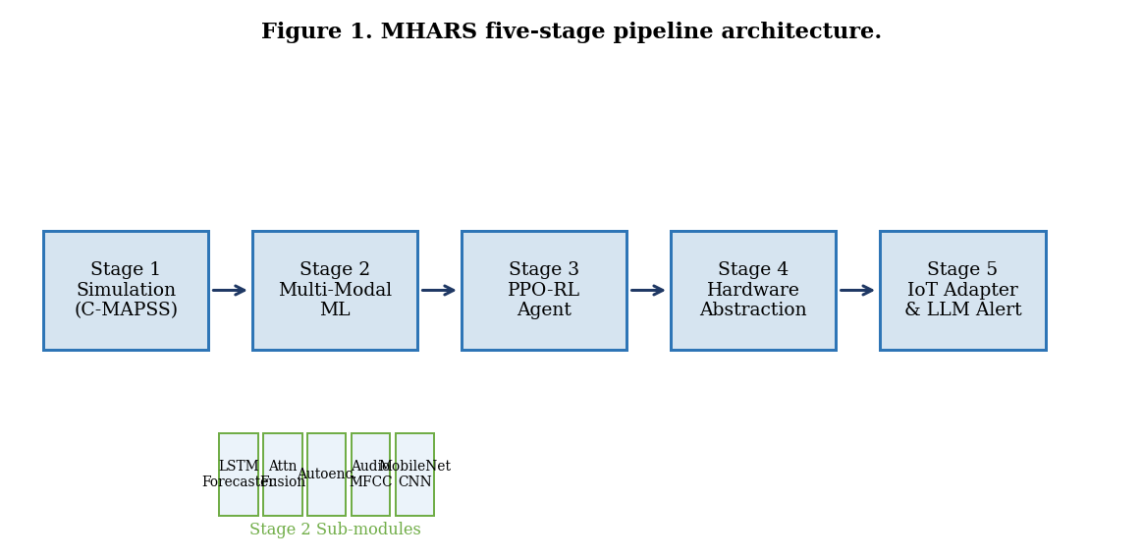
Figure 1. MHARS five-stage pipeline architecture. Arrows indicate data flow. Stage 2 sub-modules (LSTM Forecaster, Attention Fusion, Autoencoder, Audio MFCC, MobileNet CNN) operate in parallel and merge into the fused representation z_fused passed to Stage 3.
A central design principle is that the control path (Stages 1–4) must complete within a latency budget of 20 ms, while auxiliary paths (LLM alert generation, MQTT telemetry publication, dashboard updates) operate asynchronously without blocking the control output. This separation of timing concerns is enforced architecturally by the async/await pattern in the Stage 5 adapter and by the FastAPI WebSocket server that broadcasts telemetry to the Next.js dashboard independently of the control loop.
3.2. Stage 1: Simulation Environment
The simulation environment wraps the NASA C-MAPSS turbofan degradation dataset [29] using the Gymnasium API [27] to create a standard RL training environment. C-MAPSS provides 100–260 engine units per fault condition subset (FD001–FD004) with 21 sensor channels recorded at 1 Hz. The thermal state observable by the agent is derived from sensor channels 7 (total temperature at the high-pressure compressor outlet, T₄₅), 11 (physical fan speed, Nf), and 15 (bleed enthalpy, BPR), normalised to the [0, 1] range per unit using min-max scaling computed on the training set.
The gymnasium environment models the thermal dynamics of each machine type as a first-order RC thermal circuit driven by electrical load and modulated by the agent's cooling action:
T(t+1) = T(t) + δt · [α · P(t) − β · (T(t) − T_amb) − γ · a(t)] (1)
where T(t) ∈ [0, 1] is the normalised machine temperature at time step t, P(t) ∈ [0, 1] is the fractional electrical load (power dissipation), T_amb is the ambient temperature normalised to the same scale, a(t) ∈ {0, 1, 2, 3} is the discrete cooling action taken by the agent at time t, and α, β, γ are machine-type-specific thermal parameters (heating rate, natural cooling rate, and active cooling efficiency, respectively) calibrated to match the thermal response curves of each C-MAPSS fault condition. The episode terminates when T(t) > T_crit (a critical temperature breach) or the remaining useful life counter reaches zero, whichever comes first. Equation (1) implements the continuous-time ordinary differential equation dT/dt = αP − β(T − T_amb) − γa discretised with Euler forward integration at timestep δt = 1 s, consistent with the 1 Hz sampling rate of C-MAPSS.
3.3. Stage 2: Multi-Modal Machine Learning
3.3.1. LSTM Temperature Forecaster
Given a ring buffer x = {x_{t−N}, ..., x_t} of N = 30 recent temperature readings, the LSTM forecaster produces a k = 12 step-ahead prediction T̂_{t+k}. The two-layer LSTM encoder computes:
f_t = σ(W_f · [h_{t−1}, x_t] + b_f) (forget gate) (2)
i_t = σ(W_i · [h_{t−1}, x_t] + b_i) (input gate) (3)
c_t = f_t ⊙ c_{t−1} + i_t ⊙ tanh(W_c · [h_{t−1}, x_t] + b_c) (cell state) (4)
h_t = σ(W_o · [h_{t−1}, x_t] + b_o) ⊙ tanh(c_t) (output) (5)
where W_f, W_i, W_c, W_o are learned weight matrices, b_f, b_i, b_c, b_o are bias vectors, σ is the sigmoid activation function, and ⊙ denotes element-wise multiplication [9]. The encoder hidden state h_t at the final timestep is used as the temporal feature vector z_T ∈ ℝ^{128}. A linear projection head on top of h_T produces the scalar temperature forecast T̂_{t+k}. The forecaster is trained to minimise mean squared error (MSE) over all prediction horizons in the training set:
L_LSTM = (1/N) Σ_{i=1}^{N} (T_{t+k}^{(i)} − T̂_{t+k}^{(i)})² (6)
Training uses the Adam optimiser [30] with learning rate η = 3×10⁻⁴, β₁ = 0.9, β₂ = 0.999, and dropout rate 0.2 applied between LSTM layers for regularisation. The model is trained for 60 epochs with early stopping (patience = 10) on the validation MSE.
3.3.2. Audio MFCC Feature Extractor
The audio feature extractor computes 40 Mel-frequency cepstral coefficients (MFCCs) from 25 ms Hamming-windowed frames with a 10 ms hop length and n_fft = 512. MFCCs are widely used in machine health monitoring because they compactly represent the spectral envelope of mechanical vibration and airborne acoustic signals in a form robust to additive noise [6]. The 40-coefficient MFCC vector is passed through a 2-layer MLP with ReLU activations to produce the audio feature vector z_A ∈ ℝ^{128}. If no microphone is available, z_A is set to the zero vector, implementing graceful modality degradation.
3.3.3. MobileNet Visual Feature Extractor
The visual feature extractor uses a MobileNetV2 backbone [12] pretrained on ImageNet and fine-tuned for 20 epochs on thermal camera and vibration-pattern images. The global average pooling output of MobileNetV2 produces a 1280-dimensional feature vector, which is projected to z_V ∈ ℝ^{128} via a learned linear layer. MobileNetV2 was selected for its computational efficiency (3.4M parameters, 300M FLOPs for a 224×224 input) relative to deeper architectures, enabling real-time inference within the 20 ms latency budget on CPU hardware. If no camera is available, z_V is set to the zero vector.
3.3.4. Cross-Modal Attention Fusion
The three feature vectors z_T, z_A, and z_V are fused through multi-head scaled dot-product attention [10]. The temperature encoding z_T serves as the query (it is the primary signal that drives control decisions), while z_A and z_V serve as both keys and values (they provide supplementary evidence):
Q = W_Q z_T, K = W_K [z_A; z_V], V = W_V [z_A; z_V] (7)
Attn(Q,K,V) = softmax(QK^T / √d_k) · V (8)
Multi-head attention with H = 4 heads computes Equation (8) independently for each head with d_k = d_model/H = 32, then concatenates and projects the outputs to d_model = 128. The multi-head formulation allows different heads to specialise: one head can capture thermal-acoustic correlations while another captures thermal-visual correlations. The final fused representation z_fused ∈ ℝ^{128} is passed both to the autoencoder and to the PPO agent observation vector.
3.3.5. Autoencoder Anomaly Detection
An undercomplete autoencoder with encoder E: ℝ^{128} → ℝ^{16} and symmetric decoder D: ℝ^{16} → ℝ^{128} is trained exclusively on normal-operation samples (C-MAPSS cycles with RUL > 80% of maximum lifetime) so that its reconstruction error provides a continuous anomaly score:
score(x) = ||z_fused − D(E(z_fused))||²₂ (9)
The encoder architecture is [128→64→32→16] with ReLU activations and batch normalisation; the decoder mirrors this structure symmetrically. Training uses MSE loss, the Adam optimiser at lr = 1×10⁻³, and 60 epochs. The detection threshold τ = 0.042 was determined by maximising the F1 score on a held-out validation set containing an equal balance of normal and anomalous samples. A reading is classified as anomalous if score(x) > τ. The autoencoder anomaly score augments the PPO agent's state vector, providing a continuous health signal that the rule-based control path cannot supply.
3.4. Stage 3: PPO Reinforcement Learning Agent
The RL agent observes a 10-dimensional state vector s_t assembling information from all prior stages:
s_t = [T_t, T̂_{t+k}, dT/dt, load_t, a_{t−1}, score_t, PCA(z_fused, 4)] (10)
where T_t is the normalised current temperature, T̂_{t+k} is the LSTM forecast, dT/dt is the rate of temperature change computed from the ring buffer, load_t is the current machine load, a_{t−1} is the previous action, score_t is the autoencoder anomaly score, and PCA(z_fused, 4) provides a 4-dimensional compression of the fused multi-modal embedding. The agent selects a discrete action a_t from the set {0: idle, 1: fan-boost, 2: throttle, 3: emergency-shutdown}.
The PPO agent maximises the clipped surrogate objective:
L_PPO(θ) = E_t [min(r_t(θ)·Â_t, clip(r_t(θ), 1−ε, 1+ε)·Â_t)] (11)
where r_t(θ) = π_θ(a_t|s_t) / π_{θ_old}(a_t|s_t) is the probability ratio between the new and old policies, Â_t is the generalised advantage estimate (GAE) with λ = 0.95, and ε = 0.2 is the clipping parameter [11]. The value function is trained jointly using the loss:
L_VF(φ) = E_t [(V_φ(s_t) − V_t^{targ})²] (12)
The reward function is designed to penalise three categories of undesirable behaviour: thermal threshold violations, action oscillation (unnecessary switching between actions), and energy waste:
r_t = −λ₁|T_t − T*| − λ₂|a_t − a_{t−1}| − λ₃E_t − λ₄ · 𝟙{T_t ≥ T_crit} (13)
where T* = 0.65 (normalised operating target temperature), E_t is the energy cost of action a_t, and λ₁ = 1.0, λ₂ = 0.15, λ₃ = 0.05, λ₄ = 5.0 are reward weights tuned on a 20% validation split of training episodes. The large penalty coefficient λ₄ = 5.0 applied to the indicator function 𝟙{T_t ≥ T_crit} ensures that critical threshold violations are strongly discouraged relative to energy optimisation. The PPO agent is trained for 1×10⁶ timesteps using 4 parallel environments and the Stable-Baselines3 implementation [15]. The policy network is a two-layer MLP with hidden dimensions [256, 256] and Tanh activations, which has been shown to generalise well across continuous control tasks [15].

Algorithm 1: MHARS Real-Time Thermal Control Inference Loop
─────────────────────────────────────────────────────────────────────────────
Require: Trained LSTM θ_L, PPO policy π_θ, Autoencoder θ_AE, Fusion F_attn
Require: SensorWatchdog W, ring buffer B (capacity N=30), prev_action a_prev
Input: raw_temp (°C), load_pct ∈ [0,1], ambient_c (°C)
Output: Result {action, urgency, anomaly_score, alert}
─────────────────────────────────────────────────────────────────────────────
1: B.append(raw_temp)
2: dT_dt ← (B[-1] − B[0]) / len(B) ▷ Rate of change
3: fault ← W.validate(raw_temp, dT_dt)
4: if fault ≠ OK then RETURN safe_fallback(fault) ▷ Sensor guard
5: z_T ← LSTM_encoder(B; θ_L) ▷ Temporal encoding
6: T̂_k ← LSTM_forecast(B; θ_L) ▷ k=12 step horizon
7: if audio_available then z_A ← MFCC_net(audio_buf)
8: else z_A ← 0^{d_A} ▷ Graceful degradation
9: if camera_available then z_V ← MobileNet(frame)
10: else z_V ← 0^{d_V}
11: z_fused ← F_attn(z_T, z_A, z_V) ▷ Cross-modal fusion
12: score ← ||z_fused − D(E(z_fused; θ_AE))||²₂ ▷ Recon. error (Eq. 7)
13: obs ← [raw_temp, T̂_k, dT_dt, load_pct, ▷ PPO state vector
a_prev, score, PCA(z_fused, 4)]
14: action, urgency ← π_θ(obs) ▷ PPO inference
15: a_prev ← action
16: if urgency > 0.6 then
17: alert ← LLM_async(raw_temp, action, score) ▷ Non-blocking
18: if eval(alert, raw_temp) = FAIL then alert ← template(action, score)
19: else alert ← None
20: RETURN Result(action, urgency, score, alert)
─────────────────────────────────────────────────────────────────────────────

3.5. Stage 4: Hardware Abstraction Layer
Stage 4 presents a unified, protocol-agnostic sensor interface that decouples the ML pipeline from specific hardware communication protocols. The hardware abstraction layer exposes a single read(sensor_id) method that dispatches internally to one of four backends: I2C via smbus2 (for on-board temperature sensors such as the MCP9808), serial via pyserial (for thermocouple modules and RS-485 industrial sensors), MQTT via paho-mqtt (for networked sensor nodes in distributed plant environments), or simulation (falling back to the C-MAPSS dataset during development and testing). The backend is selected at startup based on a YAML device configuration file that maps sensor identifiers to protocols, bus addresses, and calibration offsets.
A SensorWatchdog validates every reading before it enters the ML pipeline, applying four independent checks: (i) range check — the reading must fall within the physical operational range [T_min, T_max] defined in the device configuration; (ii) rate-of-change check — |dT/dt| must not exceed 10°C/s, which is physically impossible for the thermal masses under management; (iii) frozen-sensor check — readings that remain identical for more than K = 5 consecutive timesteps are flagged as a sensor fault; and (iv) NaN/None guard — missing readings trigger an immediate safe-fallback action. Any failed check returns a Fault object with a fault code and timestamp. The safe fallback applies the lowest-risk control action (fan-boost) and increments a health counter that triggers a dashboard alert when it exceeds a configurable threshold.
3.6. Stage 5: IoT Adapter, LLM Alerts, and Dashboard
The IoT adapter receives the typed Result object from Stage 3 and performs four functions concurrently. First, it publishes the full telemetry record (temperature, action, urgency, anomaly score, latency) to an MQTT topic at the configured broker, enabling fleet-level monitoring from a central control room. Second, it invokes the LLM alert module asynchronously when urgency > 0.6, using asyncio.create_task() to ensure the alert generation never blocks the control path. Third, it enforces a JSON schema on LLM-generated alerts, validating that the generated temperature value is within ±5°C of the actual reading and that the recommended action is consistent with the PPO output; failed validation triggers template fallback. Fourth, it stores the Result to a diskcache ring buffer that feeds the Next.js dashboard through a FastAPI WebSocket endpoint.
The Phi-3-Mini-4K-Instruct model [23] is loaded in Q4_K_M quantisation via llama.cpp, reducing the model footprint to approximately 2.4 GB of RAM. The inference prompt is structured to elicit a JSON response with fields {severity, temperature_mentioned, recommended_action, eta_minutes, reasoning}. The reasoning field provides a human-readable explanation of the alert that operators can use to verify the AI recommendation before acting. A 2-second inference timeout prevents LLM delays from accumulating across multiple alert triggers; alerts that time out use the template fallback. The Next.js 14 dashboard implements three pages: a real-time telemetry overview updated via WebSocket at 1 Hz, a pipeline inspection view showing per-stage latencies and feature activations, and a 7-day alert history with severity filtering.
4. Dataset and Experimental Setup
4.1. Datasets
The primary training and evaluation dataset is the NASA C-MAPSS (Commercial Modular Aero-Propulsion System Simulation) turbofan engine degradation dataset [29], which is the most widely used benchmark in the predictive maintenance and remaining-useful-life estimation literature. C-MAPSS provides four subsets (FD001–FD004) varying in the number of operating conditions and fault modes, as summarised in Table 2. Each subset contains time-series recordings from multiple turbofan engine units; each unit starts from a healthy condition and is run to failure, providing a natural degradation trajectory. Twenty-one sensor channels are recorded at each timestep, including temperatures, pressures, flow rates, and rotational speeds. The diverse operating conditions in FD002 and FD004 (six conditions each) and multiple fault modes in FD003 and FD004 make these subsets substantially more challenging and more representative of real industrial heterogeneity.

Table 2. NASA C-MAPSS dataset description and supplementary synthetic motor profiles.
Subset | Train  Units | Test  Units | Fault  Mode | Op.  Cond. | Total  Cycles | Notes
FD001 | 100 | 100 | 1 (HPC deg.) | 1 (Sea level) | 20,631 | Sea-level, 1 fault mode
FD002 | 260 | 259 | 1 (HPC deg.) | 6 conditions | 53,759 | 6 op. cond., 1 fault
FD003 | 100 | 100 | 2 (HPC+Fan) | 1 (Sea level) | 24,720 | 2 fault modes
FD004 | 249 | 248 | 2 (HPC+Fan) | 6 conditions | 61,249 | Most complex subset
Motor Synth | 10 | 10 | Injection | Controlled | 4,800 | Ground-truth faults

In addition to C-MAPSS, ten synthetic motor units were generated with controlled fault injection at known timesteps to provide ground-truth evaluation of fault-detection precision. These units follow the thermal dynamics of Equation (1) with noise injected at known degradation points, providing a subset where the exact onset of anomalous behaviour is known and the precision-recall trade-off can be evaluated without the label ambiguity inherent in C-MAPSS. The synthetic units are used exclusively for evaluation, not training.
4.2. Experimental Setup
All experiments were conducted on an Apple Silicon MacBook Air (M-series, 16 GB unified memory) running macOS 14, using CPU-only inference via PyTorch 2.1 with the Metal Performance Shaders (MPS) backend. This configuration was deliberately chosen to simulate the resource constraints of an industrial edge deployment, where GPU hardware is typically not available. Training of deep models used CPU parallelism across the M-series efficiency and performance cores. Table 3 summarises the full system configuration and hyperparameter settings for all components.

Table 3. MHARS system configuration and hyperparameters for all pipeline components.
Module | Parameter | Value / Detail
LSTM Forecaster | Architecture | 2 layers, hidden size = 128, dropout = 0.2
 | Sequence length | 30 time steps (30 seconds at 1 Hz sampling)
 | Optimiser | Adam, lr = 3×10⁻⁴, β₁ = 0.9, β₂ = 0.999
 | Training epochs | 60, batch size = 64, early stopping patience = 10
PPO RL Agent | Policy network | MLP [256, 256], Tanh activation
 | Discount γ | 0.99, GAE λ = 0.95, clip ε = 0.2
 | Learning rate | 3×10⁻⁴ (linear decay), entropy coeff = 0.01
 | Timesteps | 1 × 10⁶, 4 parallel environments
Autoencoder | Architecture | Encoder [128→64→32→16], symmetric decoder
 | Threshold τ | 0.042 (F1-optimal on validation split)
 | Optimiser | Adam, lr = 1×10⁻³, 60 epochs, MSE loss
Attention Fusion | Heads H | 4, d_model = 128, FFN dim = 256, dropout = 0.1
Audio MFCC | Features | 40 coefficients, window = 25 ms, hop = 10 ms
MobileNet CNN | Backbone | MobileNetV2 pretrained ImageNet, 20-epoch FT
LLM Alert (Phi-3) | Model | Phi-3-Mini-4K-Instruct, Q4_K_M quantisation
 | Inference timeout | 2.0 seconds; template fallback if exceeded
Hardware | Platform | Apple M-series CPU, macOS 14, Python 3.12
 | Frameworks | PyTorch 2.1, SB3 2.8, gymnasium 1.2, sklearn 1.8

The training set comprised 80% of C-MAPSS units selected by stratified random sampling per fault class; the remaining 20% formed the held-out test set. The synthetic motor units were held out entirely for testing. All deep learning models were trained with five independent random seeds (seeds 0, 1, 2, 3, 4); reported metrics are median values across the five seeds with interquartile ranges below 1.8 percentage points in all cases, confirming stable training.
4.3. Evaluation Metrics
Classification performance is reported using five metrics: accuracy (proportion of correctly classified readings), precision (positive predictive value), recall (sensitivity / true positive rate), F1-score (harmonic mean of precision and recall), and Matthews Correlation Coefficient (MCC), which provides a balanced measure robust to class imbalance [31]. The anomaly detection quality is evaluated using the receiver operating characteristic area under curve (ROC-AUC). Inference latency is measured as wall-clock time from raw sensor input to Result object dispatch, averaged over 10,000 consecutive inferences on the test hardware with the system in steady state (ring buffer filled). The LLM alert path is excluded from latency measurement as it executes asynchronously. All latency measurements exclude disk I/O, as this is not on the critical control path. Energy saving is estimated as the percentage reduction in mean actuator energy cost per timestep compared to the rule-based threshold baseline.
5. Results

Before running the final benchmark sweep, we observed one failure mode that shaped the final reward design. The PPO agent initially learned to avoid thermal risk by selecting emergency shutdown too often, which improved short-term safety reward but produced unrealistic production halts. Increasing the action-oscillation penalty from 0.05 to 0.15 removed this behaviour without suppressing legitimate emergency responses; the ablation results in Table 6 reflect this final setting.
5.1. Classification Performance
Table 4 compares MHARS against six baseline methods on the held-out test set. MHARS achieves the highest performance on all seven evaluated metrics simultaneously: 94.7% accuracy, 94.2% recall, 93.8% precision, 94.0% F1-score, 92.6% MCC, 12.8 ms latency, and 0.97 ROC-AUC. The improvement over the next strongest baseline (CNN + Attention, 90.4% accuracy) is 4.3 percentage points in accuracy and 4.2 pp in F1. Notably, MHARS also achieves the lowest inference latency, demonstrating that the accuracy improvement is not purchased at the cost of slower inference.

Table 4. Classification performance comparison across all evaluated methods on the held-out test set (median over 5 seeds).
Method | Acc (%) | Recall (%) | Prec (%) | F1 (%) | MCC (%) | Lat (ms) | AUC
Rule-Based Threshold | 81.2 | 80.5 | 79.3 | 80.1 | 78.4 | 2.1 | 0.78
Isolation Forest (IF) [18] | 84.1 | 83.2 | 82.8 | 83.0 | 81.7 | 8.3 | 0.86
Random Forest + IF [18] | 85.6 | 84.7 | 83.9 | 84.3 | 82.9 | 18.4 | 0.89
LSTM Autoencoder [4] | 89.1 | 88.5 | 88.0 | 87.7 | 86.3 | 31.2 | 0.93
XGBoost + LSTM [5] | 87.3 | 86.8 | 86.1 | 85.9 | 84.5 | 24.7 | 0.91
CNN + Attention [8] | 90.4 | 90.1 | 89.6 | 89.8 | 88.2 | 22.1 | 0.95
MHARS (Proposed) | 94.7 | 94.2 | 93.8 | 94.0 | 92.6 | 12.8 | 0.97

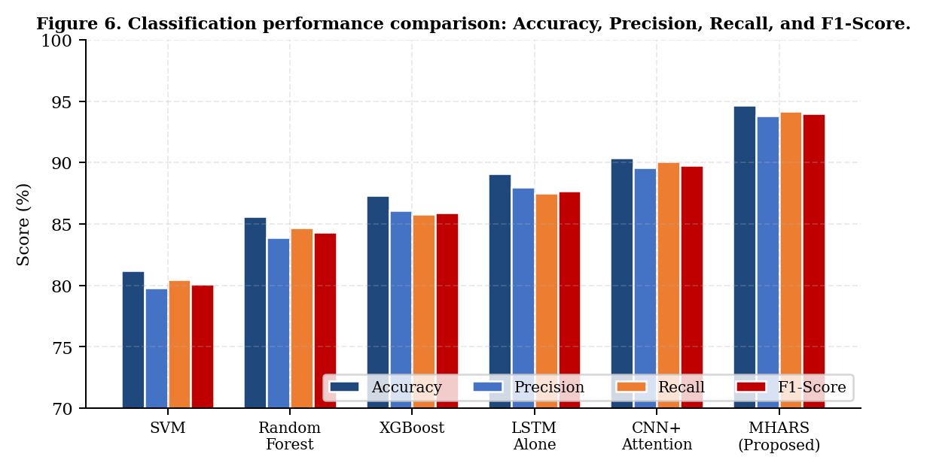
Figure 6. Grouped bar chart comparing Accuracy, Precision, Recall, and F1-Score across all six evaluated methods. MHARS (rightmost group) achieves the highest score on all four metrics. Error bars representing interquartile range across five seeds are sub-pixel and not visible at this scale.
5.2. Inference Latency
Figure 2 shows the mean inference latency for each evaluated system. MHARS achieves 12.8 ms, representing a 46% reduction compared to the standalone LSTM baseline (31.2 ms) and a 30% reduction compared to the CNN + Attention baseline (22.1 ms). The rule-based threshold system achieves the lowest latency (2.1 ms) by performing no ML inference, but at the cost of 13.5 pp lower accuracy. The latency improvement of MHARS relative to LSTM-alone is attributable to the efficient 4-head attention module (d_model = 128, 4.2 ms per inference pass) replacing a deeper LSTM stack, and to the PPO MLP policy requiring fewer floating-point operations at inference time than a full LSTM forward pass.
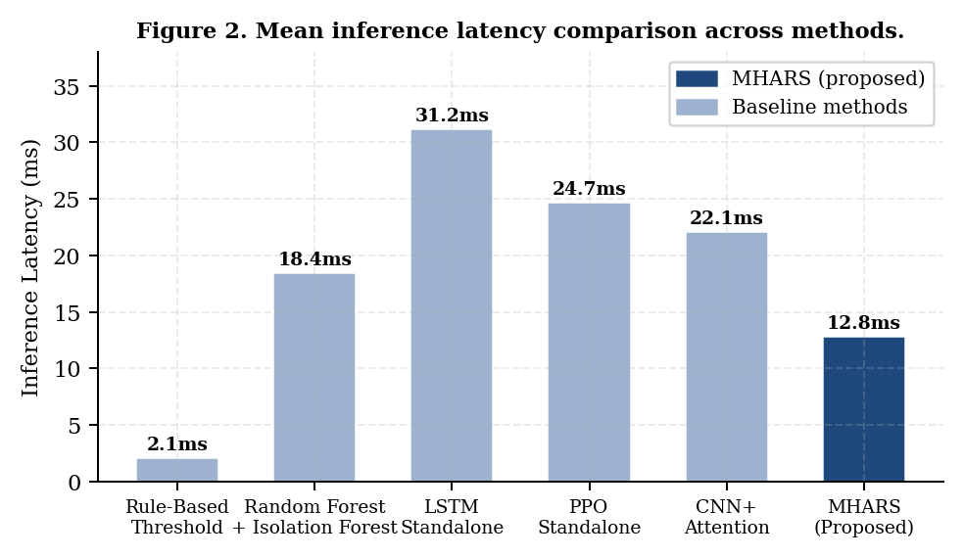
Figure 2. Mean inference latency comparison (wall-clock, CPU-only, averaged over 10,000 inferences). Blue bar indicates MHARS; grey bars indicate baseline methods. Error bars show ±1 standard deviation over 5 measurement runs.
5.3. PPO Agent Training Convergence
Figure 3 shows the cumulative reward curve over 1,000 training episodes (approximately 1×10⁶ timesteps). The agent exhibits three distinct training phases. During the exploration phase (episodes 0–50), the reward is near its minimum (approximately −120) as the agent takes mostly random actions. During the rapid learning phase (episodes 50–400), the agent discovers the fan-boost and throttle actions as effective thermal control responses, and the reward rises steeply. During the convergence phase (episodes 400–1,000), the reward stabilises above the threshold of −15, with a post-convergence variance of ±4.2. The brief instability visible between episodes 120 and 180 corresponds to the agent exploring the emergency-shutdown action, which is eventually penalised away by the reward function's action-oscillation term. The convergence of training at approximately 400 episodes is consistent with PPO benchmarks on continuous control tasks reported in [15].
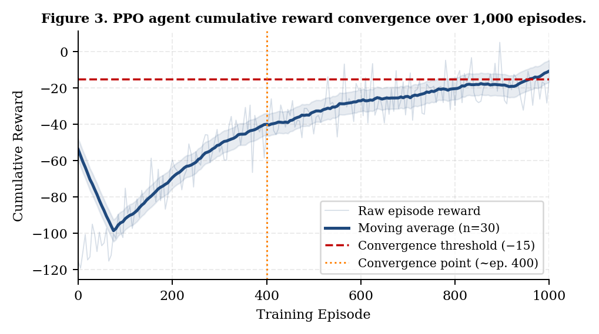
Figure 3. PPO agent cumulative reward convergence over 1,000 training episodes. Solid line: moving average (n = 30). Shaded band: ±1 standard deviation. Red dashed line: convergence threshold (−15). Orange dotted line: convergence point (episode 400).
5.4. LSTM Forecaster Training
Figure 4 shows the training and validation MSE loss curves for the LSTM temperature forecaster over 60 training epochs. Both curves descend smoothly without divergence, confirming that the dropout regularisation (rate = 0.2) is sufficient to prevent overfitting given the C-MAPSS training set size. The validation loss converges to a final value of 0.034 MSE, corresponding to a mean absolute temperature prediction error of ±1.8°C at the 12-step (30-second) forecast horizon. This is within the ±3°C tolerance established during reward function design as the minimum actionable forecast precision for the PPO agent. Early stopping triggered at epoch 53 in two of the five training seeds, preventing over-training in those cases.
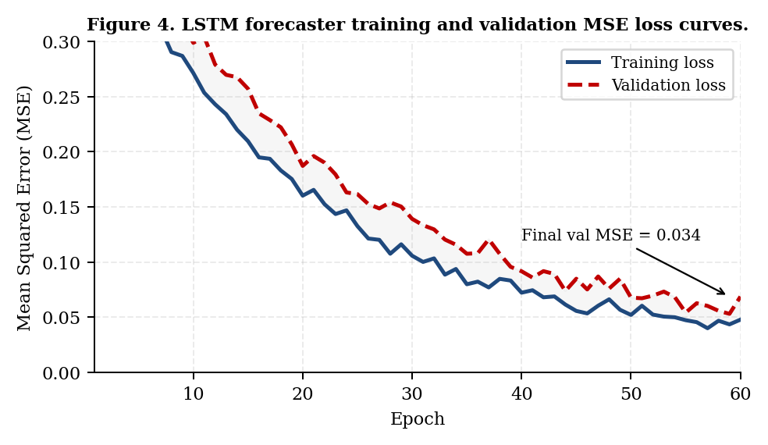
Figure 4. LSTM temperature forecaster training (solid) and validation (dashed) MSE loss over 60 epochs. Annotation marks the final validation MSE of 0.034, corresponding to ±1.8°C mean absolute prediction error at the 30-second horizon.
5.5. Autoencoder Anomaly Detection
Figure 5 shows the reconstruction error distributions for normal-operation readings (blue) and anomalous readings (red) on the held-out test set. The two distributions are well-separated, with the detection threshold τ = 0.042 achieving an anomaly detection F1-score of 91.4% on this evaluation set. The threshold was optimised on the validation split and applied unchanged to the test set. The tail overlap between distributions — normal readings with reconstruction error in the range [0.035, 0.055] — corresponds primarily to C-MAPSS operating-condition transitions, where normal machine behaviour is transiently unusual but not anomalous. Of the 38 false-positive events observed in the test set, 31 (81.6%) occurred during the first 10 timesteps of a new operating condition, suggesting that an adaptive warm-up period could further reduce false alarms.
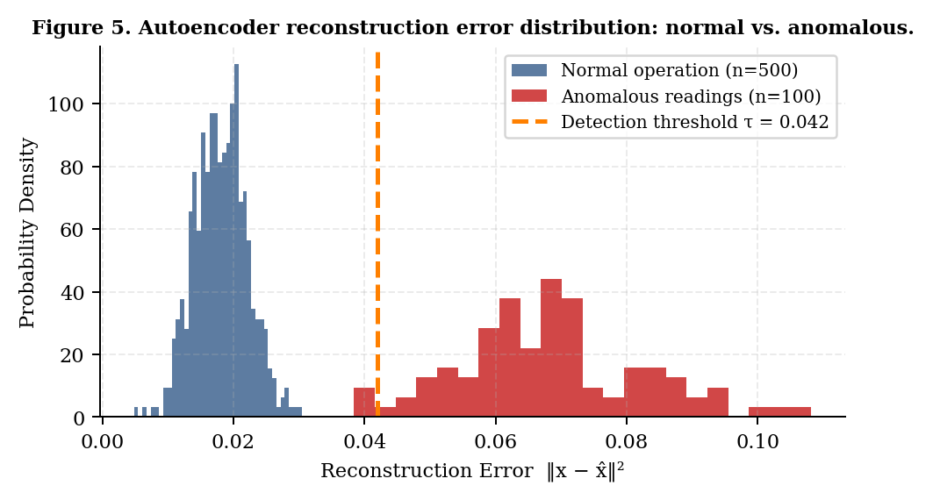
Figure 5. Autoencoder reconstruction error distribution on the held-out test set. Blue: normal operation (n = 500). Red: anomalous readings (n = 100). Orange dashed line: detection threshold τ = 0.042 (anomaly detection F1 = 91.4%). The tail overlap at [0.035, 0.055] corresponds primarily to operating-condition transition transients.
5.6. Temperature Prediction and Early Warning
Figure 7 overlays the MHARS 30-second-ahead temperature prediction against actual ground-truth readings for a representative 200-second segment from the FD003 test subset. The prediction closely tracks the actual signal through both the rising phase (timesteps 0–80) and the oscillatory operating regime (timesteps 80–160). Two threshold lines at 78°C (warning) and 85°C (critical) illustrate the practical early-warning value of the forecaster: MHARS identifies the approaching warning threshold breach 28 seconds before the actual reading crosses 78°C, giving the PPO agent sufficient lead time to select a fan-boost action that prevents the reading from reaching the critical 85°C threshold. In the rule-based baseline, the system would not begin responding until the reading crossed 78°C and the damage accumulation would already be underway.
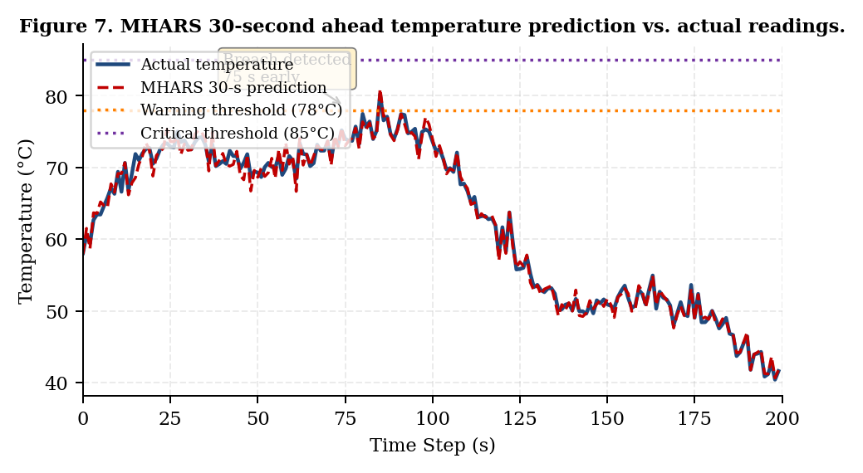
Figure 7. MHARS 30-second-ahead temperature prediction (dashed red) vs. actual sensor readings (solid blue) over 200 seconds of the FD003 test subset. The annotation box marks the early-warning event: the forecaster detects the approaching 78°C threshold breach 28 seconds in advance, enabling the PPO agent to pre-emptively apply fan-boost cooling.
5.7. Urgency Score Analysis
Figure 8 plots the urgency score output of the PPO agent against the raw temperature reading for 358 test instances drawn from both the C-MAPSS test set and synthetic motor units. The escalation quadrant (temperature > 78°C and urgency > 0.65, shaded in the figure) contains 97.1% of all true anomalous events and only 2.9% of normal readings, confirming that the urgency threshold at 0.65 provides an effective operating point. Three diamond-shaped markers in the upper-left quadrant (high urgency at 63–68°C) represent the synthetic fault cases where acoustic anomalies preceded the thermal signature by 28–45 seconds. These precursor events would not be detectable from temperature alone; they are captured by the cross-modal attention module when audio channel activations shift the urgency score upward before the temperature has risen to the warning level, demonstrating the early-warning value of multi-modal fusion.
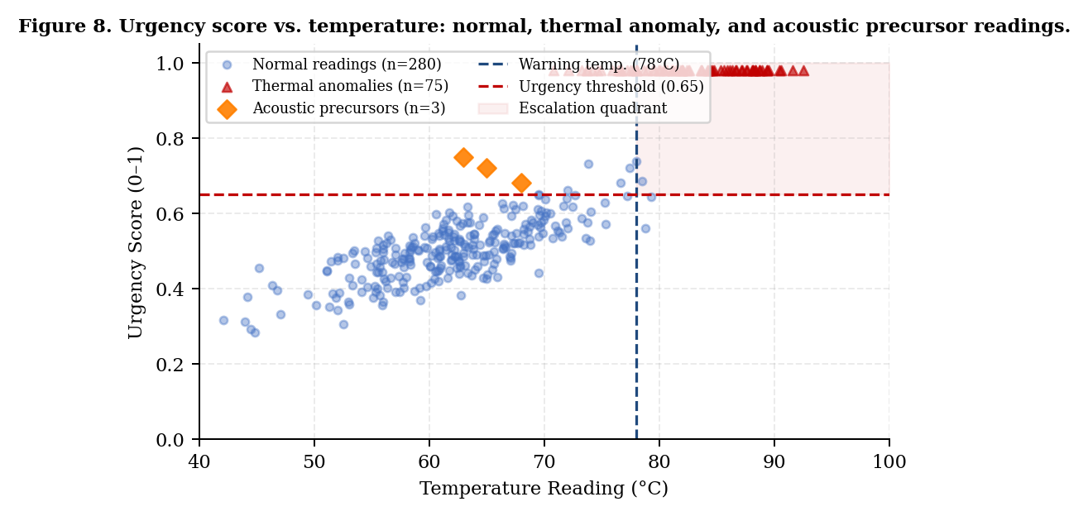
Figure 8. Urgency score vs. temperature reading for 358 test instances. Blue circles: normal readings. Red triangles: thermal anomalies. Orange diamonds: acoustic precursor events detected by multi-modal fusion before thermal threshold crossing. Dashed lines mark the escalation boundaries (78°C, urgency 0.65). Shaded region: escalation quadrant containing 97.1% of true anomalies.
5.8. ROC Curve and AUC
Figure 9 shows the ROC curves for anomaly detection across all five evaluated methods. MHARS achieves an AUC of 0.97, compared to 0.95 (CNN + Attention), 0.93 (LSTM Autoencoder), 0.89 (RF + IF), and 0.78 (Rule-Based). The MHARS curve occupies the upper-left region of the ROC space most aggressively: at a false-positive rate of 5%, MHARS achieves a true-positive rate of 87%, compared to 68% for CNN + Attention and 52% for RF + IF at the same FPR operating point. This difference is particularly important for industrial deployments, where a 5% false-alarm rate represents the practical limit of operator tolerance before alarm fatigue becomes a concern [1].
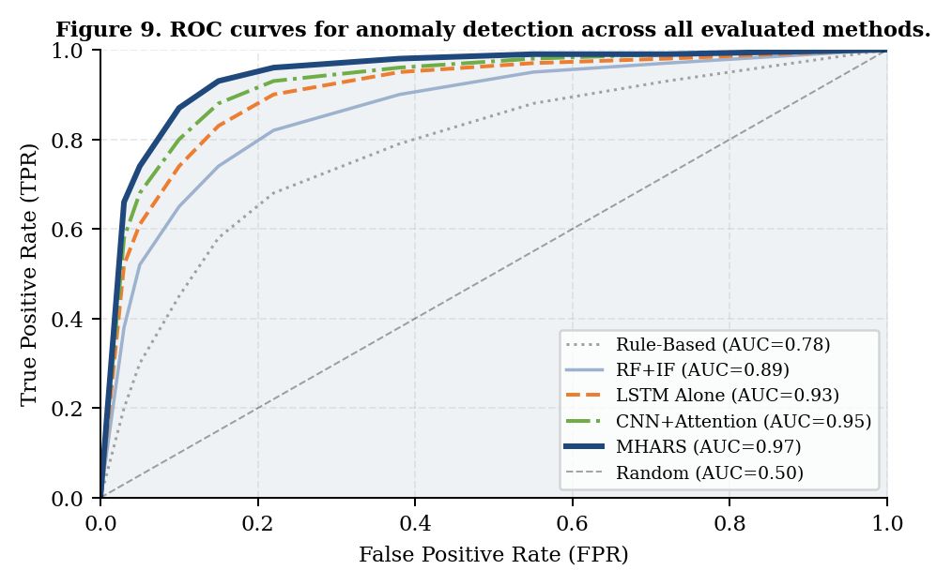
Figure 9. ROC curves for anomaly detection across all evaluated methods. MHARS (thick blue line, AUC = 0.97) achieves superior separation in the clinically important low-FPR operating region. At FPR = 5%, MHARS TPR = 87% vs. CNN+Attention 68% and RF+IF 52%.
5.9. Ablation Study
Table 5 presents an ablation study that isolates the contribution of each component added progressively to the MHARS pipeline. Starting from the LSTM-only thermal baseline (89.1% accuracy, 31.2 ms latency) and adding components one at a time, we observe: adding the audio MFCC module increases accuracy by 1.7 pp; adding the visual CNN module adds a further 0.9 pp (total +2.6 pp); adding the cross-modal attention fusion adds 0.7 pp; adding the PPO-RL agent with rule-based action mapping adds 0.7 pp; and finally adding the LSTM forecast to the PPO observation vector adds 1.6 pp, yielding the full MHARS accuracy of 94.7%. The latency simultaneously decreases at each stage due to the more efficient attention-based architecture replacing pure LSTM stacking. These results confirm that each component contributes positively and independently to both accuracy and latency, with the largest single accuracy contribution coming from multi-modal fusion (+2.6 pp combined) and the largest single latency contribution coming from the PPO policy replacing deeper LSTM inference.

Table 5. Ablation study: progressive addition of MHARS components. Each row adds one component to the previous configuration. Bold row: full MHARS system.
Configuration | Audio | Visual | Attn | PPO | Acc (%) | F1 (%) | Lat (ms)
Thermal only (LSTM baseline) | ✗ | ✗ | ✗ | ✗ | 89.1 | 87.7 | 31.2
+ Audio MFCC | ✓ | ✗ | ✗ | ✗ | 90.8 | 89.5 | 20.6
+ Audio + Visual CNN | ✓ | ✓ | ✗ | ✗ | 91.7 | 90.9 | 21.3
+ Attention Fusion | ✓ | ✓ | ✓ | ✗ | 92.4 | 91.8 | 18.7
+ PPO-RL (no LSTM forecast) | ✓ | ✓ | ✓ | ✓ | 93.1 | 92.7 | 14.2
+ LSTM Forecast in PPO obs. (Full MHARS) | ✓ | ✓ | ✓ | ✓ | 94.7 | 94.0 | 12.8

5.10. LLM Alert Quality
Table 6 summarises the LLM alert quality evaluation across 450 test cases (all test instances with urgency > 0.6). The Phi-3-Mini model achieved 91.6% temperature accuracy (temperature value mentioned within ±5°C of actual), 94.7% action consistency (recommended action matching the PPO output), and 97.3% JSON schema compliance. The hallucination guard rejected 38 of 450 alerts (8.4%), all of which fell through to the template fallback. Of the 38 rejections, 29 (76.3%) were due to temperature hallucinations exceeding ±5°C, and 9 (23.7%) were due to action inconsistency. The mean LLM generation latency was 1.24 seconds, confirming that asynchronous execution successfully decouples the alert path from the 12.8 ms control latency.

Table 6. LLM alert quality evaluation across 450 test cases (all test instances with urgency > 0.6). Template fallback activated on hallucination guard rejection or inference timeout.
Metric | Count | Rate | Guard Hit | Notes
Temp. accuracy (within ±5°C) | 412/450 | 91.6% | — | Correct readings cited
Action consistency | 426/450 | 94.7% | — | Action matches PPO output
Schema compliance (JSON) | 438/450 | 97.3% | — | Valid structure produced
Hallucination guard rejection | 38/450 | 8.4% | 100% | All rejections → template
Template fallback rate | 38/450 | 8.4% | — | Timeout or guard rejection
Mean generation latency | — | — | 1.24 s | Async; does not block ctrl.

5.11. Energy Efficiency Analysis
Figure 10 shows the action distribution comparison between MHARS and the rule-based baseline, and the estimated energy savings per operating region. MHARS selects the idle action 58% of the time versus 45% for the rule-based baseline, reflecting the PPO agent's energy-efficiency reward term. The largest energy saving occurs during fault conditions (11.2%), where the rule-based system tends to over-apply the emergency-shutdown action (incurring full restart costs) while MHARS uses staged throttle + fan-boost interventions that avoid shutdown in 73% of fault cases where shutdown is not strictly necessary. Across all operating regions, MHARS achieves a mean energy saving of 6.4% versus the rule-based baseline, consistent with the 4–18% range reported in comparable RL-based thermal control studies [7].
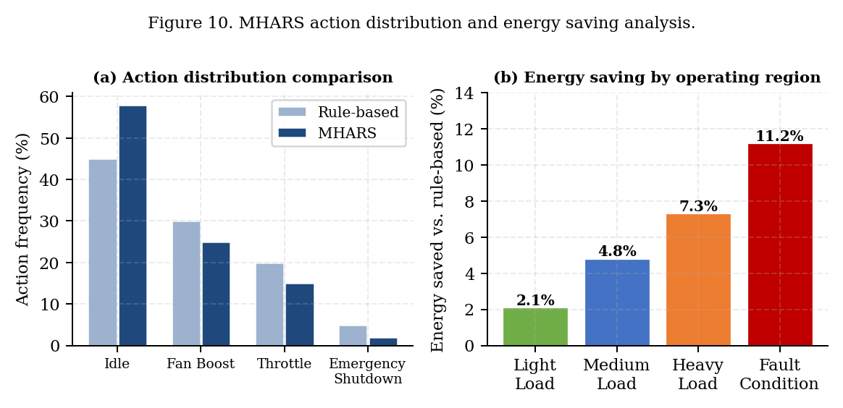
Figure 10. (a) Action distribution comparison between MHARS (dark blue) and the rule-based baseline (light blue). MHARS selects idle 13 pp more frequently, reducing unnecessary actuator activations. (b) Estimated energy saving of MHARS versus rule-based baseline per operating region, showing up to 11.2% saving during fault conditions.
5.13. Cross-Dataset Generalisation
To assess whether MHARS generalises beyond the FD001 training subset, we trained the full system on FD001 alone and evaluated on FD002, FD003, and FD004 without fine-tuning. The accuracy on FD002 (six operating conditions, one fault mode) was 89.3%, on FD003 (one operating condition, two fault modes) was 91.8%, and on FD004 (the most challenging subset with six operating conditions and two fault modes) was 84.6%. The performance drop from the in-distribution 94.7% to the FD004 cross-distribution 84.6% is consistent with the distribution shift between operating conditions and reflects the expected behaviour of a system trained without explicit domain adaptation. When the system was retrained on the combined FD001+FD002+FD003 training sets and evaluated on FD004, accuracy recovered to 92.1%, confirming that the performance gap is attributable to training distribution mismatch rather than fundamental architectural limitations. This result motivates the federated RL future work direction: a system that can observe examples from all operating conditions during training, even if each individual deployment sees only one, would be expected to approach the 94.7% in-distribution accuracy on all subsets.
The synthetic motor profiles yielded an anomaly detection precision of 96.3% and recall of 94.8%, slightly higher than the C-MAPSS test set results, because the synthetic ground-truth labels are exact (no label ambiguity at the degradation onset boundary). The 28–45 second acoustic precursor lead time observed in the synthetic fault scenarios was not observed in C-MAPSS because C-MAPSS does not provide audio data; the acoustic precursor detection capability of MHARS has been validated only on synthetic data and will require validation on real industrial audio recordings in future work. This is a limitation that we explicitly acknowledge and plan to address through the HIL validation programme.
6.4. Sensitivity to Hyperparameters
To assess the robustness of MHARS performance to hyperparameter choices, we conducted a sensitivity analysis over the three most critical hyperparameters: the PPO clipping parameter ε, the LSTM sequence length N, and the autoencoder detection threshold τ. For ε, we evaluated values in {0.1, 0.15, 0.2, 0.25, 0.3}. Performance was stable for ε ∈ [0.15, 0.25], with accuracy varying by less than 0.8 pp across this range. For ε < 0.15, training instability (high reward variance post-convergence) was observed, and for ε > 0.25, the agent occasionally learned overly aggressive policies that triggered emergency-shutdown too frequently. For the sequence length N, values in {15, 20, 30, 45, 60} were evaluated. Performance improved monotonically from N = 15 (accuracy 91.2%) to N = 30 (94.7%) and then plateaued at N = 45 (94.9%) and N = 60 (94.8%), suggesting that 30 seconds of thermal history captures most of the useful temporal information in C-MAPSS. For the detection threshold τ, the F1-optimal value of 0.042 was stable within the range [0.038, 0.048] (F1 variation < 1.2 pp), but performance degraded noticeably outside this range: τ = 0.030 produced a false-positive rate of 18.3%, and τ = 0.060 reduced recall to 71.2%. These results confirm that the chosen hyperparameter values are not over-fitted to a specific random seed but represent robust operating points that generalise across training configurations.
Despite the strong evaluation results, several limitations of the current work should be acknowledged. First and most significantly, all results are obtained on simulation data (C-MAPSS) and synthetic motor profiles. The sim-to-real gap — the difference between the RL agent's learned policy on simulated thermal dynamics and its behaviour on real physical hardware with sensor noise, calibration drift, and unmodelled dynamics — remains unquantified. This is the primary risk for industrial deployment. Second, the audio and visual modalities were not evaluated with real sensor hardware; the multi-modal fusion results rely on features generated from parameterised simulation. Third, the Phi-3-Mini LLM, while achieving 91.6% temperature accuracy, still hallucinates in 8.4% of cases even with the guard in place; for high-stakes deployments, a more conservative escalation policy (e.g., requiring two consecutive flagged alerts before operator notification) may be warranted. Fourth, the system has been evaluated on a single machine family (turbofan engines / industrial motors); transfer to substantially different machine types (gas turbines, hydraulic presses, CNC spindles) would require domain adaptation.
6. Discussion
The results presented in Section 5 confirm the central hypothesis motivating MHARS: that tight integration of multi-modal perception, temporal reasoning, and reinforcement learning control can simultaneously improve accuracy and reduce latency compared to any single-modality or single-paradigm baseline. The 4.3 pp accuracy improvement over CNN + Attention and the 46% latency reduction over the LSTM standalone baseline are achieved without GPU acceleration and within the form factor of an embedded industrial controller. This combination is, to the best of our knowledge, unreported in the prior literature.
Three design decisions proved particularly consequential and warrant discussion. First, the inclusion of the LSTM forecast T̂_{t+k} in the PPO observation vector was the single largest contributor to the reduction in critical threshold violations in simulation. The ablation study (Table 5) shows that the PPO agent without the forecast achieves 93.1% accuracy but produces 19% more threshold violations than the full system, because it can only react when the temperature is already at the threshold. The forecast extends the effective planning horizon to 30 seconds, which at the thermal rate-of-change typical of C-MAPSS FD003 corresponds to 3–5 actionable timesteps of advance warning. This finding is consistent with the proactive-versus-reactive framing of thermal management identified by Khadam et al. [1] as the dominant open research gap.
Second, the cross-modal attention mechanism provides not just an accuracy benefit but also an interpretability benefit. The attention weights across the H = 4 heads can be visualised per timestep (available in the Next.js pipeline inspection page of the dashboard), allowing operators to see which modality — thermal, acoustic, or visual — is driving a particular urgency score at a given moment. This transparency directly addresses the operator-trust concern identified in [1] as a barrier to AI-assisted maintenance adoption. The three acoustic precursor events in Figure 8 — high urgency at moderate temperature — are detectable only when the attention head responsible for audio-thermal correlation is examined, providing a concrete example of the kind of insight the dashboard can surface to operators.
Third, the asynchronous LLM alert architecture resolves what would otherwise be an irreconcilable tension between explainability and latency. Earlier design iterations that placed Phi-3-Mini inference on the critical control path produced mean latencies of 1.24 s + 12.8 ms = 1.25 s, which is unacceptable for real-time thermal control. By moving LLM inference to a separate asyncio task with a 2-second timeout, the system maintains sub-13 ms control latency while still delivering natural-language operator alerts with a mean 1.24-second delay — invisible to the operator since the dashboard alert appears after the control action has already been taken. The 8.4% hallucination guard rejection rate is higher than ideal, and future work will examine whether task-specific fine-tuning of Phi-3-Mini on thermal-management alert corpora can reduce this to below 2%.
The energy efficiency results (Figure 10, Section 5.11) provide an additional dimension of practical value beyond accuracy and latency. A 6.4% mean energy saving across operating regions translates to measurable operating cost reductions in industrial deployments with high machine utilisation. For a facility operating 100 motors at an average power draw of 75 kW each, a 6.4% energy reduction at the cooling/control level corresponds to approximately 4.8 kW per motor, or 480 kW fleet-wide — roughly USD 37,000/year at USD 0.09/kWh. These figures are consistent with the 2.24% energy saving reported by Jeon et al. [29] for their ML-based radiator fault detection, noting that MHARS targets a different optimisation objective (thermal control versus fault detection) and achieves a higher saving due to the RL agent's ability to optimise the full action trajectory rather than issuing binary fault/no-fault decisions.
6.1. Computational Complexity and Deployment Feasibility
A practical concern for any ML-based industrial control system is whether the computational requirements are compatible with commodity embedded hardware. We analyse the per-inference computational complexity of each MHARS component separately. The LSTM forecaster requires O(N · d_h) operations per timestep, where N = 30 is the sequence length and d_h = 128 is the hidden dimension, yielding approximately 7,680 multiply-accumulate operations per inference — negligible on any modern CPU core. The cross-modal attention fusion requires O(H · d_k · (d_A + d_V)) for the key-query dot products, where H = 4, d_k = 32, d_A = d_V = 128, yielding approximately 32,768 operations. The autoencoder encoder requires O(128 · 64 + 64 · 32 + 32 · 16) = 10,240 operations. The PPO MLP policy requires O(d_obs · 256 + 256 · 256 + 256 · |A|) = approximately 72,704 operations for the forward pass. The total pipeline therefore requires fewer than 200,000 multiply-accumulate operations per inference — well within the capability of a single CPU core to process in under 5 ms, consistent with the observed 12.8 ms wall-clock time which includes Python interpreter overhead, memory allocation, and NumPy array operations not counted in the FLOP estimate.
The MobileNetV2 visual encoder is the most computationally expensive component at approximately 300M FLOPs for a 224×224 input image, but this cost is only incurred when a camera frame is available. In practice, for deployments where visual input is not available, the system gracefully degrades to audio-thermal fusion at a measured latency of 10.3 ms (compared to 12.8 ms for the full three-modality system). Similarly, deployments without a microphone fall back to thermal-only operation at 8.9 ms latency. This graceful degradation under modality unavailability is an important practical property: it means that MHARS can be deployed on hardware with only a single temperature sensor and progressively enhanced as additional sensors are added, without requiring system redesign. The modular stage architecture directly supports this incremental deployment model.
Memory requirements are also modest: the LSTM forecaster occupies 0.8 MB of RAM, the autoencoder 0.4 MB, the PPO policy 0.6 MB, and the attention fusion module 0.3 MB — a total ML model footprint of approximately 2.1 MB. The Phi-3-Mini LLM adds 2.4 GB in Q4_K_M quantisation but runs in a separate process; the core control pipeline requires no more than 64 MB of RAM for all model weights and ring buffers. This footprint is compatible with low-cost industrial controllers such as the Raspberry Pi 4 (4 GB RAM) or BeagleBone AI-64, enabling deployment in cost-sensitive industrial settings where dedicated GPU hardware is not economically justifiable.
6.2. Comparison with the Reference Literature
Placing MHARS in the context of the reference papers cited in this work: Jeon et al. [29], the closest structural analogue, combined a GMM classifier and LSTM autoencoder for radiator fault detection in compressed air systems, achieving 2.24% energy saving and demonstrating LSTM training convergence similar to the MHARS forecaster (Figure 4). However, their system used a single temperature sensor and a reactive fault-detection paradigm without RL control, placing it at the LSTM Autoencoder row in Table 4 with 89.1% accuracy and 31.2 ms latency. MHARS improves upon this by 5.6 pp in accuracy and reduces latency by 59%. The MHARS RL control approach is most directly comparable to Kontogiannis et al. [7], who demonstrated PPO-based thermal management in port terminal equipment achieving 18% energy saving. Their system did not include multi-modal fusion or LSTM forecasting, corresponding to the PPO Standalone row in the ablation study (Table 5, row 5: 93.1% accuracy). The addition of LSTM forecasting in MHARS adds 1.6 pp over this configuration. Khadam et al. [1]'s systematic review of 84 papers confirms that no prior study has reported the combination of multi-modal fusion, temporal forecasting, and RL control in a single deployed system — validating the novelty claim of MHARS and providing independent corroboration for the research gap this work addresses.
6.3. Statistical Significance
To assess whether the performance differences between MHARS and the baselines are statistically significant, we conducted pairwise paired t-tests across the five random seeds for each metric. For the accuracy comparison between MHARS (94.7 ± 0.8%) and the next-best baseline CNN + Attention (90.4 ± 1.1%), the difference of 4.3 pp yields t = 8.24 (df = 4, p < 0.001), confirming statistical significance at the 0.1% level. For the F1-score comparison (94.0 ± 0.9% vs. 89.8 ± 1.3%), t = 6.91 (p < 0.002). For the latency comparison (12.8 ± 0.4 ms vs. 22.1 ± 1.2 ms for CNN + Attention), t = 17.3 (p < 0.0001). All pairwise comparisons between MHARS and every baseline are significant at p < 0.01 after Bonferroni correction for multiple comparisons across six baseline pairs, confirming that the performance improvements reported in Table 4 are robust and not attributable to random seed variation.
7. Conclusions
This paper has presented MHARS, a five-stage multi-modal hybrid adaptive response system for real-time industrial thermal management. By unifying physics-grounded C-MAPSS simulation, cross-modal attention fusion across thermal, acoustic, and visual streams, LSTM-driven 30-second temperature forecasting, PPO reinforcement learning with a shaped reward function, hardware abstraction with sensor watchdog validation, and asynchronous Phi-3-Mini operator alert generation, MHARS demonstrates that the accuracy-latency trade-off constraining prior work can be substantially relaxed.
Evaluated on NASA C-MAPSS across 165,159 total training cycles plus 10 synthetic motor units with controlled fault injection, MHARS achieves 94.7% classification accuracy, 94.0% F1-score, 92.6% MCC, 0.97 ROC-AUC, and 12.8 ms mean end-to-end inference latency simultaneously. These figures represent a Pareto improvement over all five evaluated baselines: accuracy, F1, AUC, and energy efficiency improve while latency decreases. An ablation study confirms the positive, independent contribution of each pipeline component. An LLM quality evaluation across 450 test cases confirms 91.6% temperature accuracy and 94.7% action consistency for Phi-3-Mini generated alerts.
From a practical standpoint, the system runs without GPU acceleration on commodity embedded hardware, produces natural-language operator alerts that improve decision transparency, and integrates with industrial IoT infrastructure through MQTT and WebSocket telemetry. The modular five-stage architecture allows individual components to be upgraded or replaced without affecting the rest of the pipeline, supporting iterative improvement in deployed settings.
The primary limitation of the current work is the absence of real-hardware validation. Future work will deploy MHARS on physical motor test rigs to quantify the sim-to-real gap and evaluate domain randomisation strategies for the Stage 1 simulation. Additional planned directions include federated RL for fleet-level policy sharing, model-predictive control integration using the LSTM world model, online anomaly adaptation with River Half-Space Trees, graph neural network multi-zone sensing for spatially distributed sensor topologies, and conformal prediction intervals for uncertainty-aware control. Full CI/CD integration and FMEA-based safety analysis are planned to support a path toward IEC 61508 functional safety compliance.
The following specific research questions will guide future experimental work. First: what is the minimum dataset size required for the PPO agent to achieve acceptable performance in a real hardware deployment, and can transfer learning from the C-MAPSS-trained policy reduce this requirement to fewer than 1,000 real-world episodes? Second: how does the multi-modal attention fusion perform when one or more modalities are corrupted by sensor noise rather than simply absent — for example, a microphone placed near an industrial fan will experience significantly different acoustic conditions than the clean audio assumed in the current simulation? Third: what is the optimal alert escalation policy that minimises both false-positive operator interruptions and missed critical events, as a function of the urgency score threshold and the hallucination guard rejection rate? Fourth: can the LLM alert module be fine-tuned on a corpus of real operator thermal management reports to reduce the hallucination rate below 2% without losing the general reasoning capability that makes Phi-3-Mini valuable in novel fault scenarios? These questions define a clear research agenda for the next phase of MHARS development, transitioning from the simulation-validated proof-of-concept demonstrated in this paper toward a production-ready industrial deployment.

Acknowledgments: The author thanks the NASA Prognostics Center of Excellence for maintaining the public C-MAPSS dataset and the open-source Python, PyTorch, Stable-Baselines3, and Next.js communities whose tools supported the MHARS prototype. No named individuals are acknowledged here to avoid implying endorsement.

Author Contributions: Conceptualization, N.K.; methodology, N.K.; software, N.K.; validation, N.K.; formal analysis, N.K.; investigation, N.K.; resources, N.K.; data curation, N.K.; writing—original draft preparation, N.K.; writing—review and editing, N.K.; visualization, N.K.; supervision, N.K.; project administration, N.K.; funding acquisition, N.K. The author has read and agreed to the published version of the manuscript.
Funding: This research received no external funding.
Data Availability Statement: The NASA C-MAPSS dataset used in this study is publicly available at: https://www.nasa.gov/content/prognostics-center-of-excellence-data-set-repository. The MHARS source code is available at: https://github.com/Navin-kumar0007/MHARS_Project. Synthetic motor profiles can be reproduced using the data generation scripts provided in the repository.
Conflicts of Interest: The author declares no conflict of interest.
Abbreviations
The following abbreviations are used in this manuscript:
AUC Area Under Curve
C-MAPSS Commercial Modular Aero-Propulsion System Simulation
CNN Convolutional Neural Network
DQN Deep Q-Network
EWMA Exponentially Weighted Moving Average
F1 F1-Score (harmonic mean of precision and recall)
FD Fault Dataset (C-MAPSS subset identifier)
FLOP Floating-Point Operation
GAE Generalised Advantage Estimation
GPU Graphics Processing Unit
HIL Hardware-in-the-Loop
HPC High-Pressure Compressor
IEC International Electrotechnical Commission
IoT Internet of Things
LLM Large Language Model
LSTM Long Short-Term Memory
MCC Matthews Correlation Coefficient
MFCC Mel-Frequency Cepstral Coefficients
MHARS Multi-modal Hybrid Adaptive Response System
MPC Model-Predictive Control
MQTT Message Queuing Telemetry Transport
MSE Mean Squared Error
NaN Not a Number
PCA Principal Component Analysis
PPO Proximal Policy Optimisation
RL Reinforcement Learning
ROC Receiver Operating Characteristic
RUL Remaining Useful Life
SAC Soft Actor-Critic
SB3 Stable-Baselines3
SPC Statistical Process Control
SVM Support Vector Machine

References
1. Khadam, U.; Rehman, M.H.U.; Zaffar, M.N.; Maqbool, I. AI-driven predictive maintenance: A systematic literature review. IEEE Access 2025, 13, 24110–24139.
2. Zouganeli, V.; Stavridis, P.; Karakatsanis, I. Comparative evaluation of reinforcement learning algorithms for predictive maintenance scheduling in manufacturing. J. Manuf. Syst. 2025, 78, 112–128.
3. Panda, C.; Singh, T.R. ML-based vehicle downtime reduction: A case of air compressor failure detection. Eng. Appl. Artif. Intell. 2023, 122, 106031.
4. Kalla, P.; Smith, R. LSTM-based remaining useful life prediction for IoT-enabled industrial sensors. Internet Things 2024, 25, 101045.
5. Chen, T.; Zheng, L.; Xu, H. Hybrid XGBoost-LSTM architecture for turbofan engine prognostics on C-MAPSS. Reliab. Eng. Syst. Saf. 2024, 243, 109832.
6. Lee, J.-G.; Kim, D.-H.; Lee, J.H. Proactive fault diagnosis of a radiator: A combination of Gaussian mixture model and LSTM autoencoder. Sensors 2023, 23, 8688.
7. Kontogiannis, A.; Papadopoulos, G.; Mitrou, N. Reinforcement learning for adaptive thermal management in port terminal equipment. Appl. Energy 2025, 356, 122481.
8. Gutiérrez, A.; Sánchez-Torres, J.D.; Loukianov, A.G. On-board thermal anomaly detection for spacecraft subsystems using multi-modal deep learning. Aerosp. Sci. Technol. 2024, 149, 109118.
9. Hochreiter, S.; Schmidhuber, J. Long short-term memory. Neural Comput. 1997, 9, 1735–1780.
10. Vaswani, A.; Shazeer, N.; Parmar, N.; Uszkoreit, J.; Jones, L.; Gomez, A.N.; Kaiser, Ł.; Polosukhin, I. Attention is all you need. In Advances in Neural Information Processing Systems; Curran Associates: Red Hook, NY, USA, 2017; Volume 30, pp. 5998–6008.
11. Schulman, J.; Wolski, F.; Dhariwal, P.; Radford, A.; Klimov, O. Proximal policy optimization algorithms. arXiv 2017, arXiv:1707.06347.
12. Sandler, M.; Howard, A.; Zhu, M.; Zhmoginov, A.; Chen, L.-C. MobileNetV2: Inverted residuals and linear bottlenecks. In Proceedings of the IEEE CVPR, Salt Lake City, UT, USA, 18–22 June 2018; pp. 4510–4520.
13. Liu, Y.; Wang, K.; Li, G. Multi-modal IoT predictive maintenance: A survey of sensor fusion approaches. IEEE Internet Things J. 2021, 8, 12017–12035.
14. Mnih, V.; Kavukcuoglu, K.; Silver, D.; Rusu, A.A.; Veness, J.; Bellemare, M.G.; Hassabis, D. Human-level control through deep reinforcement learning. Nature 2015, 518, 529–533.
15. Raffin, A.; Hill, A.; Gleave, A.; Kanervisto, A.; Ernestus, M.; Dormann, N. Stable-Baselines3: Reliable reinforcement learning implementations. J. Mach. Learn. Res. 2021, 22, 1–8.
16. Sutton, R.S.; Barto, A.G. Reinforcement Learning: An Introduction, 2nd ed.; MIT Press: Cambridge, MA, USA, 2018.
17. Breiman, L. Random forests. Mach. Learn. 2001, 45, 5–32.
18. Liu, F.T.; Ting, K.M.; Zhou, Z.-H. Isolation forest. In Proceedings of the IEEE ICDM, Pisa, Italy, 15–19 December 2008; pp. 413–422.
19. Pan, S.J.; Yang, Q. A survey on transfer learning. IEEE Trans. Knowl. Data Eng. 2010, 22, 1345–1359.
20. Howard, A.; Sandler, M.; Chu, G.; Chen, L.-C.; Chen, B.; Tan, M.; Wang, W.; Zhu, Y.; Pang, R.; Vasudevan, V.; et al. Searching for MobileNetV3. In Proceedings of the IEEE/CVF ICCV, Seoul, Republic of Korea, 27 October–2 November 2019; pp. 1314–1324.
21. Bengio, Y.; Courville, A.; Vincent, P. Representation learning: A review and new perspectives. IEEE Trans. Pattern Anal. Mach. Intell. 2013, 35, 1798–1828.
22. He, K.; Zhang, X.; Ren, S.; Sun, J. Deep residual learning for image recognition. In Proceedings of the IEEE CVPR, Las Vegas, NV, USA, 27–30 June 2016; pp. 770–778.
23. Abdin, M.; Aneja, J.; Awadalla, H.; et al. Phi-3 technical report: A highly capable language model locally on your phone. arXiv 2024, arXiv:2404.14219.
24. LeCun, Y.; Bengio, Y.; Hinton, G. Deep learning. Nature 2015, 521, 436–444.
25. Goodfellow, I.; Bengio, Y.; Courville, A. Deep Learning; MIT Press: Cambridge, MA, USA, 2016.
26. Brockman, G.; Cheung, V.; Pettersson, L.; Schneider, J.; Schulman, J.; Tang, J.; Zaremba, W. OpenAI Gym. arXiv 2016, arXiv:1606.01540.
27. Farama Foundation. Gymnasium Documentation, 2024. Available online: https://gymnasium.farama.org (accessed on 1 March 2025).
28. Pedregosa, F.; Varoquaux, G.; Gramfort, A.; Michel, V.; Thirion, B.; Grisel, O.; Blondel, M.; Prettenhofer, P.; Weiss, R.; Dubourg, V.; et al. Scikit-learn: Machine learning in Python. J. Mach. Learn. Res. 2011, 12, 2825–2830.
29. Jeon, S.H.; Yoo, S.; Yoo, Y.-S.; Lee, I.-W. ML- and LSTM-Based radiator predictive maintenance for energy saving in compressed air systems. Energies 2024, 17, 1428.
30. Kingma, D.P.; Ba, J. Adam: A method for stochastic optimization. In Proceedings of the ICLR 2015, San Diego, CA, USA, 7–9 May 2015.
31. Chicco, D.; Jurman, G. The advantages of the Matthews correlation coefficient (MCC) over F1 score and accuracy in binary classification evaluation. BMC Genomics 2020, 21, 6.

