Linear regression

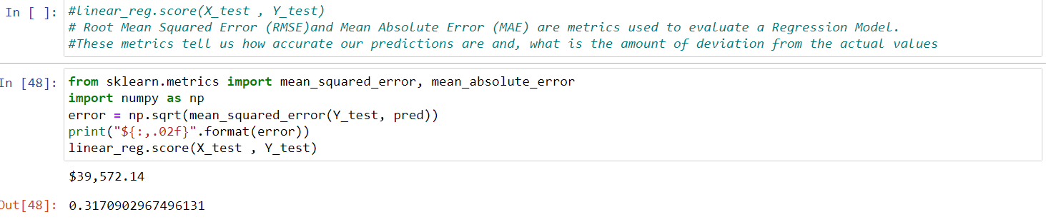

Decision tree.

Random forest.

Grid search

