**C# Additional Topics**

**Async Await usage – 1**

Create a Console application that will print messages to the User The application should contain

· Two methods that return Asynchronous task

· The first method invokes the second method and awaits till the second method returns simple string. The string data returned by the second method should be stored in a string in the first method to display it

· Use Thread.Sleep in the second method to simulate the time delay

**Program**

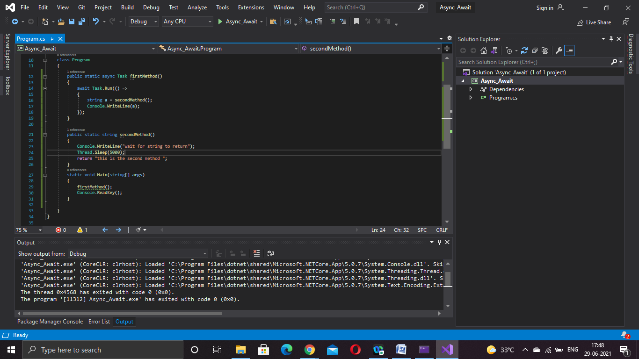

**Program.cs**

using System;

using System.Collections.Generic;

using System.Linq;

using System.Text;

using System.Threading;

using System.Threading.Tasks;

namespace Async_Await

{

class Program

{

public static async Task firstMethod()

{

await Task.Run(() =>

{

string a = secondMethod();

Console.WriteLine(a);

});

}

public static string secondMethod()

{

Console.WriteLine("wait for string to return");

Thread.Sleep(5000);

return "this is the second method ";

}

static void Main(string[] args)

{

firstMethod();

Console.ReadKey();

}

}

}

**Output:**

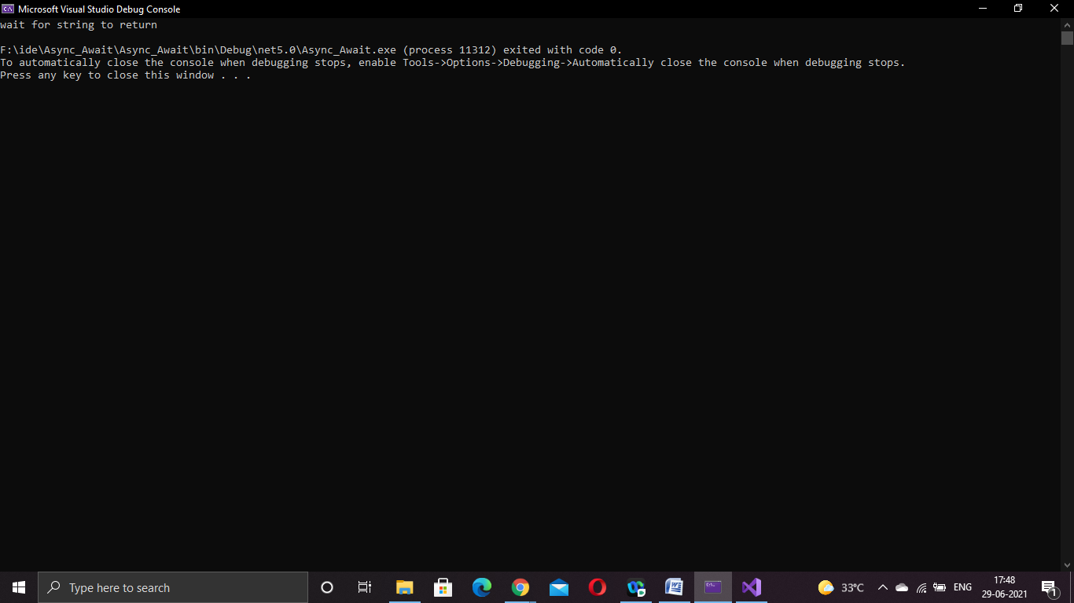

**Async Await usage – 2**

**Program:**

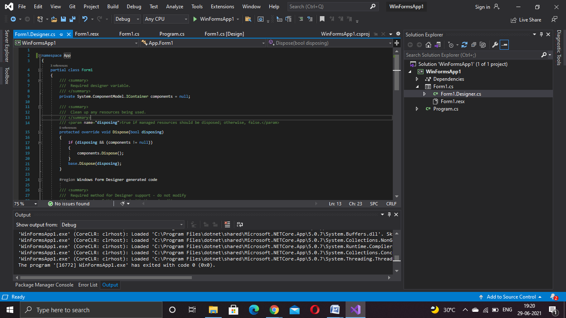

**Form1.cs:**

using System;

using System.Collections.Generic;

using System.ComponentModel;

using System.Data;

using System.Drawing;

using System.IO;

using System.Linq;

using System.Text;

using System.Threading;

using System.Threading.Tasks;

using System.Windows.Forms;

namespace App

{

public partial class Form1 : Form

{

public Form1()

{

InitializeComponent();

}

public int CountChars()

{

int count = 0;

using (StreamReader streamReader = new StreamReader("F:\\ide\\navin.txt"))

{

string content = streamReader.ReadToEnd();

count = content.Length;

Thread.Sleep(2000);

}

return count;

}

private void label1_Click(object sender, EventArgs e)

{

}

private void Form1_Load(object sender, EventArgs e)

{

}

private async void button1_Click_1(object sender, EventArgs e)

{

Task<int> task = new Task<int>(CountChars);

task.Start();

label1.Text = "File is processing";

int count = await task;

label1.Text = count.ToString() + " characters";

}

}

}

**Form1.desinger.cs**

namespace App

{

partial class Form1

{

/// <summary>

/// Required designer variable.

/// </summary>

private System.ComponentModel.IContainer components = null;

/// <summary>

/// Clean up any resources being used.

/// </summary>

/// <param name="disposing">true if managed resources should be disposed; otherwise, false.</param>

protected override void Dispose(bool disposing)

{

if (disposing && (components != null))

{

components.Dispose();

}

base.Dispose(disposing);

}

#region Windows Form Designer generated code

/// <summary>

/// Required method for Designer support - do not modify

/// the contents of this method with the code editor.

/// </summary>

private void InitializeComponent()

{

this.label1 = new System.Windows.Forms.Label();

this.button1 = new System.Windows.Forms.Button();

this.SuspendLayout();

//

// label1

//

this.label1.AutoSize = true;

this.label1.Location = new System.Drawing.Point(300, 150);

this.label1.Name = "label1";

this.label1.Size = new System.Drawing.Size(0, 20);

this.label1.TabIndex = 1;

//

// button1

//

this.button1.Location = new System.Drawing.Point(643, 381);

this.button1.Name = "button1";

this.button1.Size = new System.Drawing.Size(94, 29);

this.button1.TabIndex = 2;

this.button1.Text = "button1";

this.button1.UseVisualStyleBackColor = true;

this.button1.Click += new System.EventHandler(this.button1_Click_1);

//

// Form1

//

this.AutoScaleDimensions = new System.Drawing.SizeF(8F, 20F);

this.AutoScaleMode = System.Windows.Forms.AutoScaleMode.Font;

this.ClientSize = new System.Drawing.Size(800, 450);

this.Controls.Add(this.button1);

this.Controls.Add(this.label1);

this.Name = "Form1";

this.SizeGripStyle = System.Windows.Forms.SizeGripStyle.Show;

this.Text = "Form1";

this.Load += new System.EventHandler(this.Form1_Load);

this.ResumeLayout(false);

this.PerformLayout();

}

#endregion

private System.Windows.Forms.Label label1;

private System.Windows.Forms.Button button1;

}

}

**Program.cs:**

using System;

using System.Collections.Generic;

using System.Linq;

using System.Threading.Tasks;

using System.Windows.Forms;

namespace App

{

static class Program

{

/// <summary>

/// The main entry point for the application.

/// </summary>

[STAThread]

static void Main()

{

Application.EnableVisualStyles();

Application.SetCompatibleTextRenderingDefault(false);

Application.Run(new Form1());

}

}

}

**Output:**

**Navin.txt**

Use Windows forms application with Async Await usage. Create a Windows Forms application to read the number of characters in a text file(preferably a large file) and print that on a label. Use Async await concept to read the file content as the read operation shouldn't make the Windows form non-responding.

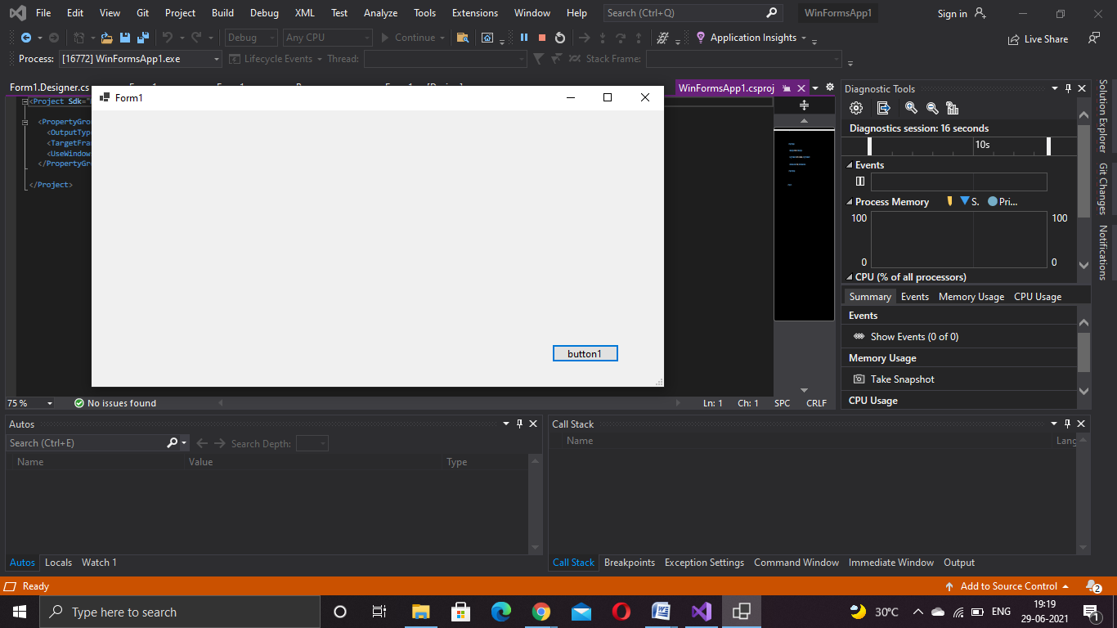

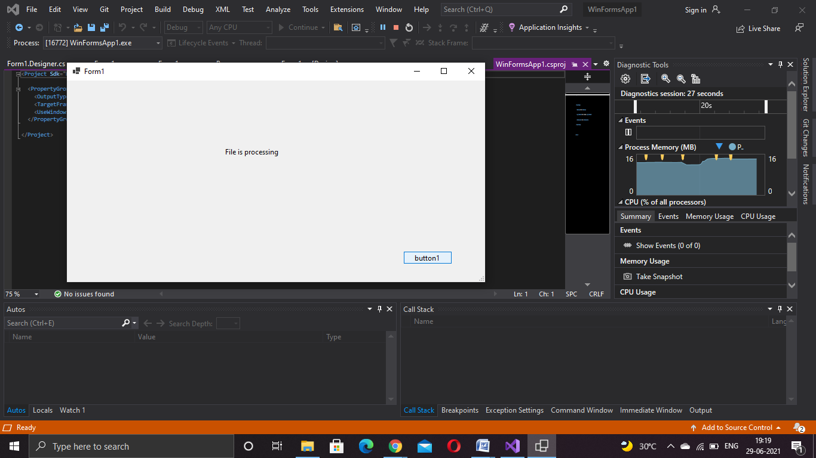

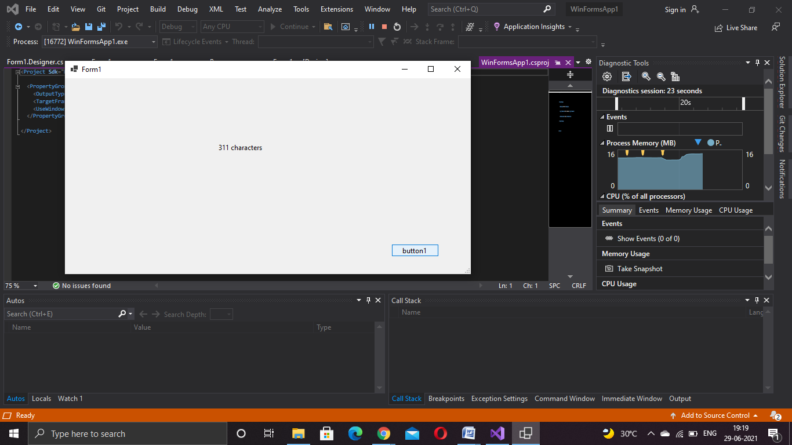

**Named parameters – Order of arguments as per the function and modify**

**Program:**

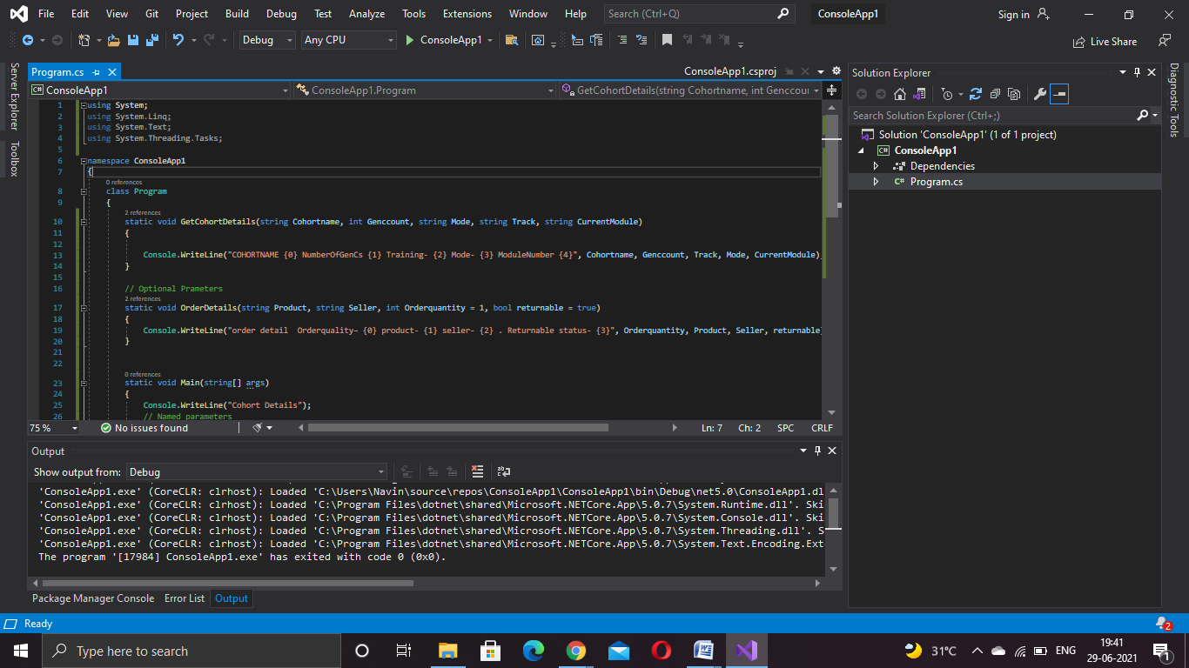

**Program.cs**

using System;

using System.Linq;

using System.Text;

using System.Threading.Tasks;

namespace ConsoleApp1

{

class Program

{

static void GetCohortDetails(string Cohortname, int Genccount, string Mode, string Track, string CurrentModule)

{

Console.WriteLine("COHORTNAME {0} NumberOfGenCs {1} Training- {2} Mode- {3} ModuleNumber {4}", Cohortname, Genccount, Track, Mode, CurrentModule);

}

// Optional Prameters

static void OrderDetails(string Product, string Seller, int Orderquantity = 1, bool returnable = true)

{

Console.WriteLine("order detail Orderquality– {0} product- {1} seller- {2} . Returnable status- {3}", Orderquantity, Product, Seller, returnable);

}

static void Main(string[] args)

{

Console.WriteLine("Cohort Details");

// Named parameters

GetCohortDetails(Cohortname: "CDE", Genccount: 18, Track: "Java", Mode: "OBL", CurrentModule: "Stage 3");

GetCohortDetails(Cohortname: "CDE", Genccount: 18, Mode: "PARC", Track: ".Net", CurrentModule: "Stage 3");

Console.WriteLine("");

Console.WriteLine("");

// Optional parameters

Console.WriteLine("Order Details");

OrderDetails(Seller: "abc", Product: "def", Orderquantity: 10, returnable: false);

OrderDetails(Seller: "abc", Product: "def");

Console.WriteLine("");

Console.WriteLine("");

Console.ReadLine();

}

}

}

**Output:**

