**Stage 3 – Angular**

**Day 1 –Session 1**

**Explain the characteristics of a Single Page Application (SPA)**

The main advantage of single-page applications is its speed. Most resources SPA needs (HTML + CSS + Scripts) are loaded at the launch of the app and don’t need to be reloaded during the usage. The only thing that changes is the data that is transmitted to and from the server. As a result, the application is very responsive to the user’s queries and doesn’t have to wait for client-server communication all the time.

Single-page applications are excellent when you have a team of developers working together. It allows backend developers to focus on the API, while the frontend developers can pay more attention to creating the best user experience based on the backend API and implementing a beautiful user interface.

**Debugging a single-page application** is also easy using the Chrome browser since it has special tools for Angular Batarang and React (the technologies used for SPAs.) Using a console, you can monitor network operations as well as investigate various page elements and associated data.

**Caching process** is also quite efficient – the application sends only one request, stores all data transmitted, and can use this data. This is especially important at times when the user can have poor connectivity – s/he can still use your app since it’s synchronized with the server when the connection improves.

**Single Page Application Lifecycle**

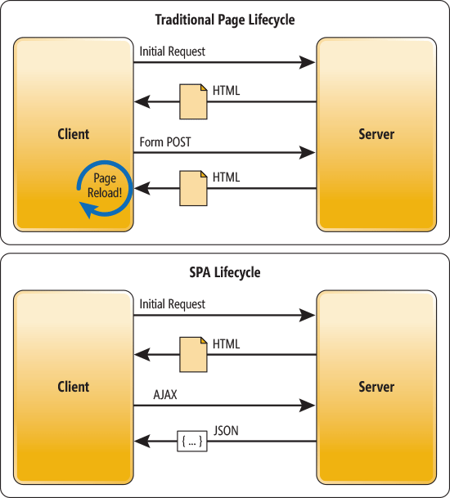

**Demonstrate usage of JavaScript Object Notation (JSON)**

**JavaScript Object - Define JavaScript object for employee**

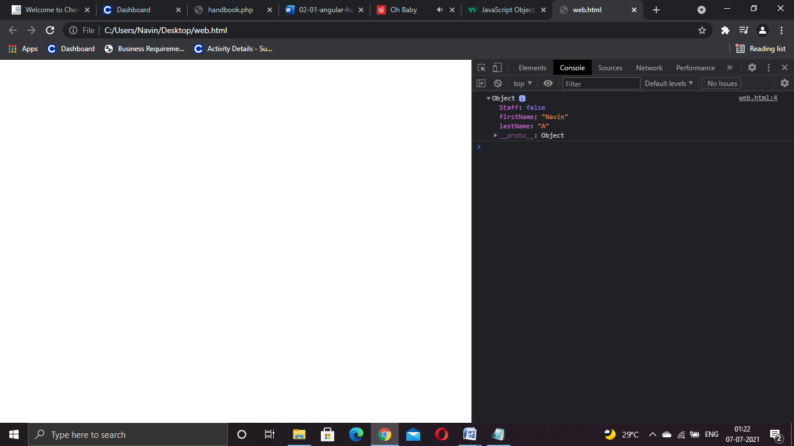

<script>

var employee = {firstName:"Navin",lastName:"A", Staff:false};

console.log(emp);

</script>

**Define JSON for employee details and parse**

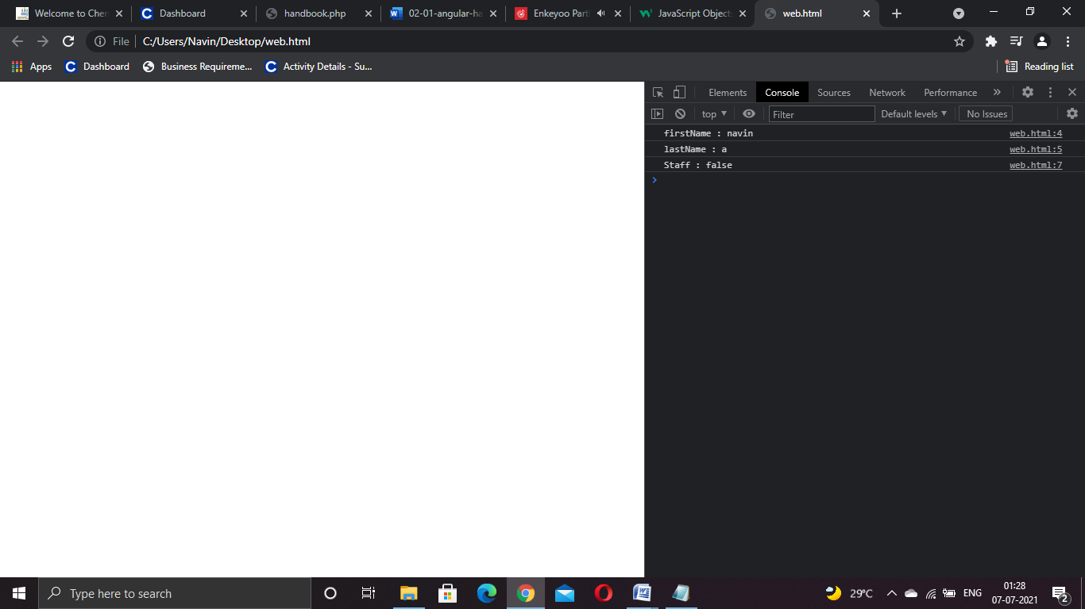

<script>

var employee = JSON.parse('{"firstName":"navin", "lastName":"a","Staff":"false"}');

console.log("firstName : "+employee.firstName);

console.log("lastName : "+employee.lastName);

console.log("Staff : "+employee.Staff);

</script>

**Add department details to employee**



<script>

const data = '{"firstName":"navin", "lastName":"a","permanentStaff":"false"}';

var employee = JSON.parse(data);

console.log("firstName : "+employee.firstName);

console.log("lastName : "+employee.lastName);

console.log("permanentStaff : "+employee.Staff);

</script>

**Explain the need and benefits of Angular**

AngularJS code is written in Javascript. Angular code is written in typescript.AngularJS code is not mobile friendly. Angular developed applications are mobile browser friendly.AngularJS project is difficult to manage with increasing size of the source code. Angular code is better structured, is easy to create and manage bigger applications.