**Day 1 – Session 2**

**TypeScript data types and interface – Define Employee interface and display**

**Employee.ts**

export interface Employee {

id:number;

name:string;

salary:number;

permanent:boolean;

}

**Employee-test.ts**

import { Employee } from './Employee';

var emp:Employee = {

id:EM003,

name:"John",

salary:5000,

permanent:true,

}

console.log("id : "+emp.id);

console.log("name : "+emp.name);

console.log("salary : "+emp.salary);

console.log("permanent : "+emp.permanent);

**Ouput**

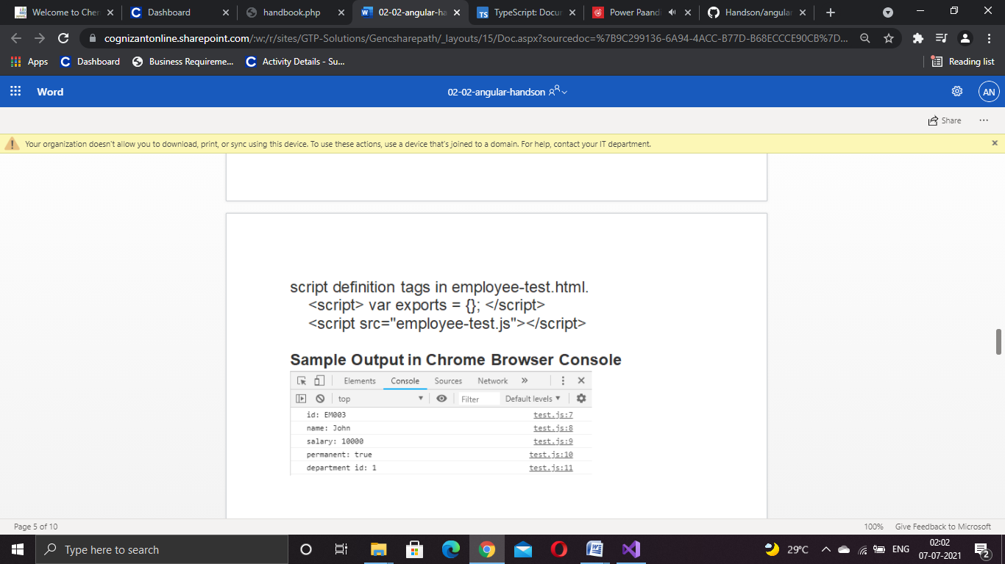

**TypeScript data types and interface – Include Department details in Employee and display**

**Department.ts**

export interface Department {

id: number;

name: string;

}

**Employee.ts**

import { Department } from './Department';

export class Employee implements Department {

id: number;

name: string;

salary: number;

permanent: boolean;

constructor(id: number, name: string, salary: number, permanent: boolean) {

this.id = id;

this.name = name;

this.salary = salary;

this.permanent = permanent;

}

}

**Employee - test.ts**

import { Department } from './Department';

import { Employee } from './Employee';

var emp1 = new Employee(EM003, "John", 5000, true);

console.log("id: " + emp1.id);

console.log("name: " + emp1.name);

console.log("salary: " + emp1.salary);

console.log("permanent: " + emp1.permanent);

var dept: Department = {

id: 1,

name: "Payroll",

}

console.log("Department id : " + dept.id);

console.log("Department name : " + dept.name);

**Output**



**TypeScript data types and interface – Define Employee interface and display**

**Department.ts**

export interface Department {

id: number;

name: string;

}

**Skill.ts**

export interface Skill {

id: number;

name: string;

}

**Employee.ts**

import { Employee } from './Employee';

import { Skill } from './Skill';

import { Department } from './Department';

var emp1 = new Employee(EM003, "John", 10000, true);

console.log("id: " + emp1.id);

console.log("name: " + emp1.name);

console.log("salary: " + emp1.salary);

console.log("permanent: " + emp1.permanent);

var dept: Department = {

id: 1,

name: "Payroll",

}

console.log("Department id : " + dept.id);

console.log("Department name : " + dept.name);

var skill1: Skill = {

id: 1,

name: "HTML",

}

var skill2: Skill = {

id: 2,

name: "CSS",

}

var skill3: Skill = {

id: 3,

name: "JavaScript",

}

console.log("Skill[0]:" + skill1.id + ", " + skill1.name);

console.log("Skill[1]:" + skill2.id + ", " + skill2.name);

console.log("Skill[2]:" + skill3.id + ", " + skill3.name);

**Employee - test.ts**

import { Employee } from './Employee';

var emp1 = new Employee(1, "HTML");

var emp2 = new Employee(2, "CSS");

var emp3 = new Employee(3, "Javascript");

console.log("Skill 1: " + emp1.id + ", " + emp1.name);

console.log("Skill 2: " + emp2.id + ", " + emp2.name);

console.log("Skill 3: " + emp3.id + ", " + emp3.name);

**Output**

