**TEMPERATURE BASED FAN CONTROL SYSTEM**

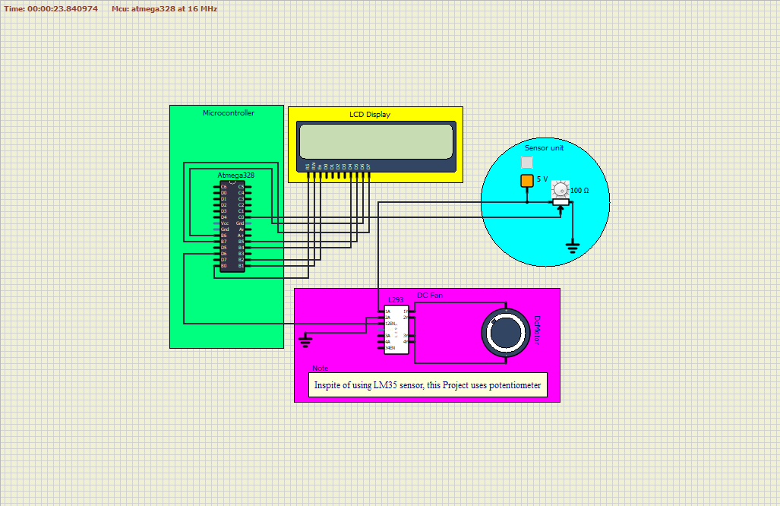

**TABLE OF CONTENTS**

|  |  |  |
| --- | --- | --- |
| **CHAPTER NO** | **CHAPTER TITLE** | **PAGE NO** |
| 1 | OVERVIEW | 1 |
|  | 1.1 ABSTRACT | 1 |
|  | 1.2 IDENTIFYING FEATURES | 1 |
|  | 1.3 STATE OF ART | 1 |
|  | 1.4 5W’S&1H | 2 |
|  | 1.5 SWOT ANALYSIS | 2 |
| 2 | REQUIREMENTS | 3 |
|  | 2.1 HIGH LEVEL REQUIREMENTS | 3 |
|  | 2.2 LOW LEVEL REQUIREMENTS | 3 |
| 3 | BLOCK DIAGRAM WITH EXPLANATION | 4 |
|  | 3.1 BLOCK DIAGRAM | 4 |
|  | 3.2 SENSORS | 4 |
|  | 3.2.1 TEMPERATURE SENSOR(LM35) | 4 |
|  | 3.3 ACTUATORS | 5 |
|  | 3.3.1 DC FAN | 5 |
|  | 3.3.2 LCD DISPLAY | 6 |
|  | 3.3.3 L293 MOTOR DRIVER | 6 |
|  | 3.4 MICROCONTOLLER(ATMEGA328) | 7 |
| 4 | ARCHITECTURE | 8 |
|  | 4.1 BEHAVIOURAL DIAGRAM | 8 |
|  | 4.1.1 HIGH LEVEL FLOW CHART DIAGRAM | 8 |
|  | 4.1.2 LOW LEVEL FLOW CHART DIAGRAM | 9 |
|  | 4.2 STRUCTURAL DIAGRAM | 9 |
|  | 4.2.1 HIGH LEVEL USE CASE DIAGRAM | 9 |
|  | 4.2.2 LOW LEVEL USE CASE DIAGRAM | 10 |
| 5 | WORKING | 11 |
| 6 | TEST PLAN AND OUTPUT | 12 |
|  | 6.1 TEST PLAN | 12 |
|  | 6.2 OUTPUT | 12 |
| 7 | APPLICATIONS | 15 |
| 8 | CONCLUSION | 16 |
| 9 | REFERENCES | 17 |

**LIST OF FIGURES**

|  |  |  |
| --- | --- | --- |
| **FIGURE NO** | **FIGURE NAME** | **PAGE NO** |
| 1 | 5W’S&1H | 2 |
| 2 | SWOT ANALYSIS | 2 |
| 3 | BLOCK DIAGRAM | 4 |
| 4 | TEMPERATURE SENSOR(LM35) | 5 |
| 5 | DC FAN | 5 |
| 6 | LCD DISPLAY | 6 |
| 7 | ATMEGA328 | 6 |
| 8 | L293 DRIVER | 7 |
| 9 | HIGH LEVEL FLOW CHART DIAGRAM | 8 |
| 10 | HIGH LEVEL FLOW CHART DIAGRAM | 9 |
| 11 | HIGH LEVEL USE CASE DIAGRAM | 9 |
| 12 | LOW LEVEL USE CASE DIAGRAM | 10 |
| 13 | VS CODE CAPTURE | 12 |
| 14 | CAPTURE 1 | 13 |
| 15 | CAPTURE 2 | 13 |
| 16 | CAPTURE 3 | 14 |

**1.OVERVIEW**

**1.1 Abstract**

The consumption of electrical energy is highly increasing now -a- days due to our day -to- day requirements. This will create a huge demand on electrical supply. This project describes the design and construction of fan speed control according to the room temperature. The temperature sensor was carefully chosen to gauge the room temperature. Depending upon the detection of temperature the system will work which is controlled by the Atmega328.

**1.2 Identifying features**

* Atmega328 controller shall be used for the control of the system.
* LCD Display shall be provided to display temperature and Fan speed.
* This system provides complete automation of rooms in home.
* Considerable amount of electricity shall be saved.
* Blind people shall get benefited.

**1.3 State of art**

This project can automatically switch ON room fan when at least one person presents in the room. The temperature and fan speed are displayed on 16*2 LCD through the Atemega328. This will save the electricity.

**1.4 5W’s 1H**

Figure No: 1 5w’s and 1h

**1.5 SWOT ANALYSIS**

Figure No: 2 Swot analysis

**2.REQUIREMENTS**

**2.1 High Level Requirements**

|  |  |
| --- | --- |
| **ID** | **High Level Requirements** |
| HLR1 | System shall control fan |
| HLR2 | There shall be an LCD to display some contents |
| HLR3 | Driver shall be used to turn on or off the fan |
| HLR4 | System Shall detect temperature |

**2.2 Low Level Requirements**

|  |  |  |  |
| --- | --- | --- | --- |
| **ID** | **Low Level Requirements for**  **HLR1** | **ID** | **Low Level Requirements for**  **HLR2** |
| LLR1.1 | According to sensor value, fan shall be controlled | LLR2.1 | Temperature, person count shall be displayed |
| LLR1.2 | The sensors shall be control by Atmgega328 | LLR2.2 | Fan and temperature status shall be displayed |
| **ID** | **Low Level Requirements for**  **HLR3** | **ID** | **Low Level Requirements for**  **HLR4** |
| LLR3.1 | Driver shall be controlled by the Atmega328 | LLR4.1 | Temperature sensor detect the room temperature |
| LLR3.2 | Driver on at certain time to operate the fan | LLR4.2 | Temperature and fan speed shall be displayed |

**3. BLOCK DIAGRAM WITH EXPLANATION**

**3.1 Block Diagram**

Figure No: 3 Block Diagram

**3.2 Sensors**

**3.2.1 Temperature Sensor (LM35)**

LM35 is a precision IC temperature sensor with its output proportional to the temperature (in °C). The sensor circuitry is sealed and therefore it is not subjected to oxidation and other processes. With LM35, temperature can be measured more accurately than with a thermistor. It also possesses low self-heating and does not cause more than 0.1°C temperature rise in still air. The operating temperature range is from -55°C to 150°C. The output voltage varies by 10mV in response to every° C rise/fall in ambient temperature (Scale factor is 0.01V/°C).

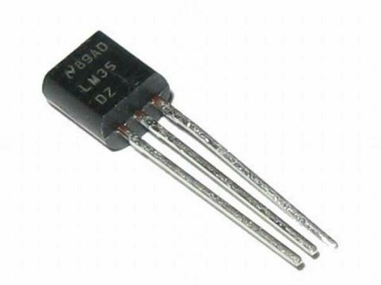

Figure No: 4 LM 35 sensor

**3.3 Actuators**

**3.3.1 Dc Fan**

A DC ceiling fan works pretty much on the same principle as the DC motor. A DC motor uses an internal arrangement of magnets with opposing polarity. As current passes through the coil around this arrangement, a strong magnetic field is produced. This magnetic field then creates a torque that causes the motor to rotate. DC fans use less energy (70% of AC Fans), quiet and more speed options. In this project 12V DC Fan is used.

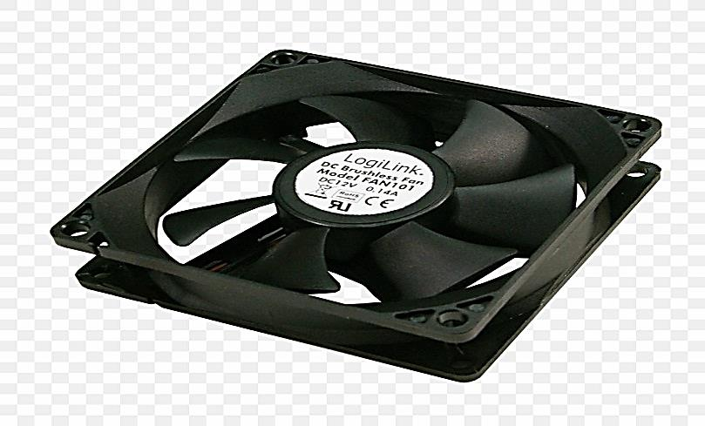

Figure No: 5 Dc Fan

**3.3.2 Lcd Display**

LCD (Liquid Crystal Display) screen is an electronic display module and find a wide range of applications. A 16*2 LCD display is very basic module and is very commonly used in various devices and circuits. The data is the ASCII value of the character to be displayed on the LCD.

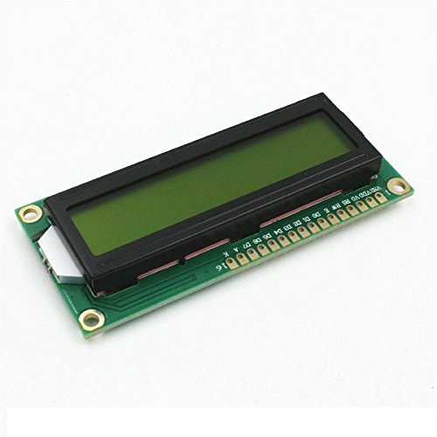

Figure No: 6 Lcd Display

**3.3.3 L293 motor driver**

L293D is a typical Motor driver or Motor Driver IC which allows DC motor to drive on either direction. L293D is a 16-pin IC which can control a set of two DC motors simultaneously in any direction. It means that you can control two DC motor with a single L293D IC. Dual H-bridge Motor Driver integrated circuit (IC).

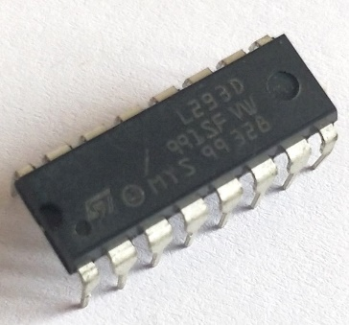

Figure No: 7 L293 driver

**3.4 Microcontroller (Atmega328)**

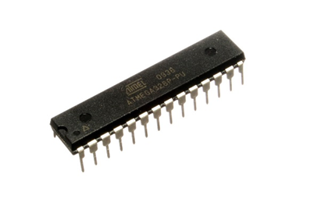**ATmega328**is an 8-bit, 28-Pin AVR Microcontroller, manufactured by Microchip, follows RISC Architecture, and has a flash-type program memory of 32KB. It has an EEPROM memory of 1KB and its SRAM memory is 2KB. It has 8 Pins for ADC operations, which all combine to form Port A (PA0 – PA7). It also has 3 built-in Timers, two of them are 8 Bit timers while the third one is 16-Bit Timer. It operates ranging from 3.3V to 5.5V but normally we use 5V as a standard. Its excellent features include cost-efficiency, low power dissipation, programming lock for security purposes, real timer counter with separate oscillator.

Figure No: 8 Atmega328

**4. ARCHITECTURE**

**4.1 Behavioral Diagram**

**4.1.1 High Level Flow Chart Diagram**

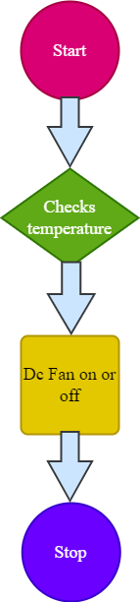

Figure No: 9 High Level Flow Chart Diagram

**4.1.2 Low Level Flow Chart Diagram**

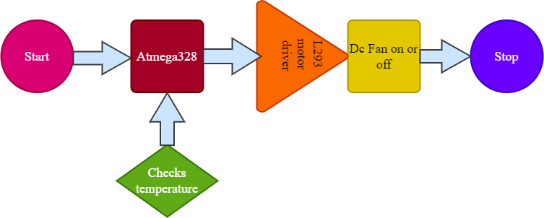

Figure No: 10 Low Level Flow Chart Diagram

**4.2 Structural Diagram**

**4.2.1 High Level Use Case Diagram**



Figure No: 11 High level Use Case Diagram

**4.2.1 Low Level Use Case Diagram**



Figure No: 12 Low Level Use Case Diagram

**5. WORKING**

In this project Power source connected to Atmega328 which requires 5V. The Atmega328 is connected with LCD screen and LM35 sensor. The outputs of the sensor are the analog inputs of the Atmga328. The output of the Atmega328 connected to the motor driver. The temperature and fan speed are displayed in the LCD screen that gets information from the Atmega328. LM35 sensor used to detect the temperature of the room. After supplying the voltage to the Atmega328 the system starts to work.

LM35 sensor detects the temperature and for different temperatures the DC fan run in different speeds that is controlled by driver which gets signals from Atmega328 loaded with the program. The Atmega328 controls motor driver to make the DC fan runs in alternate speeds.

**6. TEST PLAN AND OUTPUT**

**6.1 Test Plan**

|  |  |  |  |  |  |
| --- | --- | --- | --- | --- | --- |
| TEST ID | DESCRIPTION | I/P | EXP O/P | ACT O/P | PASSED OR NOT |
| Tp1 | Potentiometer | 10Ω | 10°C 10% | 10°C 10% | ✔️ |
| Tp2 | Potentiometer | 20Ω | 20°C 20% | 20°C 20% | ✔️ |
| Tp3 | Potentiometer | 30Ω | 30°C 30% | 30°C 30% | ✔️ |
| Tp4 | Potentiometer | 40Ω | 40°C 40% | 40°C 40% | ✔️ |
| Tp5 | Potentiometer | 50Ω | 50°C 50% | 50°C 50% | ✔️ |
| Tp6 | Potentiometer | 60Ω | 60°C 60% | 60°C 60% | ✔️ |
| Tp7 | Potentiometer | 70Ω | 70°C 70% | 70°C 70% | ✔️ |
| Tp8 | Potentiometer | 80Ω | 80°C 80% | 80°C 80% | ✔️ |
| Tp9 | Potentiometer | 90Ω | 90°C 90% | 90°C 90% | ✔️ |
| Tp10 | Potentiometer | 99Ω | 99°C 99% | 99°C 99% | ✔️ |

**6.2 Output**



Figure No: 13 Vs code capture

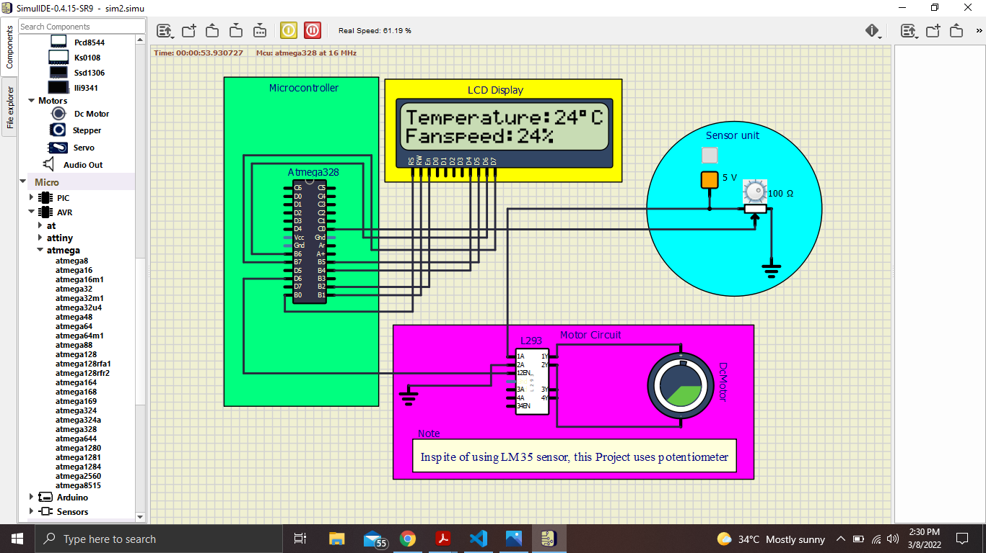

Figure No: 14 Capture 1

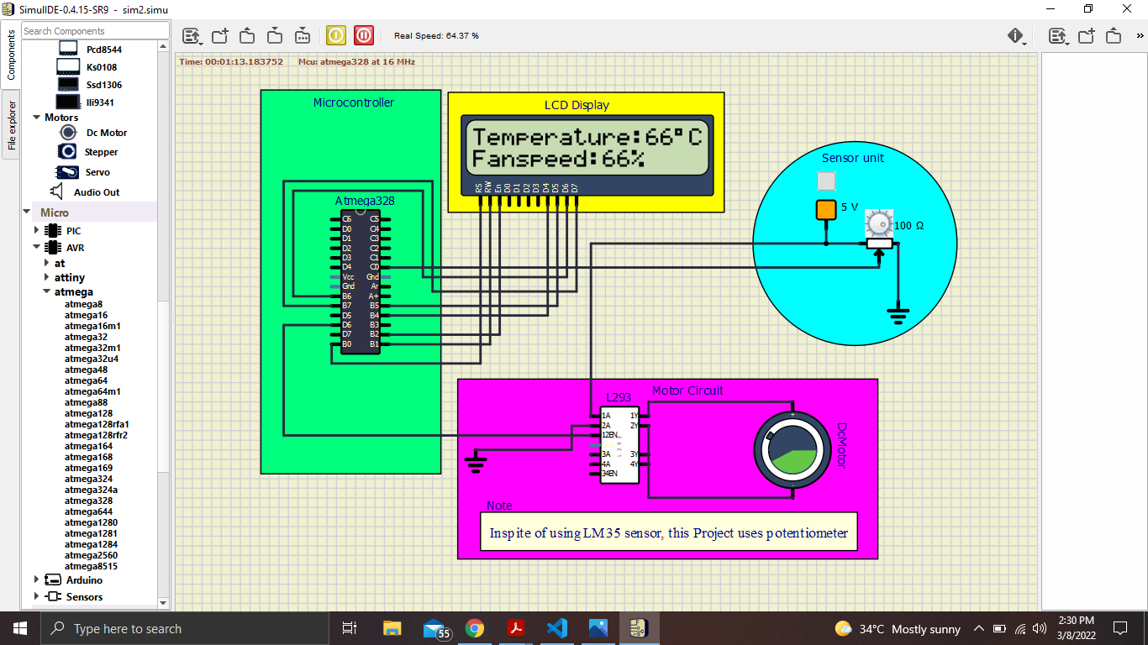

Figure No: 15 Capture 2

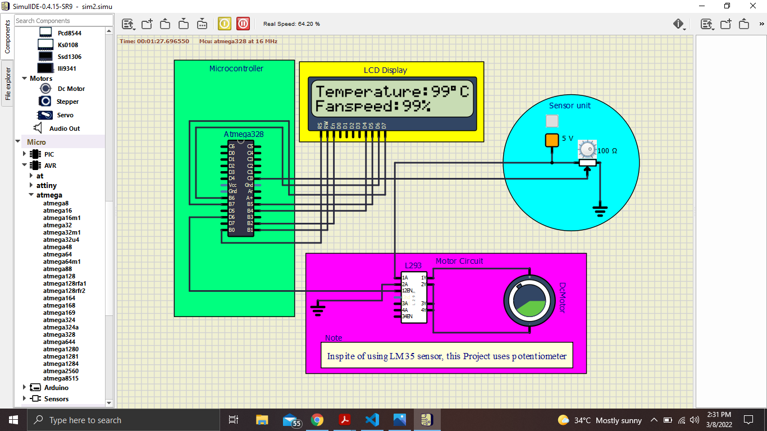

Figure No: 16 Capture 3

**7. APPLICATIONS**

* This system controls the light and fan automatically, so it reduces manpower.
* It is very economical and easy to handle by the user.
* It is very helpful to disabled people.
* Save energy by slowing down its speed in low temperature.
* The fan designed in this project can also be used in small scale industries for cooling the electrical/mechanical equipment.
* The circuit can be used for car engine to reduce the heat

**8.CONCLUSION**

In this project, the Atmega328 can successfully controlling the DC fan. Atmega328 was programmed using C language to compare temperature with standard temperature, set fan speed with their values displayed on the LCD. Moreover, the fan speed will be increased or decreased automatically based on the room temperature As Conclusion, the system which designed in this work will perform very well, for any temperature and classified as automatic control. The total effective cost of proposed system is very low as compared to existing system for home and industries, so this project can be brought into a commercial product beneficial to the society.

**9. REFERENCES**

* K. Singh, M. Dhar. P. Roy, Automatic fan speed control using Arduino, ISSN: 2456-4184 International Novel Research and Development (IJNRD) April 2021
* Circuit digest, https://circuitdigest.com/…/16*2-lcd-display-module
* Electronic circuits, https://www.build-electronic-circuits.com/how-transistor
* Encyclopedia of electronics components by C. Platt
* https://www.ijariit.com
* https://www.globalscientificjournal.com
* https://www.researchgate.net
* S. Verma, A. Das, S. Dey, P. Chowdhury, Automatic Temperature Controlled Fan Using Thermistor, ISSN: 2321-1156 Innovative Journal of Innovative Research in Technology & Science (IJIRTS) July 2020