Amazon Indian Sales Analysis

1. Project Overview
E-commerce managers often struggle to connect high-level financial performance with product-level demand and order logistics. This project addresses that gap by consolidating revenue, geographic sales, product categories, and fulfillment performance into an interactive, 3-page executive Power BI dashboard.
The resulting solution enables business directors, sales managers, and fulfillment leads to track overall profitability, evaluate category performance, analyze regional demand across India, and optimize order delivery workflows from a single unified view.

2. Dataset Summary
- Rows: 50,000
- Columns: 15
- Key Features:
- Order Details: order_id, order_date, units_sold
- Product & Category: category, brand, price_category
- Financial Metrics: total_revenue, net_revenue, aov, return_rate
- Fulfillment & Payment: delivery_status, payment_method
- Geographic Data: State / Region breakdown (India)
3. Exploratory Data Analysis using Python
We began with data preparation and cleaning in Python:
• Data Loading: Imported the 50,000 Amazon Indian sales and product records into a Data Frame using pandas
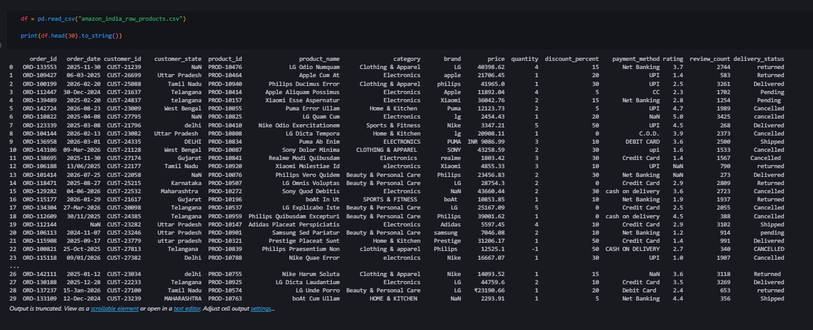

• Initial Exploration: Used df.head() to get a basic overview about the Columns and its Rows
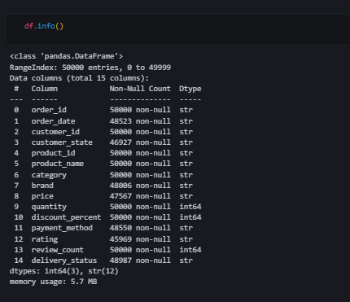

• Checking for Null & Duplicate Value: Used df.apply(lambda col : col.duplicated().sum()) to check the total number of duplicate row in the Data set
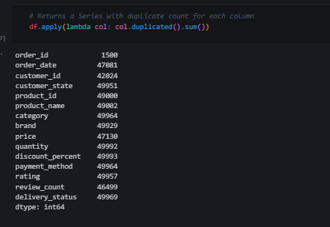

• Data Cleaning: Handled missing values, Purged duplicates (drop_duplicates())
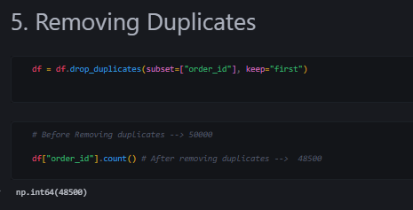
• Standardization:
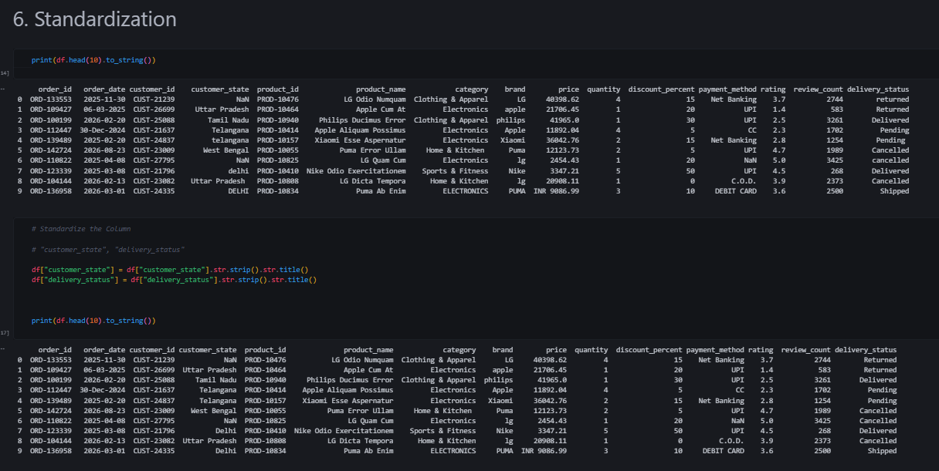

• Handling NaN:

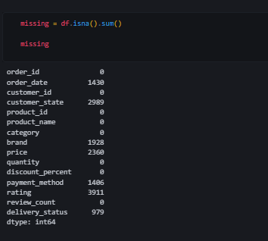
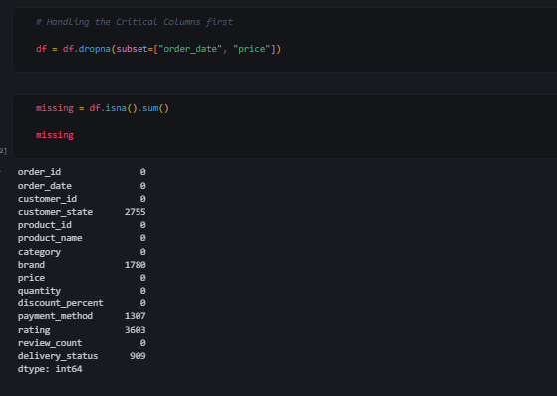
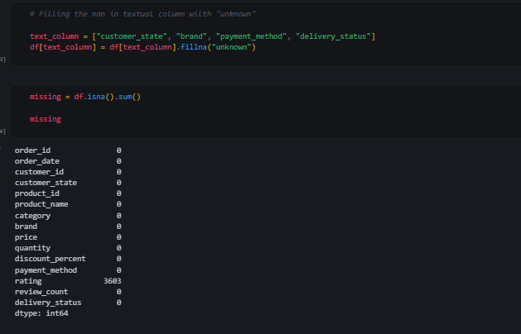
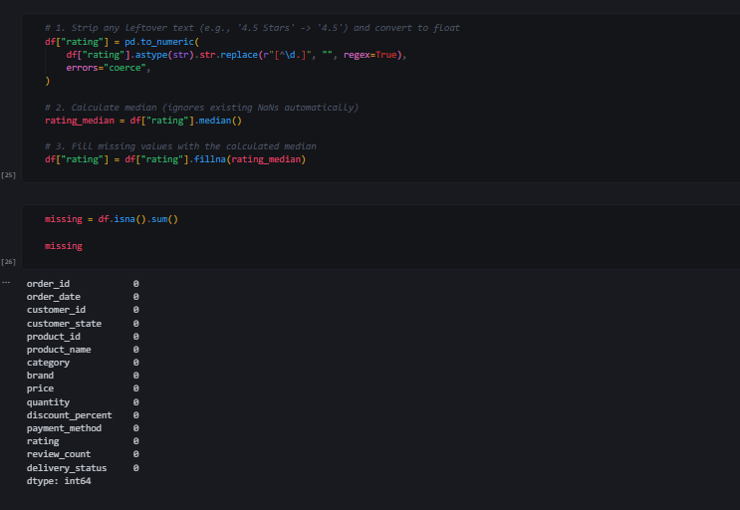
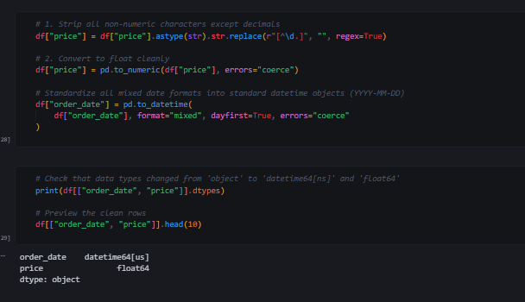
• Changing the Data Types:
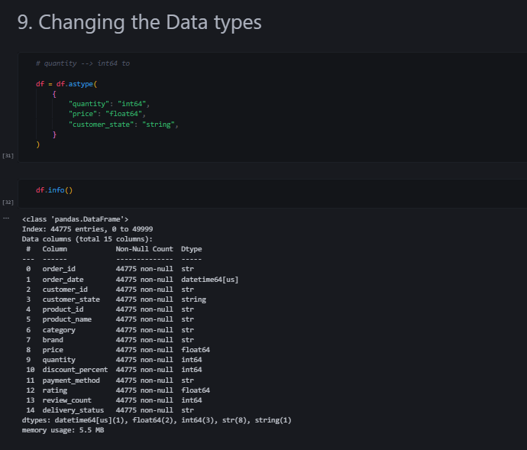

• Feature Engineering :
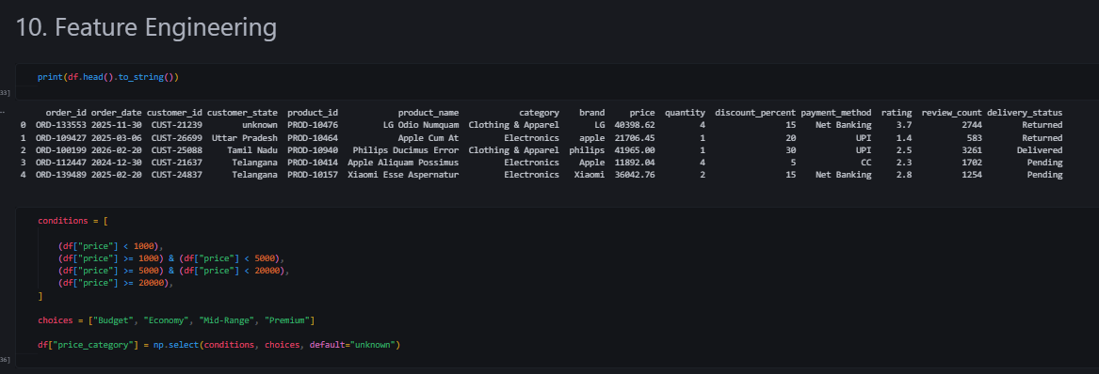

4. Power BI Data Model
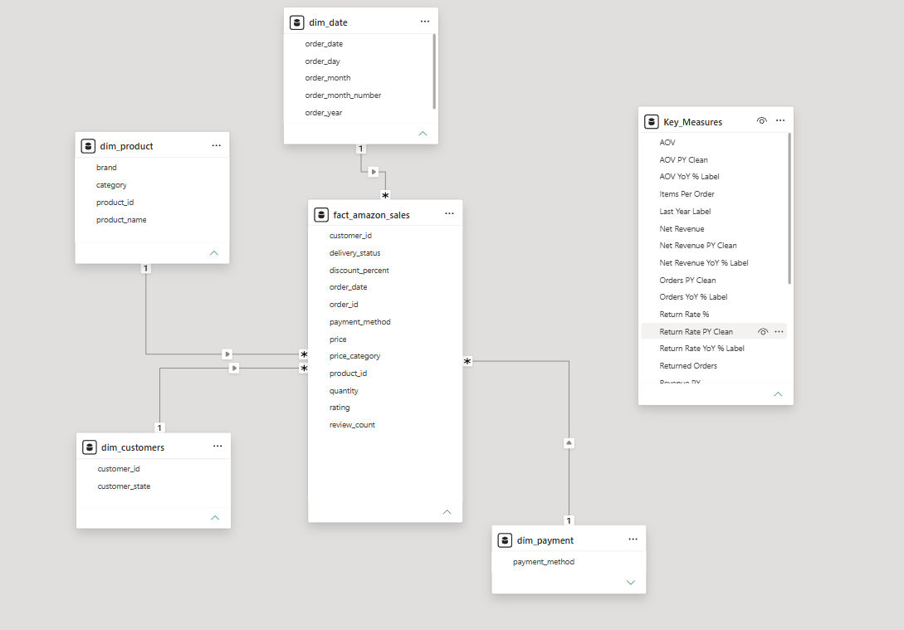

6. Dashboard
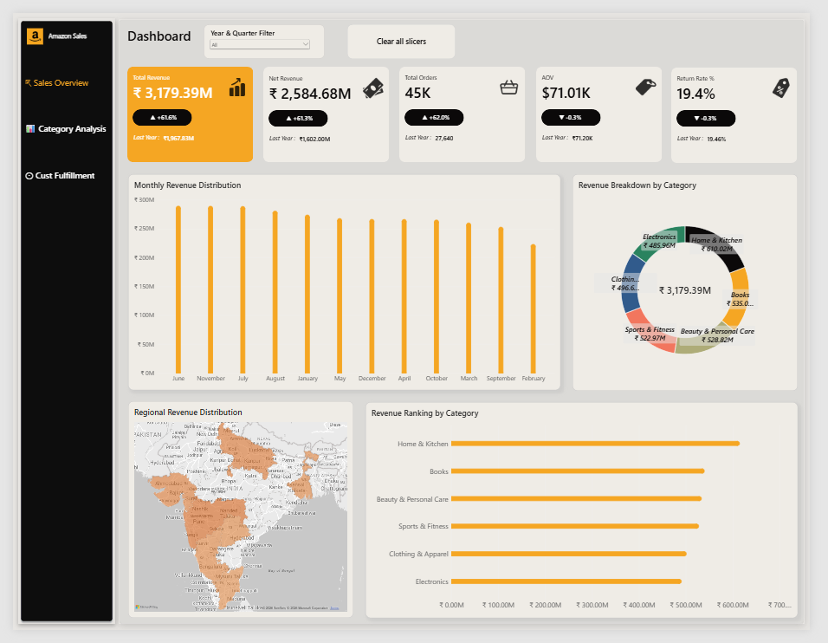
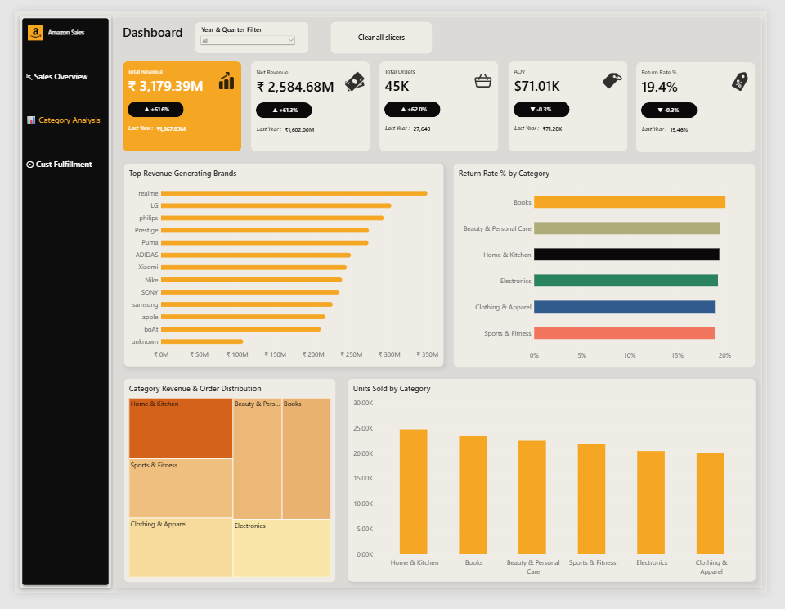
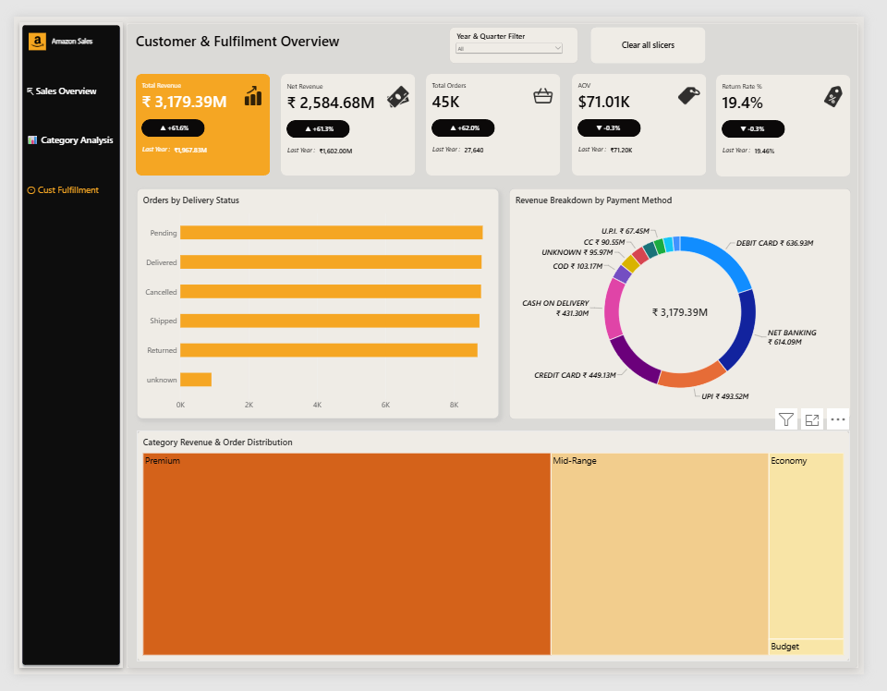

7. Strategic Recommendation
Based on the multi-dimensional analysis of the 50,000 sales records, the following data-driven strategies are recommended for executive leadership, sales, and supply chain teams:
- Supply Chain & Fulfillment Optimization • Mitigate High-Risk Return Zones: Implement targeted quality control checks and standardized size guides for categories with elevated return rates (such as apparel) to reduce reverse logistics costs. • Streamline Regional Warehousing: Capitalize on the high concentration of orders from metropolitan states by optimizing inventory placement in local fulfillment hubs, reducing delivery times for top-selling SKUs.
- Payment & Cash Flow Management • Incentivize Digital Payments: Since digital channels (UPI and Net Banking) show healthier completion rates compared to Cash on Delivery (COD), introduce micro-incentives (e.g., instant wallet cashbacks) for prepaid orders to drive down cancellation rates. • Reduce COD Risk: Apply stricter order-verification protocols for high-value Cash on Delivery transactions in emerging tier-2 and tier-3 regions to minimize last-mile return overhead.
- Commercial & Pricing Strategy • Capitalize on High-AOV Categories: Allocate higher marketing and inventory budgets toward top-performing categories (like Electronics) which yield superior Average Order Values and strong revenue contributions. • Refine Discount Thresholds: Restructure promotional campaigns so that high discounts (>20%) are paired with cross-selling bundles to protect profit margins while driving volume.

