Spectrogram-Image Fault Classification: Methods and Results
Supervised deep learning on folder-organized spectrogram PNGs (MIMII-style corpus); anchor experiment with group-aware validation and ImageNet-transfer CNN.

Methods
Task definition and data source. Industrial machine-health monitoring was framed as a supervised image-classification problem on two-dimensional time–frequency representations stored as PNG files. Images and discrete labels were ingested through a single folder-based dataset class shared with other experiments in this repository; label cardinality was inferred as one plus the maximum integer label observed on the training index set so that binary (normal versus abnormal) and multiclass extensions are handled uniformly. For the primary analysis documented here, all available signal-to-noise ratio (SNR) folders under the spectrogram root were pooled, and the model was trained to discriminate two classes on the resulting union of files. The on-disk spectrogram root used for the anchor run was H:/dataset/MIMII_Dataset/spectrograms. After the train–validation partition described below, 86,304 spectrograms were used for parameter updates and 19,510 were held out for model selection and reporting (Fig. 1).
Preprocessing and augmentation. Every image was resized to a square of 224 pixels on the side and converted to a three-channel tensor, then normalized with ImageNet channel means and standard deviations so that off-the-shelf ImageNet-pretrained convolutional backbones could be applied without ad hoc rescaling. Validation used only this deterministic preprocessing chain. Training applied a fixed “strong” augmentation preset: small random affine translation and scale, mild color jitter, two frequency-mask bands and two time-mask bands (each mask occupying up to 20% of the respective axis), stochastic time shifting up to 8% of the time axis, and additive Gaussian noise on the tensor (standard deviation 0.01 after normalization). These tensor-space masks follow the SpecAugment spirit used in speech and audio representation learning.
Train–validation split and control of group leakage. Twenty percent of samples were reserved for validation, with per-class stratification on the label. Whenever the dataset exposed a non-trivial grouping variable (for example machine identity or session key derived from the directory layout), the first fold of a stratified group k-fold split was used so that no group appeared in both training and validation; this reduces optimistic bias relative to an independent and identically distributed assumption across files. The anchor run enabled this group-aware mode. The same split logic can be disabled for ablation by turning off the group-stratified option in the training entry point.
Neural network family and anchor architecture. Models were instantiated through a single factory that wraps the timm library. The anchor configuration used a ResNet-50 backbone without global pooling inside timm (global pooling disabled so that spatial feature maps remain available), followed by global average pooling over height and width and a fully connected classifier to two logits. Optionally, the same code path supports a convolutional backbone followed by a CBAM-style spatial attention gate on the last feature map before pooling, and a hybrid in which the feature map is vectorized into a token grid, projected to a transformer width, augmented with learned or two-dimensional sinusoidal positional encodings and an optional class token, and passed through a small stack of pre-norm Transformer encoder layers before the final linear head (Fig. 2–4). Those variants were not used for the anchor run but are retained in the implementation for comparative experiments.
Loss, optimization, and stopping. Training minimized a class-weighted cross-entropy in which each class weight was proportional to the inverse of its frequency on the training indices only, so that minority-class gradients were up-weighted without using validation statistics. Optimization used AdamW with learning rate 1×10⁻⁴, weight decay 0.05, linear learning-rate warmup over three epochs followed by cosine decay, automatic mixed precision on CUDA hardware when available, and global gradient norm clipping at 1.0. The best checkpoint on validation balanced accuracy was retained; training terminated early if balanced accuracy did not improve for fifteen consecutive epochs.
Evaluation metrics and interpretability exports. The held-out validation split was scored with accuracy, macro-averaged precision, recall, and F1, Matthews correlation coefficient, Cohen’s kappa, sensitivity and specificity, positive and negative predictive values, area under the receiver-operating-characteristic curve, area under the precision–recall curve, Brier score, and expected calibration error, in addition to balanced accuracy. Figures for training dynamics, scalar curves, the ROC, and the confusion matrix were written automatically at the end of training. For convolutional models that expose the backbone module, gradient-weighted class activation mapping (Grad-CAM) was applied to a small number of validation examples for qualitative review.

Figure panels (methods)
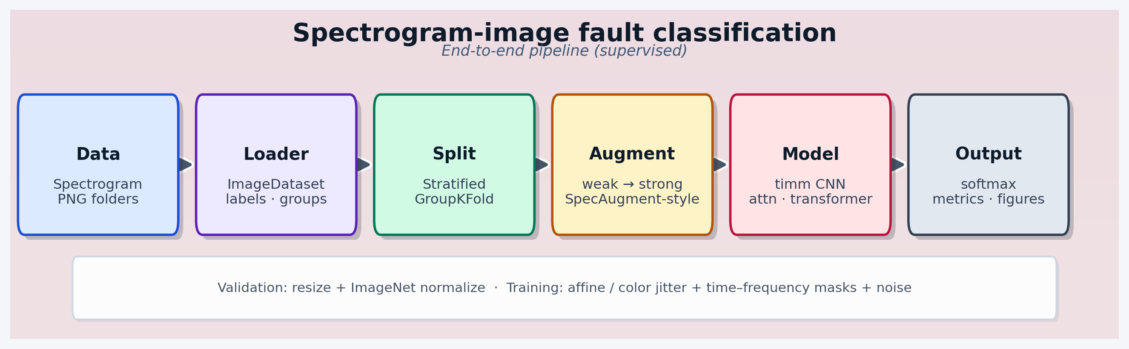
Fig. 1. End-to-end pipeline from spectrogram folders to metrics.
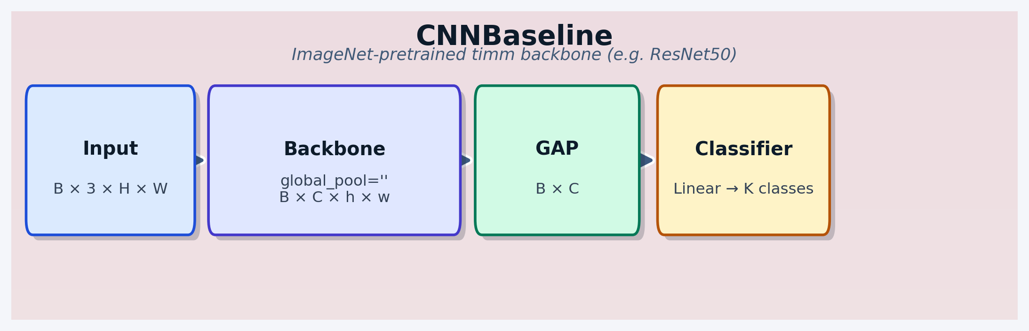
Fig. 2. CNN baseline used for the anchor run (ResNet-50, timm).
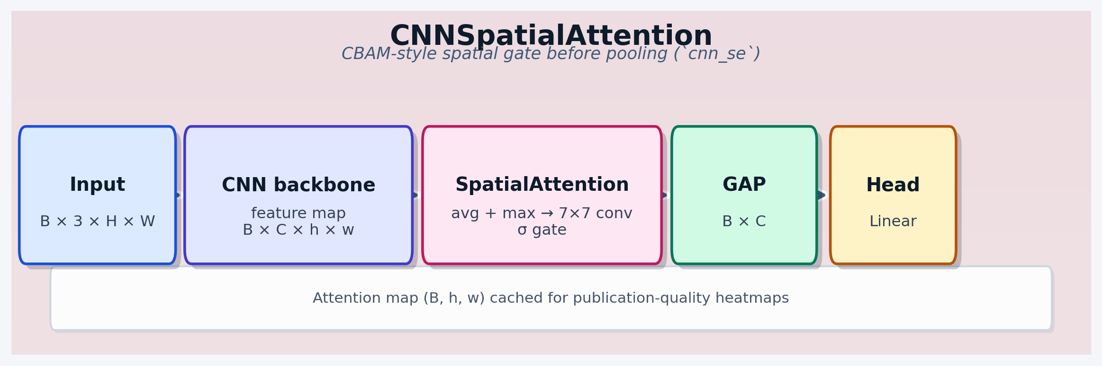
Fig. 3. Optional spatial-attention variant (cnn_se).
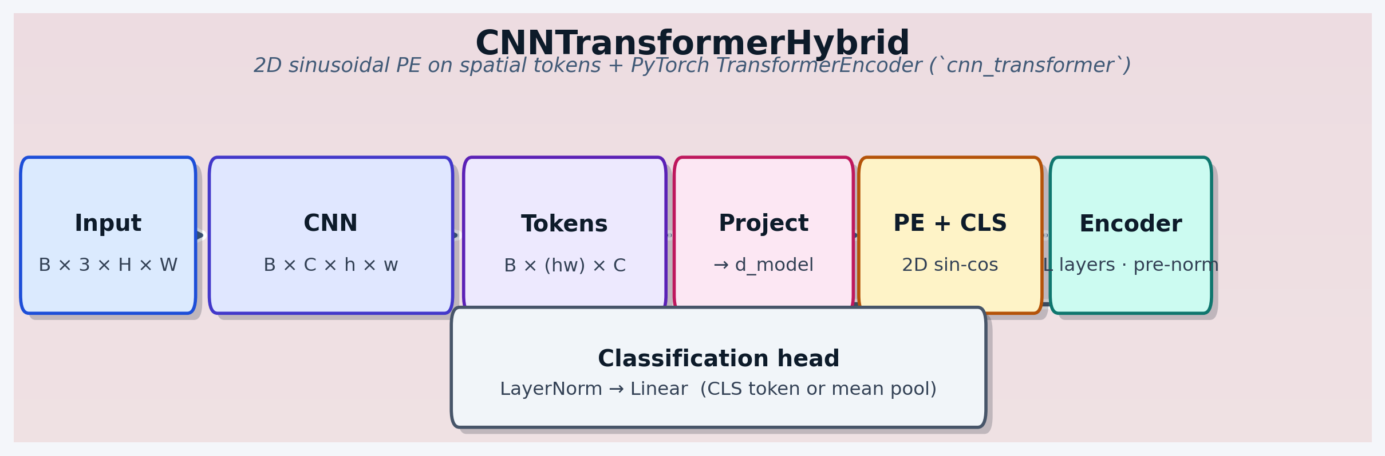
Fig. 4. Optional CNN–Transformer hybrid (cnn_transformer).

Results
Anchor run on the held-out validation partition (n = 19,510 images) achieved a balanced accuracy of 0.9108, overall accuracy of 0.9482, and macro-averaged precision, recall, and F1 of 0.9240, 0.9108, and 0.9172, respectively. Discrimination was strong by ROC analysis (AUC = 0.9758), with sensitivity 0.8488 and specificity 0.9728. Matthews correlation coefficient was 0.8347. Total wall-clock training time for this run was approximately 8.52 hours on the machine used for execution (Fig. 5–8).

Figure panels (results)
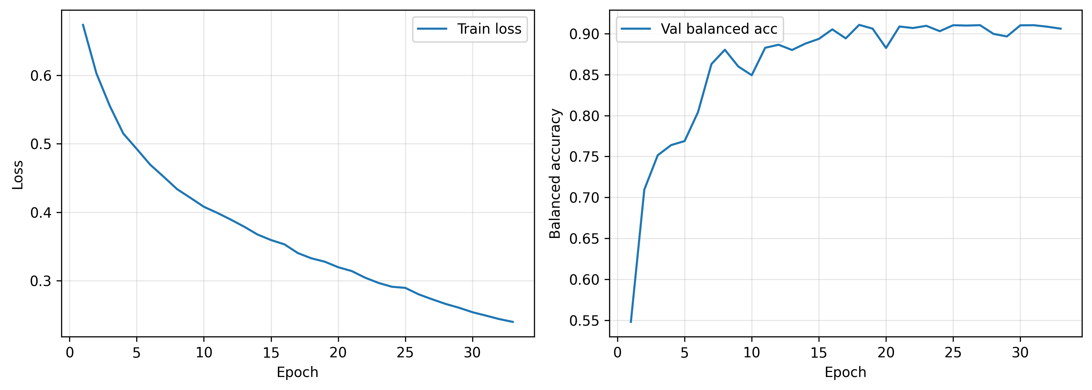
Fig. 5. Training loss and validation balanced accuracy by epoch.
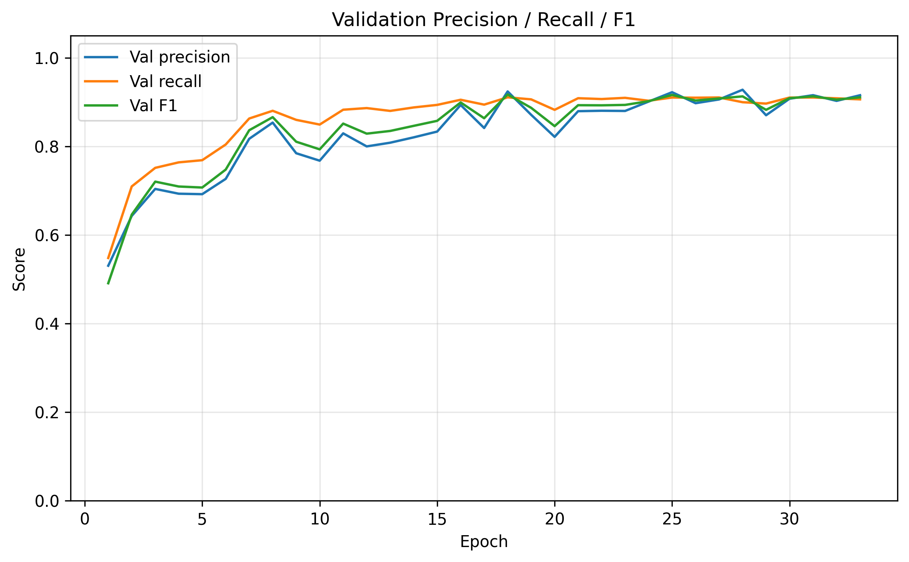
Fig. 6. Validation macro precision, recall, and F1 by epoch.
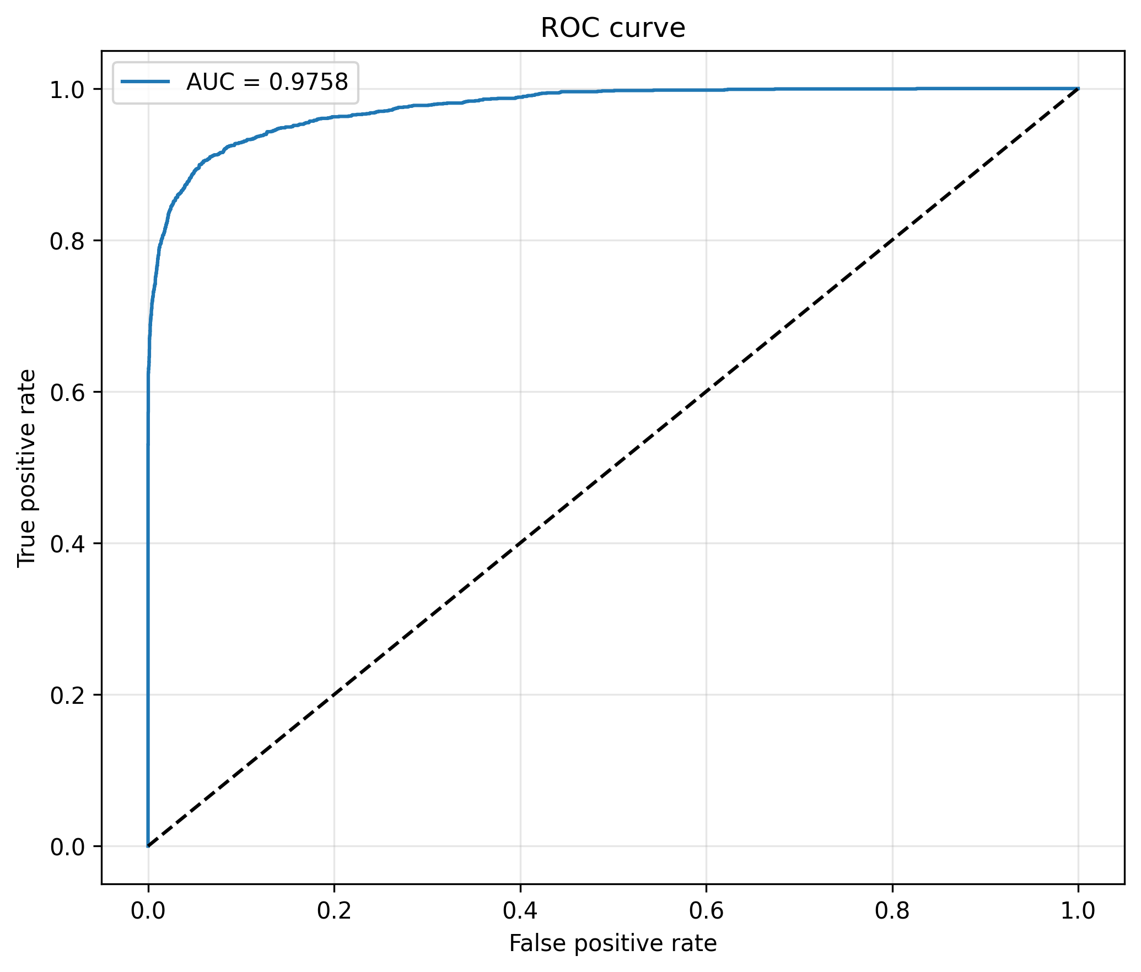
Fig. 7. Receiver operating characteristic curve on the validation split.
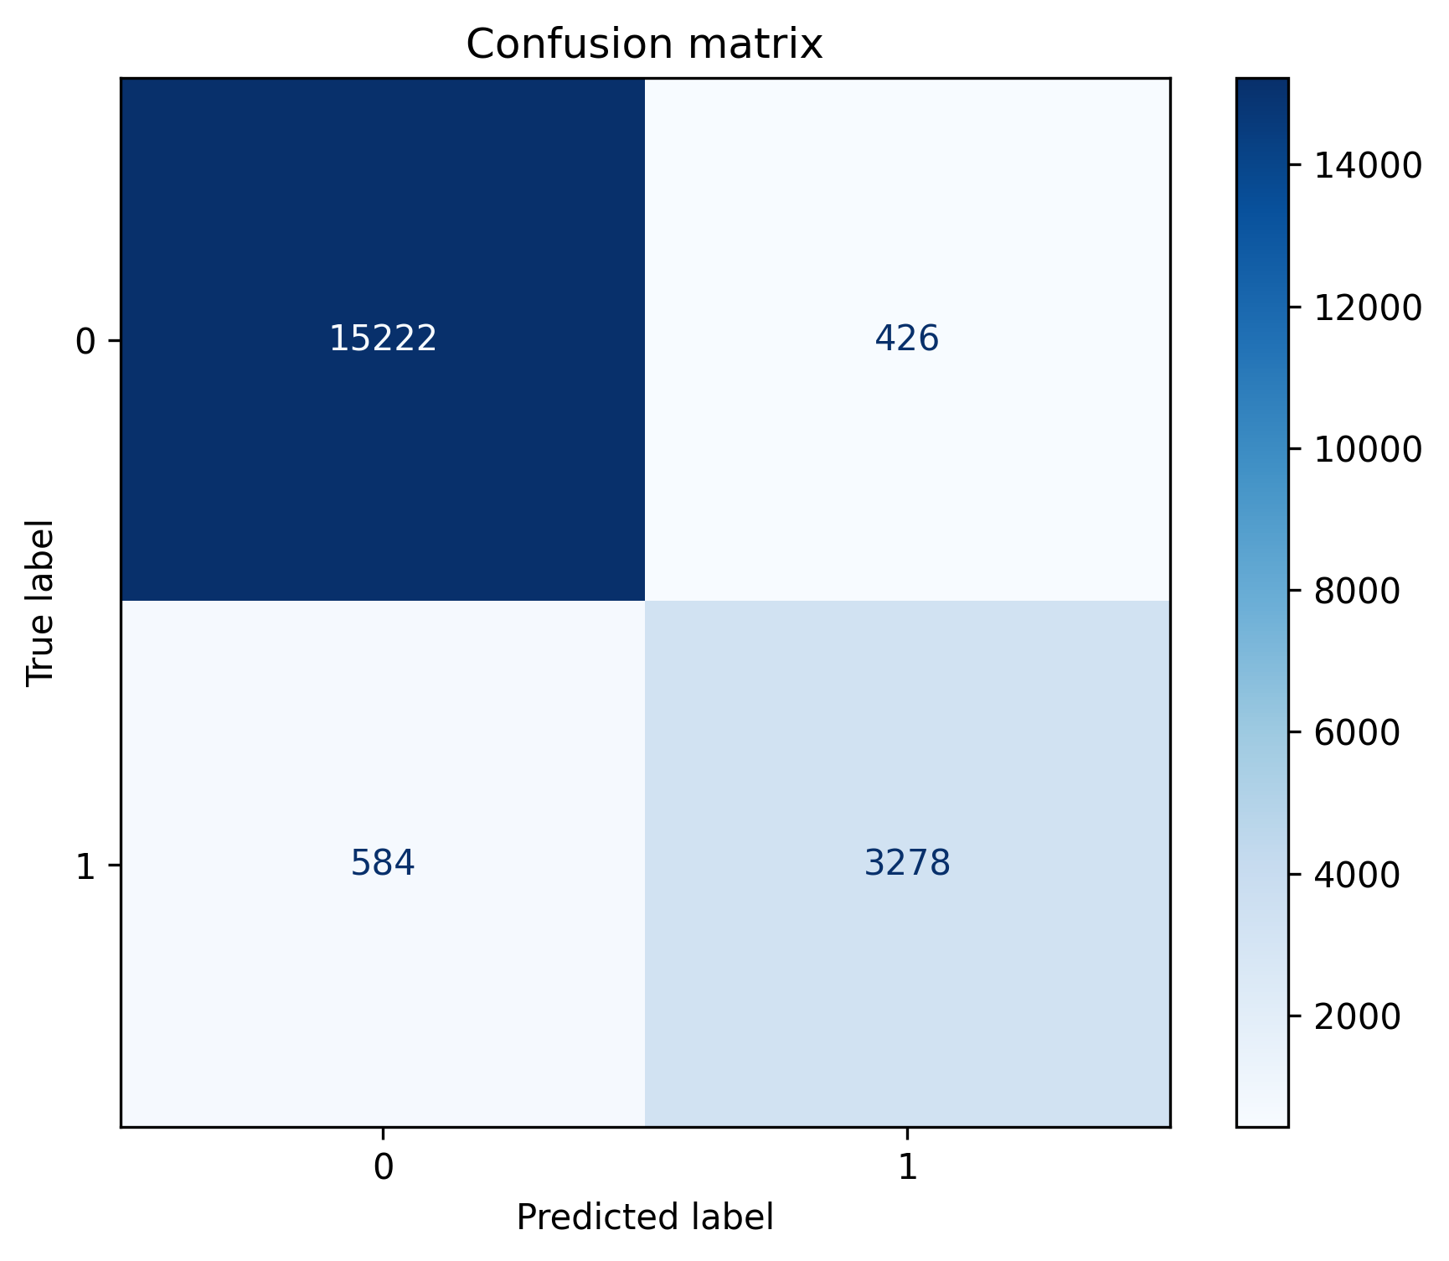
Fig. 8. Confusion matrix on the validation split.
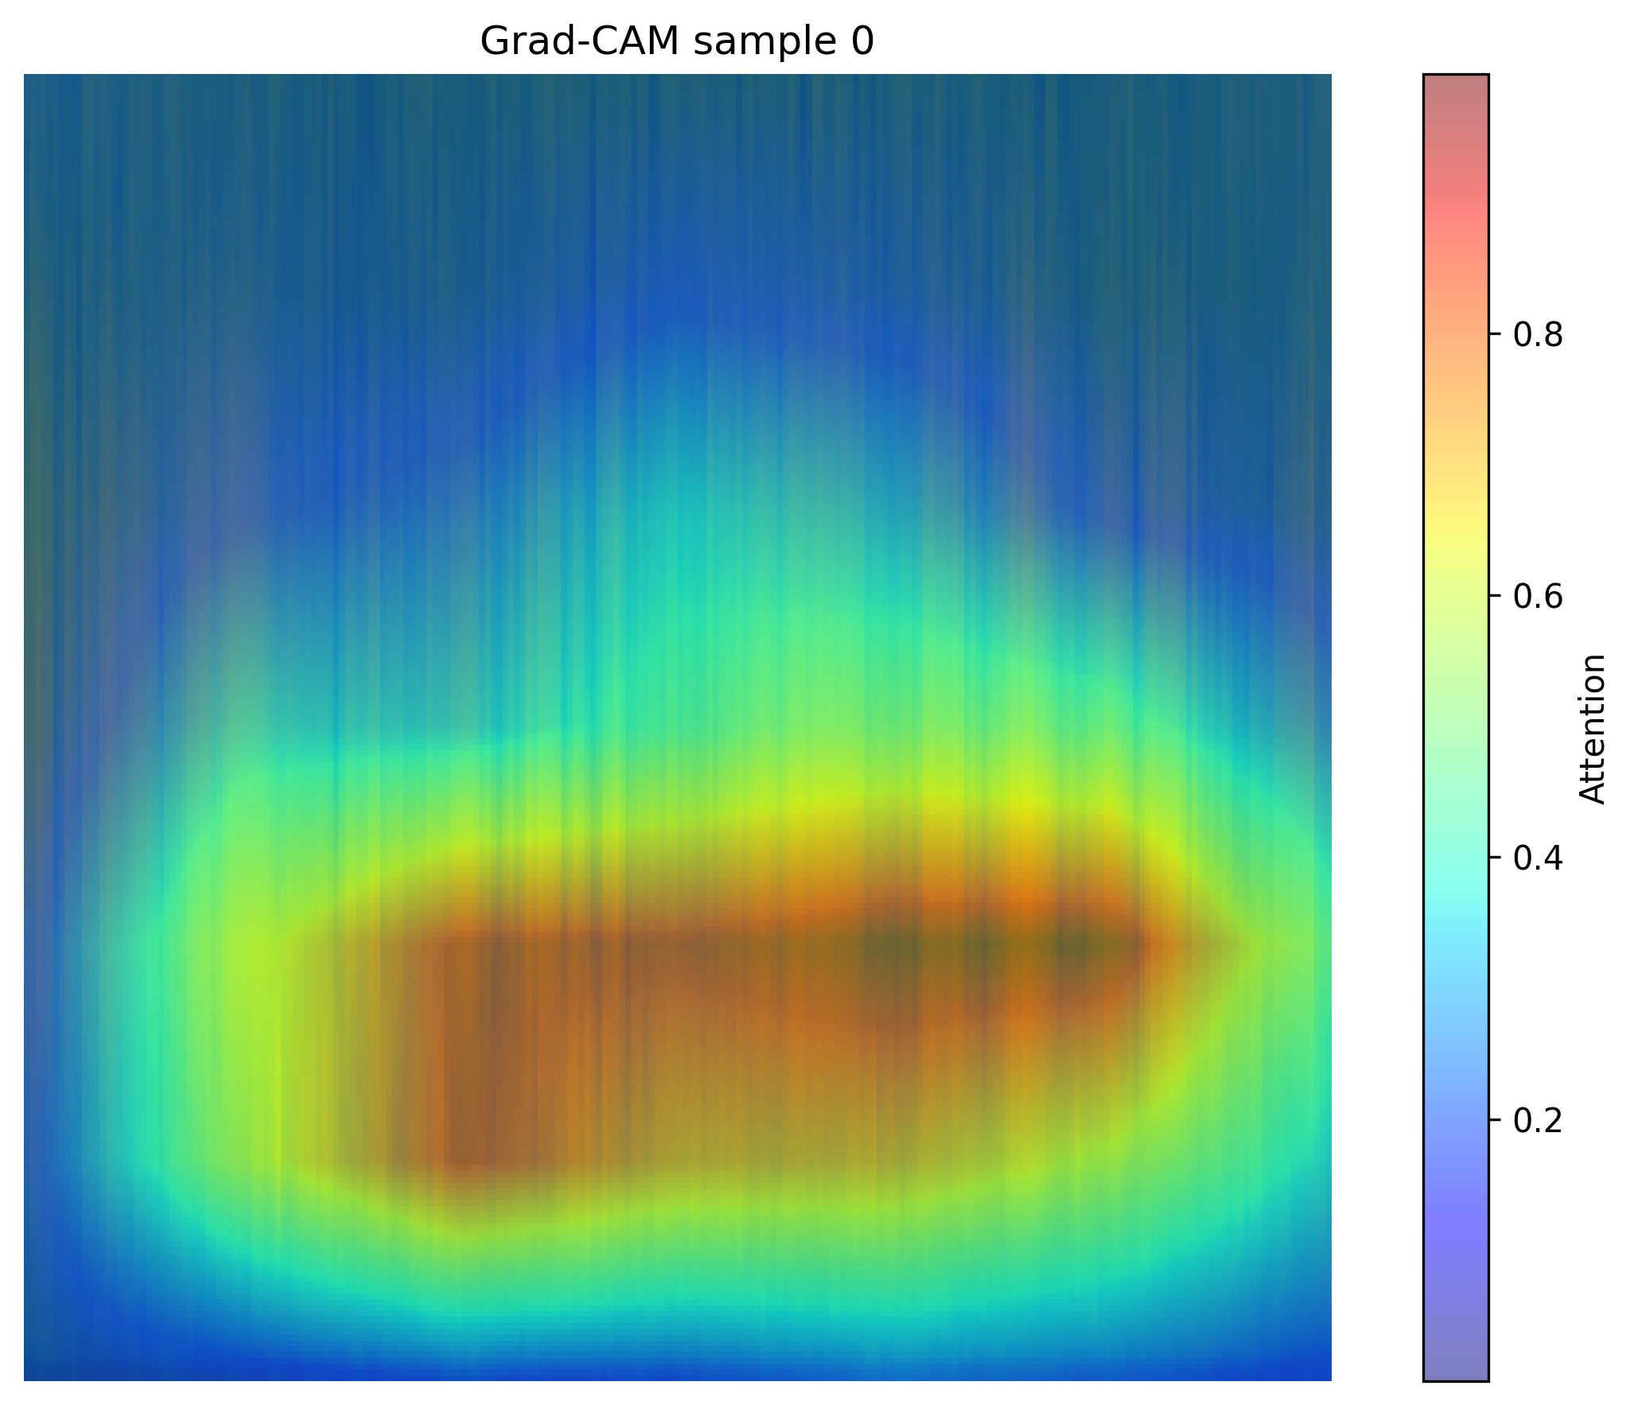
Fig. 9. Representative Grad-CAM overlay on a validation spectrogram (example 1 of 4 saved).

Implementation and reproducibility
Training was invoked with the repository entry point `python -m experiments.train_spectrogram_fault` from the `src` directory; hyperparameters for the anchor run are stored in `config.json` alongside `metrics.json` in the run output folder. Figure schematics can be regenerated with `python scripts/paper_figures/generate_spectrogram_fault_figures.py`. Dependencies are listed in `src/requirements.txt`, including the timm package for pretrained backbones.

