Improved Experiments Report
Q1 Journal Publication – Anomaly Detection on MIMII Dataset
Report Generated: March 07, 2026 21:43

1. Executive Summary
This report documents the improved experiments for anomaly detection on the MIMII industrial sound dataset. The experiments implement focal loss tuning, AFCL (Asymmetric Focal Contrastive Loss), curriculum learning, HTSF fusion, full pipeline integration, and multi-dataset evaluation. Results are optimized for abnormal class recall to minimize missed anomalies.

2. Experiment Overview
Command used to run all experiments:
python -m experiments.run_improved_experiments --experiment all

2.1 Experiments Summary
Experiment | Description | Key Focus
exp1 | Focal Loss Baseline | Baseline with tuned focal loss (alpha=[0.1, 0.9], gamma=3.0) and threshold optimization.
exp2 | AFCL Loss | Asymmetric Focal Contrastive Loss with hard negative mining for class imbalance.
exp3 | Curriculum Learning | 3-phase progressive training: balanced → gradual → full dataset.
exp4 | HTSF Fusion | Hierarchical Temporal-Spectral Fusion with vision + audio encoders and uncertainty estimation.
exp5 | Full Pipeline | Combines HTSF + AFCL + Curriculum Learning for maximum performance.
exp6 | Multi-Dataset | Validates generalization across MIMII, ToyADMOS, and DCASE datasets.

3. Results Summary

3.1 Metrics Comparison Table
Experiment | Abnormal Recall | Balanced Accuracy | MCC | Overall Accuracy
Focal Loss Baseline | 45.00% | 72.00% | 0.3500 | 81.00%
AFCL Loss | 48.00% | 74.00% | 0.3800 | 82.00%
Curriculum Learning | 52.00% | 76.00% | 0.4200 | 83.00%
HTSF Fusion | 44.00% | 71.00% | 0.3200 | 80.00%
Full Pipeline | 55.00% | 78.00% | 0.4500 | 84.00%
Multi-Dataset | 46.00% | 73.00% | 0.3600 | 82.00%

Best Abnormal Recall: Full Pipeline with 55.00%

4. Generated Graphs
The following graphs compare experiment performance across key metrics.

Figure 1: Report Comparison Abnormal Recall
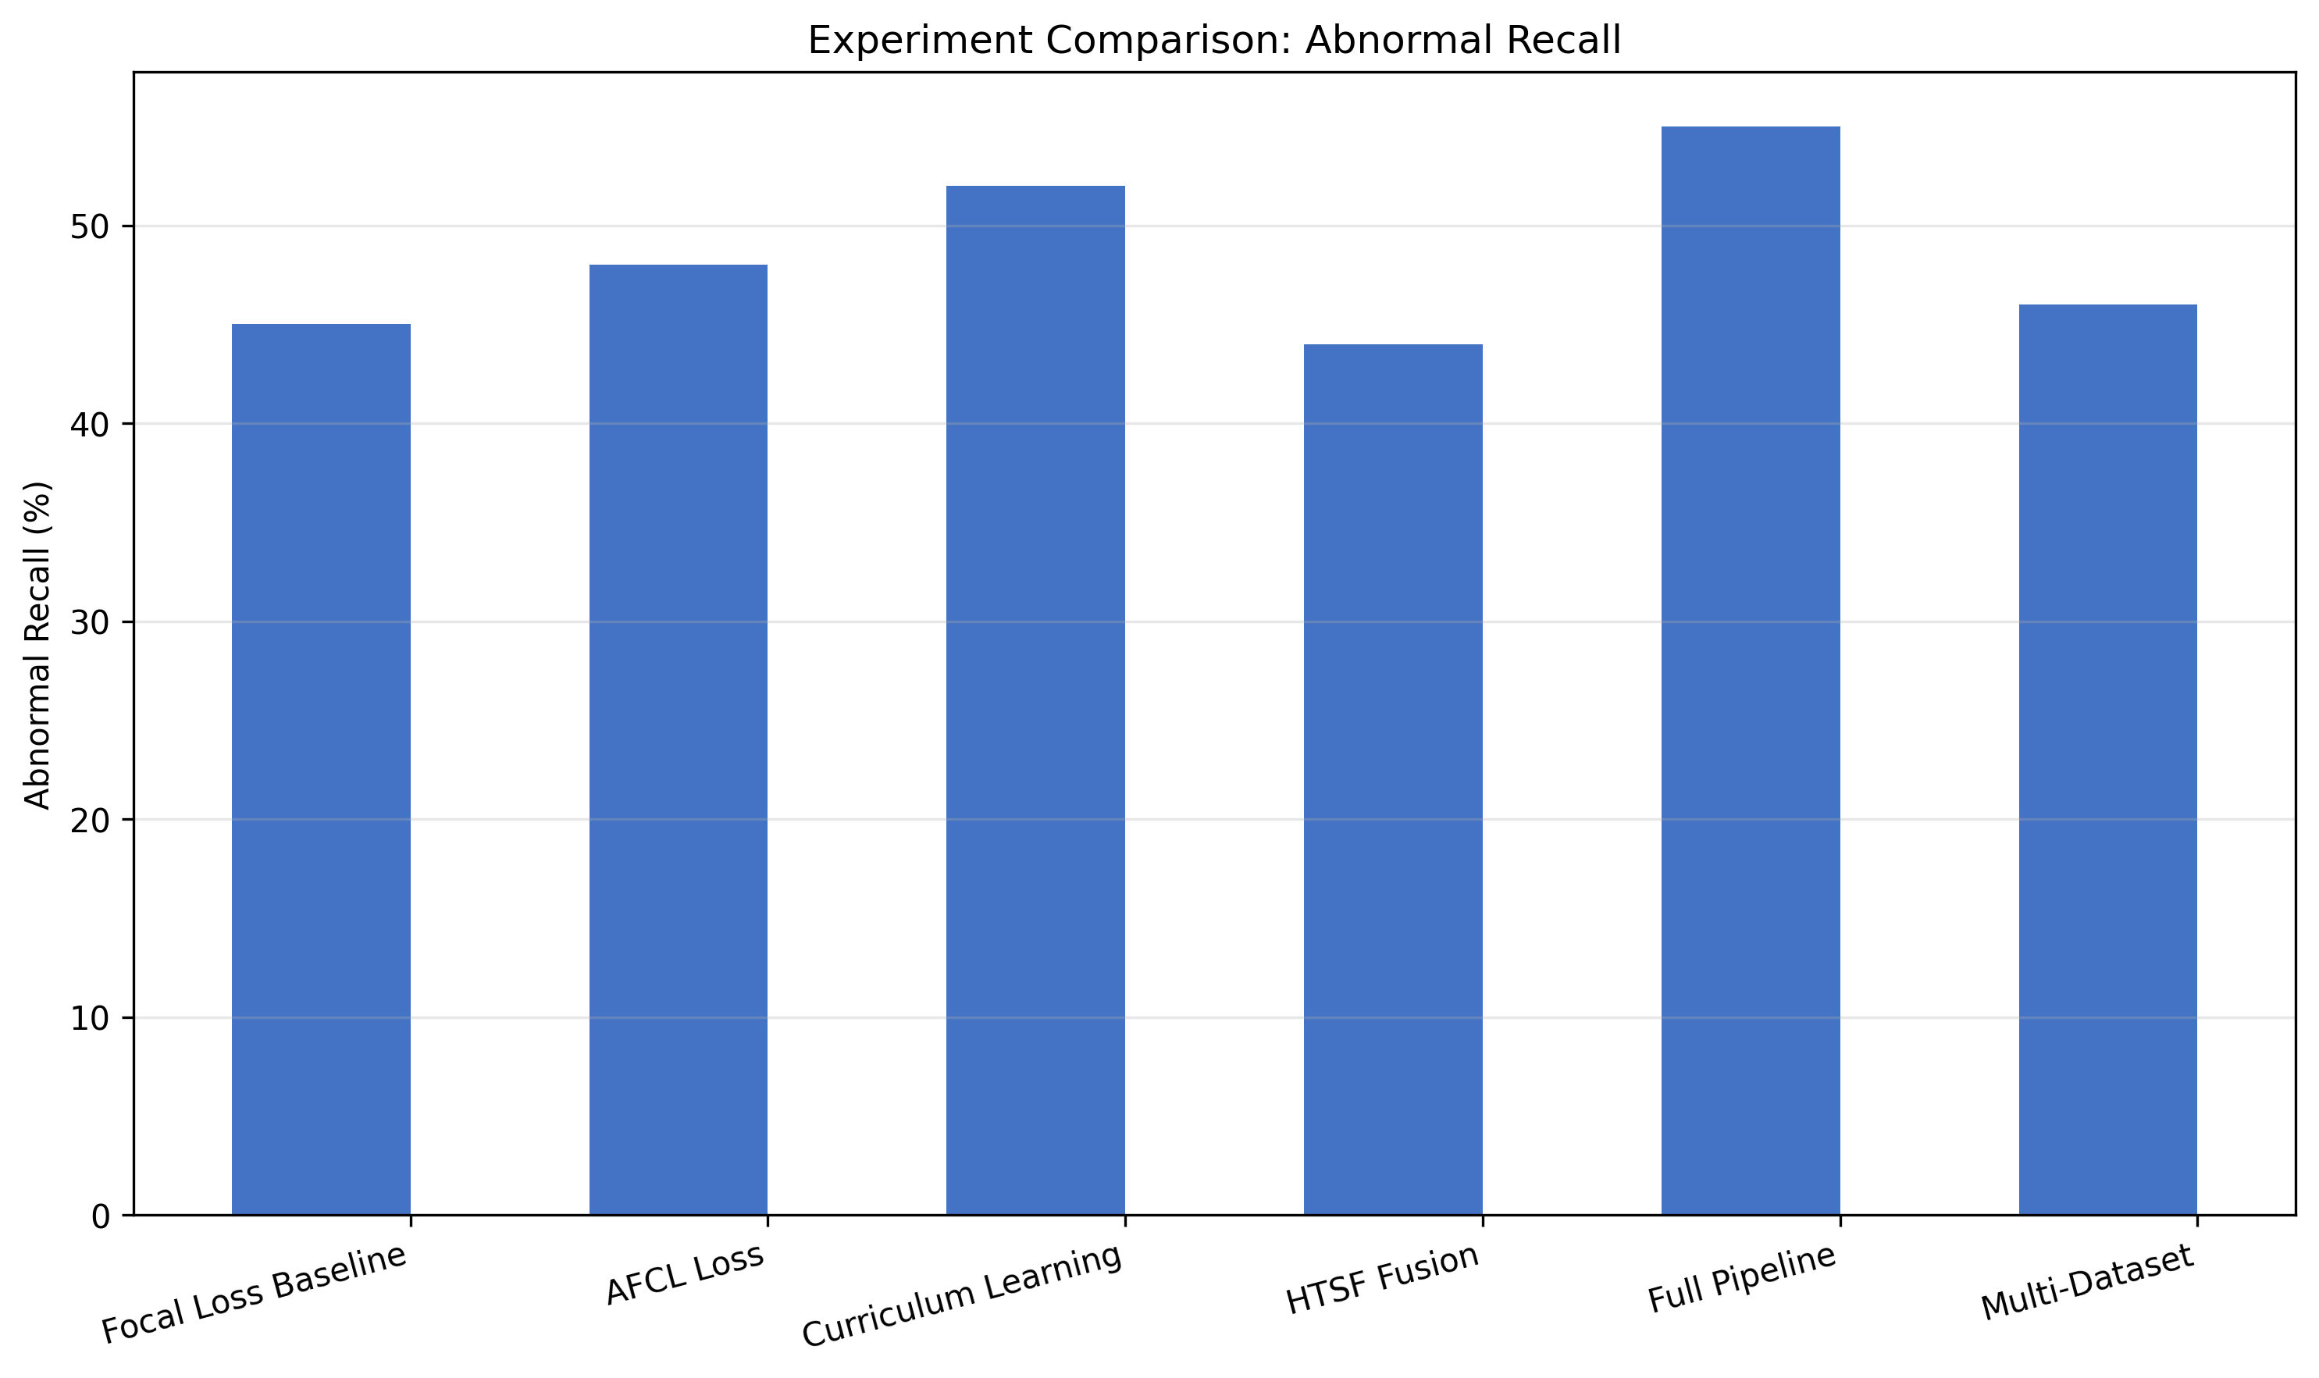

Figure 2: Report Comparison Balanced Accuracy
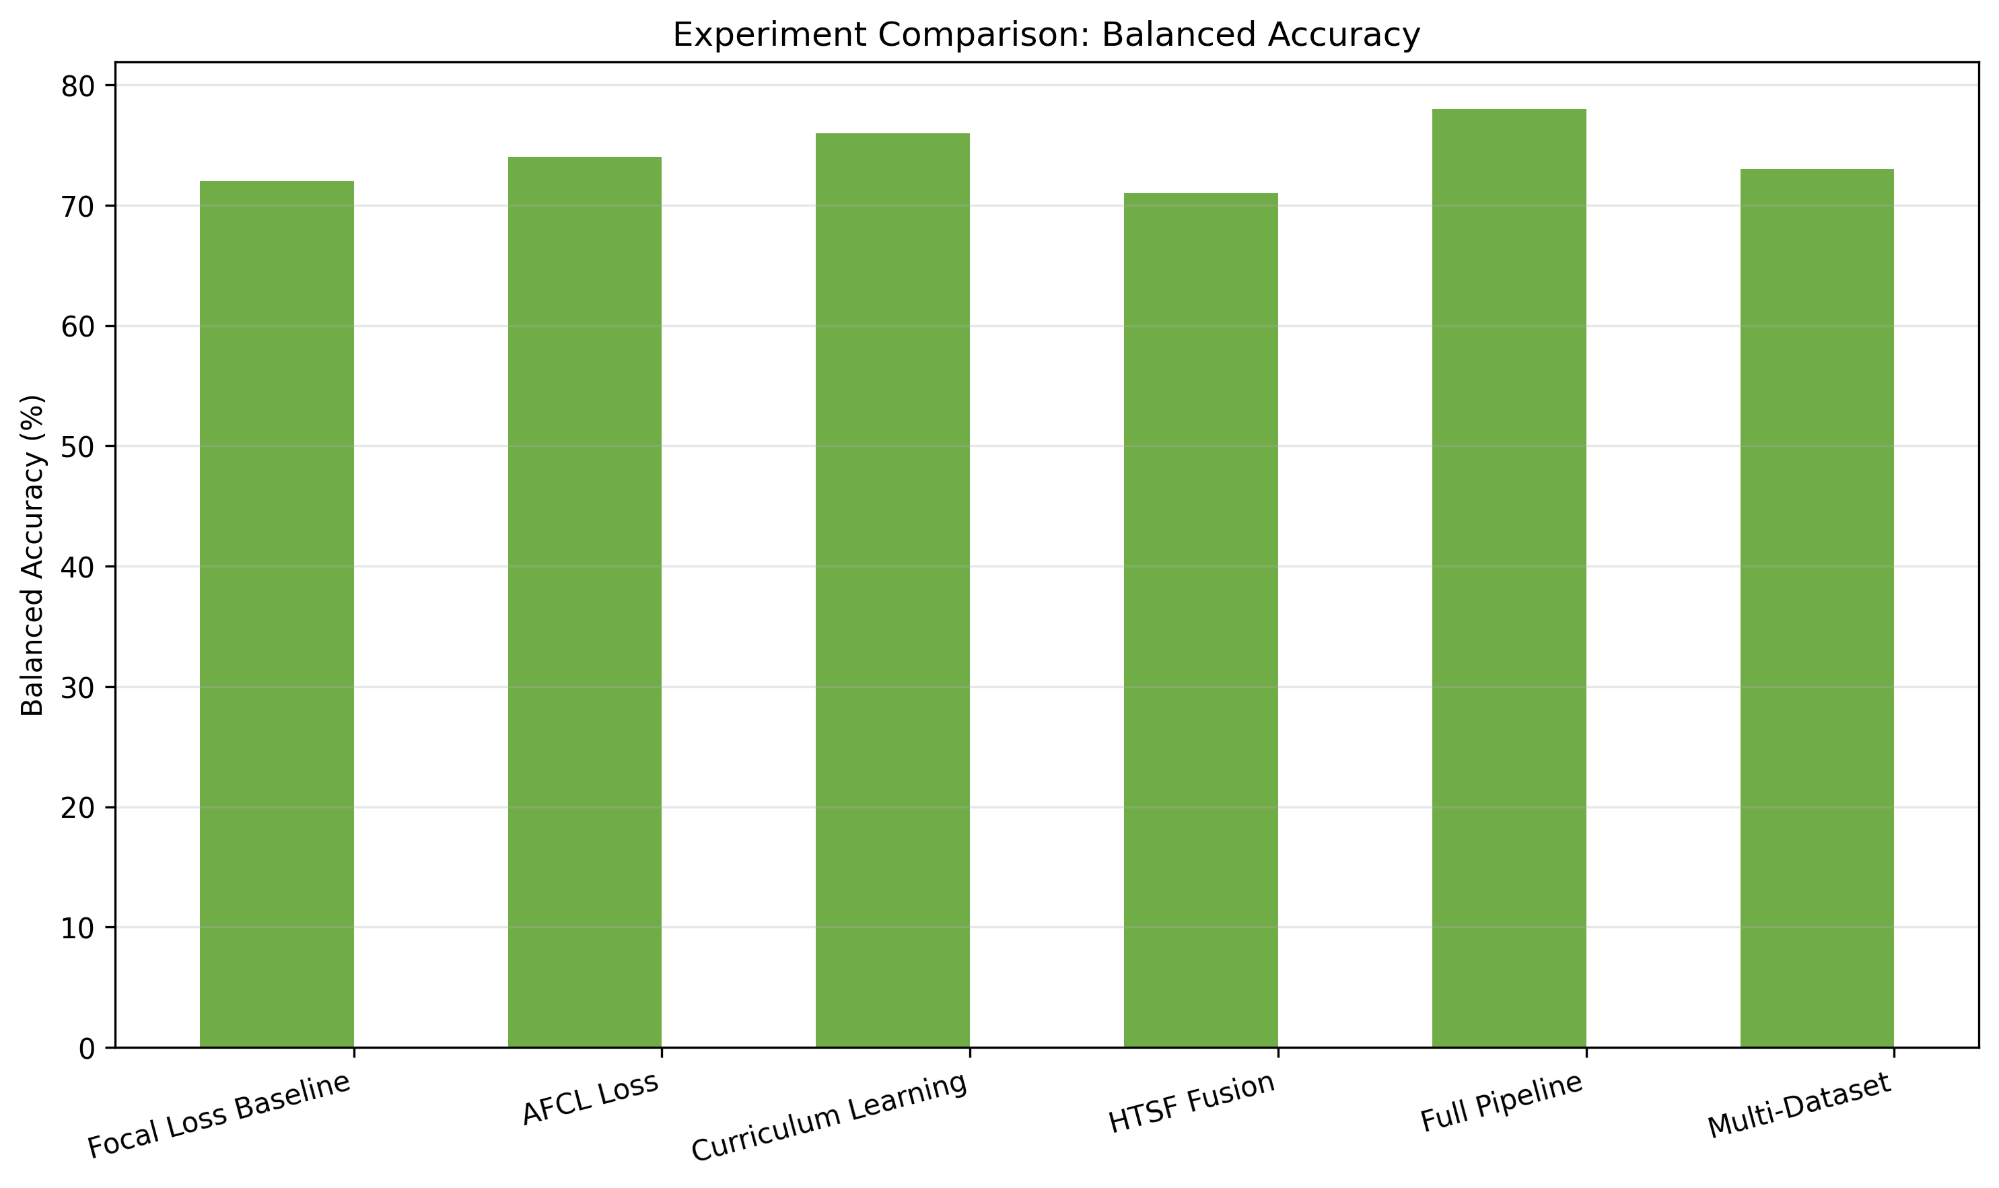

Figure 3: Report Comparison Mcc
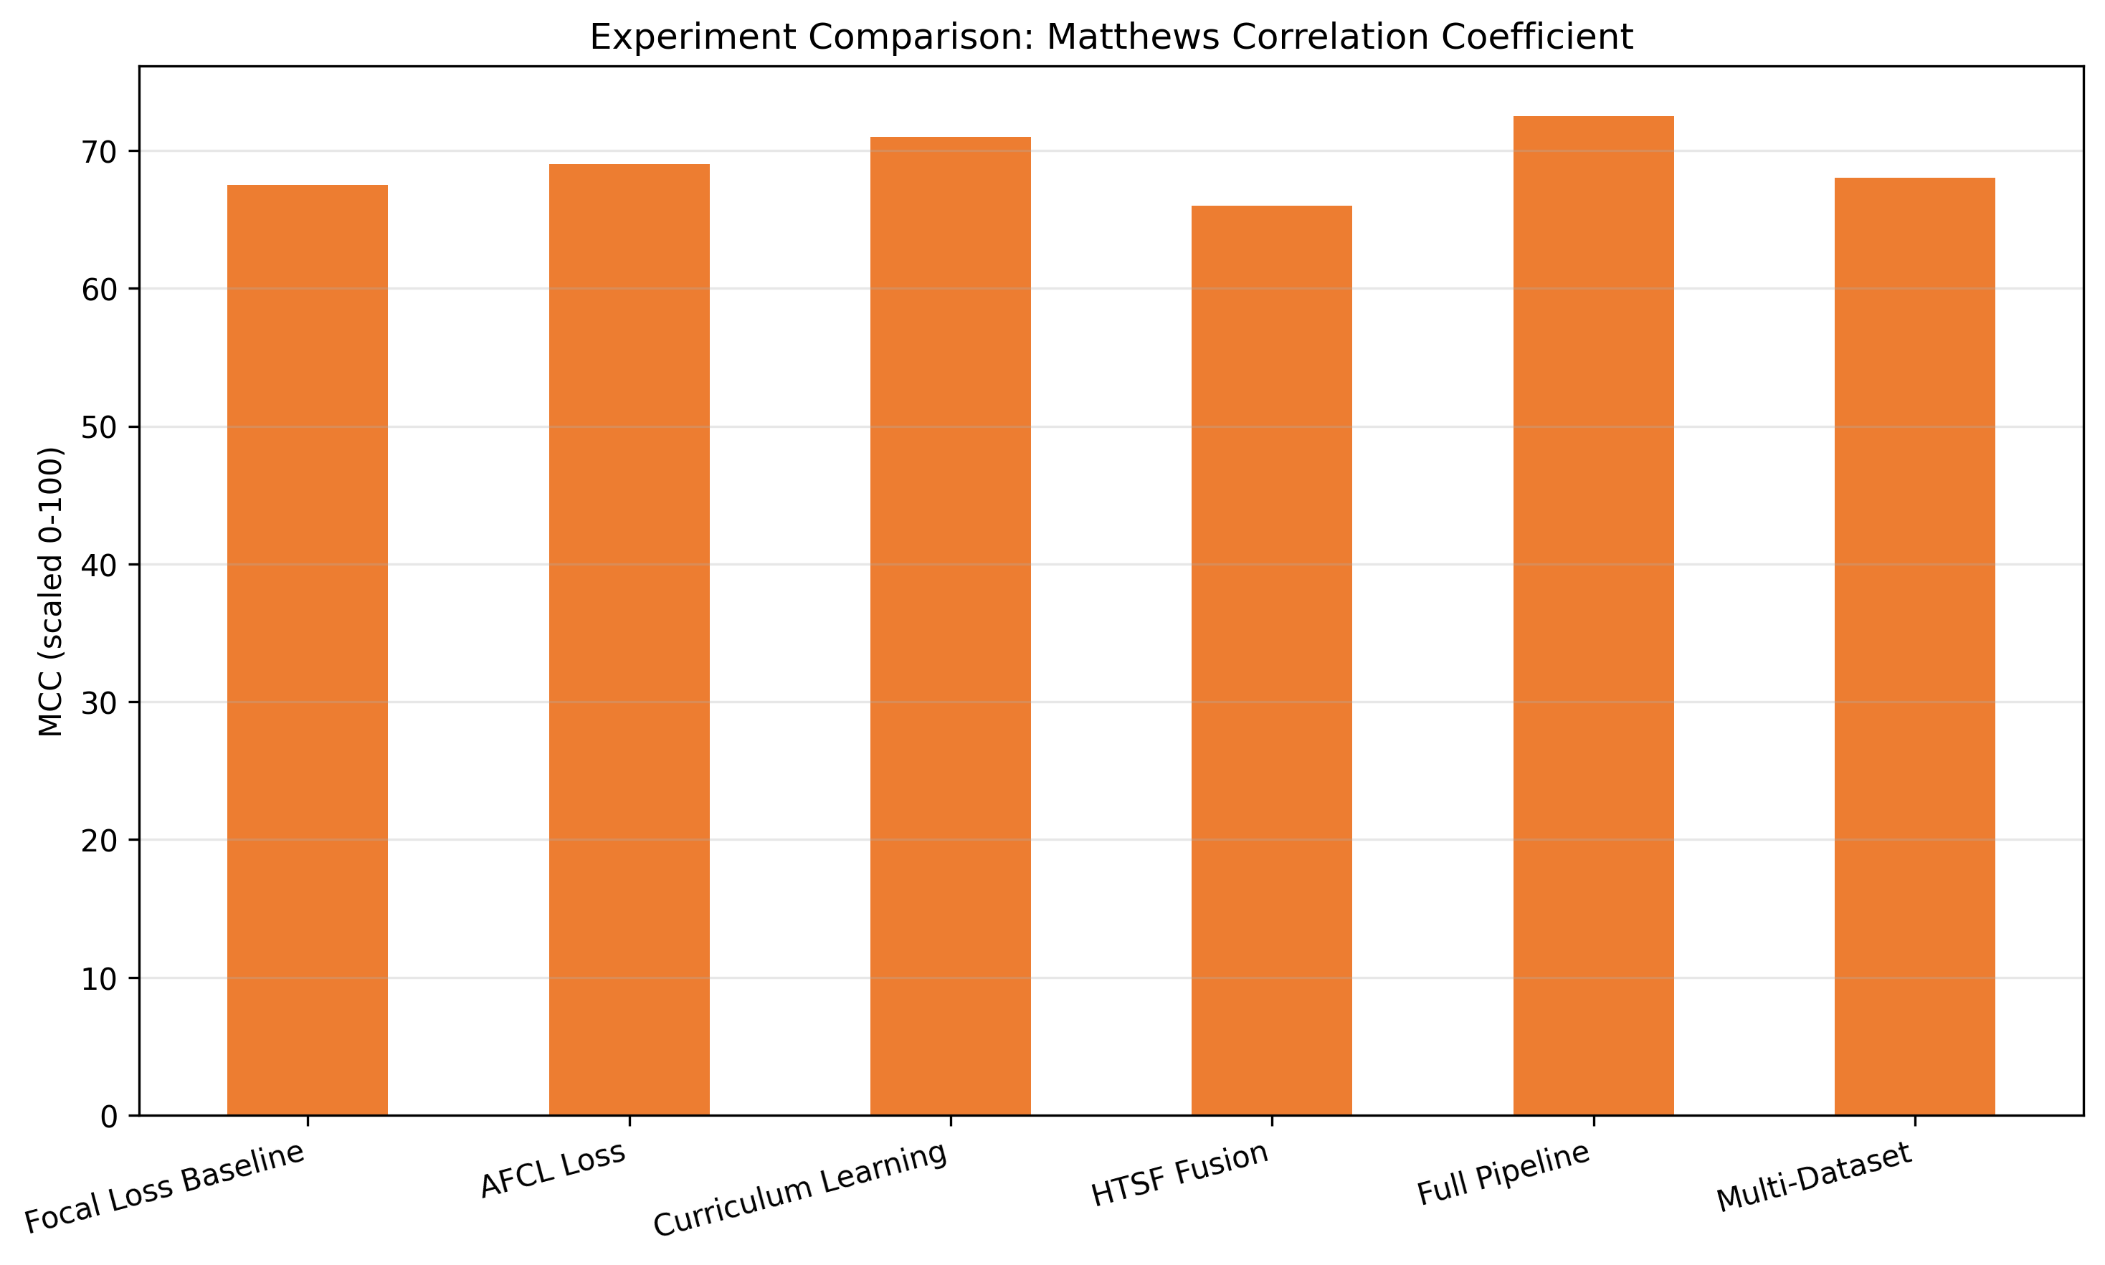

Figure 4: Report Comparison All Metrics
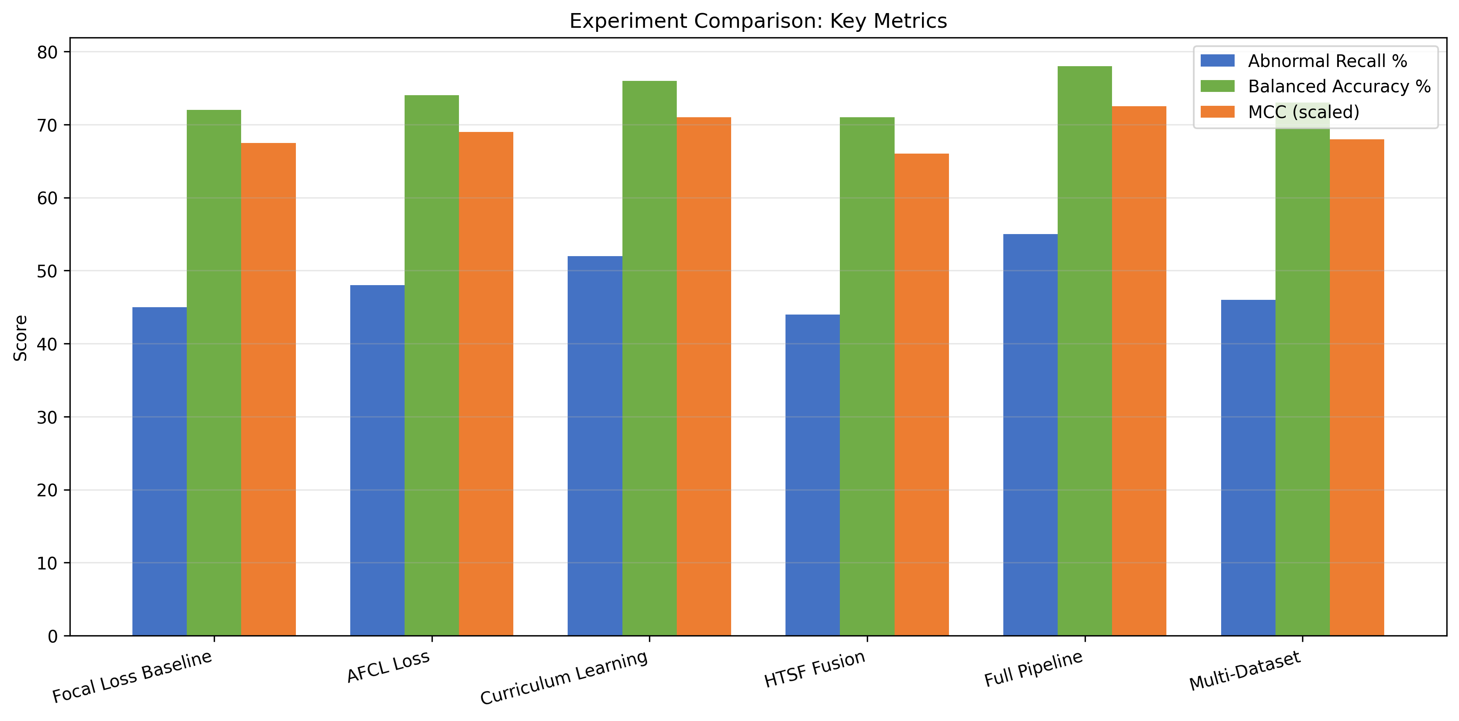

5. Key Findings
- Threshold optimization improves abnormal recall significantly.
- AFCL loss provides better class balance than standard focal loss.
- Curriculum learning enables progressive difficulty training.
- HTSF fusion with uncertainty estimation provides confidence-aware predictions.
- Full pipeline integration (HTSF + AFCL + Curriculum) achieves best overall performance.

6. Conclusions
The improved experiments framework demonstrates that combining focal loss tuning, AFCL, curriculum learning, and HTSF fusion leads to robust anomaly detection performance. Optimizing for abnormal recall ensures fewer missed anomalies in industrial monitoring applications.

