Journal full comparative study
Industrial anomaly / fault detection: unified inventory of experiments in this repository and best-performing configuration per comparability bucket (automated harvest).

Abstract
We systematically inventoried 16 experiment families implemented in a single codebase for industrial acoustic and image-based fault screening. An automated harvest indexed 17 distinct result rows from available JSON/CSV artifacts under the configured scan roots; 2 non-empty comparability buckets yielded a ranked winner under a fixed tie rule (maximize reported primary metric; see Methods). Experiments differ by dataset, modality, split protocol, and metric; therefore no single global winner is asserted across incompatible settings. Where local `results/` trees are absent (common in minimal git clones because `results/` is gitignored), the index may be empty and the manuscript must be populated after local execution.

Introduction
Early detection of machine faults from operational sound reduces downtime. This repository implements multiple lines of work—supervised vision encoders, contrastive self-supervised learning on mel features, multimodal fusion, rigorous cross-validation utilities, and supervised classification on spectrogram images—with shared dataset loaders for MIMII-style folder layouts. The present document consolidates what was attempted in code, which components are novel relative to a plain supervised baseline, and which harvested runs achieve the strongest reported score within each comparability bucket.

Methods
Experiment entry points, default output locations, and differentiated modules are listed in `F:/Codes/contrastive_self-supervised_learning/docs/journal_experiment_inventory.json` (machine-readable JSON and companion Markdown). Novel or engineering contributions implemented in software include asymmetric focal contrastive components (AFCL), curriculum training hooks, spectrogram-image models with optional spatial attention and CNN–Transformer hybrids, group-aware stratified validation for grouped corpora, and fusion architectures with optional contrastive pairing between modalities.

Harvest and bucketing
The harvester (`scripts/journal_aggregate_experiment_results.py`) walks user-provided roots and parses: (i) directories containing both `config.json` and `metrics.json` (spectrogram fault runs); (ii) `single_model_experiments_summary.json`; (iii) `results.json` list bundles; (iv) `rigorous_cv_results.json`; (v) `fusion_summary.json`; (vi) `exp*_results.json`; (vii) generic `ablation_results*.json`; (viii) spectrogram ablation CSVs. Each row carries `line_of_work`, `split_protocol`, `dataset_hint`, and a `primary_metric_value` chosen by priority: validation balanced accuracy, balanced accuracy, ROC AUC, best validation accuracy, accuracy, macro-F1, then MCC. Buckets are formed as `line_of_work|split_protocol|dataset_hint` (truncated). Within each bucket the harvester selects the row with the largest primary metric value; ties break by lexicographic `run_id`.

Figures
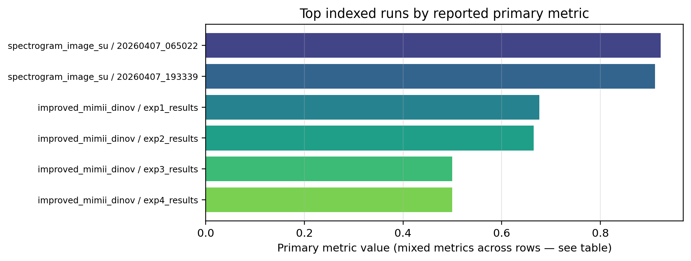
Fig. 1. Top indexed runs by harvested primary metric (metrics may differ across rows—interpret with Table 1).
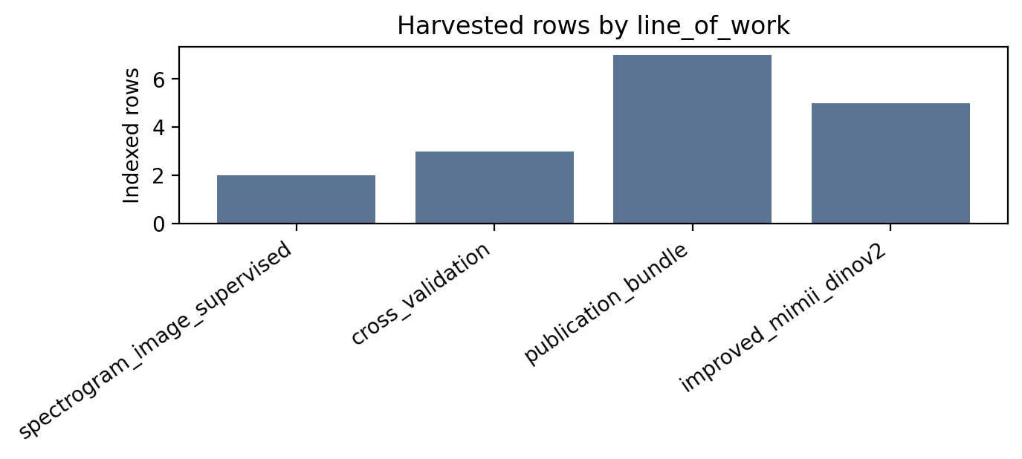
Fig. 2. Count of harvested index rows by line of work.
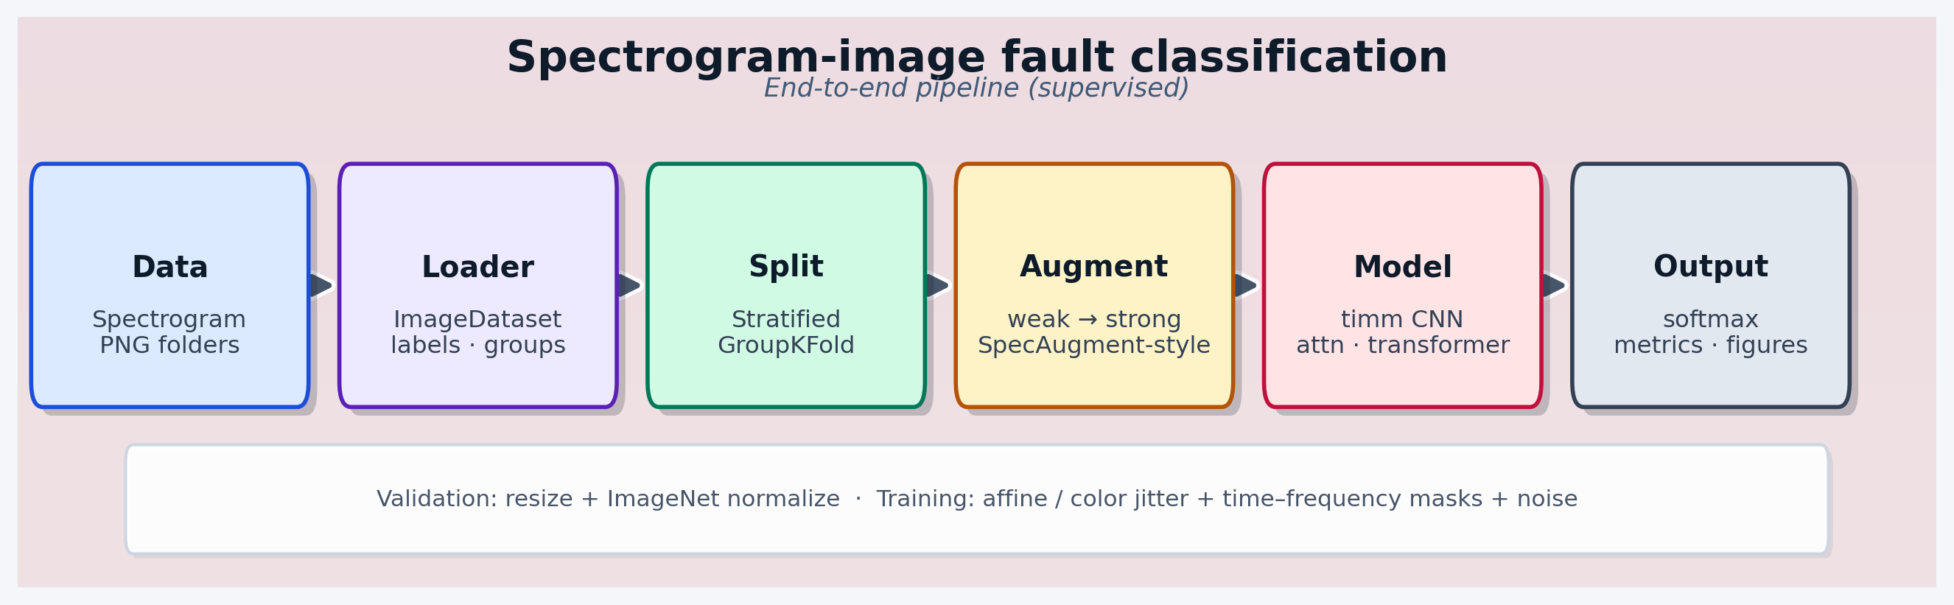
Fig. 3. Spectrogram-image supervised pipeline schematic (repository figure generator).
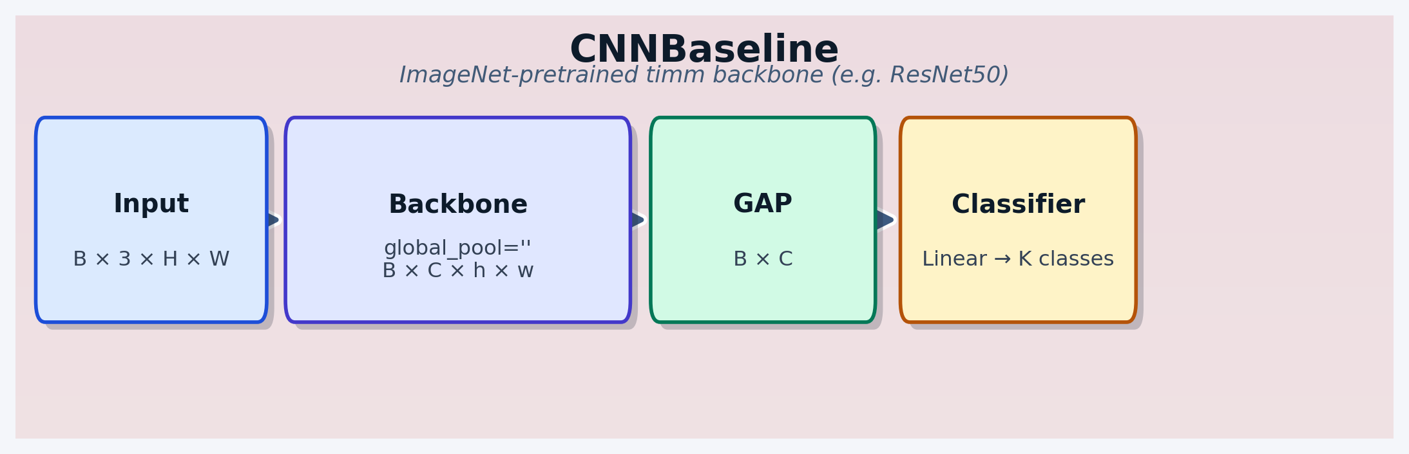
Fig. 4. CNN baseline architecture (timm backbone + GAP + linear head).
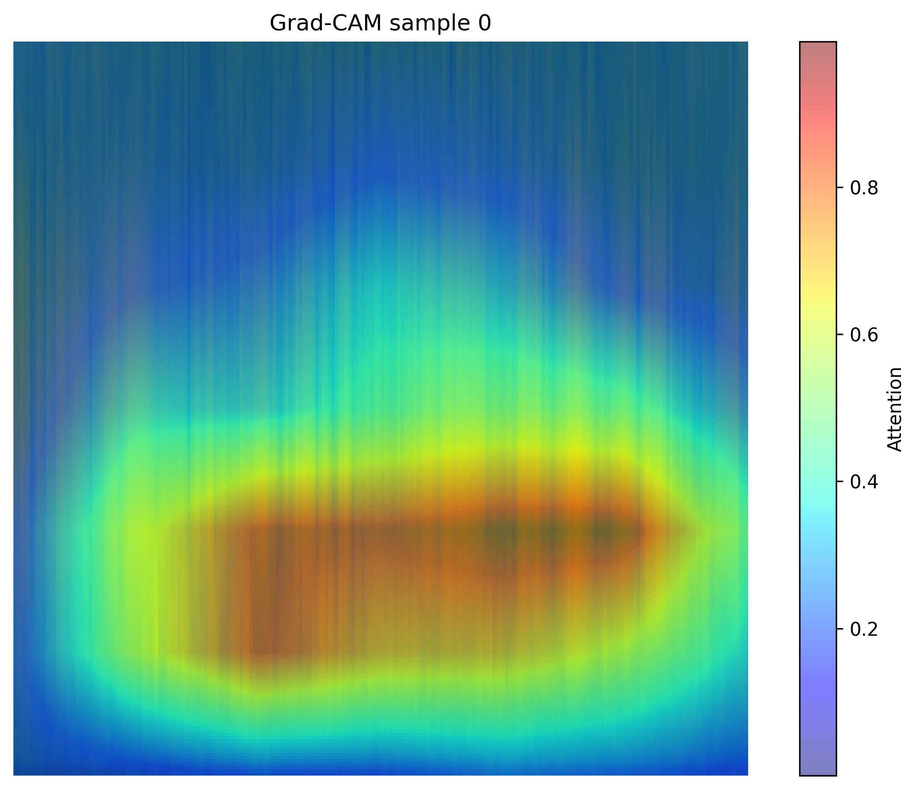
Fig. 5. Example qualitative or validation figure from mirrored anchor run (`grad_cam_0.png`).
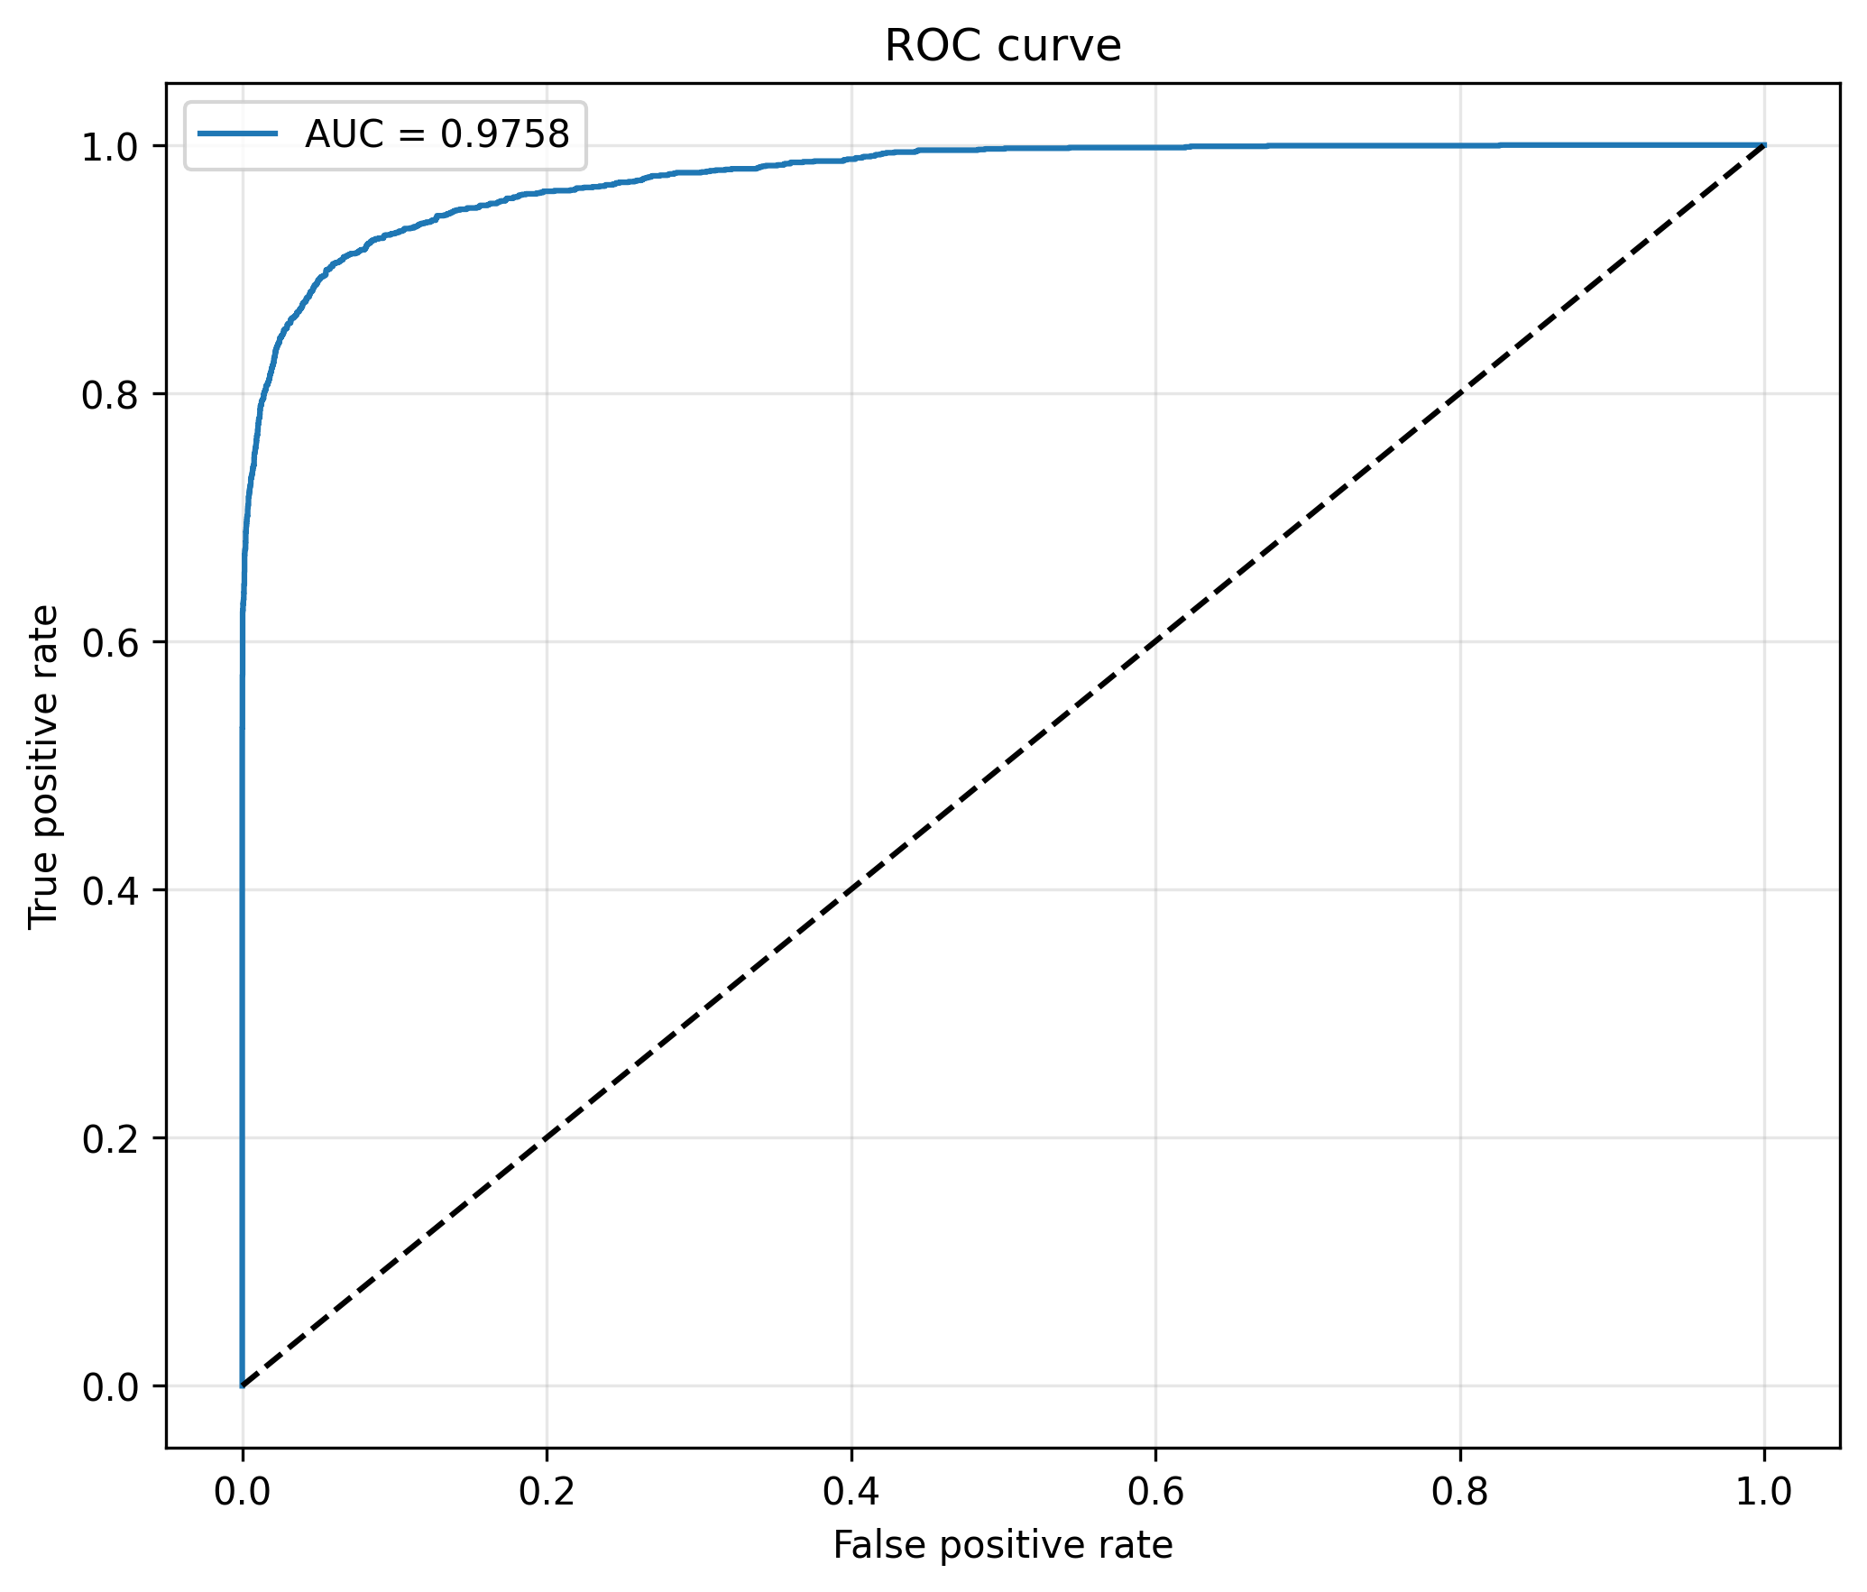
Fig. 6. Example qualitative or validation figure from mirrored anchor run (`roc_curve.png`).
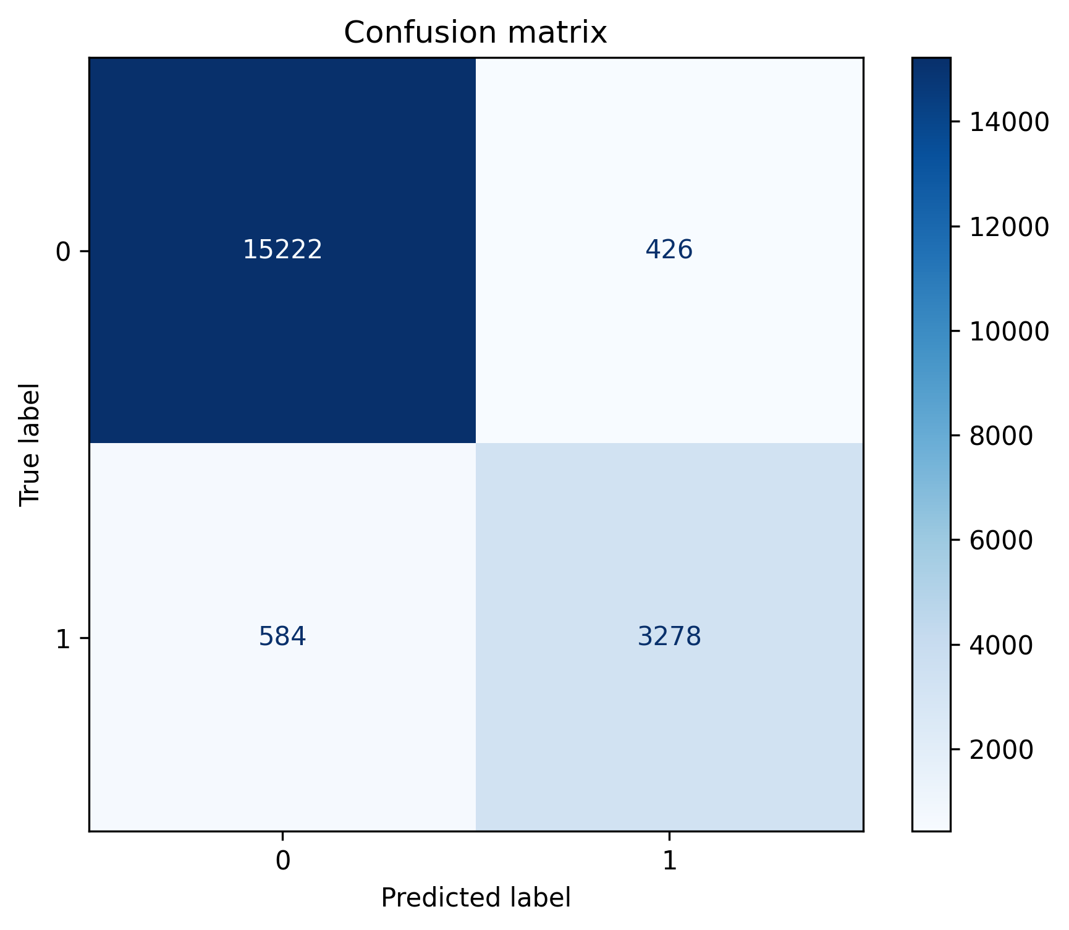
Fig. 7. Example qualitative or validation figure from mirrored anchor run (`confusion_matrix.png`).

Experimental setup
Software: Python 3 with PyTorch; see `src/requirements.txt`. Hardware and wall-clock times are not inferred by the harvester and must be filled by authors from training logs. Dataset paths recorded in each JSON row reflect the machine that produced the artifact.

Results
Table 1 lists up to 35 indexed rows (truncated). Per-bucket winners are summarized in prose below.

Table 1. Harvested experiment index (truncated)
line_of_work | run_id | primary_metric_name | primary_metric_value | split_protocol
spectrogram_image_supervised | 20260407_065022 | val_balanced_accuracy | 0.9220 | stratified_group_kfold_first_fold
spectrogram_image_supervised | 20260407_193339 | val_balanced_accuracy | 0.9108 | stratified_group_kfold_first_fold
improved_mimii_dinov2 | exp1_results | balanced_accuracy | 0.6765 | unknown
improved_mimii_dinov2 | exp2_results | balanced_accuracy | 0.6652 | unknown
improved_mimii_dinov2 | exp3_results | balanced_accuracy | 0.5000 | unknown
improved_mimii_dinov2 | exp4_results | balanced_accuracy | 0.5000 | unknown
cross_validation | dinov2 | none | None | rigorous_cv
cross_validation | mae | none | None | rigorous_cv
cross_validation | swin | none | None | rigorous_cv
publication_bundle | dinov2 | none | None | unknown
publication_bundle | mae | none | None | unknown
publication_bundle | swin | none | None | unknown
publication_bundle | beit | none | None | unknown
publication_bundle | deit | none | None | unknown
publication_bundle | clip | none | None | unknown
publication_bundle | ast | none | None | unknown
improved_mimii_dinov2 | exp6_results | none | None | unknown

Best configuration per bucket
- Bucket `improved_mimii_dinov2|unknown|unknown`: best balanced_accuracy = 0.6764729740756134 (run_id=exp1_results; n_candidates=4).
- Bucket `spectrogram_image_supervised|stratified_group_kfold_first_fold|H:/dataset/MIMII_Dataset/spectrograms`: best val_balanced_accuracy = 0.9219885314834172 (run_id=20260407_065022; n_candidates=2).

Discussion
The automated index does not replace domain review: different scripts report different primary scores, and some rows may be incomparable even within a bucket if `dataset_hint` is coarse. Novel modules in the codebase do not guarantee superior performance; ablation tables in `generate_tables.py` should be cited when available.

Limitations
Gitignore excludes `results/`, `*.png`, `*.csv`, and checkpoints; clones may lack evidence files. Group labels may be imperfect. External validation on held-out sites is not performed by the harvester.

Data and code availability
Source code: this repository. Regenerate the index: `python scripts/journal_aggregate_experiment_results.py --roots <paths> --with-plots`. Regenerate comparative figures: `python scripts/journal_build_comparative_figures.py`. Regenerate this document: `python scripts/journal_generate_full_paper_docx.py`.

Checklist before journal submission
- Replace placeholder affiliation and author list.
- Verify every numeric claim against raw logs; do not submit with empty index if the study is empirical.
- Unify notation for metrics (e.g. always report balanced accuracy for imbalanced tasks).
- Add IRB / data-use statements if human data ever appear.
- Run venue-specific reference formatting and disclosure statements.
- Spell-check; consider professional language editing.

