**ACTIVITY 1**

1. Open index.html on **Chrome**
2. Open the “**Elements**” tab of the developer’s tools (Ctrl + shift + I)

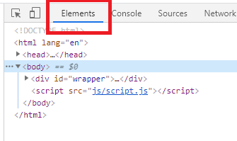

1. Answer following questions and **return your word documents on skype**:

Q1 – How many children have the element of id **add-book**?

Q2 – What is the **parent** of the element h2 “book to read”?

Q3 – What are the ID and CLASS of the element used for?

Q4 – Select the <div> of id “book-list” and delete it. What happens?