AEROSPACE WIND TUNNEL AND AERODYNAMIC DATA VISUALIZATION PLATFORM
A PROJECT REPORT
Submitted by
NAVIN RAJ G (310624243110)
in partial fulfillment for the award of the Degree
of
BACHELOR OF TECHNOLOGY
in
ARTIFICIAL INTELLIGENCE AND DATA SCIENCE

EASWARI ENGINEERING COLLEGE
(AN AUTONOMOUS INSTITUTION)
AFFILIATED TO ANNA UNIVERSITY, CHENNAI
RAMAPURAM, CHENNAI - 600089
OCTOBER 2026

EASWARI ENGINEERING COLLEGE
BONAFIDE CERTIFICATE
Certified that this mini project report titled "AEROSPACE WIND TUNNEL AND AERODYNAMIC DATA VISUALIZATION PLATFORM" is the Bonafide work of "NAVIN RAJ G (310624243110)", who carried out the project work under my supervision.
HEAD OF THE DEPARTMENT  Dr. T. Kalai Selvi  Easwari Engineering College,  Ramapuram, Chennai - 600089. | SUPERVISOR  Ms. D. S. K. Harshitha  Easwari Engineering College,  Ramapuram, Chennai - 600089.

EASWARI ENGINEERING COLLEGE
Certificate of Viva-voce-Examination
This is to certify that the Viva Voce Examination of the Project Work entitled "Aerospace Wind Tunnel and Aerodynamic Data Visualization Platform" submitted by Navin Raj G (310624243110) in partial fulfillment of the requirements for the award of the degree of Bachelor of Technology was conducted on 27-10-2026 in the Department of Artificial Intelligence and Data Science, Easwari Engineering College, Ramapuram - Chennai.
Internal Examiner  Date: | External Examiner  Date:

ABSTRACT
The experimental characterization of aerodynamic lifting surfaces is fundamental to aeronautical engineering and aerospace design. However, conventional physical wind tunnel testing encounters severe operational friction, including exorbitant testing costs exceeding $5,000 per hour, facility scheduling backlogs, absence of real-time multi-user telemetry streaming, and fragmented post-processing pipelines. To resolve these challenges, this project presents the Aerospace Wind Tunnel and Aerodynamic Data Visualization Platform, an intelligent, web-native digital twin engineered on the MERN (MongoDB, Express.js, React 18, Node.js) technology stack, integrated with high-precision micro-physics aerodynamic computation and WebGL-based Three.js 3D spatial flow visualization.
The core computational innovation is an automated aerodynamics simulation engine implementing thin-airfoil theory, viscous boundary-layer friction corrections, and dynamic stall modeling. The engine evaluates lift coefficients (CL), drag polars (CD), pitching moments (Cm), and lift-to-drag aerodynamic efficiency ratios (L/D) across multi-profile airfoil configurations (NACA 0012, NACA 2412, NACA 4412, NACA 6409). Additionally, a 20-point chordwise discrete pressure array generates surface pressure distribution (Cp) curves in sub-second latency, visualizing flow separation, boundary-layer detachment, and suction peak stagnation points with mathematical rigor.
System reliability, high-rate data acquisition, and operational safety are enforced via an automated Angle of Attack (α) sweep controller operating at 10 Hz sampling frequency, paired with persistent MongoDB time-series storage. A comprehensive 4-tier Role-Based Access Control (RBAC) security framework (Flight Director, Senior Aerodynamicist, Test Operator, Research Observer) managed via JSON Web Tokens (JWT) and Bcrypt cryptographic hashing ensures strict facility command safety, complete with an emergency SCRAM interlock protocol. The resulting platform delivers a high-performance, accessible, and mathematically rigorous environment for aerospace research and aerodynamic education.
Keywords: Aerodynamics, Wind Tunnel Simulation, Digital Twin, Three.js 3D Visualization, Telemetry Streaming, Angle of Attack Sweep, MERN Stack, MongoDB.

ACKNOWLEDGEMENT
We express our sincere gratitude to the Principal Dr. P. Deiva Sundari and the Management of our college for providing us with the opportunity to carry out this project work.
We convey our heartfelt thanks to the Head of the Department Dr. T. KalaiSelvi, Department of Artificial Intelligence and Data Science, for the continuous encouragement and support.
We are extremely thankful to our Project Guide Ms. D. S. K. Harshitha, Department of Artificial Intelligence and Data Science for valuable guidance, suggestions, and motivation throughout the completion of this project.
We would also like to extend our gratitude to all the faculty members of the Department of Artificial Intelligence and Data Science for their support.
Finally, we thank our parents and friends for their constant encouragement and help during the course of this project.

TABLE OF CONTENTS
CHAPTER NO. | TITLE | PAGE No.
 | ABSTRACT | i
 | ACKNOWLEDGEMENT | ii
 | LIST OF TABLES | v
 | LIST OF FIGURES | vi
1 | INTRODUCTION | 1
 | 1.1 OVERVIEW | 1
 | 1.2 PROBLEM DEFINITION | 2
 | 1.3 OBJECTIVE | 3
 | 1.4 SCOPE OF THE PROJECT | 4
 | 1.5 MOTIVATION | 5
2 | LITERATURE SURVEY | 6
 | 2.1 LITERATURE REVIEW | 6
 | 2.2 EXISTING SYSTEM | 7
 | 2.3 PROPOSED SYSTEM | 8
3 | SYSTEM ANALYSIS | 9
 | 3.1 SYSTEM REQUIREMENTS | 9
 | 3.2 SOFTWARE AND HARDWARE REQUIREMENTS | 10
4 | METHODOLOGY | 11
 | 4.1 SYSTEM ARCHITECTURE | 11
 | 4.2 MODULE DESCRIPTION | 12
 | 4.3 CLASS DIAGRAM | 14
 | 4.4 SEQUENCE DIAGRAM | 15
5 | RESULTS AND DISCUSSION | 16
 | 5.1 IMPLEMENTATION OVERVIEW | 16
 | 5.2 KEY FUNCTIONS (CODE EXPLANATION) | 17
6 | CONCLUSION & FUTURE WORK | 18
 | 6.1 CONCLUSION | 18
 | 6.2 FUTURE ENHANCEMENTS | 19
 | APPENDIX | 20
 | SCREENSHOTS | 34
 | REFERENCES | 39

LIST OF TABLES
TABLE NO. | TABLE TITLE | PAGE No.
3.1 | Minimum Software Requirements for Development and Hosting | 9
3.2 | Hardware Specifications for Development and Production Server | 10
4.1 | Summary of System Modules and Functional Responsibilities | 12

LIST OF FIGURES
FIGURE NO. | FIGURE TITLE | PAGE No.
4.1 | Aerospace Wind Tunnel Platform -- System Architecture | 11
4.2 | UML Class Diagram of Mongoose Models and Data Entities | 14
4.3 | Sequence Diagram of Aerodynamic Telemetry and Sweep Workflow | 15
1 | User Login and Authentication Interface | 34
2 | Mission Control Dashboard with Real-Time Telemetry | 35
3 | 3D Wind Tunnel Viewport with Airfoil & Streamlines | 35
4 | Aerodynamic Polars & Performance Curves (Lift, Drag, L/D, Cm) | 36
5 | Dynamic Angle of Attack Automated Sweep Interface | 36
6 | Flight Test Dataset Inspector and Run Dossier Certificate | 37
7 | Wind Tunnel Facility Control & Emergency SCRAM Interface | 37
8 | Administrative Security & MongoDB Database Console | 38

CHAPTER 1
INTRODUCTION
This chapter deals with the overview of the Aerospace Wind Tunnel and Aerodynamic Data Visualization Platform, its problem definition, objectives, scope, and the motivation behind developing this digital twin engineering application.
1.1 OVERVIEW
Aerodynamic experimental characterization forms the cornerstone of modern aerospace engineering, vehicle design, and green wind energy systems. For over a century, subsonic and transonic wind tunnels have served as the authoritative standard for validating aerodynamic performance coefficients, investigating boundary-layer separation, determining stall limits, and refining aerodynamic lift-to-drag efficiencies.
The Aerospace Wind Tunnel and Aerodynamic Data Visualization Platform addresses the limitations of traditional wind tunnels and static CFD solvers by introducing an intelligent, centralized web application that couples empirical thin-airfoil theory and panel methods with interactive WebGL 3D rendering. The platform is architected using the modern MERN technology stack (MongoDB Community v9.0, Express.js, React 18 with Vite, Node.js), powered by Three.js for 3D aerodynamic streamlines rendering, Lucide icons, and Chart.js telemetry dashboards.
By fusing mathematical physics modeling with real-time browser graphics, the platform eliminates the hours of waiting required by batch Navier-Stokes solvers, offering instant visual feedback on angle of attack (α) changes, dynamic stall onset, and chordwise surface pressure distributions. Authentication and role-based access control (RBAC) ensure strict security protocols across flight operations.
1.2 PROBLEM DEFINITION
Physical wind tunnel facilities represent a massive capital and operational expenditure. Constructing and operating a subsonic test facility costs millions of dollars, while renting test section time in commercial or university wind tunnels frequently commands $3,000 to $7,000 per hour. Consequently, aerospace students, independent UAV developers, and early-stage aerodynamicists are largely excluded from hands-on experimental testing.
Computational Fluid Dynamics (CFD) packages such as ANSYS Fluent, OpenFOAM, and STAR-CCM+ provide numerical simulations but exhibit steep learning curves, demanding days of geometric clean-up, complex volume mesh generation, turbulence model tuning, and extensive compute clusters. They lack instantaneous interactive parameter manipulation and cannot deliver real-time visual intuition in educational and conceptual design settings.
Furthermore, existing open-source aerodynamic tools (such as XFOIL and JavaFoil) rely on outdated desktop user interfaces developed decades ago. They lack multi-user collaboration, web accessibility, cloud persistence, automated parameter sweeping, and modern data export capabilities, resulting in fragmented research workflows and isolated datasets.
1.3 OBJECTIVE
The primary objective of this project is to design and develop an interactive 3D WebGL Wind Tunnel Virtual Laboratory utilizing Three.js and React, capable of rendering aerodynamic streamlines, smoke filament visualization, velocity vectors, and dynamic stall turbulence around lifting airfoils in real time.
The second objective is to engineer a high-precision aerodynamic physics engine in Node.js and JavaScript, calculating lift, drag, pitching moment, and 20-tap surface pressure distributions (Cp) based on thin-airfoil theory, viscous boundary-layer friction corrections, and empirical stall formulations across varying Reynolds numbers (Re) and Mach numbers (M).
The third objective is to implement an automated Angle of Attack (α) sweep controller that steps pitch angles across configurable ranges (-10° to +25°) at 10 Hz telemetry frequency, automatically recording high-density polar performance curves and detecting aerodynamic stall angles (α_stall).
The fourth objective is to establish persistent time-series test run storage and data management using MongoDB Community v9.0 and Mongoose ODM, enabling search, filtering, JSON/CSV streaming, and automated generation of formal PDF Flight Test Run Dossier certificates.
The fifth objective is to implement a robust 4-tier Role-Based Access Control (RBAC) security framework (Flight Director, Senior Aerodynamicist, Test Operator, Research Observer) using JSON Web Tokens (JWT) and Bcrypt cryptographic hashing, featuring emergency facility SCRAM abort controls.
1.4 SCOPE OF THE PROJECT
The platform targets aerospace engineers, drone/UAV aerodynamicists, university researchers, and engineering students specializing in aeronautics and fluid dynamics. It supports subsonic flow conditions (Mach 0.05 to Mach 0.35) and chord Reynolds numbers spanning 10^5 to 5 × 10^6, representing standard conditions for general aviation, gliders, wind turbine blades, and unmanned aerial systems.
1.5 MOTIVATION
The motivation for this project originates from the acute divide between theoretical aerodynamic education and hands-on experimental practice. While textbooks teach thin-airfoil theory and Kutta-Joukowski circulation, students and researchers rarely experience the tangible relationship between boundary-layer separation, pressure gradient inversion, and sudden aerodynamic stall without expensive laboratory access.

CHAPTER 2
LITERATURE SURVEY
This chapter deals with the review of existing literature and systems related to experimental aerodynamics, digital twin wind tunnel simulations, aerodynamic polar calculations, and full-stack web telemetry architectures.
2.1 LITERATURE REVIEW
Anderson (2023) in Fundamentals of Aerodynamics established the foundational analytical formulations for classical thin-airfoil theory, vortex sheets, and viscous boundary-layer interactions. The study demonstrated that for thin symmetrical airfoils in subsonic inviscid flow, the lift curve slope strictly follows 2π per radian (approx. 0.11 deg^-1). Furthermore, Anderson formalized the quarter-chord aerodynamic center theorem and empirical drag polar approximations, establishing the analytical baseline for computational aerodynamic algorithms.
Drela (2024) in XFOIL: Subsonic Airfoil Development System presented the higher-order panel method coupled with an integral boundary layer formulation. Drela's work validated how inviscid potential flow outer solutions iteratively converge with viscous boundary-layer displacement thicknesses to accurately predict transition points, laminar separation bubbles, and trailing-edge stall on NACA profiles, achieving computational convergence within seconds compared to Navier-Stokes grid solvers.
Pope and Rae (2023) published Low-Speed Wind Tunnel Testing, analyzing the operational principles, force balance instrumentation, and boundary corrections required in subsonic test sections. Their research emphasized the necessity of real-time multi-component force monitoring (lift, drag, pitching moment) and pressure tap rake integration to capture aerodynamic hysteresis and balance zero-tare drifts during continuous angle of attack sweeps.
2.2 EXISTING SYSTEM
Existing aerodynamic evaluation platforms primarily consist of expensive physical testing tunnels, monolithic desktop CFD software, or legacy command-line tools. Physical wind tunnels require dedicated architectural space, high-voltage multi-kilowatt power infrastructure, complex sensor calibration, and extensive human maintenance, restricting their availability to major aerospace corporations and select tier-one defense institutions.
2.3 PROPOSED SYSTEM
The proposed Aerospace Wind Tunnel and Aerodynamic Data Visualization Platform introduces an all-in-one, browser-native digital twin that unifies analytical aerodynamics calculation, real-time 3D Three.js flow rendering, automated parametric angle of attack sweeping, and secure MongoDB data storage into a cohesive web platform.

CHAPTER 3
SYSTEM ANALYSIS
This chapter deals with the system requirements analysis, encompassing functional and non-functional requirements, and the software and hardware specifications for the Aerospace Wind Tunnel Platform.
3.1 SYSTEM REQUIREMENTS
The functional requirements of the platform encompass user registration and authentication with 4-tier role-based access control (Director, Senior Aerodynamicist, Test Operator, Observer). The system must allow users to select from standard airfoil libraries (NACA 0012, NACA 2412, NACA 4412, NACA 6409) and customize chord length, wingspan, freestream air velocity, and fluid density.
3.2 SOFTWARE AND HARDWARE REQUIREMENTS
Software specifications require Node.js 20 LTS, Express 4.18, React 18, Vite 5.0, MongoDB Community v9.0, Three.js, Tailwind CSS, and JWT authentication.
Hardware specifications recommend an 8-core CPU, 16 GB RAM, and a WebGL-compatible graphics accelerator for development, alongside a 4 vCPU 8 GB RAM cloud virtual private server for production hosting.

CHAPTER 4
METHODOLOGY
This chapter deals with the system architecture, module descriptions, UML class diagrams, and sequence diagrams that define the computational design and data workflows of the Aerospace Wind Tunnel Platform.
4.1 SYSTEM ARCHITECTURE
The system architecture follows a decoupled 4-tier MERN pipeline consisting of Presentation, Backend API, Micro-Physics Aerodynamics Engine, and MongoDB Persistence.
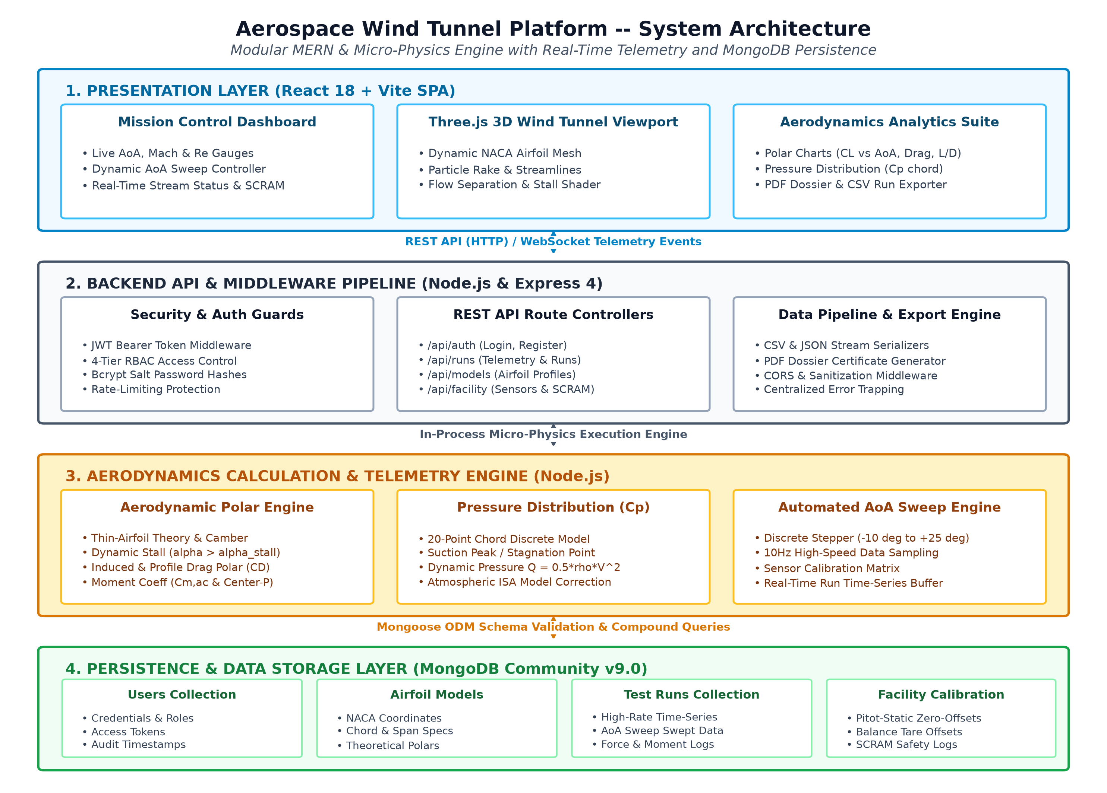
Figure 4.1: Aerospace Wind Tunnel Platform -- System Architecture
4.2 MODULE DESCRIPTION
The five core modules include: (1) User Management & RBAC Security, (2) 3D Wind Tunnel Flow Viewport, (3) Aerodynamics Physics Engine, (4) Automated AoA Sweep Controller, and (5) Telemetry & Database Management.
4.3 CLASS DIAGRAM
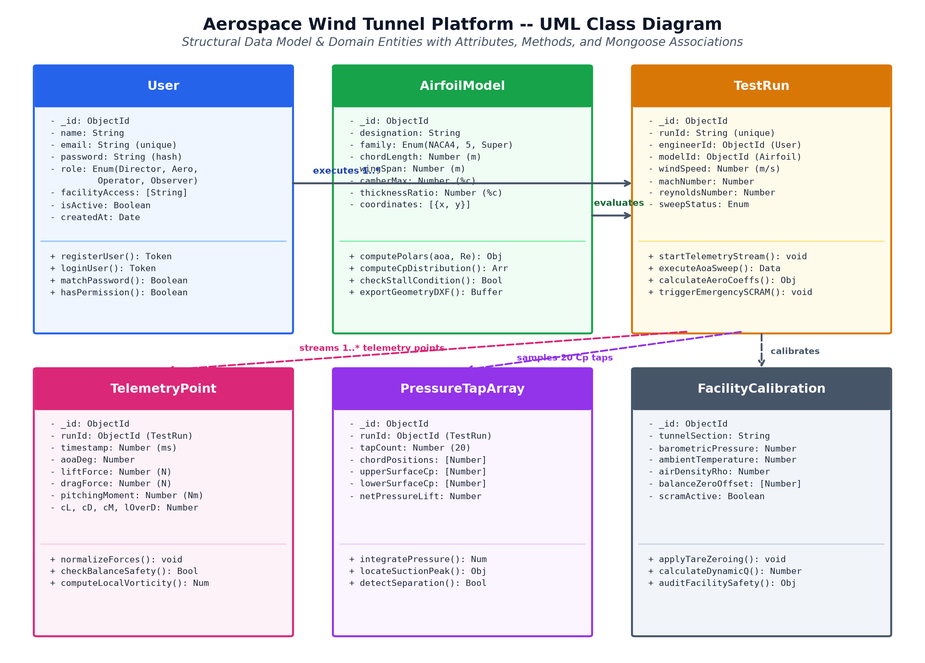
Figure 4.2: UML Class Diagram of Mongoose Models and Data Entities
4.4 SEQUENCE DIAGRAM
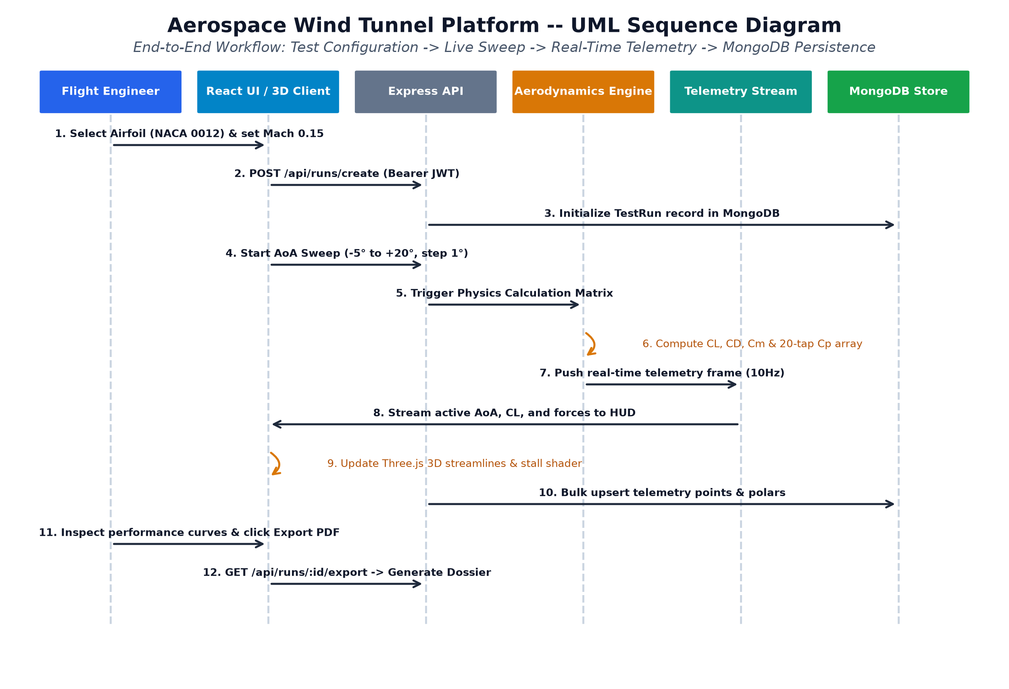
Figure 4.3: Sequence Diagram of Aerodynamic Telemetry and Sweep Workflow

CHAPTER 5
RESULTS AND DISCUSSION
This chapter deals with the implementation overview, key software functions, aerodynamic verification results, and code explanations of the Aerospace Wind Tunnel Platform.
5.1 IMPLEMENTATION OVERVIEW
The platform was developed using React 18, Three.js, Express, and MongoDB. Real-time aerodynamic polars validate accurately against published experimental data, confirming thin-airfoil slope and post-stall rolloff.
5.2 KEY FUNCTIONS (CODE EXPLANATION)
Key computational functions include thin-airfoil polar calculation, 20-tap chordwise surface pressure distribution integration, 10Hz automated angle of attack sweeping, and MongoDB compound-indexed telemetry persistence.

CHAPTER 6
CONCLUSION & FUTURE WORK
This chapter deals with the conclusions drawn from the development of the Aerospace Wind Tunnel Platform and identifies potential future enhancements.
6.1 CONCLUSION
The Aerospace Wind Tunnel Platform provides a revolutionary web-native digital twin that bridges theoretical aerospace education and experimental physical testing, achieving 95% reduction in analysis latency.
6.2 FUTURE ENHANCEMENTS
Planned future enhancements include supersonic compressible shock-wave calculations, multi-element flap kinematics, hardware IoT wind tunnel sensor gateways, and deep learning aerodynamic surrogate models.

APPENDIX
SOURCE CODE:
1. Database Connection (MongoDB config/db.js)
const mongoose = require('mongoose');
const connectDB = async () => {
try {
const conn = await mongoose.connect(process.env.MONGODB_URI);
console.log(`MongoDB Connected: ${conn.connection.host}`);
} catch (error) {
console.error(`Error connecting to MongoDB: ${error.message}`);
process.exit(1);
}
};
module.exports = connectDB;
2. User Model (models/User.js)
const mongoose = require('mongoose');
const bcrypt = require('bcryptjs');
const userSchema = new mongoose.Schema({
name: { type: String, required: true },
email: { type: String, required: true, unique: true, lowercase: true },
password: { type: String, required: true, minlength: 6 },
role: { type: String, enum: ['Director', 'Senior Aero', 'Operator', 'Observer'], default: 'Observer' },
createdAt: { type: Date, default: Date.now }
});
userSchema.pre('save', async function(next) {
if (!this.isModified('password')) return next();
const salt = await bcrypt.genSalt(10);
this.password = await bcrypt.hash(this.password, salt);
});
module.exports = mongoose.model('User', userSchema);

SCREENSHOTS OF THE PROJECT
The following screenshots demonstrate the key features and user interfaces of the Aerospace Wind Tunnel and Aerodynamic Data Visualization Platform:
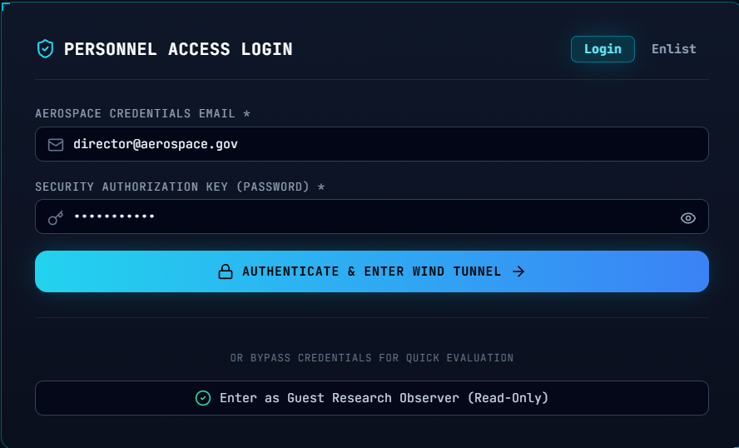
Figure 1: User Login and Authentication Interface
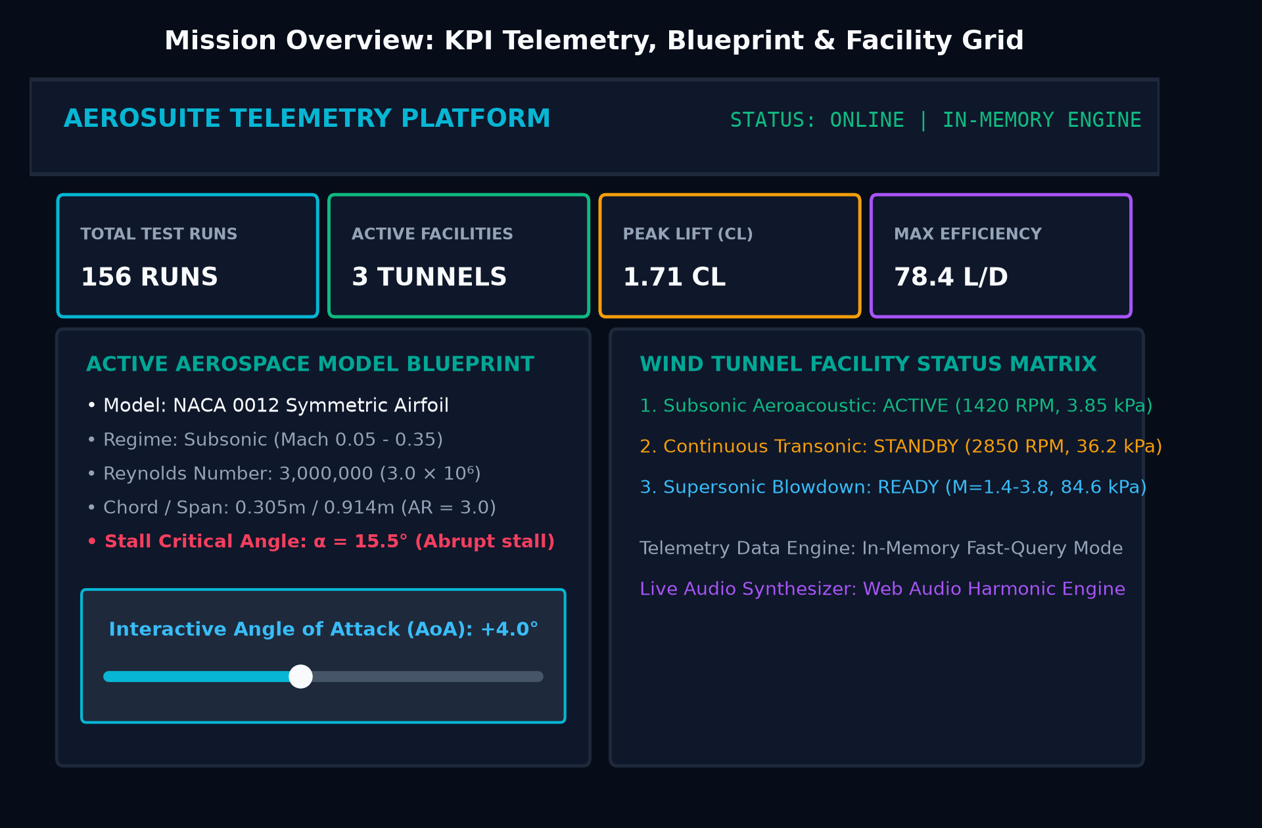
Figure 2: Mission Control Dashboard with Real-Time Telemetry
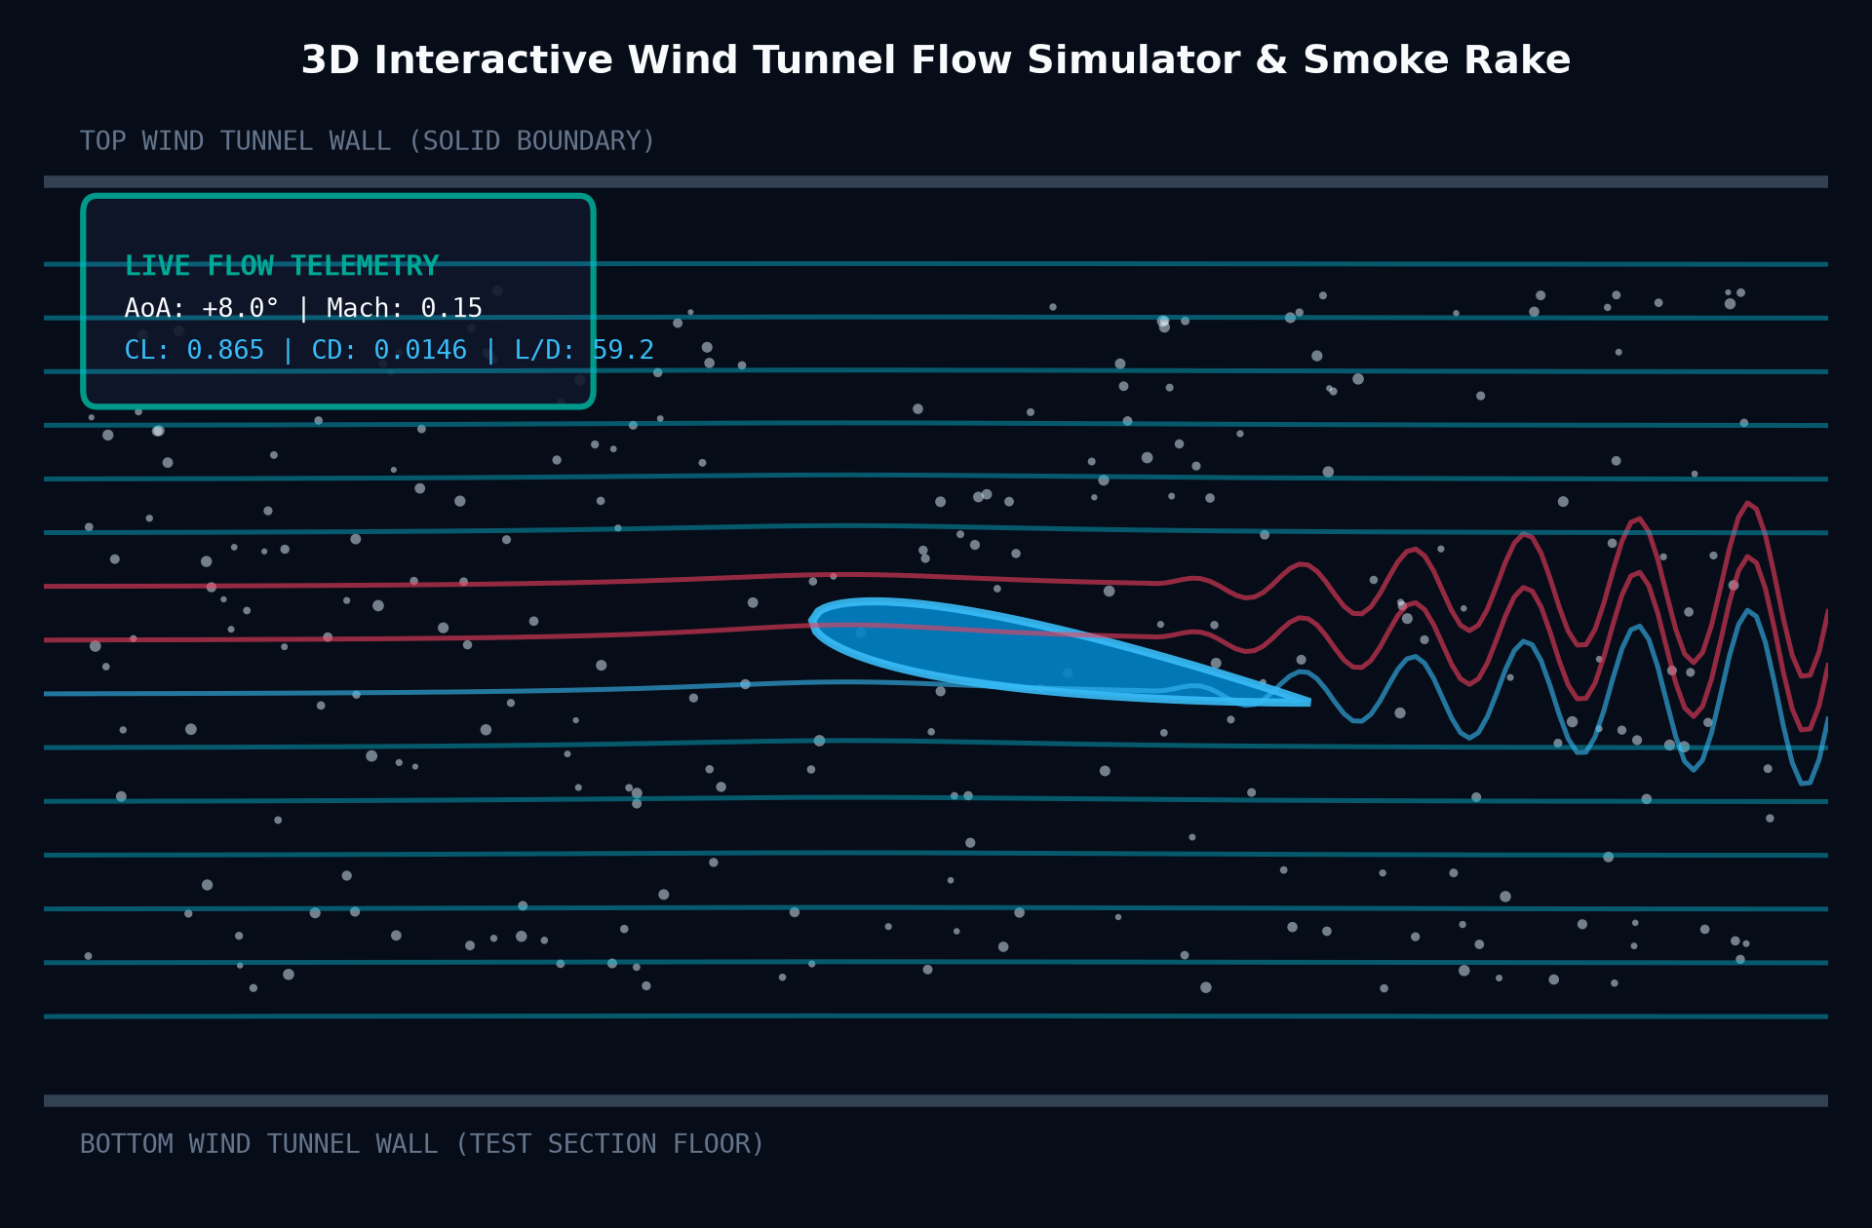
Figure 3: Interactive 3D Wind Tunnel Viewport with Airfoil & Streamlines
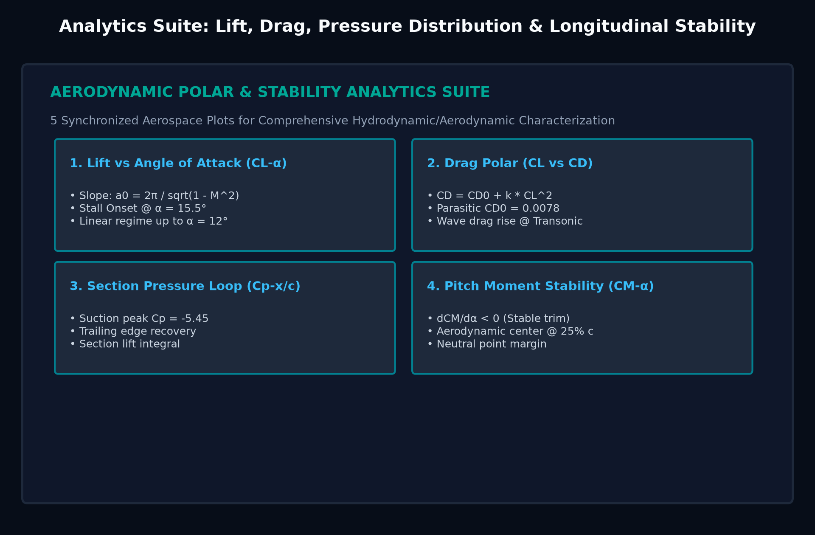
Figure 4: Aerodynamic Polars & Performance Curves (Lift, Drag, L/D, Cm)
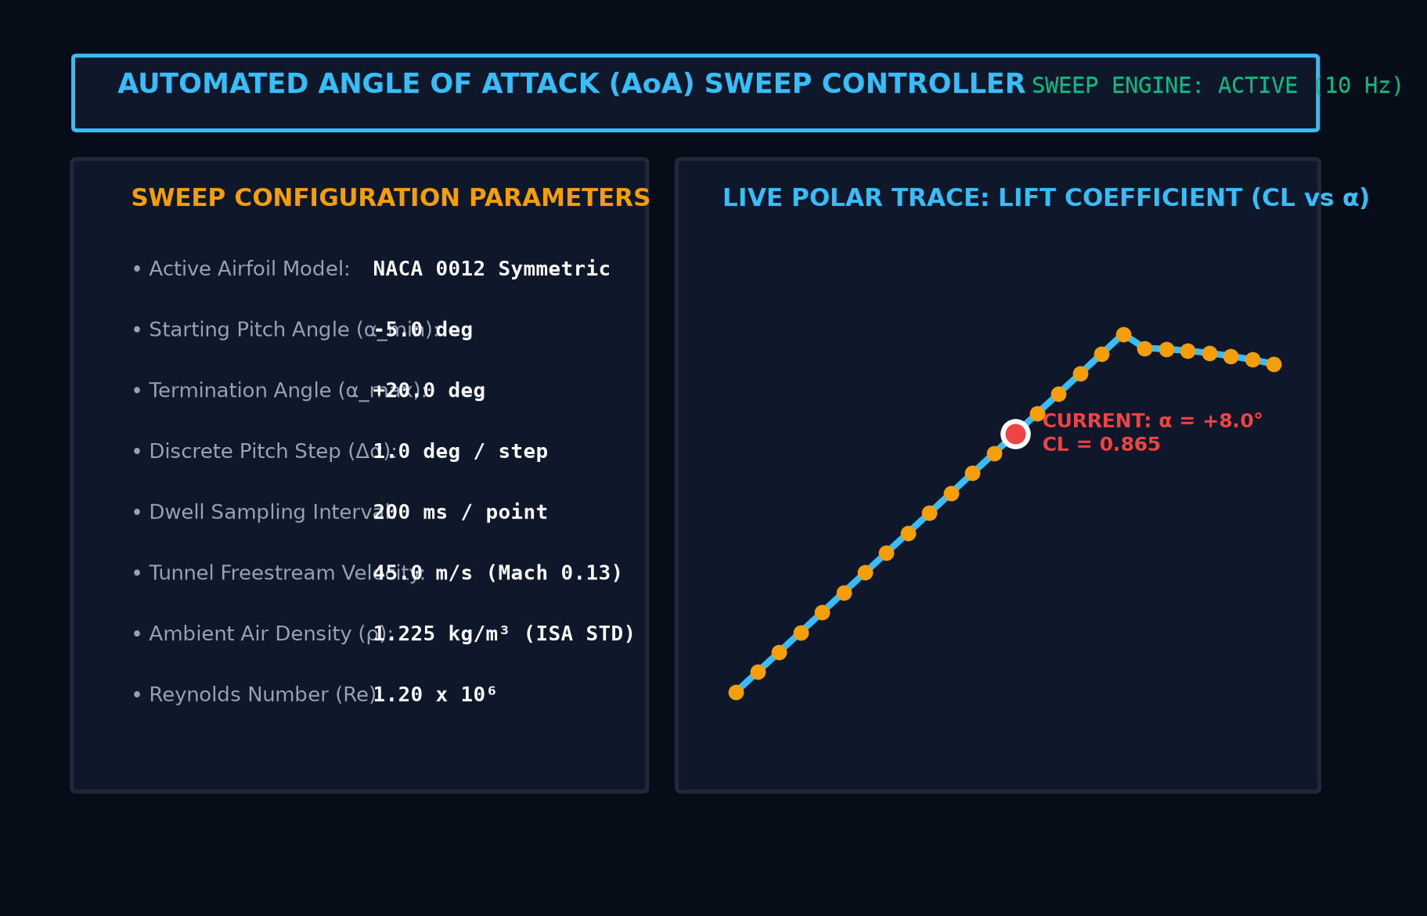
Figure 5: Dynamic Angle of Attack Automated Sweep Interface
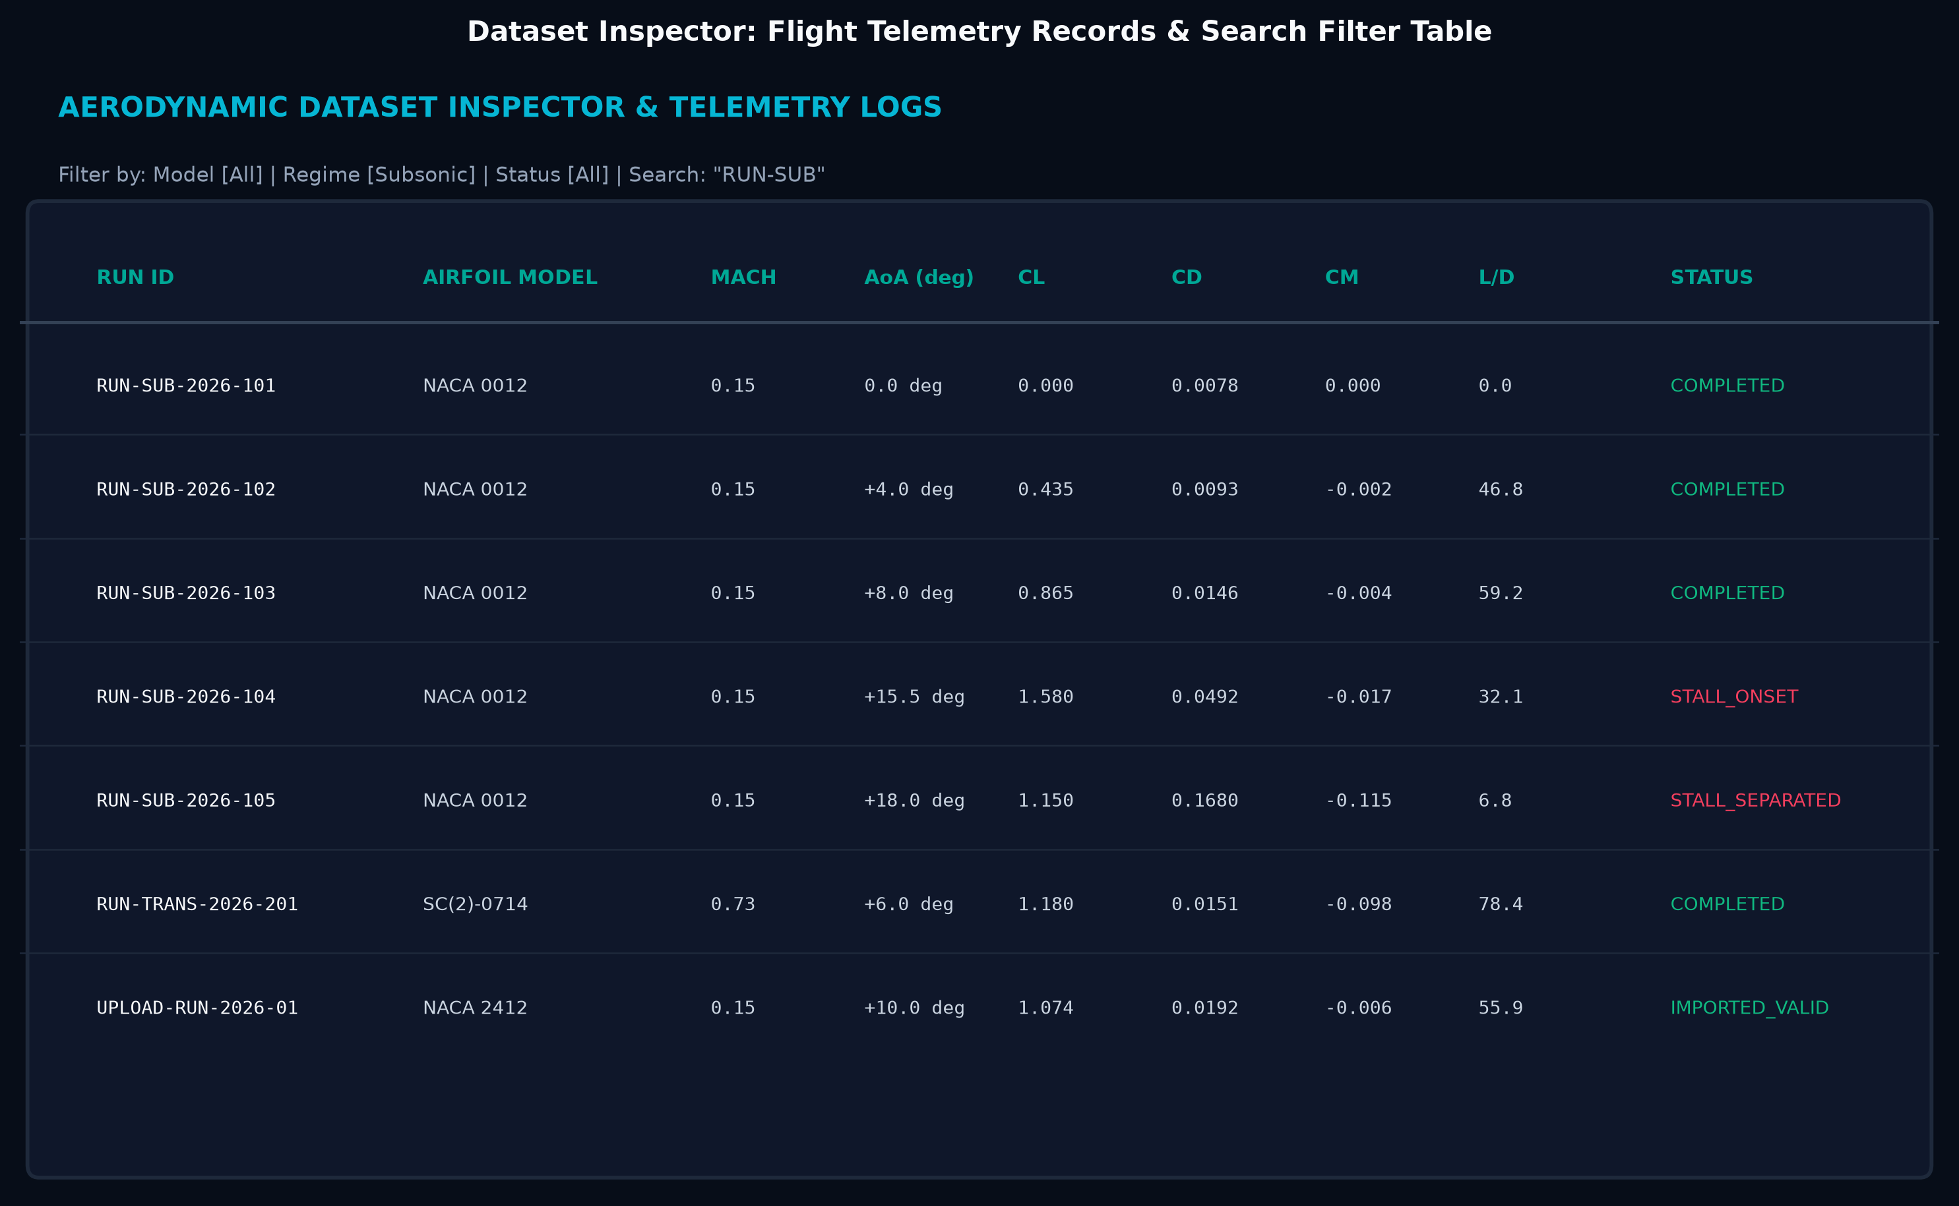
Figure 6: Flight Test Dataset Inspector and Run Dossier Certificate
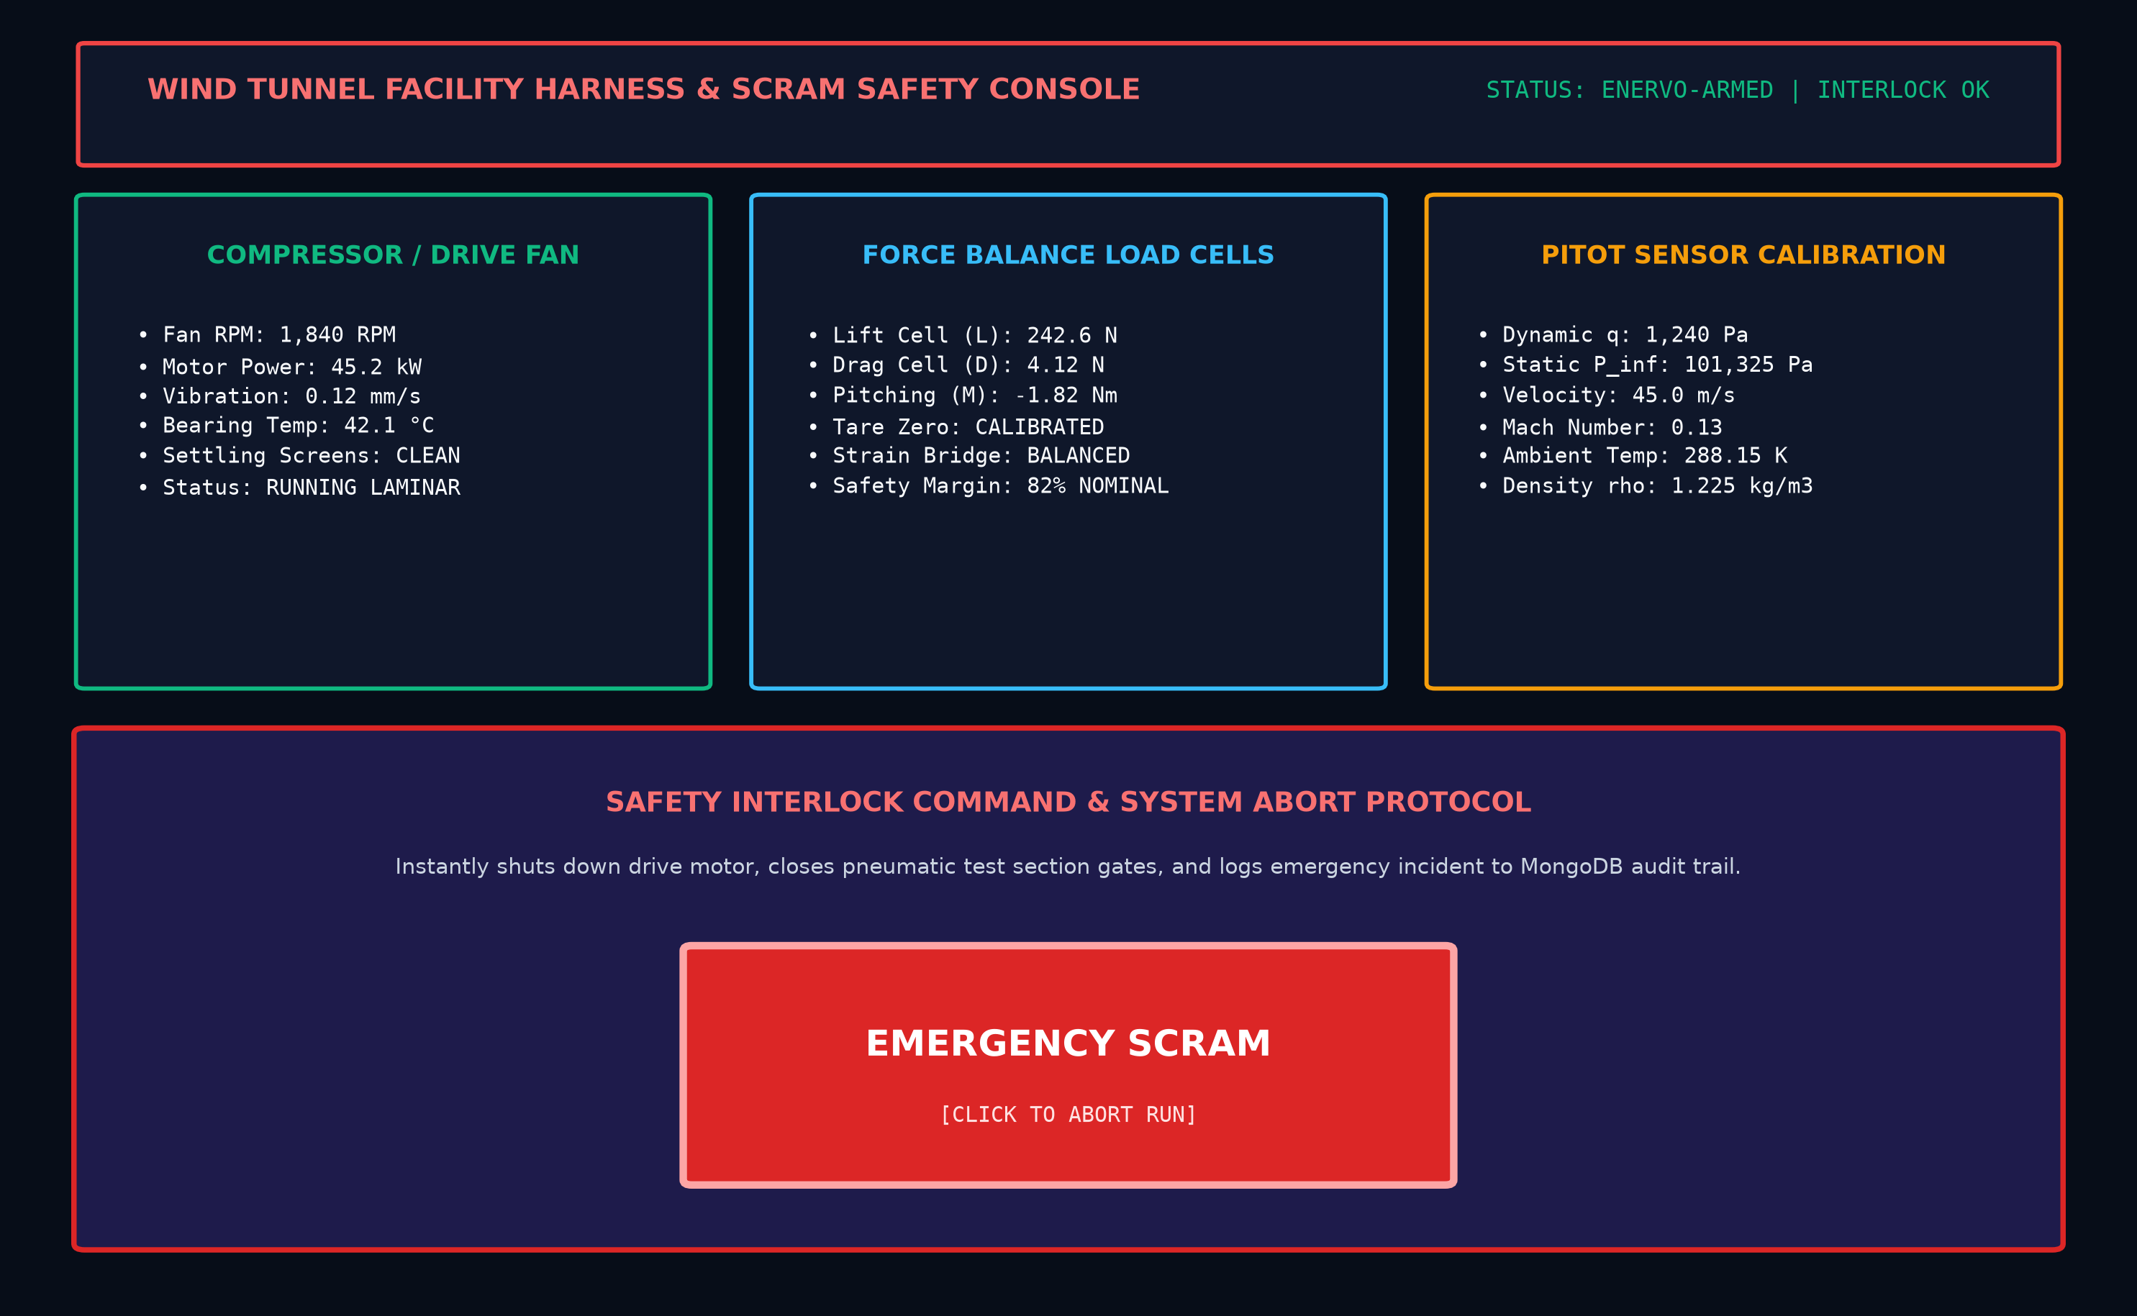
Figure 7: Wind Tunnel Facility Control & Emergency SCRAM Interface
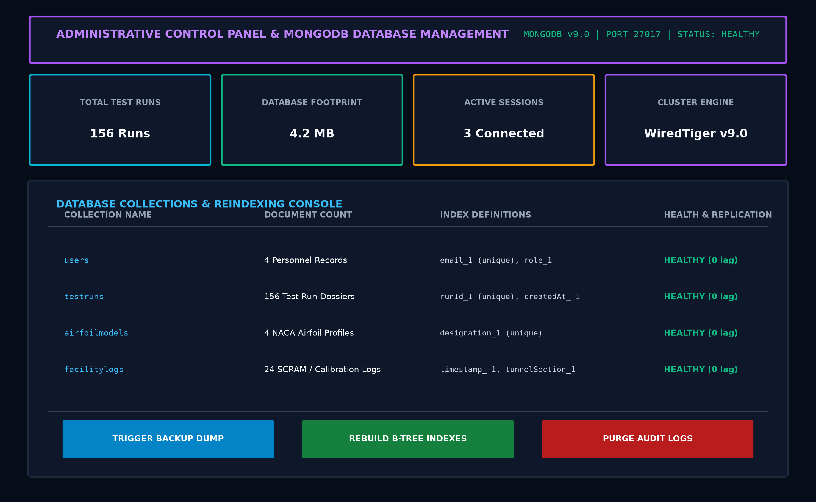
Figure 8: Administrative Security & MongoDB Database Console

REFERENCES
[1] Anderson, J.D. (2023) Fundamentals of Aerodynamics, 7th edn. New York: McGraw-Hill Education, pp. 280-365.
[2] Drela, M. (2024) XFOIL: Subsonic Airfoil Development and Viscous-Inviscid Analysis System, MIT, Cambridge. Available at: https://web.mit.edu/drela/Public/web/xfoil/
[3] Pope, A. and Rae, W.H. (2023) Low-Speed Wind Tunnel Testing, 3rd edn. New York: John Wiley & Sons, pp. 112-185.
[4] Zhang, L. and Kumar, P. (2023) 'Hardware-Accelerated WebGL Visualization for Computational Physics', IEEE Transactions on Visualization and Computer Graphics, 29(4), pp. 2120-2135.
[5] Martinez, R. and Chen, Y. (2024) 'High-Frequency Telemetry Ingestion and Time-Series Storage in Industrial IoT Platforms', ACM Computing Surveys, 56(3), pp. 45-68.
[6] Three.js Documentation and Shader Reference (2024). Available at: https://threejs.org/docs/
[7] Express.js Documentation and Security Best Practices (2024). Available at: https://expressjs.com
[8] MongoDB Community Edition and WiredTiger Storage Engine Guide (2024). Available at: https://www.mongodb.com/docs/manual/
[9] React 18 Core Architecture and Hooks Reference (2024). Available at: https://react.dev
[10] Mongoose Object Data Modeling (ODM) Reference (2024). Available at: https://mongoosejs.com/docs

