1.Count all letters, digits, and special symbols from a given string

Source Code:

string = input("Please Enter your Own String : ")

alphabets = digits = special = 0

for i in range(len(string)):

if(string[i].isalpha()):

alphabets = alphabets + 1

elif(string[i].isdigit()):

digits = digits + 1

else:

special = special + 1

print("\nTotal Number of Alphabets in this String : ", alphabets)

print("Total Number of Digits in this String : ", digits)

print("Total Number of Special Characters in this String : ", special)

Output: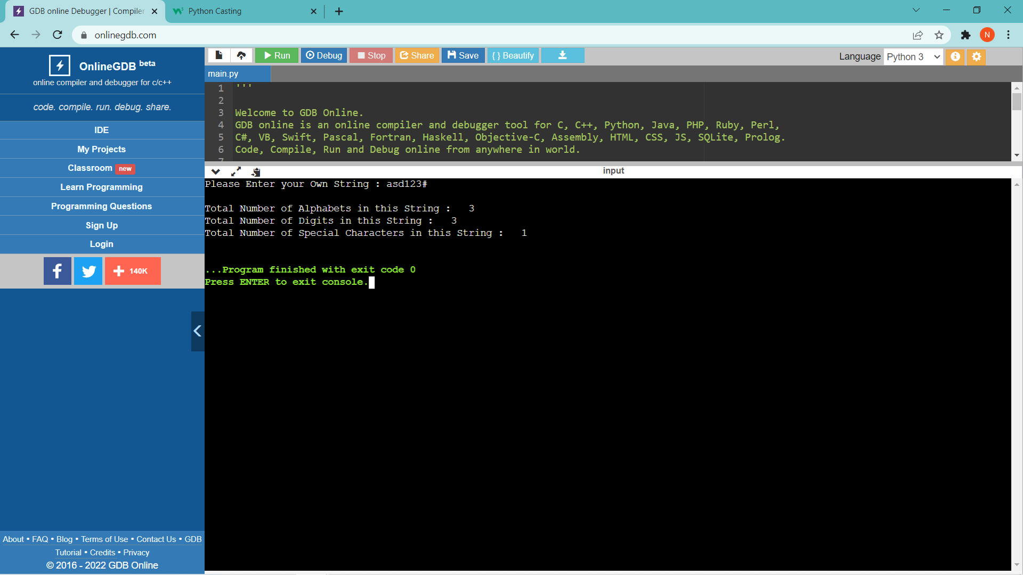

2.List out inbuilt string methods. Explain any 2 with example.

Ans: There are many different and different types of inbuilt string functions there are dozens of them. They are used to study in different structures one of the example is given above.

1. Capitalize():

It converts the first character of the word into uppercase for instance if we have word ‘hello’ then it turns it into ‘Hello’

1. Upper()

It used to convert the string into uppercase or in simple words if we have an word ‘hello’ then it converts it into ‘HELLO’

Ex:

* 1 txt = “hello”

print(txt.capitalize())

1. 2 txt = ‘hello’

Print(txt.upper())

3.Write a Python program to get the sum of a non-negative integer using

function (I. e input 123 output 6)

def sum(input):

temp=0;

while(input >1):

reverse = input%10

input = input/10

temp = temp+reverse

print(int(temp))

a = int(input("Enter the number: "))

sum(a)

output:

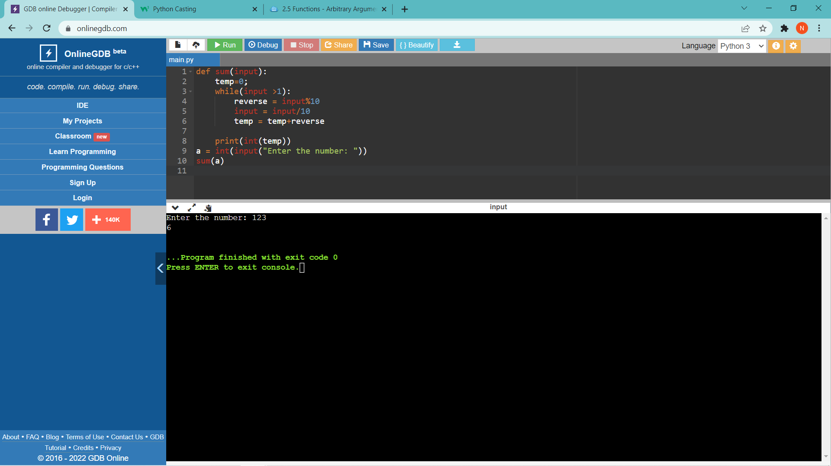

4.Explain arbitrary number of arguments in function using example.

The arbitrary arguments are **passed as tuple (with one asterisk*) to the function**, (you can change it to a list as shown in the code) and calculate the sum of its elements, by coding yourself using a for loop; if don't want to use the sum() method of python.

Ex: def summing(*arg):

li = list(*arg)

x = 0

for i in range((len(li)-1)):

x = li[i]+x

return x

#creating a list and pass it as arbitrary argument to the function

#to colculate the sum of it's elements

li = [4, 5 ,3, 24, 6, 67, 1]

print summing(li)

5.Explain lambda function with the use of filter function.

To filter a list in Python, you can use the built-in filter() function.

* The first argument is the filtering condition, defined as a function. This filtering condition function is often dynamically-created using [lambda functions.](https://blog.finxter.com/a-simple-introduction-of-the-lambda-function-in-python/)
* The second argument is the iterable to be filtered—the lambda function checks for each element in the iterable whether the element pass the filter or not.

The filter() function returns an iterator with the elements that pass the filtering condition.

lst = [**1**, **2**, **3**, **4**, **5**]

# Filter all elements <3

my_list = filter(**lambda** x: x<**3**, lst)

print(list(my_list))

# [1, 2]