# Week #5

**Week 5 - Understanding Transport layer and Network Layer**

**SRN : PES2UG20CS237**

**Name : P K Navin Shrinivas**

**Section : D**

## Task 1 :UDP and DNS

* Opening wireshark and filtering for DNS and UDP signals specific to my ip address.
* Pinging [www.pluralsight.com](http://www.pluralsight.com) to generate DNS packets.

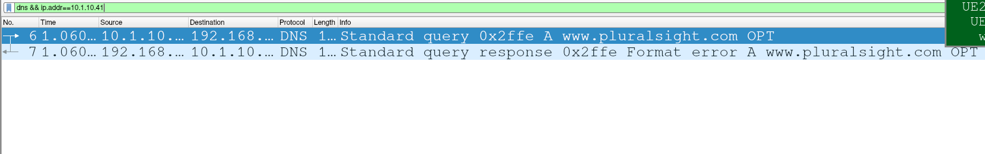

Filtered packets

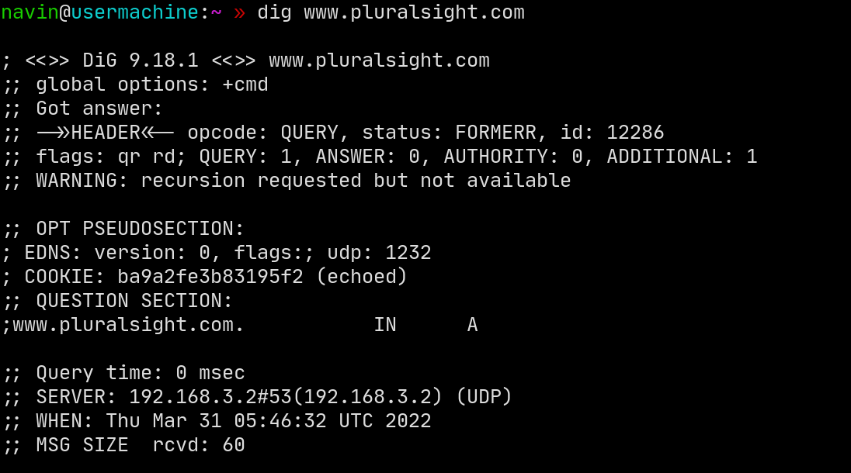

dig command to generate UDP packets

## (Q) My predictions for UDP structure :

|  |  |
| --- | --- |
| 2 bytes for source port | 2 bytes for dest port |
| 2 bytes for length | 2 bytes for UDP checksum |
| X bytes for payload | X bytes of payload |

## (Q) And in wireshark : Hence concluding predictions were right!

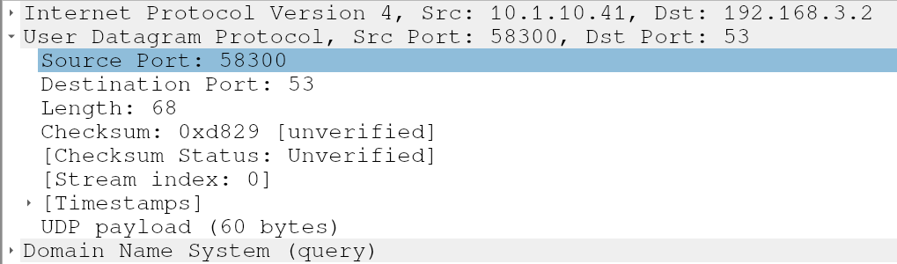

UDP in Wireshark

* Why is the checksum “unverified” in wireshark UDP packets? It is because these UDP packets were genrated by dig, iptrace or tcpdump will calculate these checksums and elad to “verified” status.

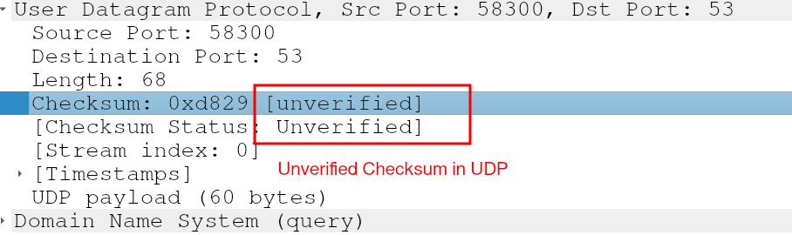

## Task 2 :TCP

* Download the file from <http://www.gutenberg.org/ebooks/2383.txt.utf-8>
* Open up wireshark and keep it prime to filter TCP packets from and to <http://www.ini740.com/Lab2/lab2a.html>
* Upload the files and stop wireshark, wireshark output :

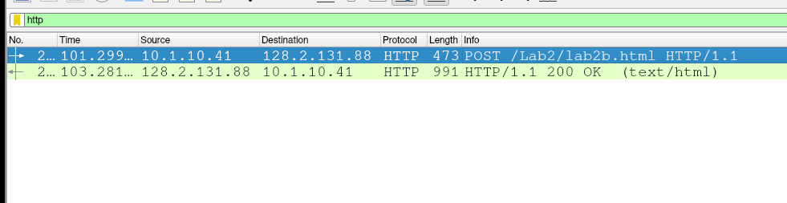

* (Q) What is the source/dest ip address and source port? IP :

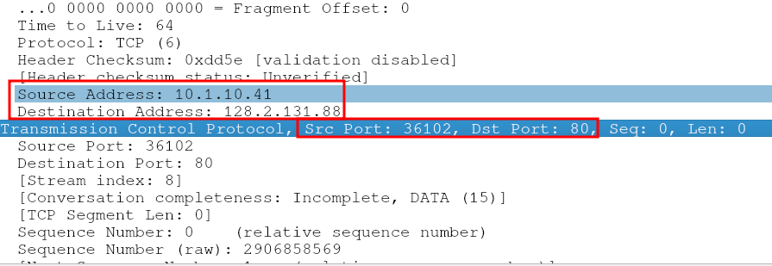

* Point of this task is to observe TCP packets, hence filter for them :

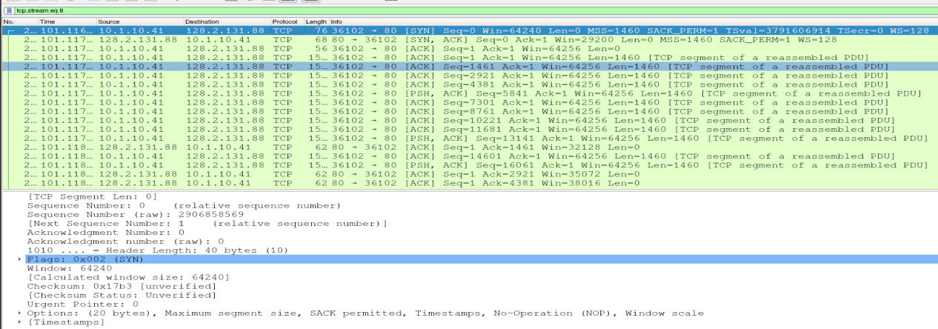

## Task 2b : TCP Basics

* (Q14) Sequence number of SYN packets are 0, SYN segments can be identified using the TCP flag segments. Yes wireshark can display absolute seq numbers by : edit->prefrence->protocols->tcp->untick relative numbering.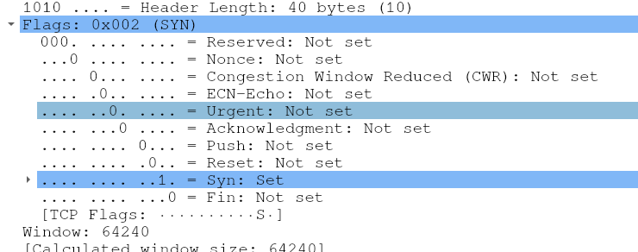

SYN Identification

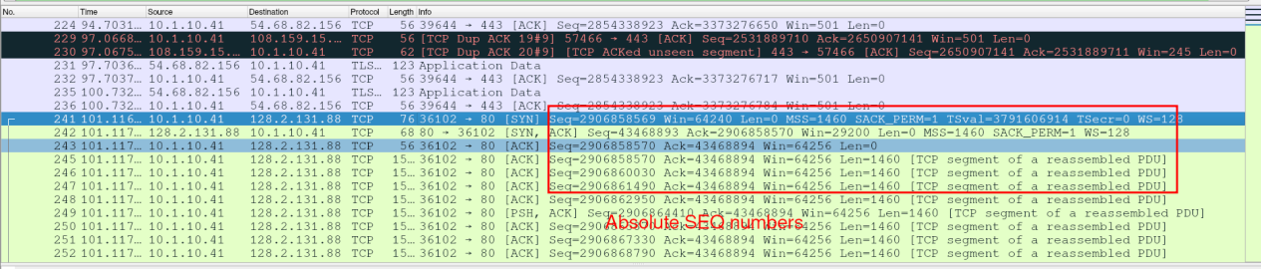

Relative TCP seq numbering

* (Q15) SYNACK has a relative sequence number of 1, ACK number of SYNACK packets is 1, this is because the server is asking for the best bit waiting for the three way handshake.The Flag field in TCP packets shows it is a SYNACK packet:

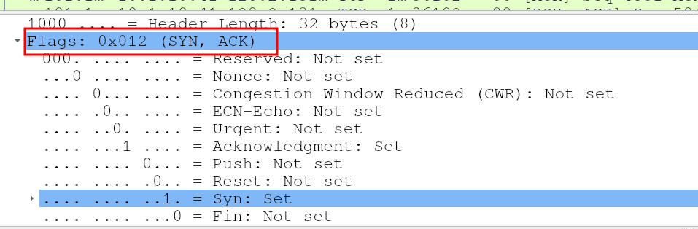

* (Q16) TCP SEQ number (relative) of HTTP post is : 1702361, this I feel is the entirty of uploaded content and remaining payload (1702278) are for headers.

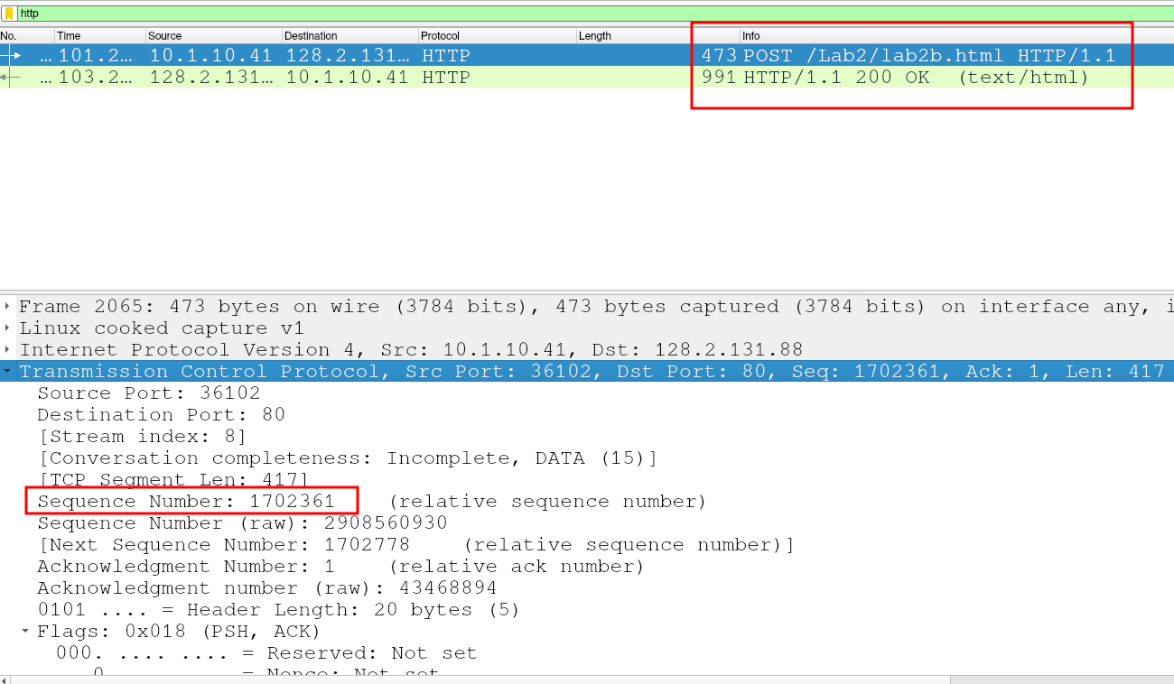

* (Q17)Sample RTT is simply the time taken to ACK a given segment, but to get smoother EstimatedRTT we take many samples from recent packets :

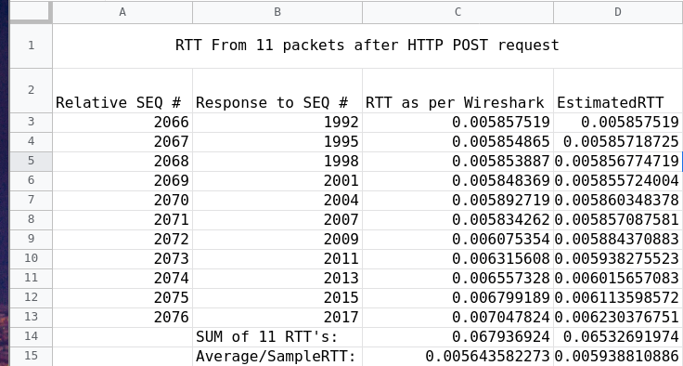

[Source](https://docs.google.com/spreadsheets/d/1hQjS8L1xW5pE3Ya-bxX8tmEiIFyVGTkClU3lQkpCMIc/edit?usp=sharing)

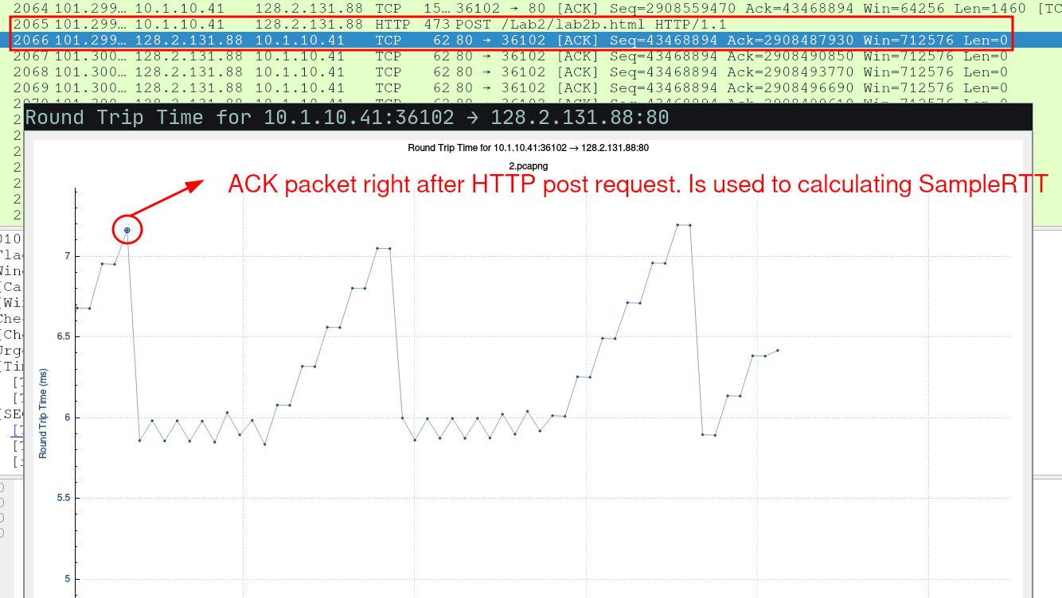

Now calculating the EstimatedRTT (In Table):

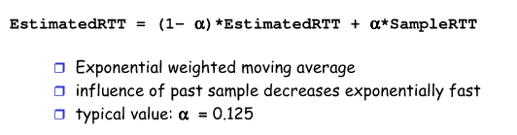

* (Q18)The window size on packets from A to B indicate how much buffer space is available on A for receiving packets. So when B receives a packet with window size 1, it would tell B how many bytes it is allowed to send to A. Hence looking at the window sizes here on reponses (ACK). We also see the windows are scaled with a factor of 128. Lowest observed window size : 32128

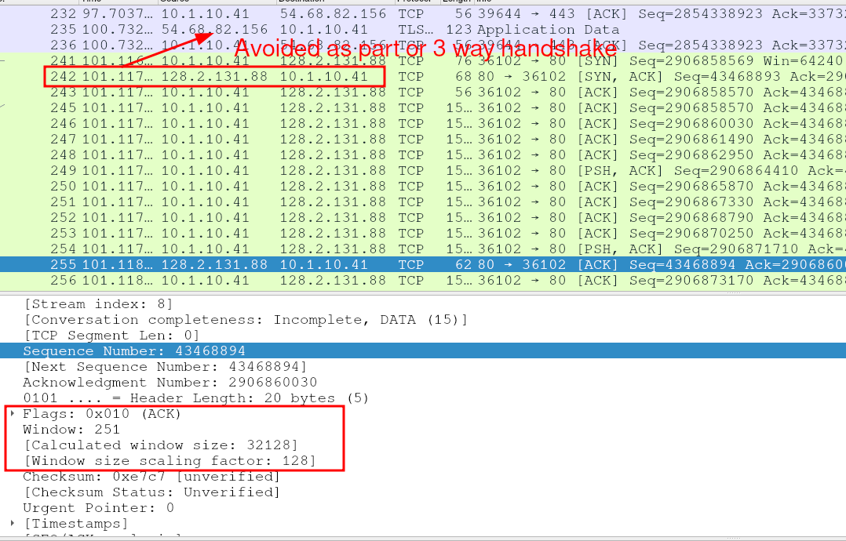

* (Q19)No, there are no retransmitted packets, I checked for these by filtering them using : tcp.analysis.retrasmission :

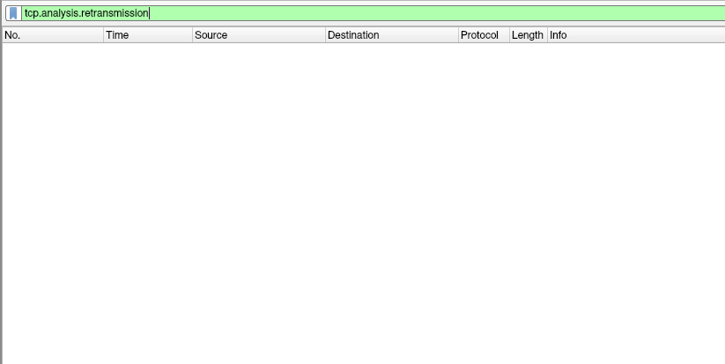

* (Q20)Comapring Sequence number of 2 consecutive ACK’s will give us the answer we need, I am comparing these two :

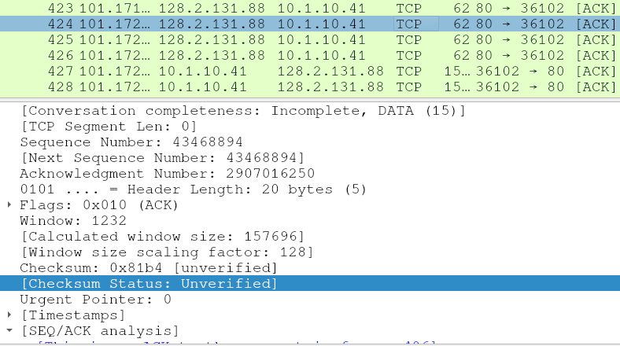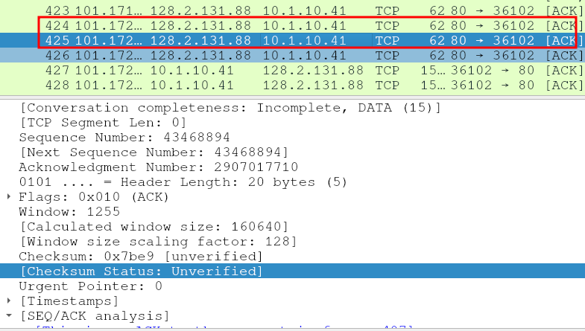

Subracting the two sequence number gives us : 1460, this the amount of bytes ACK’ed in each ACK response.Also, here we can see where the server is ACK’ing every other packet :

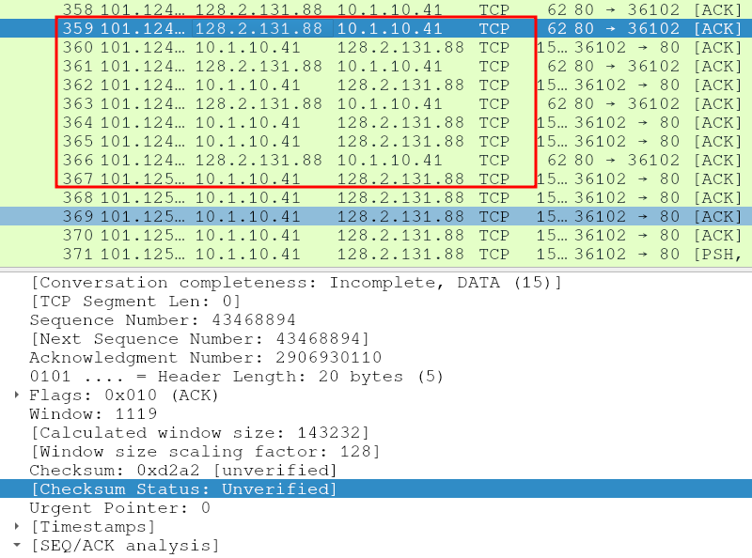

* (Q21)The HTTP reponse has a “time since request” value of 1.98 seconds, the HTTP POST has a content size of 1702219 bytes. This gives us a throughput of : ~840KB/second