Maverick
AI-ML intelligent dead reckoning for seamless navigation, on a smartphone, fully offline
Complete report and user guide: what it is, how to install and use it, methodology, pipeline, architecture, metrics and measured accuracy
Smart India Hackathon 2026 · Problem statement SIH26168 (ISRO) · AI-ML based Intelligent Dead Reckoning system for seamless navigation
Team captain: Suganthan Prabhu · Report version 3 · 27 September 2026
Every number in this report was produced by running the code on the data described. Where something is untested or weak, the report says so. The only work left is field data collection and on-road testing (section 10).

Contents

If the page numbers are missing, right-click the table of contents in Word and choose Update Field.

1. Summary
Maverick is an Android navigation app that keeps showing where a vehicle is when satellite positioning (GNSS/GPS) is lost: in tunnels, under flyovers, between tall buildings. While GPS is good it fuses GPS with the phone's motion sensors; when GPS drops out it estimates speed with AI models, heading with the gyroscope, and snaps the path to an offline OpenStreetMap road network. When GPS returns it switches back without a jump. Maps, search, routing and the AI models are all on the phone: it works with no internet.
The problem statement asks for drift below 10 % of the distance travelled during a GNSS outage. Measured median drift on 4 held-out IO-VNBD drives (the full on-phone engine, noisy 1 Hz GNSS, automatic outage detection):
Engine | Sensors | 30 s outage | 60 s outage | 120 s outage | Outages
Phone engine (the app) | Smartphone IMU only | 9.7 % | 6.6 % | 6.0 % | 291 / 289 / 285
Edge engine | External vehicle IMU | 7.5 % | 5.5 % | 4.4 % | 291 / 290 / 286
Floor: gyro + hold last GPS speed | Smartphone IMU | 26.7 % | 29.1 % | 36.6 % | same outages
OFFGRID car engine (another team) | Car CAN bus | 15.9 % | 21.8 % | 27.4 % | 296 / 295 / 291
- Target met: the phone engine is under 10 % at every outage length (30 s only just: 9.7 %); the edge engine is under 10 % everywhere.
- Tail: the worst 10 % of outages still drift 25–40 %, mostly where the map is missing a road or a turn is detected late.
- On the phone: the app was installed on a LAVA LXX506 (Android 14) and tested feature by feature. Demo drives on the phone gave median drift of 4.9 % (4 GPS-loss tests, 7.95 km) and 3.9 % (3 tests, 6.37 km).
- How to use it: section 3 is a user guide for anyone (install from the shared Maverick.apk, first start, buttons, a real drive step by step, sending drives, common problems).
- Code quality: an independent code review found 19 defects (none crashing on the normal path); all 19 are fixed and re-tested on the phone (section 8).
- What is left: field data collection and on-road testing in Coimbatore (car and two-wheeler), the one-time final test on the reserved drive M, and the bike model (beta until about 2 hours of rides are recorded).

2. What Maverick is

2.1 The problem
Phone navigation depends on GNSS. In tunnels, underpasses, multi-level flyovers, dense city blocks and parking structures the signal is lost or badly wrong, and ordinary apps freeze the position or let it jump. SIH26168 asks for an AI-ML dead-reckoning system that keeps the position accurate (drift under 10 % of distance) through the outage, handles the loss and return of GNSS seamlessly, runs at 10 Hz on a phone, and also works with an external IMU.

2.2 What the app does
- Shows your position on an offline map with a direction beam (like Google Maps) and a compass with degrees and N / NE / E / SE / S / SW / W / NW.
- Searches places and streets offline, draws the route and gives turn-by-turn directions with voice, re-routing automatically.
- Keeps navigating through GPS loss: blue dot = GPS + sensors, amber dot = dead reckoning, with an uncertainty circle that grows with distance.
- Measures its own accuracy on every drive and saves a report picture with drift %, MAE, RMSE and R², plus all raw data for training.
- Keeps separate statistics and recordings for each of your vehicles (car or bike, with your own names).
- Runs a demo drive from the ISRO IO-VNBD dataset, so the dead reckoning can be shown indoors to judges.

2.3 Problem-statement requirements
Requirement (SIH26168) | How Maverick meets it | Status
Drift below 10 % of distance | Phone 9.7 / 6.6 / 6.0 %, edge 7.5 / 5.5 / 4.4 % median at 30 / 60 / 120 s | Met on the dataset; field test pending
Map matching and non-holonomic constraints | Particle filter on OpenStreetMap roads; motion only along the heading | Done
Alignment / calibration engine | Yaw from gyro projected on gravity (any mount); gyro bias learned at every stop | Done
AI speed and vibration filter | LightGBM stop detector + LightGBM speed correction on 79 vibration features | Done
AI-based GNSS + INS fusion | EKF (x, y, heading, speed) fed by the AI speed/stop models; map layer during loss | Done
Seamless GNSS loss and return | GNSS loss detected 0.6 s after the outage begins (average); return after 2 good fixes; 2 s glide | Done
10 Hz output on the phone | Engine tick every 100 ms; exact Java port of the Python models | Done
Edge engine for external IMU (e.g. 200 Hz FOG) | Edge engine with its own model; runner bins any IMU rate to 10 Hz | Done on dataset IMU; no FOG hardware tested
Real-time navigation UI | Android app (map, search, routing, voice, compass, reports) | Done
Position plots on IO-VNBD | Figures 5 and 6; drive-report PNG on every drive | Done

3. User guide: how to use Maverick
This section is written for anyone who uses the app: friends, testers, judges. No laptop is needed. Section 3.10 is only for the team, to build the app from source.

3.1 What you need
- An Android phone with Android 10 or newer and a gyroscope (almost every phone has one).
- About 200 MB free for the app, plus about 60 MB per hour of driving if sensor saving is on.
- A phone holder for the car dashboard or the bike handlebar (for real drives).
- No internet and no account. Maps are included for Coimbatore and the ISRO demo area (Coventry, UK); elsewhere the app still tracks position but shows no map.

3.2 Install the app from the APK file
The team shares one file: Maverick.apk (about 48 MB), for example over WhatsApp as a document, Telegram, Google Drive or a USB cable.
- Open Maverick.apk on the phone (from WhatsApp, Files or Downloads).
- Android asks to allow installing unknown apps from that app (WhatsApp or Files): allow it once, go back, and tap Install.
- If Google Play Protect warns about an unknown developer, tap More details › Install anyway. It warns only because the app is not from the Play Store.
- Open Maverick. When asked, allow Location › While using the app › Precise, and allow notifications (they keep navigation running with the screen off).
- Updating to a newer version: install the new APK over the old one. If Android says it cannot install, uninstall the old Maverick first (your drive folders in Documents/Maverick stay).

3.3 First start (2 minutes)
- The map opens at your location with a blue dot; the light beam shows the way the phone faces, and the compass (top right) shows the direction in degrees.
- Tap the vehicle chip above Start ("🚗 My car ▾") › ＋ Add a vehicle: type a name (e.g. "Pulsar 150") and choose Car or Bike / scooter. Pick the vehicle you are using before every drive.
- Try it indoors: ☰ › Demo drive. A recorded car drive plays, GPS is cut every 3 minutes, and you see the dead reckoning (amber dot) against the true position. Press Stop, then 📊 Open last drive report.
- Dark or light look: ☰ › Appearance (Same as phone, Light, Dark).

3.4 The screen and buttons
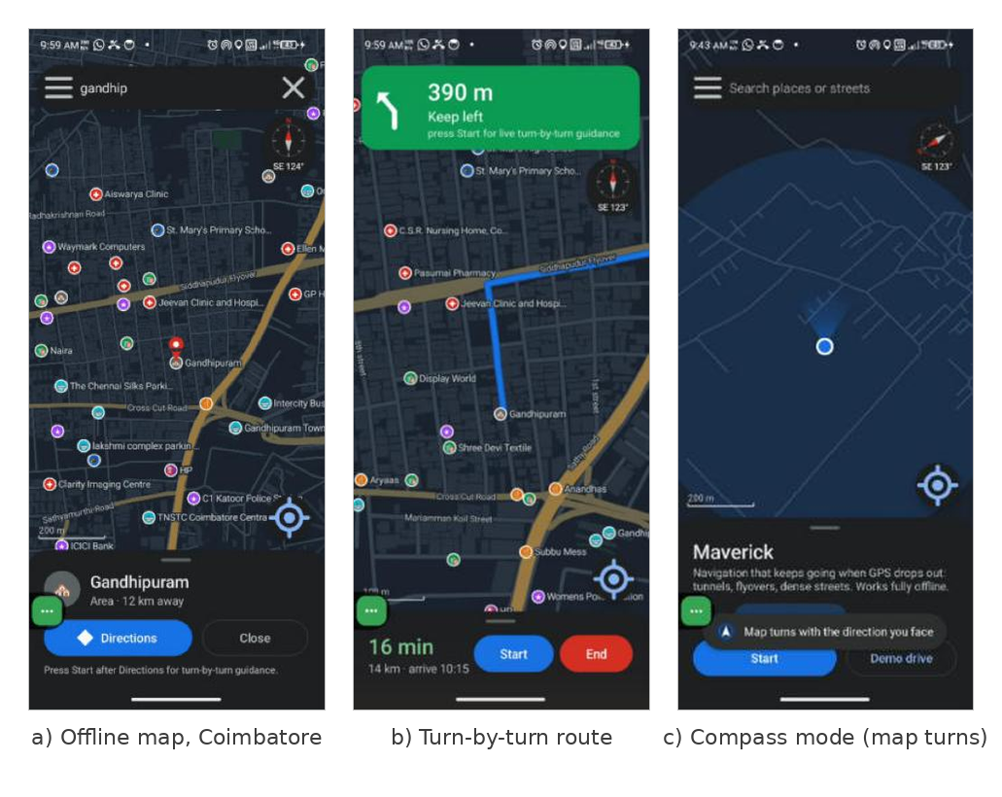
Figure 1. The app on the test phone: offline map of Coimbatore with place and street names; a route with the turn banner; compass mode, where the map turns with the phone.
Element | What it does
Search bar (top) | Type a place or street. Results show a category icon and the distance. Tap one to see it, then Directions.
☰ menu | Demo drive, Stop, Save sensor data for training, Sensor log rate, Vehicles & statistics, Appearance, Open last drive report, What is Maverick?
Compass (top right) | N points to north on the map; the label is the direction the phone faces, e.g. "SE 123°". Tap it to go back to north up.
Status chip | "GPS + sensors" (green) or "No GPS · dead reckoning 0:42" (amber) while driving.
Blue dot + beam | Your position and the way you face. Amber dot = dead reckoning, with an uncertainty circle.
Locate button | 1st tap: centre on you. 2nd tap: compass mode (map turns with you). 3rd tap: north up.
Map gestures | Drag to move, pinch to zoom, double-tap to zoom in, twist with two fingers to rotate, tap a place to select it, long-press to drop a pin.
Bottom panel | Vehicle chip, Start, Demo drive; while driving: speed, mode, error, Stop, Test GPS loss; while navigating: time, distance, arrival time, Start/Stop, End.

3.5 A real drive, step by step
- Choose your vehicle: tap the vehicle chip (e.g. "🏍 bike a · beta ▾"). Add vehicles with your own names and type (Car or Bike). Car uses the car model; Bike uses the beta bike model.
- Mount the phone firmly (a dashboard or handlebar holder). Any orientation works; do not move it during the drive.
- Press Start. Wait for "GPS + sensors" before driving off (the first minutes also calibrate the gyroscope at stops).
- To navigate: search, tap the result, Directions. The map turns so your direction of travel is up, and a voice announces turns. End stops guidance.
- To see dead reckoning in action: press Test GPS loss. GPS is hidden from Maverick (not from the phone), the dot turns amber and the panel shows the live error against the real GPS. Tap again to restore.
- Press Stop at the end. The drive is saved and a report is made (section 3.7).

3.6 Demo drive (for judges, works indoors)
☰ › Demo drive replays drive S1 of the ISRO IO-VNBD dataset (Coventry, UK) at 5× speed with a car model that never saw that drive. GPS is cut for 60 s every 3 minutes; the true position is drawn as a ring labelled "true position", and the panel shows the error in metres and % of distance. Press Stop at any time; a demo report is saved in Documents/Maverick/Demo.
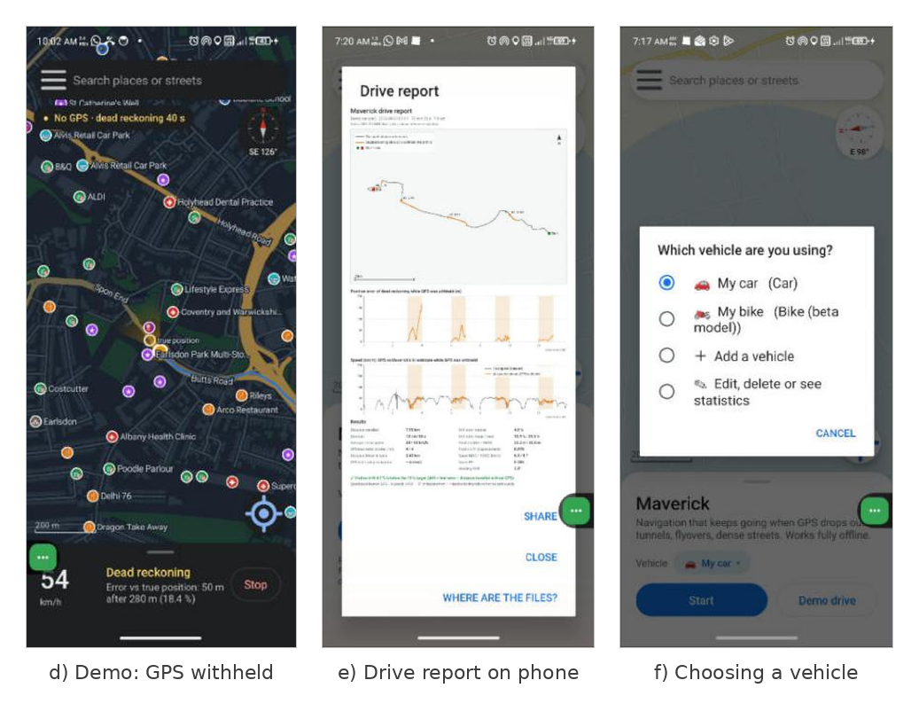
Figure 2. Demo drive during a GPS cut (amber dot vs the true position); the drive report on the phone; the vehicle chooser.

3.7 Drive files and the report
Every drive creates a folder automatically: Documents/Maverick/<vehicle>/drive_<date_time>/ (demo drives: Documents/Maverick/Demo/). Copy it to the laptop over USB (choose "File transfer" on the phone). Nothing has to be created by hand.
File | Contents
report.png | Map of the GPS track and the dead-reckoned test sections, error and speed charts, results table
summary.json | All metrics (drift, MAE, RMSE, R², speed and heading errors) and every test window
track.csv | 10 rows/s: Maverick position, speed, heading; test-engine position; latest GPS fix and its age; error
sensors.csv | One row per step (default 50 rows/s), one column per axis: accelerometer, gyroscope, gravity, linear acceleration, magnetic field, rotation vector, yaw/pitch/roll, latest GPS fix and its age, event counts (n_acc, n_gyr)
gnss.csv | Every GPS fix with its own timestamp (about 1 per second)
track.geojson / track.gpx | Tracks for QGIS, Google Earth or geojson.io
info.txt | Vehicle name and type, phone model, Android version, log rate
Settings: ☰ › Save sensor data for training (on by default, about 60 MB per hour at 50 Hz) and ☰ › Sensor log rate (10, 25, 50 or 100 Hz). GPS gives about one new fix per second, so in sensors.csv the GPS columns repeat the latest fix and gnss_age_s shows how old it is; gnss.csv holds only the real fixes.

3.8 Sending your drives to the team
- Connect the phone to a laptop by USB and choose File transfer on the phone (or use the Files app and share the folder as a zip).
- Open Internal storage › Documents › Maverick. There is one folder per vehicle and one sub-folder per drive (date and time in the name).
- Copy the drive folders and send them to the team. After copying you may delete old folders on the phone to free space.
The drive report of any drive can also be sent straight from the app: 📊 Open last drive report › Share.

3.9 Questions and problems
Situation | What to do
"Waiting for GPS…" does not change | Go outdoors with open sky; the first fix can take up to a minute. Check that Location is on and set to Precise.
No map, only the blue dot | Your area is outside the included maps (Coimbatore, Coventry). Tracking and drive files still work; the team can add a map for your city.
Few shop or street names | The map comes from OpenStreetMap, which has fewer names than Google Maps. Zoom in: more names appear. Internet does not change this.
The map turned and will not straighten | Tap the compass (top right) to return to north up.
The map does not follow me | Tap the locate button (bottom right) once.
"No report" after a drive | A report needs a GPS fix and at least about 3 minutes of driving (the first accuracy test starts 2 minutes after the first fix). Drive data is still saved.
App closed unexpectedly | Open it again: it shows a crash report with a Copy button. Paste it to the team.
Phone storage filling up | ☰ › untick Save sensor data for training, or lower ☰ › Sensor log rate to 10 or 25 Hz.
Battery | Keep the phone on a charger for drives over an hour; the screen can be off, navigation keeps running.

3.10 For the team: build from source and add city maps
- Install Android Studio on the laptop. Open the folder D:\Maverick_Final\MaverickGRID (File › Open) and wait for Gradle sync.
- On the phone: Settings › About phone › tap Build number 7 times, then Developer options › USB debugging on. Connect by USB and allow debugging.
- Pick the phone in the device list and press Run ▶ to install and test. To make a file for others, use Build › Generate App Bundles or APKs › Generate APKs; the file is app/build/outputs/apk/debug/app-debug.apk (the Run build cannot be installed on other phones).
City maps. Download the state or region .osm.pbf file from Geofabrik, then in PowerShell (about 10 minutes for South India):
cd D:\Maverick_Final\maptools
py pbf_to_mgr.py --in D:\Downloads\southern-zone-260925.osm.pbf --bbox 10.85,76.80,11.20,77.15 --out ..\MaverickGRID\app\src\main\assets\maps\coimbatore.mgr
Then rebuild the app (Run ▶, then Generate APKs). The app picks the map that covers your location automatically (Coimbatore and Coventry are included).

4. Architecture
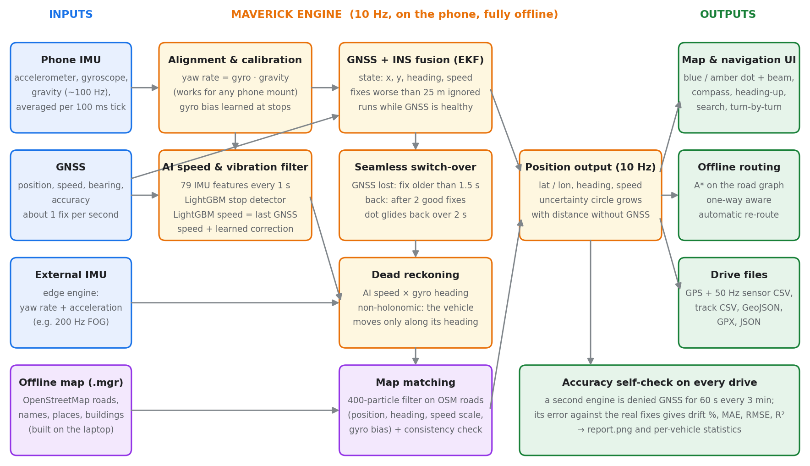
Figure 3. Maverick architecture: inputs, the 10 Hz engine on the phone, and outputs.

4.1 Software components
Layer | Component (Java) | Role
Engine (pure Java, no Android) | Engine, Core, ImuFeatures, Gbdt, Model | 10 Hz loop: features, LightGBM evaluation, EKF, outage detection, dead reckoning, recovery
 | MapFilter, Roads, Geo | Particle filter on OSM roads; map file reader with a spatial grid; local metric frame
 | Router, Navigator, PlaceSearch, Fmt | A* routing, turn instructions and progress; offline search; number formatting
 | EdgeRunner | Feeds an external IMU at any rate into the engine in 100 ms bins
App service | NavService (foreground, location type) | Engine thread at 10 Hz, sensors and GPS, map loading, routing, voice, the check engine, drive saving
 | RideLogger, DriveLog, DriveStore, ReportImage | gnss.csv and 50 Hz sensors.csv; metrics and track files; public Documents folder; report picture
App UI | MainActivity, MapCanvasView, CompassView, Icons, Ui | Screens and panels; map renderer with rotation, labels, buildings; compass; light and dark themes
 | Garage, CrashLog | User vehicles and their statistics; crash report shown on the next start
Laptop tools (Python) | idr package, pbf_to_mgr.py, app_ride.py | Training and evaluation; map building; loading phone recordings for training

4.2 Threads and timing
- Engine thread: sensor events are averaged per 100 ms tick (anti-aliasing), then the engine runs once; GPS fixes arrive on the same thread, so no locks are needed in the engine.
- Background thread: map loading, map index building, route computation and report writing, so the UI never waits for them.
- UI thread: draws the map from a snapshot of the engine state about 10 times a second.
- Foreground service keeps navigation running with the screen off, and stays alive until the drive files are saved.

4.3 Offline map file (.mgr)
Built on the laptop from OpenStreetMap: drivable road segments with class, one-way flag and name; places with category; building, water and park outlines. The Coimbatore file covers 10.85–11.20 N, 76.80–77.15 E: 268,479 road segments, 4,040 names, 3,907 places and 168,638 outlines (18.9 MB). OpenStreetMap is thinner than Google Maps in Coimbatore (only about 11 % of road segments and 2 % of residential streets have names), so fewer names appear than on Google Maps.

5. Methodology and pipeline

5.1 Data: IO-VNBD and what had to be fixed
IO-VNBD contains drives with a phone, a vehicle IMU and a reference VBOX GNSS. Before training, the data was audited and these problems were fixed in code:
Problem found | Fix
Phone "GPS SPEED (Kmh)" is actually m/s (speed ratio 3.6 before, 1.00–1.03 after) | Read as m/s
Phone GPS updates only every ~9 s and lags ~4.5 s | Lag measured per drive; 10 Hz engine inputs use held values exactly as on a phone
Phone and car files offset by up to minutes | Each drive re-aligned from its own gyro and speed
Phone gyro unusable on most drives (vibration-dominated) | Drives classed USABLE (4), SPEED-ONLY (31), EXCLUDED (36)
Yaw axis mislabelled | Yaw found from the data; the app projects the gyro on gravity instead
OpenStreetMap newer than the drives (a road on S3c no longer exists) | Consistency check in the map layer
Test drives: S1, S2, S3a, S3c (5.8 h, 183 km). Drive M (Driver B) is locked away as the one-time final test and has never been loaded.

5.2 Training and evaluation protocol
- Leave-one-drive-out: each test drive is scored with models trained on all other drives, never on itself.
- Simulated outages: GNSS withheld for 30, 60 or 120 s, starting every 60 s while moving: about 290 outages per length.
- No peeking: during an outage only the IMU and the offline map are used.
- Map settings chosen on separate drives (S3b, S4, Y1), then run once on the test drives.
- Paired statistics: every change compared with the current best on the same outages, with a bootstrap 95 % confidence interval of the median difference. 32 experiments were run; 9 succeeded, 3 partly, 19 failed, 1 inconclusive (bike).
- Exact phone port: the Java engine reproduces the Python models exactly (parity tests on all 4 drives), and the complete engine is re-scored end to end with noisy 1 Hz GNSS and automatic outage detection (section 7.2).

5.3 The 10 Hz pipeline
- Sensor pre-processing. Accelerometer and gyroscope events are averaged over each 100 ms tick; gravity is the latest value (or a low-pass of the accelerometer). Yaw rate = gyroscope projected on the gravity direction, so the phone can be mounted any way.
- Features. Every second, 79 features from the last seconds of acceleration, gyro and gravity: vibration energy in frequency bands, statistics, jerk, turn rate.
- Stop detector (AI vibration filter). LightGBM classifier on the features: 0–2.6 % false stops while moving, 89–97 % of real stops caught.
- Calibration. While the vehicle is stopped, the gyro reading is its bias; the median over recent stops is subtracted during dead reckoning (halved the heading error at 120 s: 31.6° → 15.9°).
- GNSS + INS fusion. An EKF with state (x, y, heading, speed) predicts from the yaw rate and updates with each fix (position, Doppler speed, bearing above 3 m/s). Fixes worse than 25 m are ignored.
- Outage detection. If no good fix has arrived for 1.5 s (15 ticks), dead reckoning starts from the EKF state. In the replay test the loss was declared on average 0.6 s after the outage began.
- AI speed (S1 model). Speed = last GNSS speed + a LightGBM correction learned from the vibration features and the speed history before the outage; 0 when the stop detector fires. The edge engine adds the integrated longitudinal acceleration since the outage start as a physics input.
- Dead reckoning with non-holonomic constraint. Position advances along the heading only (no sideways motion), heading from the bias-corrected gyro.
- Map matching. A 400-particle filter over position, heading, speed scale and gyro bias; particles are weighted by distance to (σ 12 m) and alignment with (σ 15°) nearby OSM roads, one-way aware; speed scale starts within ±15 % and may drift 3 %/s. The road geometry corrects both heading and speed.
- Consistency check. If the map solution departs from plain dead reckoning far beyond normal drift (it may be following a wrong road), the output is pulled back towards dead reckoning.
- Recovery. After 2 consecutive good fixes the EKF restarts from the dead-reckoned state; the displayed dot glides to the fix over 2 s instead of jumping.

5.4 Accuracy self-check on every drive
On a real road there is no reference trajectory, so Maverick measures itself: a second engine runs in parallel with navigation and is denied GNSS for 60 s every 3 minutes (after a 2-minute warm-up). Its position is compared, at the exact fix times, with the GPS fixes it did not receive. Navigation itself keeps GPS. Windows with less than 100 m of driving are not scored. This gives drift %, MAE, RMSE and R² on every drive, per vehicle, without disturbing the driver.

5.5 Learning from field data
The models are trained on the laptop, not on the phone. Field recordings (gnss.csv + sensors.csv) are loaded by app_ride.py, which rebuilds the engine's exact 10 Hz inputs from the 50 Hz rows using the event counts; the same training pipeline then retrains the speed and stop models, which are exported to the app. On the phone, each vehicle's statistics also record its speed pattern (GPS speed ÷ AI speed, e.g. 1.10 means the model under-reads by 10 %). This is measured but not yet applied; it will be switched on only if field drives show it reduces the error.

6. Metrics
Metric | Definition | Why it is used
Drift % | Final position error at the end of a GNSS outage ÷ distance travelled during the outage × 100 | The problem statement's benchmark (< 10 %)
Median, p90, % under 10 % | Over all outages of one length (30, 60, 120 s) | Typical case, bad-case tail, share meeting the target
Position MAE / RMSE (m) | Mean absolute / root-mean-square distance between dead-reckoned and true position at every truth sample inside the outages | Error size along the whole outage; RMSE weights big errors
Position R² (displacement) | 1 − Σ|true − estimated displacement since GPS loss|² ÷ Σ|true displacement − its mean|² | 1 = dead reckoning follows the true path exactly
Speed MAE / RMSE / R² | AI speed vs true (or GPS) speed during outages | Speed is the main error source
Heading MAE (°) | Dead-reckoned heading vs GPS bearing when faster than 3 m/s | Heading limits long outages
Detection delay | Time from the last fix to entering dead reckoning | Seamless handling of GNSS loss

7. Results and accuracy

7.1 Offline evaluation (Python, held-out drives)
Metric | Outage | Floor (B1) | Phone, no map | Phone final | Edge, no map | Edge final
Median drift | 30 s | 26.7 % | 17.4 % | 11.0 % | 11.1 % | 7.5 %
 | 60 s | 29.1 % | 17.1 % | 7.4 % | 11.5 % | 6.0 %
 | 120 s | 36.6 % | 18.7 % | 8.7 % | 12.3 % | 5.2 %
90th percentile | 30 s | 99.1 % | 37.2 % | 34.7 % | 31.7 % | 28.6 %
 | 60 s | 80.9 % | 34.5 % | 33.2 % | 29.8 % | 28.4 %
 | 120 s | 74.2 % | 38.0 % | 37.2 % | 25.0 % | 34.4 %
Outages under 10 % | 30 s | 19.6 % | 27.5 % | 46.7 % | 45.7 % | 60.1 %
 | 60 s | 13.5 % | 23.2 % | 58.1 % | 43.8 % | 64.8 %
 | 120 s | 10.5 % | 23.5 % | 53.3 % | 40.9 % | 60.8 %

7.2 End-to-end on the phone engine (Java, as in the app)
The complete Java engine from the app was replayed on every outage: it saw only the IMU and GNSS fixes with 3 m noise at 1 Hz, detected the loss itself, dead-reckoned with the map, and recovered. Re-run on 27 September 2026:
Engine | Outage | n | Median drift | p90 | Under 10 % | Loss detected after
Phone | 30 s | 291 | 9.71 % | 34.66 % | 50.9 % | 0.60 s
Phone | 60 s | 289 | 6.61 % | 31.75 % | 58.5 % | 0.60 s
Phone | 120 s | 285 | 6.03 % | 39.71 % | 57.9 % | 0.60 s
Edge | 30 s | 291 | 7.45 % | 33.13 % | 61.2 % | 0.60 s
Edge | 60 s | 290 | 5.53 % | 24.41 % | 67.6 % | 0.60 s
Edge | 120 s | 286 | 4.42 % | 28.29 % | 66.1 % | 0.60 s

7.3 Per test drive
Drive | Phone final (offline) | Phone, no map | Edge final (offline) | Edge, no map
S1 | 8.7 % | 18.7 % | 6.9 % | 13.3 %
S2 | 9.2 % | 16.7 % | 7.4 % | 12.6 %
S3a | 5.2 % | 9.8 % | 4.9 % | 8.3 %
S3c | 15.7 % | 23.1 % | 5.6 % | 10.0 %

7.4 Drive-report metrics (the app's self-check)
The drive-report code of the app was run on the laptop over the whole of drive S1 (1 h 26 min, 38 km), once as the demo (truth = dataset reference) and once exactly as on a live drive (check engine denied GPS, truth = noisy 1 Hz fixes):
Metric | Demo (dataset truth) | Live mode (GPS fixes as truth)
GPS-loss tests scored | 28 of 28 | 25 of 29
Drift median / mean / max | 6.3 / 10.4 / 31.6 % | 6.7 / 13.7 / 63.9 %
Position MAE / RMSE | 23.5 m / 36.3 m | 39.9 m / 72.6 m
Position R² (displacement) | 0.979 | 0.937
Speed MAE / RMSE | 7.4 / 9.5 km/h | 8.1 / 11.0 km/h
Speed R² | 0.53 | 0.60
Heading MAE | 4.1° | 4.8°
Speed pattern (GPS ÷ AI speed) | 1.05 | 1.10
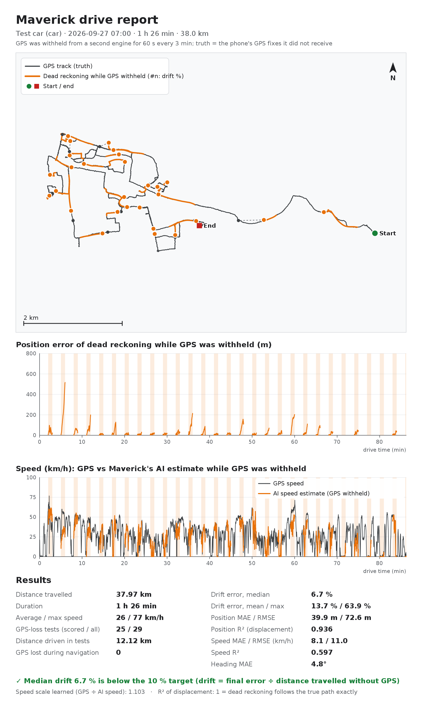
Figure 4. A drive report as saved by the app (laptop run of the live mode on drive S1).

7.5 On the test phone
Test (LAVA LXX506, Android 14) | Result
Demo drive, 4 GPS cuts, 7.95 km | Median drift 4.9 %; report and files saved to Documents/Maverick/Demo
Demo drive, 3 GPS cuts, 6.37 km | Median drift 3.9 %; per-cut errors 3.9 % and 2.3 % shown live
Demo drive, first GPS cut only | 31 % (166 m over 535 m): the first cut of drive S1 is consistently the hardest
Live start indoors (no GPS fix) | sensors.csv saved at ~14 KB/s (50 rows/s), gnss.csv empty, "no GPS fix, so no report" shown
Search, route, turn banner, Start/Stop/End | Working; route of 14 km from the phone's location to Gandhipuram, Coimbatore
Compass mode, north up, two-finger rotation code | Compass mode and north-up checked; two-finger twist needs a real hand to test
Light/dark switch during a demo | Demo keeps running; map stays loaded (fixed in this version)
Coimbatore map re-check (27 Sep, 10:54) | Search "rs puram" gives the area, a school and hospitals; the RS Puram map shows dozens of shops, clinics and hotels with names and street names (e.g. Diwan Bahadur Road); Directions: 17 km, 19 min route with turn banner

7.6 Position plots (IO-VNBD, held-out drives)
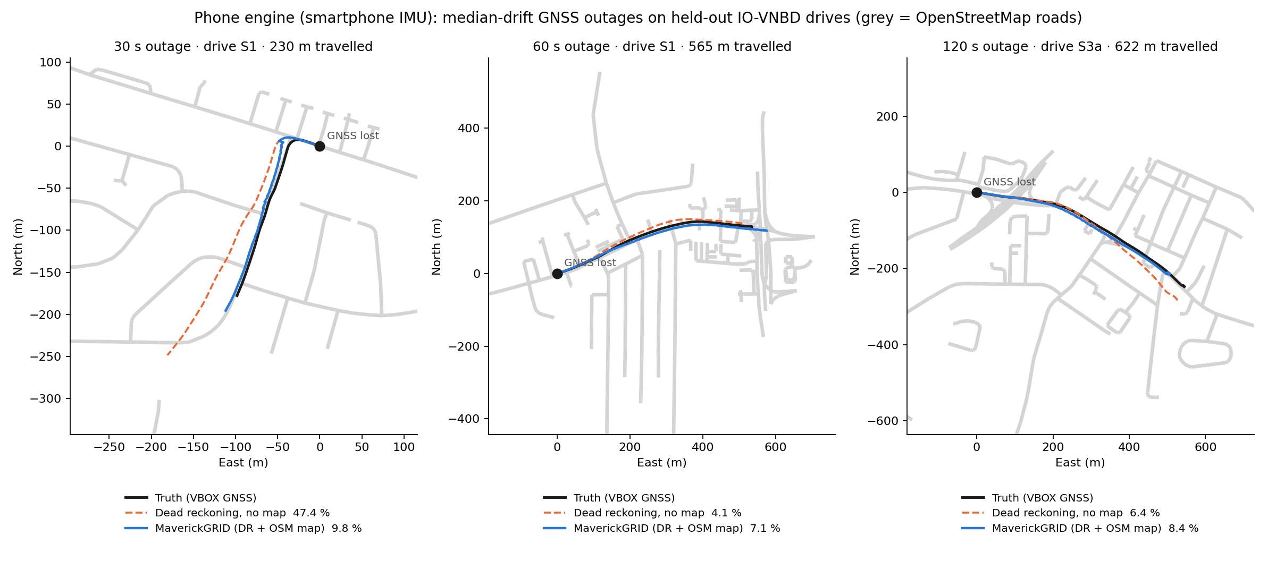
Figure 5. Phone engine: truth (black), dead reckoning without map (orange dashed), Maverick with the OSM map (blue). Median cases, not best cases.
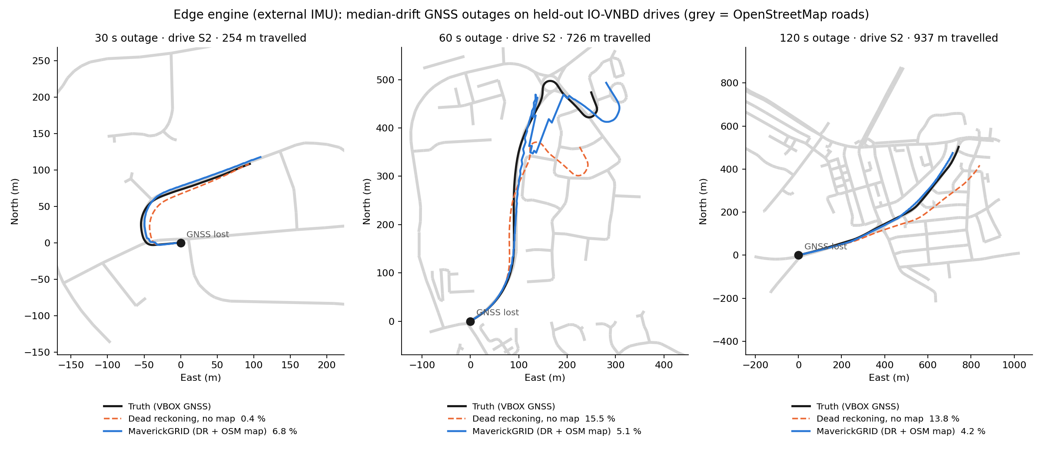
Figure 6. Edge engine on the external IMU: same layout.

7.7 Two-wheeler (bike) model
Trained on only 4 short rides (about 8 minutes). Leave-one-ride-out it beats hold-last-speed only at 30 s (20.3 % vs 26.0 %); car models do not transfer to a bike with the phone on the handlebar (89–127 %). The bike model is therefore marked beta in the app until about 2 hours of rides are recorded and it is retrained.

7.8 Other checks
- Routing: 40 of 40 test routes found, about 5 ms each on a laptop.
- Search: exact names first, then real places before streets with the same word (e.g. "hospital" lists hospitals before "Hospital Lane"), duplicates within 300 m removed.
- sensors.csv: exactly 50 rows per second in a synthetic test with jitter and gaps; no sensor event lost; the laptop loader reproduces the engine's 10 Hz averages exactly.

8. Verification and bug fixing
An independent reviewer read the whole app for crashes, threading problems, wrong results and usability problems. It confirmed that the map rotation mathematics, the drive metrics and the Android 14/15 foreground-service handling are correct, and found 19 defects. All were fixed, compiled against Android 10 and 15, installed, and the ones visible on screen were re-tested on the phone.
# | Defect | Fix
1 | Pressing Stop could lose the drive files if the app was closed while they were being written | Service stays alive until the report is saved; queued work is never dropped
2 | An error while writing the report left the raw data invisible | Files are published in all cases
3 | Changing light/dark mode stopped a running demo and reloaded the map | Demo runs as a started service; the connection survives screen re-creation
4 | Rare crash when the app closed during a tick | Shutdown moved onto the engine thread
5 | "Test GPS loss" stayed on into the next drive | Reset at every start
6 | No way to stop a live drive while navigating | Start/Stop button in the navigation panel
7 | Pinch-zoom stopped the map following the car | Pinch and twist no longer count as panning
8 | Some visible places could not be tapped | Tap tolerance matches the zoom where places are drawn
9 | sensors.csv could drop events at step edges on some phones | Two steps are kept open before writing
10 | Vehicle statistics counted test GPS loss as real | Excluded
11 | "arrived" stayed on screen for the rest of the drive | Cleared after 20 s
12 | In the demo the map turned with the phone instead of the demo car | Uses the demo car's heading
13 | Vehicle dialog showed the old recordings folder | Shows Documents/Maverick/<vehicle>/
14 | Double-tapping Start created an empty drive | Second tap within 3 s ignored
15 | Demo drive ended a live drive without asking | Confirmation dialog
16 | Share failed with a misleading message in fallback storage | Clear message
17 | Magnetometer ran even when not needed (battery) | Only when sensor saving is on
18 | On Android 11+ the keyboard could hide search results | Result list sized to the space above the keyboard
19 | Misleading message when no offline map covers the area | Says so
Improvements made during the phone test: street names drawn along roads (main roads first), place names from a lower zoom, labels never overlap, map index built in the background (removed a ~1 s freeze when a map loads), returning to your own area right after a demo, last report link kept after a restart, and an Android Studio setting so external file edits are always rebuilt.

9. Limitations
- No real-road test yet. All accuracy figures come from the IO-VNBD dataset (one driver, one city: Coventry). Live GPS tracking, the self-check on real roads, voice guidance and re-routing on real roads are untested.
- Bad-case tail: 25–40 % of drift for the worst 10 % of outages (missing roads, late turn detection, the first outage before calibration).
- Bike model is beta (8 minutes of training data).
- Edge engine is validated on the dataset's vehicle IMU at its native rate; a 200 Hz FOG has not been connected, and the edge engine is not wired into the phone app.
- Map data: OpenStreetMap in Coimbatore has far fewer shop and street names than Google Maps.
- Battery and heat over long drives (two engines plus 50 Hz logging) are not yet measured.
- Drive M (Driver B) has not been scored; it is reserved for one final test after the system is frozen.

10. What is left: field data collection and testing

10.1 Before each session
- Phone charged above 60 %, at least 2 GB free, screen timeout long, battery saver off for Maverick.
- Firm holder (dashboard for car, handlebar for bike); the phone must not move during the drive.
- Choose the right vehicle in the vehicle chip; Save sensor data ✓; Sensor log rate 50 Hz.

10.2 Car drives (target: 3–4 hours)
- Press Start, wait for "GPS + sensors", drive normally. Include stops at signals (they calibrate the gyro).
- Mix of routes: arterial roads (Avinashi Road, Trichy Road), dense old town (Town Hall, Gandhipuram), flyovers and underpasses, a parking basement if possible.
- Drive at least 20–30 minutes per session; the self-check scores a GPS-loss test every 3 minutes.
- Twice per session, press Test GPS loss for about 60 s on a straight road and on a road with turns; note the error shown.
- Press Stop; open 📊 Open last drive report; copy the drive folder to the laptop.

10.3 Two-wheeler rides (target: about 2 hours)
Same steps with the bike vehicle selected, phone on the handlebar. These rides are what the bike model needs to leave beta; after recording, the laptop retrains it with the existing pipeline and the app is rebuilt.

10.4 Pass criteria for the field test
Check | Pass if
Median drift over all scored self-check tests (car) | below 10 %
Real GPS outages (tunnel/underpass) | amber dot stays on the correct road; smooth return when GPS comes back
Navigation | turn announcements before each junction; re-route within about 10 s of a wrong turn
Stability | no crash in a 1-hour drive; phone not overheating; battery use noted
Data | every drive folder complete (report.png, summary.json, track.csv, sensors.csv, gnss.csv)

10.5 Then
- Retrain the phone and bike models with the Coimbatore recordings (laptop pipeline), rebuild the app.
- Freeze the system and score drive M once.
- Put the field reports and drive-M result in the SIH proposal.

Appendix: glossary
Term | Meaning
GNSS / GPS | Satellite positioning (GPS, GLONASS, Galileo, NavIC)
IMU | Inertial measurement unit: accelerometer + gyroscope
Dead reckoning (DR) | Continuing the position from speed and heading when GNSS is missing
EKF | Extended Kalman filter: fuses GNSS fixes with the motion model
Particle filter | Many candidate positions weighted by how well they fit the road map
NHC | Non-holonomic constraint: a road vehicle does not move sideways
LightGBM | Gradient-boosted decision trees; small and fast enough for a phone
B1 | Floor method: gyro heading + hold the last GNSS speed
S1 | Speed model: last GNSS speed + learned correction
E2 | Edge engine speed model with integrated acceleration
IO-VNBD | Inertial and odometry vehicle navigation benchmark dataset used for training and testing
OFFGRID | Another team's public SIH26168 entry used as a reference
Drive M | Held-out drive of a second driver, reserved for the final test

