**a. Retrieve all the books from the database.**

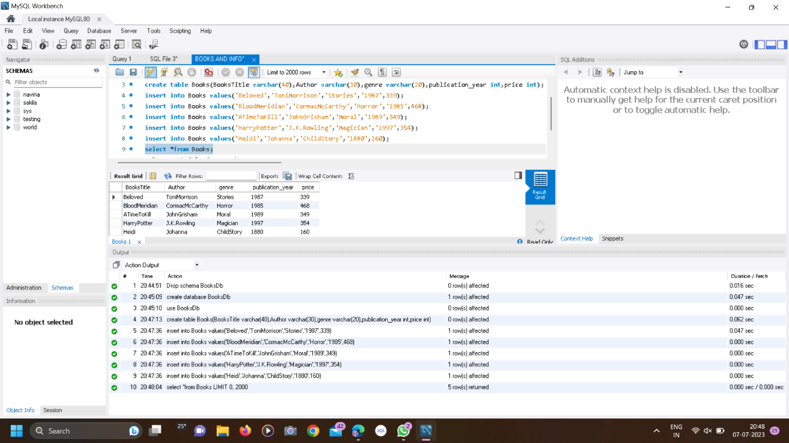

**b. Retrieve the details of a book based on its title.**

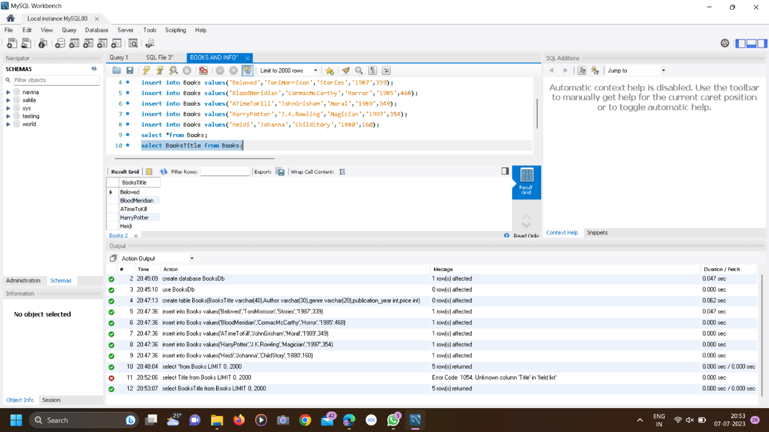

**c. Update the price of a book.**

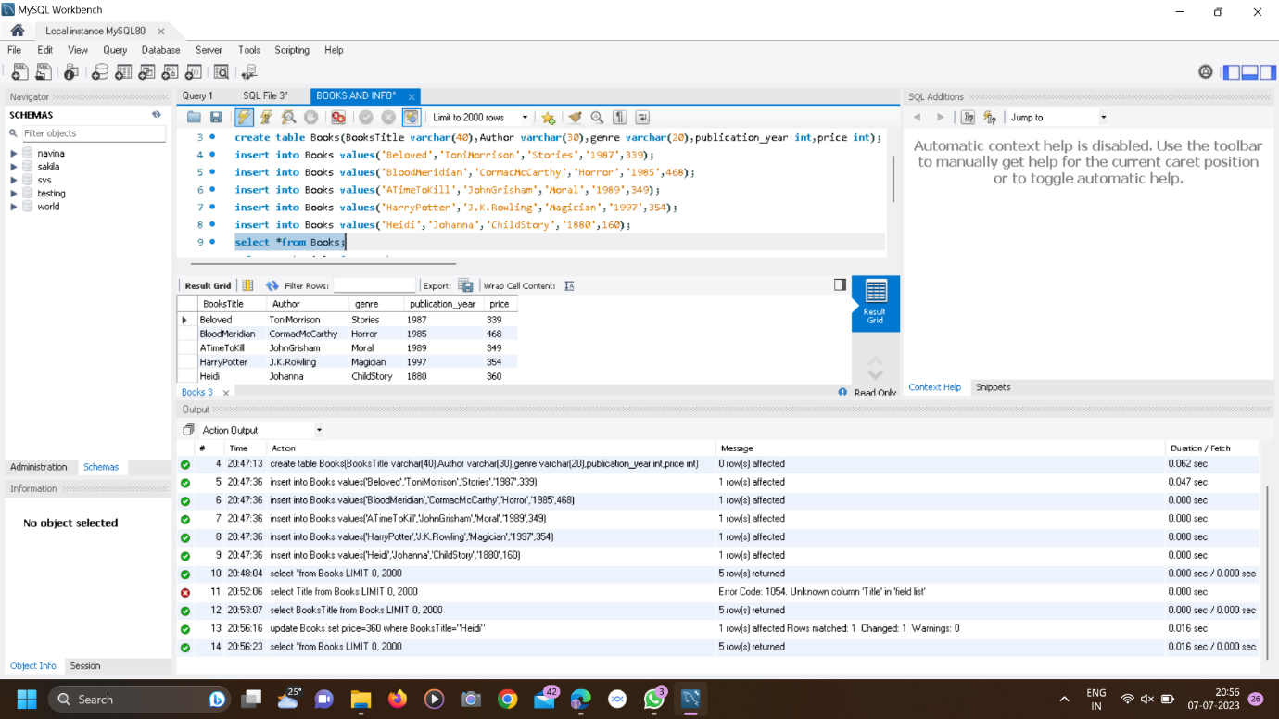

**d. Delete a book from the database based on its title.**

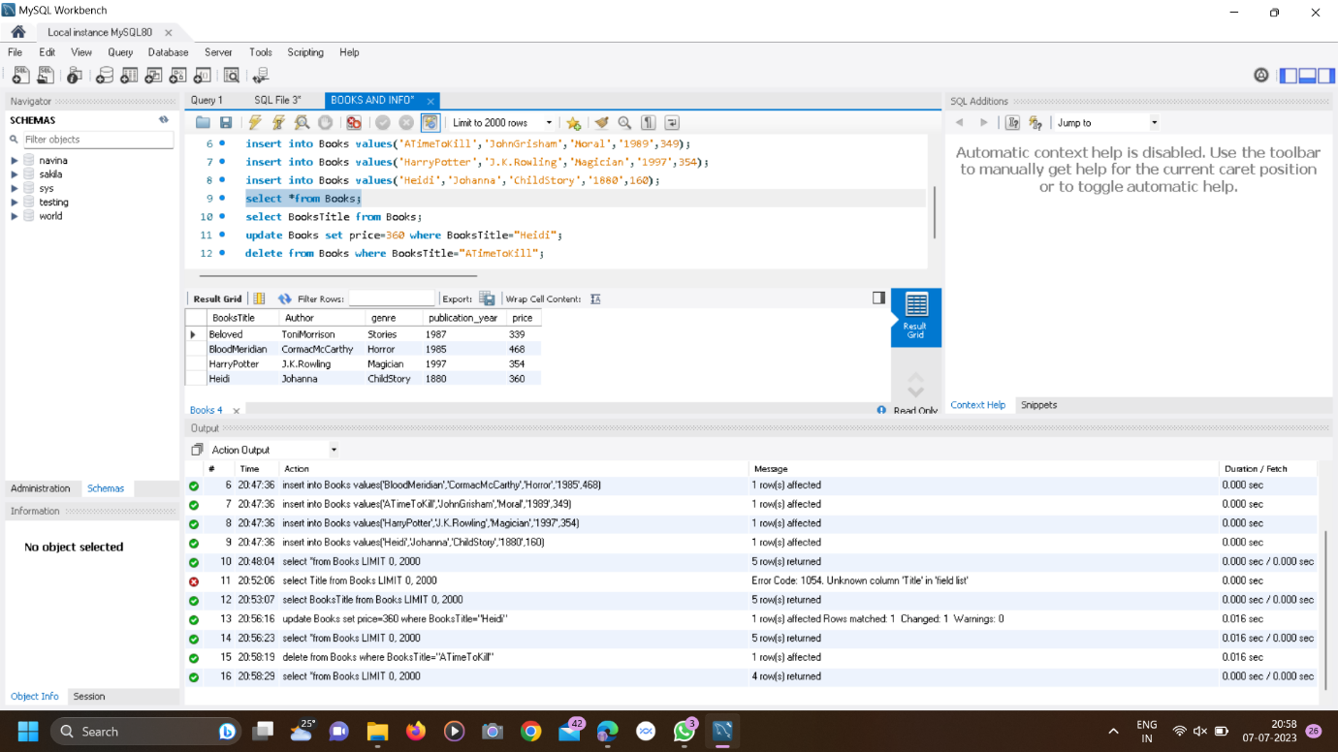

**e.The average price of all the books in the database.**

