BloxLogicAI System Diagrams
This document contains industry-standard system diagrams that explain the underlying architecture, data flow, and user interactions of the BloxLogicAI platform.

Table of Contents
BloxLogicAI System Diagrams 1
1. BloxLogicAI Use Case Diagram 2
2. System Architecture Diagram 3
Layer Breakdown: 3
3. BloxLogicAI Data Flow Diagram 4
Flow Breakdown: 4
4. BloxLogicAI User Flow Diagram 5

1. BloxLogicAI Use Case Diagram
This Use Case Diagram outlines the specific interactions and capabilities available to the two primary actors within the BloxLogicAI system: End Users and Administrators.
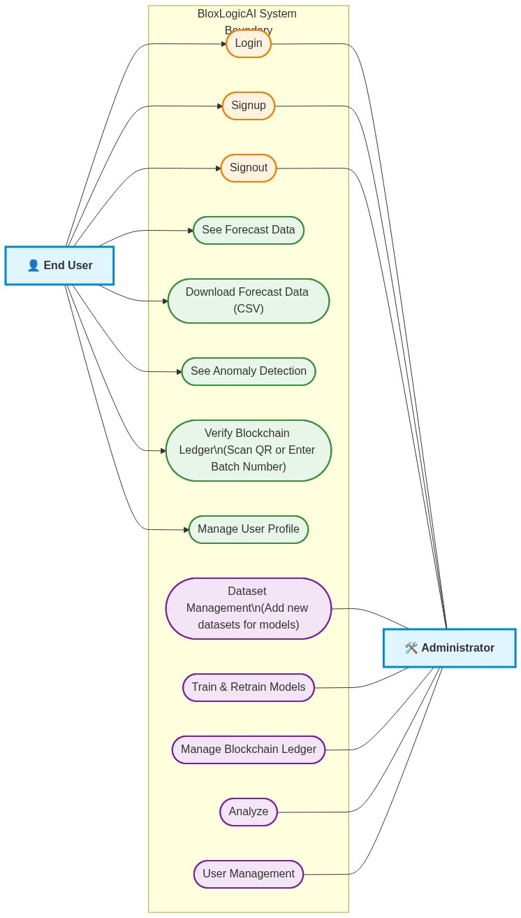
Use case Diagram

2. System Architecture Diagram
This diagram represents the high-level infrastructure of BloxLogicAI. It follows a standard multi-tier architecture, separating the application into the Presentation Layer (Frontend), Application Layer (Backend Logic), AI Engine, and the Data/Security Layer.
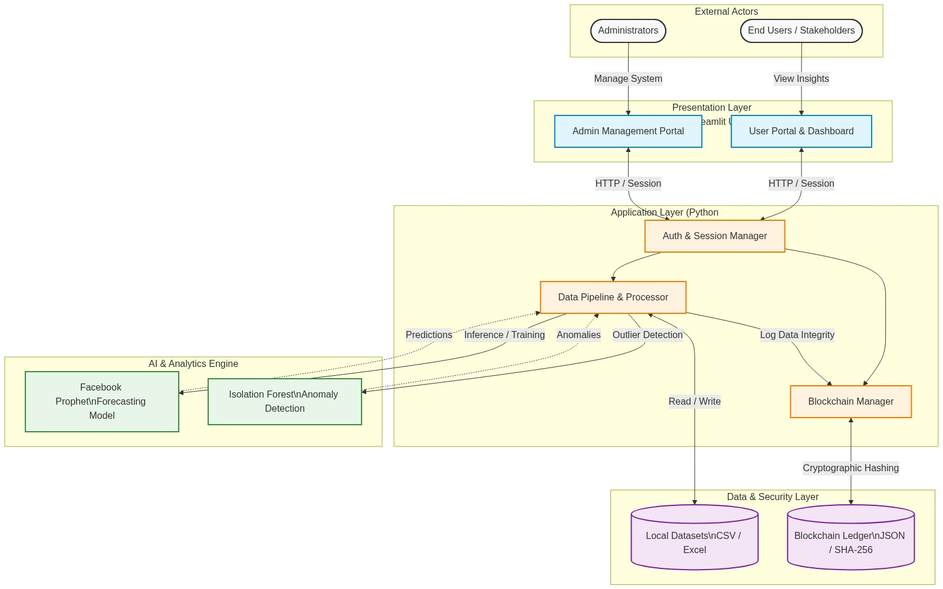
Diagram

Layer Breakdown:
- External Actors: Represents the human interactions with the system. Users view data; Admins manage it.
- Presentation Layer: Built entirely with Streamlit, handling the UI rendering and user inputs natively in Python.
- Application Layer: The core Python logic that handles user sessions, processes data using Pandas/NumPy, and acts as the middleman to the database and blockchain.
- AI Engine: The isolated machine learning models. They receive cleaned data from the pipeline and return mathematical predictions and anomaly flags.
- Data & Security: The persistent storage. Datasets are stored locally, while the Custom Blockchain ensures that historical records remain immutable.

3. BloxLogicAI Data Flow Diagram
This diagram (a Level 1 DFD) illustrates how information moves through the BloxLogicAI system. It tracks the journey of raw tea export data from the moment an administrator uploads it, through the AI and blockchain processing, until it is visualized for the end user.

Diagram

Flow Breakdown:
- Data Ingestion: The Admin uploads a dataset. The Python backend validates the format and cleans any missing values.
- Blockchain Hashing: Simultaneously, the new data payload is sent to the Blockchain Manager, which calculates a new SHA-256 hash linking it to the previous block, storing it in ledger.json.
- AI Inference: The raw data from the CSV is passed into the Prophet and Isolation Forest models. These models crunch the numbers and output their predictions and anomalies into memory.
- Visualization: The Streamlit frontend pulls the AI results and the Blockchain integrity status, rendering them into the interactive charts the end user sees.

4. BloxLogicAI User Flow Diagram
This diagram maps out the screens and paths a user can take when interacting with the BloxLogicAI platform.
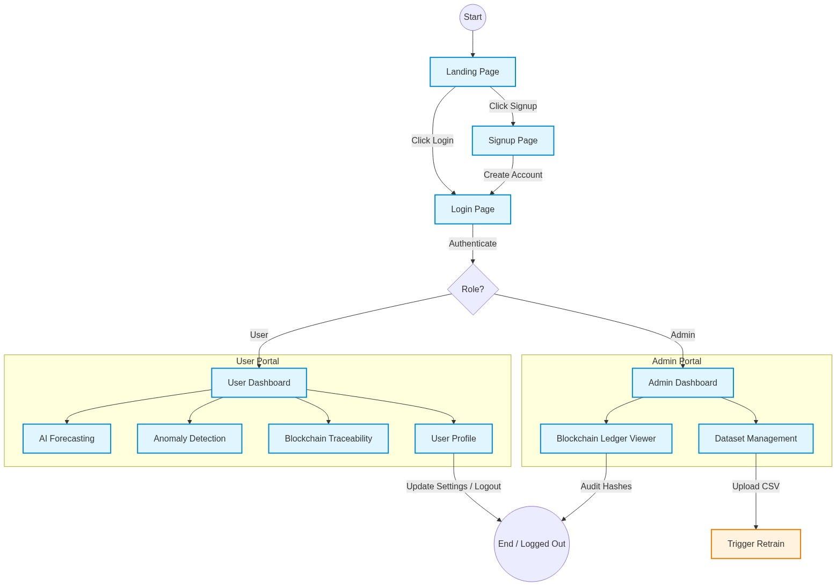
Diagram

