BloxLogicAI Sequence Diagrams
This document contains the sequence diagrams for all major processes within the BloxLogicAI system.

Contents
BloxLogicAI Sequence Diagrams 1
1. Authentication Processes (Common) 1
1.1 User Signup 1
1.2 User Login 2
1.3 User Signout 3
2. End-User Processes 4
2.1 View & Download Forecast Data 4
2.2 View Anomalies & Suggestions 5
2.3 Verify Tea Batches (QR / Batch Number) 6
2.4 Manage Profile (Update Email / Password) 7
3. Administrator Processes 8
3.1 Train & Retrain Models 8
3.2 Add New Datasets & Retrain 9
3.3 Manage Blockchain Ledger 10
3.4 Manage Users (Add, Update, Remove) 11

1. Authentication Processes (Common)

1.1 User Signup
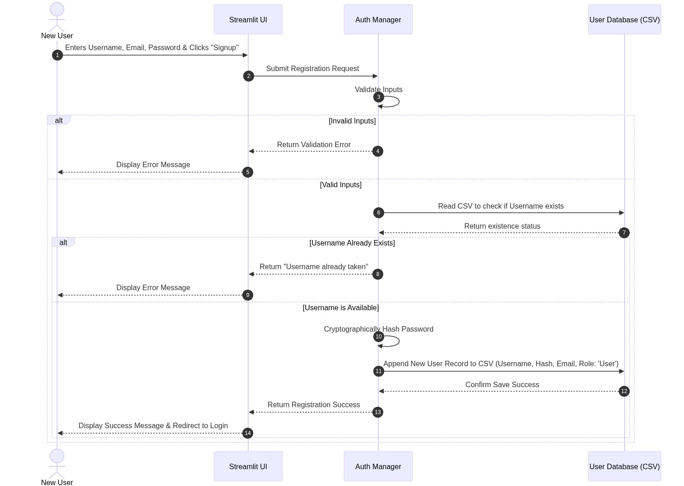

1.2 User Login
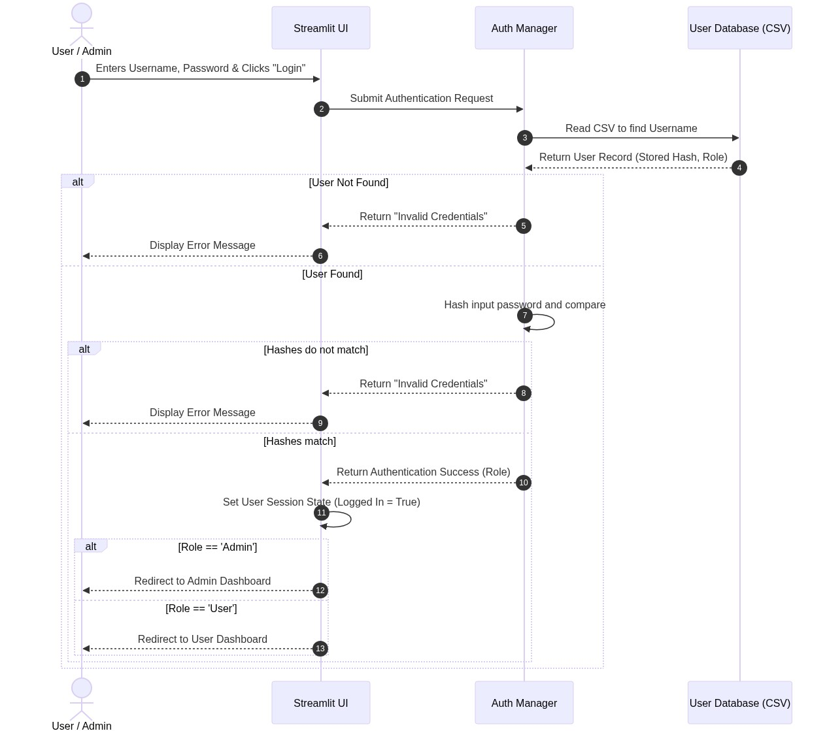

1.3 User Signout
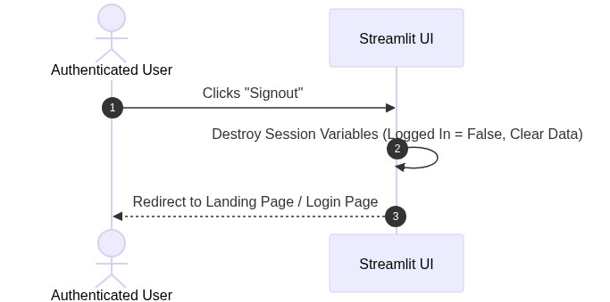

2. End-User Processes

2.1 View & Download Forecast Data
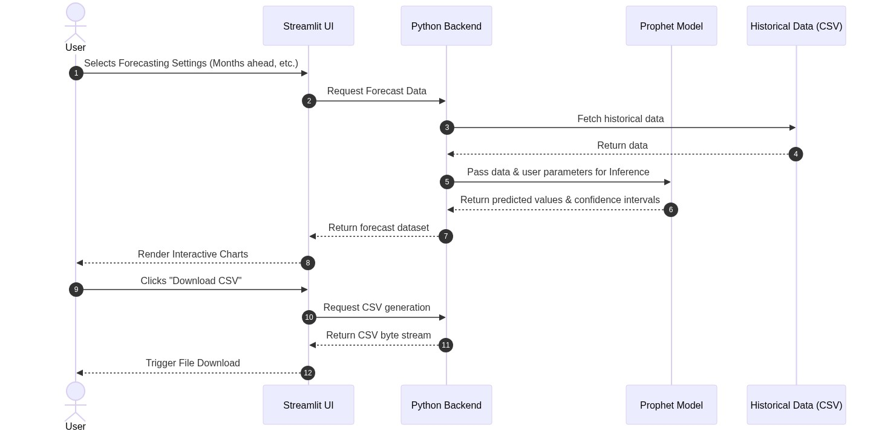

2.2 View Anomalies & Suggestions
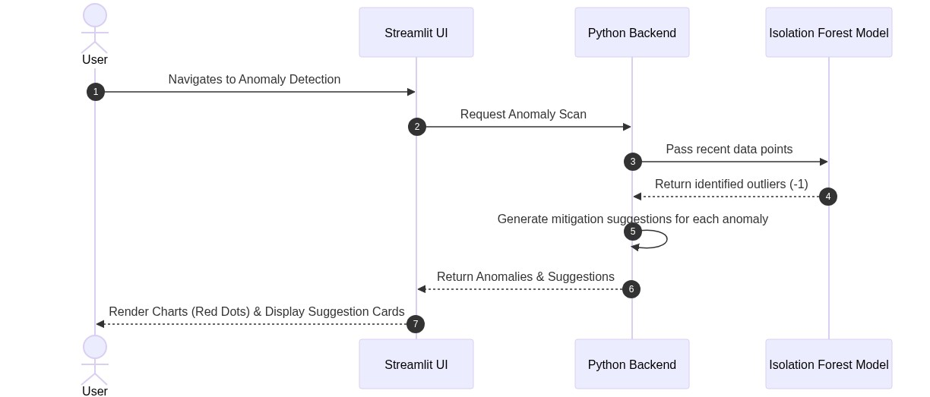

2.3 Verify Tea Batches (QR / Batch Number)
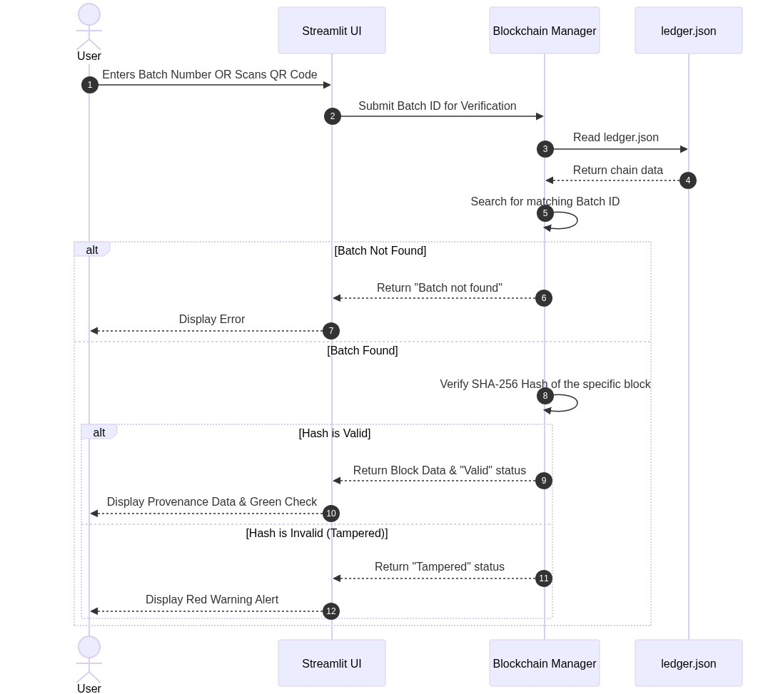

2.4 Manage Profile (Update Email / Password)
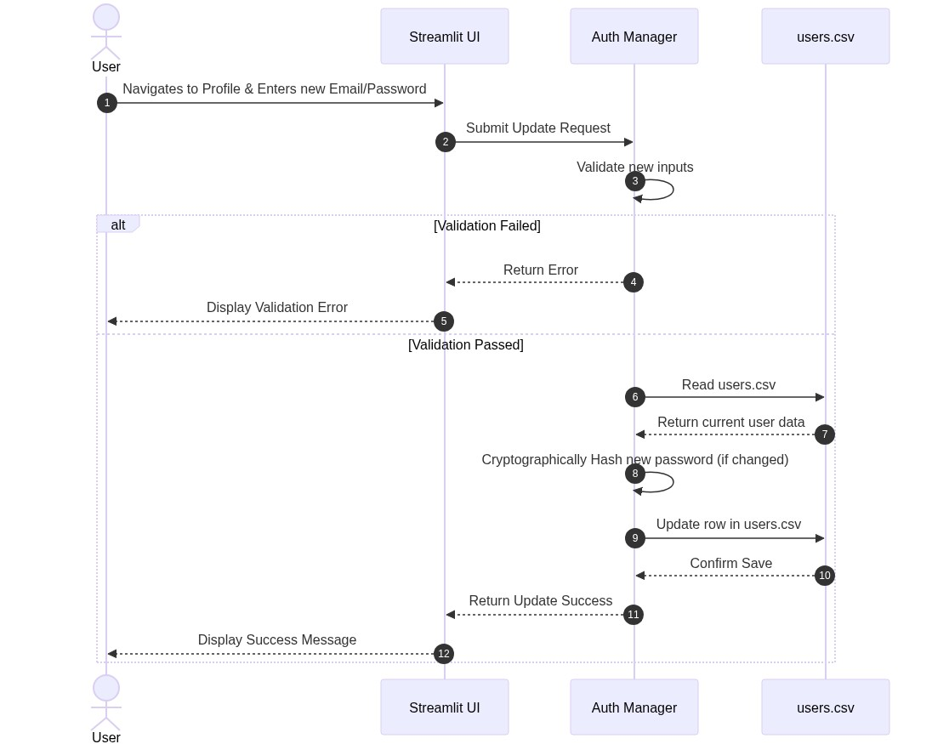

3. Administrator Processes

3.1 Train & Retrain Models
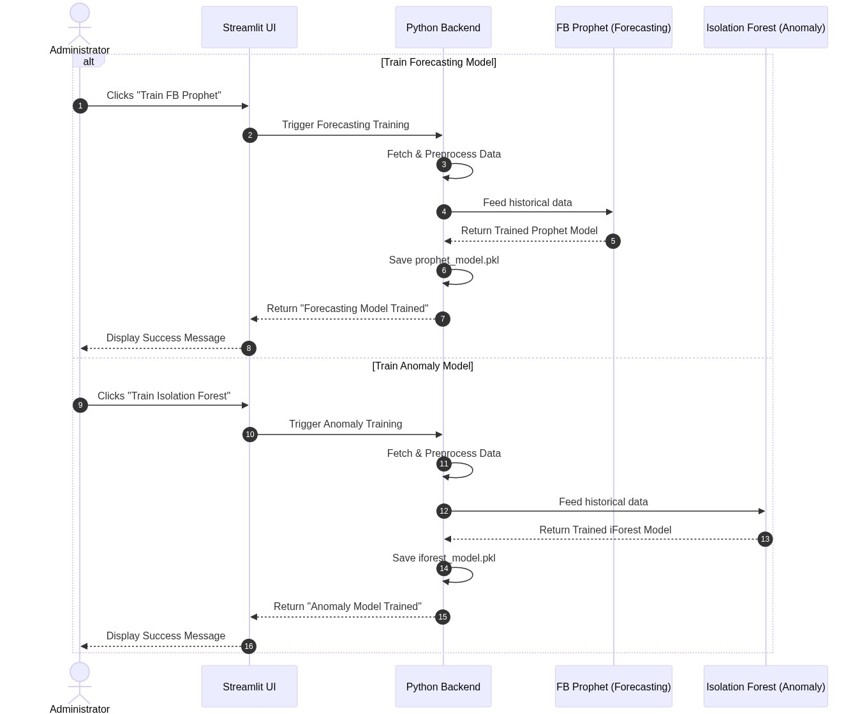

3.2 Add New Datasets & Retrain
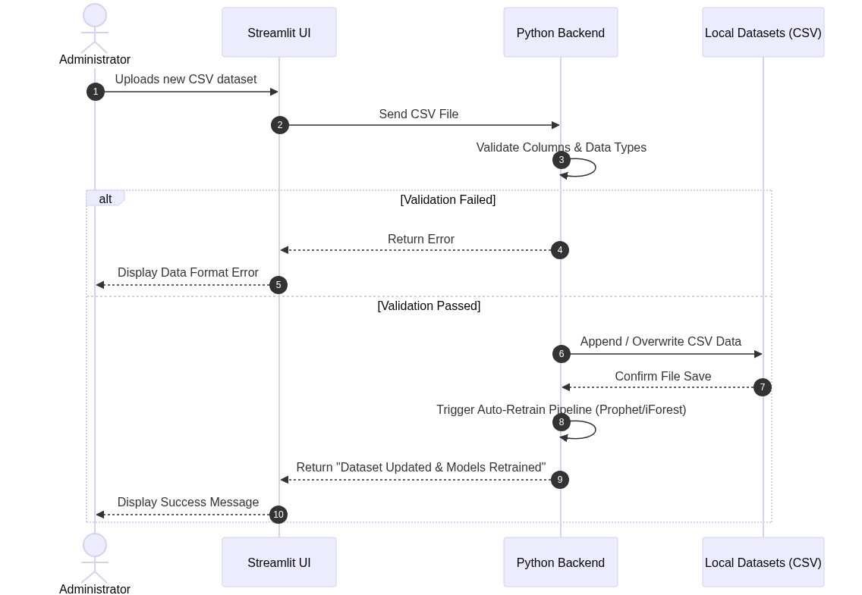

3.3 Manage Blockchain Ledger
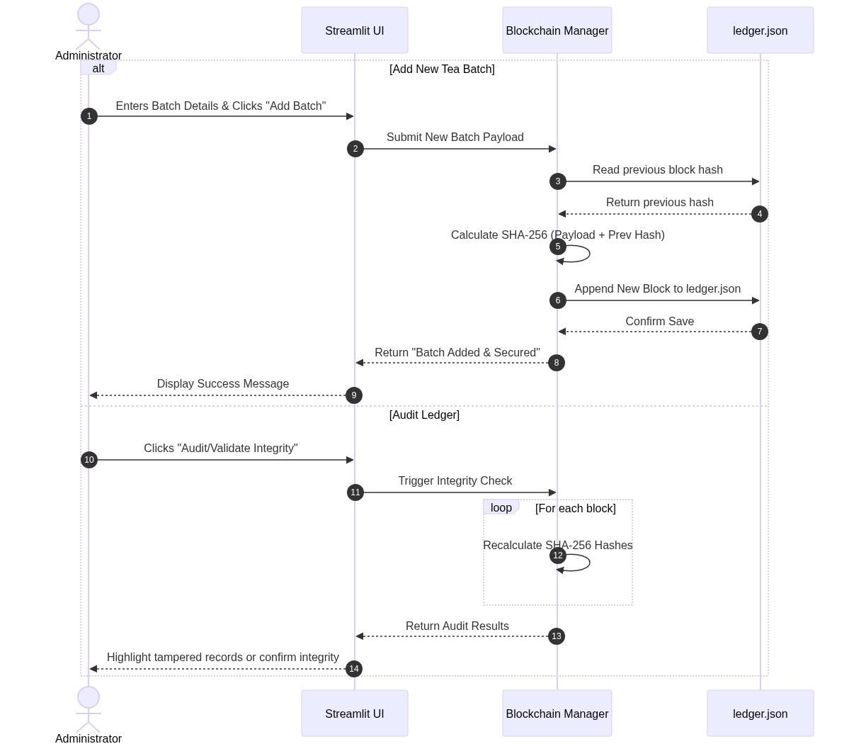

3.4 Manage Users (Add, Update, Remove)
