BloxLogicAI User Manual



Name :
Registration Number:
Project Name:

Table of Contents

- Project Overview
- How It Works
- User Guide
  - Landing Page
  - Signup
  - Login
  - User Dashboard
  - AI Forecasting
  - Anomaly Detection
  - Blockchain Traceability
  - User Profile
- Administrator Guide
  - Admin Dashboard
  - Dataset Management
  - Blockchain Ledger Viewer
- Troubleshooting & FAQs

1. Project Overview
BloxLogicAI is a state-of-the-art web application built to bring absolute transparency and predictive intelligence to Sri Lanka’s tea supply chain. The tea industry faces challenges with supply chain disruptions, fluctuating market demands, and the need to verify the origin and authenticity of exports. BloxLogicAI addresses these by providing AI-driven forecasts and cryptographically securing supply chain records on a blockchain ledger.

2. How It Works
The platform operates on two core technologies working in tandem: 1. Machine Learning (AI): We use Facebook Prophet to forecast future export volumes based on historical data and macroeconomic trends. Alongside this, an Isolation Forest model continuously monitors for anomalies—such as unexpected drops in yield or price spikes—alerting stakeholders to potential supply chain disruptions. 2. Blockchain: To guarantee data integrity, every record processed by the system is hashed using SHA-256 cryptography. Each batch of data points to the previous one, creating an unbreakable chain. If any data is tampered with, the blockchain instantly flags it as invalid.

3. User Guide
This section covers the step-by-step process for a standard user navigating the platform.

Landing Page
When you first access BloxLogicAI, you arrive at the Landing Page. This is the public face of the application. - Hero Section: Provides a brief introduction to the platform’s mission. -Forecast Chart: Shows predicted values in next 12 months, - Features Overview: Highlights the core capabilities: AI Forecasting, Anomaly Detection, and Blockchain Traceability. - Navigation: Use the top menu or the “Get Started” buttons to proceed to the Login or Signup pages.
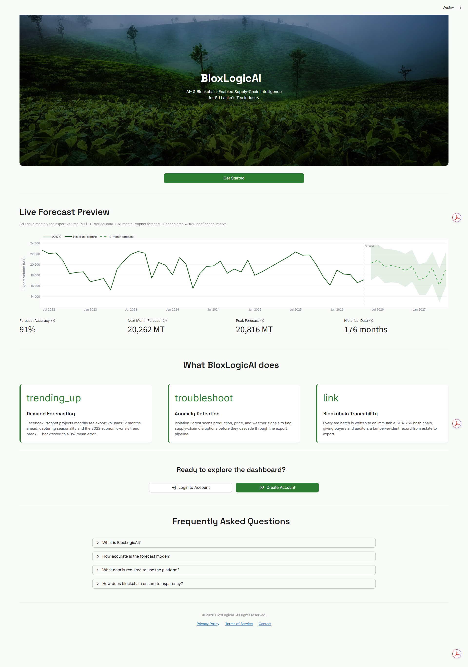
Figure 1: The BloxLogicAI Landing Page.

Signup
New users must create an account to access the dashboard. - Navigate to the Signup page. - Enter your desired Username, Email, and a secure Password. - Once registered, your credentials will be securely stored, and you will be redirected to the Login page.
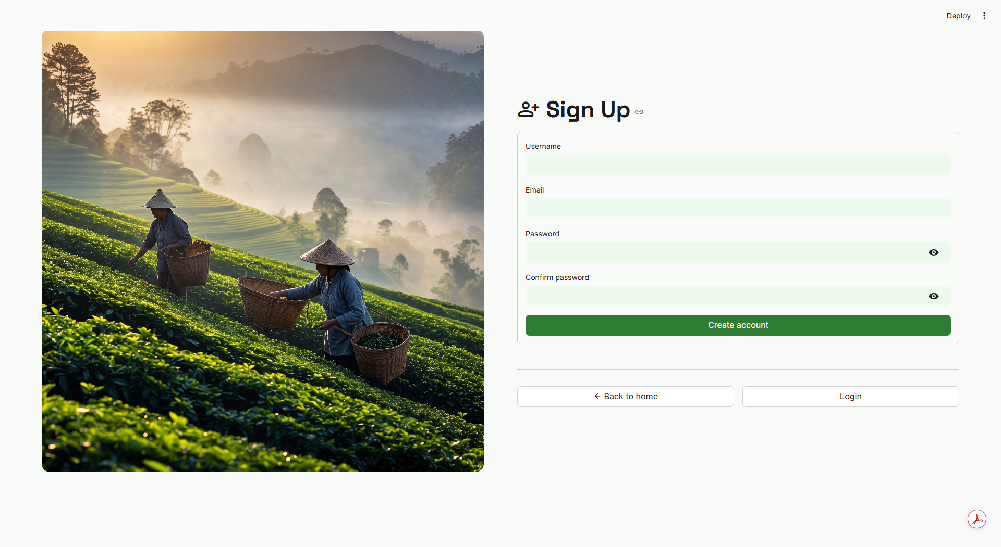
Figure 2: The User Signup Page.

Login
Existing users and newly registered users authenticate here. - Navigate to the Login page. - Enter your Username and Password. - The system will verify your credentials and direct you to the User Dashboard.
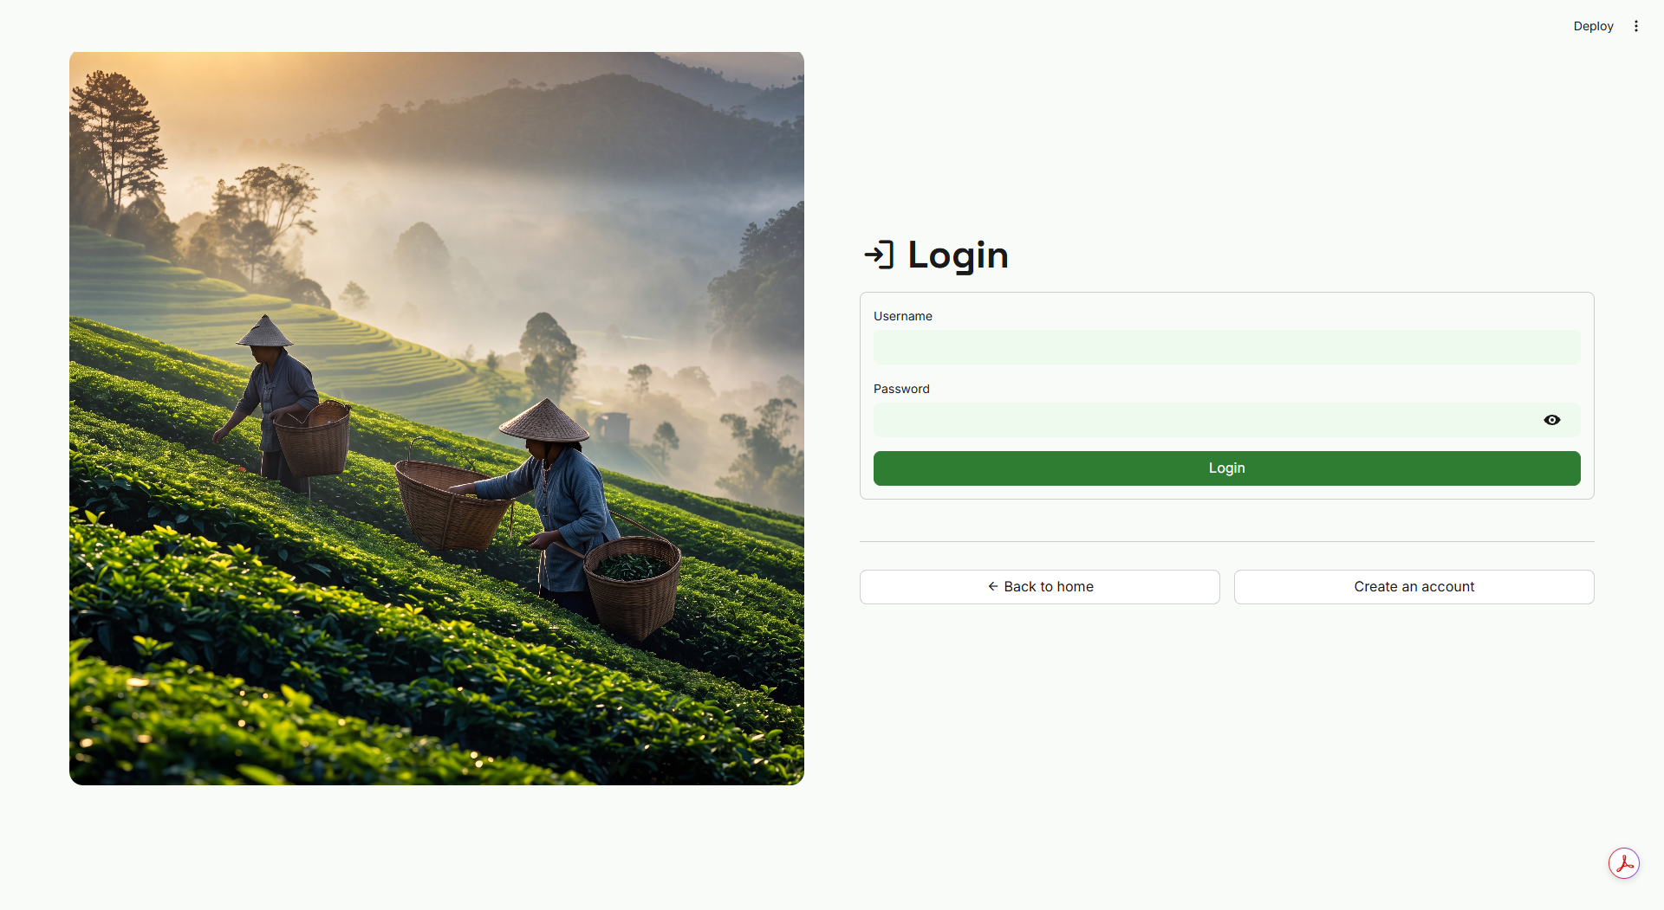
Figure 3: The User Login Page.

User Dashboard
Upon successful login, you are greeted by the User Dashboard. This is your command center. - Key Metrics: At the top, you’ll see high-level statistics summarizing current supply chain health. - Navigation Sidebar: Use the left-hand sidebar to switch between Forecasting, Anomaly Detection, Blockchain, and Profile pages.

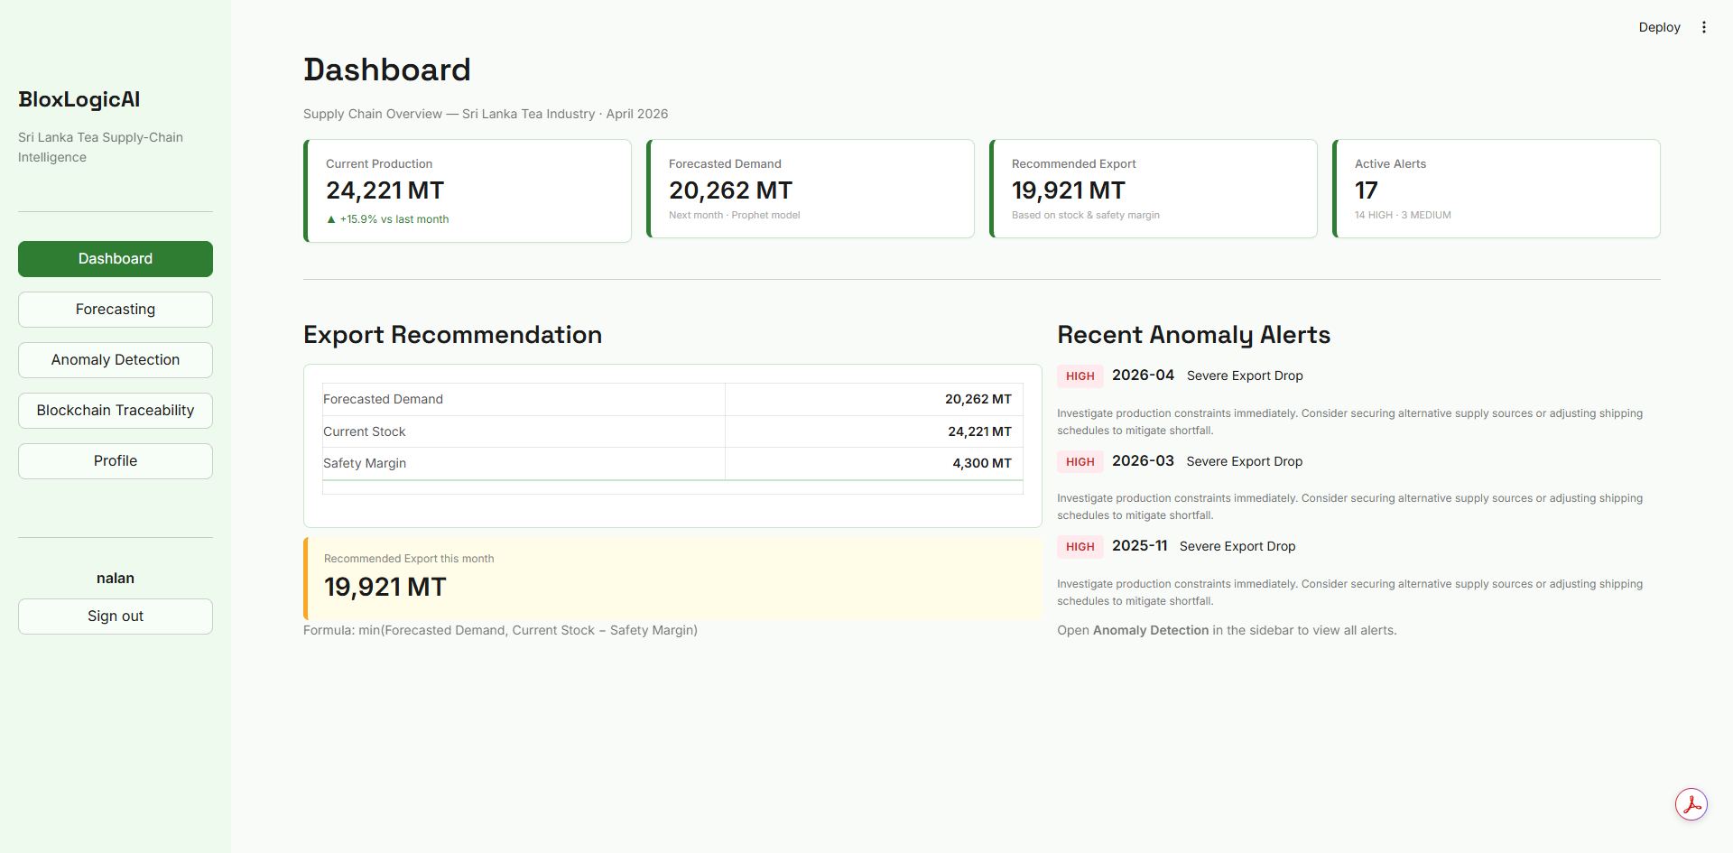
Figure 4: The Main User Dashboard.

AI Forecasting
The Forecasting tab provides predictive insights. - The interactive charts show historical export volumes alongside future projections generated by our AI model. - You can hover over the data points on the graph to see exact projected quantities for upcoming months. - This allows stakeholders to plan inventory and resources ahead of time.
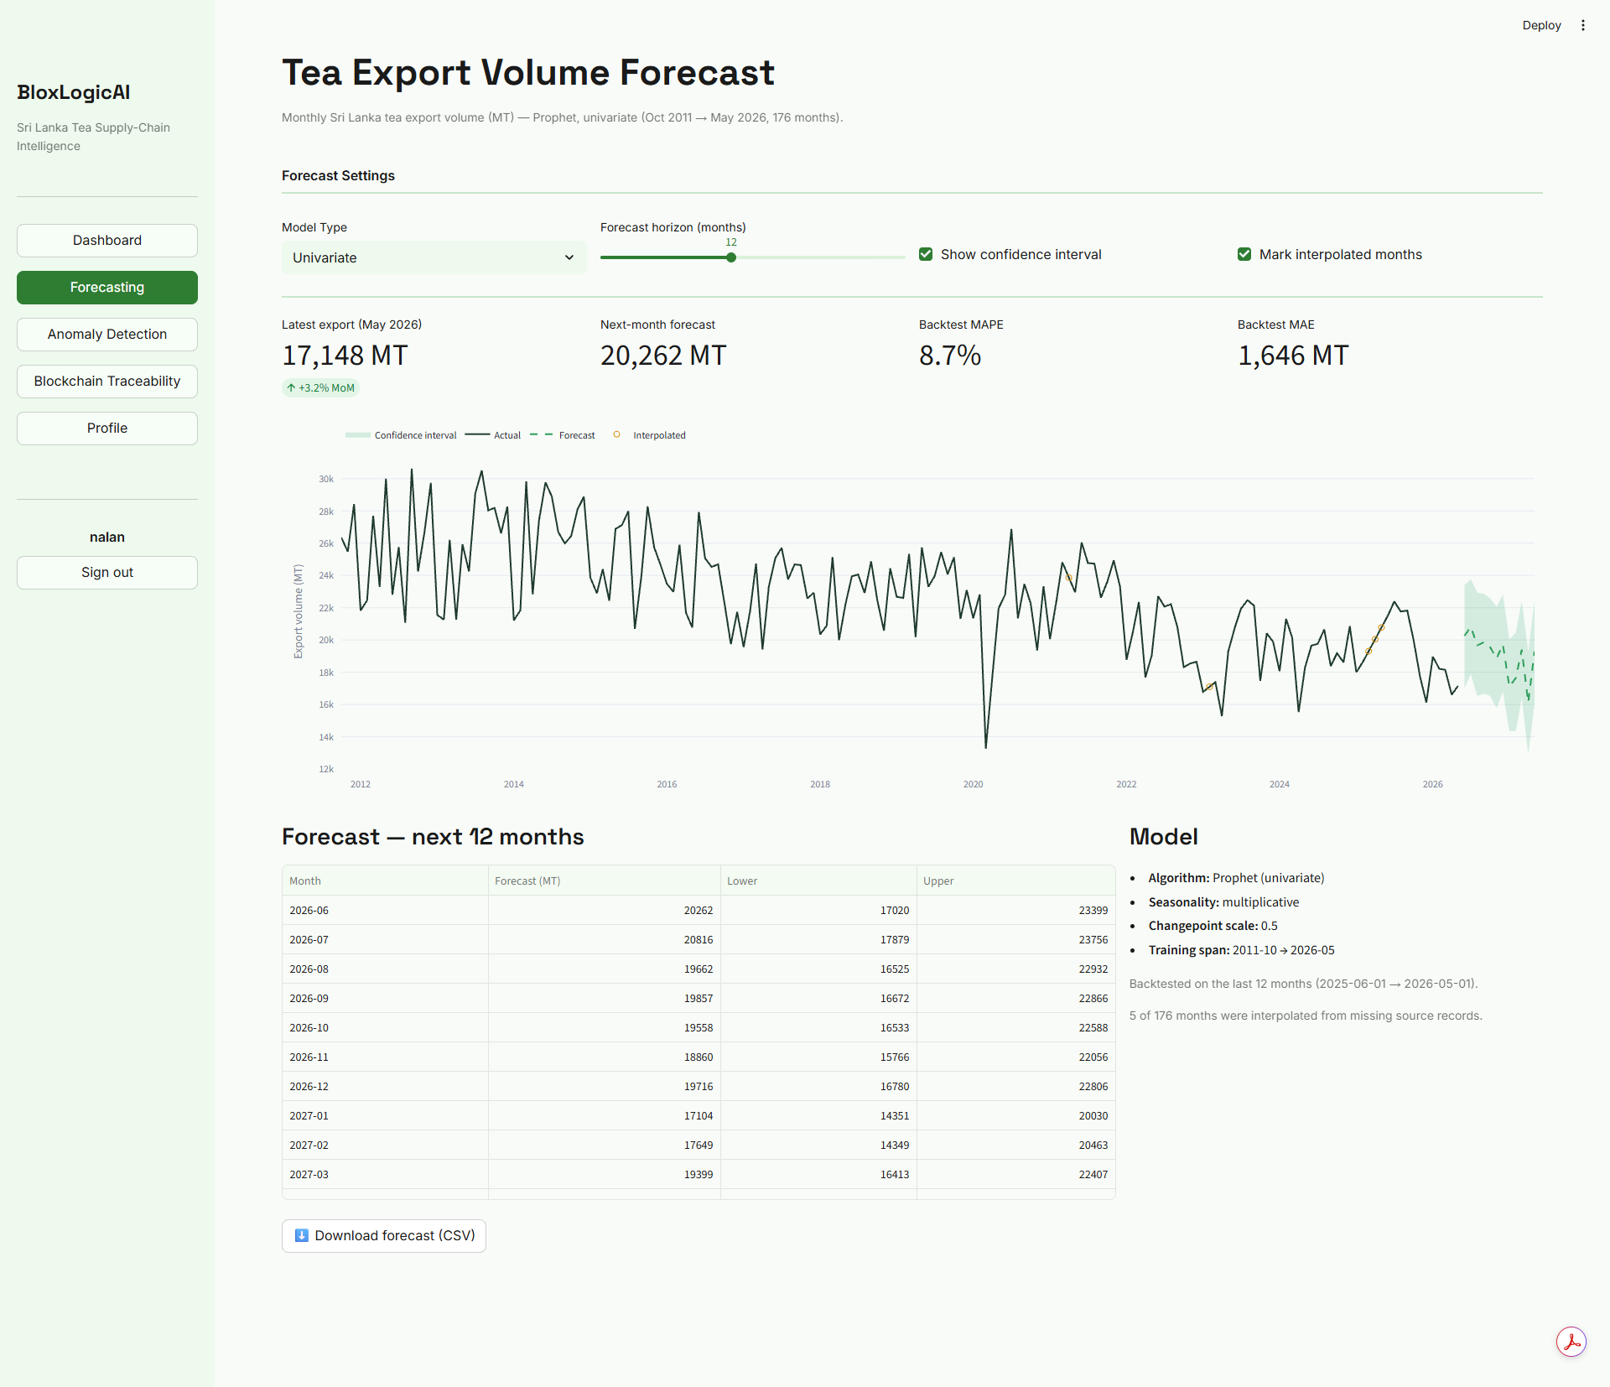
Figure 5: AI Forecasting projections.

Anomaly Detection
The Anomaly Detection tab acts as a proactive early-warning system. - The charts display historical data with specific points highlighted in red. - These red points indicate data anomalies (e.g., sudden disruptions in supply due to weather or economic factors). - By identifying these outliers, users can investigate the causes of past disruptions to better mitigate future risks.
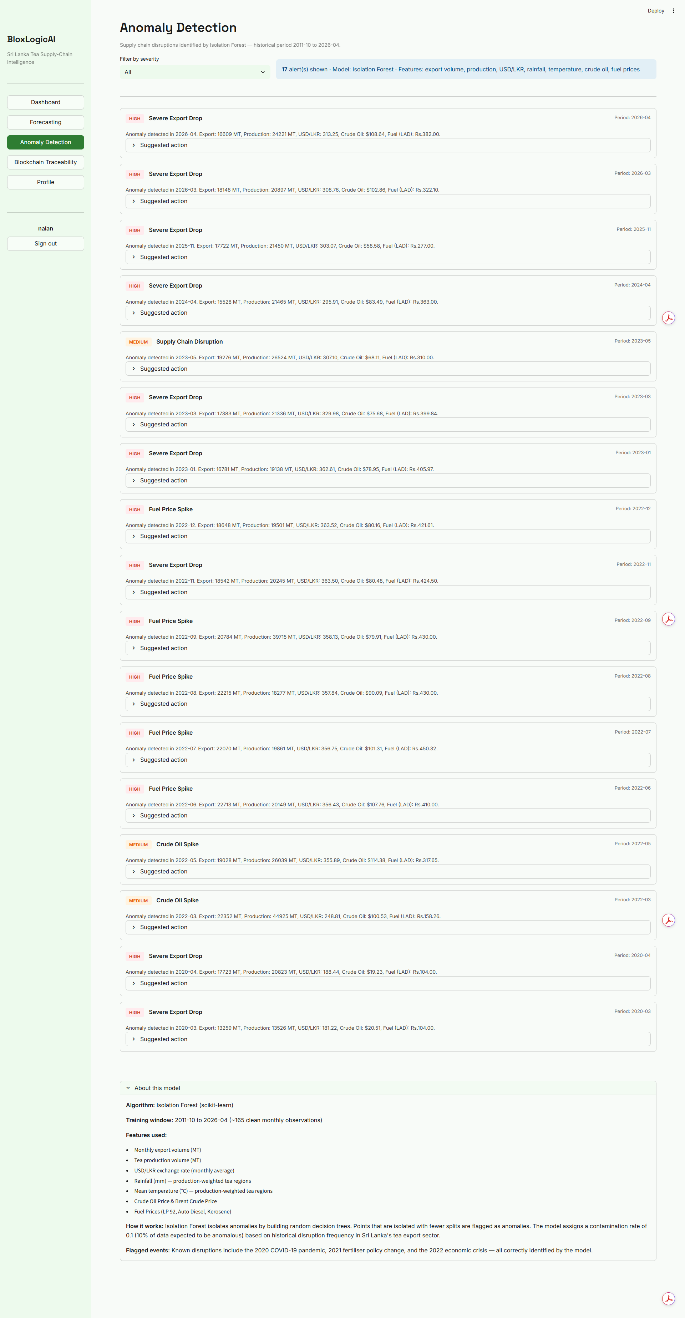
Figure 6: Detecting supply chain anomalies.

Blockchain Traceability
The Blockchain tab allows users to verify the authenticity of the data they are viewing. - The system displays the cryptographic hash history for recent records. - Users can visually confirm that the blockchain is intact and that no records have been altered post-entry.
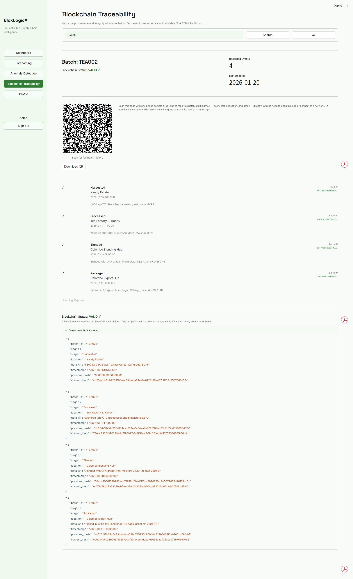
Figure 7: User verification of blockchain records.

User Profile
Manage your account details here. - View your account information, role, and settings. - You can update your password or log out securely from this page.
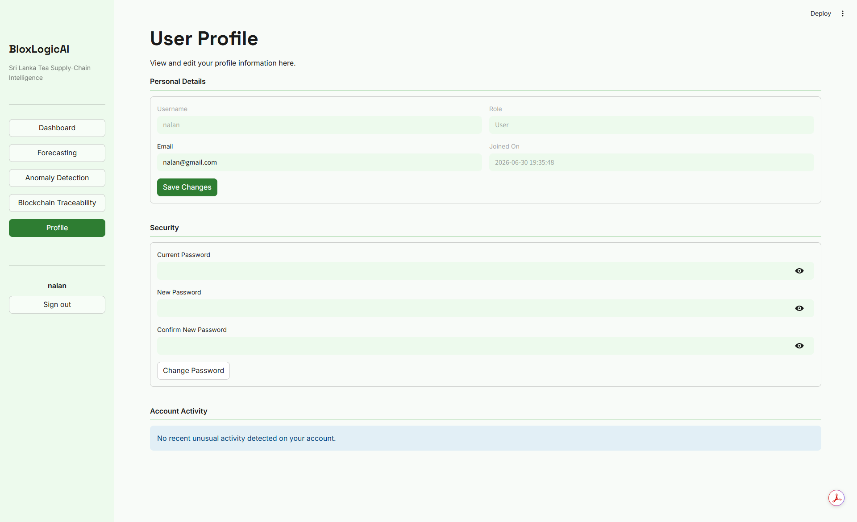
Figure 8: The User Profile page.

4. Administrator Guide
Administrators have access to a distinct set of tools for managing the platform’s backend data and AI models.

Admin Dashboard
Administrators log in through a dedicated admin portal to access their dashboard. - The Admin Dashboard provides an overview of system health, active users, and recent database activity. - The sidebar grants access to specialized data management tools.
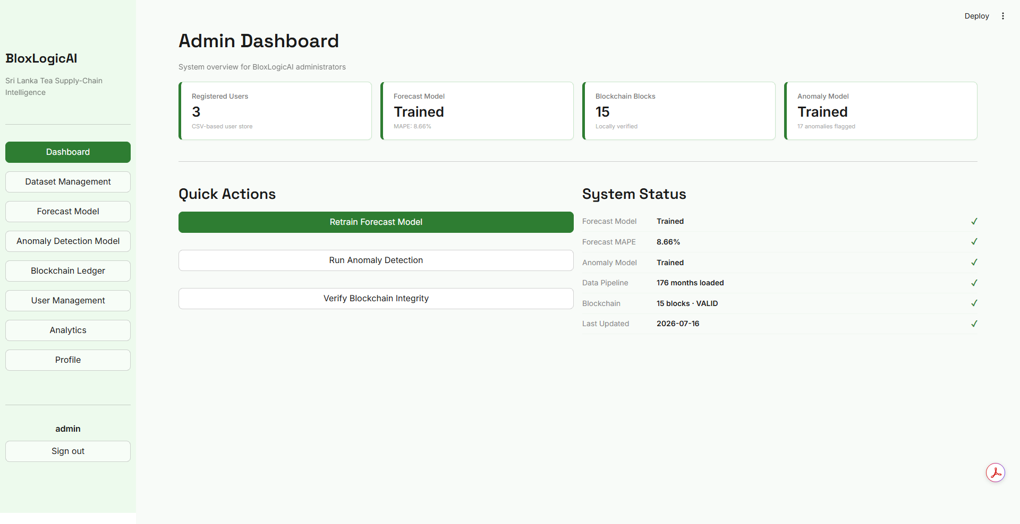
Figure 9: The Administrator Dashboard.

Dataset Management
Data is the lifeblood of the AI models. Administrators use this page to ingest new data. - Upload Data: Use the drag-and-drop interface to upload new CSV or Excel files containing the latest tea industry statistics. - The system will automatically validate the data, append it to the database, and trigger a retraining of the AI models if necessary.
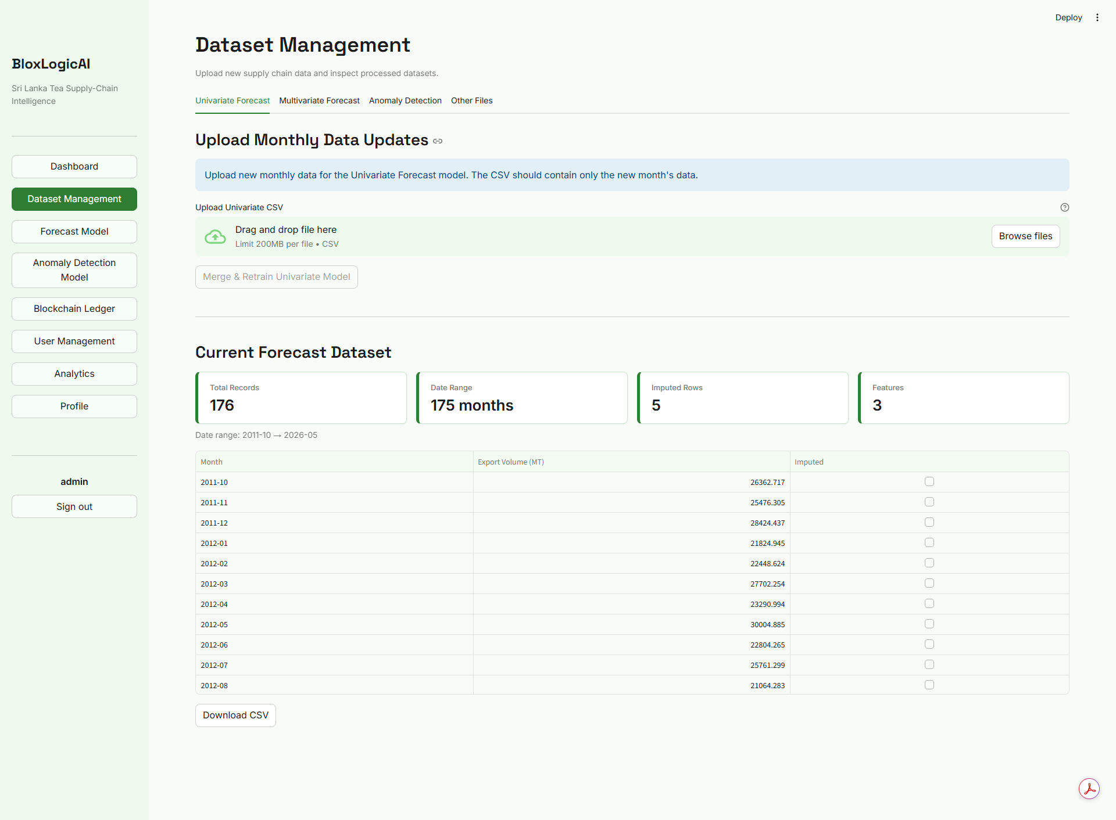
Figure 10: Admin interface for uploading and managing datasets.

Forecast Model Training
This section allows administrators to retrain the AI demand forecasting model using the latest data. The system utilizes Facebook Prophet, and administrators can trigger a complete retrain when new tea export datasets are uploaded. Admins use this feature to ensure the forecasting predictions remain highly accurate and reflect the most recent market trends, keeping stakeholders well-informed.

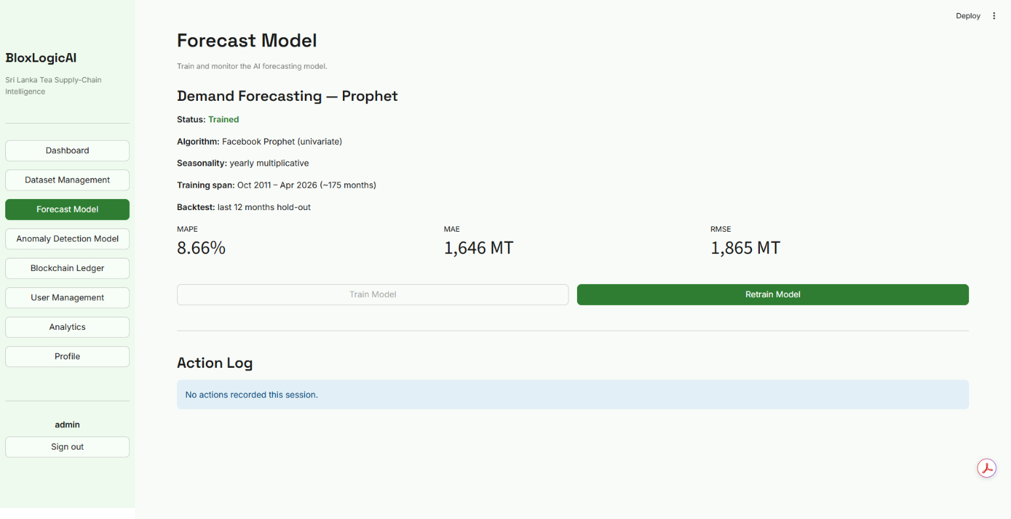
Figure 11: Admin interface for train forecasting model.

Anomaly Detection Model Training
The anomaly detection training interface enables administrators to update the Scikit-Learn Isolation Forest model. By retraining this model, the system recalibrates its understanding of "normal" supply chain behavior based on newly ingested historical data. Admins use this to refine the early-warning alerts, ensuring the platform accurately flags new types of disruptions such as novel climate events or sudden geopolitical shifts without generating false positives

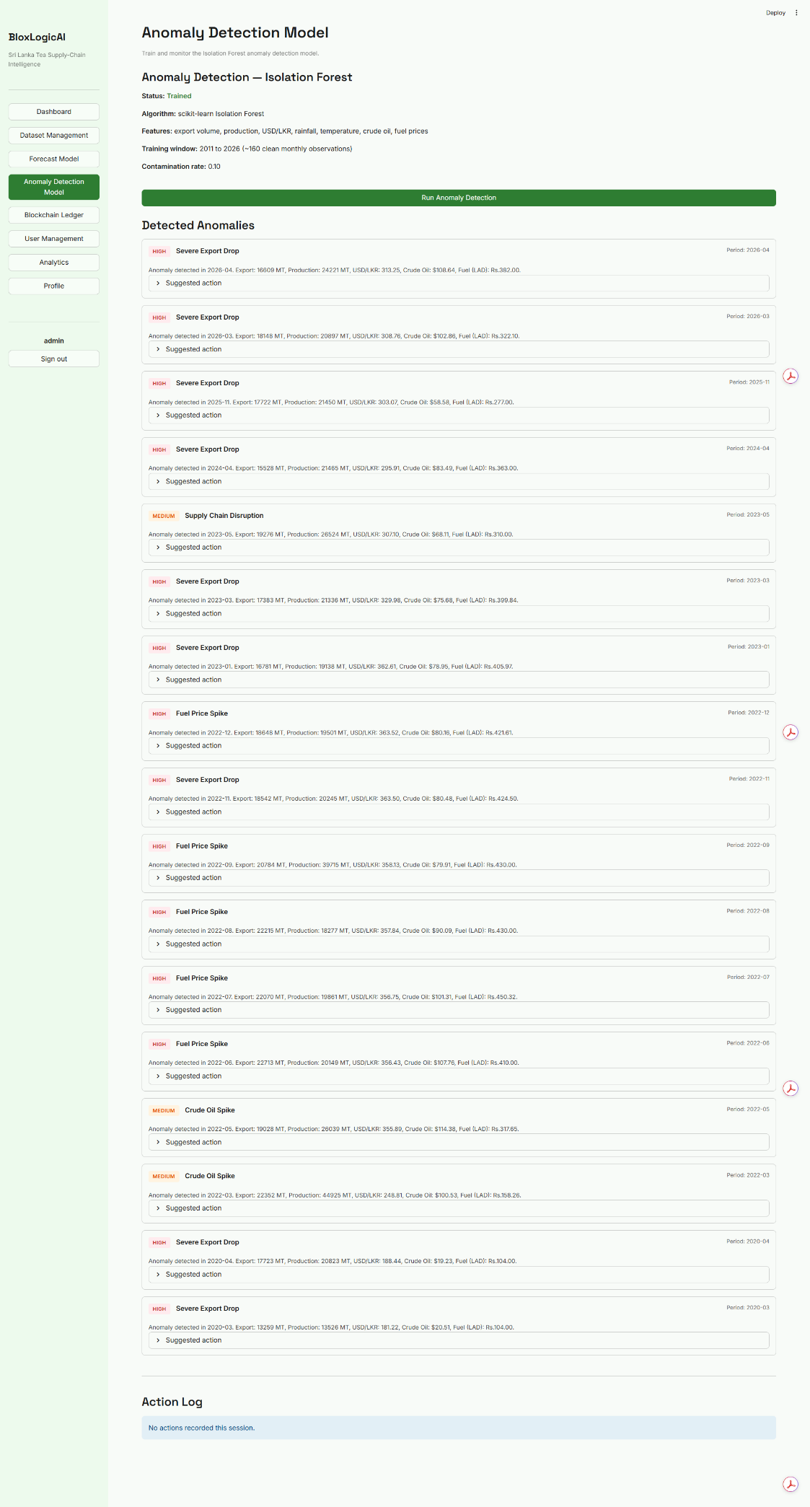
Figure 12: Admin interface for training anomaly detection (isolation forest).

User Management
The User Management panel provides administrators with tools to control access to the BloxLogicAI platform. It allows admins to view a list of all registered users, reset passwords, change user roles (e.g., standard user vs. admin), and deactivate accounts if necessary. Admins use this centralized interface to maintain system security, ensure only authorized personnel access sensitive supply chain data, and assist users who have lost their login credentials.

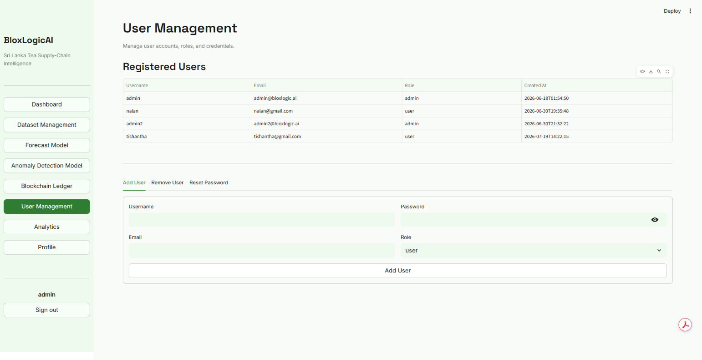
Figure 13: Admin interface for managing users.

Analytics
The Analytics dashboard gives administrators a comprehensive, high-level view of overall system usage and performance metrics. It aggregates data on user activity, model performance, and the frequency of anomalies detected over time. Admins use these insights to monitor the health of the application, identify usage bottlenecks, and report on the overall value the platform is delivering to the tea industry.

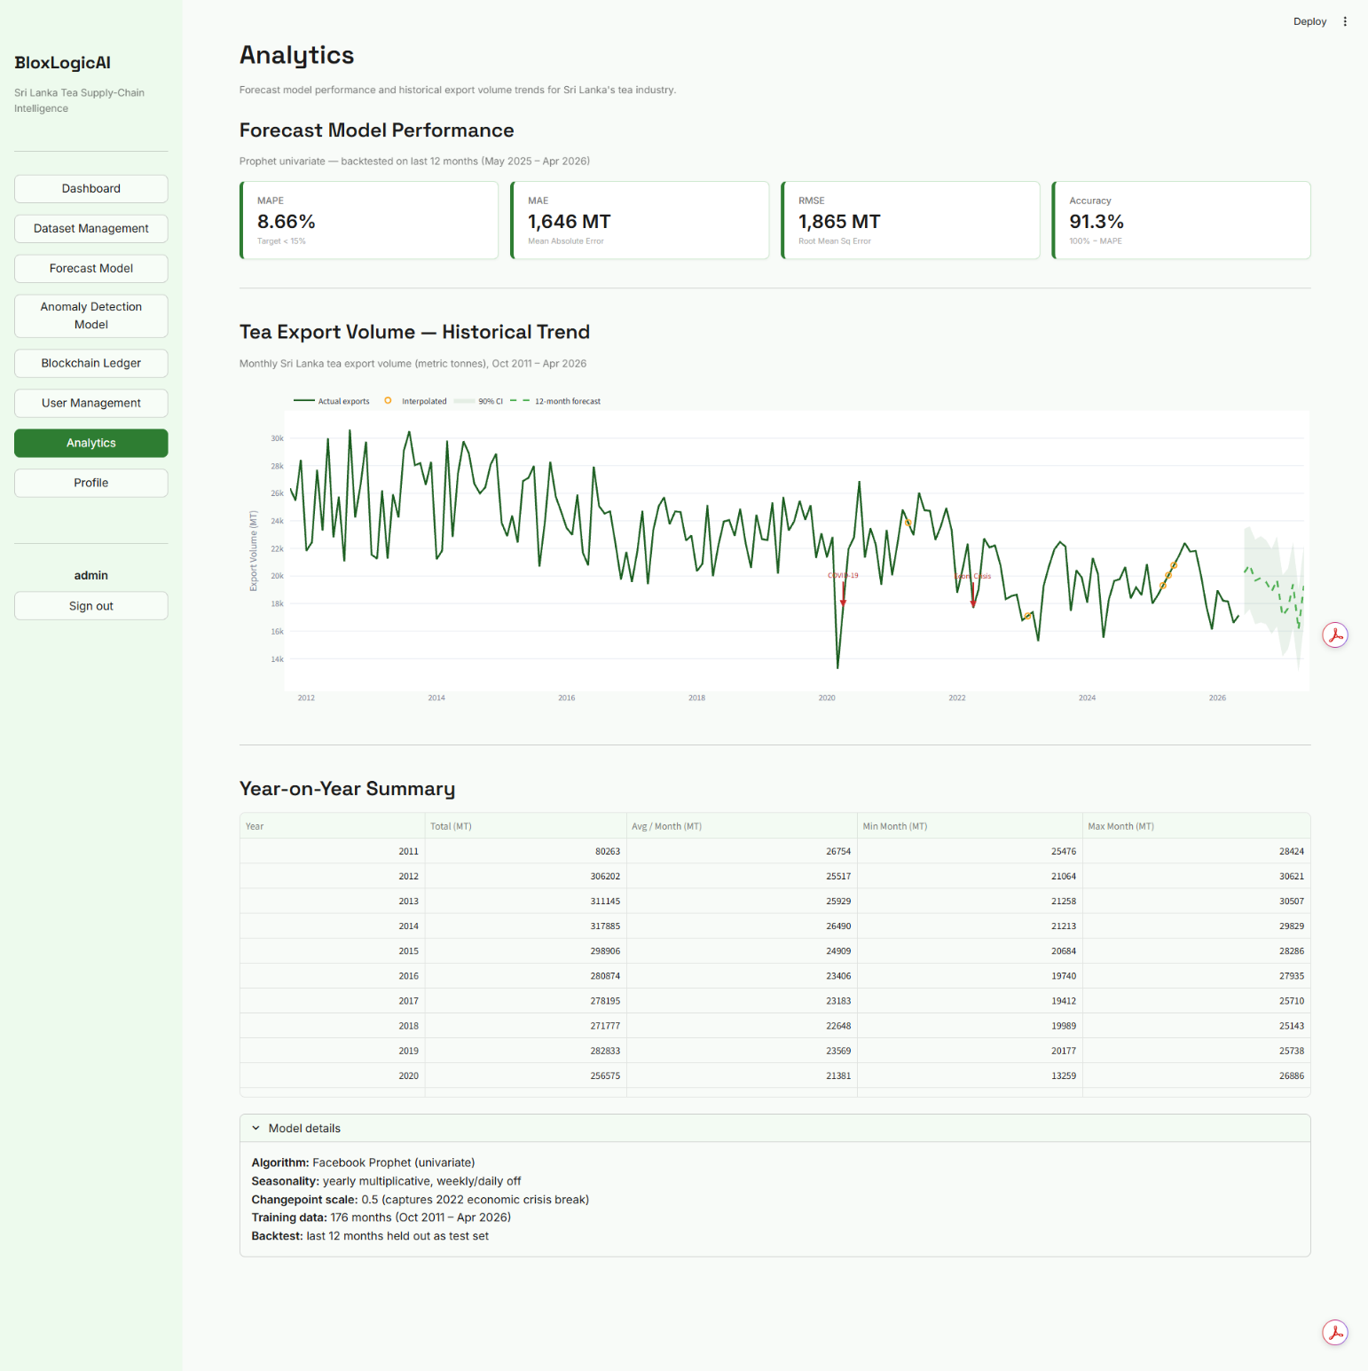Figure 14: Admin interface for analyzing forecast model predictions.

Blockchain Ledger Viewer
Administrators have full visibility into the raw Blockchain Ledger. - This view exposes the underlying JSON ledger blocks. - Admins can inspect the previous_hash, current_hash, timestamp, and the payload data for every transaction to perform deep system audits.
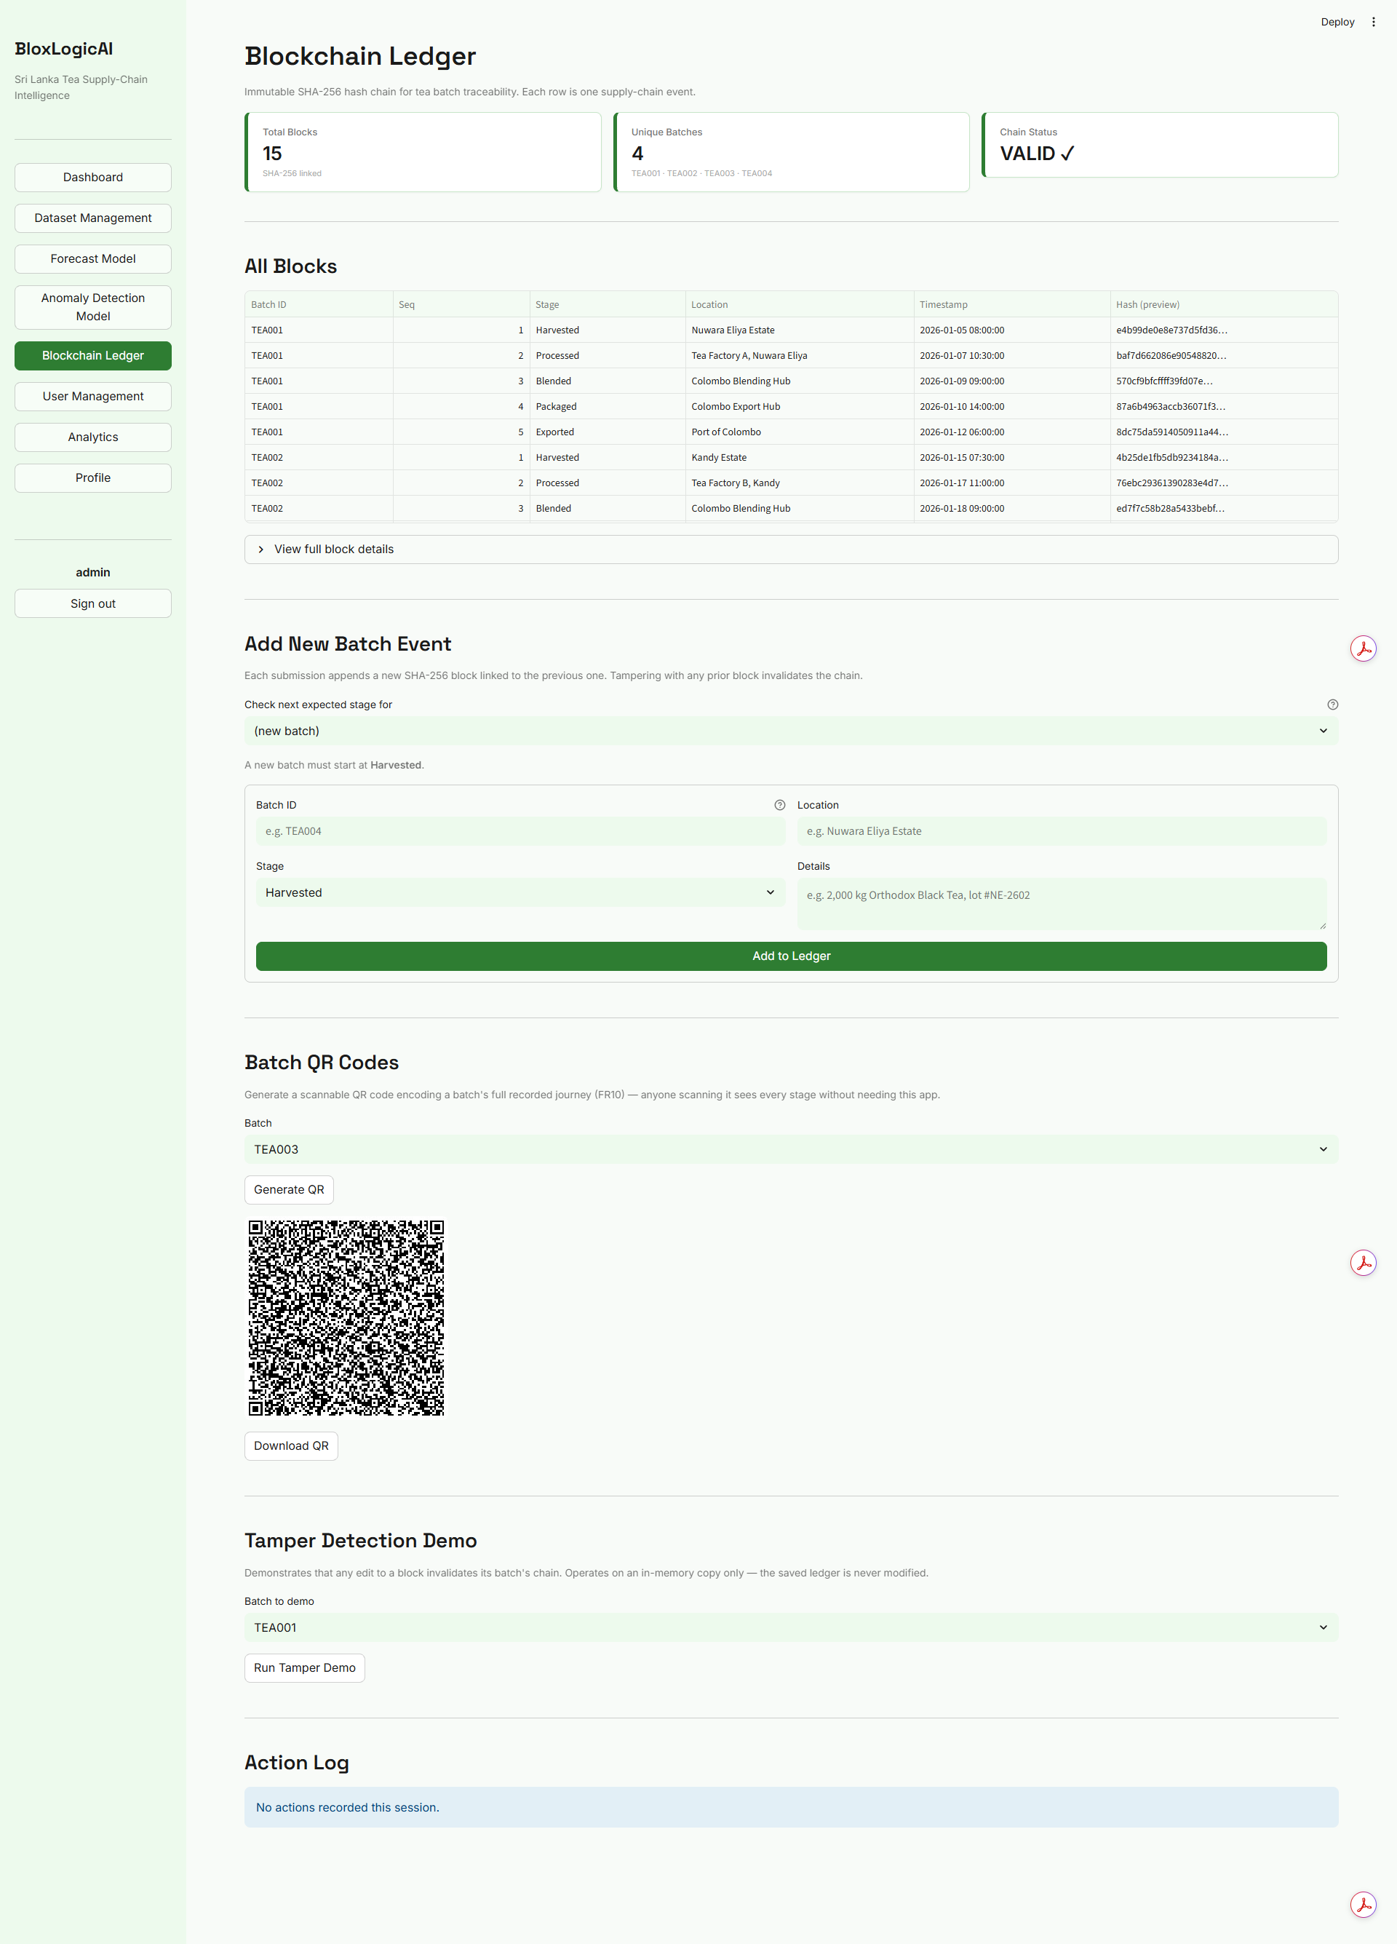
Figure 15: The raw cryptographic ledger viewed by an admin.

5. Troubleshooting & FAQs
Q: I forgot my password, how do I log in? A: Currently, you will need to contact a system administrator to reset your credentials.
Q: The charts are not loading or look incomplete. A: Ensure you have a stable internet connection. If an administrator is currently uploading a new dataset, the AI model may be retraining. Please refresh the page in a few minutes.
Q: What exactly does an anomaly mean? A: The AI flags a data point as an anomaly when it deviates significantly from expected historical patterns. This could indicate a real-world event (like a sudden strike or extreme weather) that impacted the tea supply chain.
Q: How do I know the data is secure? A: Every record is hashed and linked to the previous record using SHA-256 encryption. If any data is modified directly in the database, the blockchain validation will instantly fail, exposing the tampering.

