

ROI – Power BI Integration

1. Create Azure App

Better to create an app for embedding Power BI.

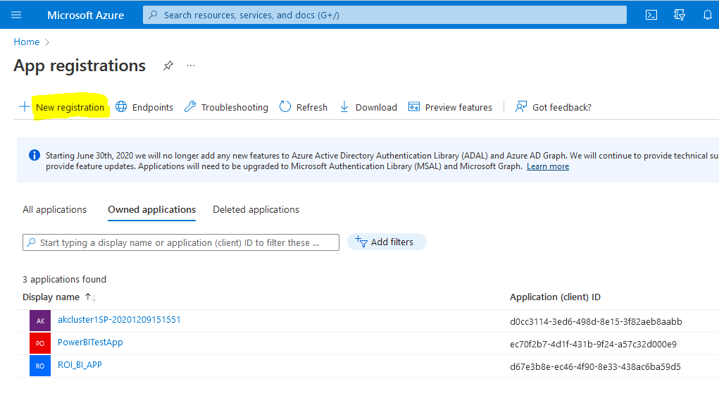

1. Get App details

once we create an app, we should copy the following details.

* App name
* Client Id
* Tenant Id
* Generate Client credentials (take the client secret value)

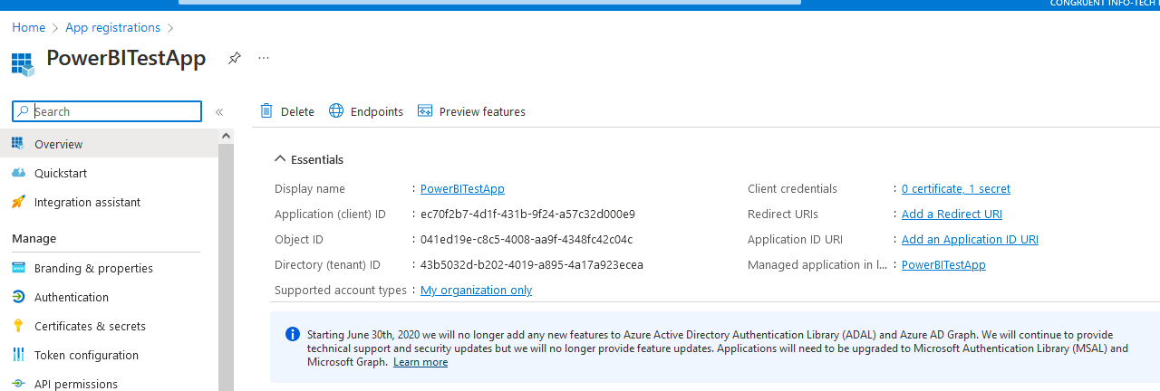

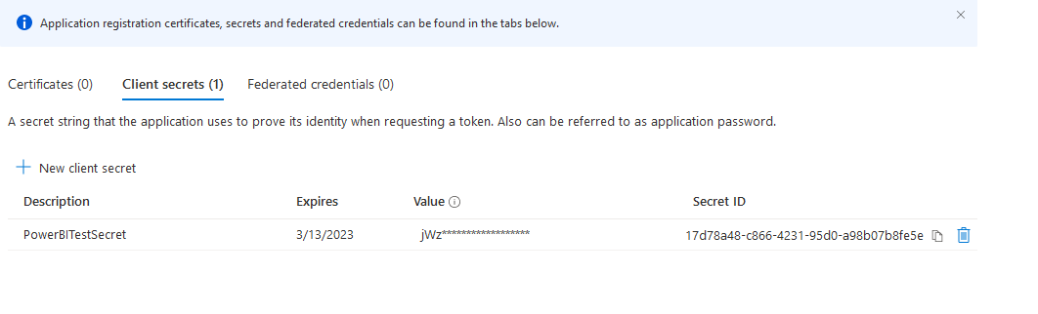

1. Create a Workspace in the Power BI

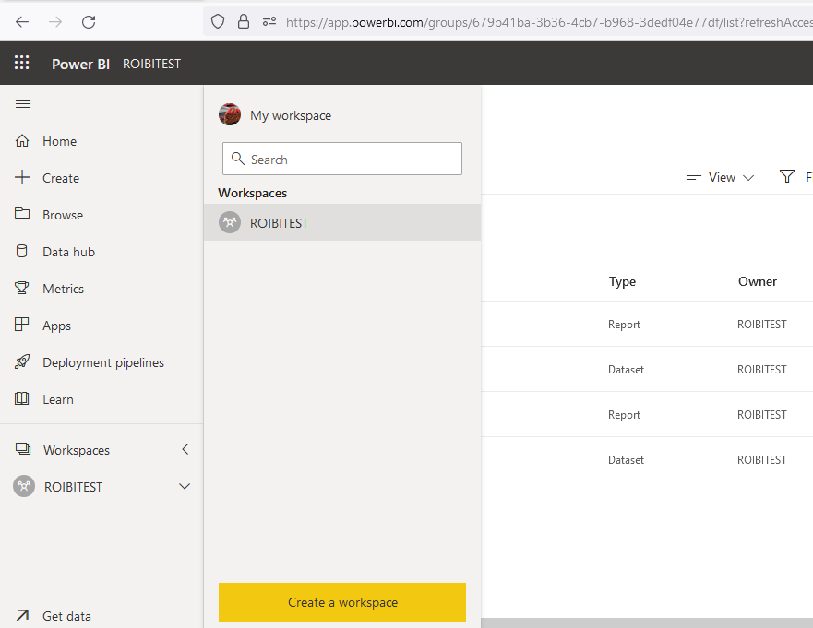

Make sure the below configuration settings are enabled.

Settings 🡪 Admin Portal 🡪 Tenant Settings 🡪 Developer Settings

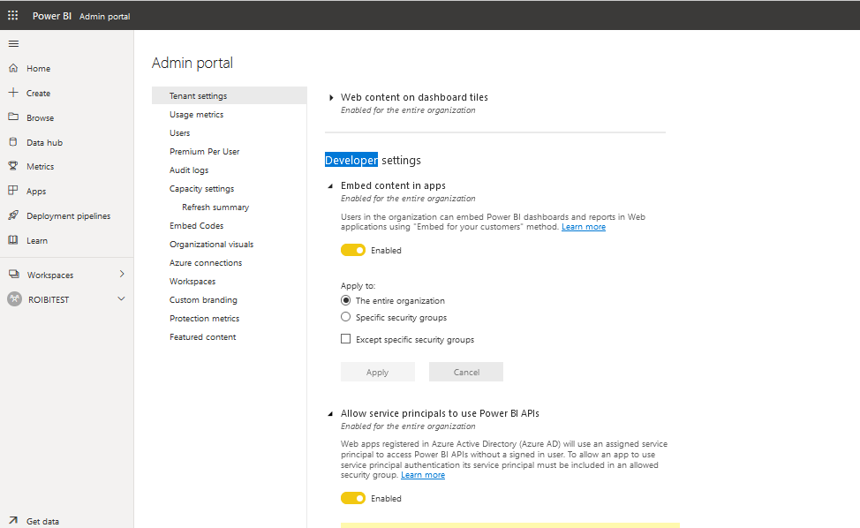

* Embed content in apps
* Allow service principals to use power apis

1. Provide access to the Azure App

* Select workspace and click on the workspace access section
* Search for the Azure App name and add it.

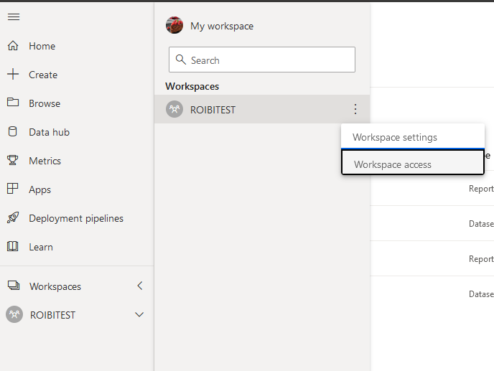

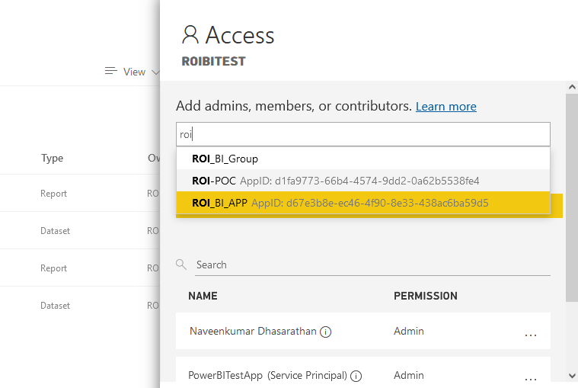

1. Publish reports to the Power BI

* Publish report to the Power BI workspace from the desktop app.

