SIT719 Analytics for Security and Privacy

Workshop for week 9

During week 8’s workshop, we have introduced the ARX tool and some simple use of k-anonymity with respect to different k values. In this workshop, we learn how to apply some advanced methods, like differential privacy.

First, let’s open the example project file “example.deid” as we did in week8. It should like this:

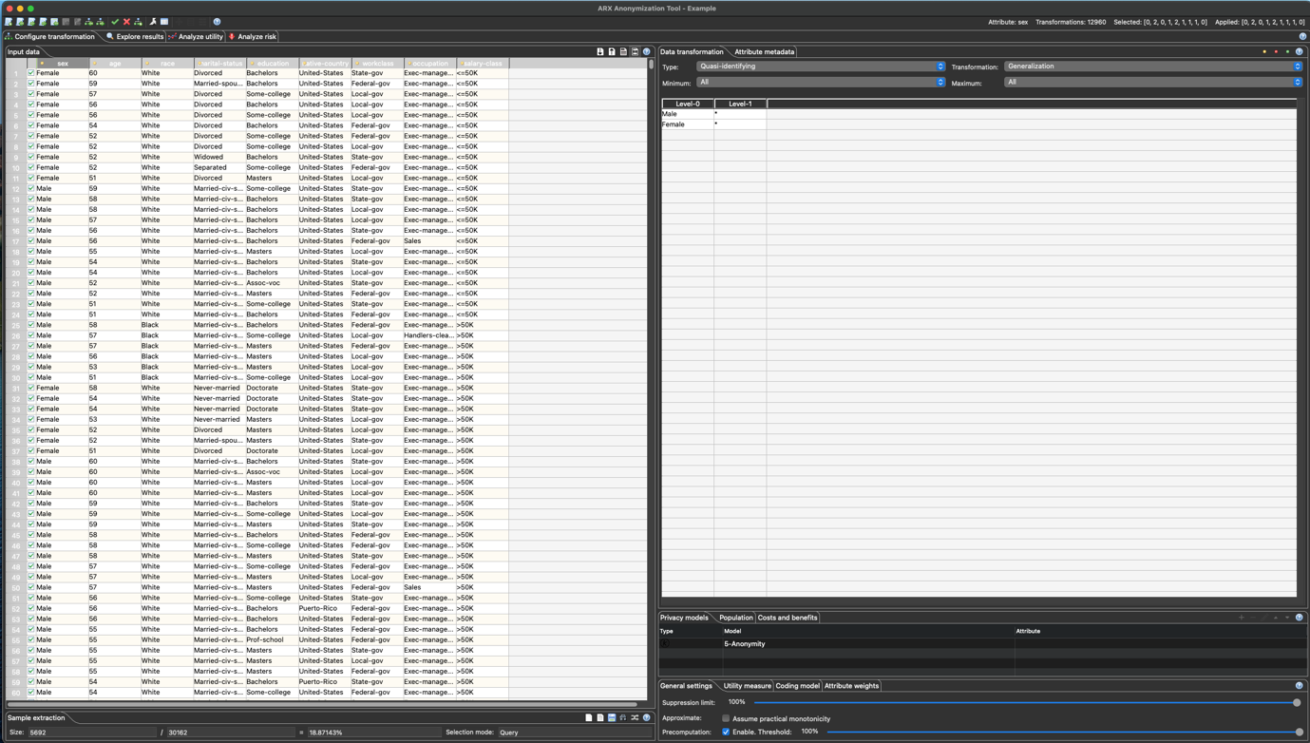

On the left panel in the “Sample extraction” panel, you should notice that only 5692 records are selected. To use some privacy preserving methods, all records must be selected. We click the “Select all” button in the “Sample extraction” panel, then we will see the following:



Once we selected all the records, we are ready to apply the differential privacy method. First, we need to select the default model in the “Privacy models” tab. Then, we need to click the “-“ logo to remove the current 5-Anonimity method.

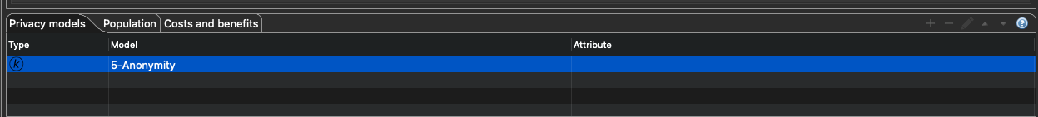

Once it is removed, we click the “+” logo and choose the Differential privacy model.

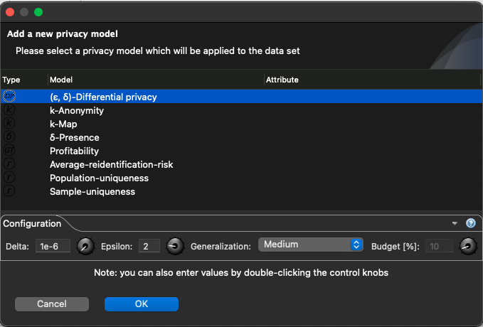

Click “Ok” and then run the model over the whole dataset by clicking the tick logo in the menu bar. And the result will be generated as follows:

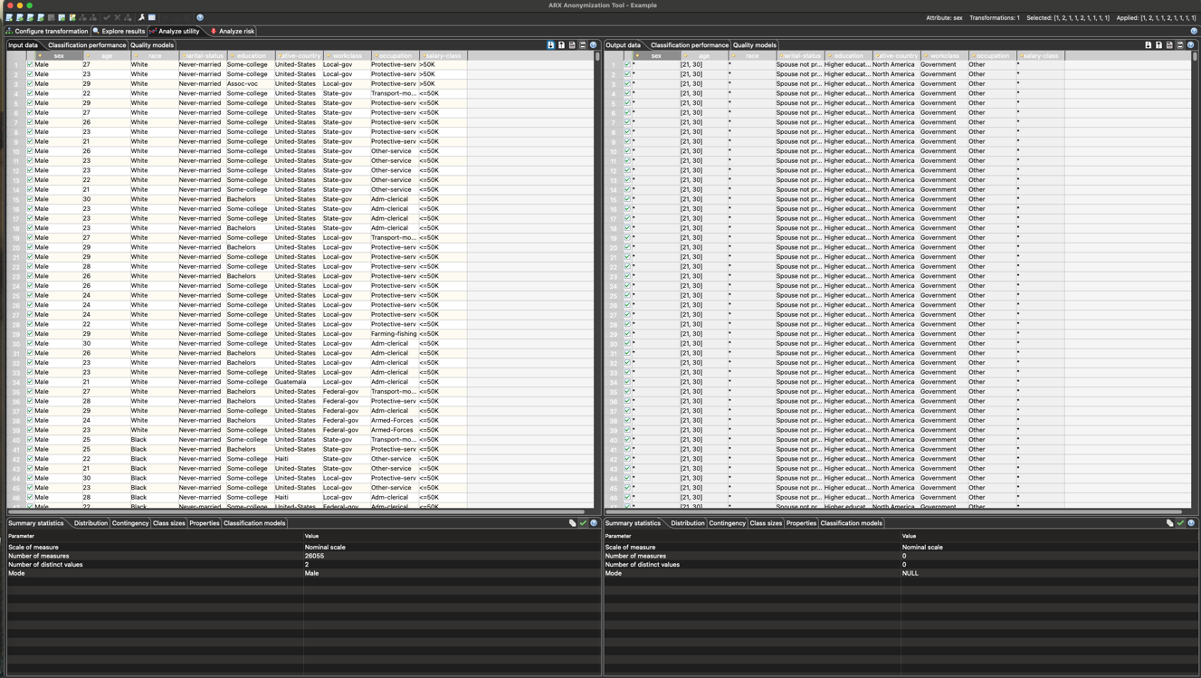

Please note that DP works quite differently to simple methods like k-Anonymity and a few others.

We have a step-by-step demo in Week 9’s CloudDeakin site, named “Demo: Using the ARX tool to anonymize data”.

Make sure that you watch the video demo for technical details.