# Load necessary libraries  
library(readxl)

## Warning: package 'readxl' was built under R version 4.4.1

library(ggplot2)

## Warning: package 'ggplot2' was built under R version 4.4.1

library(dplyr)

##   
## Attaching package: 'dplyr'

## The following objects are masked from 'package:stats':  
##   
## filter, lag

## The following objects are masked from 'package:base':  
##   
## intersect, setdiff, setequal, union

# Load the data  
file_path <- "C:\\Users\\ASUS\\OneDrive\\Desktop\\Food Delivery Sales.1.xlsx"  
food_data <- read_excel(file_path, sheet = "Food_Delivery")  
# Display the first few rows of the data  
head(food_data)

## # A tibble: 6 × 8  
## `Delivered through` Date Region `Delivery person` `Customer ID`  
## <chr> <dttm> <chr> <chr> <chr>   
## 1 Swiggy 2021-01-01 00:00:00 South… Suresh C1   
## 2 Swiggy 2021-01-02 00:00:00 South… Mahesh C2   
## 3 Swiggy 2022-01-03 00:00:00 South… Mahesh C2   
## 4 Swiggy 2021-01-03 00:00:00 North… Raju C3   
## 5 Swiggy 2021-01-03 00:00:00 South… Raj C16   
## 6 Swiggy 2022-01-04 00:00:00 North… Nilesh C4   
## # ℹ 3 more variables: `Food Item` <chr>, `Cost Price` <dbl>,  
## # `Selling Price` <dbl>

# Convert Date column to Date type  
food_data$Date <- as.Date(food_data$Date)

# Visualization 1: Sales Trends Over Time  
ggplot(food_data, aes(x = Date, y = `Selling Price`)) +  
 geom_line(stat = "summary", fun = sum, color = "blue") +  
 labs(title = "Sales Trends Over Time", x = "Date", y = "Total Sales")

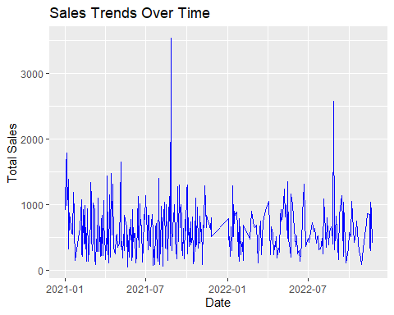

# Visualization 2: Sales by Region  
ggplot(food_data, aes(x = Region, y = `Selling Price`, fill = Region)) +  
 geom_bar(stat = "summary", fun = sum) +  
 labs(title = "Sales by Region", x = "Region", y = "Total Sales") +  
 theme(axis.text.x = element_text(angle = 45, hjust = 1))

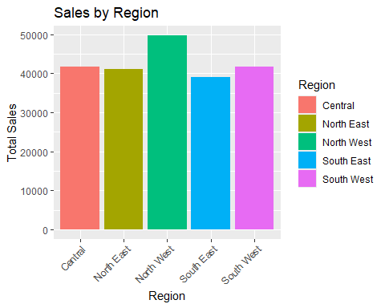

# Visualization 3: Profit Analysis  
food_data <- food_data %>%  
 mutate(Profit = `Selling Price` - `Cost Price`)  
  
ggplot(food_data, aes(x = `Food Item`, y = Profit, fill = `Food Item`)) +  
 geom_bar(stat = "summary", fun = sum) +  
 labs(title = "Profit by Food Item", x = "Food Item", y = "Total Profit") +  
 theme(axis.text.x = element_text(angle = 45, hjust = 1))

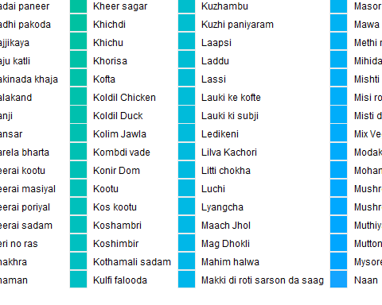

# Visualization 4: Delivery Person Performance  
ggplot(food_data, aes(x = `Delivery person`, y = `Selling Price`, fill = `Delivery person`)) +  
 geom_bar(stat = "summary", fun = sum) +  
 labs(title = "Performance by Delivery Person", x = "Delivery Person", y = "Total Sales") +  
 theme(axis.text.x = element_text(angle = 45, hjust = 1))

