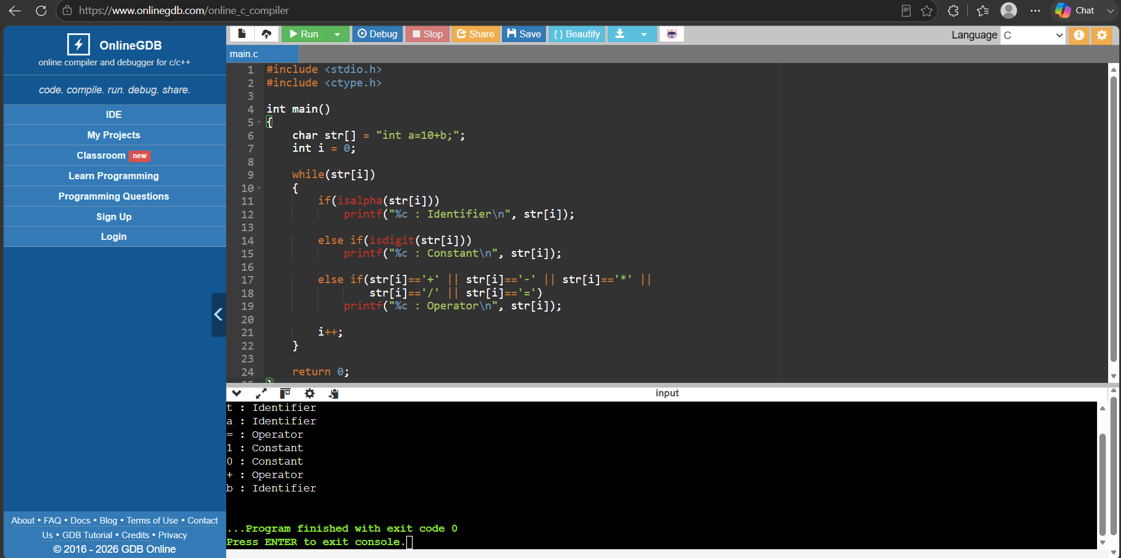
1. Lexical Analyzer to Identify Identifiers, Constants and Operators

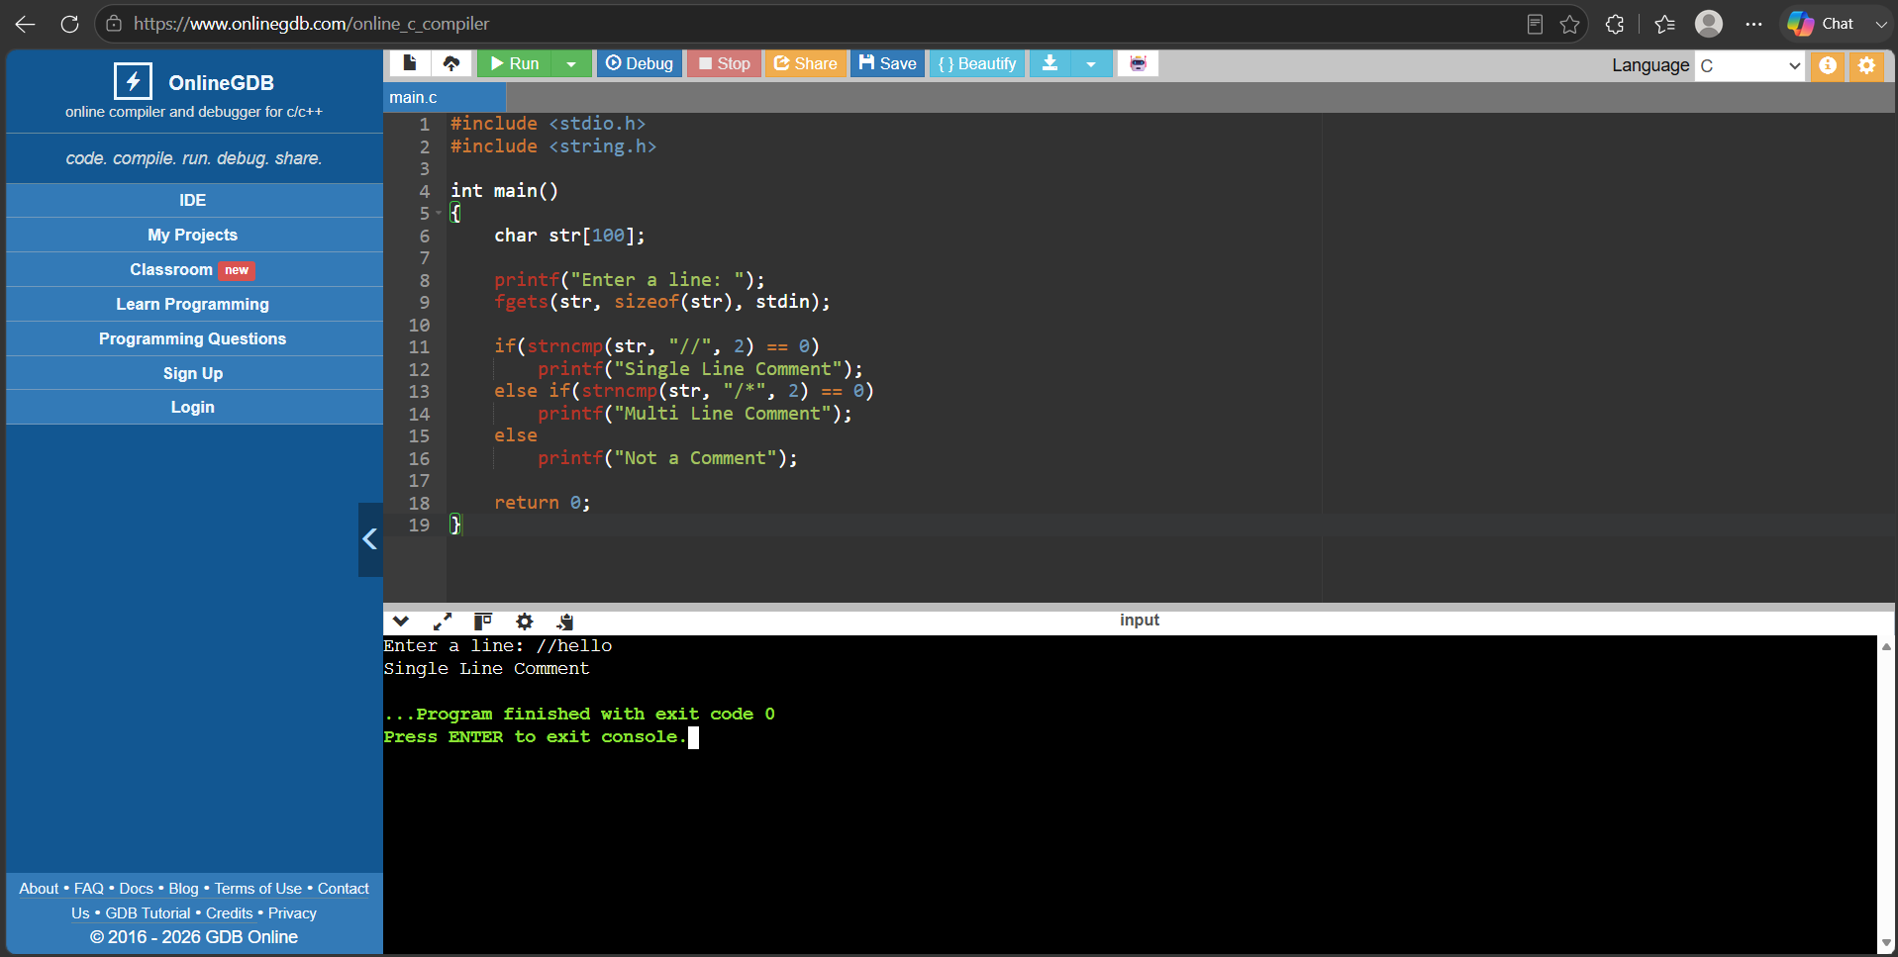
2. Lexical Analyzer to Check Comments

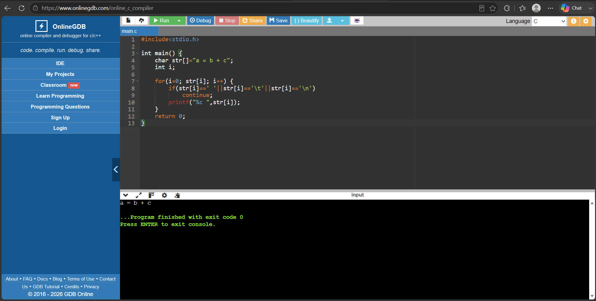
3. Lexical Analyzer Ignoring Spaces, Tabs, Newlines and Comments

4. Lexical Analyzer for Arithmetic Operators

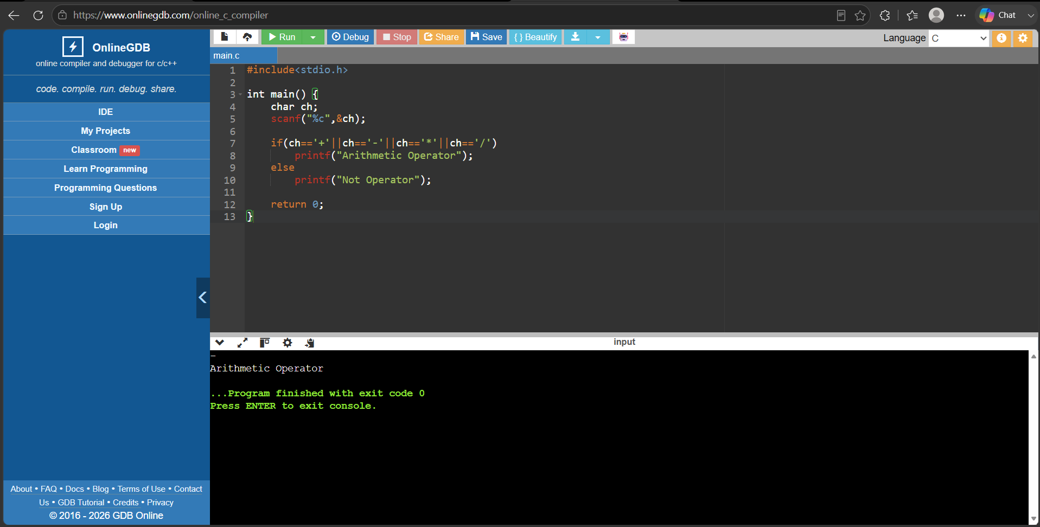

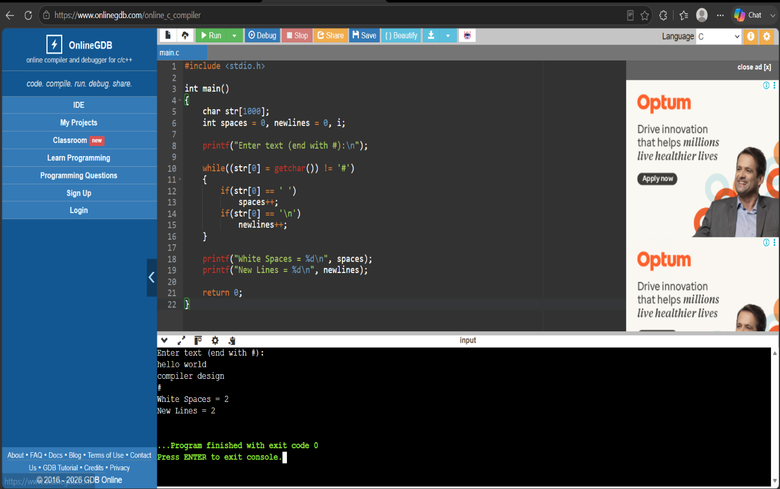
5. Lexical Analyzer to Count Whitespaces and Newlines

6.Lexical Analyzer to Test Valid Identifier
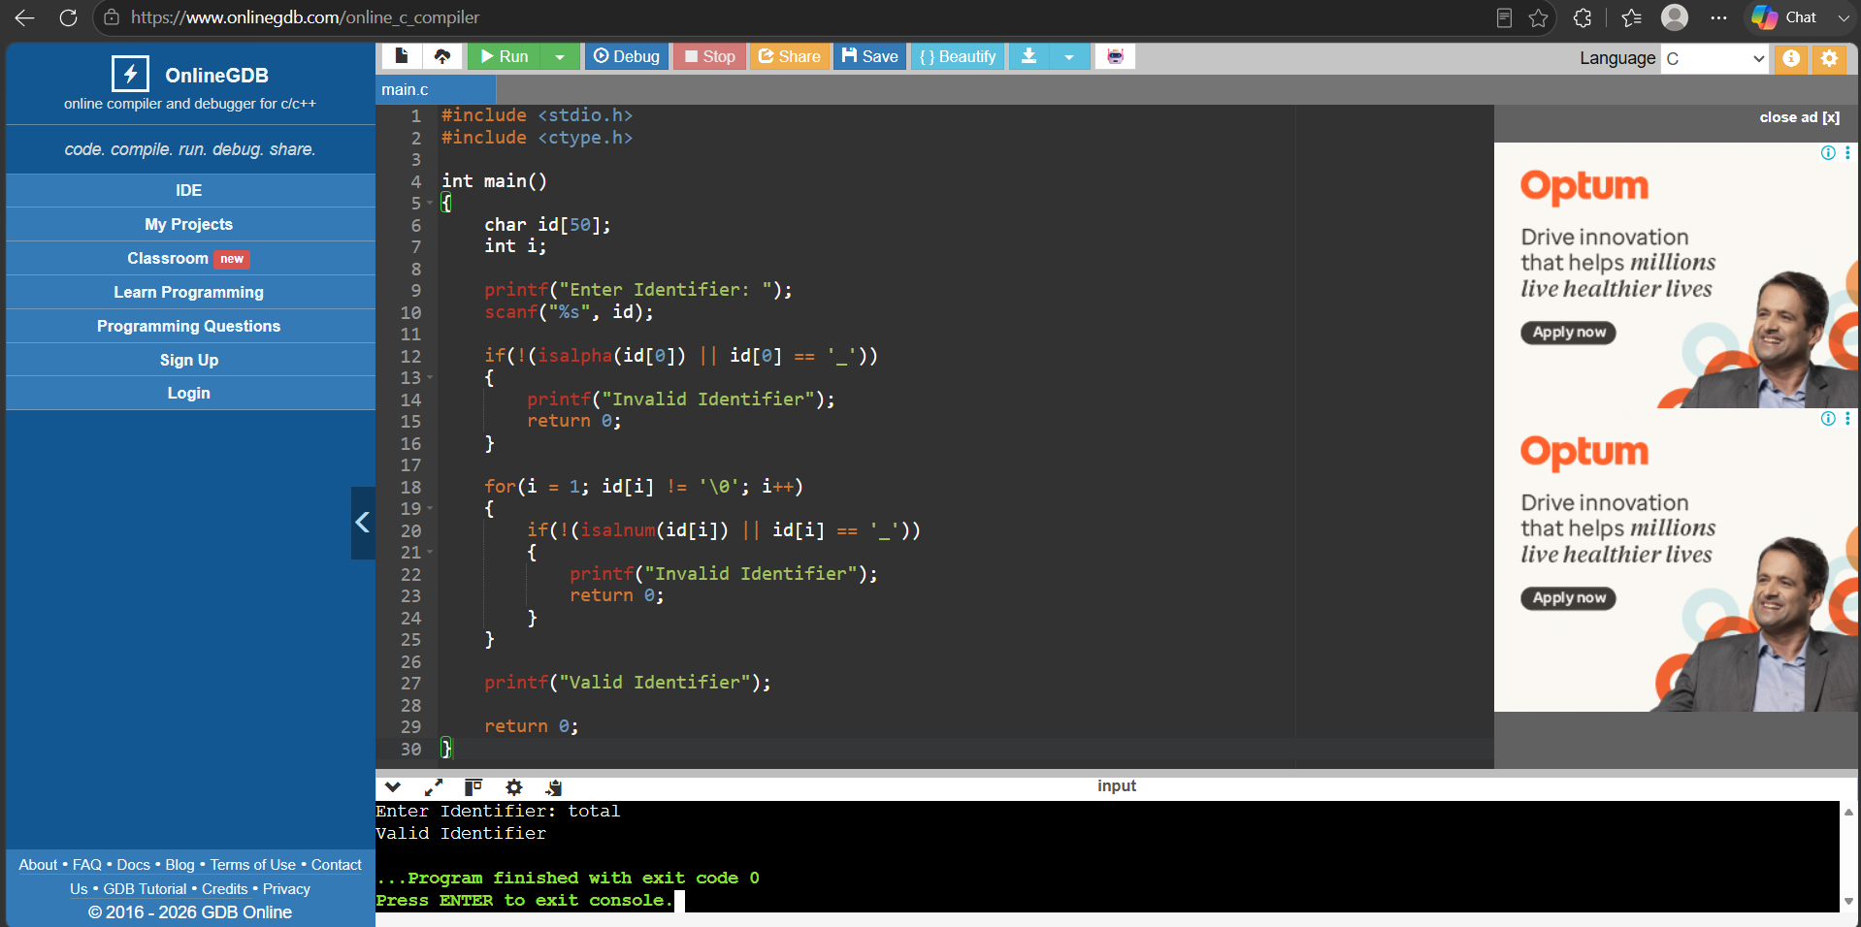

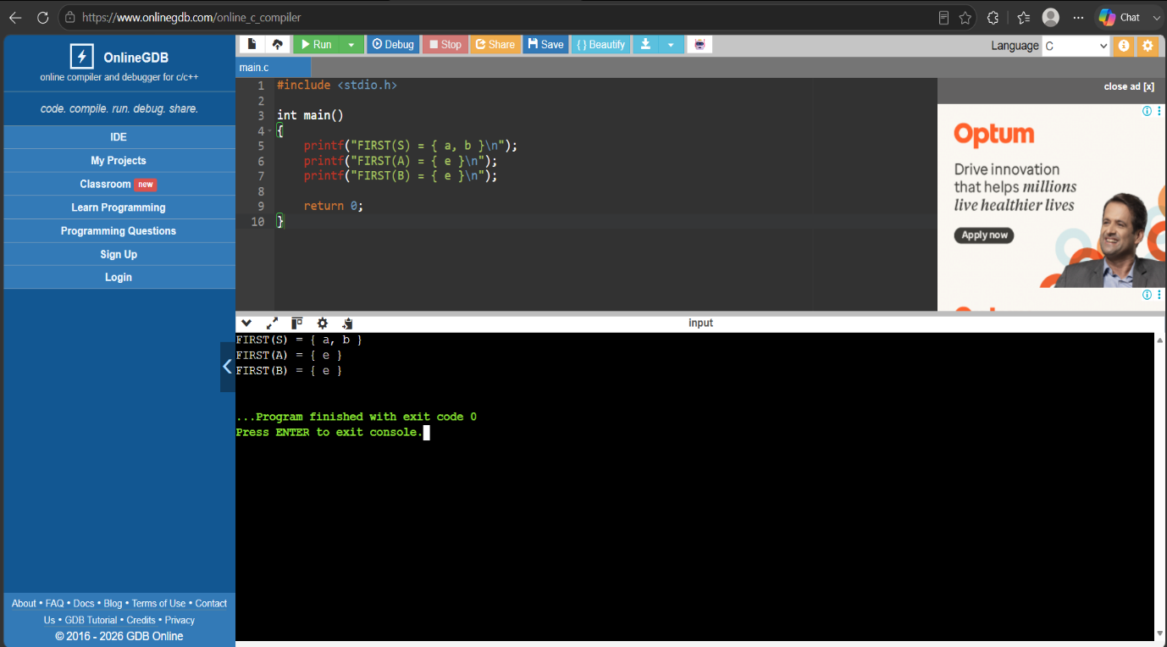
7.FIRST() of Grammar

9. Elimination of Left Recursion
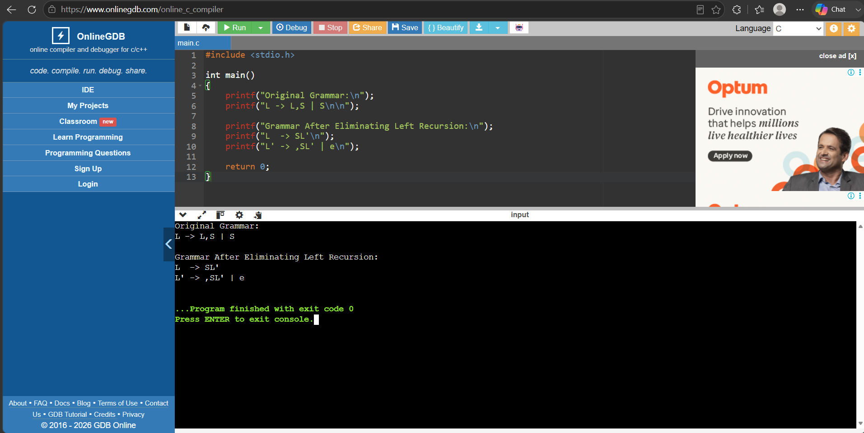

10. Eliminate Left Factoring from CFG
