Advanced Data Analysis and Visualization in Logistics
Project Title: Logistics Data Analytics for Delivery Time Prediction and Cost Optimization Using Python
Internship Task: Week 3 — Advanced Data Analysis and Visualization in Logistics
Name: [Enter Your Full Name]
Dataset note: This report uses a hypothetical/simulated dataset created for educational demonstration. It does not represent real company operations.

1. Abstract
This report explores a simulated logistics dataset using Python, Pandas, NumPy, and Matplotlib. The analysis examines delivery-time distribution, transportation cost, shipment distance, shipment volume, vehicle categories, and regional performance. Descriptive statistics and correlation analysis are used to summarize the data, while charts communicate trends, distributions, group comparisons, and relationships. The findings are illustrative and should be validated against authorized real-world data before operational decisions are made.

2. Objectives
- Perform exploratory data analysis on hypothetical logistics records.
- Calculate central tendency and distribution statistics for key numeric variables.
- Examine relationships among distance, shipment volume, delivery time, and transportation cost.
- Create visualizations and explain why each chart is appropriate.
- Derive sample-based recommendations for improving logistics efficiency.

3. Dataset Structure and Simulation
The dataset contains 120 shipment records and 9 columns. Each row represents a hypothetical shipment. Variables include order ID, order date, region, vehicle type, distance in kilometres, shipment volume in units, delivery time in hours, transportation cost in Indian rupees, and delivery status.
Variable | Type | Description
distance_km | Numeric | Shipment travel distance in kilometres
shipment_volume_units | Numeric | Shipment size represented as units
delivery_time_hours | Numeric | Total delivery time in hours
transport_cost_inr | Numeric | Transportation cost in Indian rupees
vehicle_type | Categorical | Bike, Van, or Truck
region | Categorical | North, South, East, or West
delivery_status | Categorical | On Time or Delayed

4. Methodology
The CSV was loaded with Pandas. The order-date column was converted to datetime format. Numeric variables were inspected using describe(), and missing values were checked. The analysis then calculated correlations and grouped summaries by vehicle type and region. Matplotlib was used to generate six visualizations, which were saved as PNG files. Summary tables were exported to CSV files for reproducibility.

5. Exploratory Data Analysis
Mean delivery time: 6.98 hours; median delivery time: 6.88 hours.
Mean transportation cost: ₹781.26; median transportation cost: ₹748.34.
Average shipment distance: 158.45 km; average shipment volume: 25.51 units.
Sample records marked as delayed: 11.7%. This status is generated from the simulated delivery-time rule and should not be treated as a real service-level measure.
The descriptive statistics and correlation matrix are also provided as CSV files in the outputs folder.

5.1 Delivery-Time Distribution (Histogram)
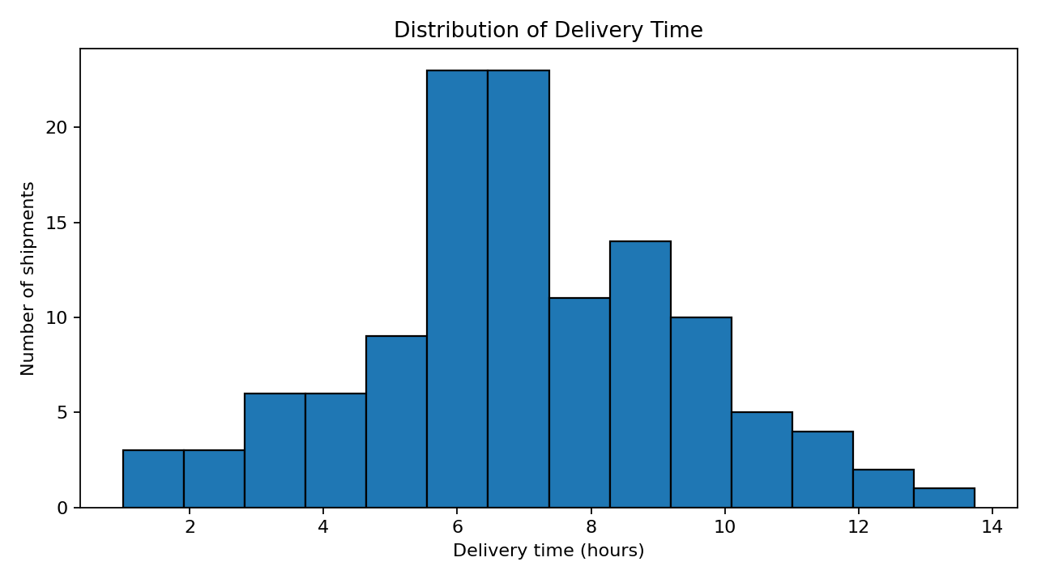
A histogram shows how delivery times are distributed across shipments. It is useful for understanding the typical range, spread, and whether a small number of shipments take much longer than most. The mean and median can be compared to assess possible skew.

5.2 Transportation Cost vs Distance (Scatter Plot)
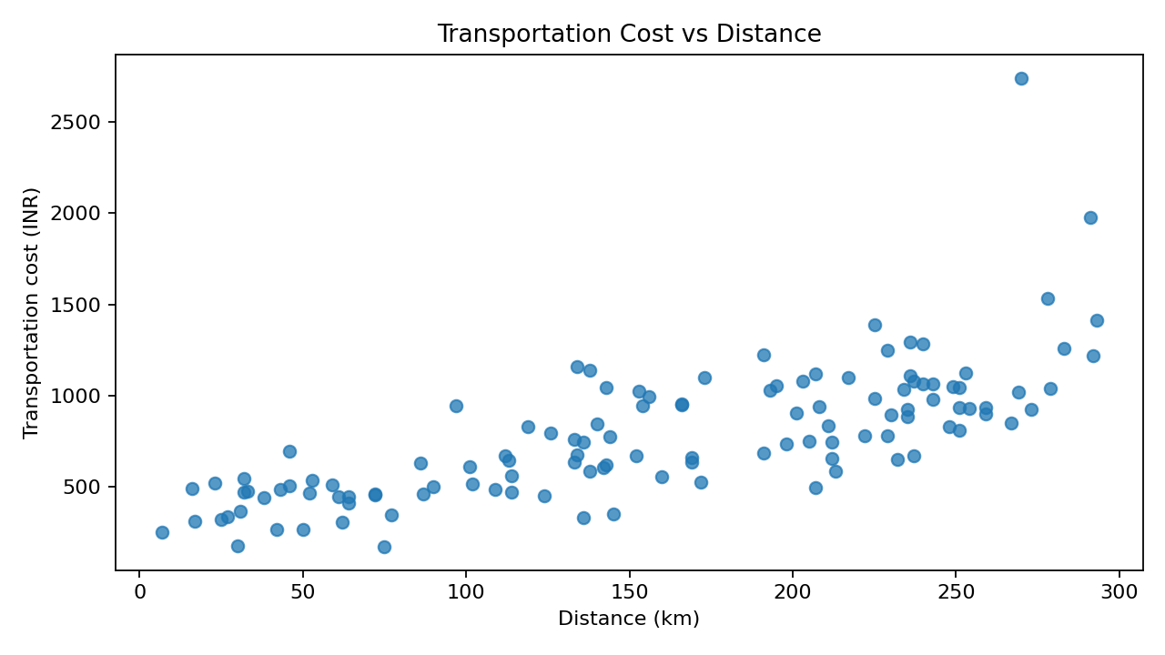
A scatter plot is appropriate for two numeric variables. It helps assess whether transportation cost tends to increase with distance and highlights unusual high-cost points that may require investigation.

5.3 Average Delivery Time by Vehicle Type (Bar Chart)
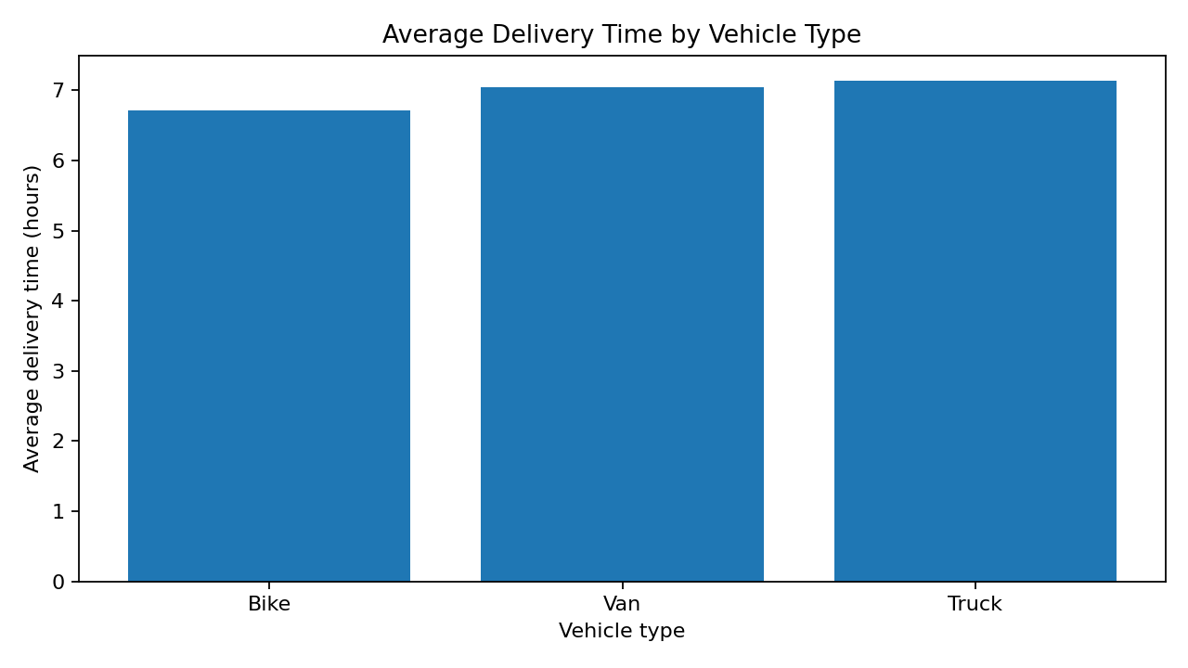
A bar chart compares average delivery times across Bike, Van, and Truck categories. It provides a straightforward view of group differences, but averages should be interpreted alongside distance and shipment volume.

5.4 Average Transportation Cost by Region (Bar Chart)
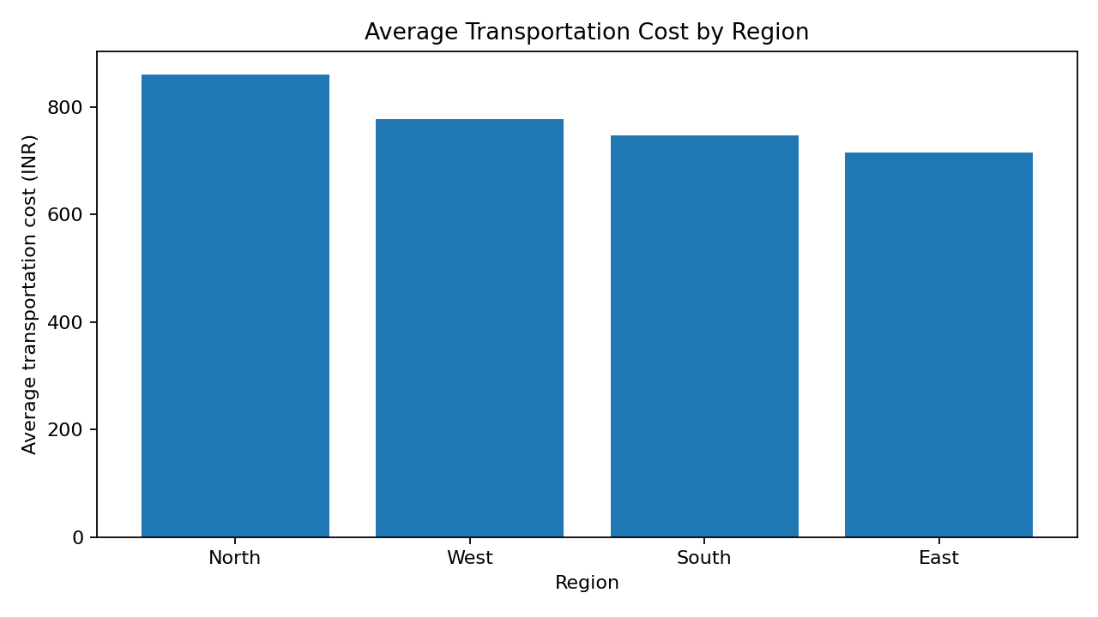
A regional bar chart compares average transportation cost across regions. It can help identify regions that may need route, carrier, or workload review. Differences may also reflect different distances and shipment sizes.

5.5 Correlation Matrix
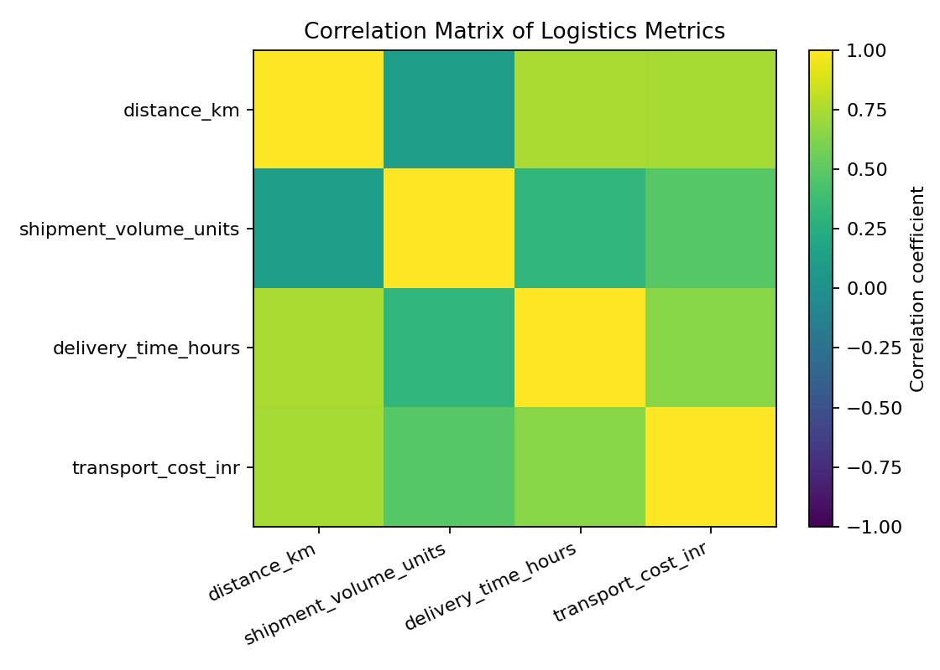
The correlation matrix summarizes linear relationships between numeric variables from -1 to +1. Positive values indicate that variables tend to increase together; correlation does not prove causation and can be influenced by outliers.

5.6 Delivery-Time Trend
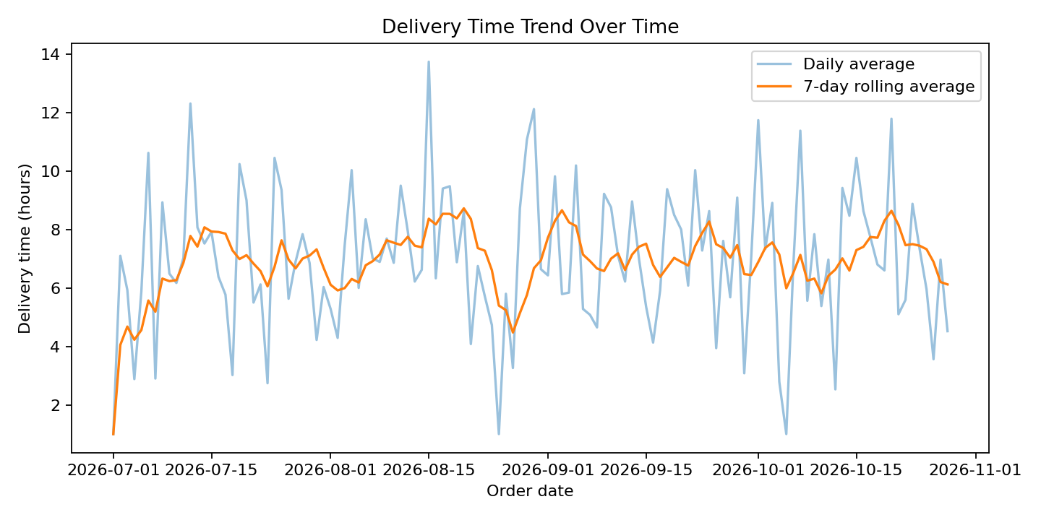
The line chart shows daily delivery time and a seven-day rolling average. The rolling average reduces day-to-day noise and helps reveal broader changes over the simulated period.

6. Key Analytical Insights
In this simulated dataset, distance and transportation cost have a correlation of 0.731. Distance and delivery time have a correlation of 0.744. These values describe associations in the generated sample, not guaranteed causal effects.
The region with the highest average cost is North (₹861.05), while the lowest is East (₹715.60). Regional cost differences should be compared after accounting for distance, shipment volume, vehicle type, and route conditions.
Among vehicle groups, Bike has the lowest average delivery time (6.72 hours) and Truck has the highest (7.14 hours) in this sample. This may reflect differences in shipment types and distances, so it should not be interpreted as a definitive ranking of vehicle efficiency.
A few unusually high transportation-cost values were deliberately added to the simulated data to demonstrate why scatter plots and summary statistics are useful for identifying records that merit review.

7. Recommendations
- Monitor cost per kilometre and cost per shipment unit, rather than comparing total costs alone.
- Review high-cost shipments to check for route detours, special handling, low vehicle utilization, or data-entry errors.
- Compare delivery times across vehicle types only after controlling for distance, shipment size, region, and service type.
- Track delivery-time trends weekly and investigate sustained increases rather than reacting to one-day fluctuations.
- Use real, authorized historical data and validate data quality before building prediction models or making business decisions.

8. Limitations
The dataset is simulated and relatively small. It does not include real traffic, weather, fuel prices, route geometry, warehouse waiting time, or actual carrier records. The findings are suitable for demonstrating analytical methods only. Correlation does not establish causation.

9. Conclusion
This task demonstrates an end-to-end exploratory analysis workflow using Python. Descriptive statistics summarize logistics metrics, while visualizations help communicate distributions, trends, group differences, and relationships. The results show how visual analysis can guide further investigation of delivery performance and cost drivers. Future work should apply the workflow to verified operational data and develop predictive models only after proper validation.

10. Python Tools and Execution
Libraries: Pandas, NumPy, and Matplotlib. Run the project with: python -m pip install -r requirements.txt followed by python analyze_logistics.py.
The full script is included as analyze_logistics.py, and the chart PNG files are stored in the visualizations folder.

11. References
Pandas documentation: https://pandas.pydata.org/docs/
Matplotlib documentation: https://matplotlib.org/stable/
NumPy documentation: https://numpy.org/doc/

