WEEK 4 TASK REPORT
Predictive Modeling and Optimization in Logistics Systems
Prepared by: [Enter Your Full Name]

1. Abstract
This project demonstrates predictive modeling for logistics planning using a hypothetical dataset of 500 shipments. The target is delivery time in hours. Linear Regression and Random Forest Regression were trained and compared using an 80/20 train-test split and five-fold cross-validation. MAE, RMSE and R-squared were used to evaluate the models. Prediction charts and feature importance were reviewed, and practical optimization recommendations were developed. All data are simulated for educational use and do not represent a real company.

2. Problem Definition
The goal is to estimate delivery_time_hours using information available when a shipment is planned. Reliable forecasts can help dispatchers estimate arrival times, identify likely delays, plan capacity and communicate proactively with customers.

3. Dataset and Features
The dataset contains 500 simulated records. Features are distance_km, shipment_volume_units, shipment_weight_kg, traffic_level, weather_condition, vehicle_type, region and weekend_delivery. The target variable is delivery_time_hours. transport_cost_inr is included for operational context and cost scenario analysis.
Feature | Type | Use
distance_km | Numeric | Trip distance
shipment_volume_units | Integer | Shipment size
shipment_weight_kg | Numeric | Shipment weight
traffic_level | Category | Traffic conditions
weather_condition | Category | Weather conditions
vehicle_type | Category | Vehicle used
region | Category | Operating region
weekend_delivery | Binary | Weekend indicator
delivery_time_hours | Target | Predicted delivery duration

4. Data Preparation and Methodology
- Load CSV using Pandas and separate features from target.
- Split data into 80% training and 20% test records using random_state=42.
- Use median imputation for numeric features and most-frequent imputation for categorical features.
- Apply one-hot encoding to categorical variables; unseen categories are ignored safely.
- Use a scikit-learn Pipeline and ColumnTransformer to prevent inconsistent preprocessing between training and testing.
- Use shuffled five-fold cross-validation to estimate the stability of the MAE.

5. Model Selection
Linear Regression provides a simple baseline and is relatively easy to explain. Random Forest Regression is an ensemble method that can learn non-linear patterns and interactions. Both models use the same features and data split for comparison.

6. Performance Evaluation
MAE is the average absolute prediction error in hours. RMSE gives more weight to larger errors. R-squared summarizes how much target variation is explained by the model. Lower MAE and RMSE are generally better; higher R-squared is generally better, but none of these scores alone guarantees real-world performance.
Model | MAE (h) | RMSE (h) | R-squared | 5-fold CV MAE
Linear Regression | 1.139 | 1.370 | 0.843 | 1.324
Random Forest | 1.307 | 1.630 | 0.778 | 1.501
Based on lowest test MAE, the best model in this run is Linear Regression. Scores are specific to this simulated dataset and split.

7. Visualizations
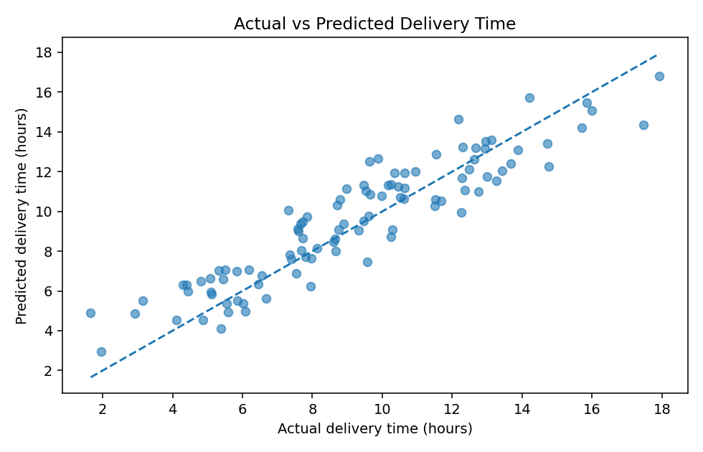
Figure 1. Actual versus predicted delivery time. Points near the diagonal indicate more accurate estimates.
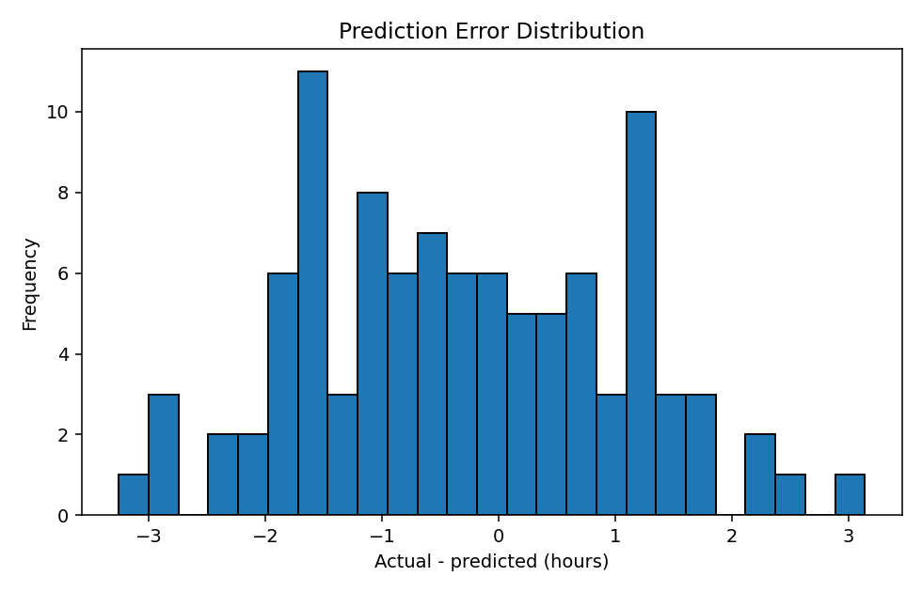
Figure 2. Prediction errors (actual minus predicted). This helps reveal bias and unusually large errors.
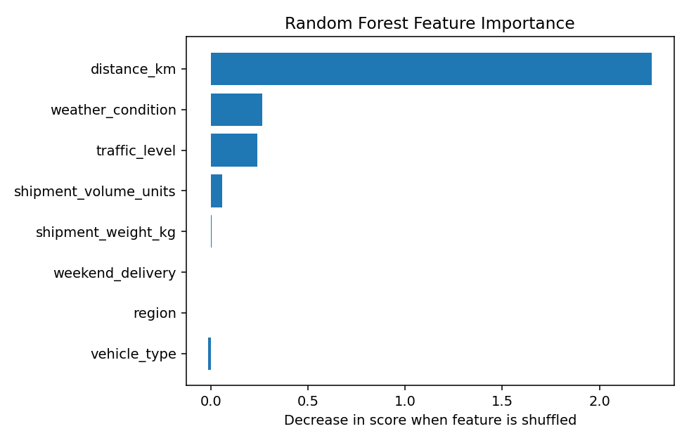
Figure 3. Permutation feature importance for Random Forest. A larger score decrease after shuffling suggests the feature contributes more to predictive performance.

8. Optimization Recommendations
- Use predicted delivery time to flag shipments likely to miss service targets and notify dispatchers early.
- Compare feasible routes using predicted time, distance, traffic and weather; validate with live routing data.
- Consolidate compatible shipments by region and delivery window while respecting vehicle capacity and promised arrival times.
- Plan extra buffers during high traffic or severe weather instead of relying on the prediction alone.
- Track actual versus predicted times weekly and retrain only after checking data quality, drift and service outcomes.

9. Illustrative Cost Optimization Scenario
The scenario file assumes 5% cost reduction from route planning and 8% from route planning plus load consolidation. These percentages are illustrative assumptions, not model predictions or guaranteed savings. Real savings should be measured in a pilot while monitoring service quality, fuel use, distance and failed deliveries.
Scenario | Assumed reduction | Estimated savings (INR)
Baseline | 0% | ₹0.00
Route planning improvement | 5% | ₹46,162.87
Route planning + load consolidation | 8% | ₹73,860.59

10. Python Code Excerpt
X_train, X_test, y_train, y_test = train_test_split(
X, y, test_size=0.20, random_state=42
)
pipeline.fit(X_train, y_train)
predictions = pipeline.predict(X_test)
mae = mean_absolute_error(y_test, predictions)
rmse = mean_squared_error(y_test, predictions) ** 0.5
r2 = r2_score(y_test, predictions)

11. Limitations
The dataset is synthetic and simplified. Real deliveries may depend on depot delays, driver schedules, road restrictions, holidays, loading time and live traffic. A chronological train/test split should be considered for a real future-forecasting use case. Validate the model on representative operational data before making decisions.

12. Conclusion
This project covers the main predictive modeling workflow: define a logistics target, prepare data, train and compare models, validate performance, visualize errors and convert findings into actionable recommendations. It provides an educational starting point for delivery-time forecasting and logistics optimization.

How to Run the Code in VS Code
Open the extracted project folder, choose Terminal > New Terminal, and run: python -m pip install -r requirements.txt. Then run: python predict_logistics.py. Check the outputs and visualizations folders.
Dataset note: All records and optimization scenarios are hypothetical.

