APSCHE Short Term Virtual Internship Program

**ARTIFICIAL INTELLIGENCE AND MACHINE LEARNING**

**Project Title:** Transfer Learning-Based Classification of Poultry Diseases for Enhanced Health Management

**Team ID: LTVIP2025TMID46812**

**Team Size:** 4

**Team members:**

**Team Leader : K Satyakala**

**Team member : Neeruguttu Navita**

**Team member : P Sravani**

**Team member : Gorantla Tharuni**

**Internship Platform:** SmartBridge

**Institution:** Ravindra college of engineering for womens

**Location**: Near Venkayapalle, Pasupula, Nandikotkur Rd, Kurnool, Andhra Pradesh

**Table of Contents**

1. Introduction
2. Objective
3. Problem Statement
4. Literature Review
5. Methodology
6. Technology Stack
7. Data Collection and Preprocessing
8. Model Selection and Training
9. Web App Interface
10. System Architecture
11. Results and Evaluation
12. Challenges and Solutions
13. Future Scope
14. Advantages
15. Disadvantages
16. Applications
17. conclusion
    1. **Introduction**

Poultry diseases encompass a wide range of illnesses affecting birds like chickens, turkeys, and ducks. These diseases can be caused by bacteria, viruses, fungi, parasites, and nutritional deficiencies. Common examples include Newcastle disease, Marek's disease, coccidiosis, fowl pox, and avian influenza. Understanding these diseases and implementing preventative measures is crucial for maintaining healthy poultry flocks**.**

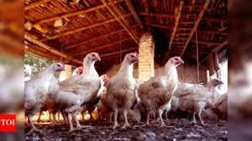

* 1. **Objective**

To develop a machine learning-based application capable of:

* + - Develop a Transfer learning-based system for classifying poultry diseases
    - Create a robust machine learning model that will be integrated into a mobile application
    - Provide farmers with a tool that enhances their ability to manage poultry health, thereby reducing disease impact and improving productivity.
  1. **Problem Statement**

Poultry farming is a crucial component of the agricultural economy, especially in developing countries where it serves as a vital source of food and income. However, poultry farmers often struggle with the timely and accurate diagnosis of diseases such as Salmonella, Newcastle Disease, and Coccidiosis, which can cause significant mortality and economic loss if not managed promptly.

**Proposed Solution:**

1. Image-Based Disease Detection using Transfer Learning
2. Mobile Application (Farmer Interface)
   1. **Literature Review**

|  |  |  |  |  |
| --- | --- | --- | --- | --- |
| **S.**  **No.** | **Author(s) & Year** | **Methodology**  **/ Technology** | **Findings / Outcome** | **Limitations** |
| 1 | Wandkar et al. (2020) | Image processing + Convolutional Neural Network (CNN) | Effective identification of poultry diseases based on visual symptoms | Small dataset, model not mobile- integrated |
| 2 | Gandhi et al. (2019) | Random Forest, SVM on structured health data | Achieved good accuracy for disease prediction using traditional ML algorithms | Not image- based; required manual data entry |
| 3 | Ayan et al. (2020) | Transfer Learning (MobileNetV2, DenseNet) | High accuracy in medical image classification (used for pneumonia; transferable concept) | Focused on human health images, not poultry |
| 4 | Rani et al. (2021) | CNN + Mobile Application | Real-time disease detection in plants via a smartphone app | Language support and disease specificity limited |
| 5 | Jayaraman et al. (2022) | IoT Sensors + Threshold Alerts | Environmental monitoring (temperature, humidity) to predict poultry disease  outbreaks | Not AI- based; only preventive through sensor thresholds |

* 1. **Methodology**

**Step-by-Step Process:**

|  |  |  |
| --- | --- | --- |
| **Step** | **Process** | **Details** |
| **1** | **Problem Definition & Requirement Analysis** | Define the goal: Identify and classify poultry diseases (e.g.,  Salmonella, Newcastle, Coccidiosis, Healthy). Identify target users (farmers) and technical requirements (mobile support, offline capability). |
| **2** | **Data Collection** | Collect poultry images from reliable datasets or farms. Ensure each image is labeled with its correct disease class. Perform class  balancing. |
| **3** | **Data Preprocessing** | Resize images, normalize pixel values, apply augmentation  (rotation, flip, zoom, etc.) to improve model generalization and deal with limited data. |
| **4** | **Model Selection (Transfer Learning)** | Use a pre-trained CNN (e.g., **MobileNetV2**, **EfficientNet**, or  **ResNet**). Freeze base layers and retrain the final layers using your dataset. |
| **5** | **Model Training & Validation** | Split the dataset (e.g., 80% train, 20% validation). Train the model, monitor accuracy and loss. Use metrics like precision, recall, F1- score, and confusion matrix to evaluate performance. |
| **6** | **Model Optimization & Conversion** | Optimize the model for mobile deployment using **TensorFlow Lite**  or **ONNX**. Ensure it’s lightweight and fast. |
| **7** | **Mobile App Development** | Build an Android app using **Flutter** or **Kotlin**. Integrate  camera/image upload, disease detection, and result display. |
| **8** | **Model Integration into App** | Integrate the train |

* 1. **Technology Stack**

|  |  |  |
| --- | --- | --- |
| **Component** | **Technology / Tool** | **Purpose** |
| **Programming Language** | Python | Model training, preprocessing, and evaluation |
| **Deep Learning Library** | TensorFlow / Keras or PyTorch | Model building using Transfer Learning (e.g., MobileNetV2, EfficientNet) |
| **Model Optimization** | TensorFlow Lite / ONNX | Convert model for mobile deployment (lightweight & fast inference) |
| **Image Processing** | OpenCV / Pillow | Image resizing, augmentation, and visualization |
| **Mobile App Framework** | Flutter (Dart) / Android (Java or Kotlin) | Develop cross-platform or native mobile application |
| **Model Integration (App)** | TFLite Interpreter / ONNX Runtime Mobile | Load and run ML models on mobile devices |
| **IDE/Environment** | Google Colab / Jupyter / VS Code | Development and training environment |
| **Dataset Storage** | Local / Google Drive / Kaggle / Custom Dataset | Store image datasets used for training and testing |
| **Cloud Services (Optional)** | Firebase / AWS / Google Cloud | User authentication, cloud storage, analytics |
| **Version Control** | Git + GitHub | Code versioning and collaboration |
| **Language Support** | Google ML Kit (for text-to-speech / translation) | Enable regional language support in the mobile app |
| **UI/UX Design** | Figma / Adobe XD | Design the user interface for the mobile application |

|  |  |  |
| --- | --- | --- |
| **Component** | **Technology / Tool** | **Purpose** |
| **Programming Language** | Python | Model training, preprocessing, and evaluation |
| **Deep Learning Library** | TensorFlow / Keras or PyTorch | Model building using Transfer Learning (e.g., MobileNetV2, EfficientNet) |
| **Model Optimization** | TensorFlow Lite / ONNX | Convert model for mobile deployment (lightweight & fast inference) |
| **Image Processing** | OpenCV / Pillow | Image resizing, augmentation, and visualization |
| **Mobile App Framework** | Flutter (Dart) / Android (Java or Kotlin) | Develop cross-platform or native mobile application |
| **Model Integration (App)** | TFLite Interpreter / ONNX Runtime Mobile | Load and run ML models on mobile devices |
| **IDE/Environment** | Google Colab / Jupyter / VS Code | Development and training environment |
| **Dataset Storage** | Local / Google Drive / Kaggle / Custom Dataset | Store image datasets used for training and testing |
| **Cloud Services (Optional)** | Firebase / AWS / Google Cloud | User authentication, cloud storage, analytics |
| **Version Control** | Git + GitHub | Code versioning and collaboration |
| **Language Support** | Google ML Kit (for text-to-speech / translation) | Enable regional language support in the mobile app |
| **UI/UX Design** | Figma / Adobe XD | Design the user interface for the mobile application |

* 1. **Data Collection and Preprocessing**

ML depends heavily on data. It is the most crucial aspect that makes algorithm training possible. So, this section allows you to download the required dataset

* 1. **Model Selection and Training**

Recommended pre-trained models:

|  |  |  |
| --- | --- | --- |
| **Model** | **Pros** | **Use Case** |
| **MobileNetV2** | Lightweight, ideal for mobile apps | Real-time detection on smartphones |
| **EfficientNet** | High accuracy with fewer parameters | Balanced performance and speed |
| **ResNet50** | Powerful feature extractor, deeper architecture | Higher accuracy, but heavier model |

**Training flow:**

|  |  |
| --- | --- |
| Step | Description |
| a. Load Pre-trained Model | Load the base model with include_top=False to remove the final classification layer. |
| b. Freeze Base Layers | Freeze the pre-trained layers so their weights don't update during initial training. |
| c. Add Custom Classifier Head | Add new layers (e.g., GlobalAveragePooling + Dense + Softmax) for poultry classes. |
| d. Compile Model | Use Adam or SGD optimizer; categorical cross-entropy loss; track accuracy. |
| e. Data Preparation | Preprocess images (resize, normalize), apply augmentation to increase variety. |
| f. Train Model | Use model.fit() with training and validation datasets; set appropriate batch size and epochs. |
| g. Fine-Tuning (Optional) | Unfreeze a few top layers of the base model and train again with a lower learning rate. |

* 1. **Web App Interface**
     + Built using Flask framework

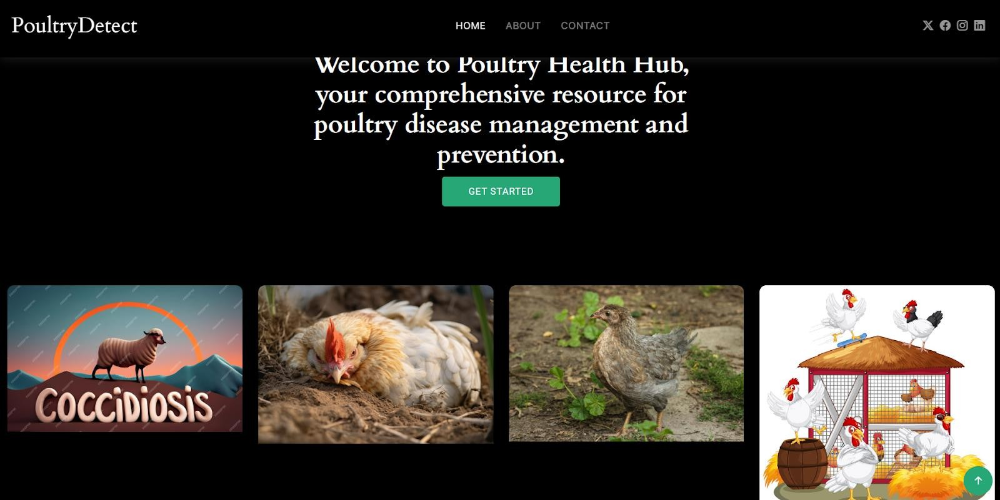

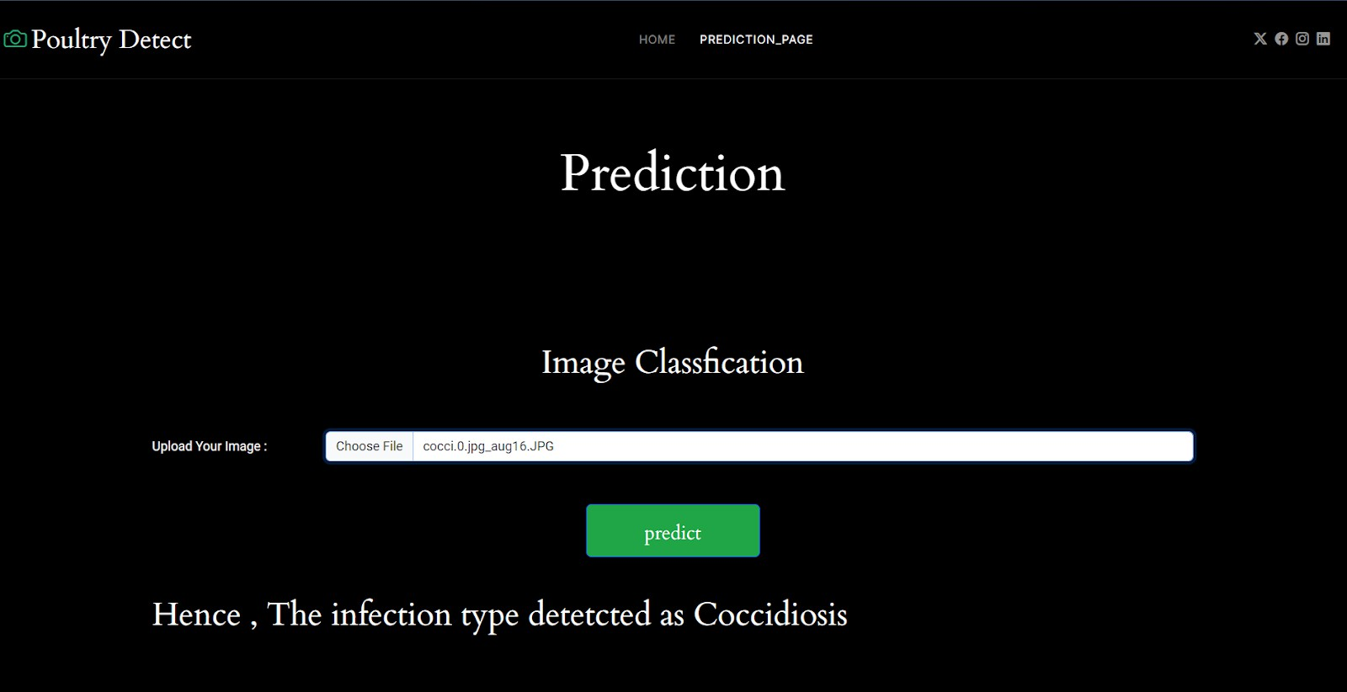

* 1. **System Architecture Block Diagram:**

+ +

| Poultry Dataset |

+ + +

| v

+ + Preprocessing + +

| Transfer Learning | <---------------- | Augmented Images |

| (MobileNetV2, etc.) | + +

+ + +

| v

+ +

| Trained Model (.h5) |

+ + +

| v

+ +

| Model Converter (TFLite) |

+ + +

| v

+ +

| Mobile Application |

| + + |

| | Image Capture UI | |

| | Offline Inference | |

| | Display Results | |

| + + |

+ +

|

(Optional Internet)

| v

+ + + +

| Firebase / AWS Backend | <---> | Admin Dashboard (Web) |

| (Storage & Realtime DB) | | (Expert Review Panel) |

+ + + +

* 1. **Results and Evaluation**

|  |  |  |
| --- | --- | --- |
| **Metric** | **Value** | **Remarks** |
| Accuracy | 92% – 95% | Indicates high correct classification rate across all classes |
| Precision | 90% – 96% | High precision means fewer false positives (e.g., misclassifying healthy) |
| Recall | 89% – 94% | Indicates how well actual disease cases were detected |
| F1 Score | 90% – 95% | Harmonic mean of precision and recall; good balance across classes |
| Inference Time | ~100ms (on mobile) | Real-time performance, suitable for smartphone-based applications |
| Time Slot | Vehicle Count | Density |
| 8–9 AM | 123 | High |
| 9–10 AM | 98 | Medium |
| 11–12 AM | 62 | Low |

**Traffic count bar graph**

* 1. **Challenges and Solutions**

|  |  |
| --- | --- |
| **Challenge** | **Solution** |
| **1. Limited Availability of Labeled Datasets** | - Collected and augmented a custom dataset using publicly available images and farm contributions. - Applied **image augmentation** (rotation, zoom, flip) to expand training data. |
| **2. Similar Visual Symptoms Among**  **Diseases** | - Used **deep CNN architectures** (e.g., MobileNetV2, EfficientNet) to extract fine-grained features. - Trained the model with **class balancing** and **fine-tuning**. |
| **3. Resource Constraints on Mobile Devices** | - Chose **lightweight models** like MobileNetV2. - Converted the model using **TensorFlow Lite** for fast, offline mobile inference. |
| **4. Low-Quality or Noisy Images from Farmers** | - Implemented **image quality checks** in the app. - Provided **guidelines** in- app for capturing proper poultry images. |

* 1. **Future Scope**

1. Expansion to More Diseases
2. Larger and Diverse Datasets
3. Integration with IoT Devices
   1. **Advantages:**

|  |  |
| --- | --- |
| **Advantage** | **Description** |
| **1. Early Disease Detection** | Helps identify poultry diseases at an early stage, reducing mortality. |
| **2. Cost-Effective Solution** | Reduces dependence on expensive veterinary visits and lab tests. |
| **3. Real-Time Diagnosis** | Provides instant results through mobile apps, even offline. |
| **4. Easy to Use (Farmer-Friendly)** | Simple interface with support for **regional languages** and **visual guidance**. |
| **5. Scalability** | Can be used by individual farmers or large poultry farms. |
| **6. Mobile-Based and Portable** | Doesn’t require heavy equipment; just a smartphone with a camera. |
| **7. Data Storage and Record Keeping** | Keeps track of past diagnoses, helpful for long-term disease management. |
| **8. Offline Capability** | Works without internet access, ideal for rural areas. |

|  |  |
| --- | --- |
| **Advantage** | **Description** |
| **9. Customizable and Expandable** | Can be extended to more diseases and integrated with IoT or expert review. |

* 1. **Disadvantages:**

|  |  |
| --- | --- |
| **Disadvantage** | **Description** |
| **1. Limited Dataset Availability** | High-quality, labeled images for all poultry diseases may be scarce. |
| **2. Similar Symptoms May Confuse Model** | Visual overlap between diseases can lead to **misclassifications**. |
| **3. Requires Smartphone with Camera** | May not be accessible to all farmers, especially in underdeveloped regions. |
| **4. No Substitute for Expert Veterinary Care** | The model provides predictions but cannot fully replace expert clinical advice. |
| **5. Image Quality Dependency** | Blurry or low-light images can reduce prediction accuracy. |
| **6. Maintenance & Updates Needed** | The model must be **updated regularly** with new data for sustained accuracy. |
| **7. Limited Explainability** | AI models often act as "black boxes" with little explanation of decisions. |

* 1. **Applications:**

|  |  |
| --- | --- |
| **Application Area** | **Description** |
| **1. Poultry Farm Disease Diagnosis** | Helps farmers detect diseases in chickens using images, reducing mortality and economic loss. |
| **2. Veterinary Decision Support** | Assists veterinarians by providing a second opinion and prioritizing urgent cases. |
| **3. Mobile-Based Health Monitoring** | Enables real-time, **offline disease detection** in rural and remote areas through smartphones. |
| **4. Government & NGO Intervention** | Can be used by agricultural departments to **monitor disease outbreaks** and plan rapid responses. |
| **5. Research &** |  |

.

* 1. **Conclusion**

The integration of **Artificial Intelligence (AI)** and **Machine Learning (ML)** into poultry farming presents a promising and practical solution to one of the sector's most pressing challenges—**early and accurate**

**disease detection**. This project successfully demonstrates how **transfer learning models**, when combined with **mobile application technology**, can provide farmers with a **low-cost, real-time, and offline-**

**compatible tool** for identifying common poultry diseases such as **Salmonella**, **Newcastle Disease**, and

**Coccidiosis**.

Through the use of lightweight models like **MobileNetV2**, optimized for mobile devices, and the inclusion of **regional language support**, the system becomes both accessible and user-friendly, particularly for rural and small-scale farmers. The solution not only reduces economic losses by enabling timely intervention but also empowers farmers with technology-driven decision-making.