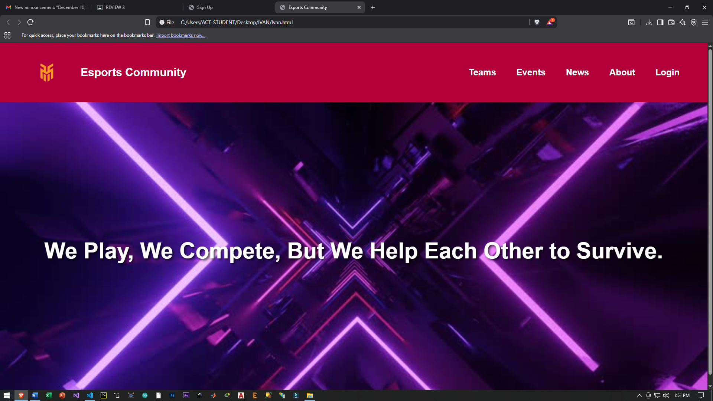
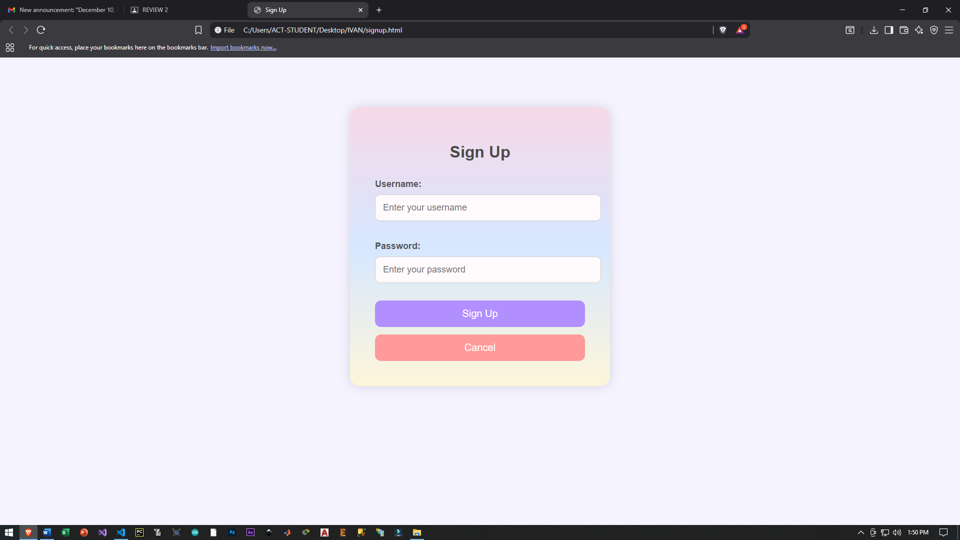

Code:
<!DOCTYPE html>
<html>
<head>
<title>Sign Up</title>

<style>
body {
background: #f5f3ff;
font-family: "Poppins", sans-serif;
}

.login-container {
margin: 100px auto;
width: 420px;
padding: 50px;
border-radius: 20px;
background: linear-gradient(#f7d8e8, #d6e7ff, #fdf6d9);
box-shadow: 0 0 20px rgba(0,0,0,0.15);
}

h1 {
text-align: center;
margin-bottom: 35px;
font-size: 32px;
color: #4a4a4a;
}

label {
display: block;
margin: 20px 0 10px;
font-weight: 600;
font-size: 18px;
color: #555;
}

input {
width: 100%;
padding: 15px;
border: 1px solid #ccc;
border-radius: 10px;
font-size: 18px;
margin-bottom: 20px;
background: #fffafc;
}

button {
width: 100%;
padding: 15px;
margin-top: 15px;
background: #b28fff;
color: white;
font-size: 20px;
border: none;
border-radius: 12px;
cursor: pointer;
transition: 0.3s;
}

button:hover {
background: #9c74ff;
}

.cancel-btn {
background: #ff9a9a;
}

.cancel-btn:hover {
background: #ff7c7c;
}
</style>
</head>

<body>
<div class="login-container">
<h1>Sign Up</h1>

<form id="signupForm">
<label for="username">Username:</label>
<input
type="text"
id="username"
name="username"
placeholder="Enter your username"
required
>

<label for="password">Password:</label>
<input
type="password"
id="password"
name="password"
placeholder="Enter your password"
required
>

<button type="submit">Sign Up</button>
<button type="button" class="cancel-btn" id="cancelBtn">Cancel</button>
</form>
</div>

<script>
document.getElementById("signupForm").addEventListener("submit", function(event) {
event.preventDefault();
alert("Registration successful!");
window.location.href = "home.html";
});

document.getElementById("cancelBtn").addEventListener("click", function() {
window.location.href = "home.html";
});
</script>

</body>
</html>

