Project Report

on

IMPACT OF SLEEP ON LIFESTYLE AND HEALTH

Submitted by:- Navjot Kaur
Roll No:- 2419907
Branch:- Computer Science and Engineering

ABSTRACT

Sleep plays a vital role in maintaining physical and mental health. Insufficient sleep can affect stress levels, physical activity, body mass index, blood pressure, and overall quality of life. The objective of this project is to analyze the relationship between sleep patterns and various health and lifestyle factors using data analysis and visualization techniques.
The dataset used contains information about sleep duration, quality of sleep, stress levels, physical activity, BMI category, blood pressure, occupation, and sleep disorders. Python libraries such as Pandas, NumPy, Matplotlib, and Seaborn were utilized for preprocessing, analysis, and visualization.
The study reveals that longer sleep duration generally leads to better sleep quality, lower stress levels, healthier BMI categories, and improved physical activity. Furthermore, sleep disorders such as insomnia and sleep apnea are associated with poor sleep quality and higher stress levels.

CHAPTER 1: INTRODUCTION
Sleep is one of the most essential biological processes required for maintaining human health and well-being. Lack of sleep can negatively affect concentration, mood, cardiovascular health, stress levels, and physical performance.
Modern lifestyles, work pressure, and unhealthy habits have significantly increased sleep-related problems. Therefore, analyzing the impact of sleep on health factors becomes important for understanding lifestyle patterns and improving overall quality of life.
This project investigates how sleep duration and quality influence different health parameters including stress level, physical activity, BMI category, blood pressure, occupation, and sleep disorders.

CHAPTER 2: PROBLEM STATEMENT
In today's fast-paced world, people often neglect sleep due to workload and lifestyle habits. Poor sleep quality can lead to various health problems including obesity, hypertension, stress, and sleep disorders.
There is a need to analyze sleep patterns and identify their relationship with health indicators so that individuals can maintain healthier lifestyles.

CHAPTER 3: OBJECTIVES

- To study sleep duration distribution.
- To analyze the relationship between sleep duration and sleep quality.
- To examine the impact of stress levels on sleep.
- To study the relationship between physical activity and sleep.
- To investigate BMI categories with respect to sleep quality.
- To analyze blood pressure variations among individuals.
- To identify the occurrence of sleep disorders.
- To derive insights through visualizations.

CHAPTER 4: DATASET DESCRIPTION

The dataset contains information related to sleep and health characteristics of individuals.

Feature | Description
Gender | Male/Female
Age | Age of person
Occupation | Profession
Sleep Duration | Hours of sleep
Quality of Sleep | Sleep quality score
Physical Activity Level | Daily physical activity
Stress Level | Stress score
BMI Category | Weight category
Blood Pressure | Blood pressure reading
Heart Rate | Heart rate
Daily Steps | Steps per day
Sleep Disorder | Insomnia, Sleep Apnea, None

CHAPTER 5: TOOLS AND TECHNOLOGIES USED

Programming Language :- Python

Libraries

Pandas :- Used for data cleaning and manipulation.

NumPy :- Used for numerical operations.

Matplotlib :- Used for plotting graphs.

Seaborn :- Used for advanced visualizations.

Jupyter Notebook:- Used as the development environment.

CHAPTER 6: METHODOLOGY

The methodology followed consists of:

Step 1: Data Collection
Sleep Health and Lifestyle Dataset was imported.

Step 2: Data Cleaning
- Missing values handled.
- Duplicate records checked.
- BMI categories standardized.
- Blood pressure column split into systolic and diastolic values.

Step 3: Feature Engineering
Created sleep categories:
- Poor Sleep (<6 hours)
- Normal Sleep (6–8 hours)
- Good Sleep (>8 hours)
Step 4: Exploratory Data Analysis
Graphs and statistical analysis performed.
Step 5: Interpretation
Patterns and relationships were identified.

CHAPTER 7: DATA PREPROCESSING

Missing Values
Missing values in Sleep Disorder column were replaced with "None".
Duplicate Rows
Dataset checked for duplicate entries.
BMI Category Correction
Normal Weight converted into Normal category.
Blood Pressure Splitting
Blood Pressure column divided into:
- Systolic Pressure
- Diastolic Pressure

CHAPTER 8: EXPLORATORY DATA ANALYSIS

Several graphs were generated:

- Histogram
- KDE plot
- Count plot
- Pie chart
- Scatter plot
- Regression plot
- Box plot
- Heatmap

These visualizations helped understand data distribution and relationships.

CHAPTER 9: SLEEP QUALITY ANALYSIS
Sleep quality is one of the most important factors affecting physical and mental well-being. In this chapter, the relationship between sleep quality and various parameters is analyzed using graphical representations.

9.1 Distribution of Sleep Quality

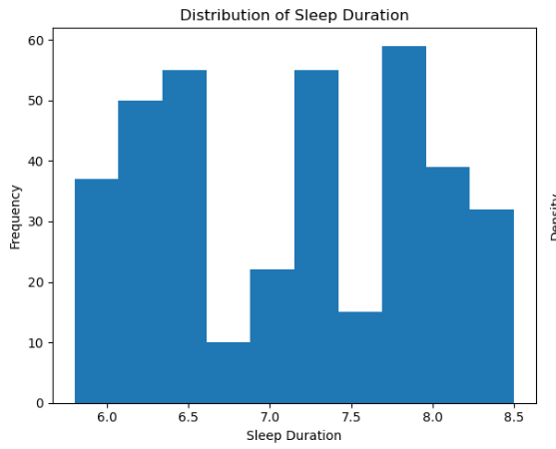 | 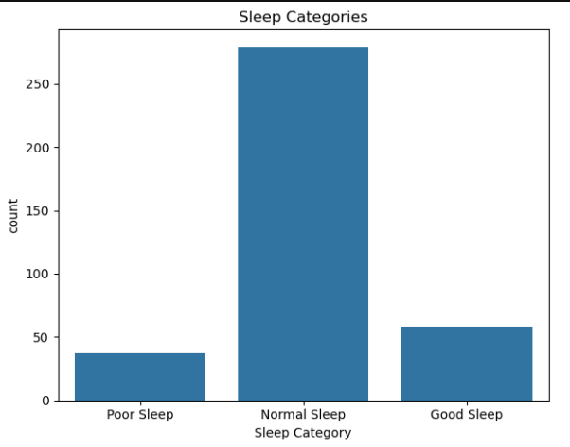

Observation
- Majority of individuals have good sleep quality.
- Very few individuals have extremely poor sleep quality.
- Sleep quality is concentrated around average values.

9.2 Sleep Duration vs Sleep Quality

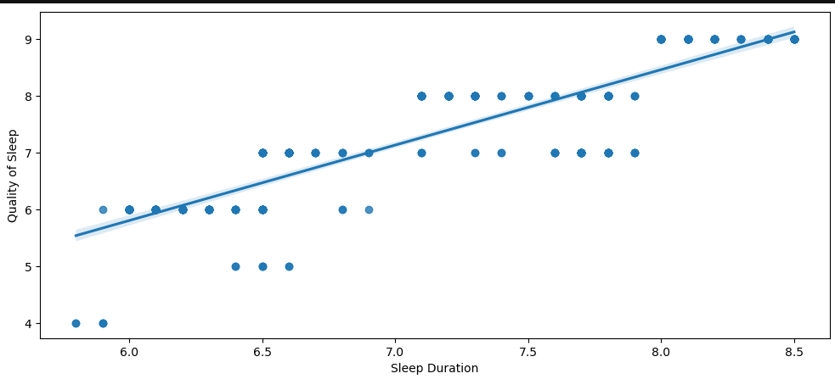

Observation
- Sleep quality increases with sleep duration.
- Short sleep duration often results in poor sleep quality.
- A positive trend is observed.

CHAPTER 10: STRESS LEVEL ANALYSIS

Stress significantly affects sleep patterns and overall health.
10.1 Stress Level vs Sleep Duration
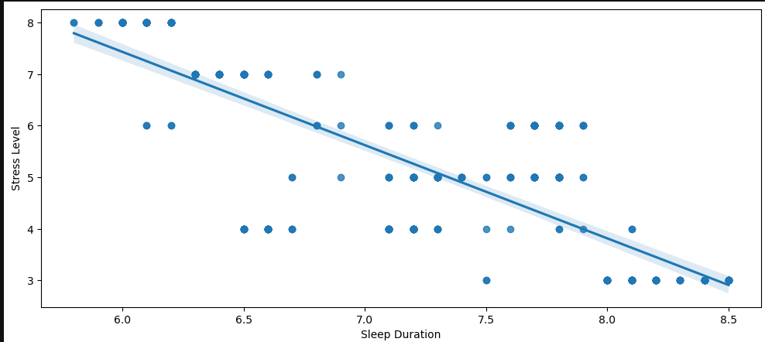

Observation
- Higher stress leads to shorter sleep duration.
- Lower stress is associated with better sleep habits.

10.2 Stress Level vs Sleep Quality
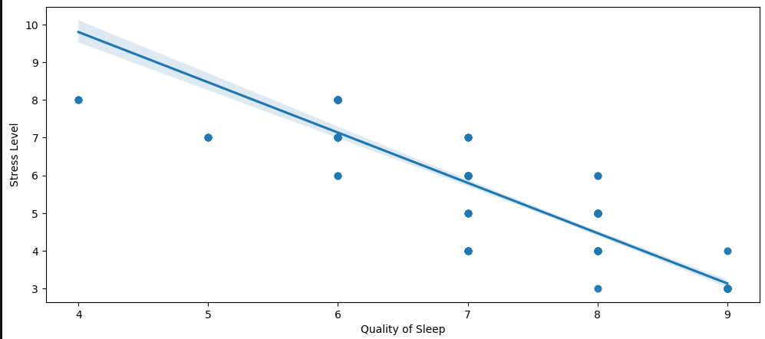
Observation
- Stress adversely affects sleep quality.
- Sleep disturbances increase with stress.

CHAPTER 11: PHYSICAL ACTIVITY ANALYSIS
Physical activity plays a vital role in maintaining a healthy lifestyle. Regular exercise improves cardiovascular health, reduces stress, and contributes to better sleep quality. In this chapter, the relationship between physical activity and sleep characteristics is analyzed.

11.1 Sleep Duration and Physical Activity Level
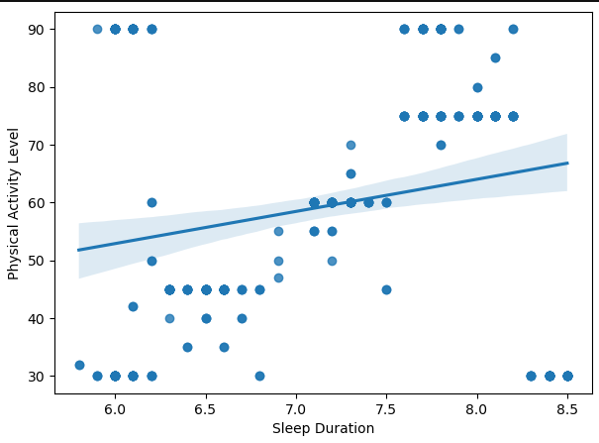
Observations
- Physical activity level increases with increasing sleep duration.
- Individuals sleeping around 7.5–8 hours tend to show higher activity levels.
- Shorter sleep durations are associated with lower activity levels.
- Adequate sleep contributes to maintaining an active lifestyle.

11.2 Sleep Duration vs Heart Rate
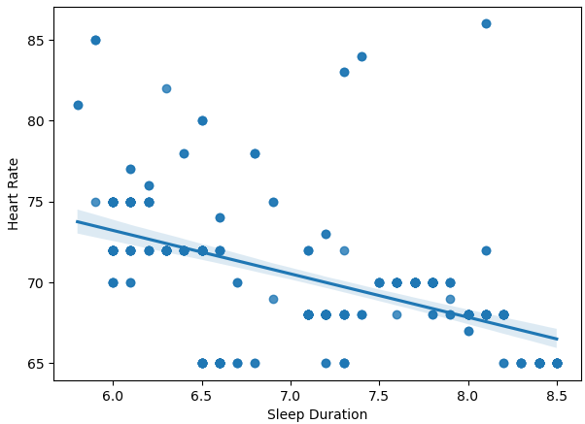
The graph shows a slight negative relationship between sleep duration and heart rate. Individuals who sleep longer tend to have lower heart rates, indicating better cardiovascular health.

11.3 Sleep Duration vs Daily Steps
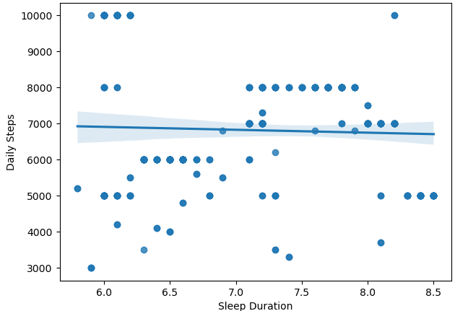
The scatter plot illustrates the association between sleep duration and daily step count. Individuals with adequate sleep generally maintain moderate to higher levels of physical activity throughout the day

11.4 BMI Category and Lifestyle Factors
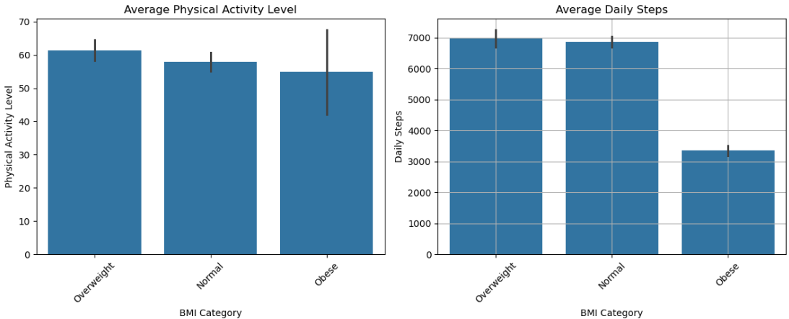
The bar charts show that individuals belonging to the Normal and Overweight BMI categories exhibit relatively higher physical activity levels and daily step counts compared to individuals in the Obese category. Lower daily movement is associated with higher BMI values.

11.5 Observation
The analysis indicates that sleep duration is closely associated with lifestyle-related factors. Longer sleep duration is generally linked with higher physical activity levels, lower heart rates, and better daily activity patterns. Additionally, individuals with lower BMI categories tend to maintain more active lifestyles, emphasizing the importance of adequate sleep and regular physical activity for overall well-being.

CHAPTER 12: BMI AND SLEEP ANALYSIS
Body Mass Index (BMI) is an important indicator of an individual's health status. This chapter examines the relationship between BMI category and sleep-related factors such as sleep duration, sleep quality, and stress level.
12.1 BMI Category and Sleep Duration
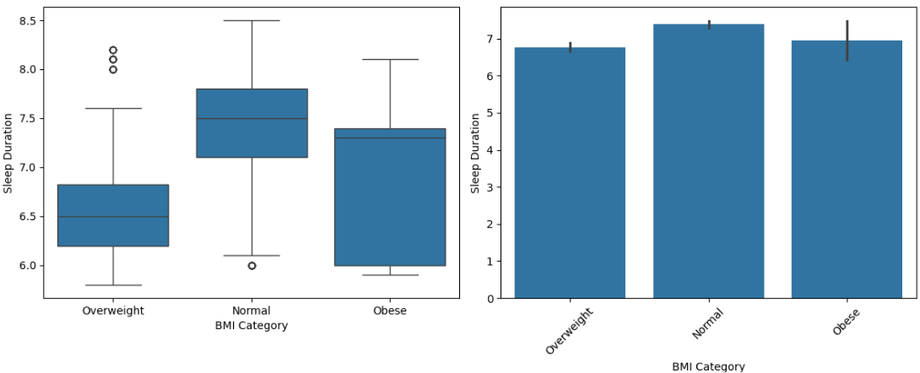
Individuals with normal BMI exhibit relatively higher average sleep duration, while overweight individuals tend to have shorter sleep durations.

12.2 BMI Category and Sleep Quality
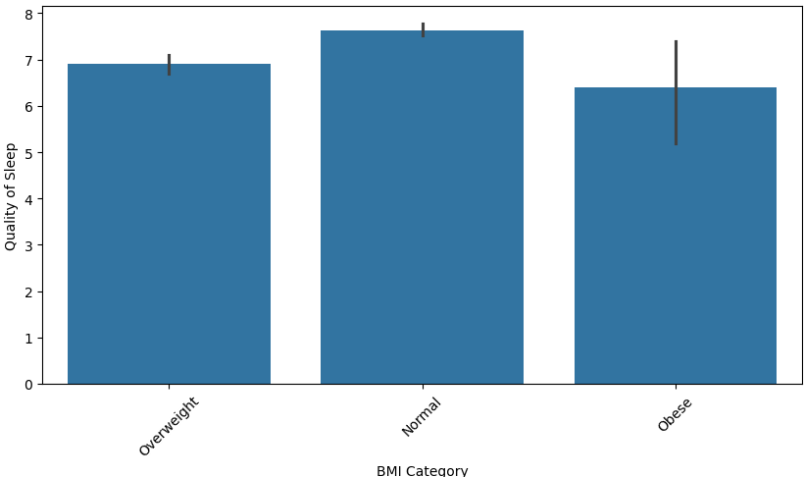
The graph indicates that individuals with normal BMI experience better sleep quality compared to overweight and obese individuals. Lower sleep quality is observed among people with higher BMI values.

12.3 BMI Category and Stress Level
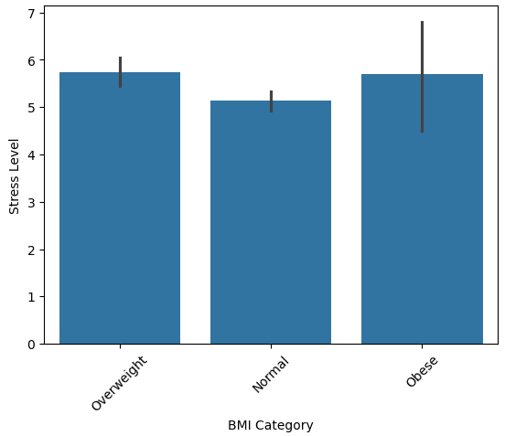
The bar chart illustrates that stress levels vary across BMI categories. Individuals with normal BMI generally have lower stress levels, whereas overweight and obese individuals exhibit comparatively higher stress.

12.4 Observation
The analysis reveals a noticeable relationship between BMI and sleep-related characteristics. Individuals with normal BMI generally experience better sleep quality, longer sleep duration, and lower stress levels. In contrast, overweight and obese individuals tend to exhibit poorer sleep patterns and higher stress. These findings suggest that maintaining a healthy BMI contributes to improved sleep and overall well-being.

CHAPTER 13: BLOOD PRESSURE ANALYSIS
Blood pressure is an important indicator of cardiovascular health. In this chapter, the relationship of blood pressure with sleep duration, stress level, and BMI category is analyzed.

13.1 Distribution of Blood Pressure
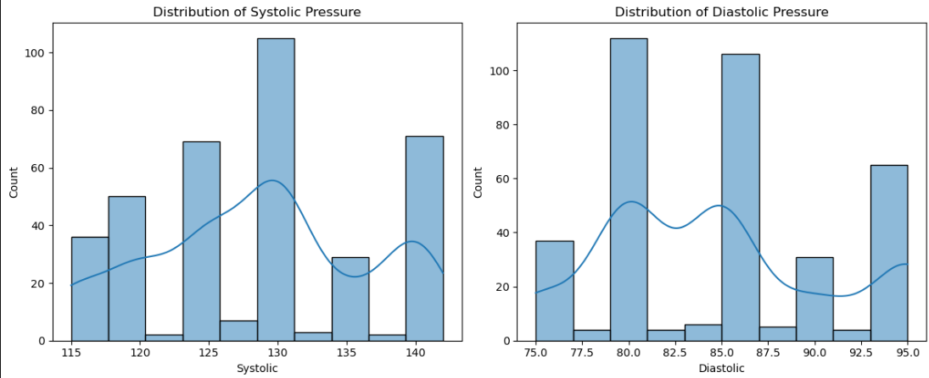
The histograms show that most individuals have systolic blood pressure values around 125–135 mmHg and diastolic blood pressure values around 80–90 mmHg, indicating that the majority of individuals fall within a normal blood pressure range.

13.2 Sleep Duration and Blood Pressure
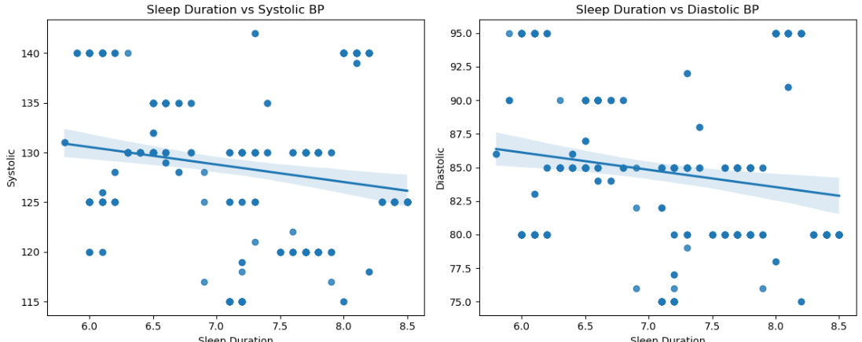
The regression plots indicate a slight negative relationship between sleep duration and blood pressure. Individuals with longer sleep duration generally exhibit lower systolic and diastolic blood pressure values.

13.3 Stress Level and Blood Pressure
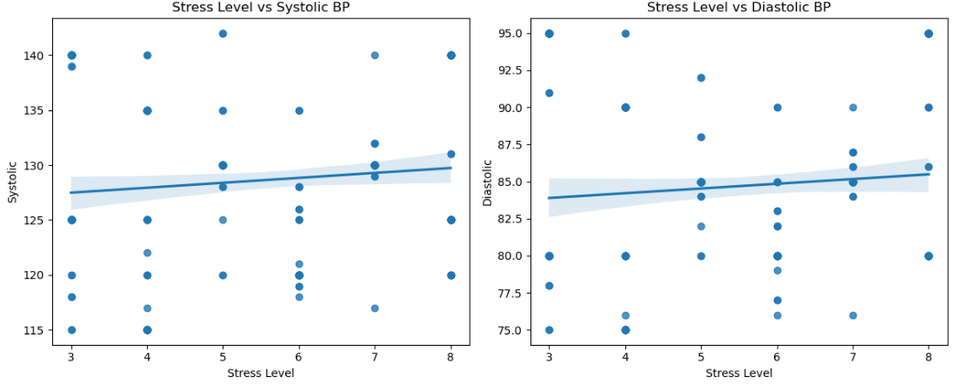
The graphs show a positive association between stress level and blood pressure. Higher stress levels are associated with increased systolic and diastolic blood pressure values.

13.4 BMI Category and Blood Pressure
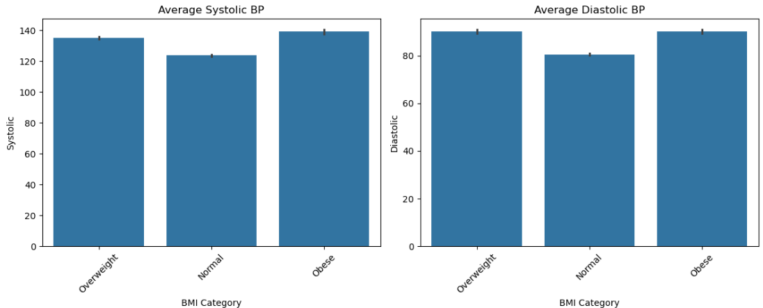
The bar charts illustrate that individuals belonging to the obese category exhibit the highest average blood pressure values, while individuals with normal BMI show comparatively lower blood pressure

13.5 Observation
The analysis indicates that adequate sleep is associated with lower blood pressure, whereas increased stress and higher BMI are linked with elevated systolic and diastolic blood pressure values. These findings suggest that maintaining healthy sleep habits and body weight may contribute to better cardiovascular health.

CHAPTER 14: SLEEP DISORDER ANALYSIS
Sleep disorders can affect sleep quality, stress levels, and overall health. This chapter examines the distribution of sleep disorders and their impact on sleep-related characteristics.

14.1 Distribution of Sleep Disorders and Stress Levels
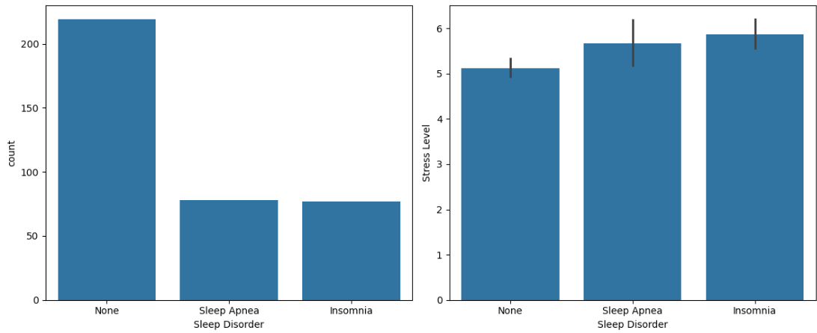
The count plot shows that most individuals do not suffer from any sleep disorder. Individuals affected by insomnia and sleep apnea exhibit comparatively higher stress levels than those without any disorder.

14.2 Effect of Sleep Disorders on Sleep Quality and Duration

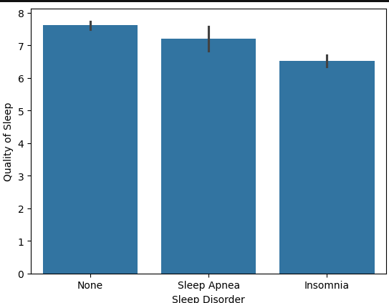 | 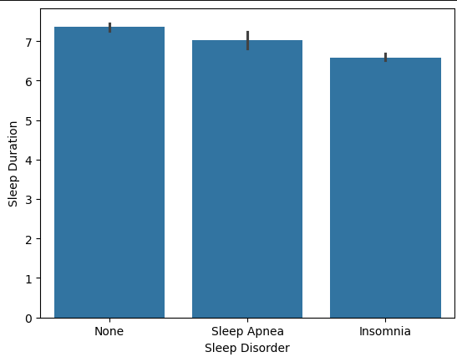

The graphs indicate that individuals suffering from insomnia generally experience poorer sleep quality and shorter sleep duration compared to individuals without sleep disorders.
14.3 Blood Pressure across Sleep Disorder Categories
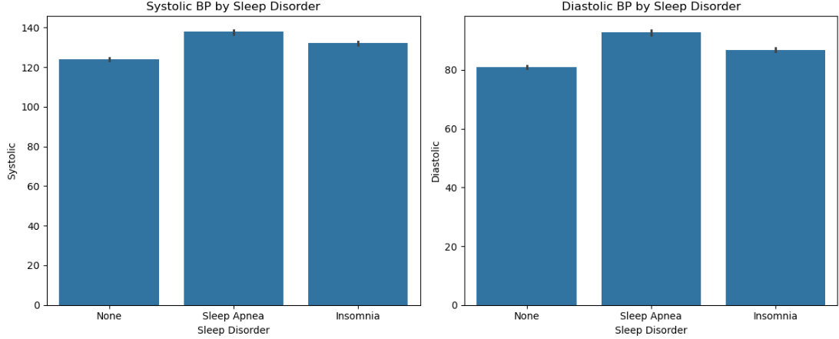
The bar charts show that individuals with sleep apnea and insomnia tend to have higher systolic and diastolic blood pressure values than individuals without any disorder.

14.4 Observation
The analysis reveals that sleep disorders negatively affect overall health. Individuals with insomnia and sleep apnea generally experience higher stress levels, poorer sleep quality, shorter sleep duration, and elevated blood pressure compared to individuals without any sleep disorder.

CHAPTER 15: AGE ANALYSIS
Age influences sleep duration, sleep quality, and stress levels. This chapter examines how these factors vary with age.
15.1 Age and Sleep Characteristics
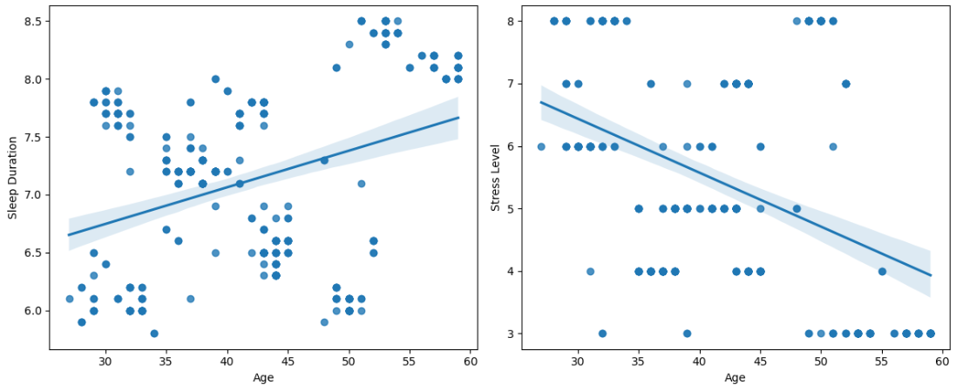
The regression plots indicate that sleep duration tends to increase with age, while stress levels show a decreasing trend.
15.2 Age and Sleep Quality
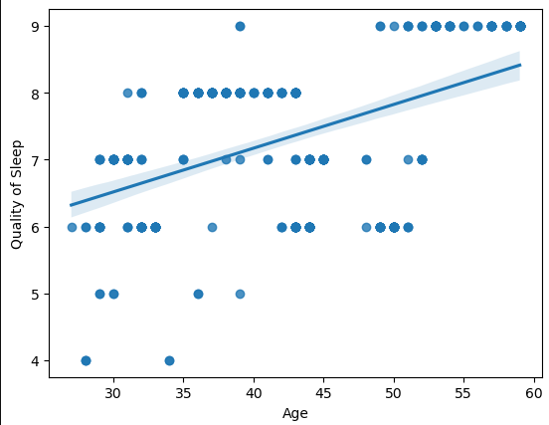
The graph shows a positive relationship between age and sleep quality, suggesting that older individuals generally experience better sleep quality.

15.3 Observation
The analysis indicates that age influences sleep duration, sleep quality, and stress levels. Sleep duration and sleep quality tend to improve with age, whereas stress levels show a decreasing trend.

CHAPTER 16: GENDER ANALYSIS

Gender-based differences in sleep patterns and stress levels are analyzed in this chapter.
16.1 Sleep Duration by Gender

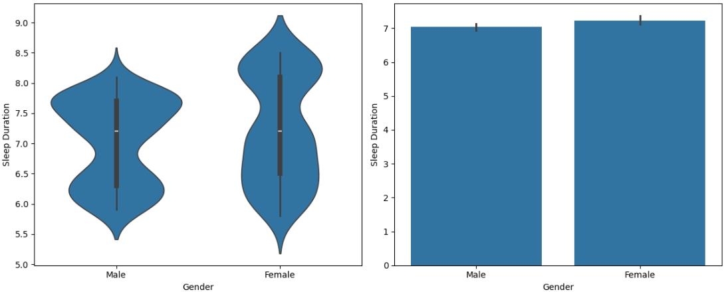
The violin plot and bar chart show that female participants exhibit slightly higher average sleep duration than male participants.

16.2 Stress Level and Sleep Quality by Gender
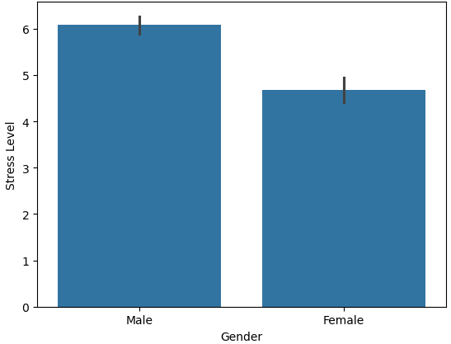 | 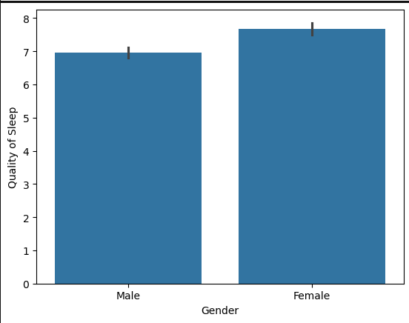

The graphs indicate that males generally exhibit higher stress levels, whereas females tend to have better sleep quality.

16.3 Observation
The gender-based analysis reveals noticeable differences in sleep patterns. Female participants generally exhibit longer sleep duration and better sleep quality, while males show comparatively higher stress levels.

CHAPTER 17: OCCUPATION ANALYSIS
Occupation plays an important role in determining sleep patterns and stress levels. This chapter analyzes the impact of profession on sleep-related characteristics.

17.1 Average Sleep Duration by Occupation
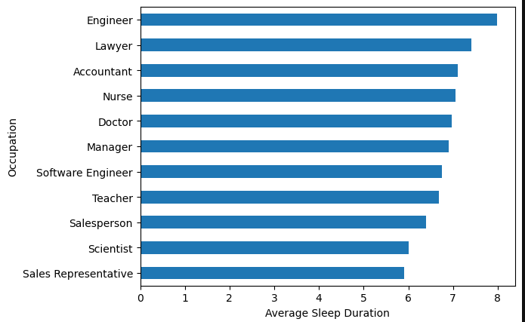
The graph shows variations in average sleep duration among different professions. Engineers exhibit the highest average sleep duration, whereas sales representatives have comparatively lower sleep duration.
17.2 Average Stress Level by Occupation
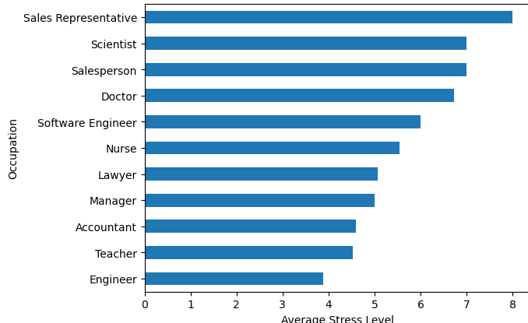
The graph indicates that stress levels vary considerably among professions. Sales representatives and scientists exhibit relatively higher stress levels, while engineers show lower stress levels.

17.3 Average Sleep Quality by Occupation
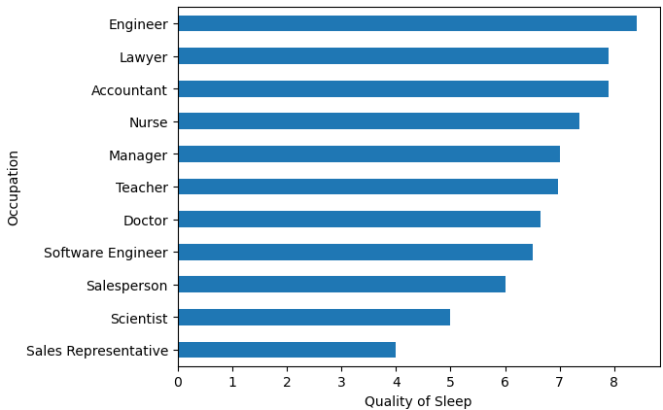

The graph reveals that engineers and lawyers exhibit better sleep quality, whereas sales representatives show comparatively lower sleep quality.

17.4 Observation
The analysis indicates that occupation significantly influences sleep duration, stress levels, and sleep quality. Professions associated with higher stress generally exhibit poorer sleep quality and shorter sleep duration, highlighting the impact of work-related factors on overall well-being.

CHAPTER 18: CORRELATION ANALYSIS
Correlation analysis helps in understanding the relationships among different numerical variables in the dataset. A correlation heatmap was generated to identify positive and negative associations between sleep characteristics and health indicators.

18.1 Correlation Heatmap
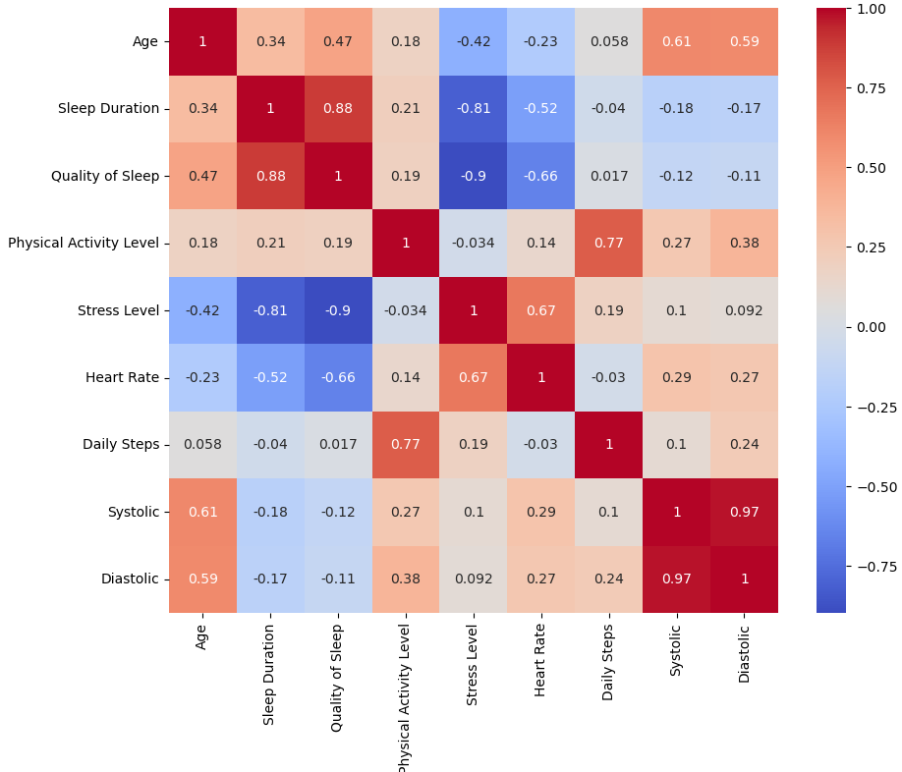
The heatmap reveals several important relationships among the variables. Sleep Duration and Quality of Sleep show a strong positive correlation, indicating that individuals with longer sleep duration generally experience better sleep quality. Stress Level exhibits a strong negative correlation with both Sleep Duration and Quality of Sleep, suggesting that higher stress levels are associated with poorer sleep.

Physical Activity Level and Daily Steps display a strong positive relationship, while Heart Rate shows moderate positive correlation with Stress Level. Systolic and Diastolic Blood Pressure are highly positively correlated, indicating that both measures tend to increase together.

18.2 Observation
The correlation analysis confirms that sleep duration, sleep quality, stress level, physical activity, heart rate, and blood pressure are closely interconnected. These relationships support the findings obtained throughout the analysis.

CHAPTER 19: CONCLUSION
This project analyzed the relationship between sleep patterns and various health and lifestyle factors using exploratory data analysis techniques. The study demonstrates that sleep is closely associated with stress levels, physical activity, BMI, blood pressure, age, gender, occupation, and sleep disorders.
The analysis reveals that adequate sleep is associated with better sleep quality, lower stress levels, healthier cardiovascular indicators, and improved lifestyle habits. Individuals with higher physical activity levels and healthier BMI categories generally exhibit better sleep characteristics, whereas elevated stress levels and sleep disorders negatively affect overall well-being.
Overall, the findings highlight that maintaining healthy sleeping habits, regular physical activity, and stress management are essential for achieving better physical and mental health.

