SurgeSeat
Architecture, Service Roles and Request Flows
High-performance distributed event ticket reservation system
Author: Navjot Singh
Version 0.1 (design baseline), October 2026
Constraint: $0 budget, all tooling open source and run locally

Contents

1. Purpose and scope
SurgeSeat is a deliberately simple product (register, browse events, reserve tickets, see status, get a confirmation) wrapped in a deliberately serious architecture. The product is the excuse; the architecture is the point. Every component exists to demonstrate a specific production concern: load balancing, horizontal scaling, caching, asynchronous processing, concurrency control, security, fault tolerance, rate limiting and observability.
The single hardest problem in the system, and the one the whole design is built around, is this:
Core invariant: no matter how many users click "Reserve" at the same moment, the system must never sell more tickets than exist, and must never book the same request twice.
Everything else (cache, queue, load balancer) is there to make that invariant hold while staying fast and available.

1.1 What this document covers
- The overall architecture and how the pieces connect.
- The role of every service: what it does, what it owns, and what it must never do.
- Step-by-step flows for each user action, including failure paths.
- The data model, Kafka topics, and the concurrency strategy.
- A recommended build order, so you know exactly where to start.

2. High-level architecture
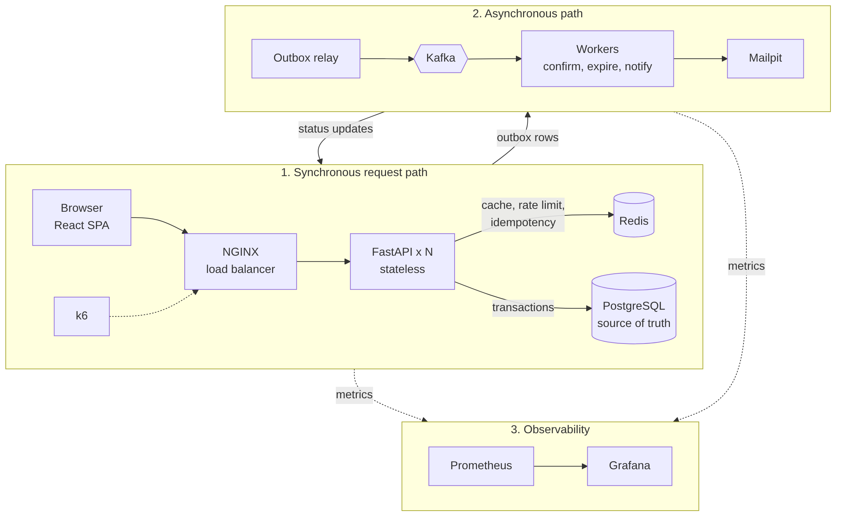
Figure 1. SurgeSeat component view. Solid arrows are request or data paths, dotted arrows are metrics scraping.
The system splits into four tiers:
- Edge: NGINX receives all traffic and spreads it across API instances.
- Synchronous tier: stateless FastAPI instances answer user requests quickly. They do only the work that must happen before the user gets a reply.
- Data tier: PostgreSQL holds the truth; Redis holds fast, disposable copies and short-lived counters.
- Asynchronous tier: Kafka and workers do everything that can happen after the reply: confirmations, emails, expiring unpaid holds.
Prometheus and Grafana sit beside all of this and watch it. k6 sits outside and attacks it.

2.1 Design principles
- PostgreSQL is the only source of truth. Redis and Kafka can be wiped and the system must recover from the database alone.
- API instances hold no state. Any instance can serve any request, so instances can be added, killed or restarted freely.
- Do the minimum synchronously. The reservation request only claims inventory and records the fact. Everything else is an event.
- Every write is idempotent. Retries from clients, NGINX or Kafka must never create duplicates.
- Fail closed on inventory, fail open on optimisations. If Redis is down, the app gets slower, not wrong.
- Measure, then claim. Scalability goals and measured numbers are kept separate (see section 9).

3. Role of each service
This table is the quick reference. Each service is then described in more detail below.
Service | Role in one line | Stateful? | How it scales
NGINX | Single entry point; load balances, terminates TLS, first-line rate limiting | No | One instance locally; in production, multiple behind DNS or a cloud LB
FastAPI (API) | Handles HTTP requests: auth, validation, reads, the reservation transaction | No | Horizontally: add containers
PostgreSQL | Source of truth for users, events, inventory, reservations, outbox | Yes | Vertically first, then read replicas, then partitioning
Redis | Cache, rate-limit counters, idempotency keys, optional inventory gate | Yes (disposable) | Single node locally; Sentinel or Cluster later
Outbox relay | Moves committed events from the outbox table into Kafka | No | One active instance (or partitioned by key)
Kafka | Durable event log between the API side and the workers | Yes | Add partitions and brokers
Workers | Consume events: confirm bookings, send emails, expire holds | No | Up to one consumer per partition
Mailpit | Fake SMTP server that captures emails for viewing ($0) | No | N/A (dev only)
Prometheus | Scrapes and stores metrics from every service | Yes | Single node is plenty locally
Grafana | Dashboards and alerts on top of Prometheus | No | N/A
React frontend | Minimal UI that calls the API | No (browser) | Static files served by NGINX
k6 | Generates load and reports latency, throughput and errors | N/A | Runs from your machine

3.1 NGINX (load balancer and gateway)
Does: accepts every request on port 80/443, serves the React build, and proxies /api/* to the pool of FastAPI instances (round-robin or least_conn). Removes an instance from rotation when it fails (passive health checks via max_fails / fail_timeout) and retries idempotent requests on another instance. Applies coarse per-IP rate limiting (limit_req) so floods are dropped before they reach Python.
Must never: contain business logic, or retry a non-idempotent POST blindly. Reservation POSTs rely on the Idempotency-Key header so that a retry is safe.
Demonstrates: load balancing, horizontal scaling, fault tolerance at the instance level, edge rate limiting.

3.2 FastAPI API service
Does: the synchronous brain. Verifies JWTs and roles, validates input, serves event listings (from cache when possible), and runs the reservation transaction. Exposes /health (liveness), /ready (can it reach PostgreSQL and Redis) and /metrics.
Must never: keep anything in memory that another instance would need (sessions, locks, counters). No in-process locks for inventory; the database does that. Must not call Kafka inside the request path for critical events; it writes to the outbox table instead (see 6.3).
Demonstrates: stateless design, async I/O, connection pooling, authN/authZ, idempotent APIs.
Internal layering (maps to backend/app/):
- api/v1 routes, thin: parse request, call service, return response.
- services business rules, e.g. ReservationService.reserve().
- repositories all SQL lives here.
- auth token issue/verify, password hashing, role checks as FastAPI dependencies.
- cache, messaging, middleware, observability Redis helpers, outbox writer, rate-limit and request-ID middleware, metrics.

3.3 PostgreSQL
Does: owns all durable data and enforces correctness. Inventory is protected by an atomic conditional UPDATE (or row locks) inside a transaction, plus CHECK and UNIQUE constraints as a last line of defence. Also stores the outbox table so that "reservation created" and "event to publish" commit together or not at all.
Must never: be bypassed. If Redis says a ticket is available but PostgreSQL disagrees, PostgreSQL wins.
Demonstrates: transactions, isolation, concurrency control, indexing, constraint design.

3.4 Redis
Does: four jobs, all optional for correctness:
- Cache: event lists and event details (cache-aside with TTL; invalidated when an admin edits an event).
- Rate limiting: per-user and per-IP token bucket or sliding window, shared across all API instances.
- Idempotency store: maps Idempotency-Key to the original response for ~24h so retries return the same result.
- Inventory gate (later phase): an atomic DECR counter per ticket tier that rejects obvious sell-outs before they touch PostgreSQL. This cuts database contention during a surge. It is only a filter; PostgreSQL still makes the final decision.
Must never: be the only place a fact lives. If Redis restarts empty, caches refill, counters are rebuilt from PostgreSQL, and the system stays correct.
Demonstrates: caching strategies, distributed rate limiting, reducing database load, graceful degradation.

3.5 Outbox relay
Does: a small process that repeatedly reads unpublished rows from the outbox table (SELECT ... FOR UPDATE SKIP LOCKED), publishes them to Kafka, waits for the broker acknowledgement, then marks them published.
Why it exists: if the API wrote to PostgreSQL and then to Kafka directly, a crash between the two would leave a reservation with no event (or an event with no reservation). The outbox pattern makes the database commit the single point of truth, and gives at-least-once delivery to Kafka.
Demonstrates: the dual-write problem and its standard solution.

3.6 Apache Kafka
Does: stores events durably in ordered, partitioned topics and lets independent consumer groups read them at their own pace. Partitioning by reservation_id (or event_id) keeps related events in order.
Must never: be assumed to deliver exactly once to your code. Consumers must be idempotent.
Local setup: a single broker in KRaft mode (no ZooKeeper) keeps memory reasonable. A three-broker setup with replication factor 3 can be run later to demonstrate broker failure; it is heavier on RAM.
Demonstrates: asynchronous processing, decoupling, back-pressure, replay, consumer groups.

3.7 Workers
Does: consume Kafka events and perform the slow or retryable work:
- Confirmation worker: reservation.created → mark CONFIRMED → emit reservation.confirmed.
- Notification worker: reservation.confirmed → send email through Mailpit.
- Expiry worker: releases holds that were never confirmed (scheduled scan or delayed events) and returns inventory.
Key rules: commit Kafka offsets only after the database work succeeds; record processed event IDs so a redelivered event is a no-op; send poison messages to a dead-letter topic after N retries.
Demonstrates: reliable background processing, retries, dead-letter queues, recovery after a worker crash.

3.8 Prometheus and Grafana
Does: Prometheus scrapes /metrics from API instances, workers and exporters (postgres-exporter, redis-exporter, kafka-exporter, nginx-exporter). Grafana shows dashboards for the four golden signals: traffic, latency (p50/p95/p99), errors and saturation, plus business metrics such as reservations per second, sold-out rejections and consumer lag.
Demonstrates: observability, finding bottlenecks, proving improvements with data.

3.9 React frontend
Minimal pages: Login, Register, Events, Event detail with Reserve button, My reservations. It stores the access token in memory, sends an Idempotency-Key (a UUID) with every reservation, and polls the reservation status until it becomes CONFIRMED.

3.10 k6
Scripts in load-tests/k6/scenarios simulate realistic traffic: browsing (read heavy), a flash sale (thousands of users reserving the same tier at once), and soak tests. Results are saved to load-tests/results and summarised in docs/benchmarks.

4. Request flows

4.1 Register and log in
- Client POSTs /api/v1/auth/register with email and password.
- API validates input, hashes the password (Argon2 or bcrypt), inserts the user with role USER. A UNIQUE index on email prevents duplicates even under concurrent sign-ups.
- Client POSTs /api/v1/auth/login. API verifies the hash and returns a short-lived access token (JWT, ~15 min) and a refresh token (longer-lived, stored hashed in PostgreSQL so it can be revoked).
- Every later request carries Authorization: Bearer <access token>. Any API instance can verify it locally using the signing key, with no database or session lookup. This is what keeps the API stateless.
- When the access token expires, the client calls /auth/refresh. Refresh tokens are rotated on each use; reuse of an old one revokes the whole family.
OAuth 2.0 / OIDC: start with this built-in JWT flow. In a later phase, add Keycloak (free, runs in Docker) as an OpenID Connect provider. The API then validates tokens issued by Keycloak using its public keys (JWKS), and roles come from token claims. The route code barely changes because authorization is already a dependency.

4.2 Browse events (read path)
- Client GETs /api/v1/events?page=1.
- API checks Redis for key events:list:page:1.
- Cache hit: return it immediately (typically single-digit milliseconds).
- Cache miss: query PostgreSQL (indexed on starts_at), store the result in Redis with a TTL (e.g. 30 to 60 s), return it.
- Availability counts change constantly, so they are either cached with a very short TTL or read live. The UI shows them as approximate; only the reservation itself is authoritative.
Why: reads vastly outnumber writes in ticketing. Caching them protects PostgreSQL for the writes that matter.

4.3 Reserve a ticket (the critical path)
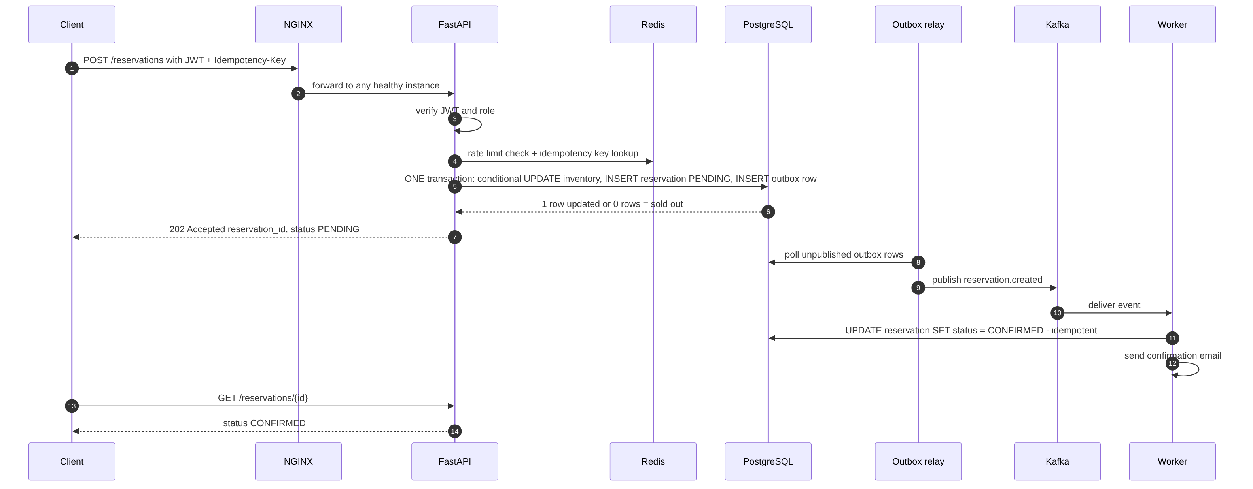
Figure 2. Reservation sequence. Steps 1 to 7 are synchronous; steps 8 onwards happen in the background.

Synchronous part (what the user waits for)
- Edge: NGINX applies per-IP rate limits and forwards to a healthy instance.
- Auth: API verifies the JWT and that the role is allowed to reserve.
- Rate limit: per-user limit in Redis (e.g. 5 reservation attempts per 10 s). Exceeding it returns 429 with Retry-After.
- Idempotency: look up the Idempotency-Key in Redis. If this exact request was already processed, return the stored response. Nothing is reserved twice.
- Optional inventory gate: Redis DECRBY on the tier counter. If it drops below zero, INCRBY it back and return 409 Sold Out without touching PostgreSQL.
- One database transaction:
UPDATE ticket_tiers
SET available = available - :qty
WHERE id = :tier_id AND available >= :qty
RETURNING available;
-- 0 rows -> sold out: ROLLBACK, return 409
-- 1 row -> continue:
INSERT INTO reservations (..., status) VALUES (..., 'PENDING');
INSERT INTO outbox (topic, key, payload) VALUES ('reservation.created', ...);
COMMIT;
- Respond: 202 Accepted with reservation_id and status PENDING. Store the response under the Idempotency-Key.
Why the conditional UPDATE works: PostgreSQL takes a row lock on that ticket tier for the duration of the UPDATE. Concurrent transactions queue on that row, and each re-checks available >= qty after acquiring the lock. It is impossible for two transactions to both take the last ticket. A CHECK (available >= 0) constraint backs this up.

Asynchronous part (after the reply)
- Outbox relay reads the new outbox row and publishes reservation.created to Kafka, then marks the row published.
- Confirmation worker consumes it. If the event ID is already in processed_events, it skips. Otherwise, in one transaction, it sets status CONFIRMED (only if still PENDING) and records the event ID. Then it commits the Kafka offset.
- The worker writes reservation.confirmed to the outbox; the notification worker sends the email via Mailpit.
- If a reservation is never confirmed within its hold window (e.g. 10 minutes, relevant once you add a mock payment step), the expiry worker marks it EXPIRED and adds the quantity back to available in the same transaction.

4.4 View reservation status
- Client GETs /api/v1/reservations/{id} (or /me/reservations).
- API checks that the reservation belongs to the caller (or the caller is ADMIN). Returning 404 instead of 403 for other users’ reservations avoids revealing that the ID exists.
- API reads from PostgreSQL (a short-TTL Redis cache is optional). The client polls every 1 to 2 seconds until the status is CONFIRMED, EXPIRED or FAILED. Server-Sent Events can replace polling later.

4.5 Admin creates or edits an event
Requires role ADMIN. The API writes to PostgreSQL, then deletes the relevant Redis cache keys and resets the inventory counter for that tier from the database value. Demonstrates RBAC and cache invalidation.

5. Data model (initial)
Table | Key columns | Notes
users | id, email (UNIQUE), password_hash, role, created_at | role is USER or ADMIN
refresh_tokens | id, user_id, token_hash, family_id, expires_at, revoked_at | Enables logout and rotation
events | id, name, venue, starts_at, status | Index on (status, starts_at)
ticket_tiers | id, event_id, name, price, capacity, available | CHECK (available >= 0); this row is the contention point
reservations | id, user_id, tier_id, qty, status, idempotency_key, expires_at, created_at | UNIQUE (user_id, idempotency_key); index on (user_id, created_at), partial index on status = PENDING
outbox | id, topic, key, payload (JSONB), created_at, published_at | Partial index WHERE published_at IS NULL
processed_events | consumer, event_id, processed_at | PRIMARY KEY (consumer, event_id) makes consumers idempotent

Reservation states: PENDING → CONFIRMED, PENDING → EXPIRED, PENDING → FAILED, CONFIRMED → CANCELLED. Every transition is a conditional UPDATE (… WHERE status = 'PENDING') so it can only happen once.
Hot row note: a single ticket_tiers row for a hugely popular event becomes a bottleneck because every buyer locks it. That is a real problem worth measuring with k6. Known fixes, in order: the Redis gate, splitting inventory into N bucket rows and picking one at random, or assigning specific seats instead of counts.

6. Messaging design

6.1 Topics
Topic | Producer | Consumers | Key
reservation.created | Outbox relay (from API) | Confirmation worker | reservation_id
reservation.confirmed | Outbox relay (from worker) | Notification worker, analytics | reservation_id
reservation.expired | Outbox relay (from expiry worker) | Notification worker | reservation_id
*.dlq | Any worker after N failures | Manual inspection or replay | same as source

6.2 Delivery guarantees
- Producer: acks=all and idempotent producer enabled, so the broker does not store duplicates from producer retries.
- Consumer: at-least-once. Process, write to the database, then commit the offset. A crash before the commit means the event is redelivered, and processed_events turns the redelivery into a no-op.
- Ordering: guaranteed per partition, so all events for one reservation go to the same partition by key.

6.3 Why not publish to Kafka directly from the API?
Because "write to DB" and "write to Kafka" are two separate systems and cannot share a transaction. The outbox makes the database commit the only decision point. It also means the API keeps accepting reservations even if Kafka is down; events simply queue in the outbox until Kafka returns.

7. Failure scenarios and expected behaviour
These are the experiments to run later (kill a container during a k6 test and watch Grafana). Each row is a claim the system must prove.
Failure | What happens | User impact
One API instance dies | NGINX marks it down and routes to others; in-flight requests on it may fail and the client retries with the same Idempotency-Key | Brief errors for a few requests, no duplicates
All API instances restart | Stateless, so they come back with nothing to recover | Outage only while restarting
Redis down | Cache misses fall through to PostgreSQL; rate limiter fails open (or closed, a policy choice); inventory gate is skipped | Slower, still correct
PostgreSQL down | Reads may be served from cache; writes return 503; /ready fails | No new reservations; nothing is oversold
Kafka down | Reservations still commit and land in the outbox; relay retries with backoff | Confirmations delayed, not lost
Worker crashes mid-event | Offset not committed, so Kafka redelivers to another consumer; processed_events prevents double work | Small delay
Outbox relay crashes | Unpublished rows remain; on restart it continues | Confirmations delayed
Poison message | Retried N times, then moved to the DLQ | That reservation needs manual handling; others continue
Traffic spike | NGINX and Redis rate limits shed excess load with 429s; the Redis gate absorbs sold-out traffic | Some users told to retry; system stays up

8. Security model
- Authentication: short-lived JWT access tokens plus rotating refresh tokens. Passwords hashed with Argon2id or bcrypt. Later, OIDC via Keycloak.
- Authorization: RBAC with USER and ADMIN roles enforced as FastAPI dependencies on every route, plus ownership checks on every resource (object-level authorization).
- Transport: HTTPS at NGINX (self-signed certificate locally). Internal services on a private Docker network; only NGINX, Grafana and Mailpit ports are exposed.
- Input: Pydantic validation on every request, parameterised SQL only, request body size limits at NGINX.
- Abuse: rate limits at two layers, login attempt throttling, generic error messages for auth failures.
- Secrets: .env files kept out of Git (already in .gitignore); no secrets baked into images.
- Headers: CORS restricted to the frontend origin, security headers (HSTS, X-Content-Type-Options, etc.) set at NGINX.

9. Scalability: goals versus measurements
The brief asks to design toward one million concurrent users while being honest about what is measured. This section keeps those two separate.

9.1 What a laptop can prove
Running everything in Docker on one machine, the bottleneck will be your CPU and RAM, not the architecture. You can realistically measure: throughput and latency for one versus N API instances, the effect of caching on read latency and database load, zero overselling under thousands of concurrent reservation attempts, and recovery behaviour when containers are killed. Record real numbers in docs/benchmarks with the hardware used.

9.2 What the architecture allows (not measured)
- API tier scales linearly because it is stateless; add instances behind more load balancers.
- Reads scale with Redis (Cluster) and PostgreSQL read replicas.
- Writes scale by partitioning inventory (per event, or bucketed rows) and, later, sharding PostgreSQL by event_id.
- Async work scales with Kafka partitions and more worker instances.
- A waiting room (queue users at the edge, admit them in batches) is the standard technique real ticketing sites use for flash sales; it is a good stretch goal.
Rule for your write-up: every performance claim states whether it is "measured on <hardware> with k6" or "expected from design". Never mix them.

10. How the folders map to services
Folder | Contains
backend/app/* | FastAPI service (section 3.2)
backend/migrations | Alembic migrations for the tables in section 5
workers/app/consumers, handlers | Outbox relay, confirmation, notification and expiry workers
frontend/src | React pages and the API client
infra/nginx | nginx.conf: upstream pool, rate limits, TLS
infra/postgres, redis, kafka | Init scripts, configs, topic creation
infra/prometheus, grafana | Scrape config, dashboards as JSON, provisioning
infra/k8s | Optional manifests for kind or Minikube
load-tests/k6 | Scenarios and saved results
docs/adr | Architecture Decision Records (one short file per major choice)
docs/benchmarks | Measured results with hardware and settings

11. Where to start: recommended build order
Build the correct system first, then make it fast, then make it resilient. Each phase ends with something you can run and demonstrate. Add observability before load testing so every improvement can be measured.
Phase | Build | You can then show
0 | docker-compose.yml with PostgreSQL only; FastAPI app with /health; one Dockerfile | docker compose up gives a running API
1 | Database models and Alembic migrations; register, login, JWT, refresh, RBAC | Secure auth with roles
2 | Events and ticket tiers (admin CRUD); reservation endpoint with the conditional UPDATE and idempotency keys | Correct reservations
3 | A concurrency test: 1,000 parallel reservations for 100 tickets | Exactly 100 succeed, zero oversold
4 | Prometheus metrics in FastAPI; Prometheus and Grafana containers; first dashboard | Live latency and throughput
5 | k6 baseline: browse and flash-sale scenarios against one instance | Baseline numbers recorded
6 | NGINX in front of 3 API instances | Throughput change versus baseline; kill an instance live
7 | Redis: cache-aside for reads, distributed rate limiting, idempotency store | Lower latency and DB load; 429s under abuse
8 | Kafka (KRaft), outbox table, outbox relay, confirmation and notification workers, Mailpit | Async confirmations; Kafka outage does not lose bookings
9 | Expiry worker, DLQ, Redis inventory gate | Holds released; surge absorbed by Redis
10 | Fault-injection runs with k6 plus docker kill | Documented failure behaviour (section 7)
11 | Minimal React frontend | End-to-end demo
12 | Optional: Keycloak OIDC, Kubernetes with kind, 3-broker Kafka | Production-style extras

11.1 Your first step
Phase 0. Create docker-compose.yml with a PostgreSQL service, a minimal FastAPI app in backend/app with a /health endpoint that also checks the database connection, and a Dockerfile for the backend. Once docker compose up returns healthy, everything else is added one container at a time on top of that foundation.

11.2 Why this order
- Correctness (phases 1 to 3) before speed: an oversold fast system is a broken system.
- Metrics (phase 4) before load tests: otherwise you see numbers but not causes.
- Baseline (phase 5) before scaling: every later phase has something to beat.
- Kafka late: it is the heaviest component and only makes sense once there is a working synchronous core to decouple.

12. $0 budget checklist
Need | Free choice
Containers | Docker Desktop (free for personal use) or Docker Engine in WSL2
Kafka | Apache Kafka image in KRaft mode; Kafka UI or kcat for inspection
Email | Mailpit (local SMTP with web inbox)
Identity provider | Keycloak in Docker
Kubernetes | kind or Minikube (Minikube is already on your machine)
CI | GitHub Actions free tier
Monitoring | Prometheus, Grafana OSS, official exporters
Load testing | k6 OSS, run locally

RAM tip: the full stack (3 API instances, PostgreSQL, Redis, Kafka, workers, Prometheus, Grafana) needs roughly 6 to 8 GB of RAM for Docker. Set memory limits per container in Compose and only start the services each phase needs (Compose profiles help).

