Library Management System
Design Document: Repository Structure, Architecture and Data Model
Repository: library-management-system | Author: Navjot Singh | Version 1.0, November 2026

1. Project Overview
A REST API for running a library: managing books, authors and categories, registering members, and tracking borrowing and returns with automatic fines for overdue books. Built with FastAPI and PostgreSQL, with role-based access for members, librarians and admins. A React frontend is planned for Phase 2.
GitHub description: Library Management System built with FastAPI, PostgreSQL, SQLAlchemy, JWT auth and role-based access.

1.1 Key Features
- User authentication with JWT and role-based access (Member, Librarian, Admin)
- Manage books, authors and categories (CRUD)
- Borrow and return books with due-date tracking
- Automatic fine calculation for overdue returns
- Search and filter books by title, author, category and availability, with pagination
- Member management and loan history
- Reports: popular books, overdue loans, active members

1.2 Tech Stack
Layer | Technology | Why
API framework | FastAPI | Fast, automatic validation and /docs, type-hint driven
Validation | Pydantic v2 | Request/response schemas, clear 422 errors
Database | PostgreSQL | Reliable relational DB, transactions, row locking
ORM | SQLAlchemy 2.x | Python models instead of raw SQL
Migrations | Alembic | Versioned, repeatable schema changes
Auth | JWT + passlib (bcrypt) | Stateless tokens, hashed passwords
Testing | pytest + httpx TestClient | Unit and integration tests
Packaging | Docker + Docker Compose | One command to run API + DB
Frontend (Phase 2) | React | Web UI consuming the API
Later (Phase 3) | Redis, background jobs | Caching, overdue reminders

2. Repository Structure
The backend is organized by feature module: everything for one feature (its tables, schemas, rules and endpoints) lives in one folder. This keeps the code easy to navigate as the project grows, compared with putting all models in one folder and all routers in another.
library-management-system/
├── backend/
│ ├── app/
│ │ ├── main.py # (planned) creates the FastAPI app
│ │ ├── api/
│ │ │ └── v1/ # combines all module routers under /api/v1
│ │ ├── core/ # settings, security (JWT, hashing), errors
│ │ ├── db/ # engine, session, declarative base
│ │ ├── common/ # shared enums, pagination, helpers
│ │ └── modules/ # one folder per feature
│ │ ├── auth/ # login, tokens, role checks
│ │ ├── users/ # members, librarians, admins
│ │ ├── books/ # books, authors, categories
│ │ ├── loans/ # borrow, return
│ │ ├── fines/ # overdue fines
│ │ └── reports/ # analytics
│ ├── alembic/
│ │ └── versions/ # database migration files
│ ├── tests/
│ │ ├── unit/ # services and business rules in isolation
│ │ └── integration/ # full API endpoints against a test database
│ ├── scripts/ # seed data, create admin user
│ ├── requirements.txt # (planned)
│ ├── .env.example # (planned) placeholder settings, no secrets
│ ├── alembic.ini # (planned)
│ └── Dockerfile # (planned)
├── frontend/ # (Phase 2) React app
├── docs/ # design documents (this file)
├── docker-compose.yml # (planned) API + PostgreSQL
├── .gitignore # (planned)
└── README.md # (planned)

2.1 Inside Each Module
Every folder under modules/ follows the same layout. Example for loans:
modules/loans/
├── __init__.py
├── models.py # SQLAlchemy tables (Loan)
├── schemas.py # Pydantic request/response classes
├── repository.py # database queries only
├── service.py # business rules (limits, fines, transactions)
├── router.py # HTTP endpoints, calls the service
└── dependencies.py # module-specific Depends() helpers (optional)

File | Responsibility | Must NOT do
router.py | Parse the HTTP request, check auth, call the service, return the response | Contain business rules or SQL
service.py | Business rules: loan limits, availability, fines, transactions | Know about HTTP or request objects
repository.py | Read and write the database through SQLAlchemy | Make business decisions
schemas.py | Pydantic Create / Update / Out classes | Touch the database
models.py | SQLAlchemy table definitions and relationships | Contain request validation

2.2 Shared Folders
Folder | Contents
core/ | config.py (settings from .env), security.py (JWT, password hashing), exceptions.py (custom errors and handlers)
db/ | session.py (engine, SessionLocal, get_db), base.py (declarative Base, common columns like id and timestamps)
common/ | Shared enums, pagination schema, utility functions
api/v1/ | router.py that includes every module router under the /api/v1 prefix
alembic/versions/ | Auto-generated migration scripts, committed to git
tests/ | conftest.py with a test database and fixtures; unit/ and integration/ suites

3. Architecture
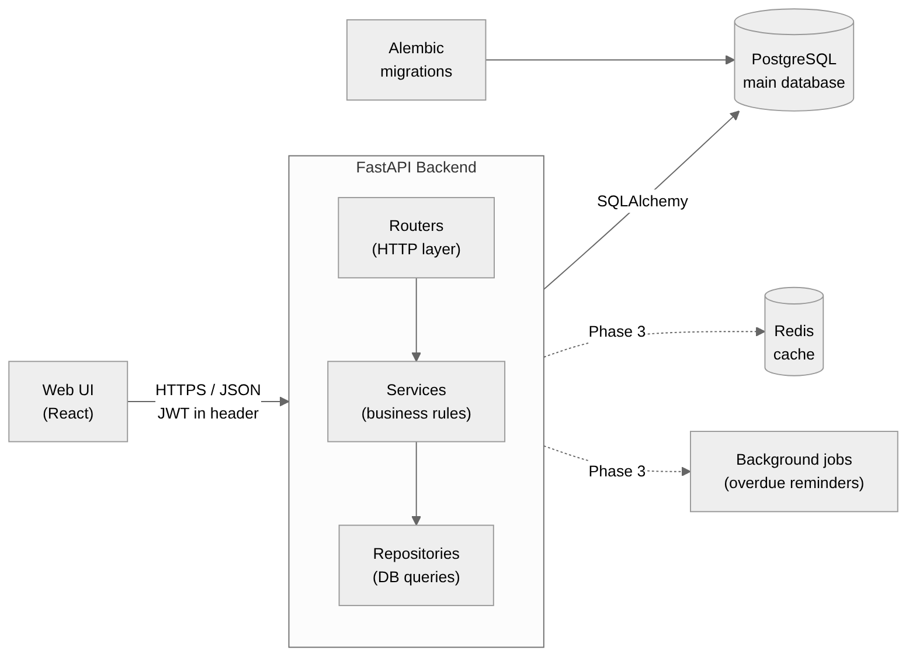
Figure 1. High-level architecture

3.1 Request Flow
Every request passes through the same layers, each with a single job:
- Client (React) sends JSON over HTTPS with the JWT in the Authorization: Bearer header.
- Router validates the body with Pydantic, resolves dependencies (get_db, get_current_user, role checks) and calls the service.
- Service applies business rules and controls the database transaction.
- Repository runs the SQLAlchemy queries.
- PostgreSQL stores the data. Alembic manages schema changes.
Redis and background jobs are marked as Phase 3. They are added only when there is a concrete need (caching popular searches, sending overdue reminders), not for the diagram.

4. Data Model

4.1 Entity Relationship Diagram
This diagram shows how the entities relate. Read the line endings as: || exactly one, o| zero or one, o{ zero or many.
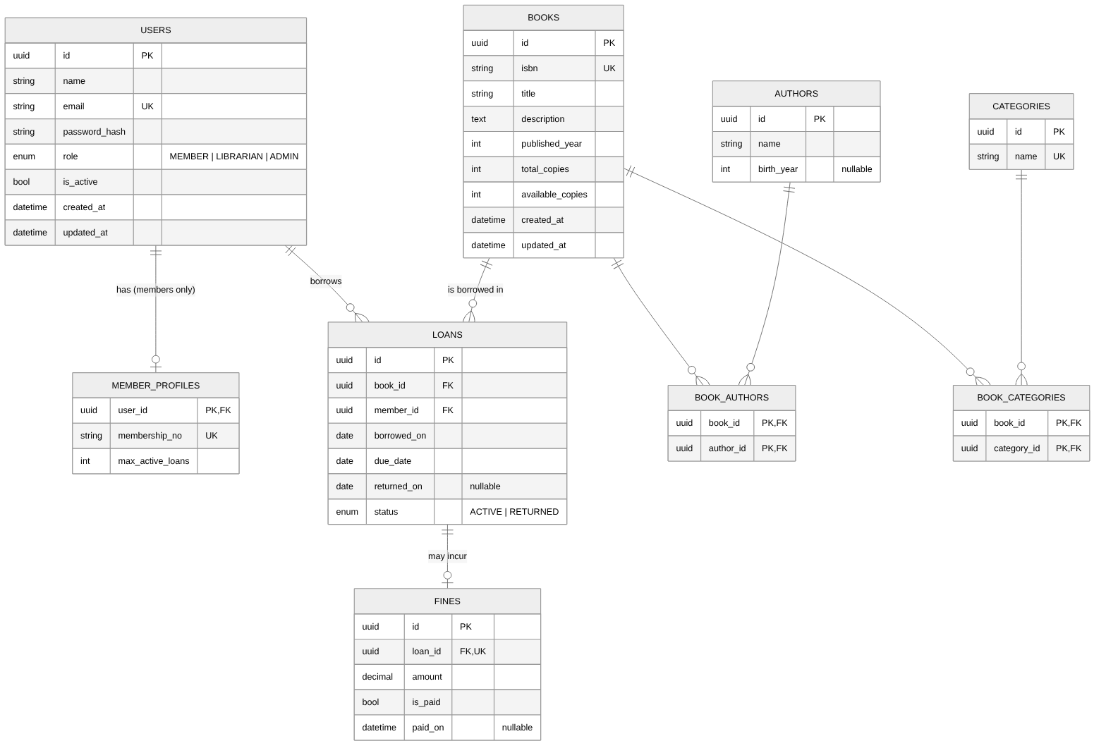
Figure 2. Entity relationship diagram

4.2 Entities
Entity | Purpose | Key constraints
users | Everyone who logs in: members, librarians, admins | email unique; role enum; password stored only as a hash
member_profiles | Member-only data, linked 1-to-1 with users | membership_no unique
books | A title in the catalogue | isbn unique; total_copies >= 1; 0 <= available_copies <= total_copies
authors | People who write books | name required; birth_year optional
categories | Genres or subjects | name unique
book_authors | Join table: book to author (many-to-many) | Composite primary key (book_id, author_id)
book_categories | Join table: book to category (many-to-many) | Composite primary key (book_id, category_id)
loans | One borrowing of one book by one member | Only one ACTIVE loan per (member, book)
fines | Charge for an overdue return | loan_id unique (at most one fine per loan); amount is Decimal

4.3 Relationships
Relationship | Cardinality | Meaning
users to member_profiles | 1 to 0..1 | Only members have a profile
users to loans | 1 to many | A member can borrow many books over time
books to loans | 1 to many | A book can be borrowed many times
books to authors | many to many | Via book_authors; a book can have co-authors
books to categories | many to many | Via book_categories
loans to fines | 1 to 0..1 | A loan has a fine only if returned late

4.4 Enums
Enum | Values | Notes
UserRole | MEMBER, LIBRARIAN, ADMIN | Drives permission checks
LoanStatus | ACTIVE, RETURNED | OVERDUE is calculated, not stored (see section 6)

5. Entity Interactions

5.1 Borrow and Return Flow
The most important workflow in the system. Note how the availability check and the decrement happen in one atomic UPDATE inside a transaction, so two members can never both get the last copy.
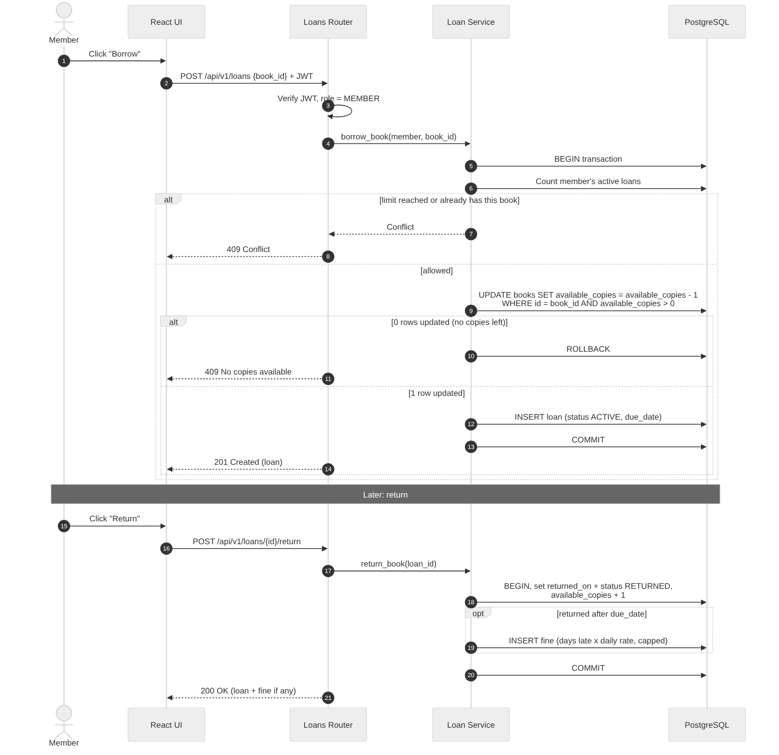
Figure 3. Borrow and return sequence

5.2 Who Can Do What
Action | Member | Librarian | Admin
Register / log in | Yes | Yes | Yes
Search and view books | Yes | Yes | Yes
Create / update / delete books, authors, categories | No | Yes | Yes
Borrow a book | Yes (self) | On behalf of a member | Yes
Return a book | Yes (own loans) | Yes | Yes
View loan history | Own only | All members | All members
Mark a fine as paid | No | Yes | Yes
Manage members (activate / deactivate) | No | Yes | Yes
Manage librarians and roles | No | No | Yes
View reports | No | Yes | Yes

5.3 Business Rules
- A member can have at most 3 active loans (configurable).
- A member cannot borrow the same book twice while the first loan is active.
- A book can be borrowed only if available_copies > 0.
- Loan period is 14 days by default, maximum 30.
- Returning a book already returned gives 400 Bad Request.
- Fine = days late x daily rate, with a grace period and a maximum cap, all set in configuration.
- A book with active loans cannot be deleted; an author with books cannot be deleted (409 Conflict).
- Deactivated members cannot borrow.

6. Key Design Decisions
Decision | Reason
Single users table with a role column | Simpler than table inheritance; member-only fields go in member_profiles
OVERDUE is calculated, not stored | Overdue changes with time on its own; a stored value would go stale. Computed as: not returned AND today > due_date
Atomic decrement of available_copies | UPDATE ... WHERE available_copies > 0 inside a transaction prevents two members borrowing the last copy at the same time
Router, service and repository layers | Each layer has one job, business rules are testable without HTTP, and the database can change without touching routes
Separate Create / Update / Out schemas | Clients never send ids; responses never leak password_hash; PATCH supports partial updates
UUID primary keys | Ids can't be guessed or counted from the URL
Decimal for money | Floats cause rounding errors
API versioning (/api/v1) | Allows breaking changes later without breaking existing clients
No Kafka | Not justified at this scale; background jobs cover notifications

7. API Endpoints (v1)
Method | Path | Access | Description
POST | /auth/register | Public | Create a member account
POST | /auth/login | Public | Get a JWT access token
GET | /users/me | Any user | Current user's profile
GET | /books | Any user | List with filters, search and pagination
GET | /books/{id} | Any user | Book detail with authors and categories
POST / PATCH / DELETE | /books, /books/{id} | Librarian+ | Manage books
CRUD | /authors, /categories | Librarian+ | Manage authors and categories
POST | /loans | Member+ | Borrow a book
POST | /loans/{id}/return | Member+ | Return a book
GET | /loans/me | Member | My loan history
GET | /loans/overdue | Librarian+ | All overdue loans
PATCH | /fines/{id}/pay | Librarian+ | Mark a fine as paid
GET | /reports/popular-books | Librarian+ | Most borrowed books

8. Roadmap
Phase | Scope
1. MVP | Users, JWT auth and roles; books, authors, categories CRUD; borrow and return; search, filter, pagination; PostgreSQL, SQLAlchemy, Alembic; pytest; Docker Compose
2. Business features | Fines; loan history; reports; React frontend
3. Production polish | Redis caching; background overdue reminders; GitHub Actions CI; deployment; rate limiting

Finish Phase 1 completely, with tests, before starting Phase 2.

9. Conventions
- Small, meaningful commits, for example Add book search with pagination.
- venv/, __pycache__/ and .env are in .gitignore from the first commit.
- Secrets live only in .env; .env.example holds placeholders.
- Every schema change goes through an Alembic migration.
- Every new endpoint gets at least one integration test.
- Python naming: snake_case for functions and variables, PascalCase for classes.

