**AUTHOR NAME - Navjot kaur**

**STUDENT ID – 100385217**

**Title - Final Project**

**COURSE NUMBER – INFO1113 S11**

**INSTRUCTOR NAME – Dr Abhijit Sen**

**DATE - NOV 26 2019**

**WEBSITE URL(TEAM MEMBER) - https://sites.google.com/view/navjotkaursite/home**

**Leader NAME – Gursewak singh**

**STUDENT ID – 100383511**

**Trello (GURSEWAK) - https://trello.com/invite/b/cR4wMUXF/62802cd6acec78ade250a07220ebb21a/finalproject**

**Git hub link (Gursewak) -: https://github.com/gursewak1428/FINALPROJECT.git**

**All the contents written down with some diagrams is done by me .**

# **Executive summary:**

The purpose of daily fitness is to prevent people from getting obese and increase their quality of life. The application aims to be one-stop for a user looking to exercise and improve there personal health a survey carried out during the gathering of requirements showed a very positive response of using a mobile application for the purpose outlined above and an overwhelming majority confirmed that they were more likely to stick with exercises as a part of group or in collaboration with other people. Finally, Daily Fitness has the potential to fill a gap in a society and help people get active and improve their health.

# **3. Project Requirements**

**3.2 Non Functional Requirements**

**(A) Reliability**

The system should be extremely reliable and have an approximate up time of 99%.

In the event of a crash or any other error the System should inform the user of any problems and gracefully terminate.

**(B) Ease of Use**

The application should be user friendly and intuitive to use **GUI**s should make their functions clear and navigation round the application should be straight forward.

User should be comfortable using the application after 30 minutes of use.

**(C) Speed**

The application should open and be ready to use within 20 seconds of being selected.

The UI should be smooth with no delays between button pressed and the reaction of the screen.

All database read writes should take no longer than 10 seconds. If the database encounters any errors a user friendly warning should be displayed on the screen.

**(D) Size**

The size of software relations to storage media should be no longer than 500MB.

**(E) Privacy**

All data retained by the system will be stored in accordance with the Data Protection Act 1998 and the Data Protection Amendment act 2003.

# **Use Case Diagram and description**

**4.1 Use case Diagram**

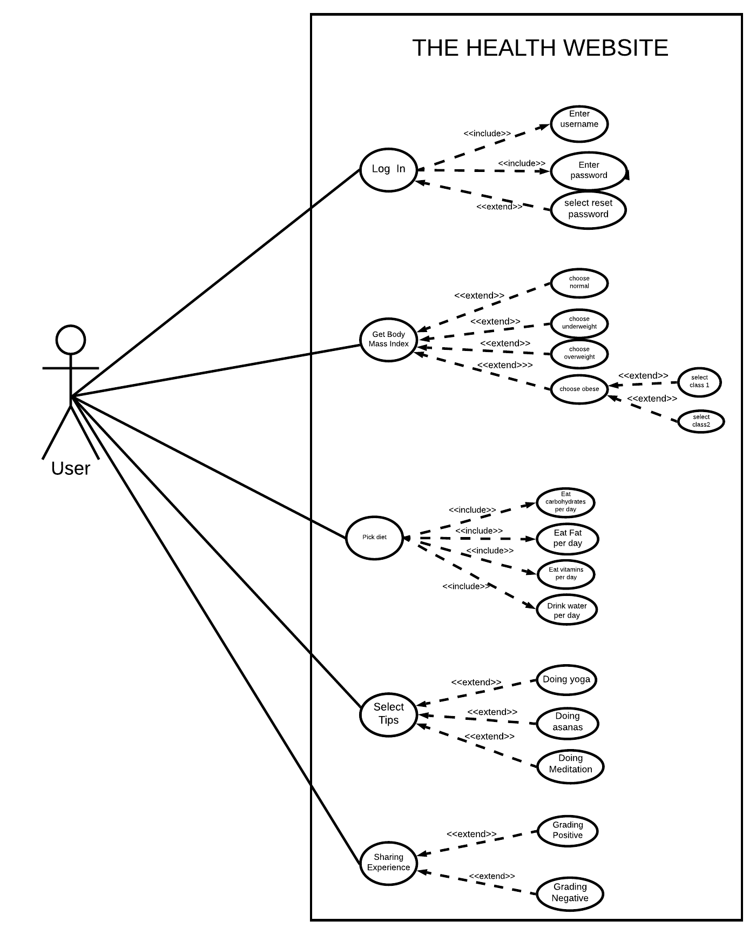

**4.2 Use Case Description:**

**Description Originator name: - Navjot kaur**

|  |
| --- |
| Use case title (second Use- case): Body mask index |
| Goal: To get the perfect health it is important know weather the user have to gain weight or loose weight. |
| Primary Actor: Anyone logged in to website & who want the healthy lifestyle can be a user. |
| Level: kite level |
| Preconditions: Height and weight must be entered. |
| Minimal Guarantee: The user may get the wrong body mass index as the values entered keeps changing. |
| Success Guarantee: The user will get the approximate body mass index of the body if the user enters height and weight. |
| Trigger: User gets the Body Mask Index.. |
| Main success scenario:  1.a User enters the height and weight to get the body mass index.  1.b System validate weather the height and weight entered is correct.  1.c User will get the body mass index when the validation takes place successfully. |
| Extensions:  1a.The Body mass index is inaccurate.  1a1. Height entered is inaccurate (e.g: The height is 49.9cm but the user enter the 49cm)  1b1. Weight entered is inaccurate (e.g: The weight is 50.8kg but the user entered 50kg ) |

**Reviewer name:- Gursewak singh**

As the **Use case title** illustrates this is the use case description on body mass index whose Goal is to get the perfect health as it is important to know weather the user have to gain weight or loose weight in which the **Primary Actor**  could be Anyone logged in to website & or who want the healthy lifestyle can be a user. Moving forward this use case description is on the Kite **level** and the only and only **Precondition** is that the Height and weight must be entered. The **Minimal Guarantee** that the user may get the wrong body mass index as the values entered keeps changing and the **Success Guarantee**  is that the user will get the approximate body mass index of the body if the user enters height and weight.

However **Main success scenario** is that a User enters the height and weight to get the body mass index. Along with this System validate weather the height and weight entered is correct. Whereas User will get the body mass index when the validation takes place successfully. **Extensions** is that the Body mass index is inaccurate. Which may be due to Height entered is inaccurate (e.g: The height is 49.9cm but the user enter the 49cm) or the Weight entered is inaccurate (e.g: The weight is 50.8kg but the user entered 50kg )

.

# **Interface Prototypes:**

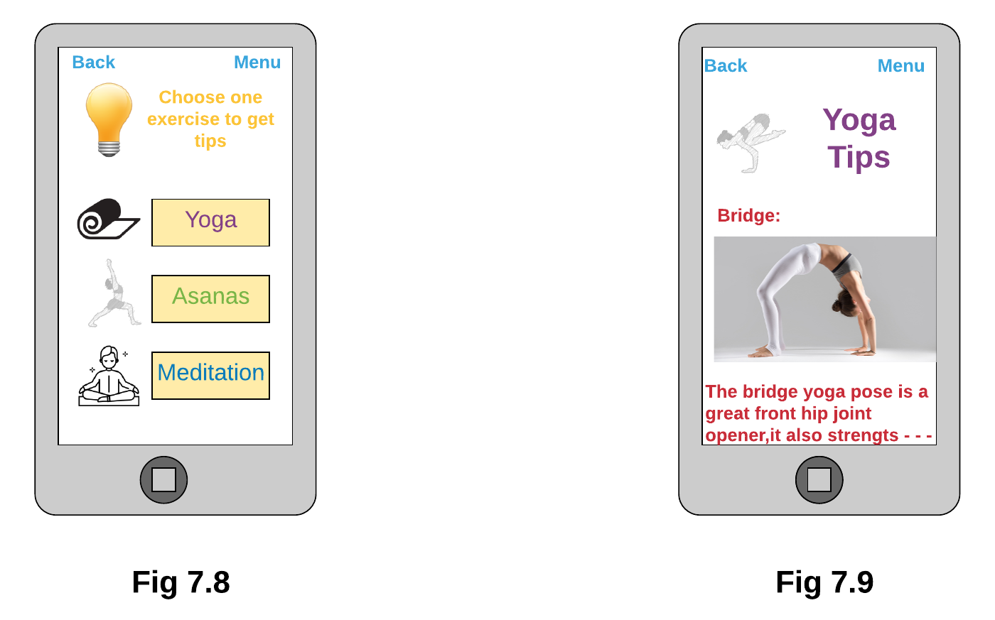  
**Fig 7.8 Now when user became aware of the diet plan The new screen will appears from which he/she can click on the any one exercise that is perfect match according to the user. Also there is back button and menu button on top back button can be used by user to go to the previous screen however, what will happen when user clicks on menu button is shown in Fig 7.10 .**

**Fig 7.9 Suppose the user clicks on the Yoga then there will be list of tips that are related to the yoga these tips can be used by the user while doing exercise. Also there is back button and menu button on top back button can be used by user to go to the previous screen however, what will happen when user clicks on menu button is shown in Fig 7.10 .**

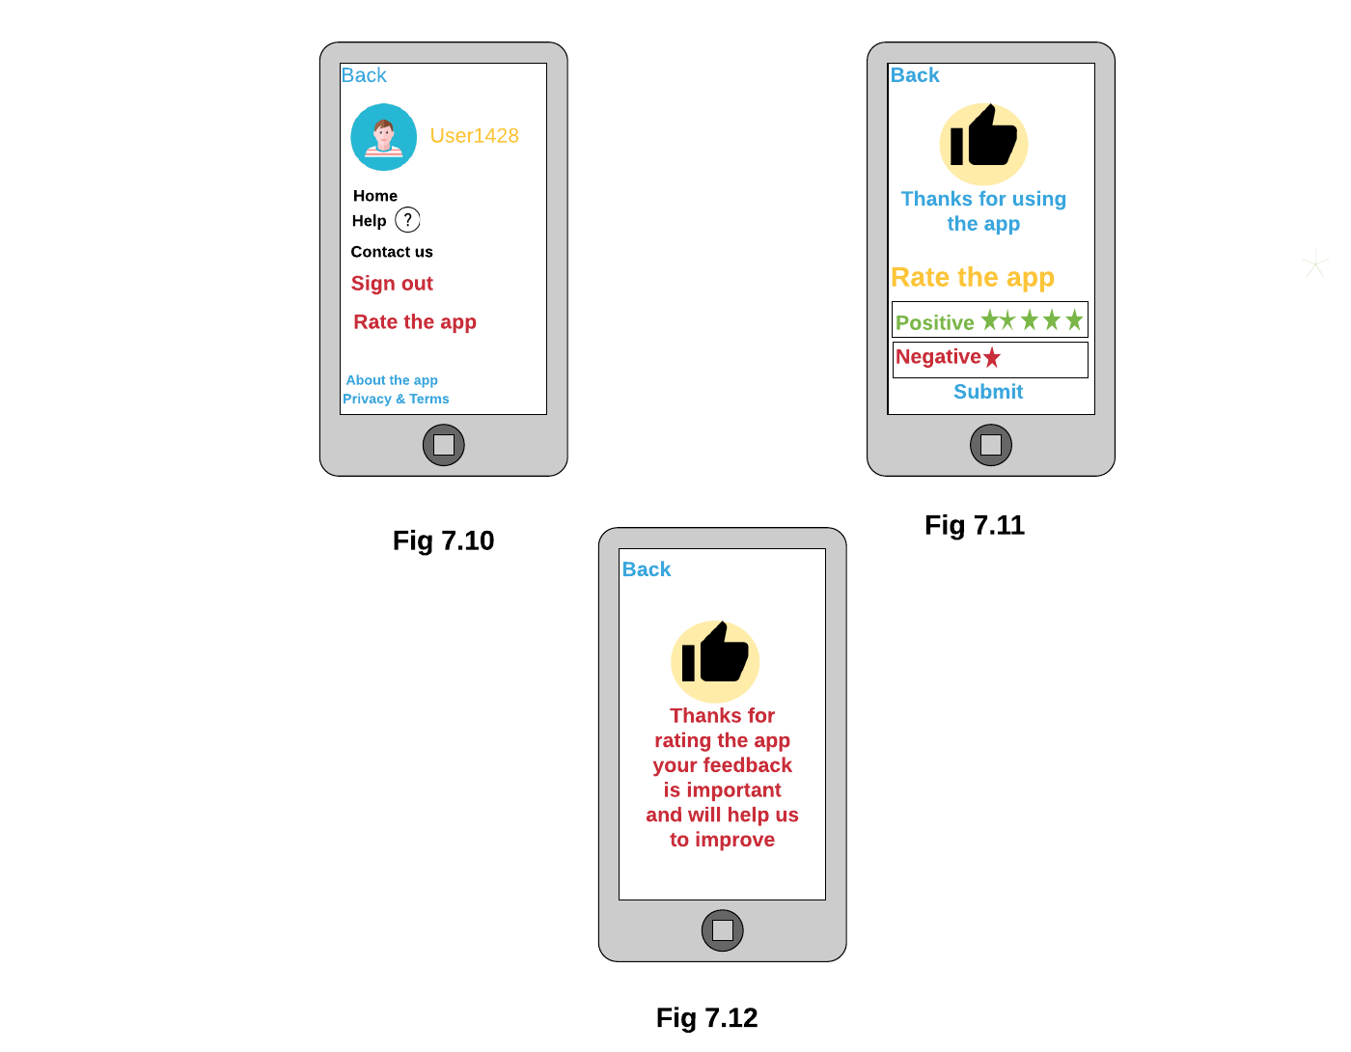

**Now user have performed and used all the functions necessary to get the perfect health so now user can rate the website and to do this.**

**Fig 7.10 User when clicks on the menu icon on top as shown in Fig 7.9 the new screen will appears on the screen from which the user can click on Rate the app. Also there is back button on top which user can use to go to previous screen.**

**Fig 7.11 After user clicks on the Rate the app button there will be new window showing message thanks for using the app as well as there will be two options Positive and Negative the user have to choose one from these depending on what type of experience user have while using the app. . Also there is back button on top which user can use to go to previous screen.**

**Fig 7.12 After user has given the rating there will be message on screen saying Thanks for rating the app your feedback is important and will help us to improve. . Also there is back button on top which user can use to go to previous screen.**

# **Relational database tables and queries:**

**(A) Queries**

**This is the query when we used userid to know the types of diet and the ExerciseTips the two different users are eating and doing.**

| **Query1** | | | | | | | |
| --- | --- | --- | --- | --- | --- | --- | --- |
| **Userid** | **Diet** | **Carbohydrate** | **Fat** | **Vitamins** | **Water** | **ExerciseTips** | **Time** |
| User444 | Non-Vegetarian | 290 | 46 | 80 | 3 | Meditation | 45 |
| User666 | Vegetarian | 250 | 45 | 70 | 2 | Asanas | 30 |

**This is the Query when we used userid to know the types of diet the two different users are eating.**

| **Query2** | | | | | |
| --- | --- | --- | --- | --- | --- |
| **Userid** | **Diet** | **Carbohydrates** | **Fat** | **Vitamins** | **Water** |
| User222 | Non-Vegetarian | 290 | 46 | 80 | 3 |
| User555 | Veg&Non-Vegetarian | 350 | 60 | 100 | 4 |
| User666 | Vegetarian | 250 | 45 | 70 | 2 |

**This is the type of Query in which userid is used to know what ExerciseTips are used by user with different id.**

| **Query3** | | |
| --- | --- | --- |
| **Userid** | **ExerciseTips** | **Time** |
| User333 | Meditation | 45 |
| User444 | Meditation | 45 |
| User555 | Yoga | 60 |

**This is the query when we used ExerciseTips Too know which exercise is done by which user (UserName) and what is the userid of the user.**

| **Query4** | | |
| --- | --- | --- |
| **ExerciseTips** | **UserName** | **Userid** |
| Yoga | Gursewak | User111 |
| Asanas | Navjot | User222 |
| Yoga | Harman | User555 |
| Asanas | Aman | User666 |

**This is the query when we used Diet to know that which type of diet is chosen by whom and what type of exercise the user is doing and also after using the application what rating he/she has given.**

| **Query5** | | | |
| --- | --- | --- | --- |
| **Diet** | **UserName** | **ExerciseTips** | **Rate** |
| Vegetarian | Gursewak | Yoga | Positive |
| Non-Vegetarian | Navjot | Asanas | Positive |
| Non-Vegetarian | Hasan | Meditation | Negative |
| Vegetarian | Aman | Asanas | Positive |

**This is the query when we used Rate to know the types of ExerciseTips the user is doing moreover the UserName as well as UserId of the user.**

| **Query6** | | | |
| --- | --- | --- | --- |
| **Rate** | **ExerciseTips** | **UserName** | **Userid** |
| Positive | Yoga | Gursewak | User111 |
| Positive | Asanas | Navjot | User222 |
| Positive | Yoga | Harman | User555 |
| Positive | Asanas | Aman | User666 |

# **Project Experience:**

Starting from the start writing an executive summary was easy for me (Gursewak) and Navjot as there was a link in assignment document which makes easy for us to write it and as the use case diagrams and descriptions were also created in last assignment we make some changes to them. But there were some things that were gone wrong by me and novjot and we corrected them with each other’s help.

1. **THIS IS WRITTEN BY me** While creating the class diagram Gursewak was not confident that everything is going right so he decided to submit the project without class diagram but then I (Navjot) helped him in drawing it and also explained everything in detail that he created the class diagram in short period of time.