USE CASE DIAGRAM AND USE CASE DESCRIPTION OF

NAME- Navjot kaur

STUDENT ID - 100385217

TEAM MEMBER GIT HUB URL- https://github.com/gursewak1428/USE-CASE.git

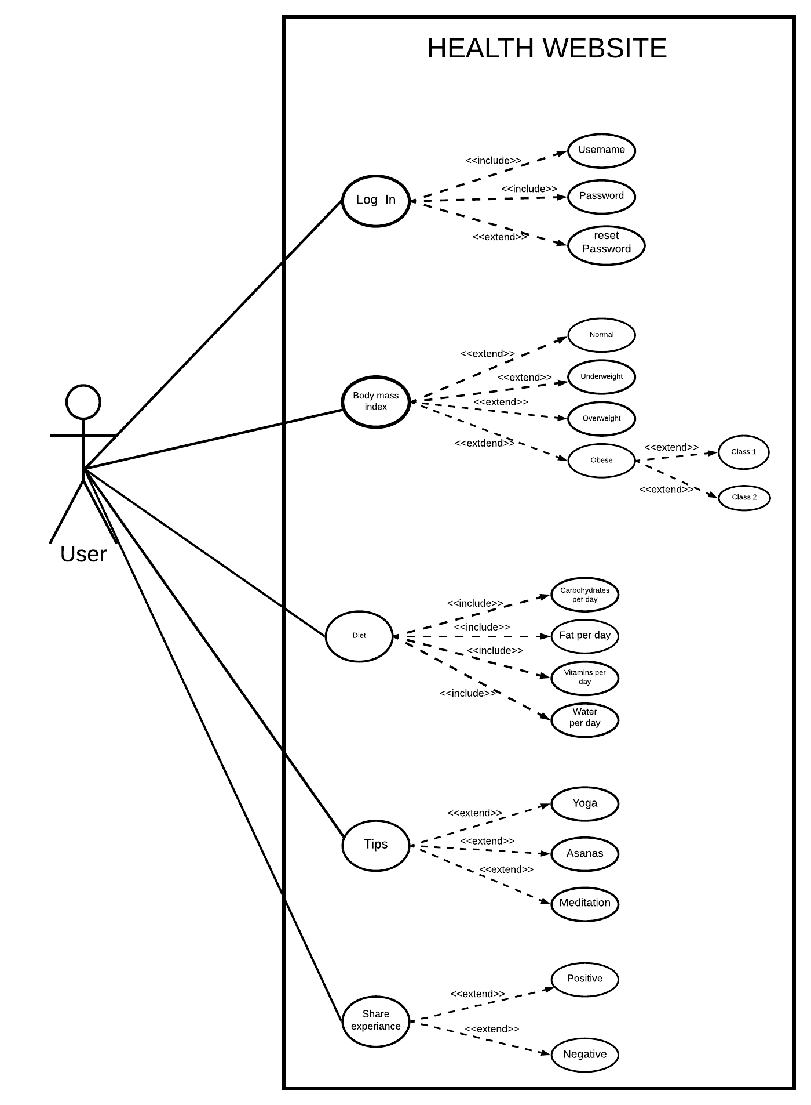

|  |
| --- |
| Use case title: Tips |
| Primary Actor: Anyone with the internet connection and logged in to website can be a user. |
| Goal: To do the exercises in correct position in order to gain weight or loose weight. |
| Level: kite level |
| Preconditions: User have to perform all the exercises very carefully. |
| Minimal Guarantee: If proper instruction is followed for at least 2 weeks more then 40% result will be seen. |
| Success Guarantee: There will be some change in mental health as well as physical health. |
| Main success scenario:   1. User selects the exercise according to level of fitness that will help to improve health . |
| Extensions:  4a User performs the exercises in incorrect position.   1. Pain while doing Exercises.   4a1. The user did the exercises not as per the website tips and it results in some kind of pain.   1. It stops paining when the user corrects the posture. |

**Use case diagram and use case description of my team member**

**Team member name – Gursewak singh**

**STUDENT ID – 100383511**

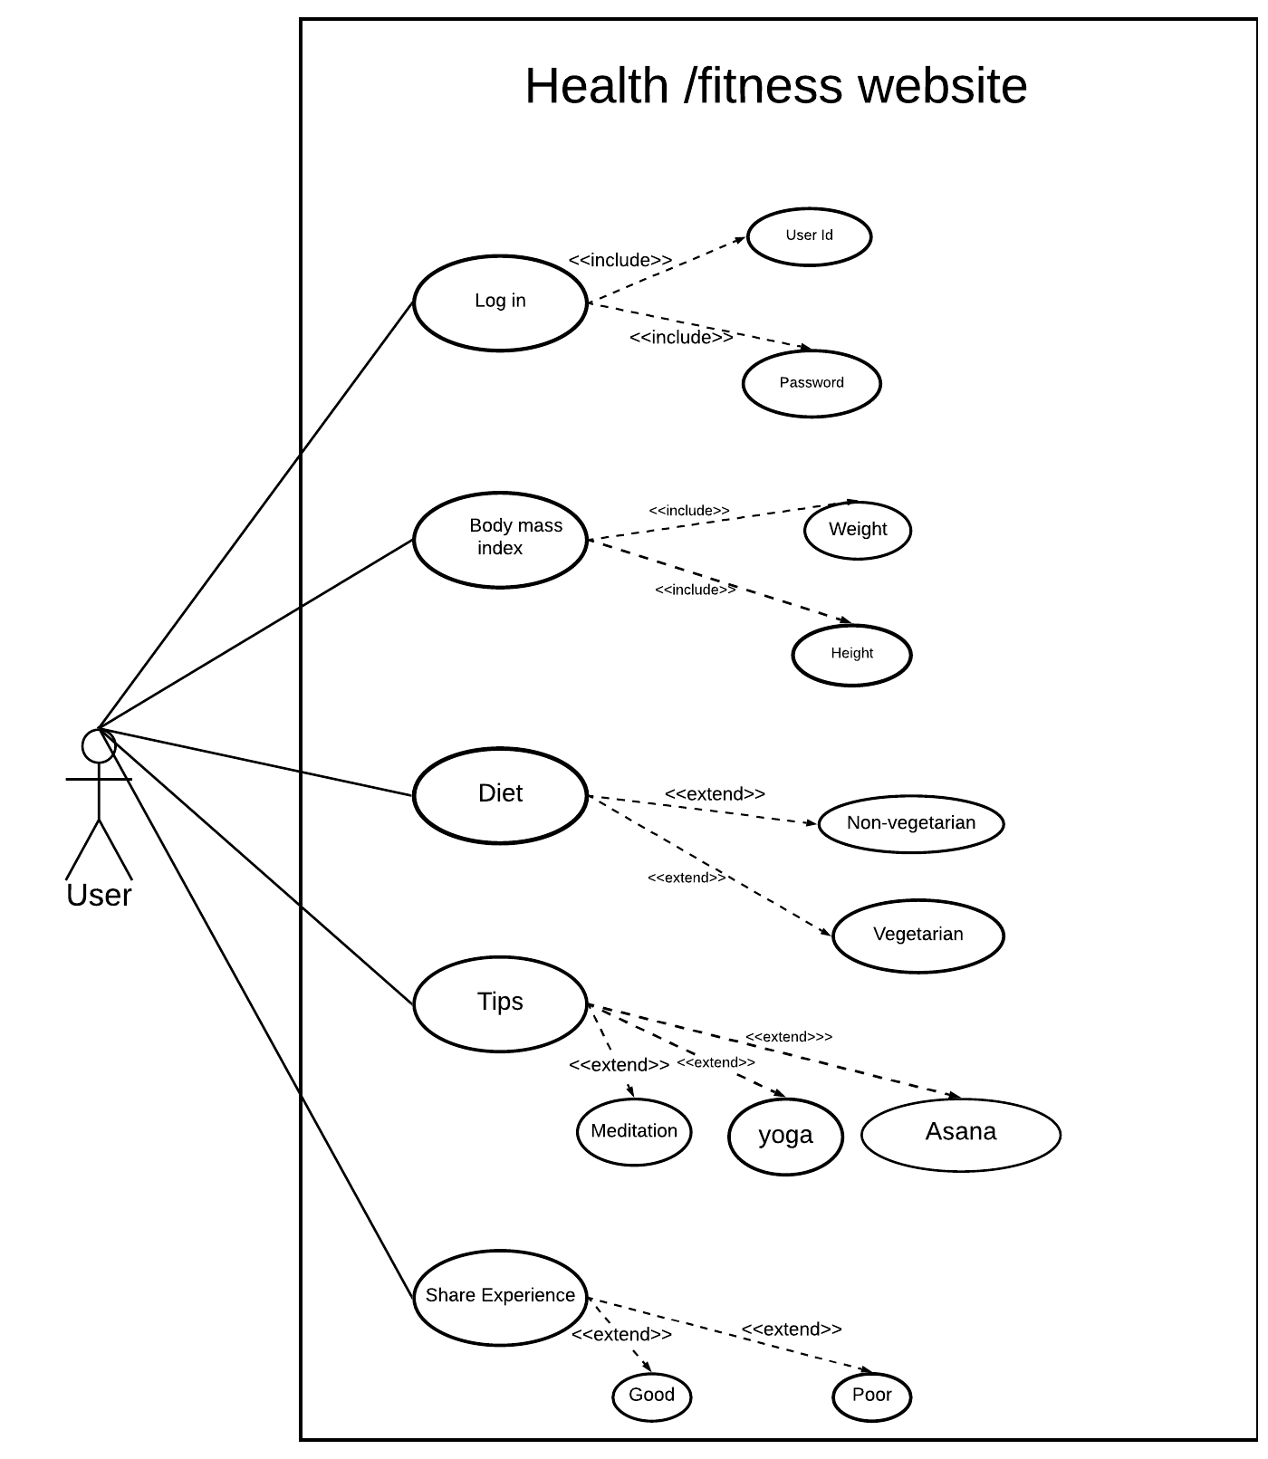

|  |
| --- |
| Use case title: Body mask index |
| Goal: To get the perfect health it is important know weather the user have to gain weight or loose weight. |
| Primary Actor: Anyone logged in to website & who want the healthy lifestyle can be a user. |
| Level: kite level |
| Preconditions: Height and weight must be entered. |
| Minimal Guarantee: The user may get the wrong body mass index as the values entered keeps changing. |
| Success Guarantee: The user will get the approximate body mass index of the body if the user enters height and weight. |
| Main success scenario:   1. User will get the body mass index when the user enters the weight and height in website. |
| Extensions:  2a.The Body mass index is inaccurate.  2a1. Height entered is inaccurate (e.g: The height is 49.9cm but the user enter the 49cm)  2b1. Weight entered is inaccurate (e.g: The weight is 50.8kg but the user entered 50kg ) |

**REVIEW**

REVIEW OF USE CASE DIAGRAM AND DESCRIPTION

DIAGRAM ORIGINATOR = **NAVJOT KAUR**

REVIEWER NAME= **GURSEWAK SINGH**

USE CASE DIAGRAM



USE CASE DIAGRAM REVIEW:

***To Log In*** the user will type the username and password for the website but in some situations if the user forgets the password the user can reset it using the reset password.The user have to choose from the options what type of ***Body mass index*** he/she have (Normal , Underweight ,Overweight ,Obese). Some of these is further divided into classes to get accurate knowledge about weather the have to gain weight or loose weight. When user click on **Diet** there is approximate quantity which the user have to take everyday to improve the health in given time.

Three different types of exercises(yoga, asanas , meditation) are available from which the user can select any one to improve the health and for the selected exercise **Tips** will be displayed on the screen. **Sharing experience -**  User will share the experience so the Other users can get aware about website ratings and also get the desired health they want.

USE CASE DESCRIPTION

|  |
| --- |
| Use case title: Log In |
| Primary Actor: Anyone with the internet access and who want the healthy lifestyle can be a user. |
| Goal : Log in to access the features of the website |
| Level: user level |
| Preconditions: Interconnection is foremost condition. |
| Minimal Guarantee: The user will logged into Website when the username and password is entered correctly |
| Success Guarantee: The user can successfully access the website and perform actions appropriate for his or her role. |
| Main success scenario:   1. The user connects to the website to validate the entered username and password if the user do not remembers the password the user click on the reset password. |
| Extensions:  1a. The website determines that the password is incorrect  1a1. The website displays the error message on screen (The password you entered is incorrect).    1b. The user do not remembers the password and clicked on the reset password.  1b1. The user verify that the account belongs to him and resets the password.  1b2. The user failed to verify that the account belongs to him and didn’t get access to the website. |

REVIEW ON USECASE DESCRIPTION

DESCRIPTION ORIGINATOR = **NAVJOT KAUR**

REVIEWER NAME= **GURSEWAK SINGH**

As the **Use case title** illustrates this is the use case description on log in in which the **Primary Actor** could be anyone with the internet access and who want the healthy lifestyle. Moving ahead the **Goal** of the Log in is to access the features of the website. This use case description is on the user **level** and the only **Precondition** is that the Internet connection is foremost condition. The **Minimal Guarantee** that the website provide is user will logged into Website when the username and password is entered correctly and the **Success Guarantee** is that The user will successfully access the website and perform actions appropriate for his or her role.

However **Main success scenario** is if everything goes right ,the user typed the password correctly and remembers the username he or she can access all the features of the website. And the **Extensions** for the log in says that if password entered didn’t match the original password the website determines that the password is incorrect and the website displays the password you entered is incorrect on screen. And to overcome this issue The user click on the reset password and the user now have to verify that the account belongs to him to resets the password. If the user failed to verify that the account belongs to him the user will not get access to the website.

FINAL USE CASE DIAGRAM AND DESCRIPTION

We (NAVJOT AND GURSEWAK ) have done the review on use case diagram and description and after our discussion this will be our final use case diagram and description.

**USE CASE DIAGRAM**



**USE CASE DESCRIPTION**

|  |
| --- |
| Use case title: Log In |
| Primary Actor: Anyone with the internet access and who want the healthy lifestyle can be a user. |
| Goal : Log in to access the features of the website |
| Level: user level |
| Preconditions: Interconnection is foremost condition. |
| Minimal Guarantee: The user will logged into Website when the username and password is entered correctly |
| Success Guarantee: The user can successfully access the website and perform actions appropriate for his or her role. |
| Main success scenario:   1. The user connects to the website to validate the entered username and password if the user do not remembers the password the user click on the reset password. |
| Extensions:  1a. The website determines that the password is incorrect  1a1. The website displays the error message on screen (The password you entered is incorrect).    1b. The user do not remembers the password and clicked on the reset password.  1b1. The user verify that the account belongs to him and resets the password.  1b2. The user failed to verify that the account belongs to him and didn’t get access to the website. |