**DESIGNING OF CHESS GAME IN JAVA WITH GRAPHICS (SWING AND AWT)**

**PROJECT SYNOPSIS**

OF MAJOR PROJECT

**BACHELOR OF TECHNOLOGY**

**COMPUTER SIENCE ENGINEERING**

**SUBMITTED BY:**

NAVJOT SINGH

1819318

**MAY 2022**



**HARYANA ENGINEERING COLLEGE**

(Affiliated to Kurukshetra University, Kurukshetra),

**JAGADHRI-135003**

**DECLARATION**

I hereby certify that the work which is being carried out in this Project titled **“DESIGNING OF CHESS GAME IN JAVA WITH GRAPHICS (SWING AND AWT)”** in fulfillment of the requirement for the degree of Bachelor of Technology in Computer Science and Engineering and submitted to **“Haryana Engineering College (Affiliated to Kurukshetra University, Kurukshetra), Jagadhri”.**

**Navjot Singh**

**Yamuna Nagar,**

**May 2022**

**TABLE OF CONTENTS**

|  |  |  |
| --- | --- | --- |
| **Chapter** | **Title** | **Page No.** |
| **1** | **Introduction** | **4** |
| **2** | **Proposed Objective** | **5** |
| **3** | **Requirement specification** | **5** |
| **4** | **Literature Review** | **6** |
| **5** | **System Design** | **7** |
| **6** | **Project Snapshots** | **10** |
| **7** | **Conclusion** | **12** |

**Chapter 1. Introduction**

**1.1. Brief description:**

The project ‘**DESIGNING OF CHESS GAME IN JAVA WITH GRAPHICS (SWING AND AWT)’** implements a classic version of Chess with a Graphical User Interface (GUI). The Chess game follows the basic rules of chess, and all the chess pieces only move according to valid moves for that piece. This implementation of Chess is for two players (use of Artificial Intelligence). It is played on an 8x8 checked board, with a dark square in each player's lower left corner.

A successfully created a GUI using text-based version, inheritance and templates, as specified. Despite several unusual bugs in the GUI, our Chess program is a great, user- friendly game for two players.

**1.2. What a chess game Possess?**

Chess is a game played by 2 people on a chessboard with 16 pieces each. This project implements the chess game with graphical user interface. The chess game follows the basic rules of chess and all the chess pieces only move according to valid moves for that piece. This implementation of chess is for two players (no artificial intelligence). It is played on an 8*8 checkered board, with a dark square in each player’s lower left corner.

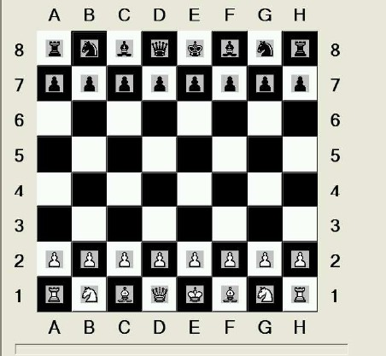

**Chapter 2. Proposed Objective**

This project implements a classic version of Chess using Java and a Graphical User Interface. The Chess game follows the basic rules of chess, and all the chess pieces only move according to valid moves for that piece. Our implementation of Chess is for two players. It is played on an 8x8 checkered board, with a dark square in each player's lower left corner.

**2.1. Goals of our Project:**

* First goal is to allow two users or players to play the game interactively from remote locations.
* The second goal will be that the program should be working and allow the users to play the game.

**2.2. What chess game can do?**

* IMPROVES PROBLEM SOLVING TECHNIQUES
* IMPROVE LOGIC AND REASONING SKILLS
* INCREASE PATIENCE AND PERSISTENCE
* IMPROVES DECISION-MAKING SKILLS

**Chapter 3. Requirement Specification**

These are some certain specifications upon which our project is based upon and with help of following our “DESIGNING OF CHESS GAME” is able to proceed through as follows:

**3.1. Software Requirement Specification:**

* **Language:** JAVA with graphics (Swing and AWT).
* **Platform:** Any JAVA Running Environment.
* **Development Software:** Intelli J idea IDE software, VS Code.

**Chapter 4. Literature Review**

Computational intelligence techniques were combined with games for the first time in 1959, when Samuel applied a simple reinforcement learning algorithm to the board game Checkers. After the early success of Samuel, the research in the field remained silent for a long time. But as part of artificial intelligence research, a few researchers have worked on applying classical AI techniques, basically especially custom-made search algorithms, to board games such as Chess and Checkers. This direction of research ultimately led to the much publicized victory of the IBM Deep Blue Chess computer over world Chess champion Gary Kasparov in 1997.

The legendary game designer Sid Meier defines a game as “a series of meaningful choices”. In discussing these and other definitions, game designer Raph Koster also gave his wonderful effects in “Theory of fun game design” book. According to Koster, a game is fun to play because we learn the game as we play; we understand and learn the patterns underlying the game, and finally master how to play it.

Thus Botvinnik for this reason placed games like chess into the class of inexact problems. As the player cannot in general see the exact influence of a move on the final goals of the game, it follows that her reasoning must be heuristic. Also S. Russell and

P. Norvig, Artificial Intelligence: A Modern Approach Prentice Hall, 1995 also had the explanation of using Artificial Intelligence Technique providing a better approach towards the designing of chess game.

**4.1. Abstract Representation of a Game:**

An abstract representation of a game is a set of rules which allow a player to play the game lawfully, but which is more compacted than the general representation of the game. The concept of abstract representation is basic to all work on games in AI. It is a prerequisite for game analysis. Thus game analysis is significantly dependent on the existence of an abstract representation of the game.

Last but not the least a literature review is one described above and the one which is an evaluative report of information found in the literature related to the selected area of study, mine is the CHESS.

**Chapter 5. System Design/Methodology**

System design is the process of defining the components, modules, interfaces, and data for a system to satisfy specified requirements. System development is the process of creating or altering systems, along with the processes, practices, models, and methodologies used to develop them.

**5.1. Flow Charts:**

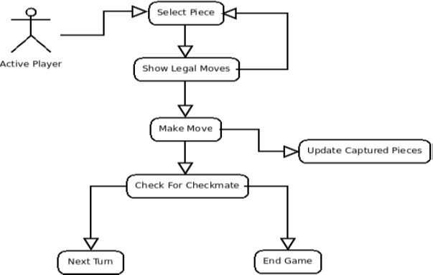

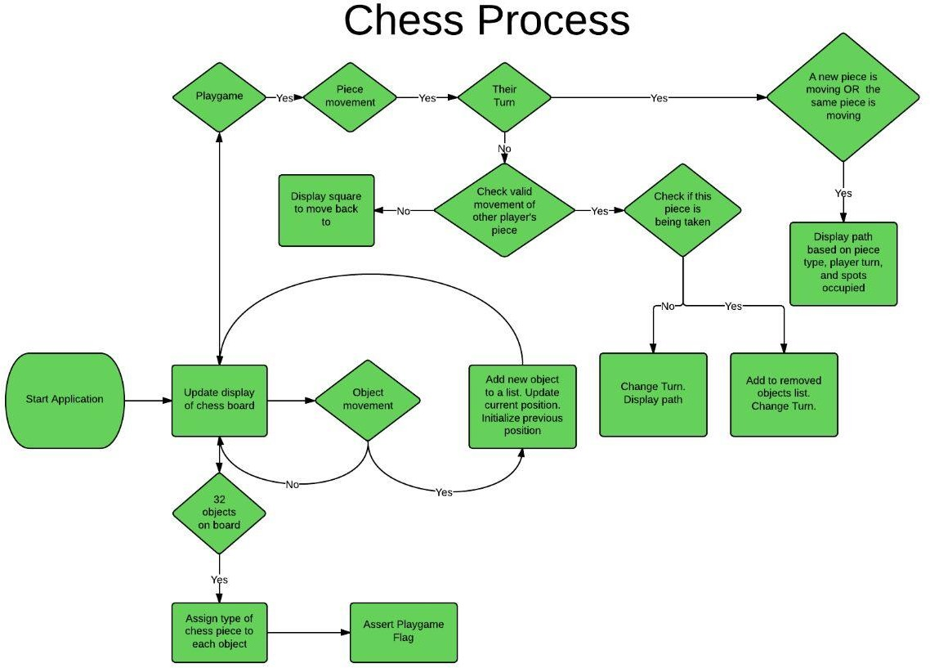**5.2. ER-Diagram:**

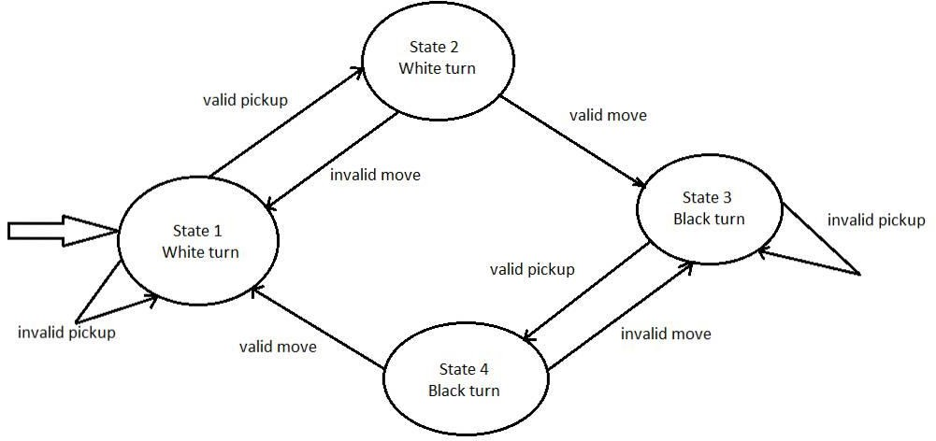**5.3. State Diagram:**

**Chapter 6. Project Snapshots**

**6.1. Opening Interface**

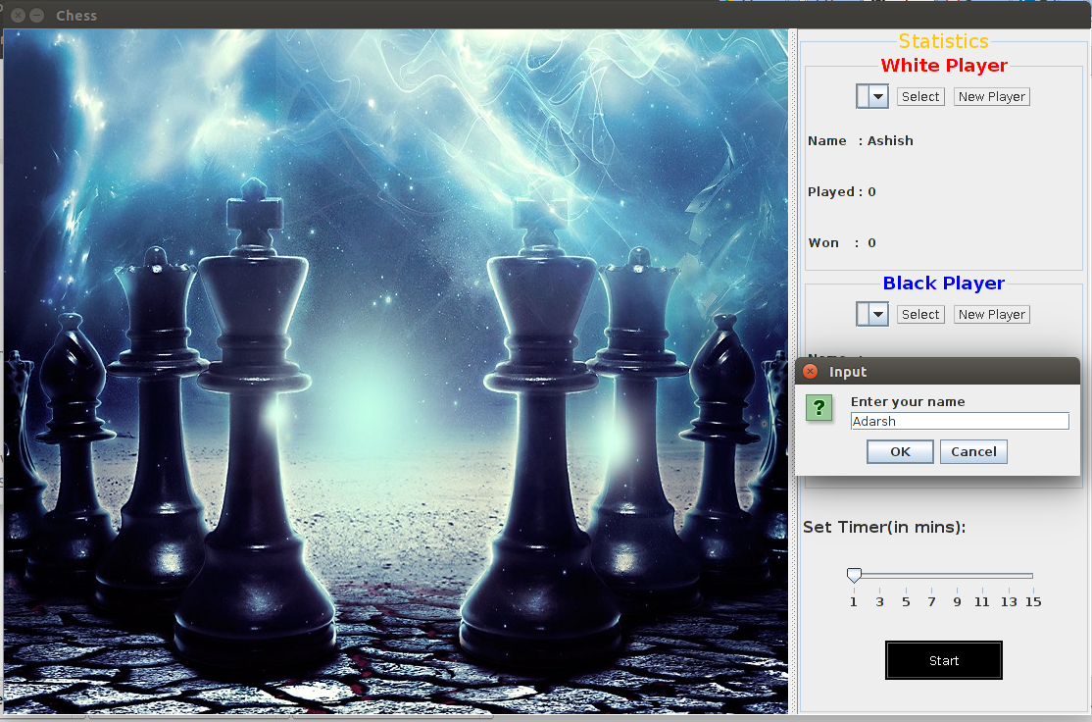

**6.2. Game In-Progress**

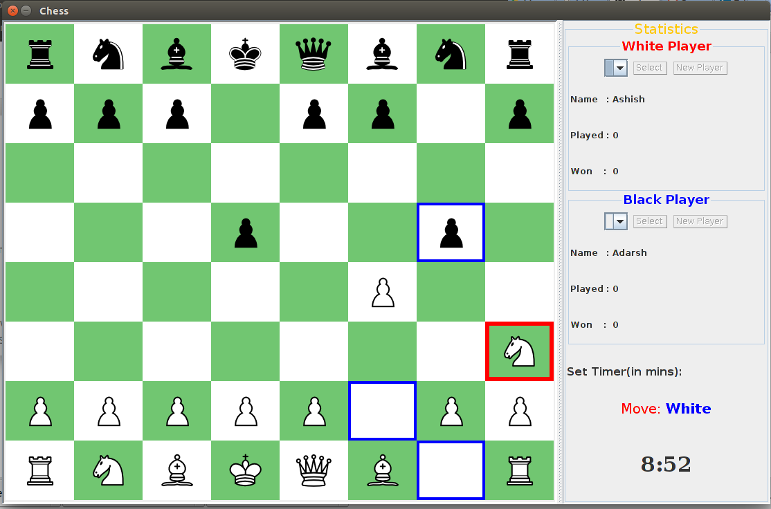

**6.3. In Check**

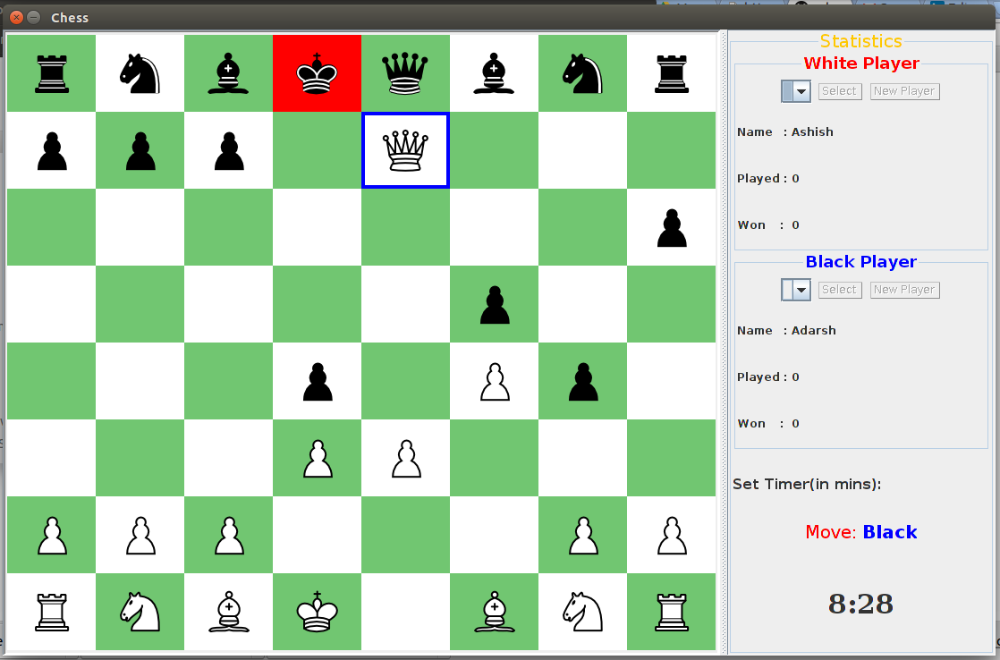

**6.3. Win**

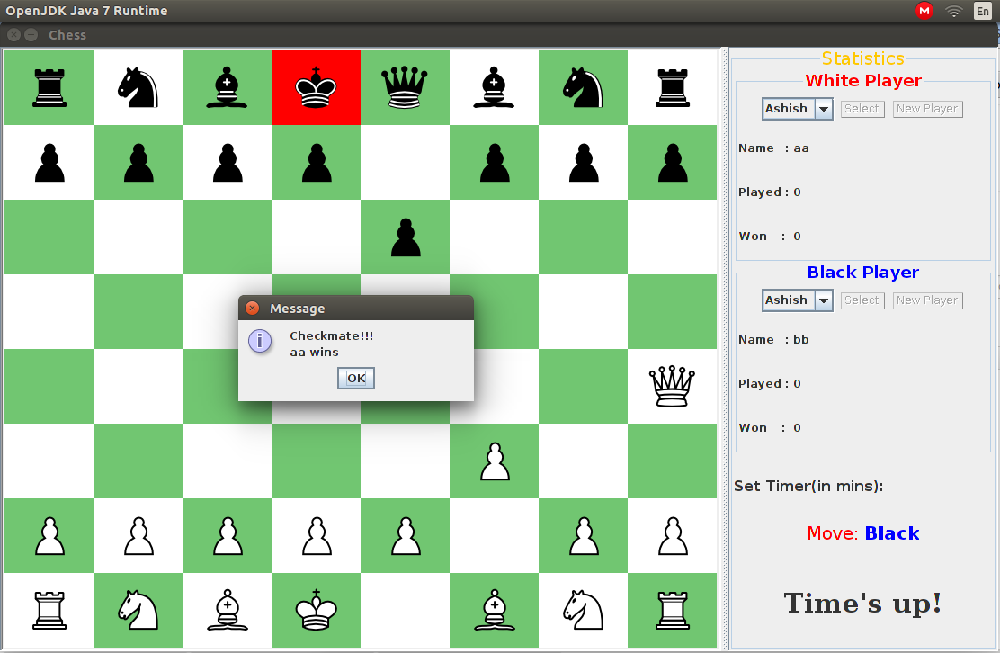

**Chapter 7. Conclusion**

In this project **(DESIGNING OF CHESS GAME IN JAVA WITH GRAPHICS [SWING AND AWT] )** the classic and standard version of Chess implemented as a GUI. Its successfully implementation of a game using inheritance, templates, and a GUI (Graphical User Interface).

The final report for the project was good, as it showed how the academic question was created from the initial problem. The next section of the report was the literature review, which contained quality sources from various different formats such as books, journals and websites. The sources gave excellent background knowledge of the topic and aided in answering the academic question.

The planning for the project was very well carried out as it initially had two weeks of slack available. This allowed for leniency if any task took longer than anticipated. All tasks were completed in the order they were anticipated.

The testing methods used in the project were appropriate. The system test ensured that all features of the chess game were functional before the beta test. There was no other suitable tests found that would test the game as thoroughly as the system test.