Attached the Json file showing the hyperparameters I used.

Following is the loss optimization graph I got with these hyperparameters.(Loss vs step)
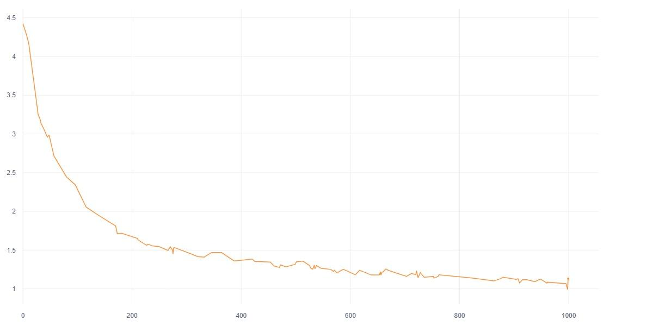

Using a lower learning rate yielded better results.

Number of outputs in this case were equal to the number of inputs. I wanted to generate only 1 output even if my starting string length was > 1.

Also feeding back the output state as input to the next iteration in the model was necessary to get correct results.

