APCO 2P99
2010/11

Project Peer to Peer

Design Specification

Student: Navjot Minhas
Student Number: 4097762
Supervisor: Dr. D. Hughes
Program: Bachelor of Accounting
Date: Mar 24, 2011

Project Peer to Peer
Overview:

The project is a peer to peer file sharing application which allows users to download media from other users on a connected network. This means that users will be able to access each others resources as long as they are connected to the network which is handled by the application.

Scenario:

A comic book fanatic wants the latest issue of his favourite comic. He/She have consulted a catalogue and have found out the latest instalment in the series came out yesterday. He/She now has to figure out which collector has this new instalment and is also interested in selling it. In order to make other collectors aware that someone is looking for a particular comic book, it is broadcast on a radio. Collectors interested will then contact the person who is broadcasting the message on the radio. The comic book fanatic will then make arrangements with an interested collector for the comic book and a transaction will occur.

System Model:
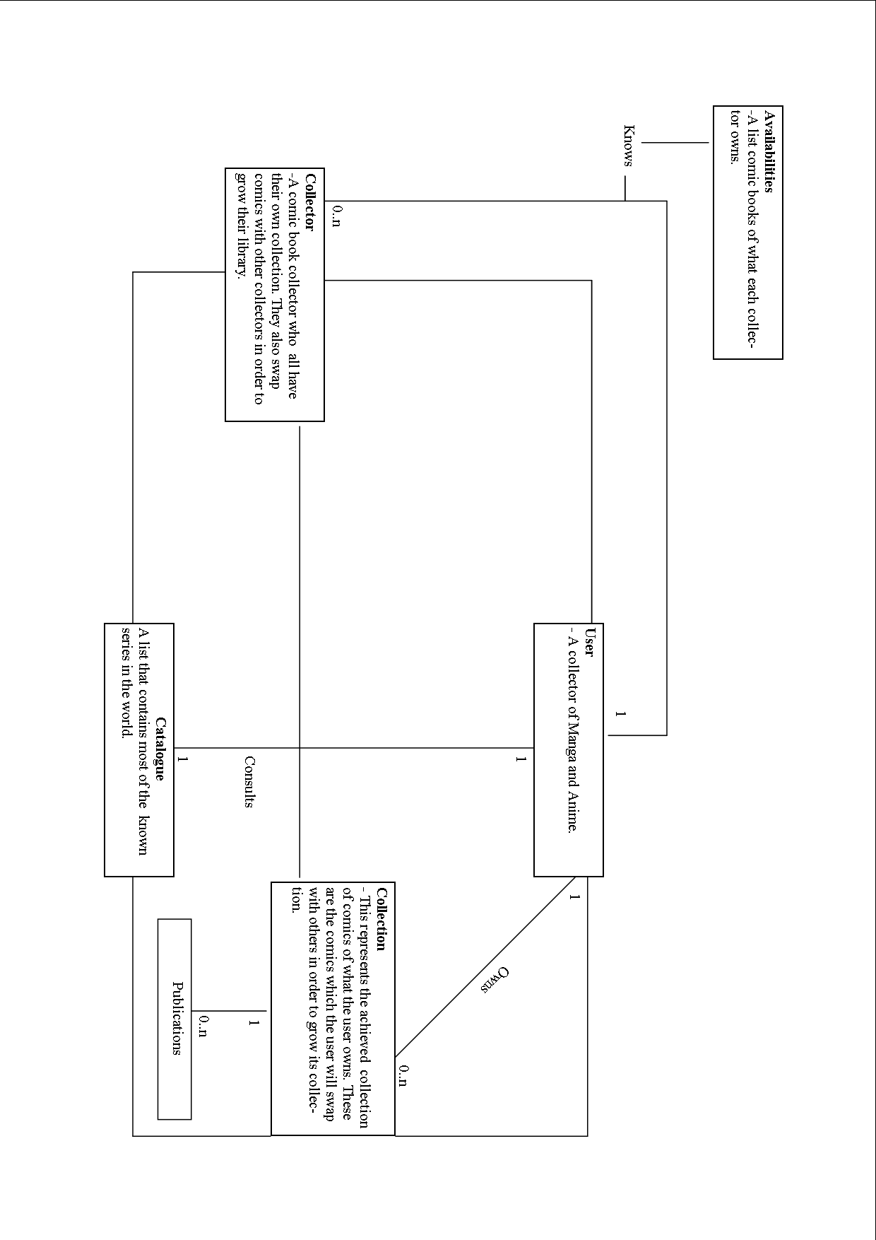

Why the User and collector are two different roles:

The user and collector roles have been separated for simplicity purposes. It gives a better understanding of the problem and the system used to solve the problem. In all, the user and the collector are essentially the same. In this system the collector becomes the user when he/she request content from other collectors. On the other hand, a user becomes a collector when another user is asking them for content. In summary, a user is a collector but is separated depending on the perspective.

This diagram represents a user search scenario perspective of the system. In this system the user is asking the other collectors for media/content. However, before search can be preformed some steps must be taken. First, the user owns a collection of publications, these publications range from videos to comic books. If a user does not have the desired publication in their collection he/she may do the following:
- Consult the catalogue which will determine if what the user is looking for has been published/released. This step is not compulsory since the user can broadcast a message to other collectors without consulting the catalogue.
- Broadcast a message to other collectors in the system asking them if they have the specific publication.
Once the user obtains a list of collectors who have the publication, the user then asks one of them for the content and the file is transferred from the collector to the user. This file is now part of collection that the user owns.

Class Description:

Catalogue
Responsibilities | Collaborators
Know:
-Location of online catalogue(s)

Doing:
- Compiles a list of all the mangas and animes in the on-line catalogue(s)

The catalogue class is responsible for knowing where to locate the external resources in order to determine all the mangas and animes that have been published. These resources will then be accessed and a list will be compiled containing all the series names along with the number of chapters/episodes each series contains. Note, the list this class compiles are the series that have been published, it is not a list of series that are guaranteed to be on the network.

User
Responsibilities | Collaborators
Know:  -what he/she owns in its own collection  -other manga and anime collectors  - knows the catalogue (s)  Doing:  - They broadcast download requests to other collectors  - They get mangas and anime from other collectors that have their requests | -Collector  -Collection  -Catalogue

The User is the role of the application when interacting with physical user to search catalogue and/or download a manga /anime. The user knows and possesses its own collection of media/content. It is imperative that user knows other collectors, thus allowing them to broadcast their advertisements to some collectors. The user class also has the ability to access the list compiled by the catalogue class. This will give the user the ability to look up most of the series that have been published in the world and get the latest feeds on the series they are currently watching/reading. In addition, the user class is responsible for handling the download to the user from another collectors; this includes preparing and handling the file transfer between the collectors and the user.

Collector
Responsibilities | Collaborators
Know:  -Its collection  -other manga and anime collectors  Doing:  - They respond to the “give me” requests of another by saying they have it.  -Send the user the content | -User  -collection

This is the collector role of the application. The collectors respond to other users’ broadcast requests for animes /mangas. They have the following to options when responding:
- They have the file and respond to the users “give me” request and say that they have it
- Or they do not have the file and propagate/ pass on the message to other collectors.
In addition, the collectors which have the file are also responsible for sending the user the content.

Collection
Responsibilities | Collaborators
Know:  - number of publications  Doing:  -Initialize the users collection and make it available on the network.  -add new content to the collection  -search for content owned by the user. | -Publication

This class is responsible for knowing the publications available on the local disk. These publications can be perceived as user owned content, this means it is what the user owns. The class is also responsible for handling, and managing these publications.

Publication
Responsibilities | Collaborators
Know:
- file name
-file size
-subbed language
-media type

The publication class is perceived as a data class. Its main objective is to know metadata about a single publication in the collector’s collection. A group of publications make up a collection.

Architecture:

This project will use the ideas introduced by KaZaa and Bit Torrent. The network will be setup with the architecture that KaZaa used which was the idea of super peers (also known as rendezvous peers). When a peer connects to the network, theoretically it must connect to a predefined seed. It is important to remember that a peer can either be a rendezvous peer or an edge peer depending on its network bandwidth. Once it connects to the seed it will be given a number of active rendezvous peers to connect itself too. However, it will only connect to one of the rendezvous peers. The IP address of more then one rendezvous peer is given to prevent the peer from being disconnected from the network if the rendezvous peer happens to disconnect. The function that it will use from Bit Torrent is the idea of parallel downloading. When a file is being downloaded it will be downloaded from multiple peers simultaneously. (See Appendix A, and Appendix B, pg. 8)

JXTA:

JXTA library will be used in the implementation of this project because the framework introduces the fundamental concepts required for creating a peer to peer application. (See Appendix B)

Appendix A

The evolution of P2P:

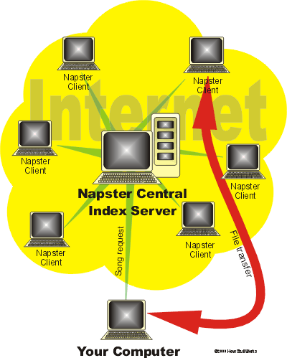

Napster: This was an application which appeared in 1999 and provided users the ability to exchange mp3 audio files with one another. The users of the application uploaded their file list of mp3 songs on a central server. Then when a user wanted to search for a song a search request was sent to that server which returned with the list of IP addresses of users having the given files. In order to download files, a connection had to be established with one of the returned IP Addresses.

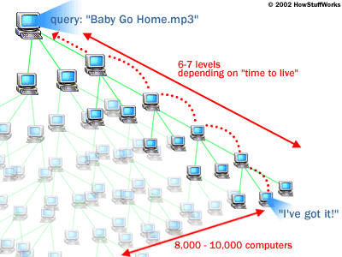

Gnutella: This was a network which appeared a year later than Napster. It was a file exchanging network similar to Napster but however it differed in its ways of discovering other peers and requesting for files. Unlike Napster which used a central server for peer discovery, Gnutella would attempt to establish a connection with set of predefined seeds. When a peer was connected to these seeds, it would obtain a list of IP addresses of other peers active on the network. It then attempted to repeat the process with the new discovered peers until a sufficient set of successful connections were made. When searches were performed the peer would send its request to the set of known peers that it gathered in the previous step. These requests would be forwarded to the peers they knew, and the process would continue to repeat itself. Eventually after repeating the process 7 times the search request could have been forwarded to 1 million people.

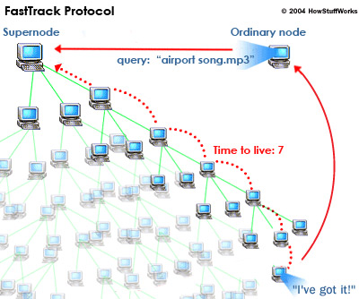

KaZaa: This was another P2P application that allowed file exchanging. Unlike Napster which used a centralized discovery process and Gnutella which used a decentralized approach, KaZaa was semi-centralized. They introduced the concept of super nodes. Unlike Gnutella where peers maintained there own list of shared files, KaZaa peers uploaded their file list to super nodes. The network had many super nodes; thus, eliminating points of failure. Furthermore, the user’s queries would be sent only to super nodes instead of flooding the network with queries. The concept of super nodes has helped to reduce the network congestion resulted from the massive query propagation done in the Gnutella network.

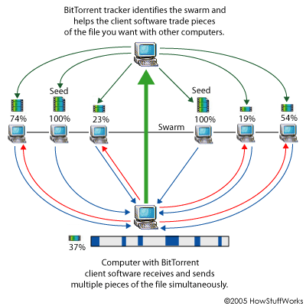

BitTorrent: This application introduced a new way of exchanging files on a P2P network. Instead of relying on a single peer for a file, it broke a file down into smaller parts. It then proceeded to download smaller parts simultaneously from different peers. This resulted in faster download speeds.

Appendix B

The JXTA library introduces many fundamental protocols for developing a peer to peer application. These protocols make it easier for a library to connect, discover and download with other peers. The protocols we will be implementing are the following:

Rendezvous Protocol:
This protocol contains three subsections:
- Message propagation protocol: The responsibility of this protocol is that it helps simple (Edge) peers propagate its individual messages to other peers in the peer group.
- PeerView protocol: This protocol states that each rendezvous peer within the peer group is responsible for maintaining their own local version of the PeerView. The peerview is a distributed list of active peers within the peer group. Every peer group has one peerview list and it is distributed across all the rendezvous nodes within the group.
- Rendezvous Lease Protocol: The rendezvous lease protocol allows non-rendezvous peers of the peer group to receive messages that get propagated between only rendezvous peers.

Peer Discovery Protocol:
This protocol’s main purpose is to find local advertisements stored in cache and more importantly advertisements of other resources within the peer group. These resources can very from actual resources such as media files, peers and other peer groups.

Endpoint Routing Protocol:
This protocol is broken down into three subsections:
- Endpoint service: The responsibility of this protocol is to transmit messages from one peer to another relying on network transportation protocols such as TCP and HTTP.
- Endpoint address: An endpoint address determines which transportation protocol will be utilized, and where a message should be sent. This is done by providing an IP address and the name of the protocol.
- Endpoint routing protocol: This protocol allows peers to send messages to other peers even when no direct routes to those destination peers is known by the sending peer. This is done by hopping from one peer to another.

Reference: Tyson, Jeff. "How the Old Napster Worked" 30 October 2000. HowStuffWorks.com. <http://computer.howstuffworks.com/napster.htm> 23 March 2011.
Reference: Brain, Marshall. "How Gnutella Works" 23 July 2002. HowStuffWorks.com. <http://www.howstuffworks.com/file-sharing.htm> 23 March 2011.
Reference: Watson, Stephanie. "How Kazaa Works" 10 February 2005. HowStuffWorks.com. <http://computer.howstuffworks.com/kazaa.htm> 23 March 2011.
Reference: Carmack, Carmen. "How BitTorrent Works" 26 March 2005. HowStuffWorks.com. <http://computer.howstuffworks.com/bittorrent.htm> 23 March 2011.

