CSCI 5408, Summer 2018

**Assignment 1: Search Query Implementation using Relational Database and Elastic Search**

Due: May 24, 2018, 11:59PM

Andrea Christians (B00412494) and Navkaran Kumar (B00782012))

Dalhousie University

Contents

Business Scenario 4

Data Analysing and Normalising 4

Relational Database Management System (RDBMS) 4

SQL Scripts: 5

Testing: 6

Elastic Search 6

Relational Database 6

Entitiy Relationship Diagram 6

Application Queries 7

MySQL queries 7

Elastic Search Queries 7

Test Results 7

MySQL 7

# Business Scenario

# Data Analysing and Normalising

## Relational Database Management System (RDBMS)

1. For all the transit routes involving *Ferry*, there was a difference in the way *route_id* and *shape_id* was represented in the trips.csv.

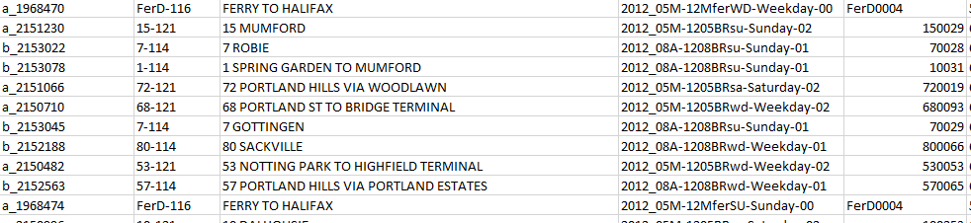

**Figure X:**

While importing data into RDBMS, *shape_id* was allocated with a datatype of *INTEGER*, which led to slow data import times and data truncation.Additionally,since the frequency of entries were high, it still appeared to be valid data. Finally, while importing the data from the *trips* table, *shape_id* was given the datatype of *varchar()* to overcome this scenario.

1. While creating relations among tables in MySQL, the length of the column needed to be specified in order to make it a primary or foreign key. In order to determine the lengths of data entries in *trip_id*, Talend Data Preparation Software was used to display the tables and it was found that they did not exceed 50 characters in length. Thus, the datatype was changed for *trip_id* was changed to *varchar (50)* in both the trips and stoptimes table using MySQL Workbench.

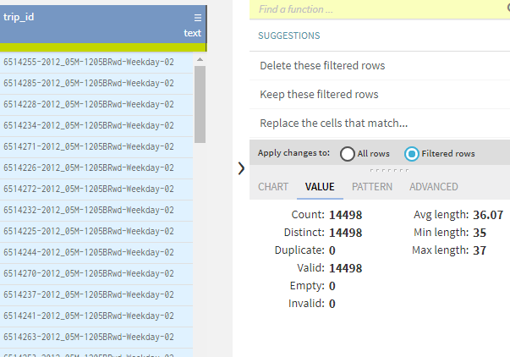

**Figure X:**

1. Finally, the *stoptimes* table had arrival and departure time that exceeded 24 hours and were not compliant with the 24-hour format.

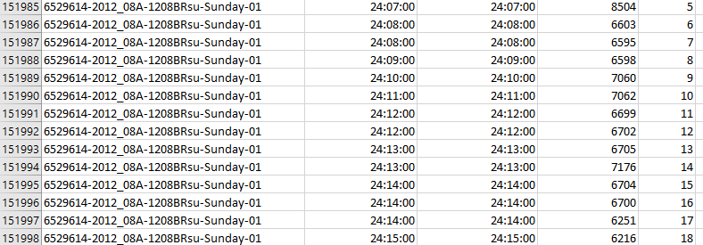

**Figure X:**

The values were replaced and corrected with actual times using a SQL script. Before running the script, the data was imported with a text data type and then it was converted into a ‘*TIME’* datatype and there was no data truncation. The script was run which updated the values of the arrival and departure time in the *stoptimes* table (see below). For example, 25:02:50 would be changed to 01:02:50 (that is 1 AM).

### SQL Scripts:

**The following scripts were used to configure the database:**

* update stoptimes set arrival_time=hour(arrival_time)-23

where hour(arrival_time)>23;

* update stoptimes set departure_time=hour(departure_time)-23

where hour(departure_time)>23;

### Testing:

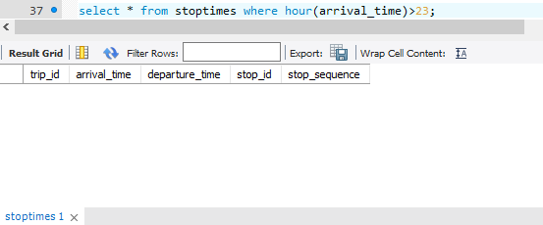

## Elastic Search

put in the github link for ruby script. And explain about it.

# Relational Database

## Entity Relationship Diagram

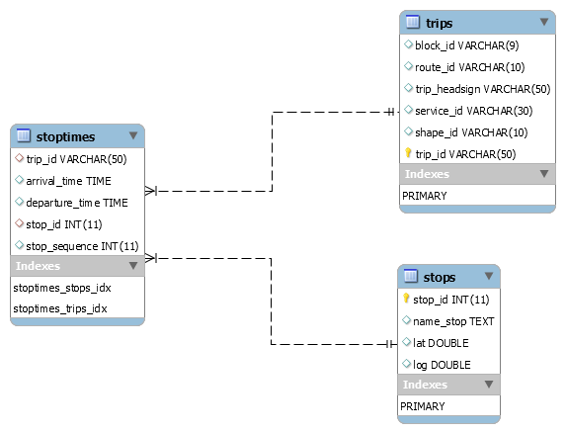

**Figure X:** An ERD diagram depicting the joins and schema.

# Application Queries

## MySQL queries

1. **Query:** select distinct(trip_headsign) from trips

join stoptimes s on trips.trip_id = s.trip_id

join stops s2 on s.stop_id = s2.stop_id

where s2.stop_id =

(select stop_id from stops where name_stop = "south Park St [northbound] after South St");

1. **Query:** select distinct(trip_headsign) from trips

join stoptimes s on trips.trip_id = s.trip_id

where s.arrival_time between "18:00:00" and "22:00:00";

1. **Query:** select trip_id,name_stop,route_id,trip_headsign,arrival_time,departure_time,

stop_sequence,lat,log from trips

join stoptimes using(trip_id)

join stops using(stop_id)

where trip_headsign="330 HALIFAX" and route_id="330-114";

1. **Query:** select count(route_id) as BD,name_stop from trips

join stoptimes using(trip_id)

join stops using(stop_id)

group by stop_id

order by BD desc limit 3;

## 

## Elastic Search Queries

1. **Query:**

{

"query": {

"has_child": {

"type": "stoptimes",

"query": {

"bool": {

"must": [

{

"match": {

"name_stop": "south Park St [northbound] after South St"

}

}

]

}

}

}

},

"size":0,

"aggregations": {

"distinct": {

"terms": {

"field": "trip_headsign"

}

}

}

}

1. **Query:**

{

"query": {

"has_child": {

"type": "stoptimes",

"query": {

"range" : {

"arrival_time" : {

"gte": "18:00:00",

"lte": "22:00:00",

"format": "HH:mm:ss"

}

}

}

}

},

"size":0,

"aggregations": {

"distinct": {

"terms": {

"field": "trip_headsign"

}

}

}

}

**C:**

{

"query": {

"has_parent": {

"parent_type": "trips",

"query": {

"bool": {

"must": [

{

"match": {

"trip_headsign": "330 HALIFAX"

}

},

{

"match": {

"route_id": "330-114"

}

}

]

}

}

}

}

}

**D:**

{

"size": 0,

"aggs": {

"group_by_state": {

"terms": {

"field": "stop_id",

"size" : 3

},

"aggregations": {

"top_three_busy_stops": {

"top_hits": {

"_source": {

"includes": [ "name_stop" ]

},

"size" : 1

}

}

}

}

}

}

# Test Results

## MySQL

1. This query stated to print out the buses that pass through a particular bus stop. I have chosen bus stop name ‘south Park St [northbound] after South St’.

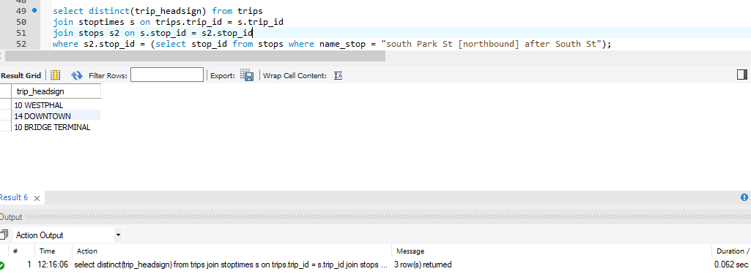

**B.**

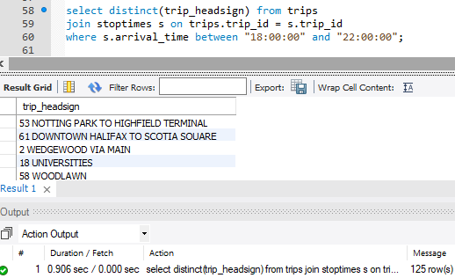

**C.**

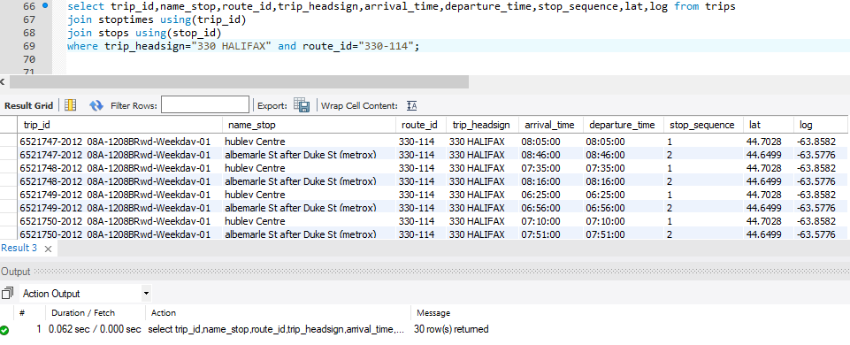

**D.**

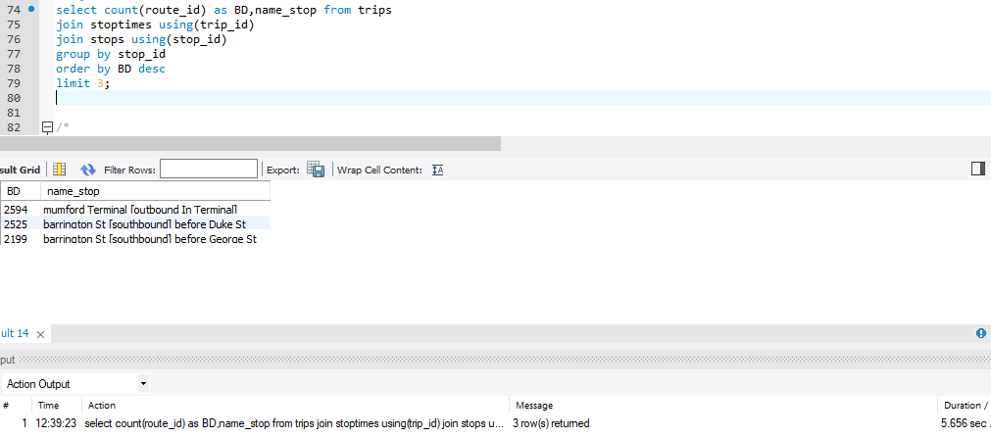

## Elastic Search

## **A.**

## 

## **B.**

## 

## **C.**

## 

## **D.**

## 

## 