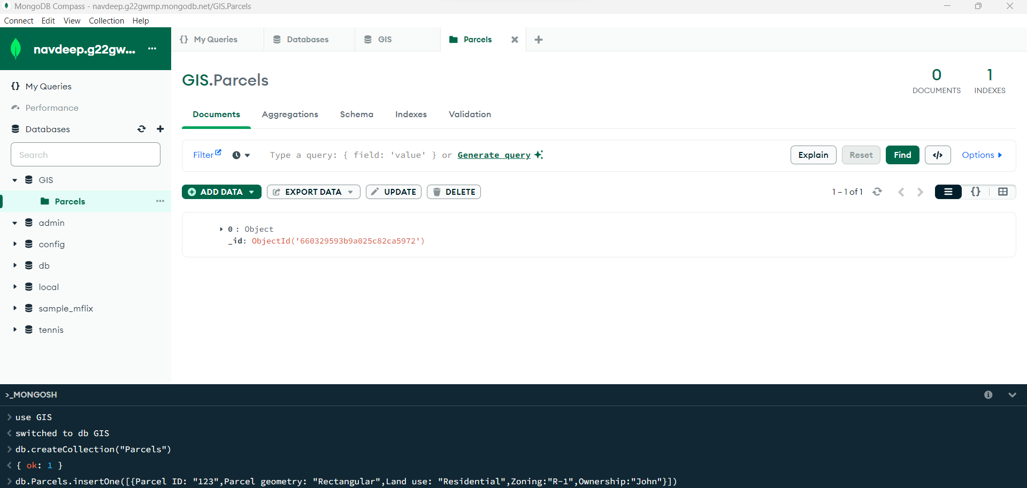

Figure 1: In this I have created the database according to my project and I have given the database name to it that is: - GIS, furthermore I created a collection named Parcels. Moreover, I inserted one document using insert One.

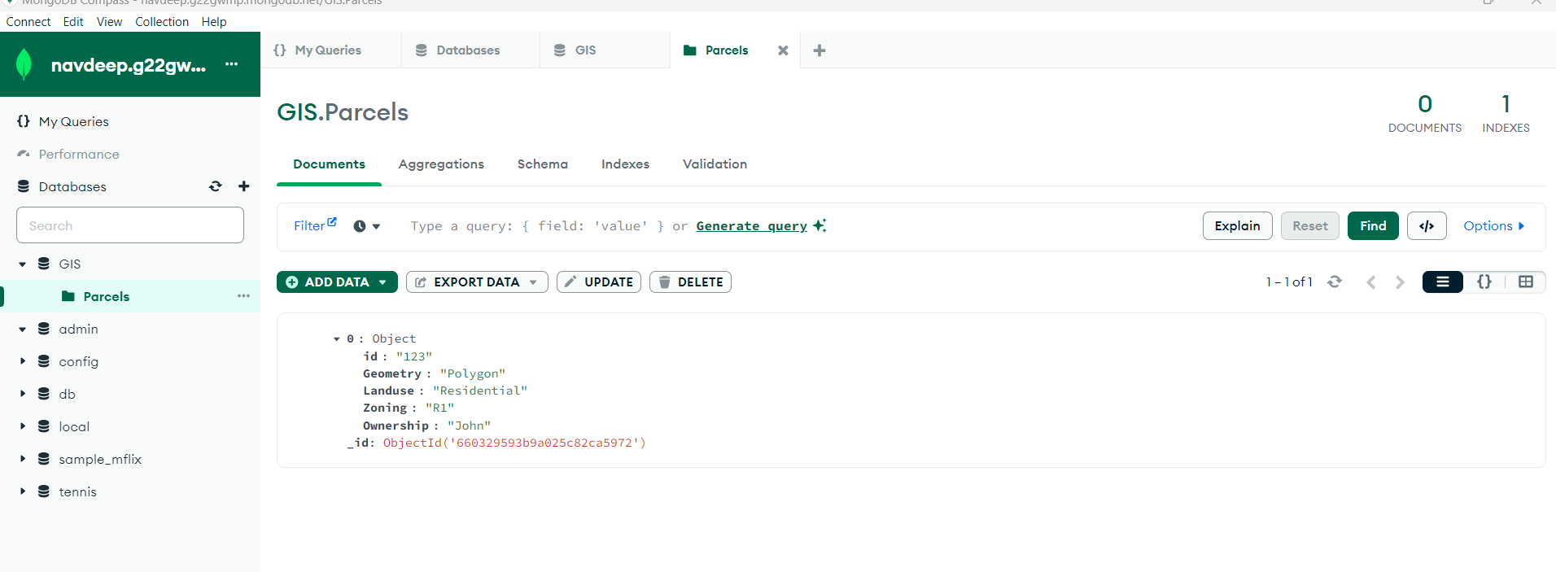

Figure 2:- here it is shown that the details are appeared when I run the insert one command.

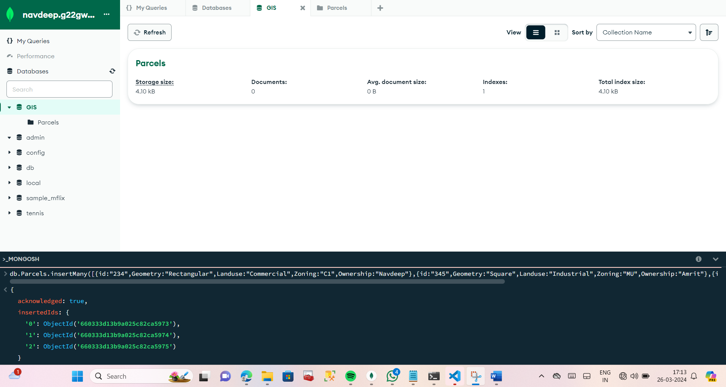

Figure 3: - I have used insertMany command and inserted 3 documents at a time.

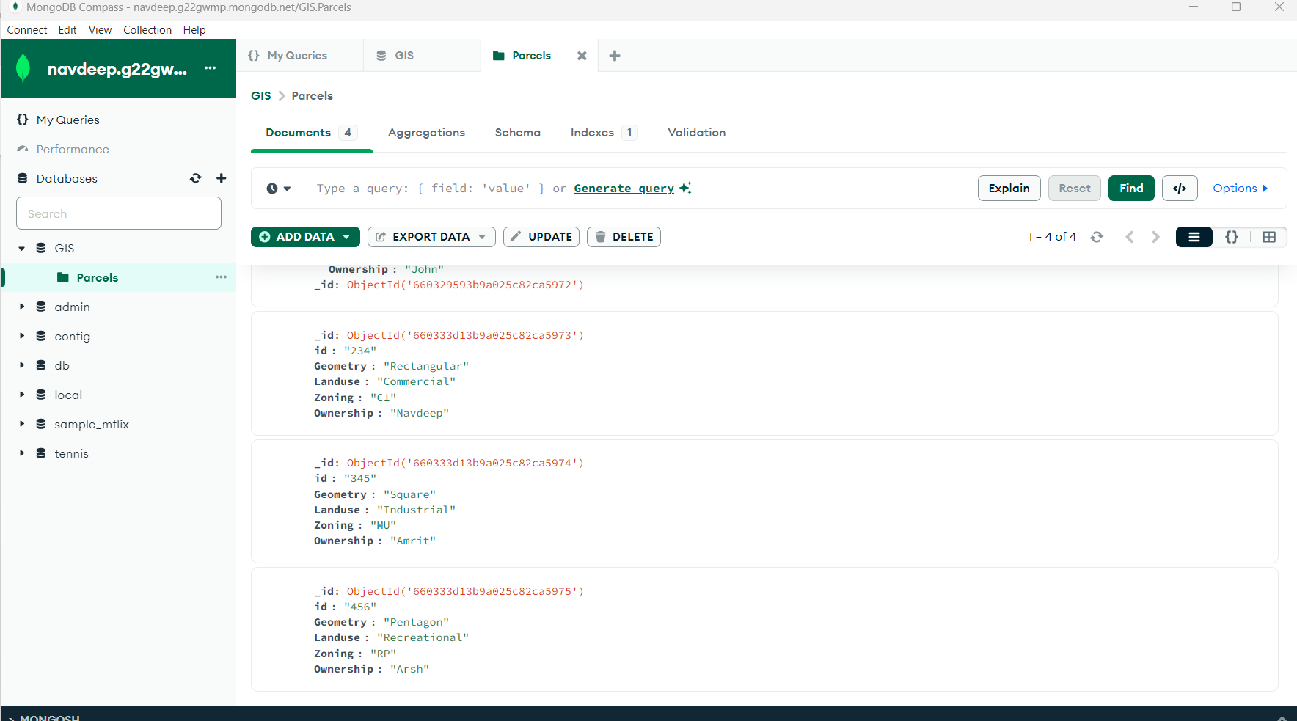

Figure 4: - the results of Insert Many

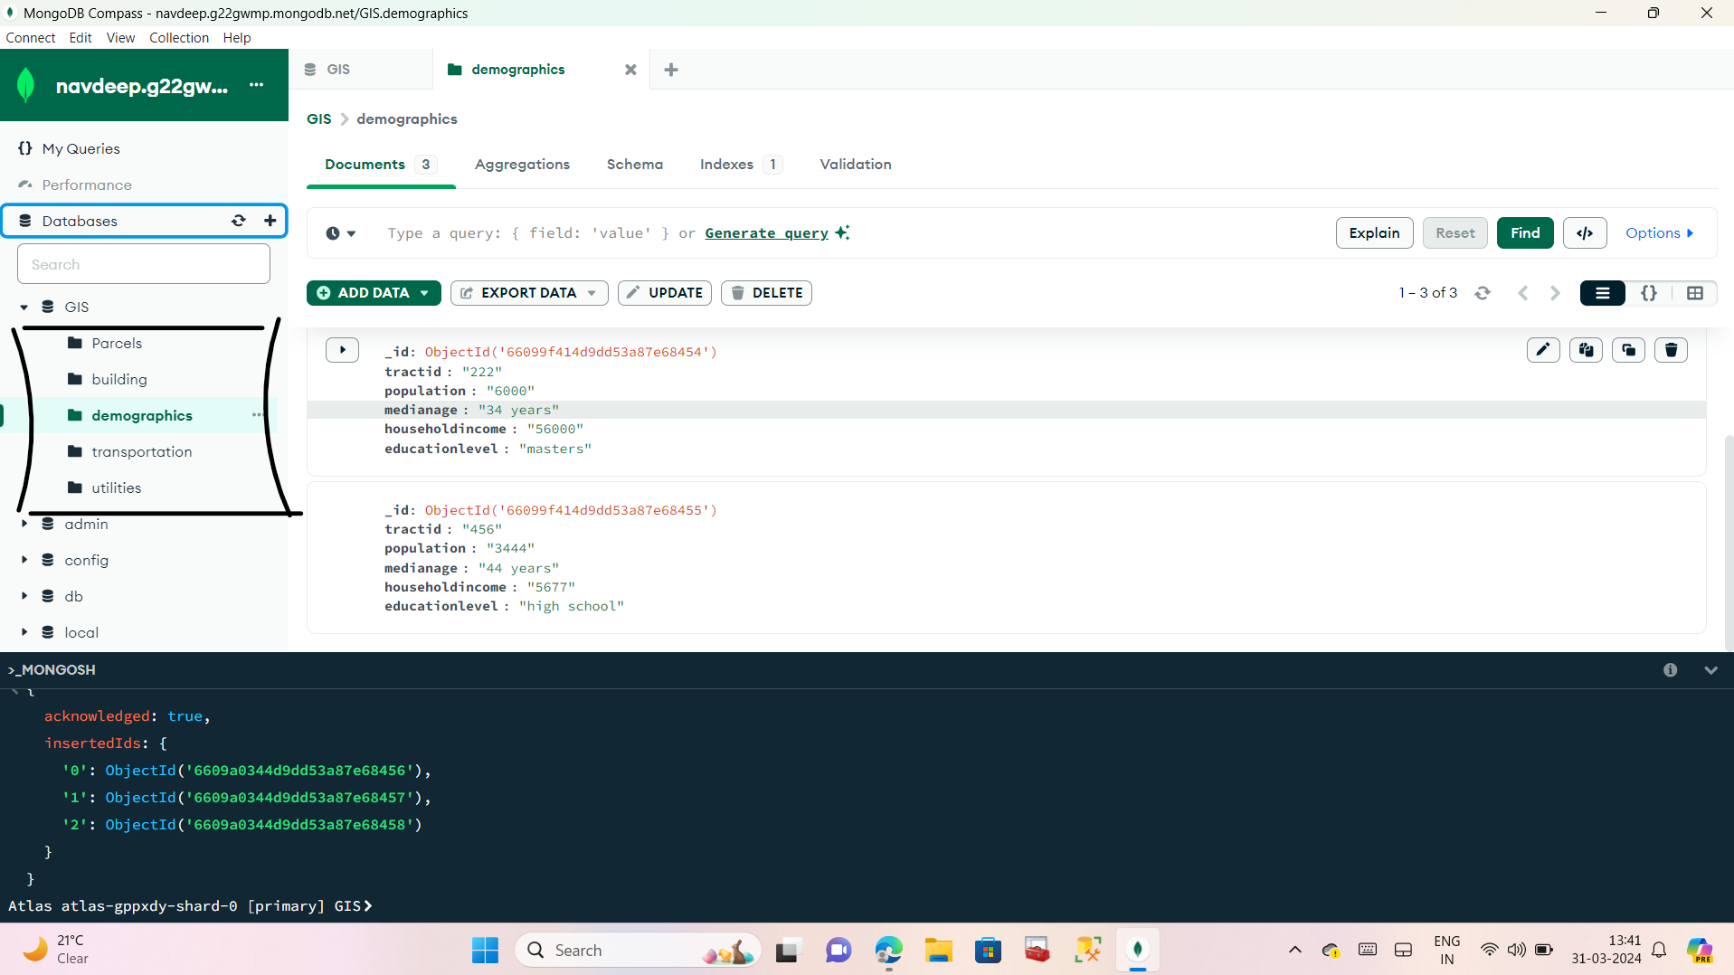

Figure 5: - here the screenshot is pasted to show that I have made all the 5 collections for my database. Also I have entered all the data in the collections.

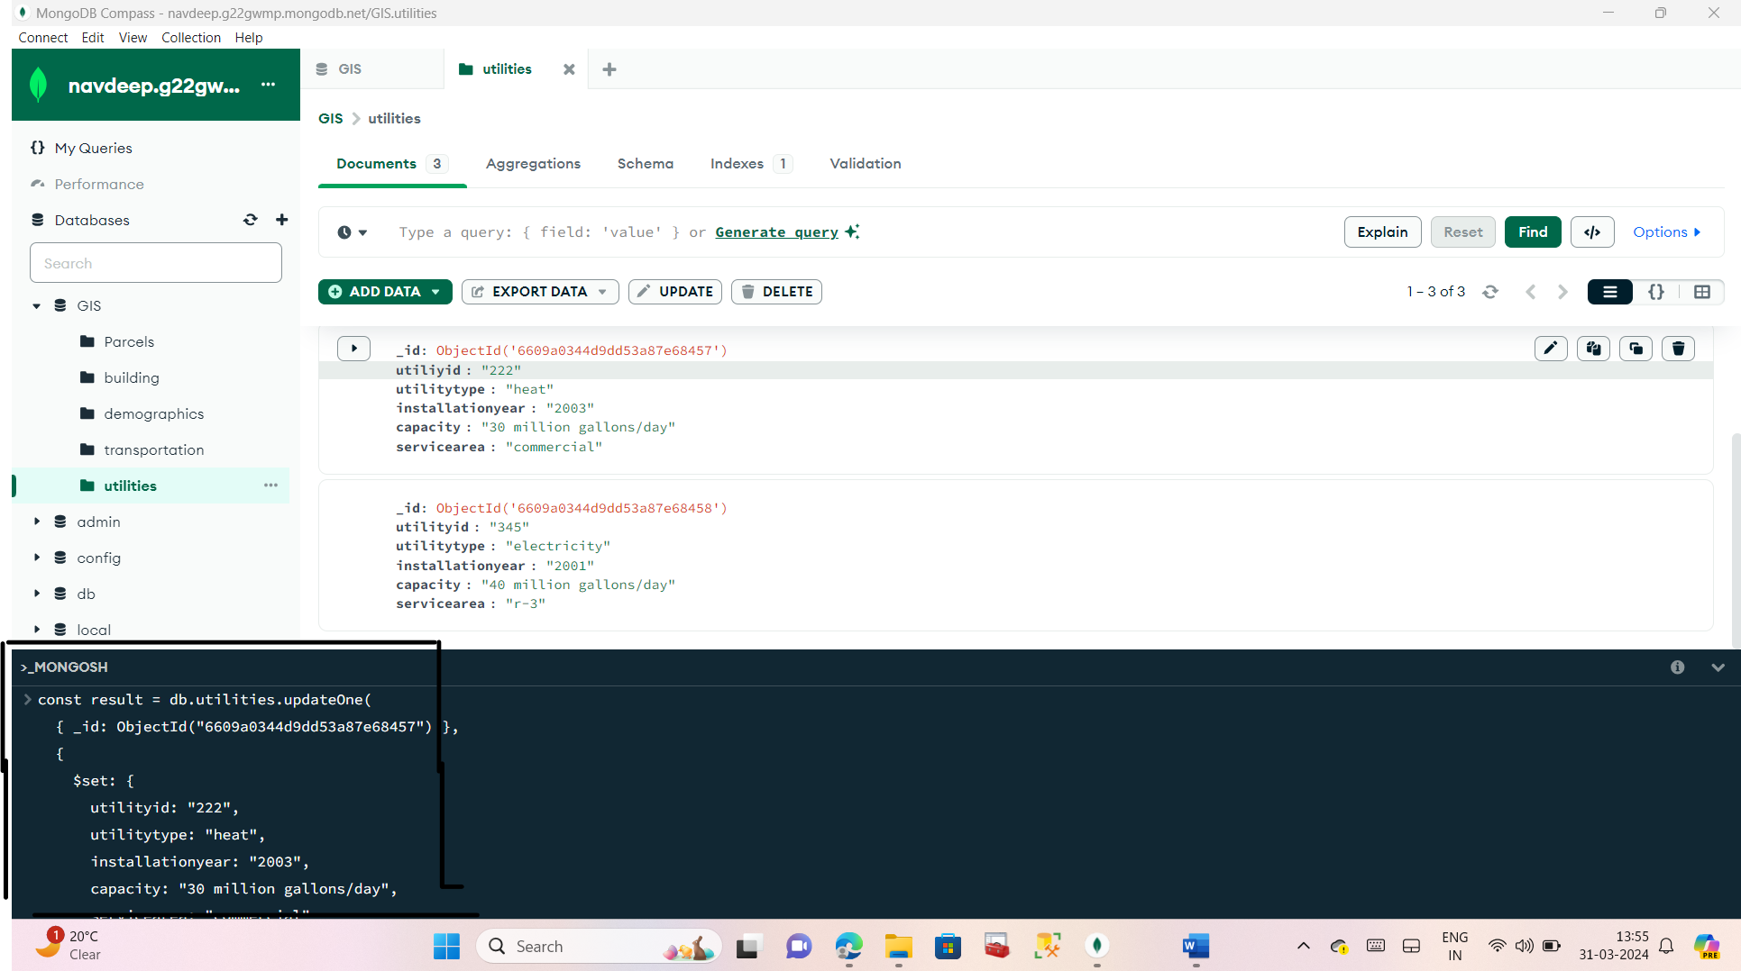

Figure 6: - Update one is used

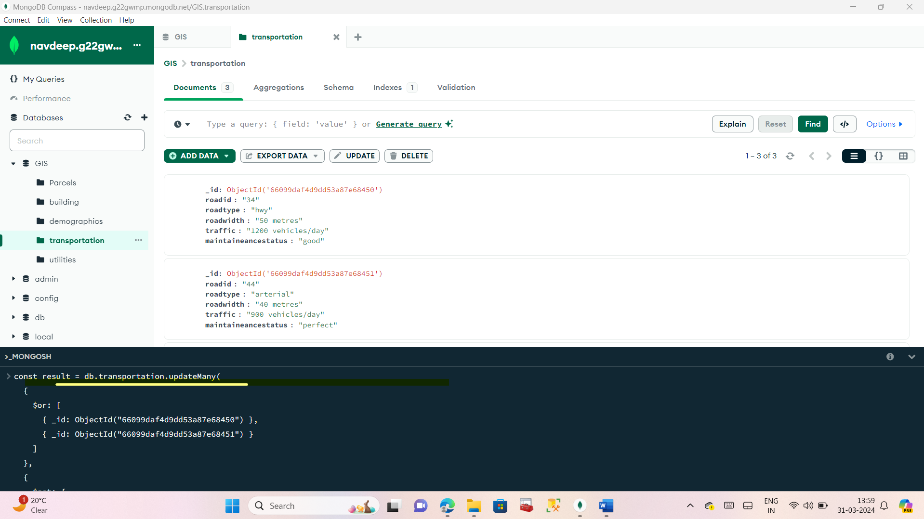

Figure 7: - updatemany is used

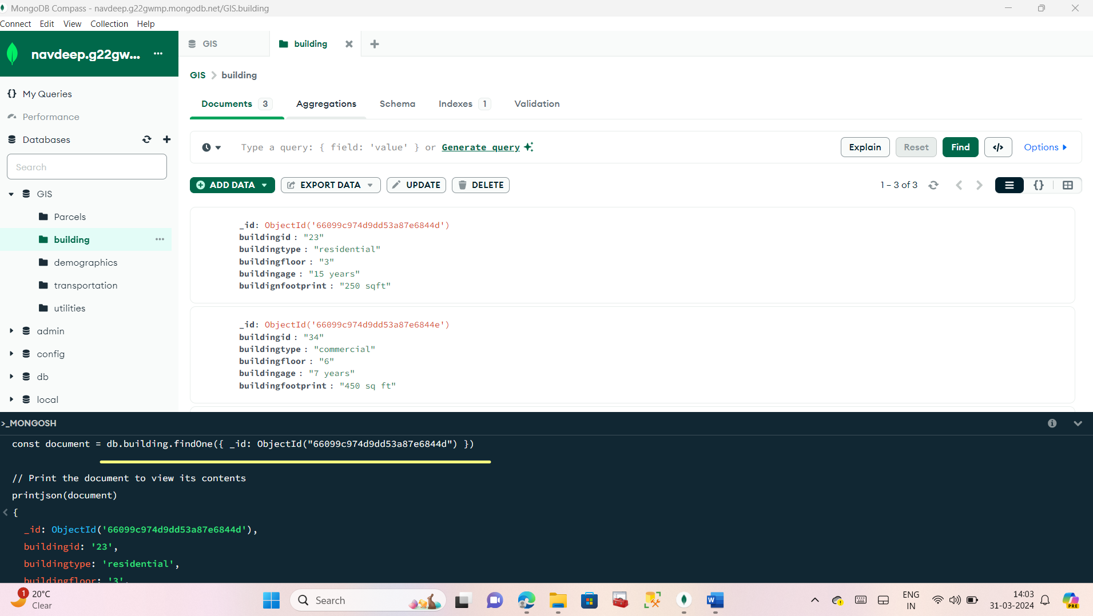

Figure 8: - find one is used

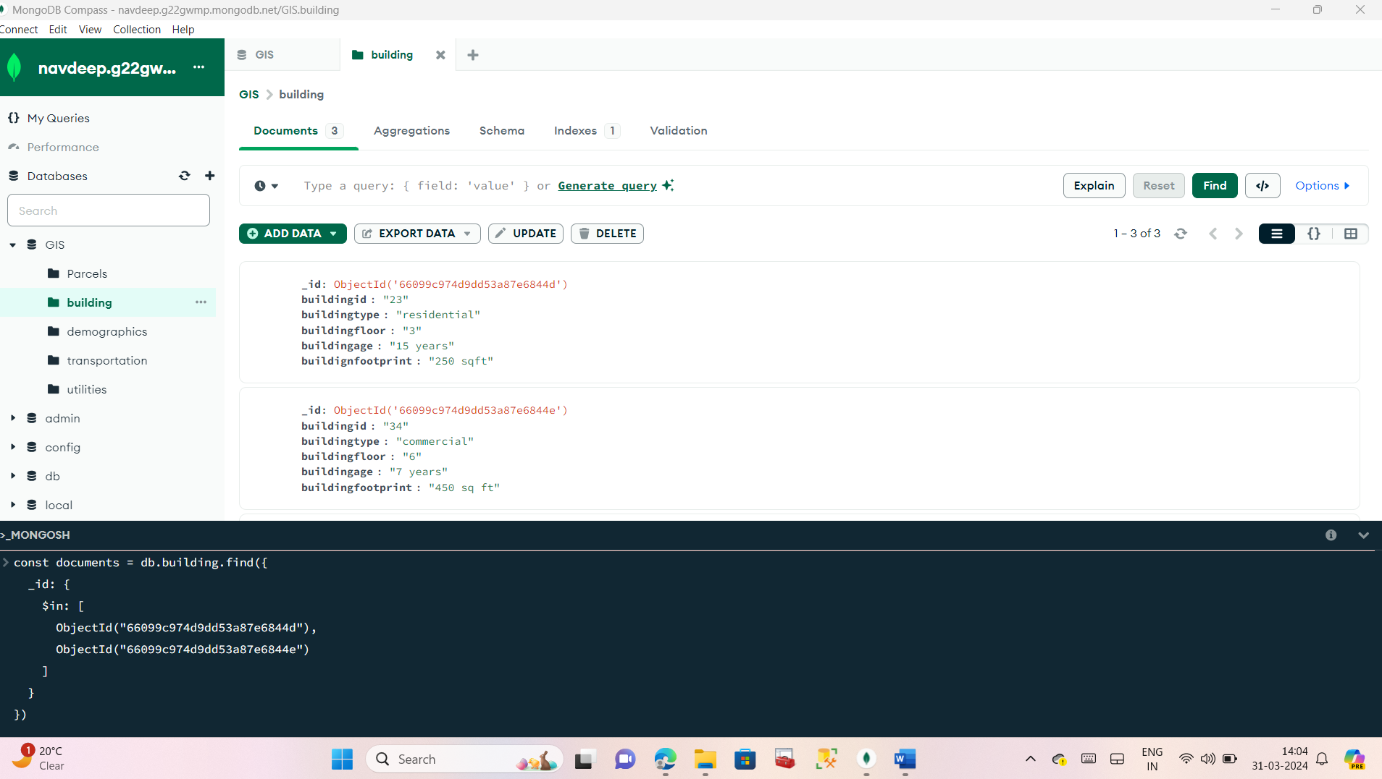

Figure 9: - find many is used

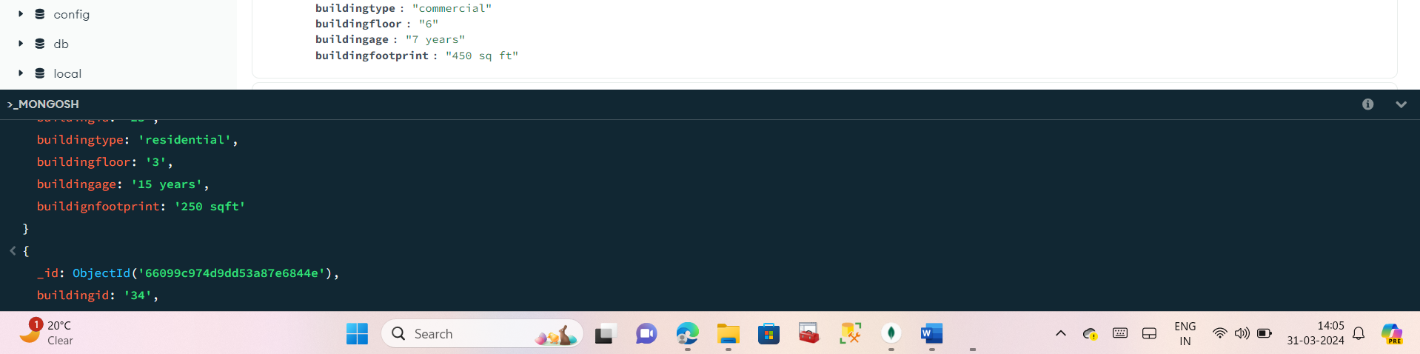

Figure 10: - result of find many

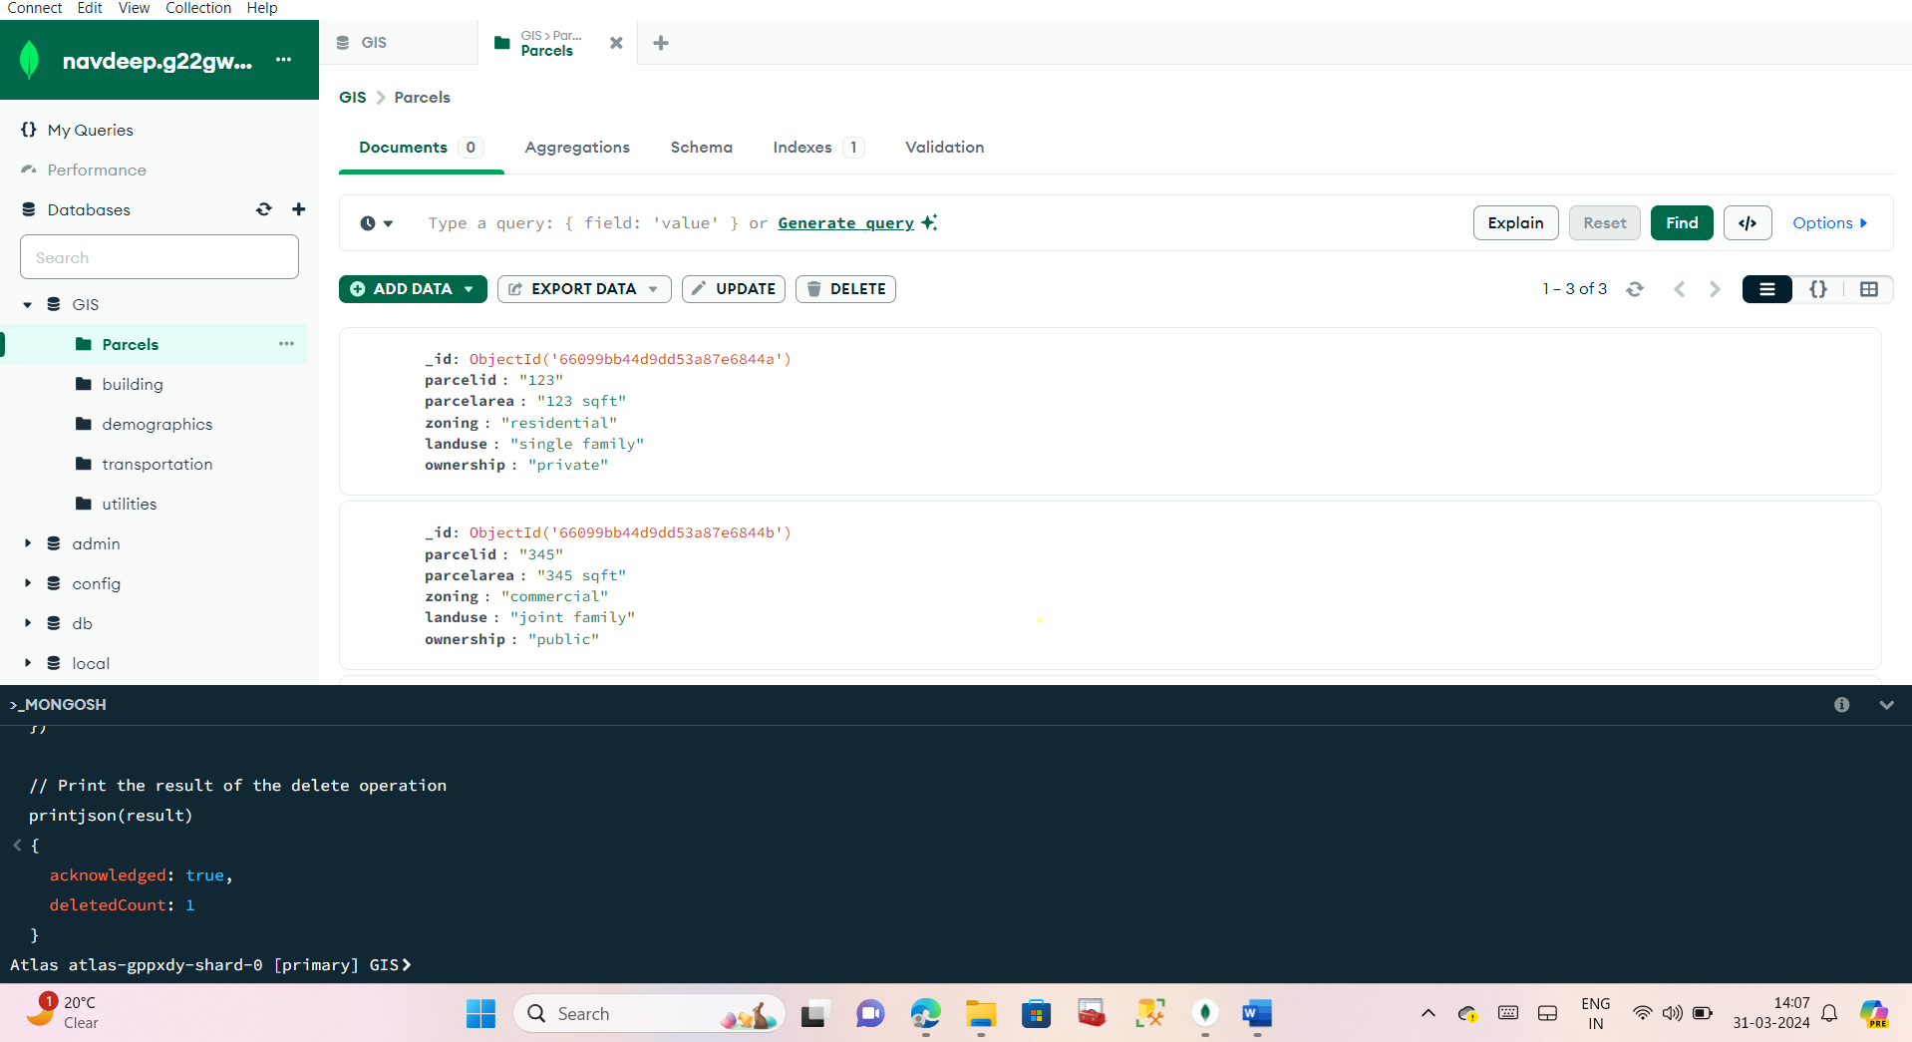

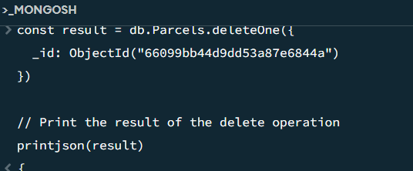

Figure 11(a) and(b): - delete one is used

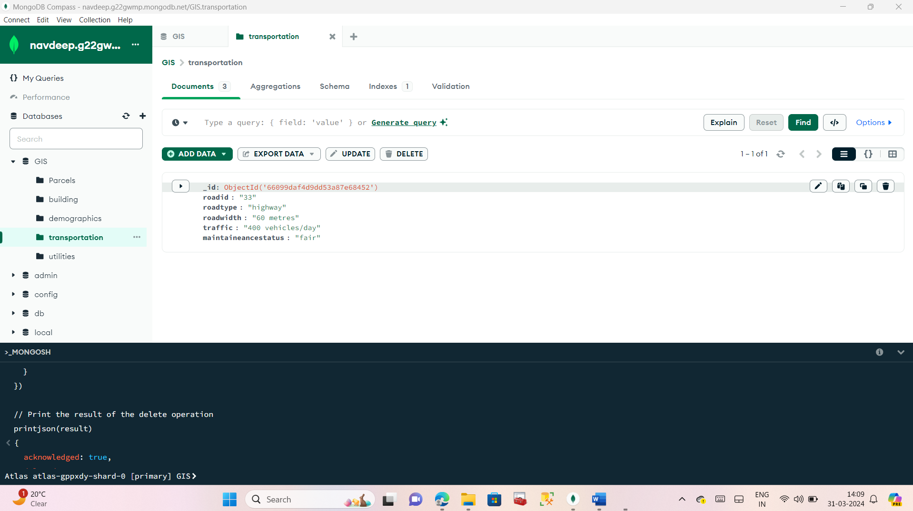

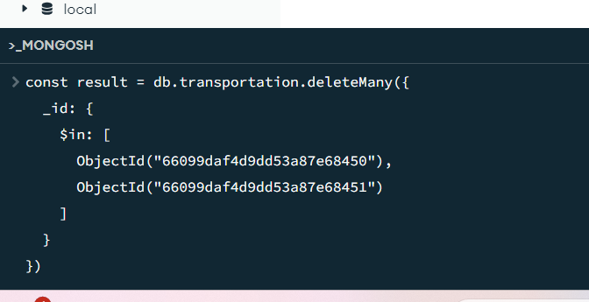

Figure 12(a)and(b) delete many is used

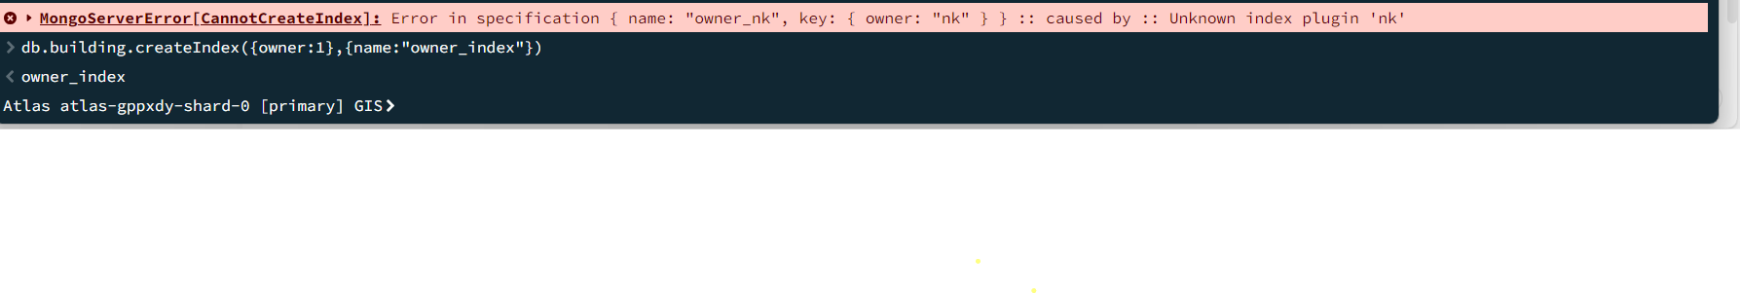

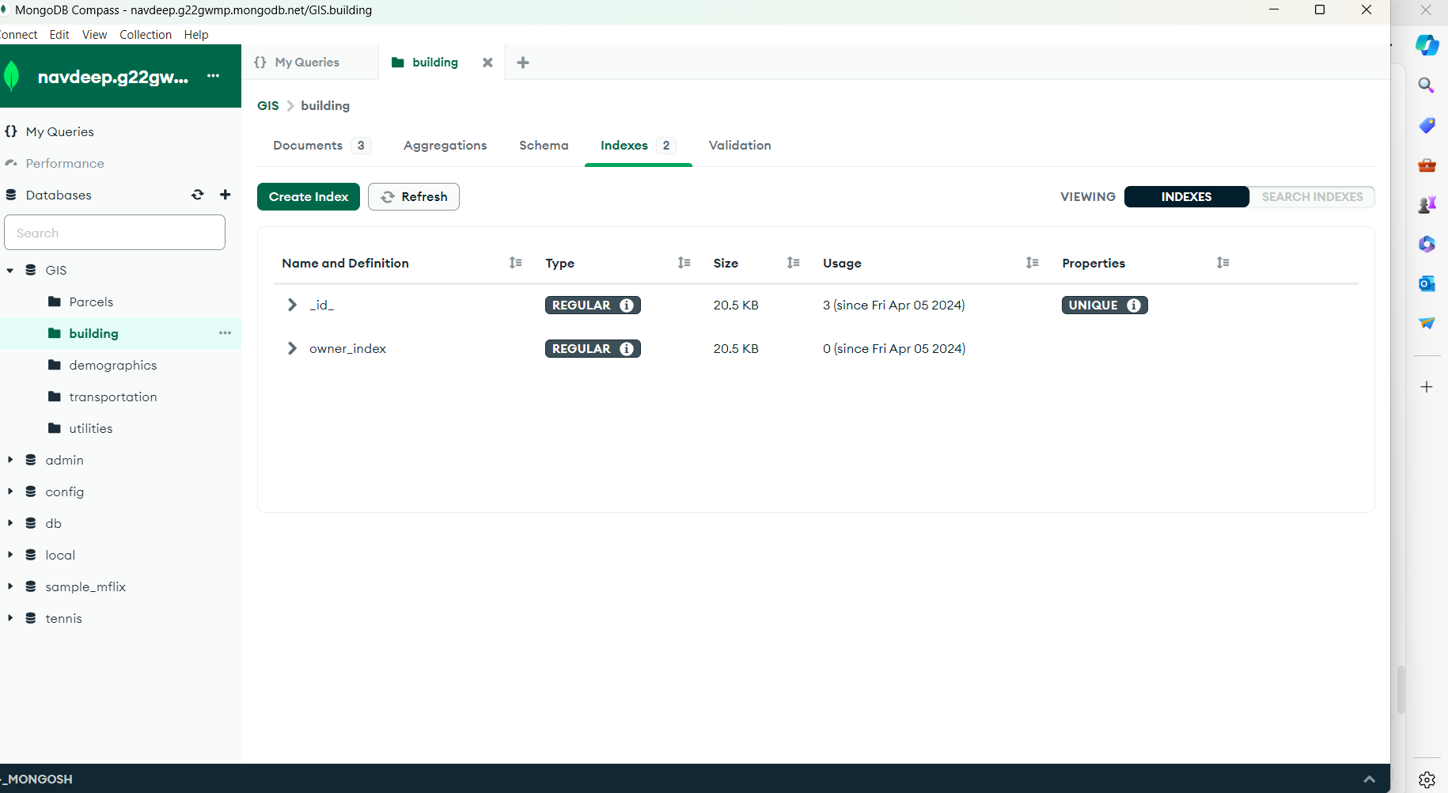

Figure 13(a) and (b) shows that I have created an index in the building collection.

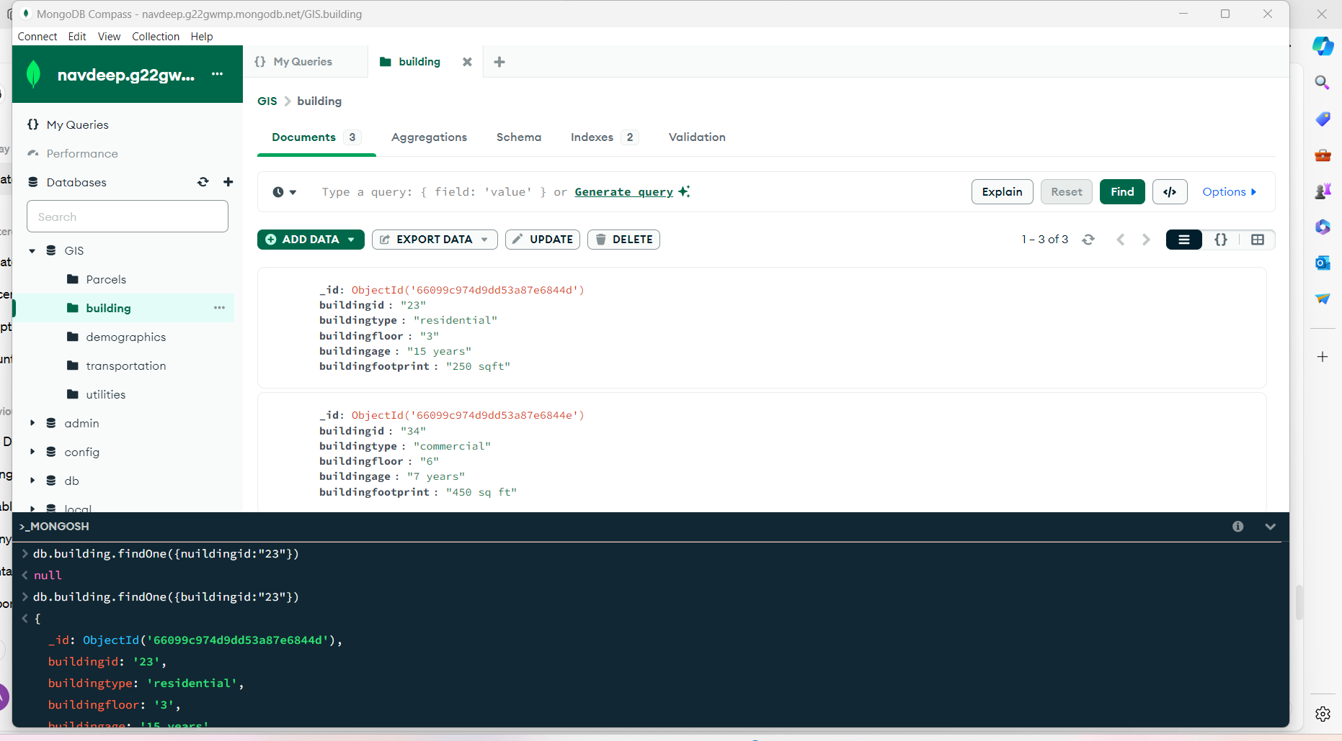

Figure 14 here I have executed the find query to again check the execution status.

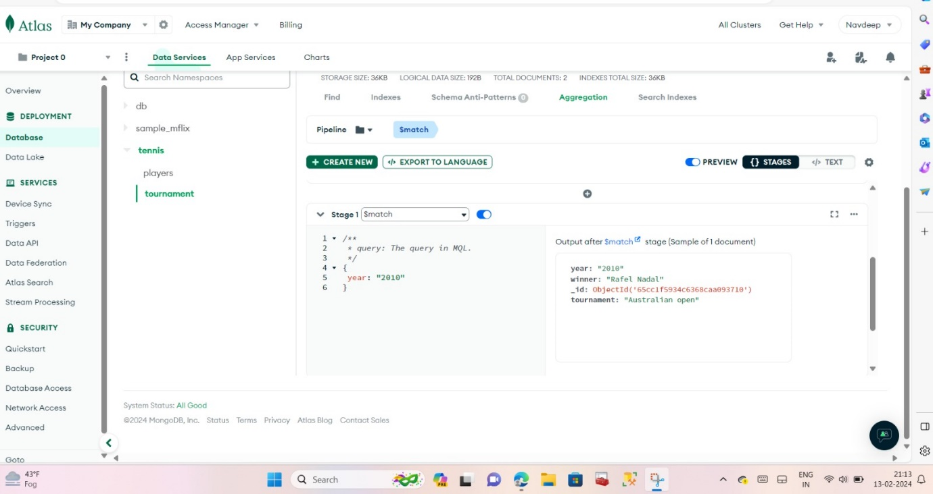

Match command

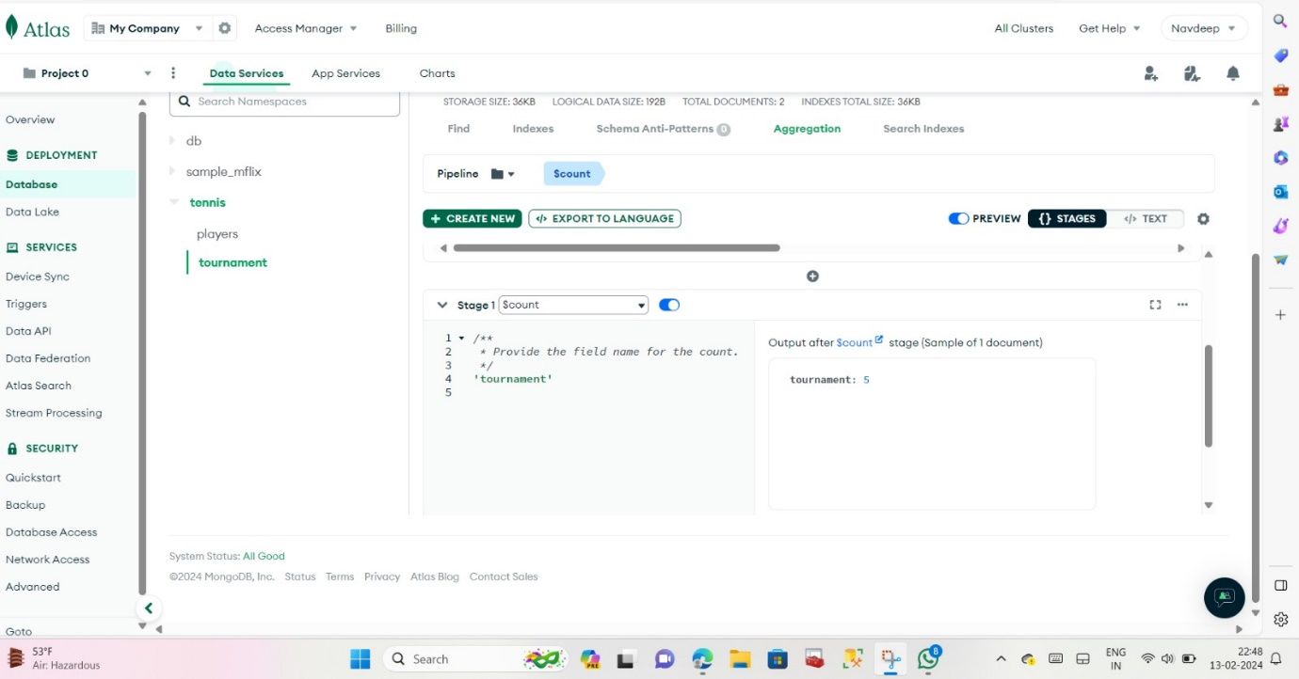

Count command

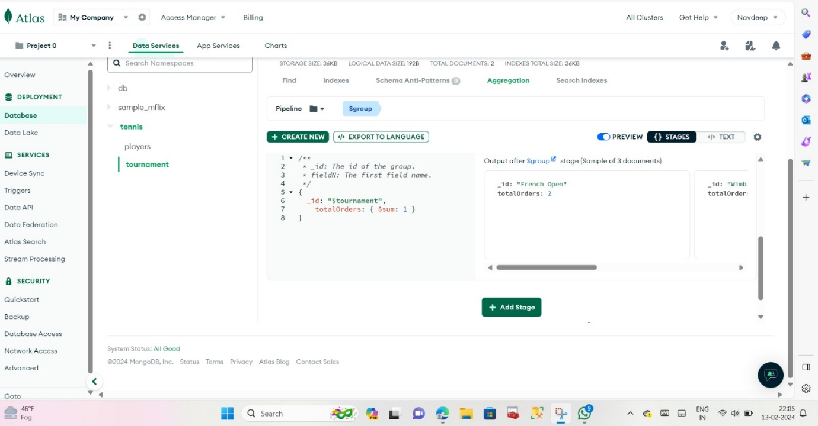

Group command

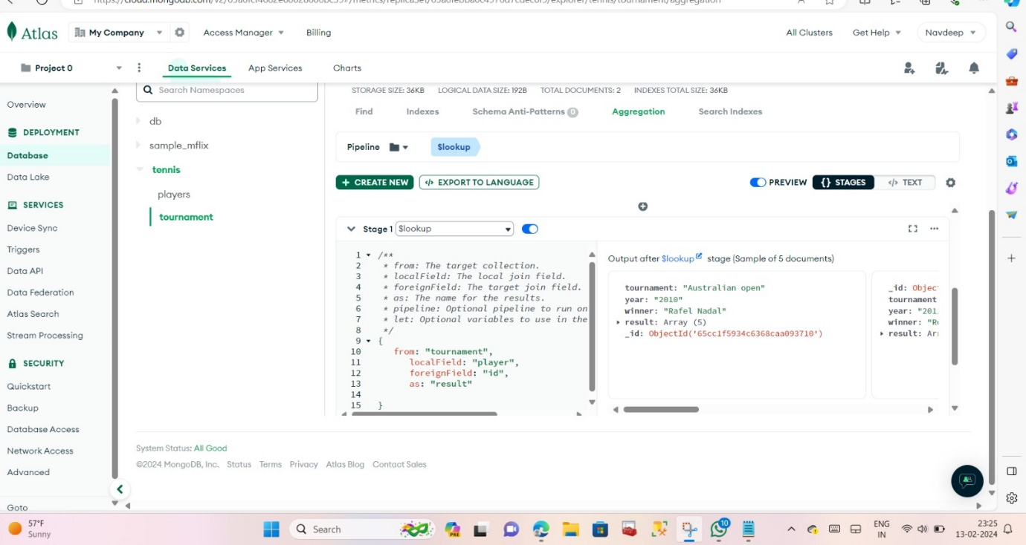

Lookup command

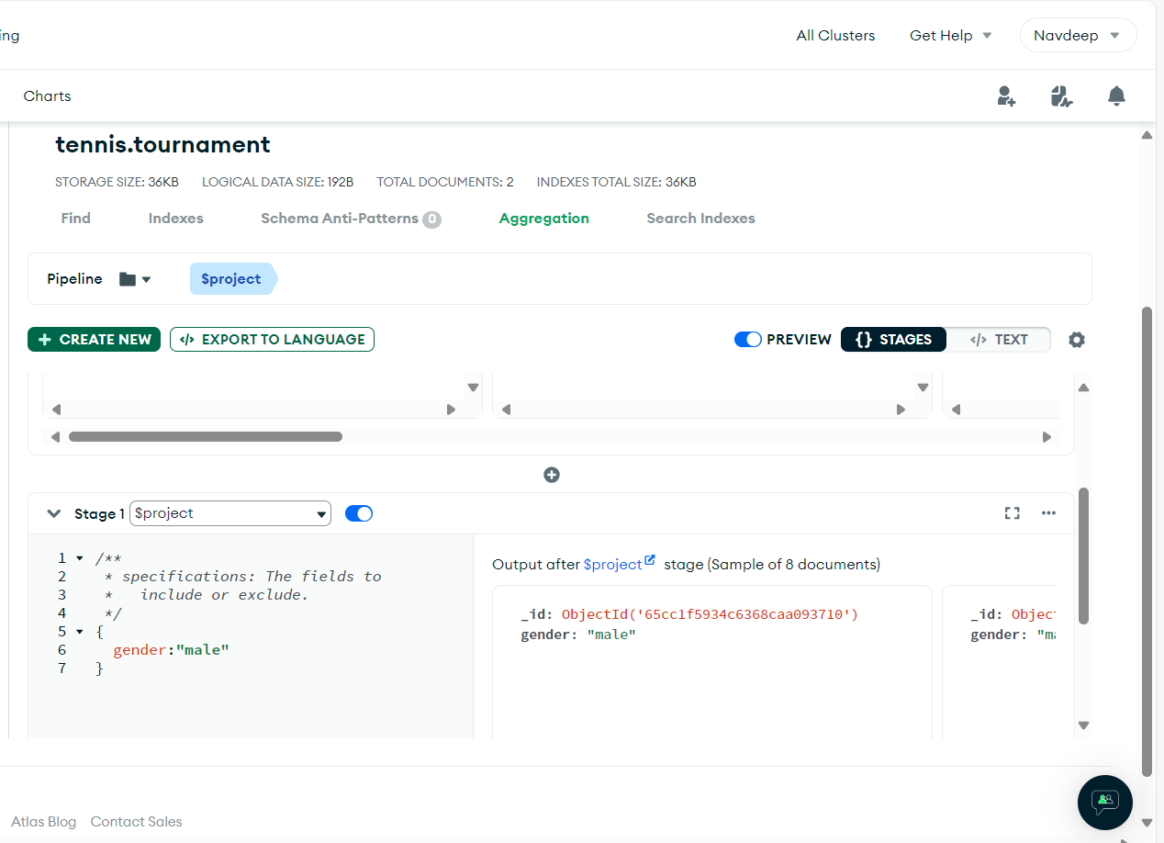

Project command

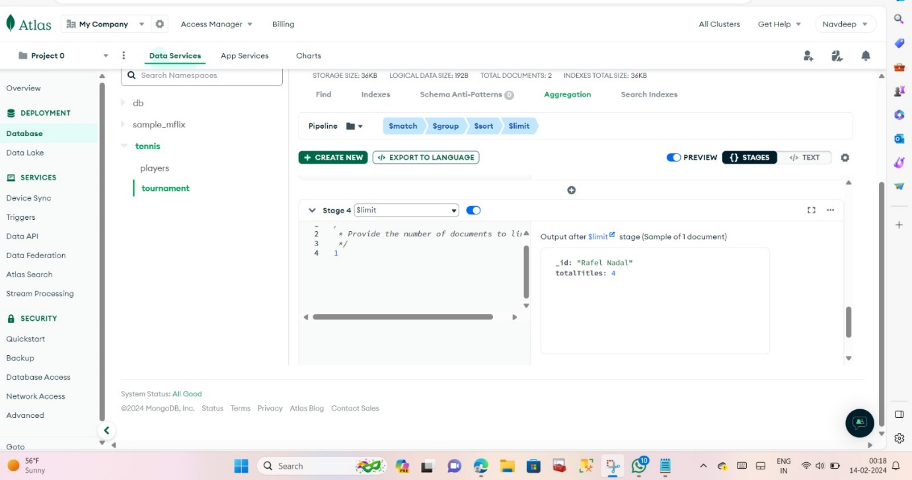

Match group sort and limit are used

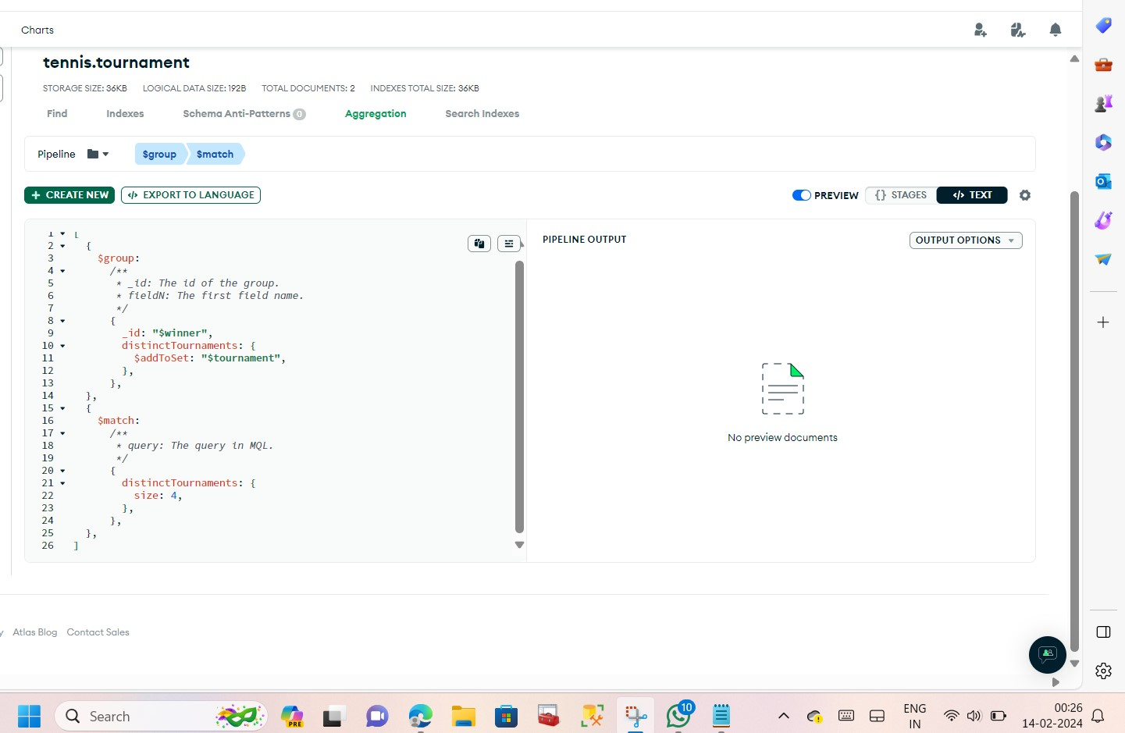

Group and match are used