Hands – On Lab Workshop 1

# Survey Form

Using HTML and CSS (inline and internal) only, create a survey form as in the given figure:

GitHub Link: <https://github.com/Navn-eet/Internet-Software-Architecture/tree/main/Navneet_Workshop/Workshop1/Task1>

Create a simple web page which must include the following sections:

1. Logo
2. Navigation Menu (Home, About, Service, Contact)
3. Search Box and icon
4. Heading Text
5. Use of <p> and <span> tag with different styling
6. Button
7. Form
8. Social media icons
9. Footer section
10. Background image

GitHub Link:

<https://github.com/Navn-eet/Internet-Software-Architecture/tree/main/Navneet_Workshop/Workshop1/Task2>

# XAMPP Control Panel

Download and install Xampp Server on your computer and run the web page build in question 1 and 2 using localhost. See the difference between running a page with localhost and directly.

Task 1:

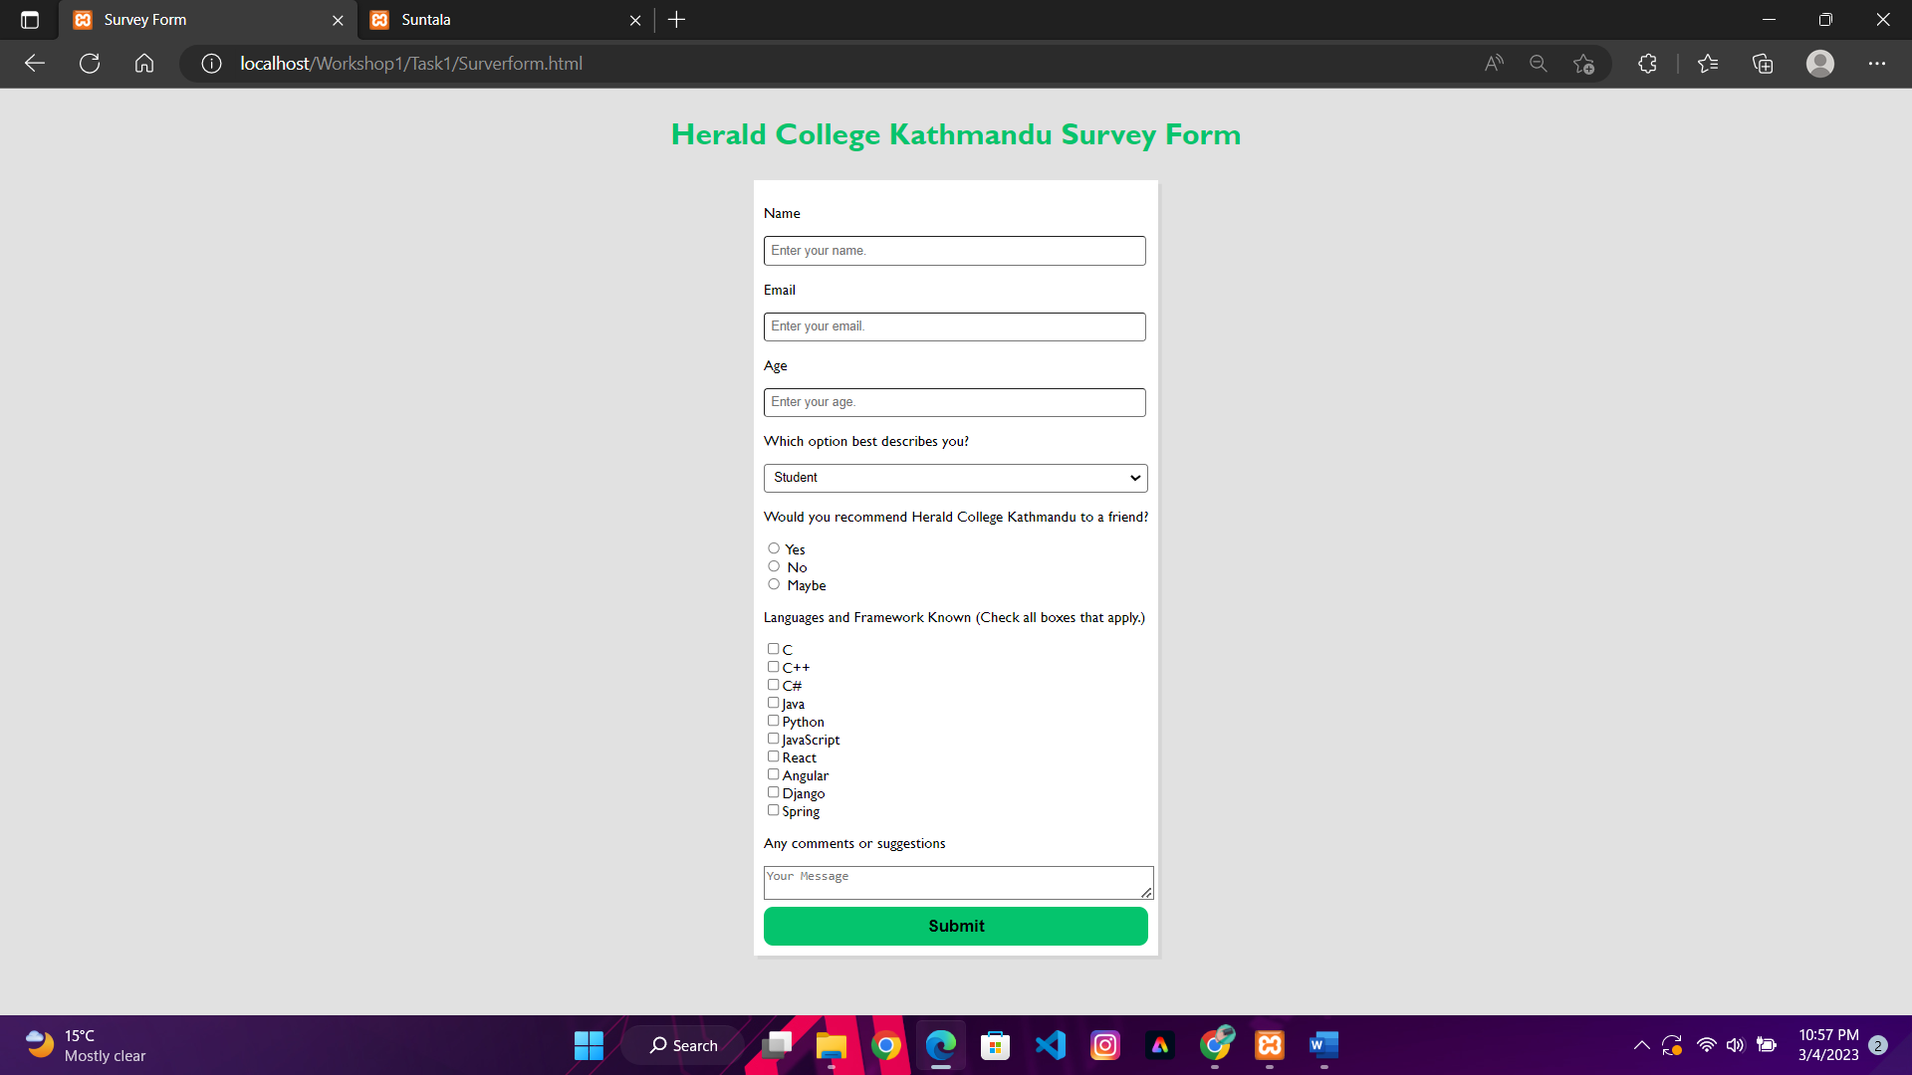

Task2:

🡪

When opening a website on an XAMPP Apache server, the font sizes and image sizes appear different than intended because the CSS file that specifies the font and image sizes does not load properly, leading to the default settings being applied. While opening the website as an HTML file directly in a web browser ensures that the CSS file is more likely to load correctly and that the font and image sizes are displayed as specified in the CSS.

# Web Performance Visualization

For the created web pages, visualize the web performance using devtools, following the steps:

1. After running the file in the browser, right click on mouse and go to inspect
2. Check the network and performance options for the visualization

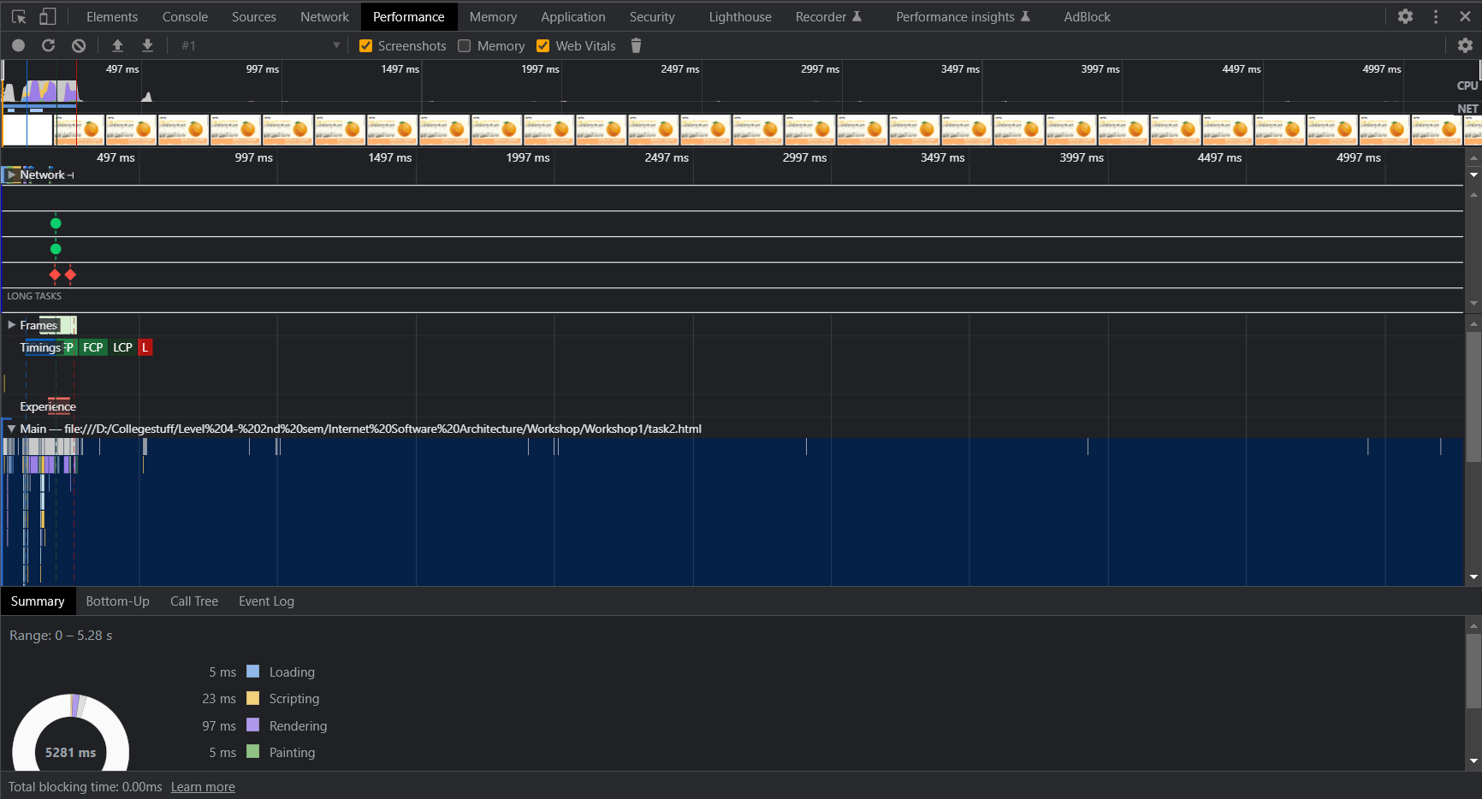

🡪 The website performance data provided indicates that the website took a total of 5.28 seconds (5281ms) to fully load, with the majority of time spent in the idle state (5046ms). This prolonged idle time raises concerns about potential underlying issues such as slow database queries or network latency, which could be causing delays in page loading. It is important to identify and address the root cause of this issue to optimize website performance.

The rendering process took 97ms, which suggests that the website may have some complexity in its design and structure, leading to delays in rendering. Similarly, the scripting process took 23ms, indicating that the website may have some inefficiencies in its code. Optimizing the code can help reduce the time it takes to execute scripts, thus improving the website's performance.

The system took 106ms, which may indicate that the server or network may have caused delays in processing requests. It is crucial to optimize network speed, database queries, and server processing to improve the overall performance of the website.

On the positive side, both loading and painting took only 5ms, indicating that there may be no significant issues with the website's resources, such as images, videos, or other multimedia content. These resources were likely optimized correctly and did not impact the website's overall performance.