Hands – On Lab Workshop 2

*Note: It is mandatory for all students to draw the diagram in drawing tools as well as in a A4 paper describing the flow of each diagram in a paragraph.*

# Activity Diagram

* 1. Using an activity diagram, describe the process of student enrollment in an University.

Steps:

Step 1: Enter Student Information.

Step 2: University Verifies Student Information.

Step 3: Requirement meet minimum criteria.

* If yes then University sends Offer letter and moves on step 4.
* If no then admission is rejected.

Step 4: After university sends offer letter, university waits for a response.

* + If student responds in time, it moves to step 5. If the student doesn't respond, a second verification mail is sent.
  + If the verification mail gets a positive response, it moves to step 5 else the process ends there.

Step 5: Payment Verification

Step 6: Create student record.

Step 7: Enroll student.

Step 8: Admission procedure ends.

* 1. Consider the scenario of Order Processing. Once the order is received, the activities split into two parallel sets of activities. One side fills and sends the order while the other side handles the billing. On the Fill Order side, the method of delivery is decided conditionally. Depending on the condition either the Overnight Delivery activity or the Regular Delivery activity is performed. Finally, the parallel activities combine to close the order. With activity diagram, describes the processing of ordering.

🡪

Steps:

Step 1: Order Processing.

Step 2: Select Items to order.

Step 3: Ask user if they want to load more items.

* If yes, Go back to step 2.
* If no continue to step 4.

Step 4: Ask user to confirm Final Order.

Step 5: Now We have 2 tasks running parallelly.

Step 6:

Task 1:

🡪 Fill Order:

🡪 Select the type of delivery.

* Type 1: Overnight.
* Type 2: Regular Delivery.

🡪 Select Address.

Task 2:

🡪Billing of Order:

🡪Select the method of payment.

* Type 1: Online Payment.
* Type 2: Cash on delivery.

🡪 Payment Verification.

Step 7: Order placed Successfully.

Step 8: End of Order Processing.

* 1. Show the flow of word processing application software with the help of activity diagram.

🡪

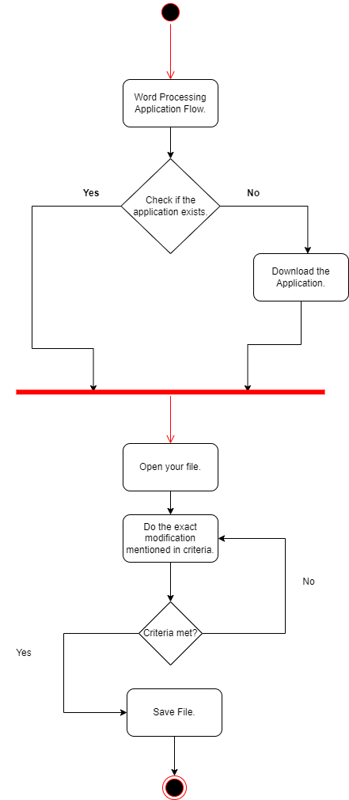

Steps:

Step 1: Word Processing Application Flow.

Step 2: Check if the application exists.

* If yes, then go to step 3.
* If no, Download the application.

Step 3: Open your application.

Step 4: Do the exact modification mentioned in criteria.

Step 5: Check whether the criteria meets or not.

* If yes, then save the file.
* If no, then go back to step.

Step 6: Save File.

Step 7: End

# Sequence Diagram

* 1. Consider a Library Management System. Using sequence diagram, show the interaction of objects in the system to perform the function ‘Create new library user accounts.

Flow:

Step 1: The user clicks on the signup button to initiate the signup process.

Step 2: When the user clicks on the signup button, the signup form is opened.

Step 3: The user enters their name.

Step 4: The user enters their preferred username.

* If the user enters a username that is already taken, the authentication server displays an error message and prompts the user to enter a different username.
* Else it continues to the next step.

Step 5: The user enters their email.

* If the user enters a email that has been used already, the authentication server displays an error message and prompts the use a different email to signup or login using your old email.
* Else it continues to the next step.

Step 6: The user enters their phone number.

* If the user enters a phone number that is already used, the authentication server displays an error message and prompts the user to enter a different number or log in using the previous number.
* Else it continues to the next step.

Step 7: The user is asked to create a password.

* If the user's password does not meet the criteria of 8 digits, an upper case letter, and a symbol, the authentication server displays an error message and prompts the user to enter a password that meets the criteria.
* Else it continues to the next step.

Step 8: The user is asked to create a password.

* If the user enters a confirmation password that does not match the previously entered password, the authentication server displays an error message and prompts the user to enter the same password again.
* Else it continues.

Step 9: Once the user has entered all their details, the authentication server prompts the user to confirm that all the details are correct.

* If the user confirms that the details are correct, the user's data is stored in the user login database, and a successful page is shown to the user.
* If the user does not confirm that the details are correct, the user is asked to edit the details.
  1. In which sequence does the Online Exam System flow? Describes using sequence diagram.

🡪

Flow:

Step 1: The user navigates to the online exam portal and is prompted to enter their login credentials to access the examination.

Step 2: The user enters their login credentials and submits them to the online exam portal.

Step 3: The online exam portal verifies the user's credentials by checking them against the student records.

* If the credentials match, the online exam portal grants the user access to the examination question database.
* Else, an error message is displayed, informing the user that the login credentials are incorrect, and they cannot proceed to the examination.

Step 4: The user accesses the examination question database and is presented with the questions to answer.

Step 5: The user accesses the examination answer database and inputs their answers.

Step 6: Once the user has answered all the questions, they hit the submit button to submit their answers to the online exam portal.

Step 7: The online exam portal accepts the user's answers and stores them in the examination answer database.

* 1. Represent the School Management System with sequence diagram.

🡪

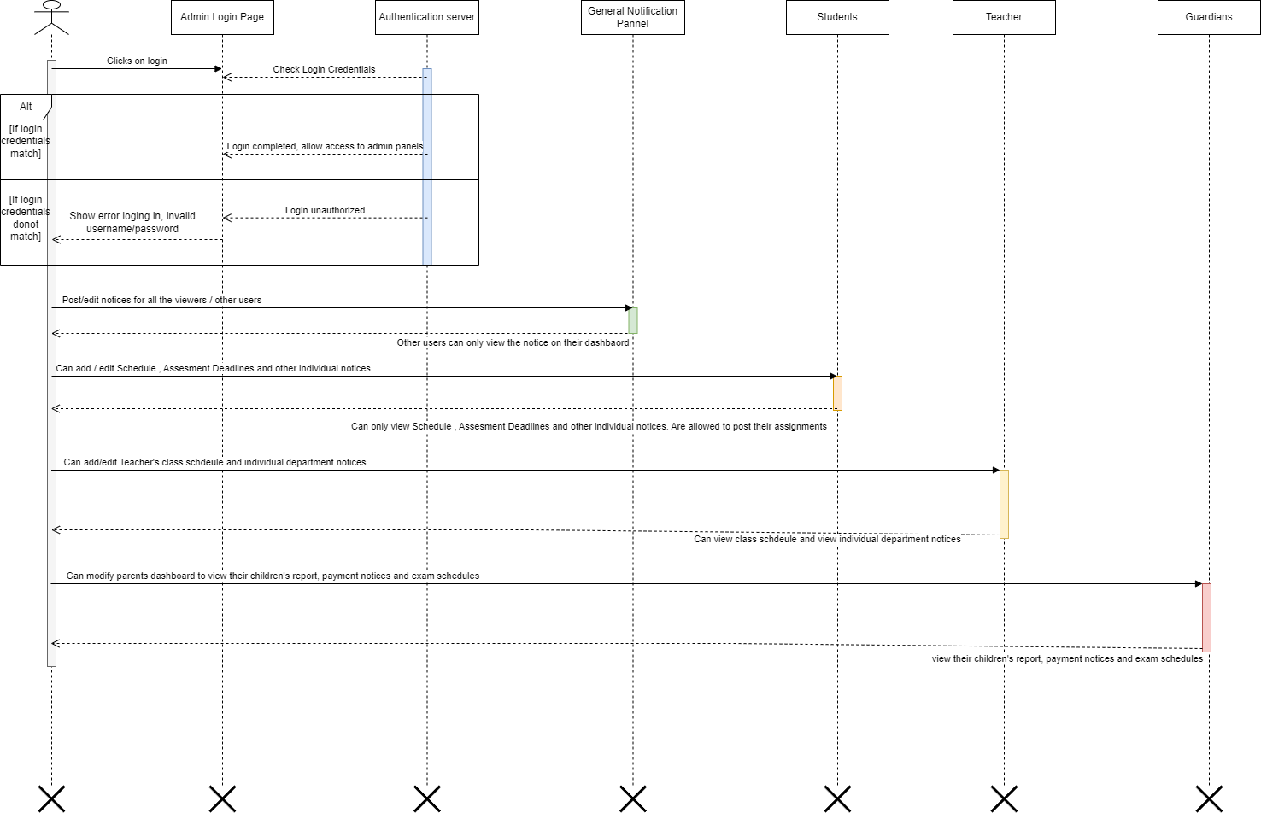

Flow:

Step 1: The actor clicks on the login page and is directed to the authentication server.

Step 2: The actor enters their login credentials (username and password).

Step 3: The authentication server verifies the user's credentials by checking them against the records.

* If the credentials match, the server grants the user admin access, and the user is directed to the admin panel.
* If the credentials do not match, an error message is displayed, informing the user that the login credentials are incorrect, and they cannot proceed.

Step 6: Once the user has admin access, they can post/edit notices for all the viewers/other users in the general notification panel.

Step 7: In the students object, the admin user can add/edit schedules, assessment deadlines, and other individual notices.

Step 8: In the teachers object, the admin user can add/edit teacher's class schedules and individual department notices.

Step 9: In the guardians object, the admin user can modify the parent's dashboard to view their children's reports, payment notices, and exam schedules. Guardians can only view it.

# Deployment Diagram

* 1. Show the necessary nodes, artifacts, associations and components required for Hospital Management System.

🡪

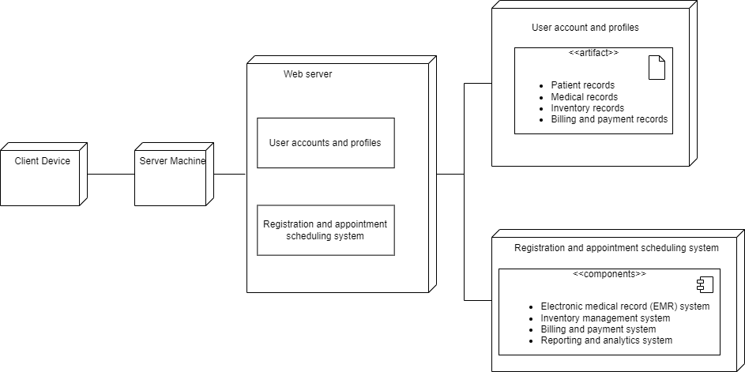

Step 1: The deployment diagram depicts the physical deployment of software components in a hospital management system.

Step 2: The system consists of two hardware nodes: client devices (e.g., desktop computers, laptops, tablets, smartphones) and server machines (e.g., database servers, application servers, web servers).

Step 3: The software components are deployed on the server machines. The components include a registration and appointment scheduling system, an electronic medical record (EMR) system, an inventory management system, a billing and payment system, and a reporting and analytics system. The user accounts and profiles consists of patient records, medical records, inventory records, and billing and payment records are stored in the server machines.

Step 4: The client devices communicate with the server machines through a deployment arrow that connects them.

* 1. Draw a deployment diagram for Hotel Management System.

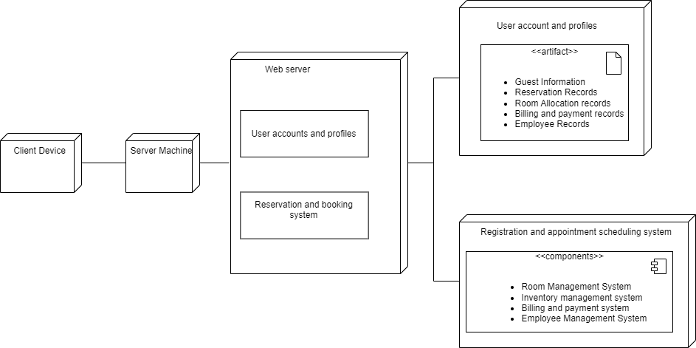

Step 1: The deployment diagram depicts the physical deployment of software components in a hotel management system.

Step 2: The system consists of two hardware nodes: client devices (e.g., desktop computers, laptops, tablets, smartphones) and server machines (e.g., database servers, application servers, web servers).

Step 3: The software components are deployed on the server machines. The components include a room management system, an inventory management system, a billing and payment system, and an employee management system.

The user accounts and profiles consists of guest information, reservation records, room allocation records, billing and payment records, employe records are stored in the server machines.

Step 4: The client devices communicate with the server machines through a deployment arrow that connects them.