**Hands – On Lab**

**Workshop 4**

**SIMPLE CALCULATOR**

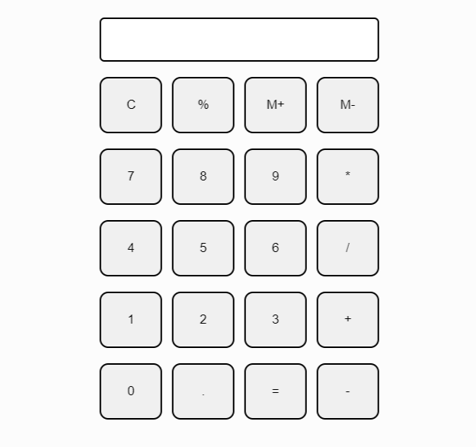Create a UI of calculator using HTML and CSS and perform addition, subtraction, multiplication and division operations. Also handle the errors and exceptions. While clicking on C button, it should clear the textbox.

**Git Hub Link:**

<https://github.com/Navn-eet/Internet-Software-Architecture/tree/main/Navneet_Workshop/Workshop4/Calculator>

**DIGITAL CLOCK**

Create a Digital Clock using setInterval and Date function in JavaScript.

*Note: Date object can be used to get the date, time, hours and seconds which can be updated using setInterval (). Try to keep the UI good looking and different from each other.*

**Git Hub Link:**

<https://github.com/Navn-eet/Internet-Software-Architecture/tree/main/Navneet_Workshop/Workshop4/Clock>

**ASYNCHRONOUS JAVASCRIPT**

1. Create a function called **getFruit** that takes in a fruit name as a parameter and returns a Promise that resolves after 1 second with a message saying "Here is your [fruit]". If the fruit name is "watermelon", the Promise should reject after 2 seconds with an error message saying "Sorry, we're out of watermelons

1. Create a function called **arrayManipulation** that takes in an array of numbers and two callback functions as parameters. The first callback function should perform an operation on each element in the array, and the second callback function should filter the resulting array based on a condition. The function should return the filtered array.

1. Create an asynchronous function called **fetchUserData** that uses **async/await** to fetch user data from a JSON API **(**[**https://jsonplaceholder.typicode.com/users**](https://jsonplaceholder.typicode.com/users)**)**. The function should take in a user ID as a parameter, and use that ID to fetch the user's data from the API. If the API returns an error, the function should throw an error. If the API returns the user data, the function should return an object containing the user's name and email

1. Fetch data from API (<https://jsonplaceholder.typicode.com/todos>) and display (UserId,Title and Status) in a browser whose completed status is true and id<=50

