**Hands on**

**Workshop Week 6**

**Write a Program:**

1. To count 5 to 15 using PHP loop.

Code:

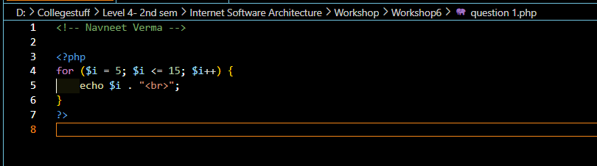

Output:

1. To print “Hello World” using PHP variable.

Code:

Output:

1. To check student grade based on marks.

Code:

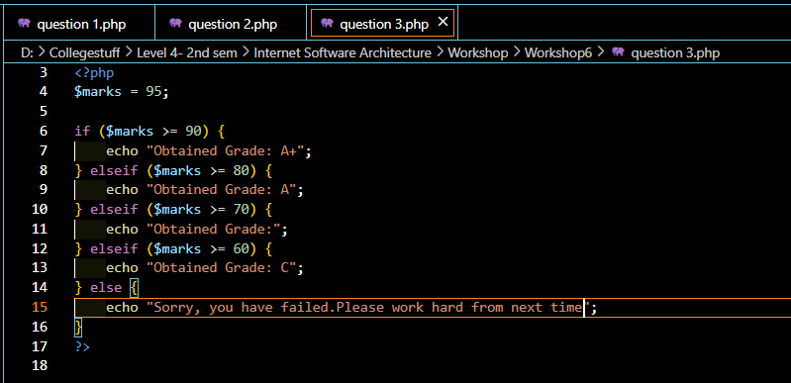

Output:

1. To find factorial of a number using loop in PHP

Code:

Output:

1. 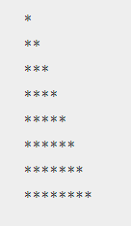To create a given pattern with * using for loop

Code:

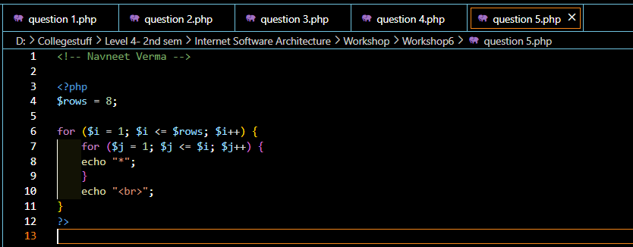

Output:

1. $list = array( "Italy"=>"Rome", "Luxembourg"=>"Luxembourg", "Belgium"=> "Brussels", "Denmark"=>"Copenhagen", "Finland"=>"Helsinki", "France" => "Paris", "Slovakia"=>"Bratislava", "Slovenia"=>"Ljubljana", "Germany" => "Berlin", "Greece" => "Athens", "Ireland"=>"Dublin", "Netherlands"=>"Amsterdam", "Portugal"=>"Lisbon", "Spain"=>"Madrid", "Sweden"=>"Stockholm", "United Kingdom"=>"London", "Cyprus"=>"Nicosia", "Lithuania"=>"Vilnius", "Czech Republic"=>"Prague", "Estonia"=>"Tallin", "Hungary"=>"Budapest", "Latvia"=>"Riga", "Malta"=>"Valetta", "Austria" => "Vienna", "Poland"=>"Warsaw") ;

Create a PHP script which displays the capital and country name from the above array $list. Sort the list by the name of the capital.

Code:

Output:

1. Write a PHP function that checks whether a passed string is a palindrome or not?

A palindrome is word, phrase, or sequence that reads the same backward as forward, e.g., madam or dad or noon.

Code:

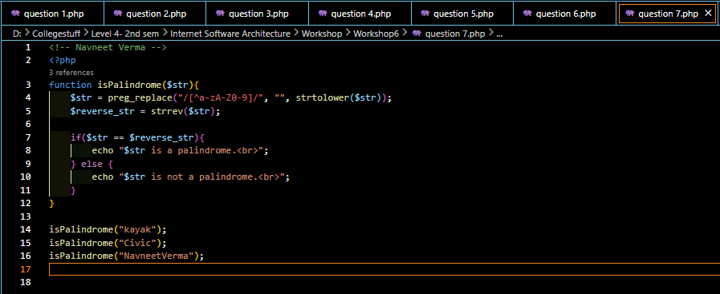

Output:

1. To swap two variables

Eg: $a = 1; $b =2; Result: $a = 2; $b=1;

Code:

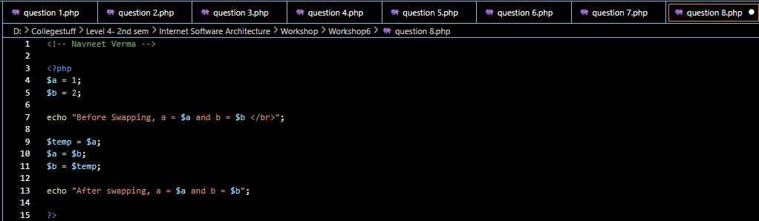

Output:

1. To print the multiple of a given number

Example:

define(‘a’,5);

5 10 15 20 25 30 35 40 45 50 use <br> to print in each line.

Code:

Output:

1. To find whether given number is Armstrong or not.

Example:

$number = 153

If ($number == 1*1*1+5*5*5+3*3*3)

Return Armstrong number

Other number: 1, 0, 371, 407 etc

Code:

Output:

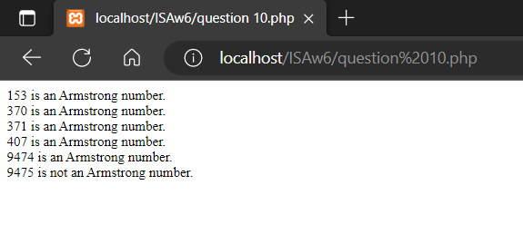

11. Suppose you have the following JSON data. Display the output on a table in HTML.

[

{

"name" : "John Garg",

"age" : "15",

"school" : "Ahlcon Public school"

},

{

"name" : "Smith Soy",

"age" : "16",

"school" : "St. Marie school"

},

{

"name" : "Charle Rena",

"age" : "16",

"school" : "St. Columba School"

}

]

Write a php program to loop over the json data.

Note: PHP allows us to easily convert JSON to arrays. PHP provides predefined functions to easily encode and decode json string inti a php array.

Code:

Output:

